Topic 1: What is a Peripheral Device?
Definition: A peripheral device is any auxiliary hardware component that connects to a computer to transfer information into or out of it. While essential for user interaction, they are not part of the core computing architecture (CPU, RAM, Motherboard chipset).
Key Concept: Dependency & Expansion
- Dependency: A peripheral relies on the host computer's processor to manage its operations. It generally cannot function autonomously.
- Expansion: They allow a generic computer to become specialized (e.g., adding a drawing tablet turns a PC into a digital studio).
Troubleshooting & Common Problems
- Problem: Device not powering on.
  - Cause: Loose cable, faulty power brick, or dead USB port.
  - Fix: The "Isolation Method". Connect the device to a different computer. If it fails there too, the peripheral is broken. If it works, the issue is your original computer's port or drivers.
- Problem: Device recognized but malfunctioning.
  - Cause: Incompatible firmware or physical damage.
  - Fix: Check for physical damage on cables (fraying/bends). Perform a "Power Cycle"—unplug the device, wait 10 seconds, and plug it back in to force a reset.

Topic 2: Input vs. Output Devices
The distinction lies purely in the direction of data flow.
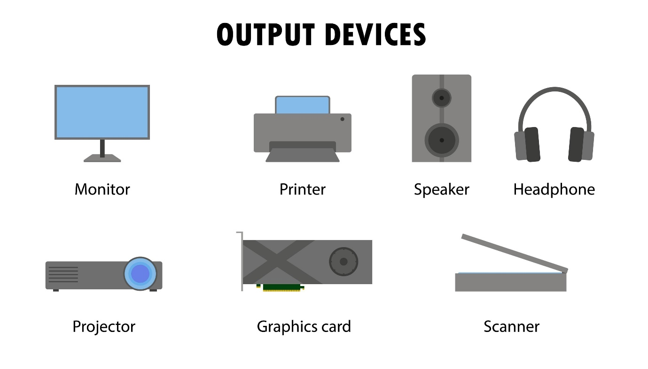
Shutterstock
Explore
1. Input Devices (Data In)
- Signal Flow: External Action Digital Signal CPU.
- Examples: Keyboards, Mice, Scanners, Microphones.
- Troubleshooting:
  - Ghosting: On cheap keyboards, pressing 3+ keys simultaneously results in missed inputs. Fix: Replace with an N-Key Rollover keyboard.
  - Drift: Mouse cursor or game controller stick moves on its own. Fix: Clean the sensor with compressed air; recalibrate in software.
2. Output Devices (Data Out)
- Signal Flow: CPU Processed Data Digital/Analog Signal Human Perception.
- Examples: Monitors, Printers, Speakers.
- Troubleshooting:
  - Artifacts: Strange lines or colors on a monitor. Fix: Check the cable tightness first; test the monitor on another PC to rule out the GPU.
  - Distortion: Audio crackling. Fix: Check for "Ground Loop" interference (electrical buzz); ensure the 3.5mm jack is fully inserted.

Topic 3: The Role of the Operating System (OS)
The OS is the traffic controller. It uses Drivers to translate generic OS commands into specific electrical signals the hardware understands.
Key Functions:
- Device Drivers: Small software packages that teach the OS how to talk to specific hardware.
- Interrupt Requests (IRQs): A hardware "doorbell" used by peripherals to get the CPU's immediate attention.
Troubleshooting & Common Problems
- Problem: The "Yellow Exclamation Mark" in Device Manager.
  - Cause: The OS detects the device but lacks the correct driver, or the driver has crashed.
  - Fix:
    - Update Driver: Right-click "Update Driver" (rarely works automatically).
    - Manually Install: Download the specific driver from the manufacturer's website (e.g., HP, Logitech), not a third-party site.
    - Rollback: If a new driver breaks the device, use the "Roll Back Driver" button in Properties.
- Problem: Code 10 / Code 43 Errors.
  - Meaning: "Device cannot start" (Code 10) or "Device descriptor failed" (Code 43).
  - Fix: Right-click and Uninstall Device, then restart the computer. Windows will attempt to reinstall a fresh copy of the driver upon reboot.

Topic 4: What is Plug and Play (PnP)?
Definition: PnP is the automation protocol that allows the OS to detect, identify, and configure hardware without user intervention.
The PnP Process:
- Enumeration: The OS asks the device "Who are you?"
- Identification: The device replies with a Vendor ID (VID) and Product ID (PID).
- Loading: The OS searches its driver store for a match to the VID/PID.
Troubleshooting & Common Problems
- Problem: "USB Device Not Recognized" notification.
  - Cause: Enumeration failed. The device didn't reply to the OS's "Who are you?" request in time, often due to a bad cable or port power issue.
  - Fix: Unplug all other USB devices to ensure the power supply isn't overloaded. Connect directly to the motherboard (rear ports), not a front panel hub.
- Problem: Device installs but acts like a generic device.
  - Cause: Windows used a generic PnP driver instead of the specific manufacturer one.
  - Fix: Force install the manufacturer's software (e.g., installing "Razer Synapse" to unlock specific mouse DPI settings).

Topic 5: Understanding I/O (Input/Output) Ports
Ports are the physical interface standards.
Port | Detail | Common Issues
USB Type-A | The standard rectangular connector. Blue often indicates USB 3.0 (SuperSpeed). | Bent Pins: A common cause of "Power Surge" errors. Inspect ports with a flashlight.
USB Type-C | Reversible, high speed, can carry power (PD) and video. | Cable Quality: Cheap cables may charge but not transfer data. Always use certified cables.
HDMI | Audio/Video transmission. | Handshake Failure: If the screen is black, unplug and replug the HDMI to force a new "handshake."
Ethernet (RJ45) | Networking. | Broken Tab: The plastic clip breaks, causing the cable to slide out intermittently.

Troubleshooting & Common Problems
- Problem: Intermittent disconnection.
  - Cause: Port wear and tear. The physical solder joints connecting the port to the motherboard may be cracked.
  - Fix: Wiggle the cable gently. If the device connects/disconnects, the physical port is likely damaged and needs professional soldering repair or a workaround (PCIe expansion card).

Topic 6: Internal vs. External Peripherals
Internal: Connected inside the case (PCIe, SATA, M.2). External: Connected outside the case (USB, Thunderbolt).
Troubleshooting & Common Problems
- Internal Issues (e.g., Graphics Card, WiFi Card):
  - Problem: Device not showing up at all.
  - Fix: Reseating. Turn off the PC, open the case, remove the card, and firmly press it back into the slot. Oxidation on gold contacts can block data; clean them with a pencil eraser.
- External Issues:
  - Problem: Cable Clutter / Bandwidth Saturation.
  - Fix: If you daisy-chain too many devices to one USB hub, they may all slow down or disconnect randomly due to shared bandwidth limits.

Topic 7: What are Human Interface Devices (HIDs)?
Definition: HID is a universal USB standard class. If a device declares itself as an "HID," the OS knows it is safe to accept input from it immediately using built-in generic drivers.
Why is this important? It allows you to use a keyboard to enter the BIOS before Windows even loads. Non-HID devices (like some complex scanners) won't work until the OS loads their specific drivers.
Troubleshooting & Common Problems
- Problem: Multiple "HID-compliant device" entries.
  - Scenario: You check Device Manager and see 10 copies of "HID-compliant mouse."
  - Cause: Every time you plug the mouse into a different USB port, Windows creates a new instance. These "Ghost" devices can eventually cause conflicts.
  - Fix: In Device Manager, go to View > Show Hidden Devices. You will see the grayed-out "Ghost" icons. Right-click and uninstall the old duplicates to clear conflicts.

Topic 8: Managing Keyboards
Core Concepts:
- Layouts & Region: The physical keys on a keyboard don't decide what letters appear on the screen; the OS settings do. The most common confusion is between US (ANSI) and UK (ISO) layouts.
- Shortcuts: Efficiency relies on shortcuts.
  - Technician Essentials: Win + X (Quick Link Menu), Ctrl + Shift + Esc (Task Manager), Win + L (Lock Screen).
- Sticky Keys/Filter Keys: Accessibility features that change how the OS interprets repeated keystrokes.
Troubleshooting & Common Problems
- Problem: The "at" (@) symbol and "double quote" (") are swapped.
  - Cause: The physical keyboard is US layout (standard in many regions), but the Windows setting is set to "United Kingdom."
  - Fix: Go to Time & Language > Language > Options. Add the "US QWERTY" keyboard and remove the "United Kingdom" one.
- Problem: The keyboard is typing numbers instead of letters (e.g., J, K, L become 1, 2, 3).
  - Cause: NumLock is active on a compact laptop keyboard that maps a number pad onto the letter keys.
  - Fix: Hold Fn + NumLock to disable it.

Topic 9: Mouse and Touchpad Settings
Core Concepts:
- Sensitivity (DPI): "Dots Per Inch" determines how far the cursor moves on screen for every inch you move the mouse. High DPI = fast cursor; Low DPI = precise cursor.
- Pointer Acceleration: Software that makes the cursor move faster if you move the mouse quickly. Gamers and graphic designers usually turn this off for consistent muscle memory.
- Touchpad Gestures: Modern "Precision Touchpads" support multi-finger commands (e.g., two-finger scroll, three-finger swipe to show desktop).
Troubleshooting & Common Problems
- Problem: Cursor jumps around while typing on a laptop.
  - Cause: Palm Rejection failed. Your palms are brushing the touchpad while you type.
  - Fix: Go to Touchpad Settings and increase "Touchpad Sensitivity" to "Low sensitivity" or enable "Disable touchpad when mouse is connected."
- Problem: Double-click isn't working / opens items with a single click.
  - Cause: Folder Options setting "Single-click to open an item" is selected, or the double-click speed setting is too fast for the user.
  - Fix: Adjust the "Double-click speed" slider in the Control Panel Mouse settings.

Topic 10: Printer Management
Core Concepts:
- Print Spooler: A service (software program) that manages the queue of documents waiting to be printed.
- Consumables:
  - Inkjet: Uses liquid ink cartridges (prone to drying out if unused).
  - Laser: Uses powder toner (good for high volume, text).
- Sharing: Printers can be shared via USB (local), Ethernet/WiFi (Network), or via a print server.
Troubleshooting & Common Problems
- Problem: Documents are stuck in the queue and won't delete.
  - Cause: The Print Spooler service has hung.
  - Fix: Open Services.msc, find Print Spooler, right-click, and select Restart. This flushes the stuck memory.
- Problem: Printer status is "Offline".
  - Cause: Network IP change (if using WiFi) or SNMP status error.
  - Fix: If networked, assign the printer a Static IP so the computer always knows where to find it.

Topic 11: Scanner Basics & AIO Setup
Core Concepts:
- Resolution (DPI):
  - 72-150 DPI: Good for text documents/email (small file size).
  - 300 DPI: Standard for printing copies.
  - 600+ DPI: High quality for photos (very large file size).
- File Formats:
  - PDF: Multi-page documents.
  - JPEG/PNG: Single images/photos.
- All-in-One (AIO) Setup: These devices combine Printer, Scanner, and Copier. Note that the Scanner and Printer often use different drivers, even if they are in the same box.
Troubleshooting & Common Problems
- Problem: Scans have black vertical lines.
  - Cause: The "ADF" (Automatic Document Feeder) small glass strip is dirty (usually white-out or ink).
  - Fix: Clean the thin strip of glass next to the main flatbed glass with alcohol.
- Problem: Printer works, but Scanner says "Communication Error".
  - Cause: Firewall blocking the "Scan to PC" protocol.
  - Fix: Reinstall the "Full Feature Software" from the manufacturer, ensuring you allow the necessary firewall exceptions when prompted.

Topic 12: External Storage & Formatting
Core Concepts:
File Systems determine how data is organized on the drive. You must choose the right one before putting data on the drive, as changing it wipes the drive.
File System | Best For | Pros | Cons
FAT32 | Compatibility | Works on Mac, Windows, Game Consoles, Linux. | Max file size is 4GB. Cannot store large ISOs or HD movies.
NTFS | Windows Drives | Security permissions, encryption, no file size limit. | Read-only on Mac (without special software).
exFAT | Modern USBs | The Gold Standard for USBs. Large files allowed, works on Win/Mac. | Older TVs/Consoles might not read it.
Troubleshooting & Common Problems
- Problem: "File is too large for the destination file system".
  - Cause: You are trying to copy a 5GB file to a FAT32 USB stick.
  - Fix: Backup the data, format the drive to exFAT or NTFS, and try again.
- Problem: Drive letter not appearing.
  - Cause: The drive is healthy but has no partition letter assigned.
  - Fix: Open Disk Management (diskmgmt.msc), right-click the drive, and choose "Change Drive Letter and Paths."

Topic 13: Safely Ejecting Hardware
Core Concepts:
- Write Caching: To speed up performance, Windows doesn't always write data to the USB immediately; it holds it in RAM (Cache) and writes it a few seconds later.
- Ejecting: Clicking "Safely Remove" forces Windows to finish writing all cached data to the drive immediately.
Troubleshooting & Common Problems
- Problem: "This device is currently in use."
  - Cause: A program (like Word, or an Explorer window) still has a file open on that drive.
  - Fix: Close all open windows. If that fails, shut down the PC before removing the drive to guarantee data safety. Never just pull it out if data is critical.

Topic 14: Docking Stations
Core Concepts:
- Function: Turns a laptop into a desktop by connecting one cable (usually USB-C) to drive monitors, Ethernet, mouse, keyboard, and power.
- Power Delivery (PD): The dock charges the laptop. Ensure the dock's wattage (e.g., 65W, 100W) matches the laptop's requirement.
- DisplayLink vs. Alt-Mode:
  - Alt-Mode: Uses the laptop's native GPU (better performance).
  - DisplayLink: Uses a driver to "fake" a video card (good for Macs or laptops with weak ports, but laggy for video).
Troubleshooting & Common Problems
- Problem: Monitors don't wake up after sleep.
  - Cause: Firmware mismatch between the dock and the laptop.
  - Fix: Update the Docking Station Firmware (separate from laptop drivers) and the laptop BIOS.
- Problem: Laptop says "Slow Charger".
  - Cause: The dock provides less power than the laptop needs (e.g., 60W dock for a 130W gaming laptop).
  - Fix: Plug the laptop's original power brick in alongside the dock.

Topic 15: Basics of Audio Peripherals
Core Concepts:
- I/O Separation: Audio is split into Playback (Speakers/Headphones) and Recording (Microphone).
- Default Device: Applications usually look for the "System Default." If you plug in a headset, Windows should switch automatically, but often doesn't.
Troubleshooting & Common Problems
- Problem: Can hear others on Zoom, but they can't hear me.
  - Cause: Hardware Mute button is active OR Windows Privacy settings are blocking the mic.
  - Fix:
    - Check physical switch on headset cord.
    - Go to Settings > Privacy > Microphone and ensure "Allow desktop apps to access your microphone" is ON.
- Problem: Audio playing through laptop speakers instead of headphones.
  - Fix: Click the Speaker icon in the taskbar and toggle the playback device from "Realtek Audio" to "Headphones (USB Audio)."

1. USB Connectors (Data & Power)
The Universal Serial Bus (USB) is the standard for connecting peripherals. You must be able to identify these at a glance to choose the right cable.
- USB Type-A: The standard rectangular plug found on almost all computers.
- USB Type-B: The "square" plug, typically used for printers and scanners.
- USB Type-C: The modern, reversible oval plug used for data, power, and video.
- Micro-USB: Common on older Android phones and small electronics.
- Mini-USB: An older standard, thicker than Micro, often found on older cameras and MP3 players.
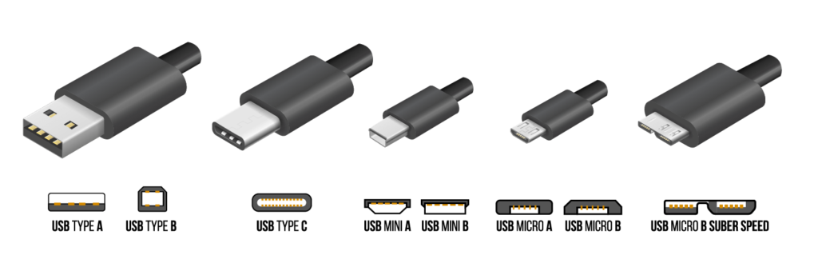

2. Video Connectors (Display)
You will often need to connect monitors and projectors. Knowing the difference prevents "square peg in a round hole" situations.
- HDMI: The standard for TVs and most monitors. Transmits Video + Audio. (Trapezoid shape).
- DisplayPort (DP): Common on business PCs and gaming monitors. One corner is flat, the other is square. Transmits Video + Audio.
- VGA (Legacy): The blue, 15-pin trapezoid connector. Analog video only (no audio). Still common in schools and older offices.
- DVI (Legacy): White, large rectangular connector with many pins. Video only.
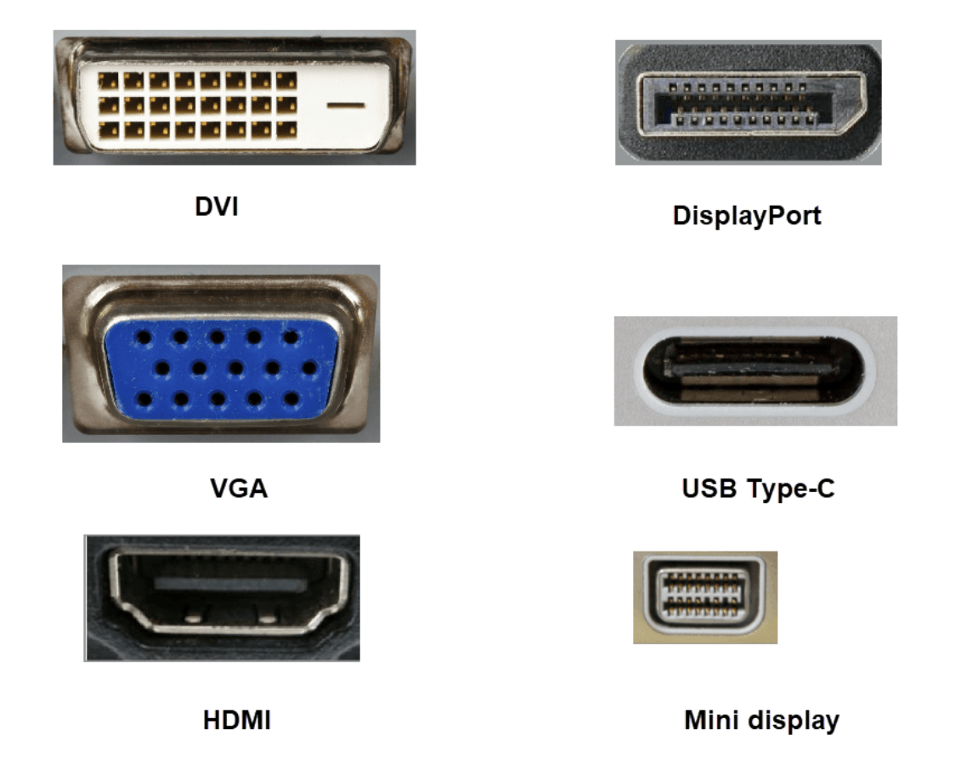

3. Network Connectors
- Ethernet (RJ-45): The standard wired networking jack. It looks like a wider telephone jack.
  - Tip: Always check the plastic "tab" on the connector. If it's broken off, the cable won't stay in the port.
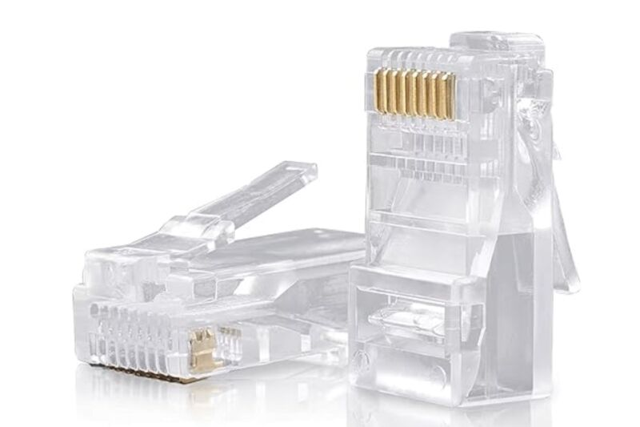
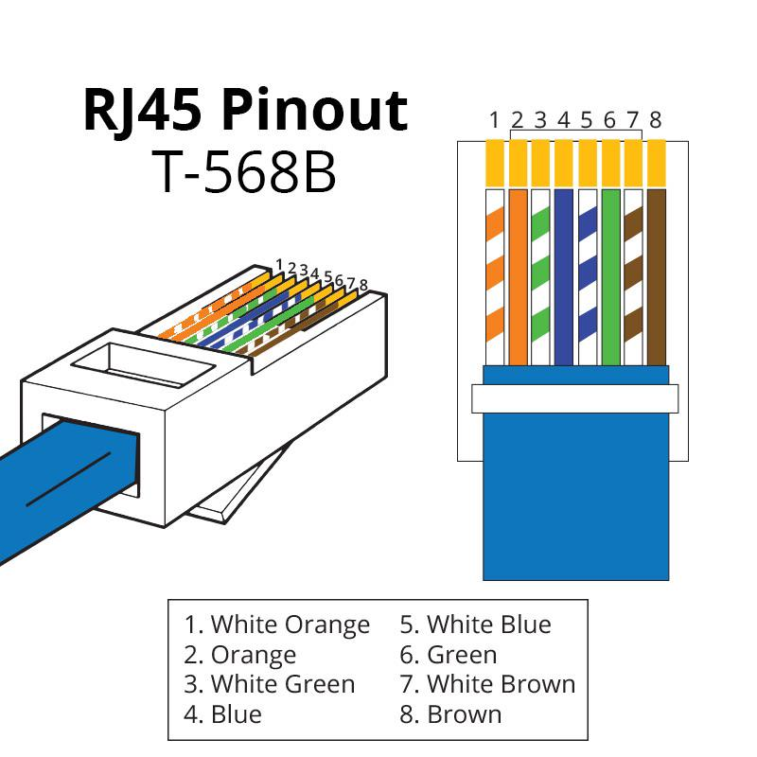

4. Audio Connectors (3.5mm)
Not all "headphone jacks" are the same. The number of black rings on the plug tells you what it can do.
- TRS (2 Rings): Stereo Audio only (Left + Right). Found on standard headphones.
- TRRS (3 Rings): Stereo Audio + Microphone. Found on mobile phone headsets and modern laptops.
  - Troubleshooting: If you plug a TRRS headset into an old PC (which expects TRS), the mic might not work without a splitter adapter.
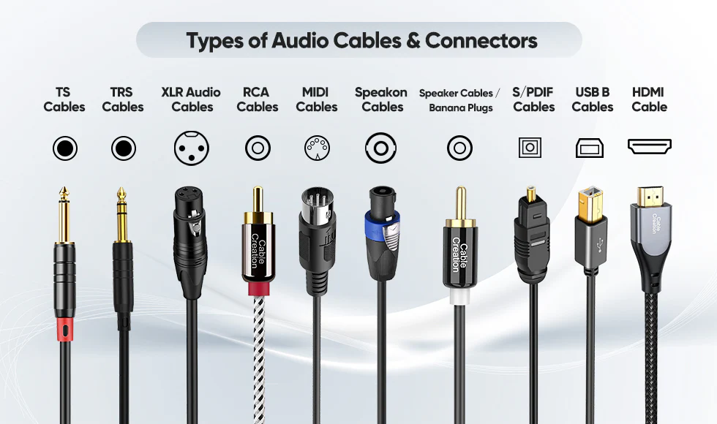

5. Internal Connectors (Inside the PC)
These connect components directly to the motherboard.
- SATA: L-shaped connector used for Hard Drives (HDD) and 2.5" SSDs.
- PCIe: The long slots on the motherboard for Graphics Cards and WiFi cards.
- M.2: The tiny screw-in slot for modern, high-speed SSDs (NVMe).
