Course: Introduction to IT Technician Fundamentals
Course Objective
To provide a foundational understanding of computer hardware, software, networking, and the professional methodology used to troubleshoot and maintain IT systems.

Module 1: The Role of an IT Technician
An IT Technician is the first line of defense for technology issues. Your primary goal is to ensure business continuity by maintaining systems and assisting users.
- Key Responsibilities:
  - Help Desk Support: Answering tickets and calls from users.
  - Maintenance: Installing updates, cleaning hardware, and managing asset inventory.
  - Repair: Diagnosing faulty hardware or corrupt software.
  - Provisioning: Setting up new computers (imaging) for employees.

Module 2: Hardware Fundamentals
You must understand the physical components of a computer to diagnose "No Power" or "Slow Performance" issues.
- CPU (Central Processing Unit): The "brain" that executes instructions. (e.g., Intel Core i5, AMD Ryzen).
- RAM (Random Access Memory): Short-term volatile memory. More RAM allows more apps to run simultaneously.
- Storage (SSD/HDD): Long-term data storage.
  - SSD (Solid State Drive): Fast, no moving parts (Standard for modern OS).
  - HDD (Hard Disk Drive): Slower, magnetic spinning platters (Good for bulk storage).
- Motherboard: The main circuit board that connects all components.
- PSU (Power Supply Unit): Converts outlet power (AC) to internal power (DC).

Module 3: Operating Systems (OS)
Hardware is useless without software to manage it. You will likely encounter three main environments:
- Windows (Corporate Standard):
  - Focus on Active Directory (managing users) and Group Policy (enforcing rules).
  - Tools: Task Manager, Device Manager, Event Viewer.
- macOS (Creative/Executive):
  - Unix-based, known for security and stability.
  - Tools: Disk Utility, Terminal, Activity Monitor.
- Linux (Server/Backend):
  - Open-source and command-line heavy.
  - Used often for servers and cloud infrastructure.
Key Concept: Drivers Drivers are small software programs that allow the OS to talk to hardware (e.g., a "Print Driver" lets Windows talk to the Printer). 50% of peripheral issues are driver-related.

Module 4: Networking Basics
Most IT issues today are network-related ("The Wi-Fi is down," "I can't access the shared drive").
- IP Address: The unique address of a device on a network (e.g., 192.168.1.15).
- LAN (Local Area Network): A network contained within a small area like an office.
- Switch: Connects devices within a network (connects computers to computers).
- Router: Connects different networks together (connects your office to the Internet).
- DHCP vs. Static:
  - DHCP: Automatically assigns IP addresses.
  - Static: You manually type in a permanent address (used for printers/servers).
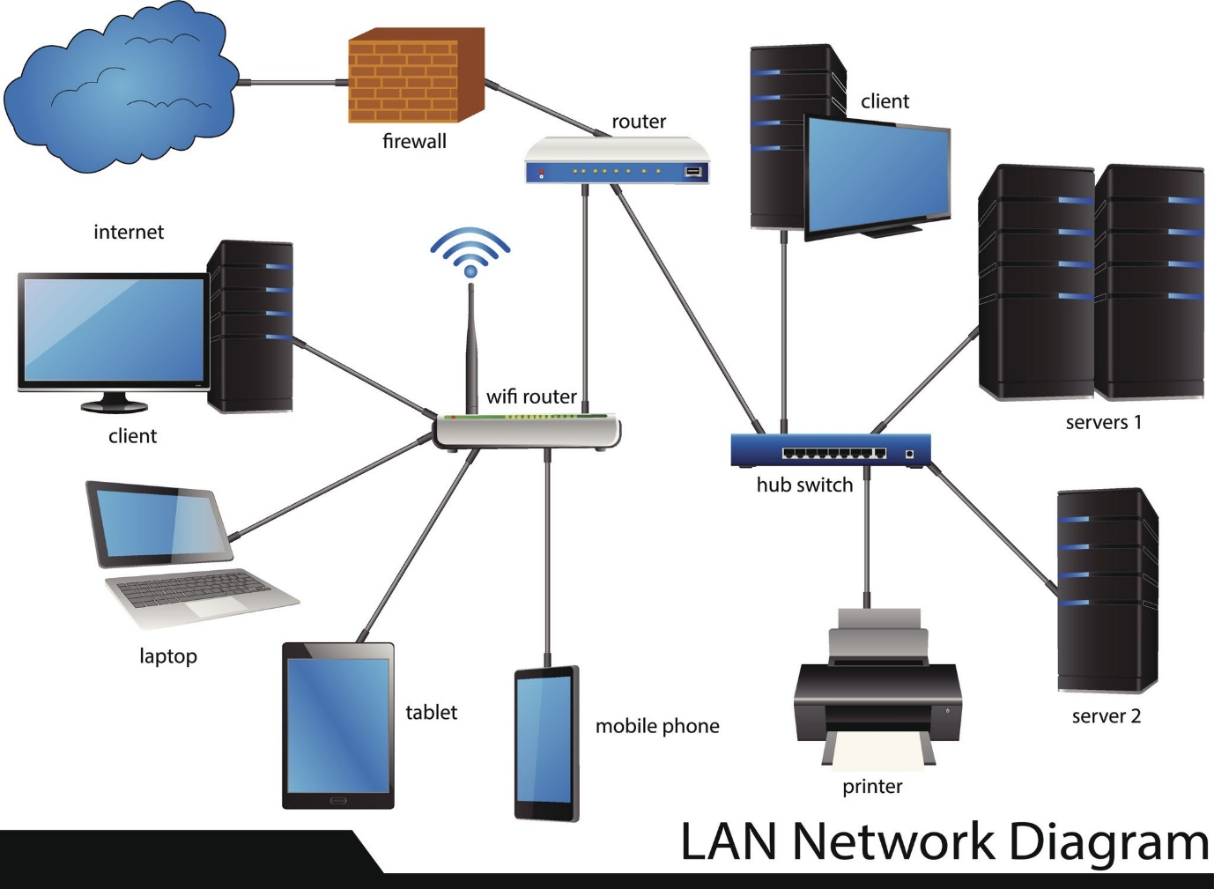
Getty Images

Module 5: The Troubleshooting Methodology
Professional technicians don't guess; they follow a standardized process (often based on CompTIA A+ standards).
- Identify the Problem: Ask the user questions ("When did it start?", "Is there an error message?").
- Establish a Theory: What is the most likely cause? (Start with the simplest solution, like checking cables).
- Test the Theory: Try your solution. If it fails, establish a new theory.
- Establish a Plan of Action: If the fix requires a reboot or buying a part, plan when to do it to minimize downtime.
- Verify Functionality: Ensure the problem is actually gone and hasn't caused new issues.
- Document Findings: Write down what the issue was and how you fixed it in the ticketing system.

Module 6: Soft Skills & Documentation
Technical skills get you the job; soft skills keep you the job.
- Avoid Jargon: Don't say "The DNS failed to resolve"; say " The computer is having trouble finding the website."
- Empathy: Users are often stressed when IT fails. Be patient and reassuring.
- Ticket Notes: clear documentation allows other technicians to pick up where you left off. Always include:
  - User Name
  - Asset Tag
  - Steps taken
  - Resolution

