Windows Systems Administration Master Training Part 2
Part 2: Advanced OS Administration (51–100)
Module 6: Windows Security & Hardening (51–60)
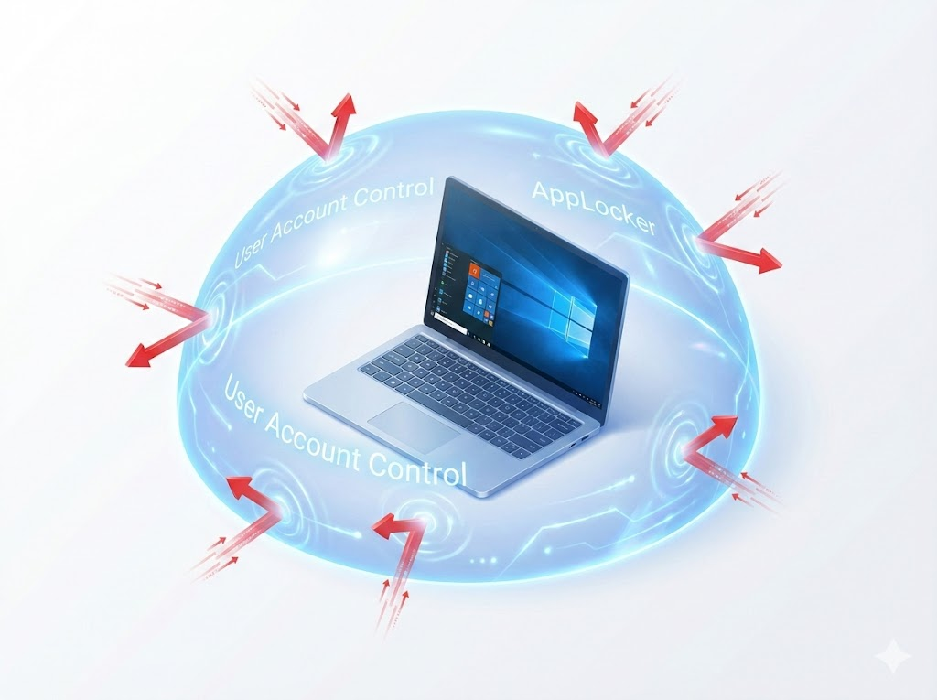
Locking down the fortress. Security is not a product; it is a process.
51. User Account Control (UAC)
- The Concept: The "Are you sure?" guard dog. In older Windows versions (XP), everyone ran as an Administrator. If you visited a bad website, the virus instantly infected the core system. UAC forces even Administrators to run as "Standard Users" until they specifically request elevation.
- Use Case: A user unknowingly downloads a PDF invoice that is actually a virus (invoice.exe). UAC pauses the screen and asks for permission. Since the user didn't expect an install prompt, they click "No," saving the PC.
- Step-by-Step Implementation:
  - Press Win key and type UAC.
  - Select Change User Account Control settings.
  - Slider Options:
    - Top (Always Notify): The screen dims (Secure Desktop). The OS pauses all other processes. Best for Kiosks/Servers.
    - Second (Default): Notify only when apps try to make changes. Best for Daily Use.
    - Bottom (Never Notify): Dangerous. Disables the security layer.
  - Click OK.
52. Local Security Policy (secpol.msc)
- The Concept: The rulebook for a single computer. It controls password complexity, lockout timers, and audit rules.
- Use Case: You are setting up a standalone laptop for a contractor. You need to ensure they can't use "1234" as a password and that the PC locks after 5 failed attempts.
- Step-by-Step Implementation:
  - Press Win + R, type secpol.msc, and hit Enter.
  - Navigate to Account Policies -> Password Policy.
  - Double-click Minimum password length. Set to 12 characters.
  - Navigate to Account Lockout Policy.
  - Double-click Account lockout threshold. Set to 5 invalid logon attempts.
  - Close the window. The rules apply immediately.
53. AppLocker (Whitelisting)
- The Concept: "Whitelisting" vs. "Blacklisting." Antivirus (Blacklist) tries to block known bad things. AppLocker (Whitelist) blocks everything except known good things.
- Use Case: Preventing Ransomware. Even if a user downloads a brand-new virus that Antivirus doesn't know yet, AppLocker blocks it simply because it isn't on the "Allowed List."
- Step-by-Step Implementation (Basic Rule):
  - Open secpol.msc.
  - Navigate to Application Control Policies -> AppLocker -> Executable Rules.
  - Right-click -> Create Default Rules (Crucial: This ensures Windows itself isn't blocked!).
  - Right-click -> Create New Rule.
  - Publisher: Select an installer (like Office setup). Use the slider to trust "Microsoft Corporation" generally.
  - Enforcement: By default, rules are "Audit Only." You must change the AppLocker Properties to Enforce Rules to actually block apps.
54. Local Admin Password Solution (LAPS)
- The Concept: If every PC in your company has the same Local Administrator password (e.g., "Admin123"), one compromised laptop means the hacker owns every laptop. LAPS randomizes this password automatically every 30 days.
- Use Case: A technician needs to install software on HR-Laptop-01 but the user is away. The tech checks Active Directory for the current specific password for that laptop.
- Step-by-Step Implementation:
  - Server Side: Install the LAPS management feature on the Domain Controller.
  - Client Side: Deploy the LAPS.x64.msi agent to all computers via Group Policy.
  - To View Password: Open LAPS UI (installed on your admin PC).
  - Type the computer name (HR-Laptop-01) and click Search.
  - Copy the password shown.
55. Windows Defender Exclusions
- The Concept: The built-in Antivirus scans every file read/write operation. This safeguards the OS but kills performance on specific tasks like compiling code or heavy database logging.
- Use Case: A developer complains that Visual Studio is "extremely slow" when building projects. The antivirus is scanning every temporary object file being created.
- Step-by-Step Implementation:
  - Open Windows Security (shield icon in tray).
  - Go to Virus & threat protection -> Manage settings.
  - Scroll down to Exclusions -> Add or remove exclusions.
  - Click Add an exclusion -> Folder.
  - Select the project folder (e.g., C:\DevProjects).
  - Warning: Never exclude C:\Users\Downloads or C:\Windows\Temp.
56. EFS (Encrypting File System) vs. BitLocker
- The Concept:
  - BitLocker: Encrypts the entire drive. Protects against theft.
  - EFS: Encrypts individual files. Protects against other users on the same computer.
- Use Case: A laptop is stolen from a car. Because BitLocker is on, the thief cannot pull data off the hard drive.
- Step-by-Step Implementation (BitLocker):
  - Open This PC. Right-click the C: drive.
  - Select Turn on BitLocker.
  - Save Recovery Key: Choose "Save to your cloud domain account" or "Save to a file" (on a USB). Do not lose this key.
  - Select Encrypt entire drive.
  - Click Start Encrypting. The PC may need a restart to check the TPM chip.
57. SmartScreen Filter
- The Concept: A reputation check. When you run a file, Windows asks Microsoft: "Is this file safe?"
- Use Case: A user tries to run a helper script you just wrote. Windows blocks it saying "Windows protected your PC" because the script is new and has no "reputation" yet.
- Step-by-Step Implementation (Unblocking):
  - If blocked, the user sees a blue window with only a "Don't Run" button.
  - Click the small More Info text link.
  - A Run Anyway button will appear. Click it.
  - Pro Tip: To prevent this for scripts, right-click the file -> Properties -> Check Unblock at the bottom.
58. Auditing (Object Access)
- The Concept: Tracking "Who deleted that file?" by turning on the security cameras for a specific folder.
- Use Case: Files are disappearing from the "Finance" shared folder. No one admits to deleting them. You enable auditing to catch the culprit.
- Step-by-Step Implementation:
  - Enable Policy: In secpol.msc (or GPO), go to Local Policies -> Audit Policy -> Set Audit object access to Success and Failure.
  - Tag Folder: Right-click the target folder -> Properties -> Security -> Advanced.
  - Click the Auditing tab -> Add.
  - Principal: Everyone. Type: All.
  - Show Advanced Permissions: Check Delete and Delete subfolders and files.
  - View Logs: Open Event Viewer -> Security Log. Look for Event ID 4663.
59. Security Identifiers (SIDs)
- The Concept: Windows doesn't use names like "Admin"; it uses long number strings (SIDs).
- Use Case: A user account was deleted and recreated with the exact same name ("JohnDoe"). Now John can't access his old files. Why? Because his new account has a new SID. The old file permissions are looking for the old (dead) SID.
- Step-by-Step Implementation:
  - Open Command Prompt (cmd).
  - Type whoami /user.
  - You will see S-1-5-21-xxxx....
  - Admin Check: SIDs ending in -500 are always the built-in Administrator.
60. Windows Sandbox
- The Concept: A disposable, pristine Windows desktop that lives in a window. When you close it, everything inside is vaporized.
- Use Case: You receive a suspicious email attachment. Instead of opening it on your real desktop, you open it in Sandbox to see if it explodes.
- Step-by-Step Implementation:
  - Enable: Search Turn Windows features on or off. Check Windows Sandbox. Reboot.
  - Run: Search Windows Sandbox in Start Menu.
  - Copy the suspicious file from your real desktop. Paste it into the Sandbox window.
  - Run the file. Observe behavior.
  - Close the Sandbox window. The data is permanently erased.

Module 7: Group Policy & Active Directory Management (61–70)
Managing the OS at scale.
61. GPO Processing Order (LSDOU)
- The Concept: Conflict resolution for policies.
- The Rule: Local -> Site -> Domain -> Organizational Unit. The last one applied wins.
- Use Case: The "Domain" policy requires a 15-minute screen lock. The "Reception" OU policy requires a 60-minute screen lock. Because the Reception PC is in the OU (processed last), it gets the 60-minute timer.
- Troubleshooting:
  - Run gpresult /r on the client machine.
  - Look at the "Applied Group Policy Objects" section to see the winning order.
62. GPO "Enforced" vs. "Block Inheritance"
- The Concept:
  - Block Inheritance: "Don't let parent settings touch me."
  - Enforced: "I am the boss. You cannot block me."
- Use Case: You block USB drives for the whole company (Domain Level). The "IT Dept" OU blocks inheritance so they can use USBs. The CEO demands no one uses USBs ever. You set the Domain policy to Enforced. It now overrides the IT Dept's block.
- Step-by-Step Implementation:
  - Open Group Policy Management (gpmc.msc).
  - Right-click a GPO link (e.g., "Disable USB").
  - Select Enforced. A padlock icon appears.
  - To block: Right-click an OU -> Select Block Inheritance. A blue exclamation icon appears.
63. ADMX Central Store
- The Concept: Storing GPO templates in a central shared folder so all Domain Controllers see the same settings.
- Use Case: You try to edit a GPO on Server B, but it says "Extra Registry Settings" because Server B doesn't have the Windows 11 templates that Server A has.
- Step-by-Step Implementation:
  - Go to C:\Windows\PolicyDefinitions on a modern Windows 11 PC.
  - Copy that entire folder.
  - Navigate to \\yourdomain.com\SYSVOL\yourdomain.com\policies.
  - Create a folder named PolicyDefinitions and paste the files there.
  - Now, when you open Group Policy Editor, it will say "Policy definitions (ADMX files) retrieved from the central store."
64. Item-Level Targeting
- The Concept: Making GPOs smart. "Apply this setting ONLY if..."
- Use Case: You have one "Drive Maps" GPO. You want the "Z: Engineering" drive to map only if the user is a member of the "Engineers" group.
- Step-by-Step Implementation:
  - Edit a GPO. Go to User Configuration -> Preferences -> Drive Maps.
  - Right-click -> New -> Mapped Drive.
  - Set Location (\\server\engineering).
  - Click the Common tab.
  - Check Item-level targeting -> Targeting...
  - Click New Item -> Security Group. Select "Engineers".
  - Click OK.
65. Loopback Processing
- The Concept: Applying User settings based on the Computer they are sitting at.
- Use Case: In a warehouse, generic "WarehousePC" accounts are used. When a Manager logs into a Warehouse PC, you don't want their full Roaming Profile and Outlook to load. You want them to get the restricted "Warehouse" user interface.
- Step-by-Step Implementation:
  - Create a GPO linked to the Computers OU (Warehouse).
  - Navigate to Computer Configuration -> Admin Templates -> System -> Group Policy.
  - Enable Configure user Group Policy loopback processing mode.
  - Mode: Merge (Add to user settings) or Replace (Wipe user settings and use only these).
66. Folder Redirection
- The Concept: Redirects "My Documents" to a server location.
- Use Case: A user's hard drive dies. You give them a new laptop. They log in, and their Desktop icons and Documents appear instantly because they were living on the server, not the dead hard drive.
- Step-by-Step Implementation:
  - Edit GPO -> User Configuration -> Policies -> Windows Settings -> Folder Redirection.
  - Right-click Documents -> Properties.
  - Setting: Basic - Redirect everyone's folder to the same location.
  - Path: \\FileServer\Users\%USERNAME%\Documents.
  - Click OK. The user must log off and on to apply.
67. WMI Filters
- The Concept: A query language to filter which PCs get a GPO.
- Use Case: You have a GPO that installs a specific Wi-Fi driver patch, but it causes Blue Screens on Windows 10. You want it to apply only to Windows 11.
- Step-by-Step Implementation:
  - In gpmc.msc, right-click WMI Filters -> New.
  - Query: SELECT * FROM Win32_OperatingSystem WHERE Caption LIKE '%Windows 11%'.
  - Save as "Windows 11 Only".
  - Select your GPO. Look at the bottom for WMI Filtering.
  - Select "Windows 11 Only" from the dropdown.
68. RSAT (Remote Server Administration Tools)
- The Concept: Managing servers from your desk.
- Use Case: You need to reset a password. Instead of Remote Desktop-ing (RDP) into the Domain Controller (which is a security risk and uses resources), you open "Active Directory Users and Computers" directly on your own Windows 11 laptop.
- Step-by-Step Implementation:
  - On your Windows 10/11 PC, right-click Start -> Apps & Features.
  - Click Optional features -> Add a feature.
  - Search RSAT.
  - Install RSAT: Active Directory Domain Services...
  - Once done, look in Windows Administrative Tools in the Start Menu.
69. SYSVOL & Replication
- The Concept: The hidden folder that syncs policies between Domain Controllers.
- Use Case: You create a new GPO, but users in the Branch Office aren't getting it.
- Troubleshooting Steps:
  - Open File Explorer on the Branch DC.
  - Go to \\localhost\SYSVOL\domain\policies.
  - Check if the new GPO folder (identified by GUID) exists there.
  - If not, the DFSR service might be stopped. Check services.msc.
70. Group Policy Preferences (Printers)
- The Concept: Deploying printers automatically without scripts.
- Use Case: The "HR" department needs the "HR-Copier" mapped automatically when they log in.
- Step-by-Step Implementation:
  - Edit GPO -> User Configuration -> Preferences -> Control Panel Settings -> Printers.
  - Right-click -> New -> Shared Printer.
  - Share Path: \\PrintServer\HR-Copier.
  - Action: Update (Creates it if missing, updates it if changed).
  - (Optional) Set as default printer.

Module 8: Advanced PowerShell & Automation (71–80)

Transitioning from clicking to coding.
71. The Verb-Noun Syntax
- The Concept: Action-Thing.
- Use Case: You forgot the command to restart a computer. You know the action is "Restart" and the thing is "Computer".
- Step-by-Step:
  - Type Restart- and press Tab. PowerShell will cycle through options.
  - You find Restart-Computer.
72. The Pipeline (|)
- The Concept: Passing the "ball" from one command to the next.
- Use Case: You need to find a process named "Notepad" and kill it immediately.
- Step-by-Step Implementation:
  - Command: Get-Process -Name Notepad | Stop-Process
  - Explanation: Get-Process finds the ID. The pipe | hands that ID to Stop-Process. Stop-Process executes the kill.
73. Variables
- The Concept: Containers for data. Start with $.
- Use Case: You are writing a script to create users. You don't want to type the Department name 50 times.
- Step-by-Step Implementation:
  - Set variable: $Dept = "Accounting"
  - Use variable: New-ADUser -Name "John" -Department $Dept
  - Use variable: New-ADUser -Name "Jane" -Department $Dept
74. Get-Member
- The Concept: The instruction manual for an object.
- Use Case: You have a list of services (Get-Service), but you don't know the specific name of the property that tells you if it's Running or Stopped (Is it "State"? "Status"? "Running"?).
- Step-by-Step Implementation:
  - Run: Get-Service | Get-Member
  - Look at the "Property" list.
  - You will see a property called Status.
  - Now you can filter: Get-Service | Where-Object Status -eq 'Running'
75. Execution Policies
- The Concept: Safety locks on scripts.
- Use Case: You download a script to fix Windows Updates, but it fails with "cannot be loaded because running scripts is disabled."
- Step-by-Step Implementation:
  - Open PowerShell as Admin.
  - Check current policy: Get-ExecutionPolicy.
  - Change policy: Set-ExecutionPolicy RemoteSigned.
  - Press Y to accept. Now local scripts run, but internet scripts require a trusted signature.
76. PowerShell ISE vs. VS Code
- The Concept:
  - ISE: Built-in, simple, legacy.
  - VS Code: Must install, powerful, modern.
- Use Case: If you are on a random server fixing a problem, use ISE (type ise in start). If you are at your desk writing a 100-line automation tool, use VS Code.
77. Enter-PSSession (Remoting)
- The Concept: SSH for Windows. Managing a PC via command line over the network.
- Use Case: A server's GUI is frozen/laggy, but the network is up. You need to restart a stuck service without logging in via RDP.
- Step-by-Step Implementation:
  - Open PowerShell as Admin on your PC.
  - Command: Enter-PSSession -ComputerName Server01
  - Prompt changes to [Server01]: PS C:\>.
  - Run: Restart-Service Spooler.
  - Run: Exit-PSSession to return to your PC.
78. Export-CSV
- The Concept: Generating reports.
- Use Case: Your boss asks for a list of all software installed on a computer to check for licenses.
- Step-by-Step Implementation:
  - Command: Get-ItemProperty HKLM:\Software\Wow6432Node\Microsoft\Windows\CurrentVersion\Uninstall\* | Select-Object DisplayName, DisplayVersion | Export-Csv C:\software_list.csv -NoTypeInformation
  - Open C:\software_list.csv in Excel.
79. ForEach Loops
- The Concept: Doing the same task for a list of items.
- Use Case: You have a text file (servers.txt) with 10 server names. You need to create a folder called "Logs" on the C: drive of all of them.
- Step-by-Step Implementation:
PowerShell
$servers = Get-Content C:\servers.txt
ForEach ($server in $servers) {
Invoke-Command -ComputerName $server -ScriptBlock { New-Item -Path "C:\Logs" -ItemType Directory }
}
80. The $PSVersionTable
- The Concept: Checking your engine version.
- Use Case: A script you found online fails. It uses a command that only exists in PowerShell 7, but you are on Server 2016 (PowerShell 5.1).
- Step-by-Step Implementation:
  - Type $PSVersionTable.
  - Look at PSVersion.
  - If it says 5.1.x, you are on standard Windows PowerShell.
  - If it says 7.x, you are on PowerShell Core.

Module 9: System Internals & Virtualization (81–90)
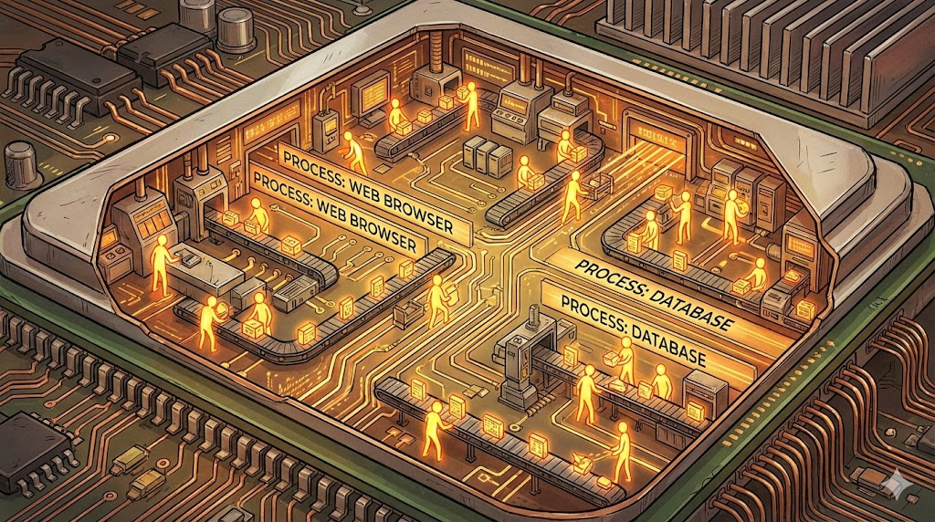
Understanding what happens under the hood.
81. Processes vs. Threads vs. Handles
- The Concept:
  - Process: The Factory (Chrome.exe).
  - Thread: The Workers inside (One plays video, one downloads file).
  - Handle: Tools checked out (Access to a file, network port).
- Use Case: You cannot delete a file because it is "In Use." This means a Process has an open Handle on that file.
- Step-by-Step Implementation:
  - Open Resource Monitor (resmon).
  - Go to CPU tab.
  - Expand Associated Handles search box.
  - Type the name of the locked file.
  - It will show you exactly which process is holding it. Right-click -> End Process.
82. The Page File (Virtual Memory)
- The Concept: An extension of RAM on your Hard Drive.
- Use Case: A user with 8GB RAM tries to edit a massive 4K video. The RAM fills up. Instead of crashing, Windows moves background apps (like Outlook) to the Page File to make room.
- Implementation:
  - System Properties (sysdm.cpl) -> Advanced -> Performance Settings -> Advanced -> Virtual Memory.
  - Best Practice: Leave it on System Managed Size. Do not disable it.
83. The Component Store (WinSxS)
- The Concept: The "Spare Parts" warehouse. It keeps backups of system files so you can uninstall updates.
- Use Case: A server is running out of disk space. C:\Windows\WinSxS is taking up 20GB.
- Step-by-Step Implementation:
  - Open CMD as Admin.
  - Run: dism /online /cleanup-image /analyzecomponentstore (Checks if cleanup is needed).
  - Run: dism /online /cleanup-image /startcomponentcleanup (Safely deletes old versions).
84. Service Startup Types
- The Concept: Controlling when background apps run.
- Use Case: A specialized accounting software service is failing because it tries to start before the SQL Database is ready.
- Step-by-Step Implementation:
  - Open services.msc.
  - Find the Accounting Service.
  - Right-click -> Properties.
  - Change Startup type to Automatic (Delayed Start).
  - This makes it wait ~2 minutes after boot, giving SQL time to load first.
85. Task Manager Details Tab
- The Concept: The "Truth" tab.
- Use Case: A computer is slow. The "Processes" tab shows CPU is low. The "Details" tab reveals that System Idle Process is at 99%.
- Explanation: System Idle Process is a placeholder. If it is high, the CPU is actually doing nothing. The slowness is likely the Hard Drive (Disk I/O), not the CPU.
86. Enabling Hyper-V
- The Concept: Running virtual machines on Windows 10/11 Pro.
- Use Case: You need to test software on Windows 11 but don't want to mess up your main PC. You create a VM.
- Step-by-Step Implementation:
  - Right-click Start -> Run -> optionalfeatures.exe.
  - Check Hyper-V.
  - Click OK and Restart.
  - Search Hyper-V Manager to start creating VMs.
87. VHDX (Virtual Hard Disks)
- The Concept: A file that acts like a physical hard drive.
- Use Case: You need to recover files from an old backup image (VHDX).
- Step-by-Step Implementation:
  - Locate the .vhdx file in Explorer.
  - Right-click -> Mount.
  - It will appear as a new Drive Letter (e.g., F:).
  - Copy the files you need.
  - Right-click Drive F: -> Eject when done.
88. Checkpoints (Snapshots)
- The Concept: A "Save State" button.
- Use Case: You are about to upgrade a critical application on a server.
- Step-by-Step Implementation:
  - Open Hyper-V Manager.
  - Right-click the VM -> Checkpoint.
  - Perform the upgrade.
  - If it fails: Right-click the Checkpoint -> Apply (Reverts instantly).
  - If it works: Right-click the Checkpoint -> Delete Checkpoint (Merges changes). Do not skip this step. Keeping checkpoints forever slows down the server.
89. Windows Subsystem for Linux (WSL)
- The Concept: Running Linux tools inside Windows.
- Use Case: A developer needs to run a Python script that relies on Linux libraries.
- Step-by-Step Implementation:
  - Open CMD as Admin.
  - Run: wsl --install.
  - Restart computer.
  - Open Start Menu -> Ubuntu.
  - You now have a full Linux terminal.
90. Registry Hives (Ntuser.dat)
- The Concept: User settings are stored in a file called Ntuser.dat in their profile folder.
- Use Case: A user logs in, but their settings are gone. They get a "Temporary Profile" error.
- Troubleshooting:
  - Log in as Admin.
  - Check C:\Users\TargetUser.
  - Look for ntuser.dat. If it is renamed to ntuser.man or corrupted, the profile will fail to load.
  - Often caused by Antivirus locking the file during logout.

Module 10: Advanced Troubleshooting & Recovery (91–100)
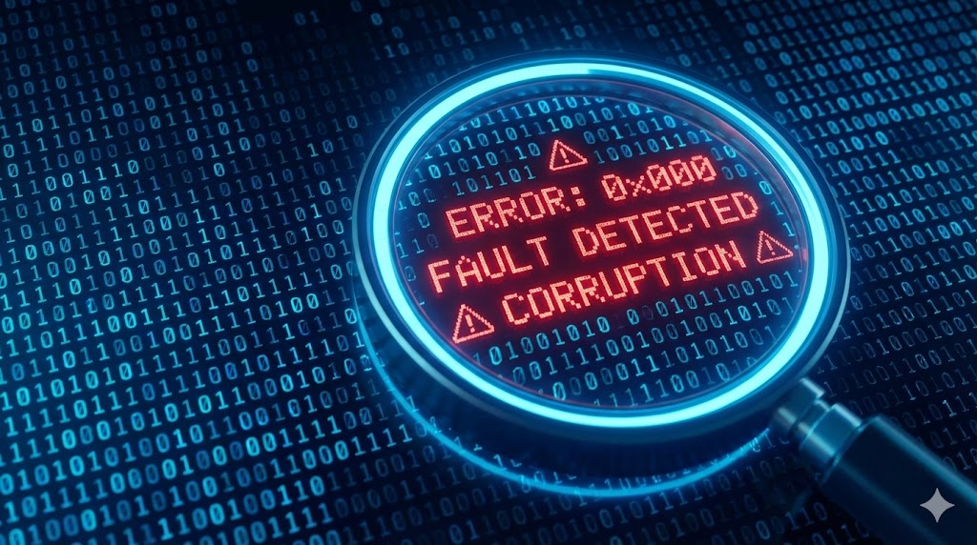
Diagnosing the invisible.
91. Custom Views in Event Viewer
- The Concept: Filtering the noise.
- Use Case: You suspect a hard drive is failing, but the System log has 50,000 entries about printers and updates.
- Step-by-Step Implementation:
  - Open eventvwr.msc.
  - Right-click Custom Views -> Create Custom View.
  - Logged: Any time.
  - Event Level: Check Critical, Error, Warning.
  - Event Sources: Select Disk and Ntfs.
  - Click OK. Name it "Disk Errors".
  - You now see only disk problems.
92. BSOD Analysis (BlueScreenView)
- The Concept: Reading the crash dump.
- Use Case: A PC crashes every time the user starts a video meeting.
- Step-by-Step Implementation:
  - After the crash, download BlueScreenView (free tool).
  - Run it. It automatically finds files in C:\Windows\Minidump.
  - Look for the Caused By Driver column (highlighted in pink).
  - If it says usbvideo.sys, the issue is the Webcam Driver. Update it.
93. Reliability Monitor
- The Concept: A user-friendly crash timeline.
- Use Case: User says, "My computer started acting weird on Tuesday."
- Step-by-Step Implementation:
  - Click Start, type Reliability.
  - Open View reliability history.
  - Click on Tuesday in the graph.
  - Look at the list. You see "Windows Update installed Driver XYZ."
  - That driver is the likely cause. Roll it back.
94. Driver Verifier
- The Concept: Stress-testing drivers to force a crash.
- Use Case: A server reboots randomly once a week. Dumps are inconclusive. You need to force the bad driver to reveal itself.
- Step-by-Step Implementation:
  - Run verifier.exe.
  - Create custom settings -> Select everything except "Low resource simulation".
  - Select driver names from a list -> Sort by Provider -> Select all Non-Microsoft drivers.
  - Reboot.
  - Warning: The PC will likely crash on boot. This is good! The crash dump will now name the exact culprit.
  - Boot to Safe Mode to turn Verifier off (verifier /reset).
95. ProcMon (Process Monitor)
- The Concept: Logging file access errors.
- Use Case: An old accounting app gives an error "Cannot save settings" but doesn't say why.
- Step-by-Step Implementation:
  - Download and run ProcMon (Sysinternals).
  - Stop the capture (Ctrl+E) and Clear (Ctrl+X).
  - Get ready to click "Save" in the app.
  - Start Capture (Ctrl+E). Click "Save" in the app. Stop Capture.
  - Filter: Click the Funnel icon. Set "Result" "is" "ACCESS DENIED".
  - It shows the app tried to write to C:\Program Files\App\Config.ini. Standard users can't write there.
  - Fix: Grant "Modify" permission to Users on that specific file.
96. Autoruns
- The Concept: Seeing everything that starts with Windows.
- Use Case: You removed a virus, but every time you reboot, a "File Not Found" error pops up.
- Step-by-Step Implementation:
  - Download and run Autoruns64.exe as Admin.
  - Wait for it to scan.
  - Look for yellow highlighted rows (File not found).
  - This is likely the remnant of the virus trying to start.
  - Uncheck or Delete the row.
97. System Restore (WinRE)
- The Concept: Undoing a bad update.
- Use Case: You installed a Windows Update and now the PC Blue Screens on boot. You can't get to the desktop.
- Step-by-Step Implementation:
  - Boot PC. When Windows logo appears, hold Power button to kill it. Repeat 3 times.
  - Windows enters Automatic Repair.
  - Select Advanced Options -> Troubleshoot -> Advanced Options -> System Restore.
  - Select a date from before the update.
  - Let it run. It will revert system files but keep your documents safe.
98. Safe Mode with Command Prompt
- The Concept: A minimal interface when the GUI is broken.
- Use Case: You log in, but the screen flashes black/white. Explorer.exe is crashing in a loop. You can't click anything.
- Step-by-Step Implementation:
  - Boot into WinRE (see #97).
  - Startup Settings -> Restart.
  - Press 6 for Safe Mode with Command Prompt.
  - You get a black window.
  - Type rstrui.exe to launch System Restore, or create a new user with net user /add to test a fresh profile.
99. DISM & SFC Repair Chain
- The Concept: Fixing corrupted system files.
- Use Case: The Start Menu refuses to open.
- Step-by-Step Implementation:
  - Open CMD as Admin.
  - Step 1: dism /online /cleanup-image /restorehealth (Connects to Microsoft servers to get healthy file copies).
  - Step 2: sfc /scannow (Uses those healthy copies to replace your broken local files).
  - Restart.
100. Clean Boot
- The Concept: Disabling all 3rd party software to isolate a bug.
- Use Case: The PC is slow. You suspect Adobe, or Dropbox, or Antivirus, but aren't sure which.
- Step-by-Step Implementation:
  - Run msconfig.
  - Services Tab: Check Hide all Microsoft services. Click Disable All.
  - Startup Tab: Open Task Manager -> Right-click and Disable everything.
  - Reboot.
  - If the PC is fast now, the problem is one of the apps you disabled. Enable them one by one to find the villain.

