
Monash University
ECE2072 Assignment Report
Processor in Verilog HDL
Loo Yi Ren Dillon
[Date]

Contents

Introduction 2
Components 2
Sign Extender 2
Tick Counter 2
ALU 3
Multiplexer 3
Register 4
Design & implemented Datapath 5
Arithmetic operations: 5
Product testing 6
Sign Extender testbench 6
Tick Counter testbench 6
ALU testbench 6
Multiplexer testbench 6
Register testbench 7
Conclusion 7
Appendix 8

Introduction
This report presents the design and implementation of a Verilog Processor, the fundamental component of modern computing systems.

Components

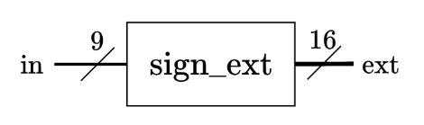
Sign Extender
Figure 1: high level diagram of sign_ext module
The sign extender module serves the vital role of expanding the 9-bit input in the processor into a 16-bit binary representation, accommodating both positive and negative 2's complement numbers. Its operation involves analysing the most significant bit (MSB) of the input and replicating it six times to the left, thereby generating the extended 16-bit output.

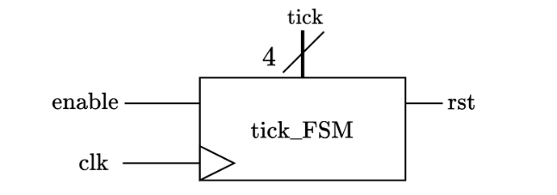
Tick Counter
Figure 2: high level diagram of ALU module
The tick counter is a finite state machine to maintain the current state of the processor. It consists of 4 states following the one hot encoding to represent each state. It updates to next state accordingly after every clock.
States | Encoding
state 1 | 0001
state 2 | 0010
state 3 | 0100
state 4 | 1000
Table 1: encoding table for tick_FSM

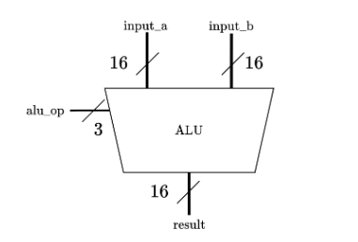
ALU
Figure 3: high level diagram of ALU module
The arithmetic logic unit (ALU) is the component that performs arithmetic operations for the processor, including:
- Addition
- Subtraction
- Multiplication
- Bit-shifting
The ALU’s requirement as per instructed is to take in two 16bit values and perform the corresponding operation as shown above depending on alu_op’s value, and result is wired to input of shift register G, subsequently output to bus which will be displayed on LEDs.

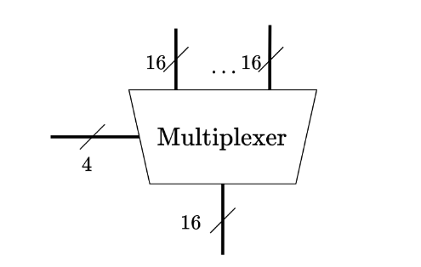
Multiplexer
Figure 4: high level diagram of Multiplexer module

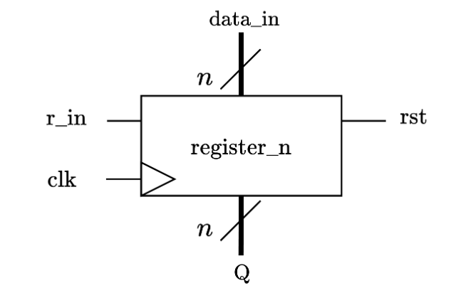
Register
Figure 5: high level diagram of Register module

Design & implemented Datapath
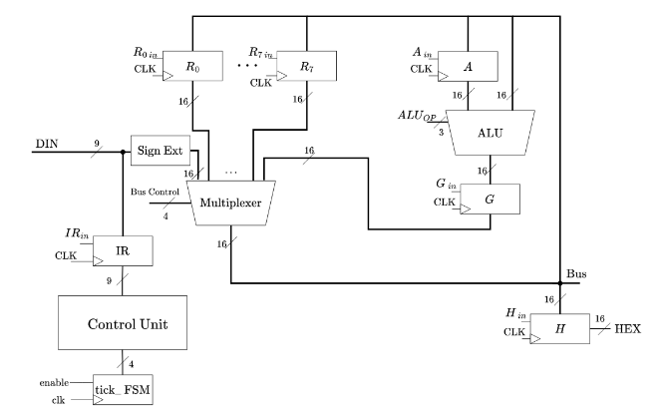
The provided diagram illustrates the Datapath configuration employed within the processor. Every aspect of control, ranging from the regulation of Multiplexer bus selection to ALU operation, as well as the activation of individual registers, is centralized and overseen by the control unit. The processor consistently initiates its operations by reading input data either during the initial cycle, which marks the processor's inception, or at the fourth cycle, or varies depending on what types of operations. During the first cycle, the processor stores the 9-bit input into the instructions register (regIR) allowing control unit to decipher the specific operation to be executed. having different operations for different instructions, and categorised as below:
- Arithmetic (addition, subtraction, multiplication)
- Display (display on 7-segment)
- Bit-shifting (shift right, shift left)
- Moving immediate

Arithmetic operations:
The arithmetic operations for this processor are operations that functions through all four ticks. First of all, since all of the registers’ enable pin has to be modified a step before its targeted state that has to be turned on, the instruction register’s enable pin is always on, constantly taking in the 9-bit input and storing it.
At tick 1, The value of the 9-bit input is saved into instructions register. At tick 2, the control unit will read the first 3 bit of the input to control ALU’s operation code needed to be performed, while also loading the middle 3 bits into register A, ready for ALU to perform the specific operation on the next state. At tick 3,

Product testing

Sign Extender testbench
In the sign extender testbench, the testing procedure involves increasing the input value one bit every 10 nanoseconds, while simultaneously recording the corresponding outputs. This output is subsequently compared to the input, focusing on the six replicated bits added to it, and their alignment with the most significant bit (MSB) of the input. When a disparity is detected between the replicated bits and the MSB, an error counter is incremented by 1 as part of the validation process. As shown in figure(), the error counter is 0 and hence the module is functioning as expected.

Tick Counter testbench

ALU testbench
To streamline the testing process for the ALU module, a simplified approach is employed due to its inherent complexity. Given that the ALU is responsible for five core operations, the increment of the ALU Operation value is divided into five separate values, each executed simultaneously. This strategy eliminates the need to modify both alu operation port independently during testing. Consequently, all five operations’ outputs are generated as simultaneously, simplifying the validation process. Additionally, it's important to note that the testbench examines shorter bit lengths for both Input A and Input B. This approach aligns with the processor's specifications, involving either two 3-bit inputs or one 6-bit input combined with an immediate value. Therefore, Input A (representing register A) is tested only up to a binary value of 111, while Input B (representing bus wire) progressively increases until reaching the maximum binary value 111111.

Multiplexer testbench

Register testbench

Conclusion

Appendix

