
Monash University
ECE2072 Assignment Report
Processor in Verilog HDL
Loo Yi Ren Dillon (33455953)
10-16-2023

Contents
Contents 1
Introduction 2
Components 2
Sign Extender 2
Tick Counter 2
ALU 3
Register 3
Multiplexer 4
Resource usage and timing analysis 4
Design & implemented Datapath 5
Arithmetic 6
Display 6
Bit-shifting 7
Move immediate 7
Product testing 8
Sign Extender testbench 8
Tick Counter testbench 8
ALU testbench 8
Multiplexer testbench 9
Register testbench 9
Processor testbench 9
Conclusion 9
Appendix A: Verilog modules 10

Introduction
This formal report presents process of designing and coding a processor using Verilog. Building a processor is a fundamental task in computer engineering, involving intricate work in digital logic design and control implementation. This report provides a detailed account of the project, outlining the decisions made, challenges encountered, and innovative solutions developed throughout the journey. The objective is to gain a deeper understanding of processor architecture and strengthen coding skills while contributing to the field of digital systems.

Components

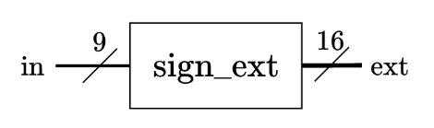
Sign Extender
Figure 1: high level diagram of sign extender module.
The sign extender module serves the role of expanding the 9-bit input of the processor into a 16-bit binary representation, accommodating both positive and negative 2's complement numbers. It’s operation involves analysing the most significant bit (MSB) of the input and replicating it six times to the left, thereby generating the extended 16-bit output.

Table 1: encoding table for tick counter.
States | Encoding
state 1 | 0001
state 2 | 0010
state 3 | 0100
state 4 | 1000

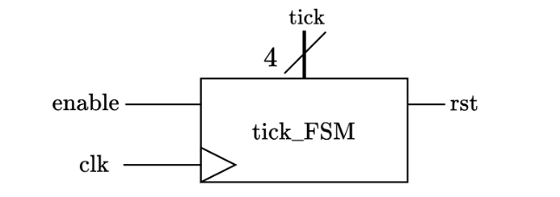
Tick Counter
Figure 2: high level diagram of ALU module.

The tick counter is a finite state machine that maintains the current state of the processor. It consists of 4 states following the one hot encoding to represent each state. It updates to next state accordingly during each clock if the enable pin is turned on. If reset pin is on, the tick counter will return to the 0th state during the next positive edge of the clock.

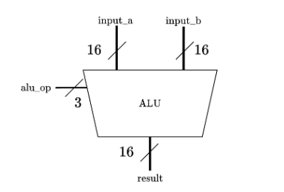
ALU
Figure 3: high level diagram of ALU module.
The arithmetic logic unit (ALU) is the component that performs arithmetic operations for the processor, including:
- Addition
- Subtraction
- Multiplication
- Bit-shifting
The ALU’s requirement as per instructed is to take in two 16-bit values and perform the corresponding operation as shown above depending on alu_op’s value, and result is wired to input of shift register G, subsequently output to bus which will be displayed on LEDs.

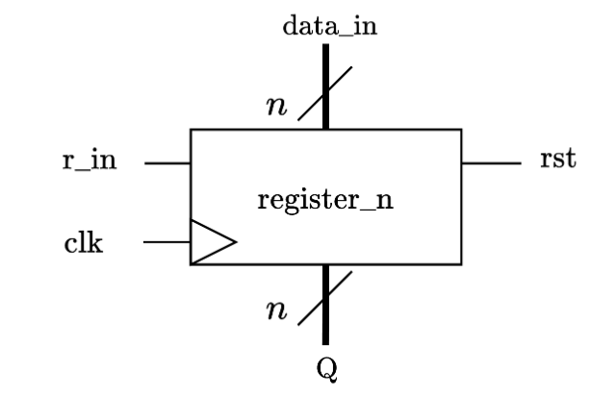
Register
Registers in a processor are high-speed storage elements used to store and manage data and instructions during the execution of a computer program. The processor employs a variety of registers, such as 8 general-purpose registers for data storage, instruction registers for storing instructions, and address registers. The control unit governs the enabling of specific registers in different states for various operations, and when the reset pin is activated, the stored values are cleared.
Figure 4: high level diagram of register module.

Output | Bus control (decimal)
Register 0 | 0
Register 1 | 1
Register 2 | 2
Register 3 | 3
Register 4 | 4
Register 5 | 5
Register 6 | 6
Register 7 | 7
Sign extend | 8
Register G | 9
Table 2: encoding table for Multiplexer.

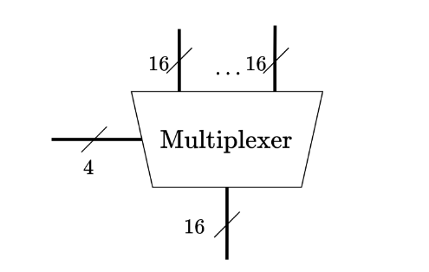
Multiplexer
Figure 5: high level diagram of Multiplexer module

The multiplexer is the component responsible of managing the selection of data to be transmitted onto the bus wire. The control pin is handled by the Control Unit, which its value will determine which of the 10 inputs of the multiplexer will appear on the output, which is connected to the bus wire.

Resource usage and timing analysis
Components | Logic Usage | Timing Constraints
Sign Extender | 26 Logic Cells + 0 DSPs | 1092.9 MHz
Tick Counter | 17 Logic Cells + 0 DSPs | 397.14 MHz
Multiplexer | 53 Logic Cells + 0 DSPs | 127.55 MHz
Register | 51 Logic Cells + 0 DSPs | 562.75 MHz
ALU | 281 Logic Cells + 10 DSPs | 52.82 MHz

Table 3: Logic usage and timing constraint data.

In summary, the Sign Extender boasts 26 logic cells and operates at an impressive 1092.9 MHz, making it ideal for real-time signal processing. The Tick Counter is compact with 17 logic cells, clocking in at 397.14 MHz, suitable for accurate event counting. The Multiplexer uses 53 logic cells, striking a balance at 127.55 MHz for data routing. The Register is equipped with 51 logic cells, efficiently managing data at 562.75 MHz. The ALU"is the most complex, requiring 281 logic cells, albeit operating at 52.82 MHz due to its complexity. These insights provide a valuable foundation for evaluating and optimizing system efficiency and performance.

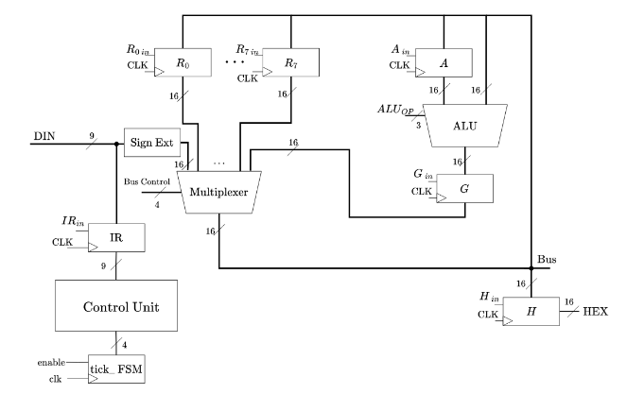
Design & implemented Datapath
Figure 6: High-level topology of the processor.
The provided diagram illustrates the Datapath configuration employed within the processor. Every aspect of control, ranging from the regulation of Multiplexer bus selection to ALU operation, as well as the activation of individual registers, is centralized at the control unit. The processor initiates its operations by reading input data either during the initial state, which marks the processor's inception, or at the fourth state. The implementation of this Datapath shown above presents a few conditions:
- Every single data pass through Multiplexer, except for value stored in register H which is connected to display output port of the processor.
- Values to be loaded into the bus wire always comes from register IR, passing through the Sign Extender Module, extending any bit-length value to be extended.
- Register A is responsible for latching the first value if operation involves 2 registers.
- Register H holds the value that has to be outputted from the display output port of the processor.

. having different operations for different instructions, and categorised as below:
- Arithmetic (addition, subtraction, multiplication)
- Display (display on 7-segment)
- Bit-shifting (shift right, shift left)
- Move immediate

Arithmetic
The arithmetic operations for this processor are operations that functions through all four ticks, and 4 processor operations fall under this category.
Tick 1: The processor stores the 9-bit input in the instructions register, and it is split into 3 storages. Opcode for bit 8 to 6, Rx for bit 5 to 3, Ry for bit 2 to 0/immediate value depending on the instruction’s opcode.
Tick 2: In this clock cycle, the control unit reads the opcode to determine the ALU operation selection. Simultaneously, if instruction is to add Rx & Ry, it loads the value of Rx into bus wire. Else if opcode is to add Rx and an immediate value, the 9-bit data input will be placed on to the bus instead. Afterwards, register A will be enabled, setting up the first operand for the ALU operation in the subsequent state.
Tick 3: This clock cycle starts with register A shifting the previously placed value on the bus, register A is then promptly deactivated. During this time, if opcode is to perform addition on Rx and Ry, value stored in register Ry will be placed onto the bus. Else if opcode is to add Rx value to immediate value. At this point, the ALU's output is ready but not yet stored, as it awaits the next state. To prepare for this, register G's enable pin is activated in this state.
Tick 4: In this clock cycle, register G promptly stores the value of the ALU's result output at the positive edge of the clock and is then deactivated simultaneously. The control pin of the multiplexer is set to value 9, allowing register G's value to be outputted onto the bus. The output of this operation will then be stored in register Rx.

Display
The display operation for this processor is a two-stage function that exclusively operates during ticks 1 and 2, remaining idle for the remaining clock cycles. In the second clock cycle (tick 2), the data stored in register H, which contains the address of a register, is transmitted through the display output port.
Tick 1: The value of 9-bit input is saved into instructions register, and it is split into 3 storages. Opcode for bit 8 to 6, Rx for bit 5 to 3, Ry for bit 2 to 0, but since only one register storage is needed, address Ry is redundant. If opcode is 3’b 000, register H’s enable pin is turned on (prepare for next tick). At the same time, bus control allows value stored address Rx into bus wire, ready for register H to take data during the next tick.
Tick 2: Register H instantly takes value before it’s disabled, outputting the value of data stored in register Rx through register H’s output, which is connected to the display output port of the processor.
Tick 3: idle
Tick 4: idle

Bit-shifting
The bit-shifting operation is akin to arithmetic operations, with the key distinction of requiring one less clock cycle since only one value is needed for the ALU to perform the shift, in contrast to mathematical operations involving two values. This operation unfolds over three clock cycles, and it remains idle during the fourth.
Tick 1: The processor stores the 9-bit input in the instructions register, and it is split into 3 storages. Opcode for bit 8 to 6, Rx for bit 5 to 3, Ry for bit 2 to 0, and in this case Ry is redundant since only one register address is required. If opcode is 3’b 101 or 3’b 110, the ALU's operation control pin is set for 'Shift left' or 'Shift right,' respectively.
Tick 2: The value stored in register Rx is loaded onto the bus wire, while simultaneously enabling register G, preparing it for the next state, where it will store a value.
Tick 3: In this clock cycle, the shifted data value is instantly shifted into register G before it's deactivated. The bus control allows the value stored in register G to appear on the bus, allowing this value to be saved back into the same register.
Tick 4: idle

Move immediate
The move immediate operation’s purpose is to store an immediate value from input data directly to the specific register Rx (register address from instruction register bit 5 to 3).
Tick 1: The processor stores the 9-bit input in the instructions register, and it is split into 3 storages. Opcode for bit 8 to 6, Rx for bit 5 to 3, Ry for bit 2 to 0, but in this case Ry is irrelevant. If 3’b 111 is read, the processor will load immediate value (data in) onto bus and turning on enable pin of register Rx.
Tick 2: Specified register instantly stores data before it gets disabled.
Tick 3: idle
Tick 4: idle

Product testing

Sign Extender testbench
In the sign extender testbench, the testing procedure involves increasing the input value one bit every 10 nanoseconds, while simultaneously recording the corresponding outputs. This output is subsequently compared to the input, focusing on the six replicated bits added to it, and their alignment with the most significant bit (MSB) of the input. When a disparity is detected between the replicated bits and the MSB, an error counter is incremented by 1 as part of the validation process. As shown in appendix, the error counter is 0 and hence the module is functioning as expected.

Tick Counter testbench
To test the tick counter, another simple approach is employed to control when the reset and enable pins are toggled on or off. This methodology offers an effective means to expose potential glitches, especially when hardware testing has already validated that the module operates as anticipated. The output tick is subsequently examined to verify whether it aligns with the expected conditions based on the activation or deactivation of the reset and enable pins. Furthermore, due to the module's simplicity, encompassing only four states, it lends itself to straightforward validation by inspecting the waveform. As illustrated in Appendix B, the visual representation demonstrates that the module operates without errors.

ALU testbench
To streamline the testing process for the ALU module, a simplified approach is employed due to its complexity. Given that the ALU is responsible for five core operations, the increment of the ALU Operation value is divided into five separate values, each executed simultaneously. This strategy eliminates the need to modify both alu operation port independently during testing. Consequently, all five operations’ outputs are generated as simultaneously, simplifying the validation process. It's important to note that the testbench examines shorter bit lengths for both Input A and Input B. This approach aligns with the processor's specifications, involving either two 3-bit inputs or one 3-bit input combined with an immediate value that is up to 9 bits maximum. Therefore, both inputs are tested up to 9-bits. The testbench also accounts for negative results, such as if Rx is smaller than Ry, but is instructed to perform subtraction, as well as multiplication if either value is negative or both. There was a small number of errors appearing, but as far as concerned, the chances of the error causing system malfunction is trivial, since the test values were large. Hence can be concluded from the testbench that, the ALU is fully functional.

Multiplexer testbench
For the multiplexer testbench, the testing regime is straightforward. The method is to increment all data by one and compare the output from bus to whichever input that corresponds to that specific selector value. After all input is looped through the random values, the selector pin will then increment. As shown in appendix there are no errors.

Register testbench
As well as register, similar to both multiplexer and tick counter’s testbenches, register’s testbench also utilizes a randomised input approach. Since it functions perfectly in hardware testing, the conventional way of testing would be hard to catch glitches.

Processor testbench
For the main processor. The method to test the extended processor was to have a constantly ticking clock, while incrementing input data with a delay 4 times of clock to ensure output is only checked after 4 ticks, which is from the clock. For non-display operations, the value of Rx is then compared to the value of both Rx and Ry manually operated values to check if it matches on tick 4. For display operation, value in RH is manually compared to value stored inside Rx to check if it matches. Since the processor has a very high complexity level function, it is not possible to test every single combination of inputs (also due to limitations of Modelsim that runs at 32-bits), this was the most efficient way to test as many combinations as possible.

Conclusion
In summary, creating a Verilog processor is a complex but highly rewarding task. It involves careful design, rigorous testing, and a deep understanding of computer architecture and Verilog coding. The flexibility and scalability of Verilog processors make them valuable for various applications, from embedded systems to high-performance computing. However, success in this endeavour relies on continuous testing and quality assurance. Rigorous testing and verification are essential to ensure the processor's reliability and correctness, but it can be said that the Verilog Processor has been perfected.

Appendix A: Verilog modules

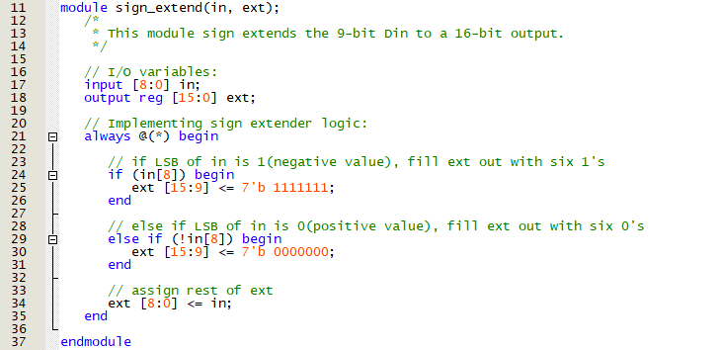
Figure A1: Verilog module for Sign Extender.
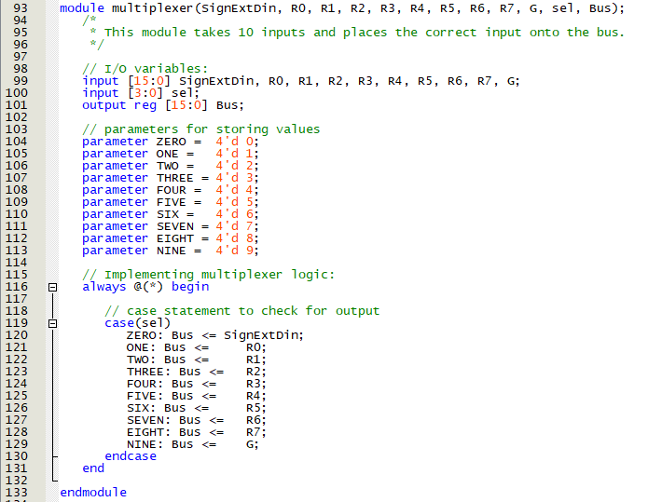
Figure A2: Verilog Module for Multiplexer.
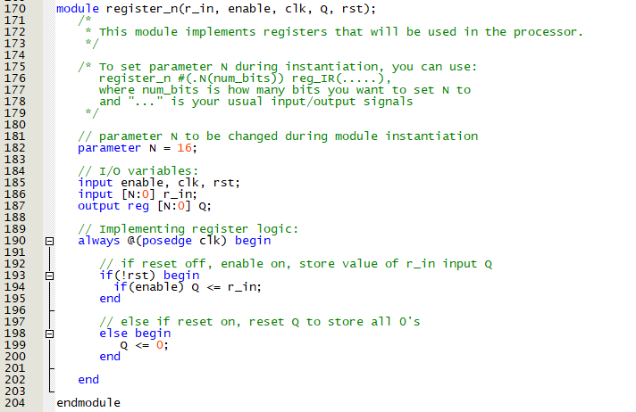
Figure A3: Verilog module for Register.
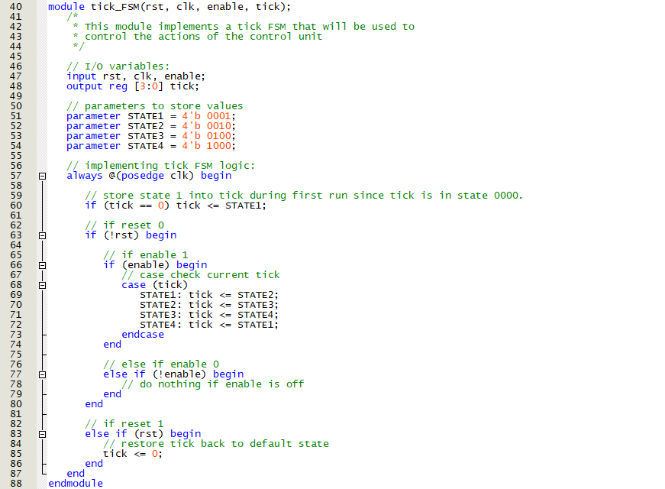
Figure A4: Verilog module for tick counter.

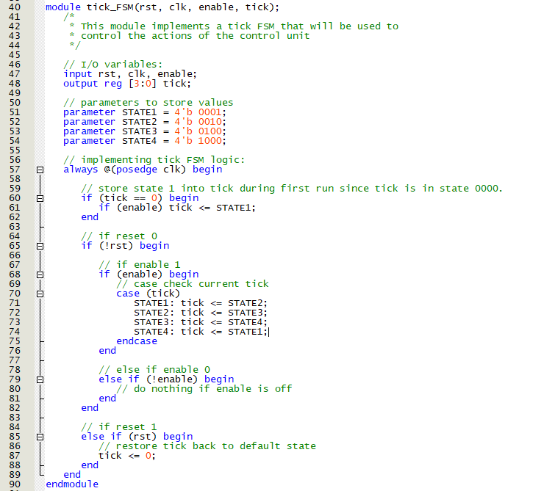
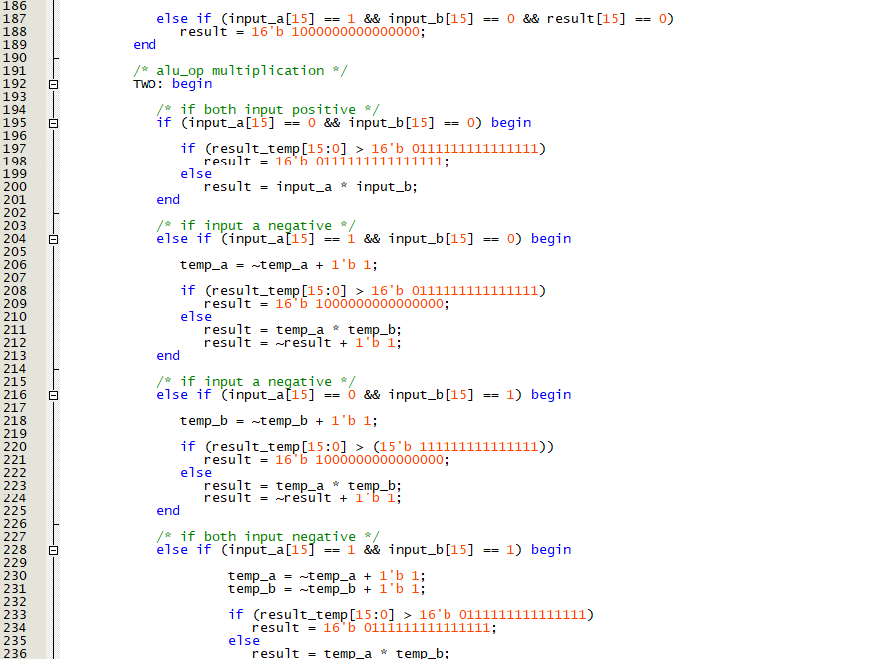
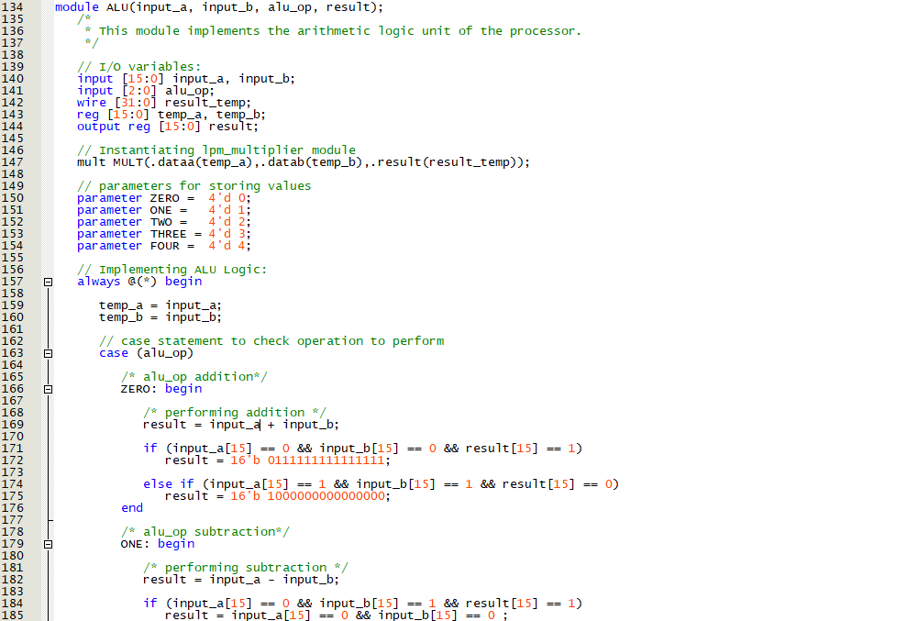
Figure A4: Verilog module for Tick Counter.
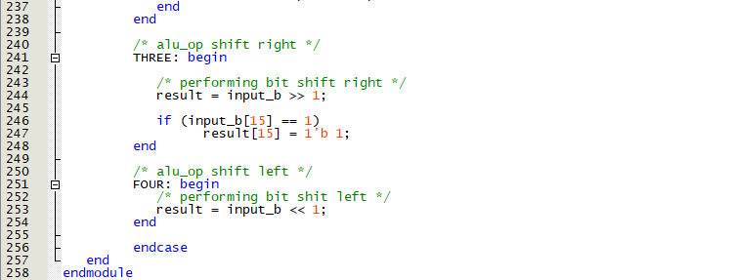
Figure A5: Verilog module for ALU
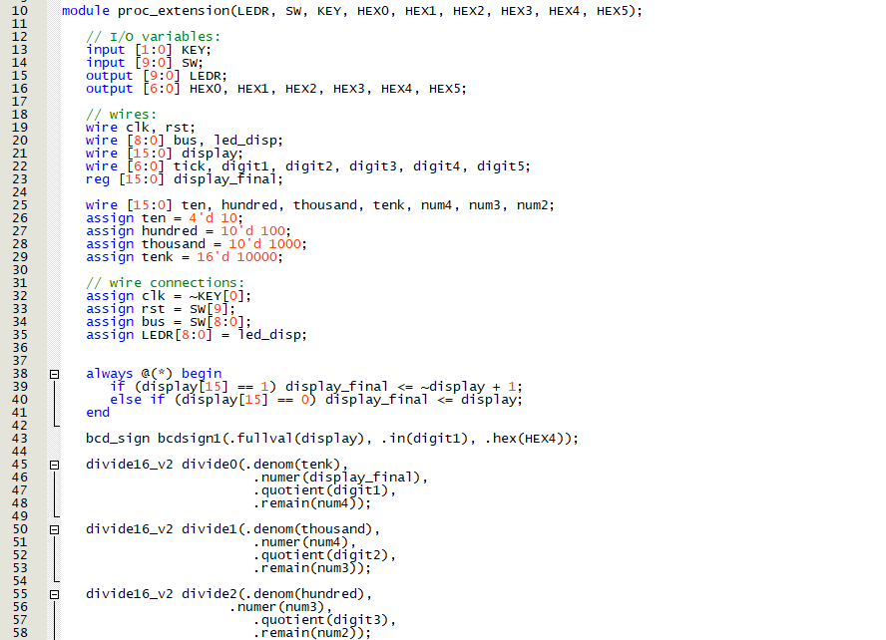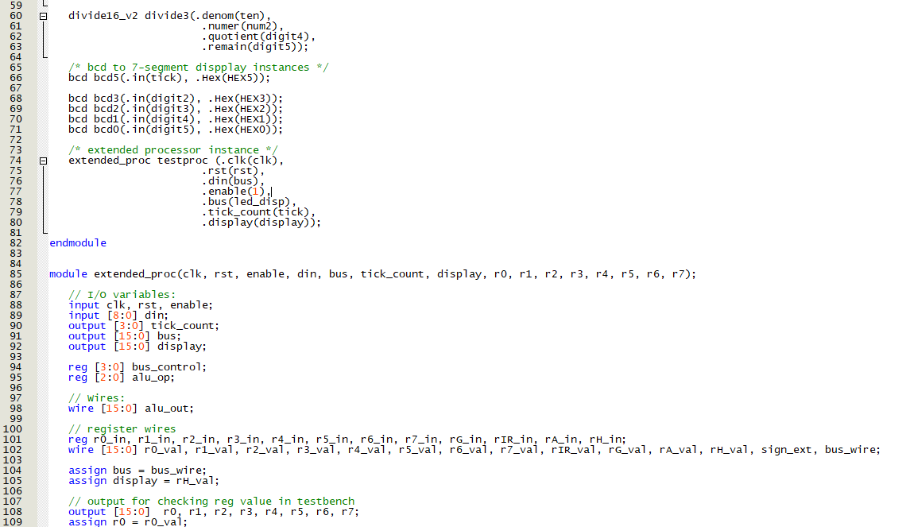

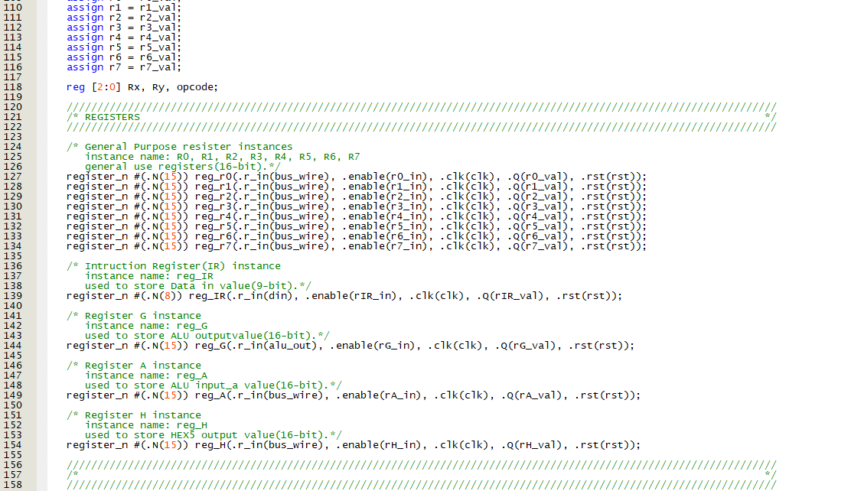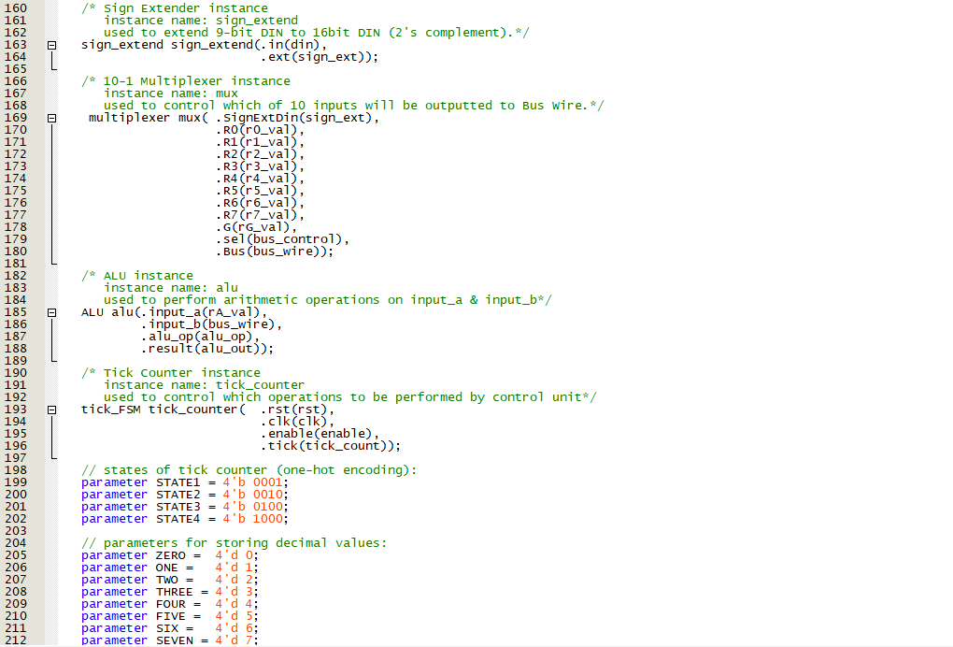

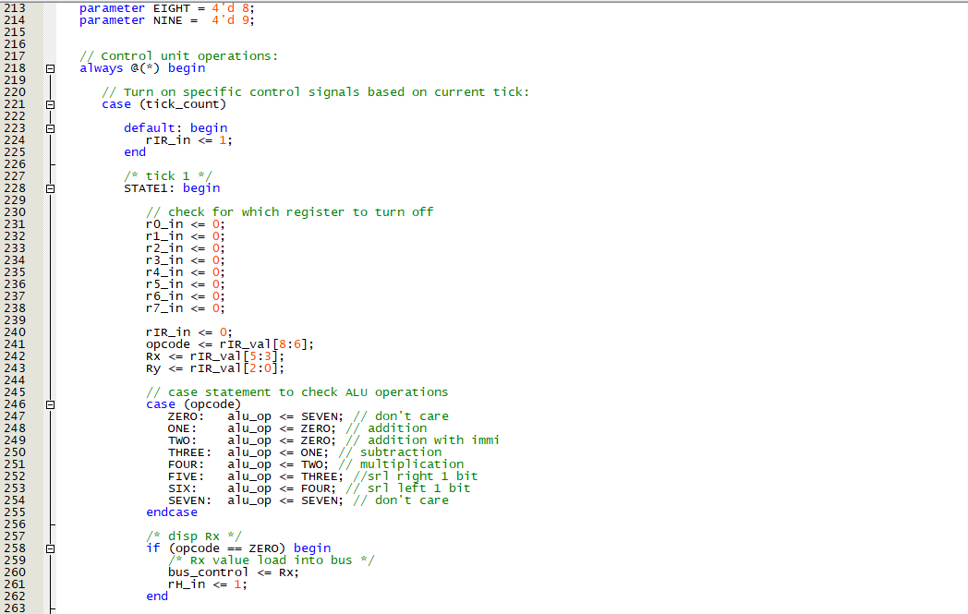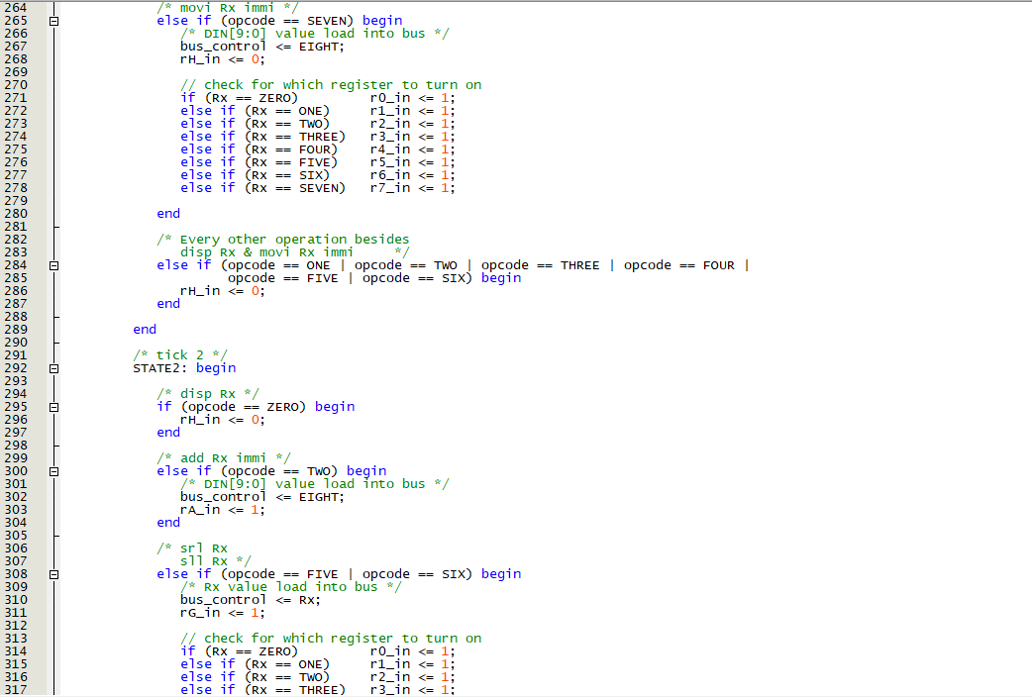

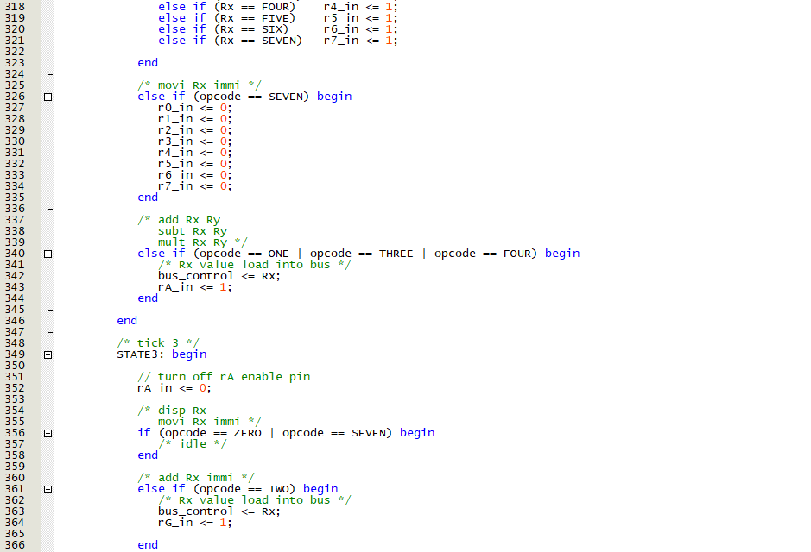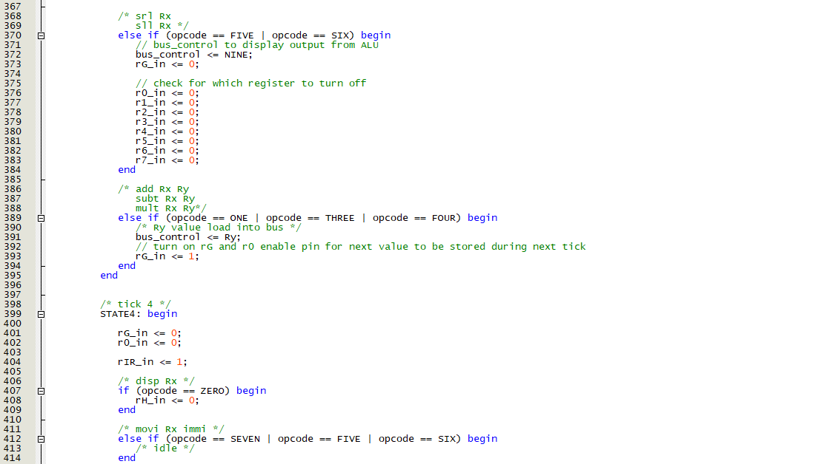
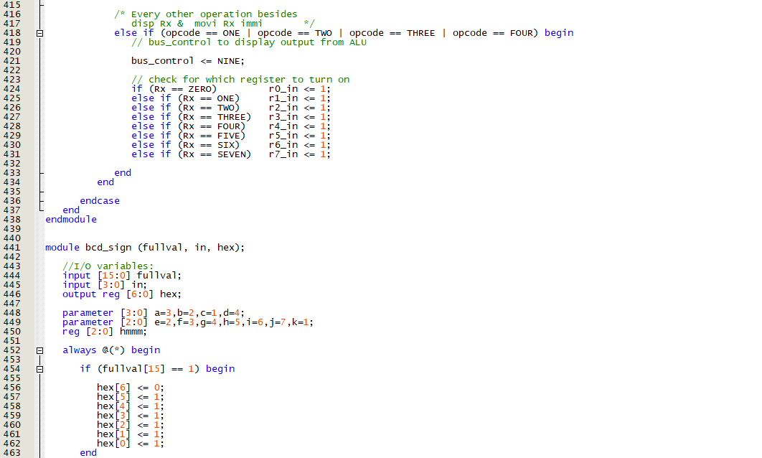
Figure A6: Verilog module for processor.
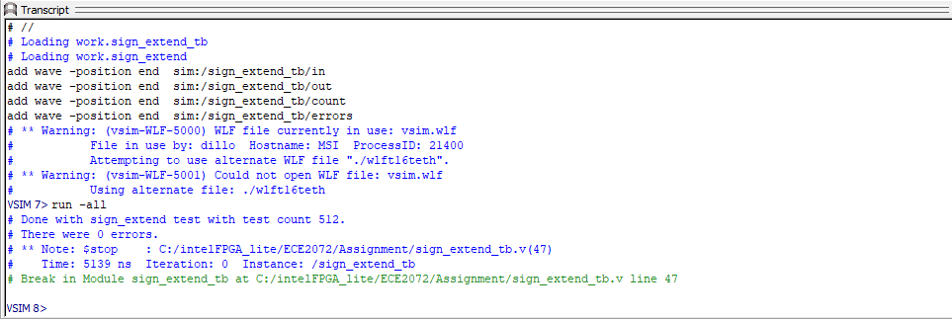
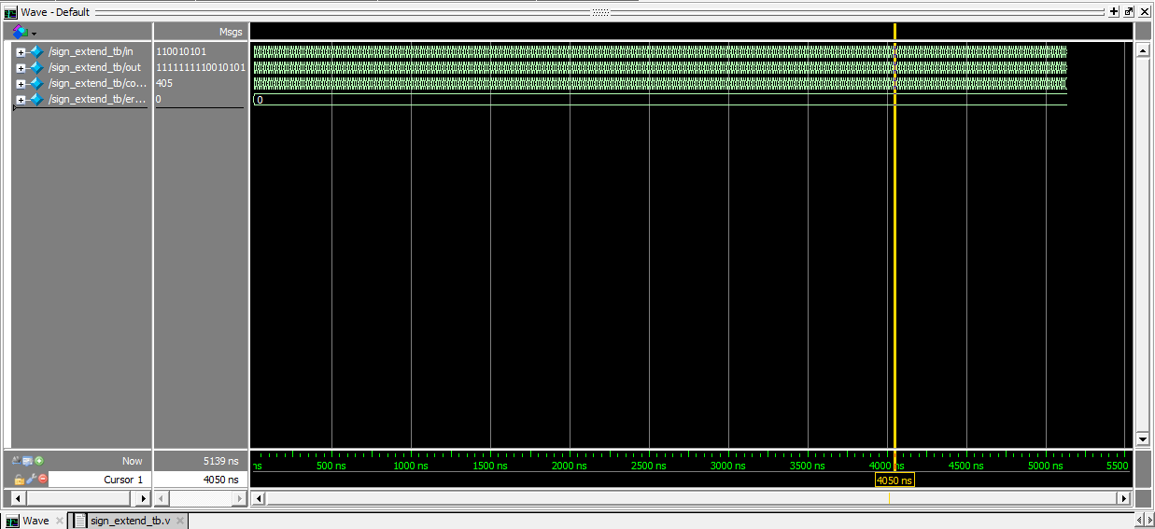
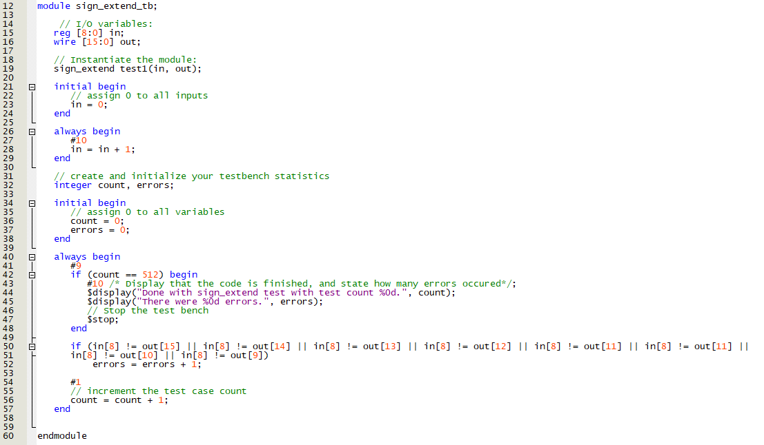
Appendix B: Testbench results
Figure B1.3: Modelsim console for Sign Extender.
Figure B1.2: Sign Extender waveform.
Figure B1.1: Verilog testbench module for Sign Extender.
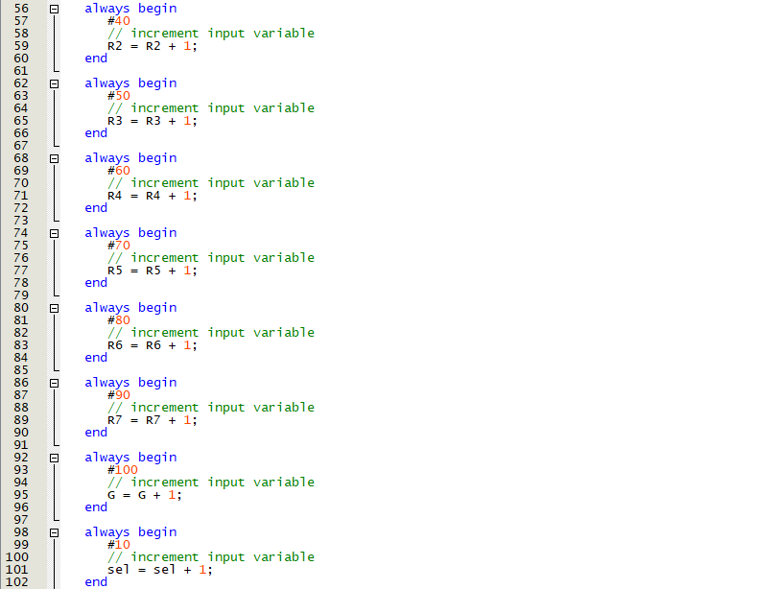
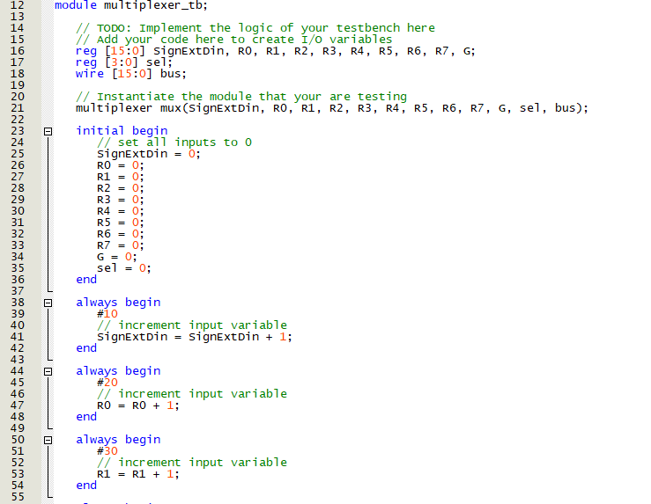

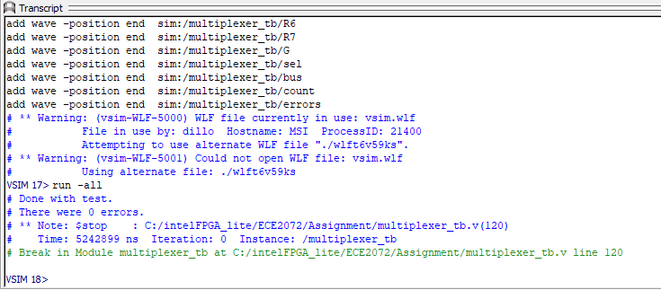
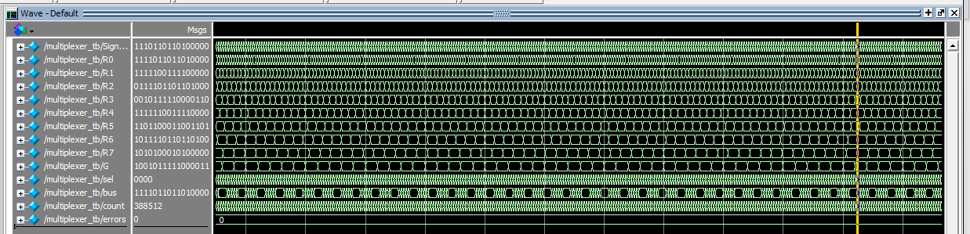
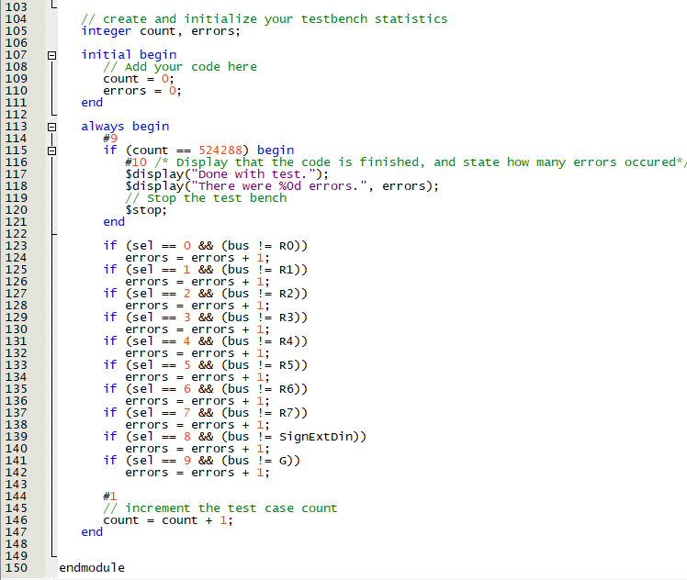
Figure B2.3: Modelsim console for Multiplexer.
Figure B2.1: Verilog testbench module for multiplexer.
Figure B2.2: Multiplexer waveform.
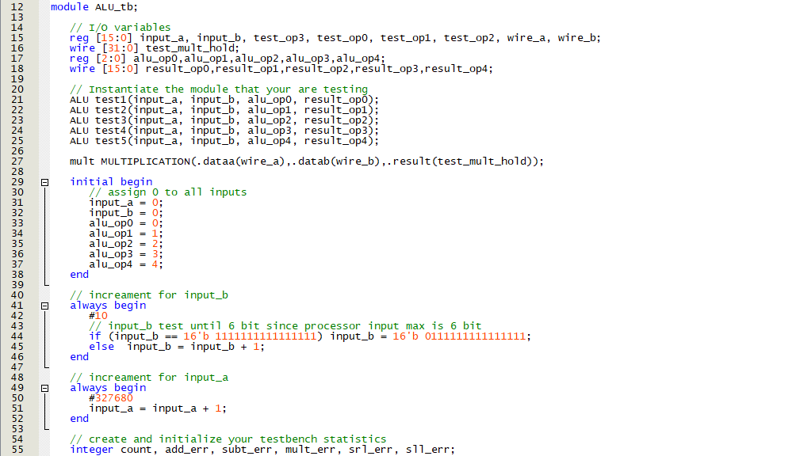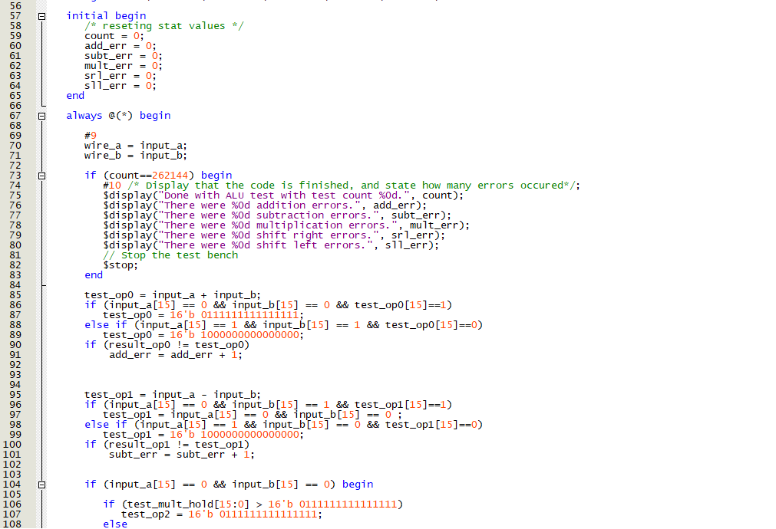

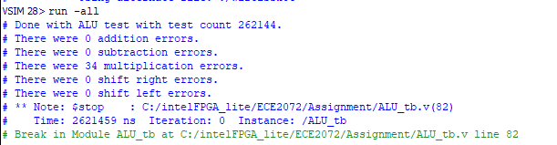
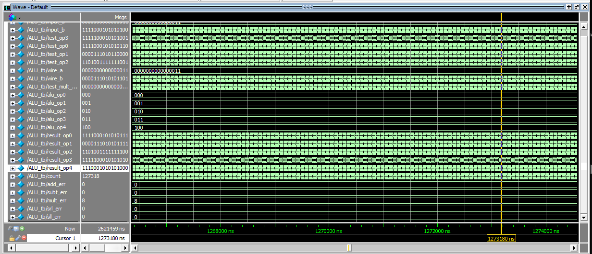
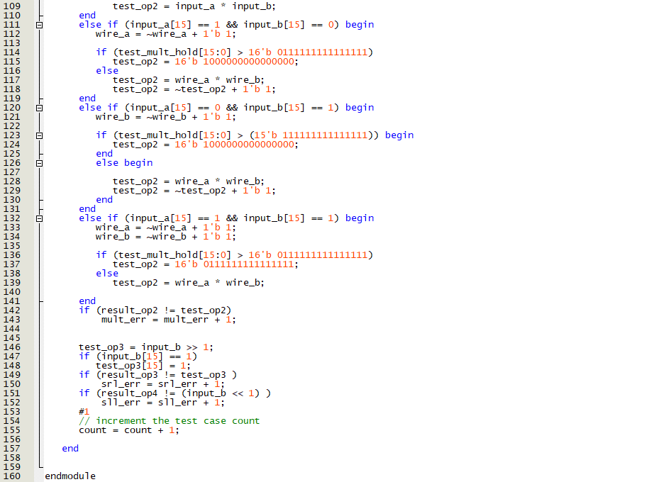
Figure B3.3: Modelsim console for ALU testbench.
Figure B3.2: ALU waveform.
Figure B3.1: Verilog testbench module for ALU.
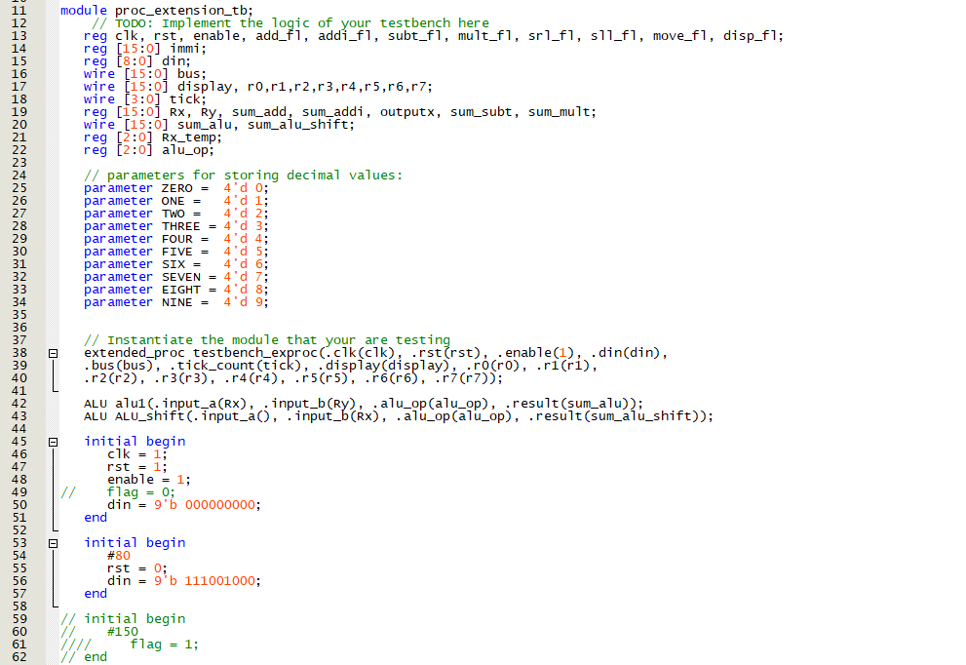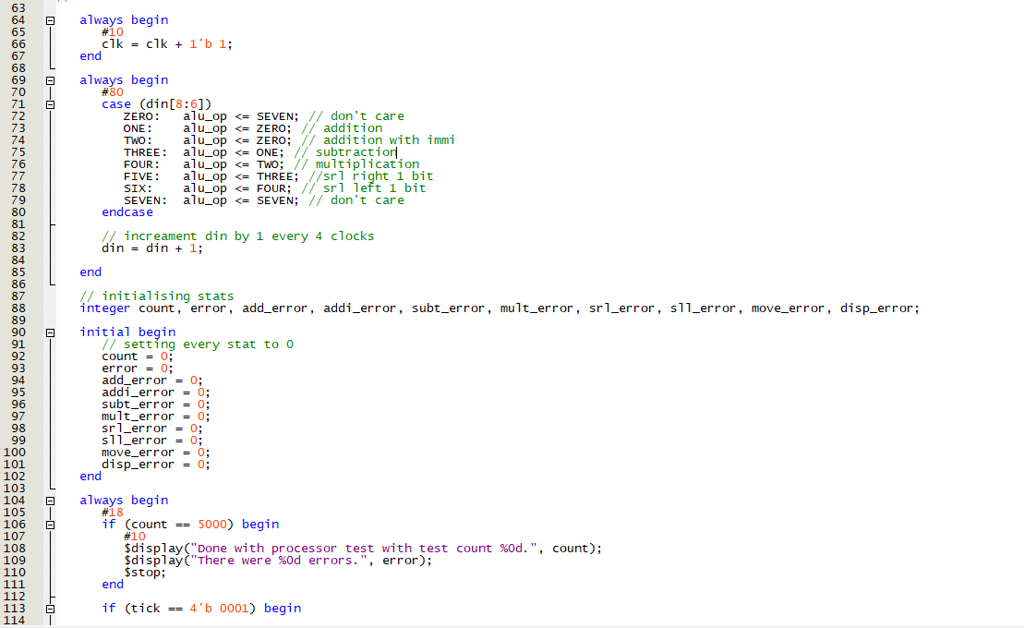
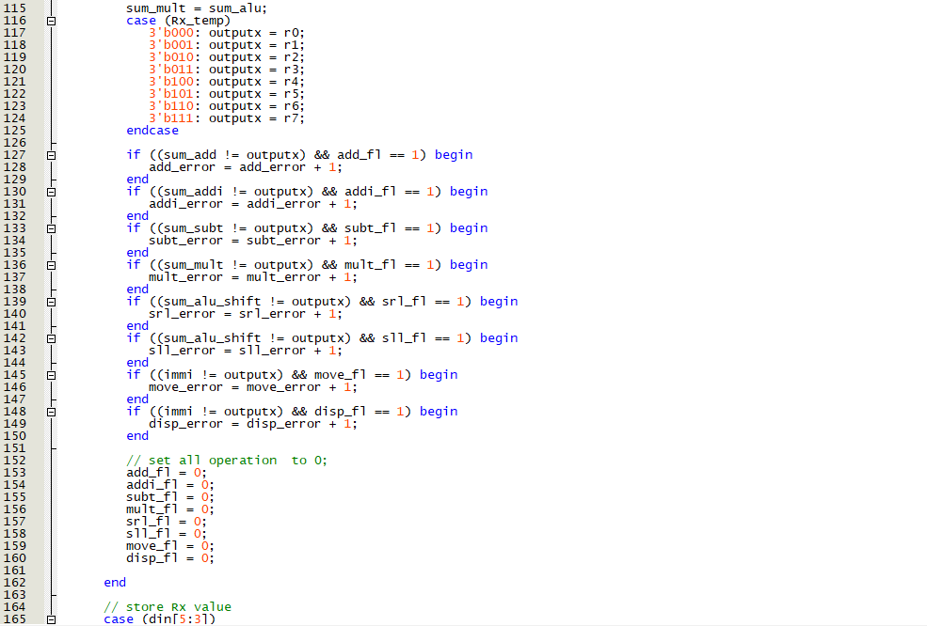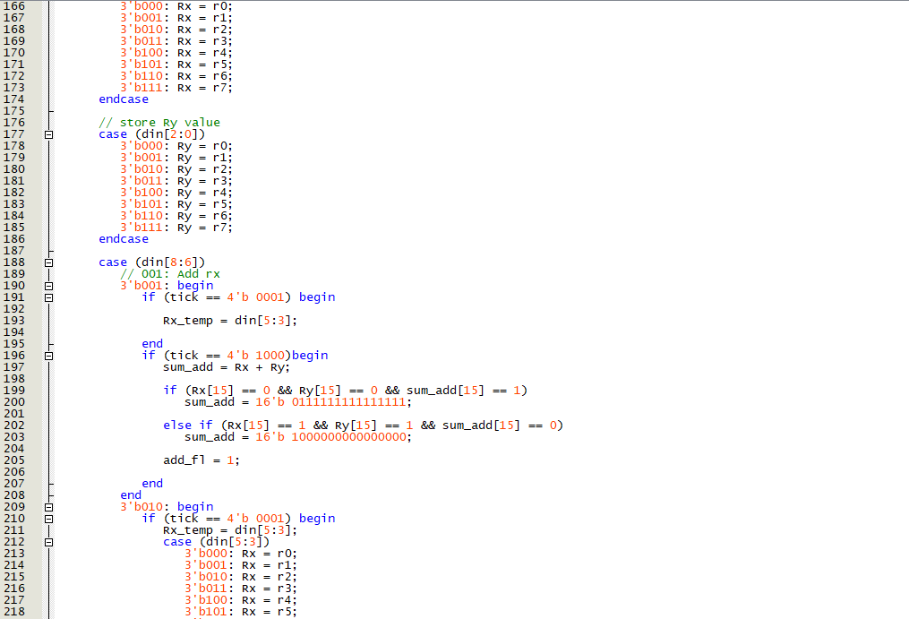
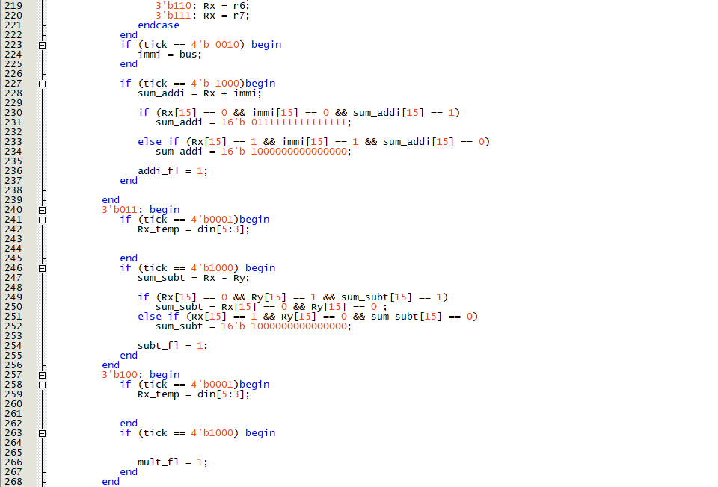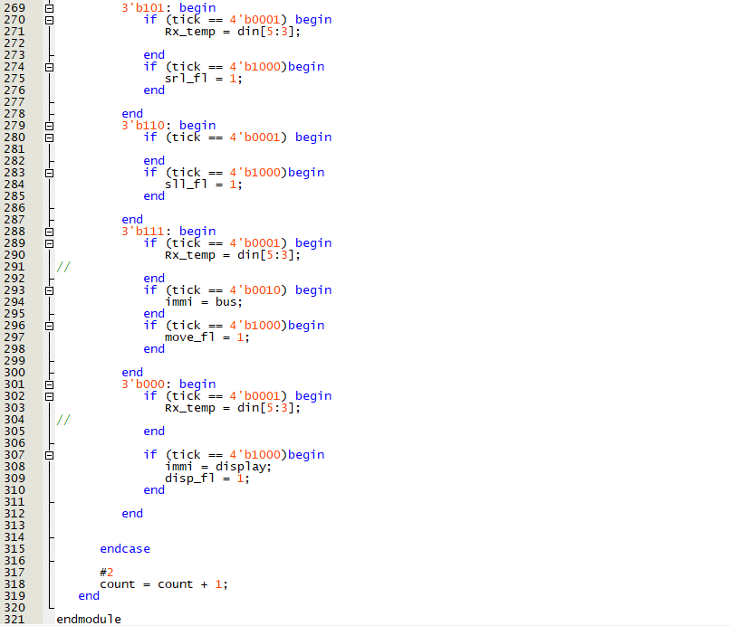
Figure B4.1: Verilog testbench module for processor.

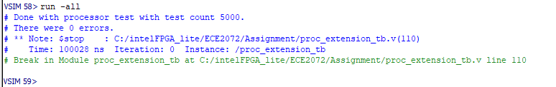
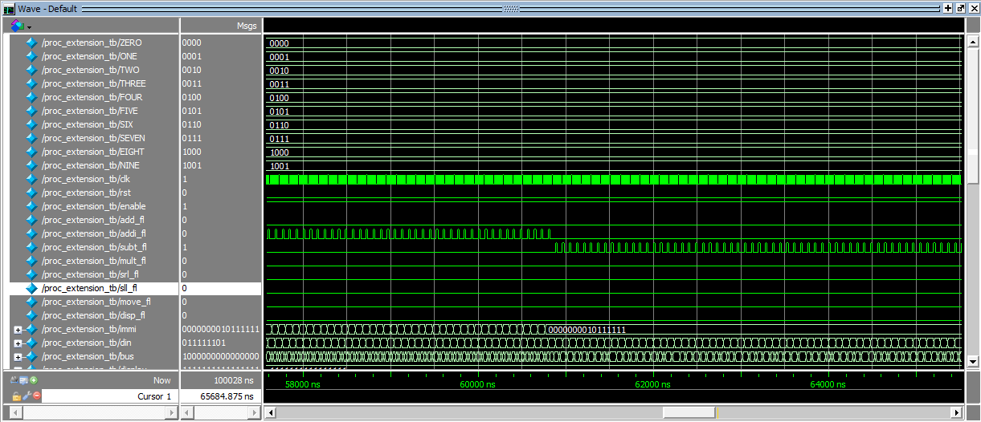
Figure B4.3: Modelsim console for processor testbench.
Figure B4.2: Processor testbench waveform.
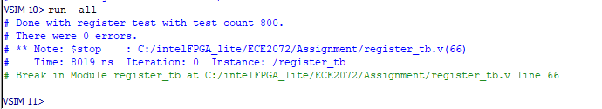
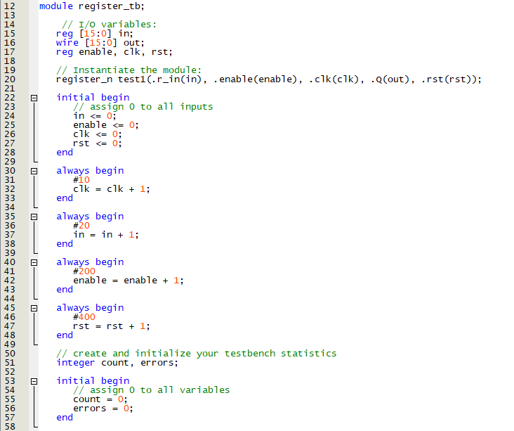
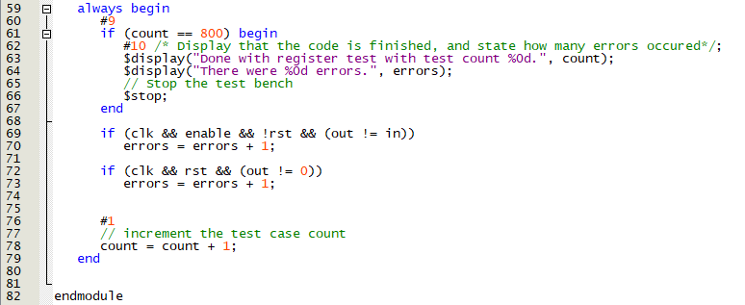
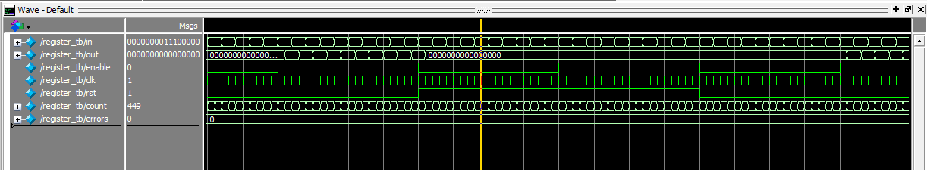
Figure B5.3: Modelsim console for register.
Figure B5.2: Register waveform.
Figure B5.1: Verilog testbench module for register.
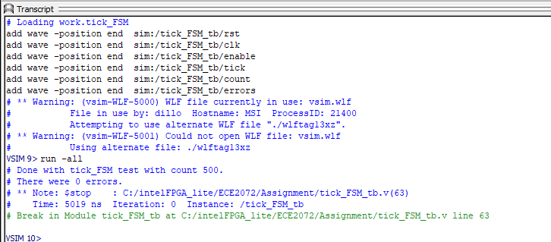
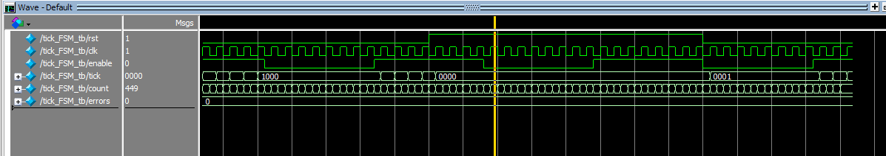
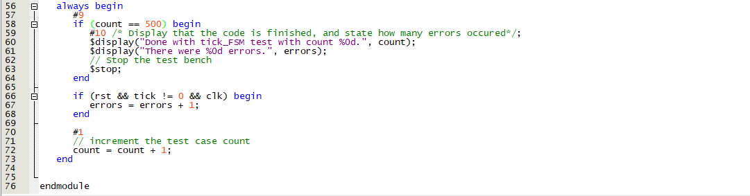
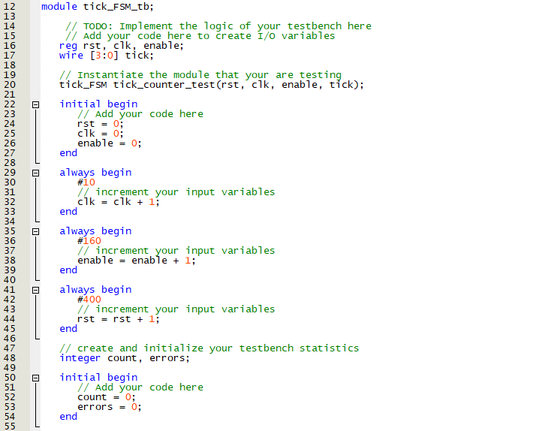
Figure B6.3: Modelsim console for tick counter.
Figure B6.2: Tick counter waveform
Figure B6.1: Verilog testbench module for tick counter.

