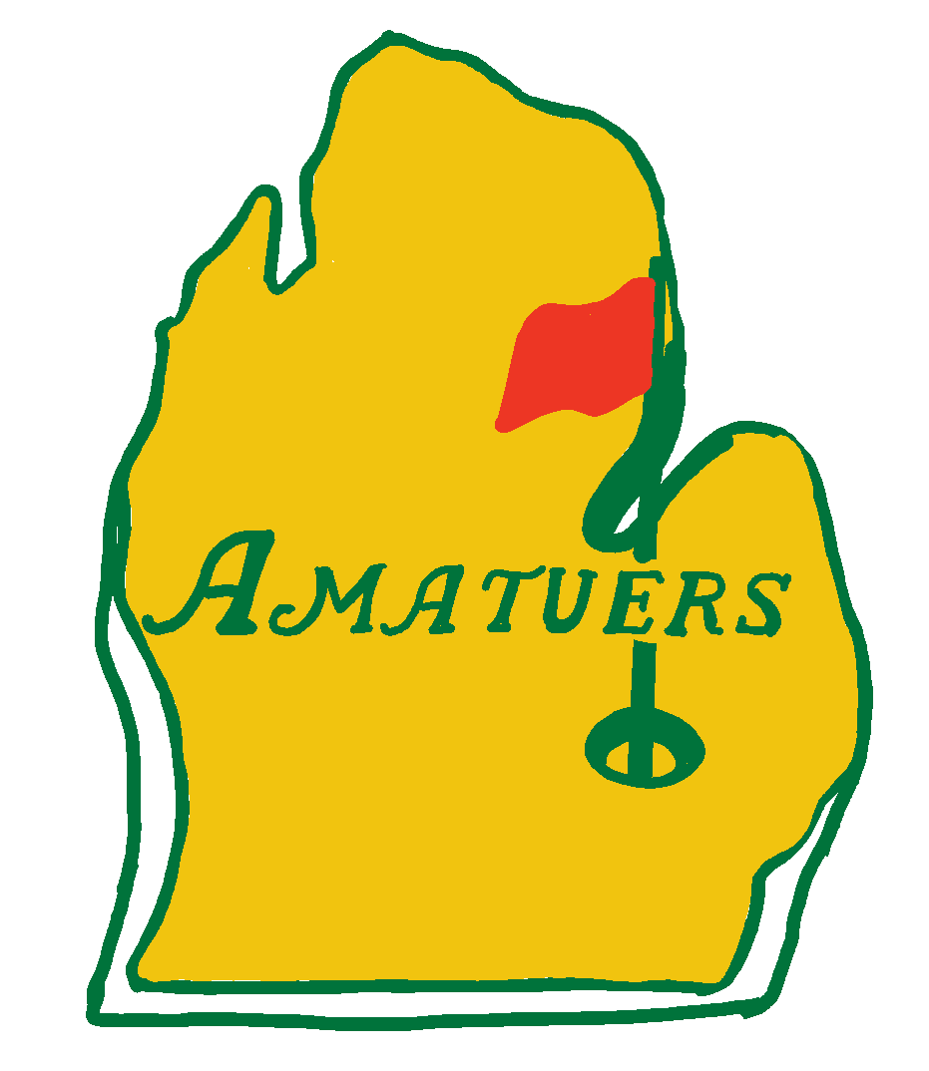
General Rules:

- For all holes we will be playing a 4- or 3-person scramble. A scramble is when every group member hits a tee shot and then the group chooses the best one out of the 3 or 4. Each player then hits a shot from that spot. Repeat until the ball is holed.

- Throughout the round, the group must use each person’s tee shot once.

- After hitting your fifth shot as a group, pick up, record a 6 (double par) on the scorecard, and move to the next hole.

- Please play the set of tees that you are comfortable with. When in doubt tee it forward. I suggest that if you do not play regularly to tee from the forward tees (red tee markers)

- For hole #2, if all group members go in the water there will be a dedicated drop zone for you to play from. For hole #9 if all members happen to go in the water, play it as lateral (red stakes = two club lengths from point of entry no closer to the hole)

- A closest to the pin challenge will be on hole #7

- There are special games for many of the holes so be sure to read below

- Have fun!!

Scoring:
- This year we will be using a modified stableford point system with the team collecting the most points winning the Jim Muneio Memorial Cup. For ease of the players please just fill out your card as if you were playing normal stroke play. I will tally up the total number of points at the end.

- For your information, the point system is below:
  - Hole in One => 20 points
  - Birdie => 5 points
  - Par => 2 points
  - Bogey => 1 point
  - Double Bogey => 0 points
  - Triple Bogey (Double Par) => -2 points

- Additionally, there will be bonus points up for grabs
  - +1 point for the following
    - Winner of closest to the pin
    - Make the blindfolded putt
    - Birdie on the non-club hole
    - Hit the green with dizzy tee-shot (per person: 4 people hit the green = +4 points)

Hole Games:
- Hole #1 & #2: normal scramble

- Hole #3: A Shot in the Dark – Once on the green, each player will putt blindfolded for only the FIRST putt. The subsequent putts will not require a blindfold. This means you need to rely on your team to orient you properly

- Hole #4: Got Milk! – Each member of the group will tee off while standing on two milk crates. Please be careful and if you are not comfortable with this game feel free to skip it.

- Hole #5: Mini Happy Gilmore – Once on the green all members of the group must putt out using a mini stick

- Hole #6: Golf Course Tilt-a-whirl – Before hitting your tee shot each member must spin around their club 5 times. Again, if you are not comfortable with doing this game feel free to skip it.

- Hole #7: Closest to the Pin; Stop Pooling Around! - Putt out with a pool cue. Please be careful not to mark the green up when getting up.

- Hole # 8: Who Needs Clubs – Without using your clubs you must hole the ball from the forward tee (We don’t want any old people throwing their arm out). You can throw, roll, or kick the ball into the hole. Please refrain from kicking the ball on the green though as our first priority should be what’s best for the turf. (Says Mr. Turfgrass)

- Hole # 9: Reverse Now Y’all - tee off with your putter from the forward tee (red tee markers) and putt with your driver. Chipping is normal (can use any club).

