General Rules:

- Every hole will be played as a 4 (or 3) person scramble. A scramble is when every group member hits a tee shot and then the group chooses the best one out of the 4 (or 3). Each player then hits a shot from that spot. Repeat until the ball is holed. Threesomes will rotate who hits two balls on each hole.

- By the end of the round, the group must have used at least one tee shot from each player on the team. The first time that each player’s tee shot is used, please mark the scorecard with their first initial. Your team will be disqualified for not complying with this rule.

- After hitting your fifth shot as a group, pick up, record a 6 (double par) on the scorecard, and move to the next hole.

- Everyone will play from the forward tee box unless you meet one of the below criteria:
  - Official handicap index <20 → White tees
  - Official handicap index <5 → Blue tees

- For holes #2 and #9, if all group members go in the water there will be a dedicated drop zone for you to play from. This will be marked by orange cones.

- A “farthest from the pin” challenge will be completed on hole #7. You will still need to hit the green to be considered for this award.

- In each groups’ bag, there is a small sheet of paper that has a question asking what species of turfgrass is in the cup. Please refrain from using your phone to look it up. The piece of paper is due to the Comissioner prior to the awards ceremony. A correct answer will receive 2 bonus points.

- There are special games for many of the holes so be sure to read below.

- Have fun!!

Scoring:
- We will use a modified stableford point system. The team collecting the most points will win the MacCallum Cup. For your convenience, please fill out your card as if you were playing normal stroke play. The Commissioner will tally up the total number of points at the end of the tournament.

- For your information, the point system is below:
  - Hole in One →20 points
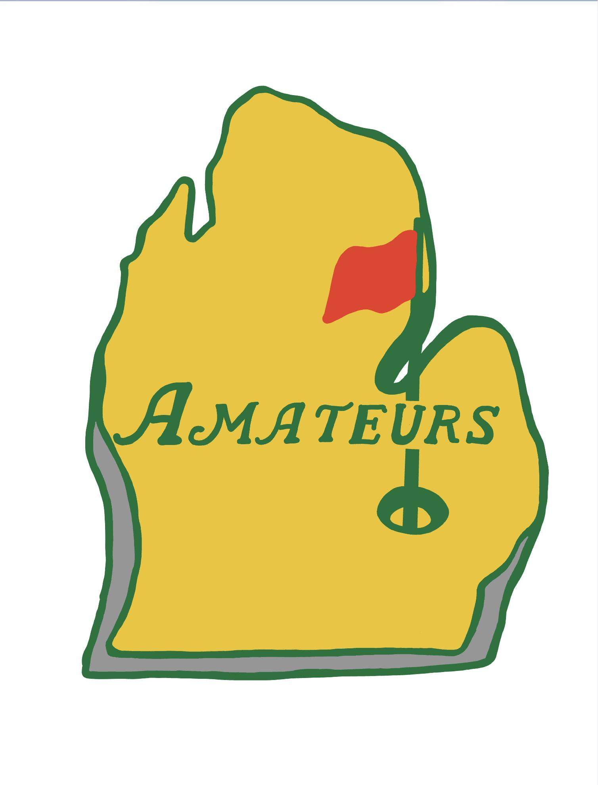
  - Birdie → 5 points
  - Par → 2 points
  - Bogey → 1 point
  - Double Bogey → 0 points
  - Triple Bogey (Double Par) → -2 points

- Additionally, there will be bonus points up for grabs
  - +1 point for the following
    - Winner of farthest from the pin
    - Hit the green with a hickory club (per person: 4 people hit the green = +4 points)
  - +2 points for the following:
    - Correct answer for Guess the Grass
  - +3 points for the following:
    - Make your first putt on the blindfolded hole
    - Birdie on the clubless hole

Hole Games:
- Hole #1 & #2: will be played as a normal scramble.

- Hole #3: Farthest from the Pin - Must hit the green to be eligible. There will be a stake on the green to keep track of who is furthest. Make sure to record your name on the sheet and place the stake in the spot where your ball came to rest.

- Hole #4: Stop Pooling Around! - Putt out with a pool cue. Please be careful not to mark the green up when squating down and getting up.

- Hole #5: Got Milk! – Each member of the group will tee off while standing on two milk crates. Please be careful and if you are not comfortable with this game feel free to skip it.

- Hole #6: Egg roll - Once on the green, there will be an egg shaped golf ball that each member on your team will putt with until the ball is holed.

- Hole #7: A Shot in the Dark – Once on the green, each player will putt blindfolded for only the FIRST putt. The subsequent putts will not require a blindfold. This means you need to rely on your team to orient you properly.

- Hole # 8: Who Needs Clubs – Without using your clubs you must hole the ball from the forward tee (We don’t want any old people throwing their arm out). You can throw, roll, or kick the ball into the hole. Please refrain from kicking the ball on the green though as our first priority should be what’s best for the turf (Says Mr. Turfgrass).

- Hole # 9: Back to the (Future) Past - Tee off from the forward tee (red tee marker) using a hickory-shafted golf club. If you need to chip, there will be a wedge by the green that you can use. When you get to the green there will be an assortment of retro putters for everyone to use.

Bad Weather:
- In the event of lightning and thunder, the golf course should have an air horn to signal everyone to come back to the clubhouse. If there is not an air horn, I will be monitoring the weather closely and will send out a mass text in the amateurs group to come inside.

- We will meet inside in the grill area. A new gameplan will be made if we are not able to finish our rounds out on the course.

