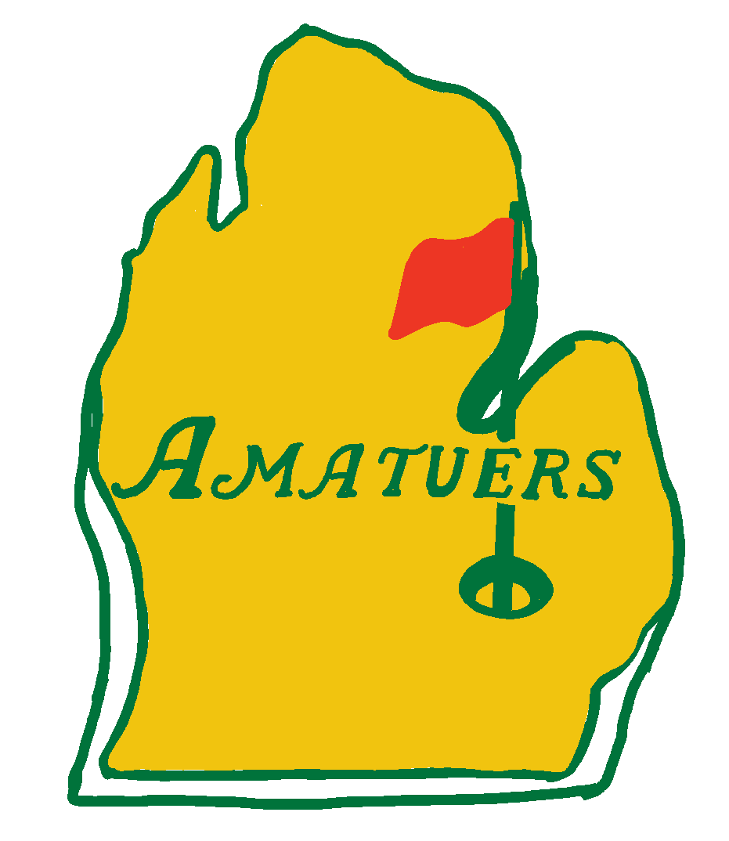

Hole Assignments:
Hole #7: Hall of Famers (Suzanne, Annmarie, Diane)
Hole #8: Diamonds in the Rough (Andrew, David, Alex, Erin)
Hole #9: Live Laugh FORE!! (Brian M, Karen M, Cheri)
Hole #1: Fairway to Heaven (Geoff, Dillon, João Paulo, Jack)
Hole #2: Beyer’s Boneheads (Emily, Louann, Drew, Joey)
Hole #3: Kiss my Putt (Andrea, Charlotte, Reid, Mitch)
Hole #4: Great Balls of Fire (Karen O, Brian O., Abby)

