General Rules:

- Every hole will be played as a 4 (or 3) person scramble. A scramble is when every group member hits a tee shot and then the group chooses the best one out of the 4 (or 3). Each player then hits a shot from that spot. Repeat until the ball is holed. Threesomes will rotate who hits two balls on each hole.

- By the end of the round, the group must have used at least one tee shot from each player on the team. The first time that each player’s tee shot is used, please mark the scorecard with their first initial. Your team will be disqualified for not complying with this rule.

- After hitting your fifth shot as a group, pick up, record a 6 (double par) on the scorecard, and move to the next hole.

- Everyone will play from the forward tee box unless you meet one of the following criteria:
  - Official handicap index <15 → Black tees

- For holes #1, #2, #6, and #9, if all group members go in the water, there will be a dedicated drop zone for you to play from. This will be marked by orange cones.

- If everyone’s ball goes into the woods or is lost, drop a ball near where the ball went out and add 1 stroke to your score at the end.

- In each group’s bag, there is a small sheet of paper that has a question asking what species of turfgrass is in the cup. Please refrain from using your phone to look it up. The piece of paper is due to the Commissioner before the awards ceremony. A correct answer will receive 2 bonus points.

- There are special games for many of the holes, so be sure to read below.

- Have fun!!

Scoring:
- We will use a modified stableford point system. The team collecting the most points will win the Jim Muneio “Bonehead” Memorial Cup. For your convenience, please fill out your card as if you were playing normal stroke play. The Commissioner will tally up the total number of points at the end of the tournament.

- For your information, the point system is below:
  - Hole in One →20 points
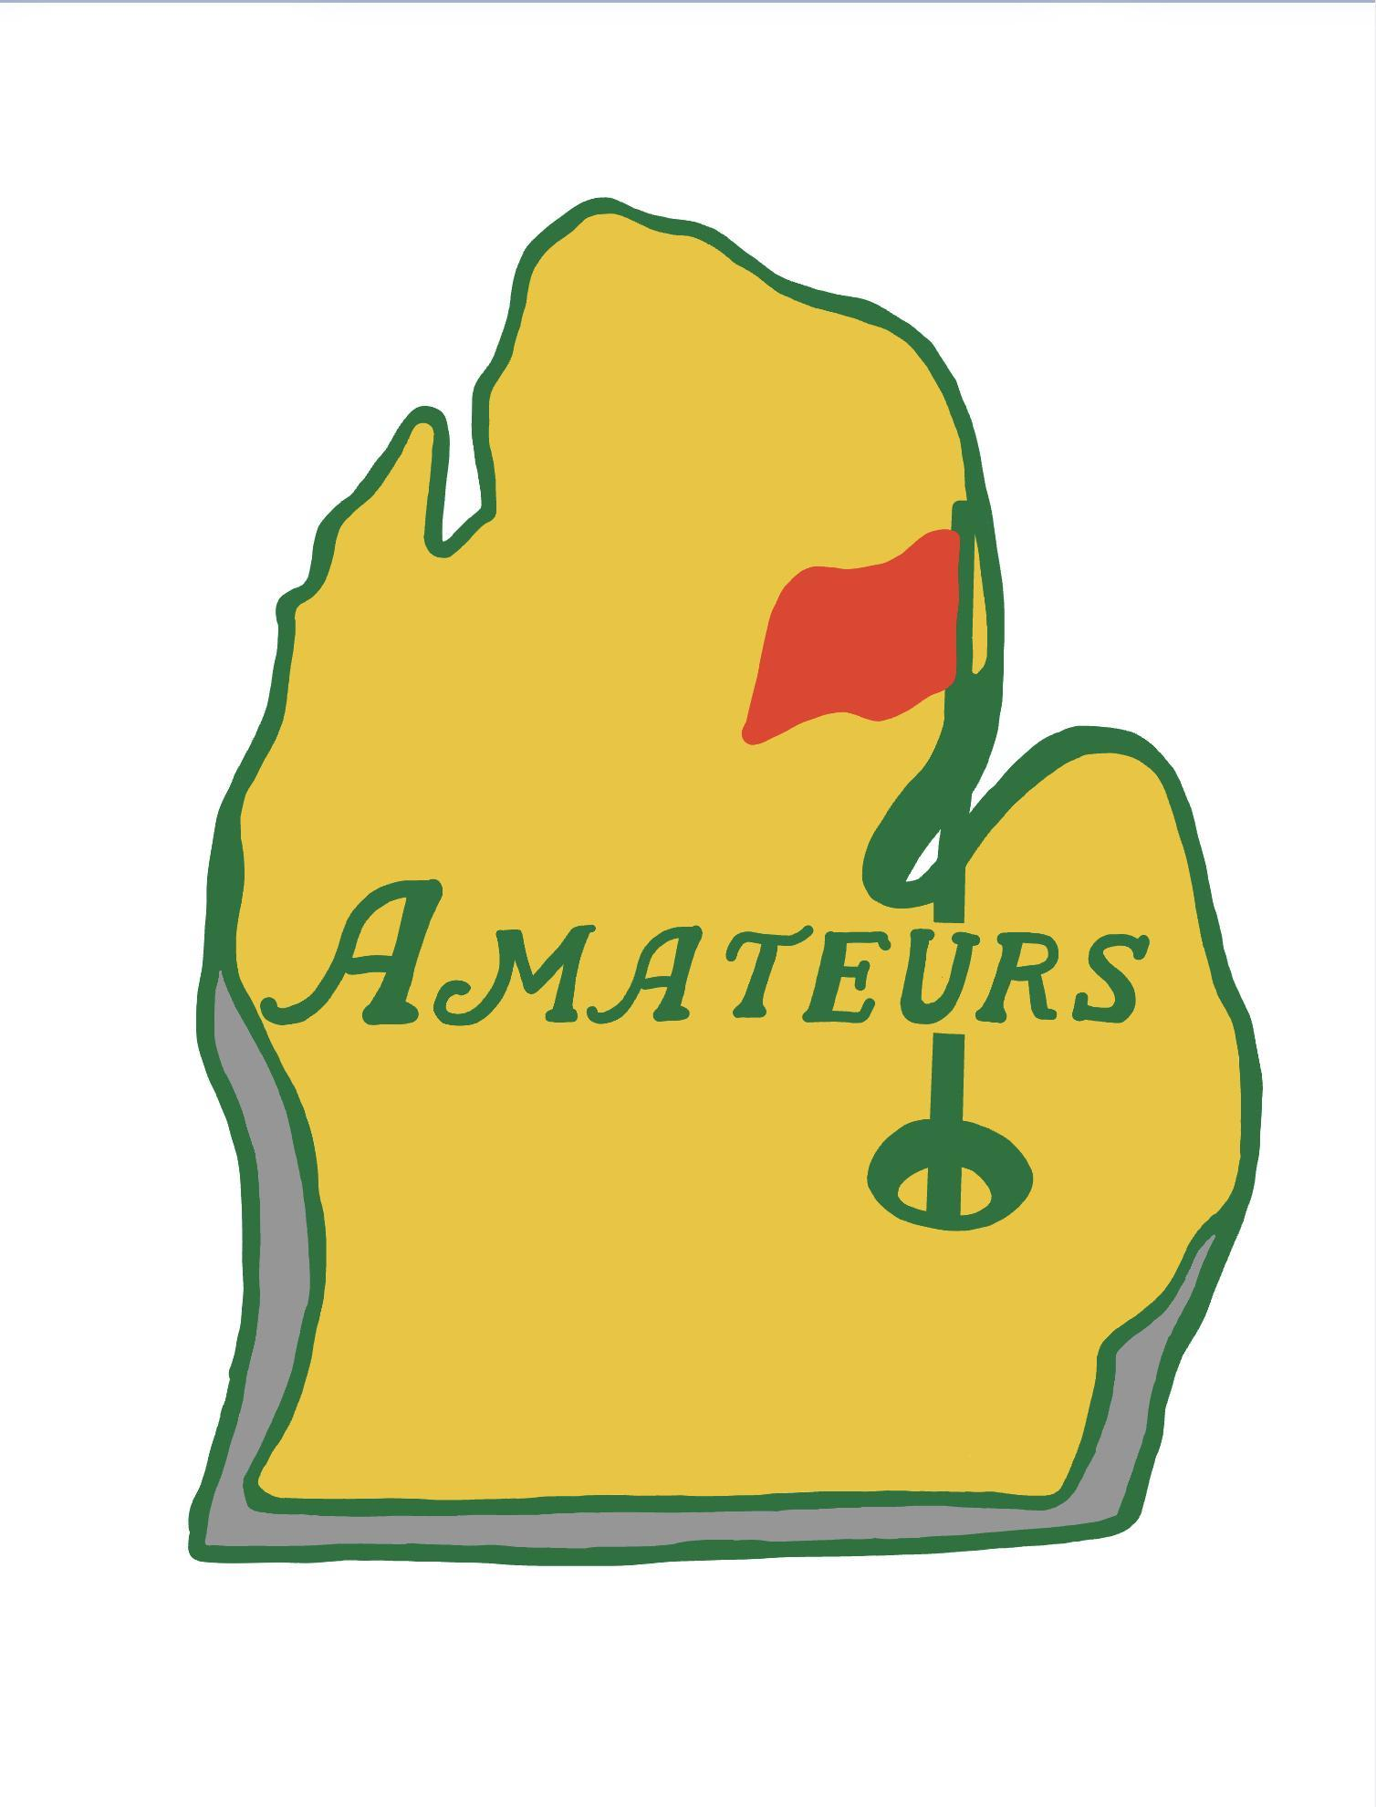
  - Birdie → 5 points
  - Par → 2 points
  - Bogey → 1 point
  - Double Bogey → 0 points
  - Triple Bogey (Double Par) → -2 points

- Additionally, there will be bonus points up for grabs
  - +1 point for the following
    - Winner of farthest from the pin
    - Per person that hits the green with a hickory club
  - +2 points for the following:
    - Correct answer for Guess the Grass
  - +3 points for the following:
    - Make your first putt with the egg-shaped ball
    - Birdie with a tennis ball

Hole Games:
- Hole #1: Farthest from the Pin - Must hit the green to be eligible. There will be a stake on the green to keep track of who is furthest. Make sure to record your name on the sheet and place the stake in the spot where your ball came to rest.

- Hole #2: Normal scramble

- Hole #3: Who Needs Clubs – Without using your clubs, you must hole the ball from the forward tee (We don’t want any old people throwing their arm out). You can throw, roll, or kick the ball into the hole. Please refrain from kicking the ball on the green, though, as our priority should be what’s best for the turf (Says Mr. Turfgrass).

- Hole #4: Wheel of (Un)Fortune - Each player will spin the wheel to determine what club they will hit from this tee box. If you do not have the club in your bag, spin again.

- Hole #5: Back to the (Future) Past - Tee off from the forward tee (Yellow tee marker) using a hickory-shafted golf club. If you need to chip, there will be a wedge by the green that you can use. When you get to the green, there will be an assortment of retro putters for everyone to use.

- Hole #6: Normal scramble

- Hole #7: A Shot in the Dark – Once on the green, each player will putt blindfolded for only the FIRST putt. The subsequent putts will not require a blindfold. This means you need to rely on your team to orient you properly.

- Hole #8: Tennis Time - This entire hole will be played using a tennis ball. Tee off with a golf club or a tennis racquet, chip and putt with your golf club.

- Hole #9: Egg roll - Once on the green, there will be an egg-shaped golf ball that each member on your team will putt with until the ball is holed.

