General Rules:

- Every hole will be played as a 2-person alternate kick. A teammate will take turns hitting each successive shot. Alternate who tees off on each hole.

- After hitting your fifth shot as a group, pick up, record a 6 (double par) on the scorecard, and move to the next hole.

- Everyone will play from the forward foot golf tee box

- Please do your best to avoid the water on holes #2 and #9 because there is no way to retrieve the ball once it goes in the water

- In each group’s bag, there is a small sheet of paper that has a question asking what species of turfgrass is in the cup. Please refrain from using your phone to look it up. The piece of paper is due to the Commissioner before the awards ceremony. A correct answer will receive 3 bonus points.

- There are special games for many of the holes, so be sure to read below.

- Have fun!!

Scoring:
- We will use a modified stableford point system. The team collecting the most points will win the Jim Muneio “Bonehead” Memorial Cup. For your convenience, please fill out your card as if you were playing normal stroke play. The Commissioner will tally up the total number of points at the end of the tournament.

- For your information, the point system is below:
  - Hole in One →20 points
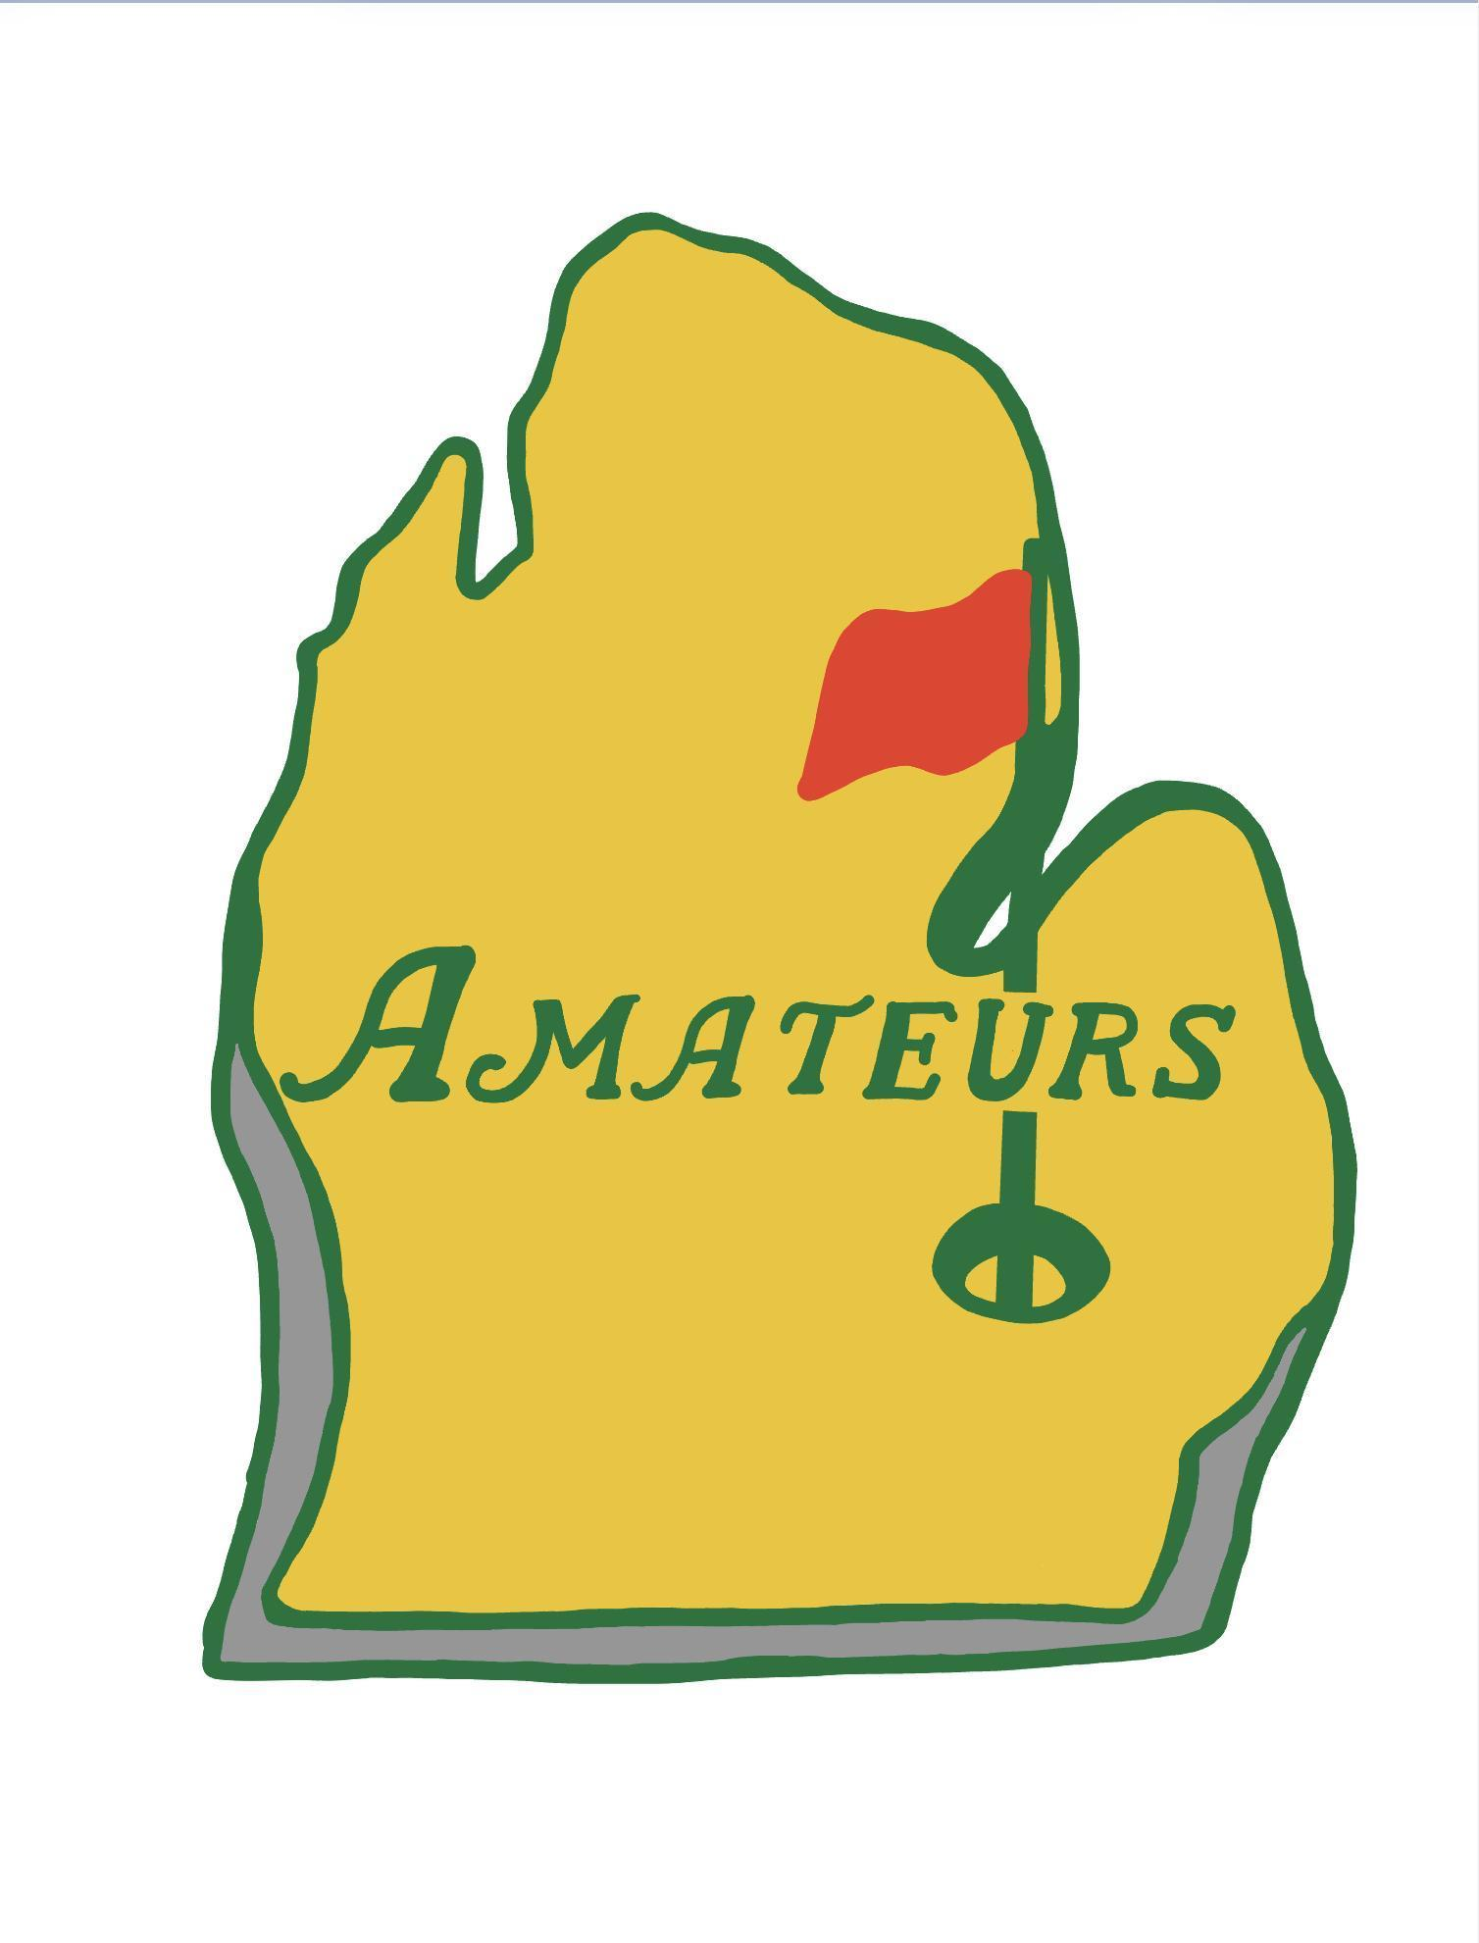
  - Birdie → 5 points
  - Par → 2 points
  - Bogey → 1 point
  - Double Bogey → 0 points
  - Triple Bogey (Double Par) → -2 points

- Additionally, there will be bonus points up for grabs
  - +1 point for the following
    - Winner of the closest to the pin (dizzy hole)
  - +2 points for the following:
    - Birdie on the non-dominant foot hole
  - +3 points for the following:
    - Correct answer for Guess the Grass

Hole Games:
- Hole #1: Normal Alternate Kick

- Hole #2: Normal Alternate Kick

- Hole #3: Dizzy Tee Shot

- Hole #4: Tee shot with an American football

- Hole #5: Throw in tee shot

- Hole #6: Croquet Gates

- Hole #7: Three-legged

- Hole #8: Non-dominant Foot Hole (Closest to the Pin)

- Hole #9: Normal Alternate Kick

