**EECE 3093 Software Engineering Spring 2016**

**Lab 1**

**Team Members: William Hauber, John Miller, Matthew Tucker, Dillon Staub**

**Project Start Date: 1/19/2016**

**Report Submission Date: 2/9/2016**

**Table of Contents**

**Objective………………………………………………………………………………………..3**

**Team Member Roles…………………………………………………………………………...3**

**Feature Status…………………………………………………………………………………..4**

**Communication & Coordination Strategies…………………………………………………11**

**Experience Gained…………………………………………………………………………….11**

**Future Risks……………………………………………………………………………………12**

**Emulator Note………………………………………………………………………………….12**

**OBJECTIVE**

Deliver the capabilities of “navigation” for Mapbox and “privacy setting” for ContactManager.

**TEAM MEMBER ROLES**

**William Hauber**

* Configure git and github on everyone’s machines; suggested team member roles
* Work on MapBox features with Matthew Tucker
* Test MapBox features on lab machines to insure compatibility

**John Miller**

* Look into how the API works and whatnot and how to move forward
* Worked on Contact Manager feature with Dillon Staub; programmed majority of the ContactManager feature implementation
* Worked on test cases for Contact Manager

**Matthew Tucker**

* Learned how Android Studio worked and became accustomed to working in this environment
* Worked on MapBox features with William Hauber
* Worked on test cases for MapBox and reflection document

**Dillon Staub**

* Setting up the development environment of Android Studio and troubleshooting issues with the project’s development environment on mine and others’ machines
* Worked on the ContactManager feature implementation with John Miller; did research on some strategies for implementing different aspects of the feature
* Reviewed some test cases for Mapbox features and coordinated final documentation of project

**FEATURE STATUS**

**Mapbox:**

M-FEATURE1 (address search dialog): Feature 1 on Mapbox is implemented and fully functional. There is a 'Navigation" menu item at the top of the main menu that when clicked, brings up a new dialog where the user can enter an address and select "Search".

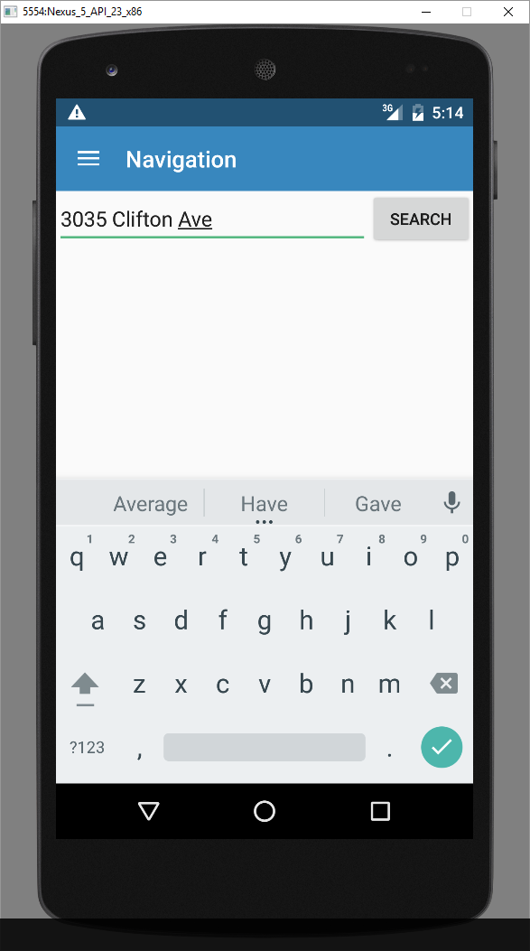

**Figure 1:** The figure above displays a demonstration of Feature 1 after it was implemented.

M-FEATURE2 (show marker on map): Feature 2 on Mapbox is implemented and fully functional. The user can enter an address and select the "Search" button and a marker will be placed on the user requested location. Previous searched will not be indicated on the map by a marker. Only the address currently being searched will be located on the map. This feature supports names of places in addition to specific addresses (such as "Paul Brown Stadium").

M-FEATURE3: (show marker information): Feature 3 on Mapbox is implemented and fully functional. When a marker is clicked, an informational dialog will be shown with basic information about the address.

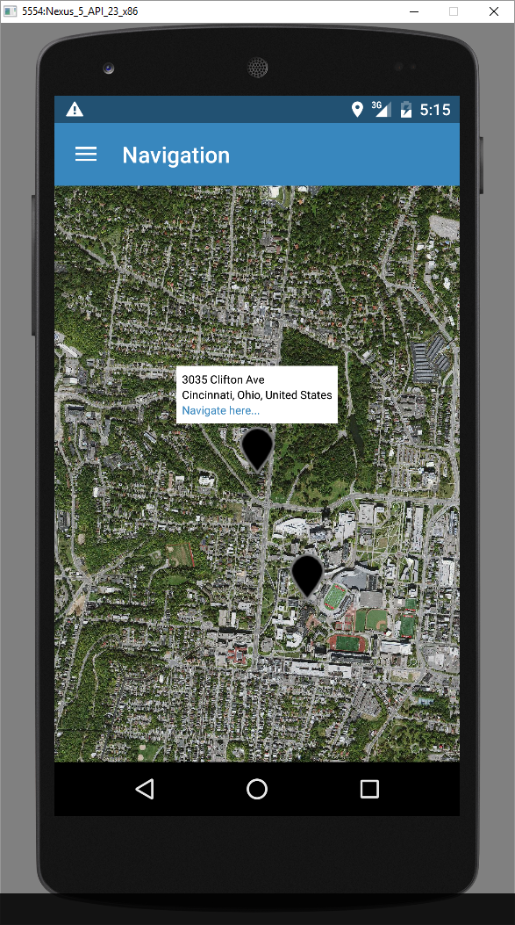

**Figure 2:** The figure above displays a demonstration of Features 1 and 2 after they were implemented.

M-FEATURE4: (route calculation): Feature 4 on Mapbox is implemented and fully functional. A hyperlink "navigate here..." was added to the informational dialog from M-FEATURE3. When clicked, this hyperlink will display the route from the current location to the requested address. Note that the current address in our program is set to the University of Cincinnati.

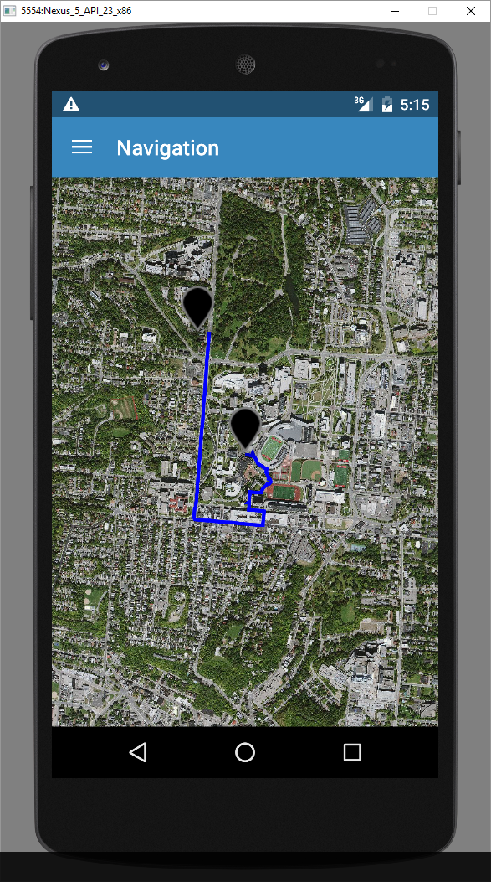

**Figure 3:** The figure above displays a demonstration of Feature 4 after it was implemented.

M-FEATURE5: (routes selection): Feature 5 on Mapbox is implemented and fully functional. If multiple routes are found between the current location and the requested location, the user will see a dialog that will allow them to select between the routes. Once a route is selected the map will be displayed with the selected route shown. Note that the user may have to click the "select route" button twice in order for the route to be displayed.

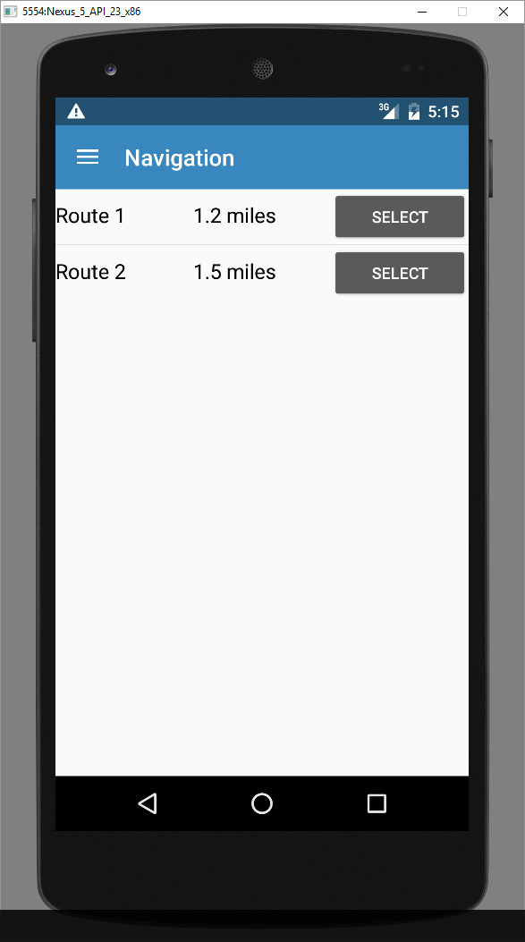

**Figure 4:** The figure above displays a demonstration of Feature 5 after it was implemented.

**ContactManager:**

C-FEATURE1: (privacy setting): This feature was fully implemented in ContactManager. Once the ContactManager application is open, the user can input a contact with the appropriate information and save this contact. In the top right hand corner of the ContactManager application is a button with 3 vertical dots. Once the user clicks this button, a drop down menu appears with “Settings” as its only option. After “Settings” is clicked, a privacy dialog opens with check boxes as displayed in Figure 6. If the user allows access to an item (meaning the check box is checked), the item is able to be selected by the user; however if the user does not allow access to an item, the user cannot select the item in the “LIST” tab. Every address entered into the ContactManager “CREATOR” tab is saved as a hyperlink, and the user can click the hyperlink if the “Allow Access” check box corresponding to the address is checked. Once the user’s privacy setting preferences are set, the user must press the “Hide dialog” button to exit the dialog menu.

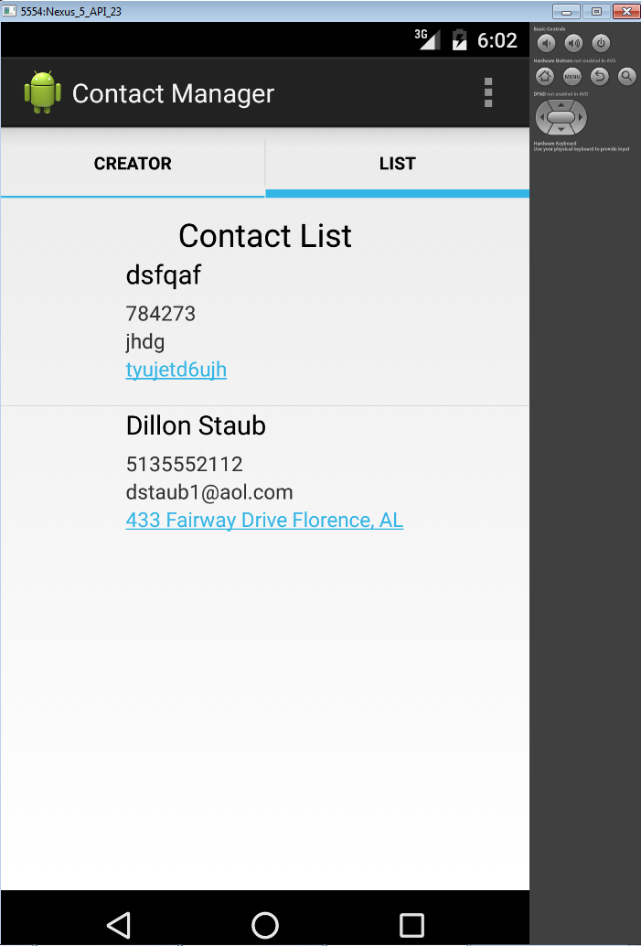

**Figure 5:** The figure above displays the “LIST” tab of ContactManager with all “Allow Access” check boxes checked in the Privacy Setting dialog.

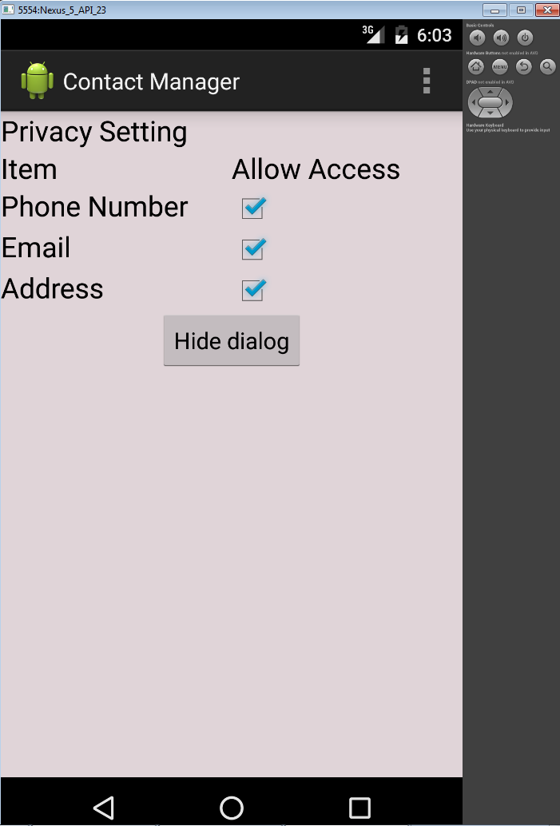

**Figure 6:** The figure above displays the Privacy Setting dialog that appears when the user clicks “Settings”.

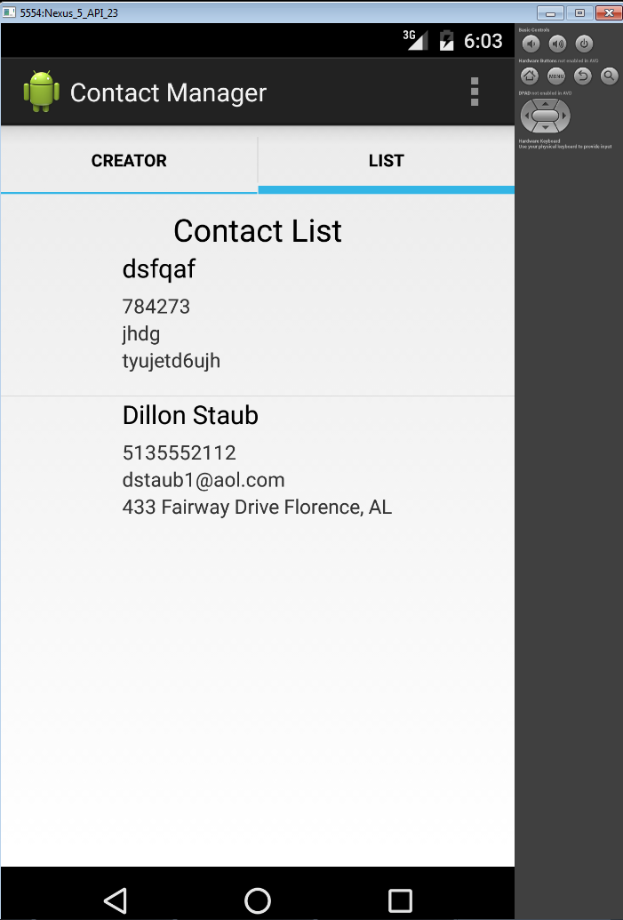

**Figure 7:** The figure above displays the “LIST” tab of ContactManager with all “Allow Access” check boxes unchecked in the Privacy Setting dialog.

**COMMUNICATION & COORDINATION STRATEGIES**

Over the course of this laboratory project, we used a variety of communication strategies including text messaging, email, GitHub, group messaging, and verbal communication during laboratory times. The more effective communication strategies were GitHub and in-person verbal communication that occurred during the laboratory meeting times. GitHub allowed us to share the changes and updates we had made to the code, and it enabled a streamlined transition between features group members worked on outside of lab time. In-person meetings were also effective because any issues could easily be discussed and understood by group members. Text messaging and emails served a purpose; however, they were not as effective because they had limited scope or were not checked as frequently. Our group practiced Agile development in that we used the scrum method to hold informal, virtual meetings to give progress updates and descriptions of difficulties we were facing. In future labs, we hope to improve on this meeting design to streamline our development process.

**EXPERIENCE GAINED**

Implementing the various features in Lab 1 gave us valuable experience working with both Android Studio and java. For some of us, it was the first time we had used Android Studio, and most of us had very limited experience with coding in java. It is difficult to jump into an existing project in a completely new environment, so this experience will help us with future lab projects.

We gained experience with setting up and installing Android Studio for the first time. We also gained experience with running our code on an emulator and debugging our code when we had issues. Technical knowledge of the Android Studio API was gained from this Lab exercise.

We were placed in a software development team and had to work together in order to accomplish the tasks set out for us in the first lab. We gained experience working together and were able to identify each team member's strengths and use them to complete our goals. Working as a team is a valuable skill that we will need to use not only throughout this course but also in our professional lives in order to be successful. One of the first tasks we identified as a team was to divide responsibilities and tasks among team members. Team members frequently checked in with one another to ensure progress was made on the various aspects of the project. Some of our communication methods were more efficient and effective, so we learned to evaluate the impact that each method had on our project.

We were required to develop and test various features in pre-existing software. We gained experience with creating test cases that ensure all parts of our program are working as intended.

**FUTURE RISKS**

**1.** Balancing the workload evenly among team members is a potential issue especially if team members have differing levels of experience. Dividing work can be difficult if features must be implemented sequentially.

**2.** At times, our communication was scattered across different platforms which can lead to a loss of information if the information was not completely or accurately transferred. It is a potential problem if team members are unsure where information should be sent to or taken from which can lead to a lack of collaboration and more individualized work.

**3.** Code coverage could have been more comprehensive if better TDD practices were used. In the future code coverage may not be adequate if this is not improved.

**4.** Methodologies for getting past roadblocks should be improved as one person spending too much time on one specific issue can delay the progress of the entire project.

**5.** The implementation of features could be improved with more informed design and planning before implementing features.

**EMULATOR NOTE**

|  |
| --- |
| Emulator: |
|  |

|  |
| --- |
|  |
| Nexus 5 API 23 x86 |
|  |
|  |
| Marshmallow - Target: Android 6.0 (with Google APIs) |
|  |
|  |
| Target: Google APIs (Google, Inc) - API Level 23 |
|  |
|  |
| CPU/ABI: Googl APIs Intel Atom (x86) |
|  |
|  |
|  |
|  |
|  |
| Android Studio: |
|  |
|  |
| Compile SDK Version: API 22: Android 5.1 (Lollipop) |
|  |
|  |
| Build Tools Version: 22.0.1 |
|  |
|  |
| Source / Target Compatibility: 1.7 |
|  |
|  |
| JDK Version: 1.7.25 |
|  |
|  |
|  |
|  |
|  |
| Note: There appears to be an issue on some of the lab machines with the Geocoder. The method getAddressObjFromAddress() in NavigationFragment.java works on some lab computers, and fails on some lab computers. This is assumed |
|  |

|  |
| --- |
| to be due to differences in the emulators and Android SDK versions; we were not able to determine the specific root cause. |