**Earthquakes and Injection Wells**

Injection wells are used to place unwanted fluids deep underground into permeable rock formations. There are many uses for injection wells including disposing of waste, storing gases, and disposing of salt water that arises as a byproduct of oil production. Some of this wastewater is produced by the process of fracking, which involves pumping millions of gallons of water deep underground to open fissures and extract the gas or oil from those fissures. Although some of this water will remain deep underground within the fissures, some of it will also come back to the surface as “flowback” [K1] that must be dealt with. Some oil companies will reuse a lot of this wastewater such as Marcellus Shale production, out of Pennsylvania, that reuse up to 87 percent of their flowback or wastewater generated [K1]. While fracking produces a certain amount of wastewater, most of the wastewater produced comes from the deposits of oil and gas themselves. These deposits often contain sizable amounts of salt water that arises when the oil or gas is removed from its deposit. While it is possible to treat this water, and reuse it like the flowback, most of the water ends up being pumped deep into injection wells. When this water is pumped into the injection wells it can pry apart the tectonic plates by opposing the frictional force that the plates usually sustain.

In recent years, amidst the fracking boom in the Midwest and California where the number of injection wells grew by twice as many, scientists have been searching for the link between injection wells and earthquakes. Most scientific studies link the rise in earthquakes in the Oklahoma region with the injection of wastewater into deep underground wells. Despite this, the U.S. Geological Survey has stated that “only a small fraction of these disposal wells have induced earthquakes that are large enough to be of concern to the public” [K2]. The important question to take away from this quote is what the USGS would define as an earthquake large enough to concern the public. The reason this is noteworthy is that in the Midwest the number of earthquakes that they face per year has grown exponentially in the past four years. In Kansas, before 2013 they had only experienced 40 earthquakes, with 6 of those being greater than magnitude 3.5, but since the start of 2013 they have experienced 2,190 earthquakes with 89 of those being of magnitude greater than 3.5. While magnitude 3.5 earthquakes are not the greatest feat, they can still be felt [K4] and there is still a very noticeable increase in seismicity in Kansas. Once again in Kansas, before 2013 they had only experienced 1 magnitude 4.0 or greater earthquake, which according to the USGS can be felt indoors by many with walls, windows, and doors being disturbed [K4], while after the start of 2013 they have experienced 15 of said earthquakes. In the eastern region of Oklahoma, before 2013 they had only experienced 483 earthquakes, with 9 of those being of magnitude greater than 4.0, while after the start of 2013 they have had 7,053 earthquakes with 49 of those being of magnitude greater than 4.0. There could be many causes for this increased seismicity, but our group is looking for a correlation, if it exists, between earthquakes in the Midwest and injection wells by using machine learning to map out a k-cluster of earthquakes on a map of the wells in the area.

**Earthquakes Data**

Our project sets out to create a k-means cluster of the earthquakes on the map of the wells to show the correlations that exist. To do this, we first had to find the earthquakes data. Keegan found a search tool from the USGS Earthquake Hazards Program that would take parameters such as location, magnitude of the earthquake, and how far back to get data for and output a CSV of the earthquakes that occurred within the parameters. For our purposes, Keegan searched through the conterminous United States for earthquakes of magnitude 2.5 or greater that can at least cause minor damage dating back to 1980. Once he had obtained the dataset, he cleaned it up by deleting any of the columns that contained useless info such as status, type, id, and net among others. This cleaning up of the data was useful because all we needed to map out the earthquakes was the time, latitude, longitude, and magnitude of the earthquake. Then, he created a simple python program to read in the CSV and arrange each of the columns into its own list i.e. time, latitude, longitude, and magnitude lists. The goal of the program was for the earthquakes data to easily be implemented with the wells data for a k-means cluster. Furthering the work on the program, he also created a simple search tool that will print out the number of earthquakes in the dataset before and after a certain time. He also implemented another search tool that will search for earthquakes that had a magnitude larger than a given magnitude for before and after a specific year. The reason for this was that we can now see how many more earthquakes have happened in recent years than have happened in the past 30 years. There is without a doubt something that has disturbed the earth beneath Kansas and some other Midwestern states and it does appear to coincide with the fracking boom in recent years. In the future, people should continue to monitor the number of earthquakes and the fracking presence in Midwestern states.

For the two maps below, we used the search tool from the USGS to map out the earthquakes in Kansas before 2013 (the first map) and after the start of 2013 (the second map) [K4].

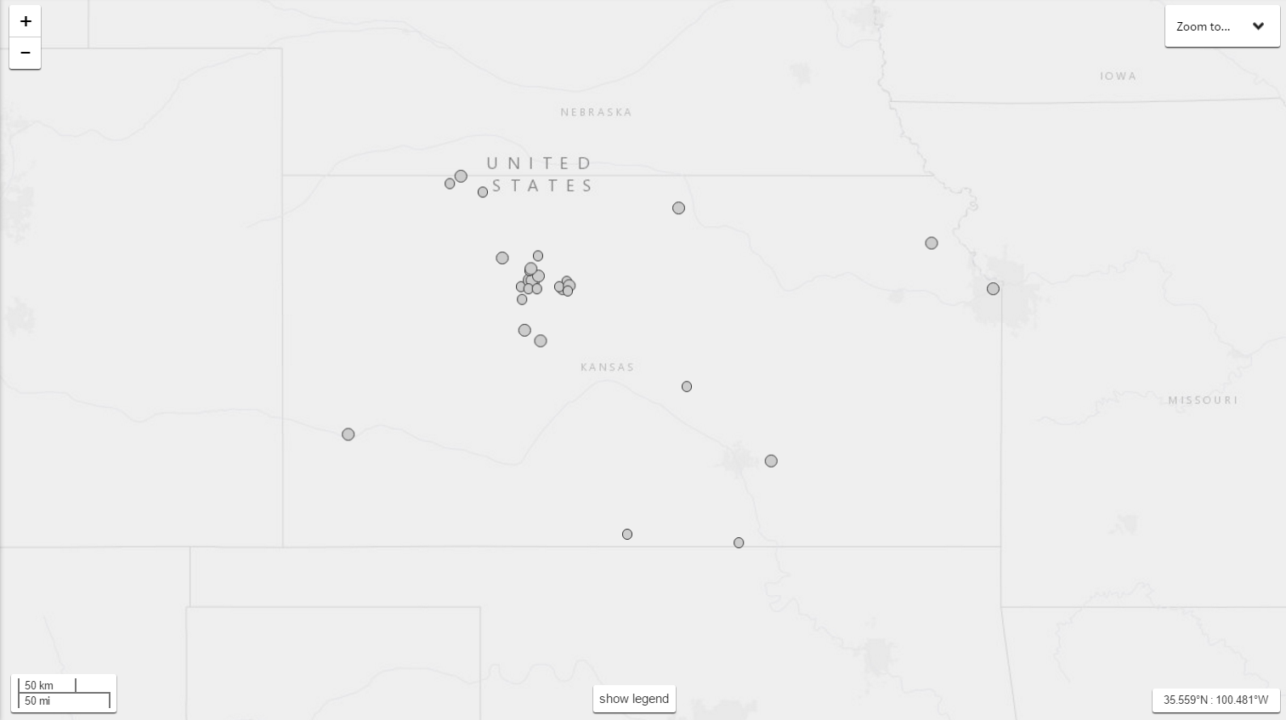

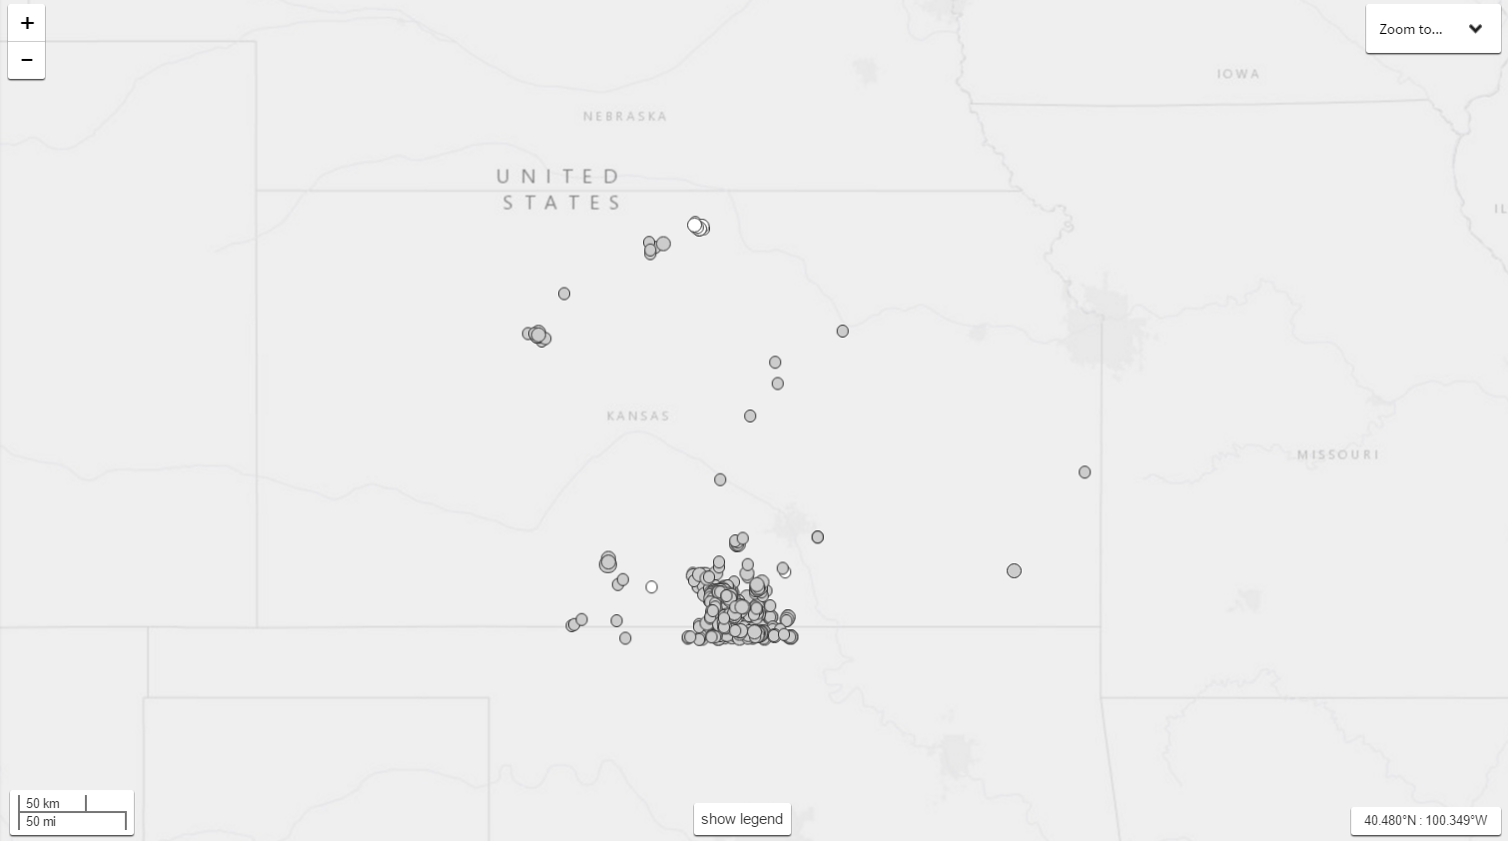

K1. “Underground Wastewater Disposal.” *Energy In Depth*, Independent Petroleum Association of America, 2015, www.bing.com/cr?IG=41FA70CCFE1D4BD6B5A1EF1610ED3E26&CID=3066B8B6E5A960873E22B2C4E439615E&rd=1&h=B5IZmza1AFGeDBWnD7T1AnhyBMdGT2n_4B7qtHQSiag&v=1&r=https%3a%2f%2fenergyindepth.org%2fwp-content%2fuploads%2f2015%2f02%2fWastewater-Disposal-Q-and-A1.pdf&p=DevEx,5060.1. Accessed 25 Apr. 2017

K2. “USGS FAQs- Earthquakes Induced by Fluid Injection.” *USGS FAQs - Earthquakes Induced by Fluid Injection - Do All Wastewater Disposal Wells Induce Earthquakes?*, U.S. Geological Survey, www2.usgs.gov/faq/categories/9833/3424_home. Accessed 27 Apr. 2017.

K3. “Magnitude / Intensity Comparison.” *U.S. Geological Survey*, U.S. Geological Survey, earthquake.usgs.gov/learn/topics/mag_vs_int.php. Accessed 28 Apr. 2017.

K4. “Search Earthquake Catalog.” *U.S. Geological Survey*, U.S. Geological Survey, earthquake.usgs.gov/earthquakes/search/. Accessed 28 Apr. 2017.