Will Ferrin

Wolverines Paper

WE ARE THE WOLVERINES

The first task we did in the clean-up of the ogs-oilandgas-well-locations.xlsx file was to separate GAS, GIW (gas injection well), WIW (water injection well), and BDW (brine disposal well) into different excel sheets for easier manipulation. We uploaded the file to the GitHub repository, but we realized some column titles were left out on some of the well types, which we promptly fixed. Some issues with the data itself was the location coordinates. There were two sets, one labeled “BH…” and the other labeled with “Wh…” or “WH…”. The “BH…” label turns out to most likely stand for bottom hole, but we still have no clue what Wh stands for. We ended up just getting rid of the “BH…” coordinates altogether because both coordinate labels were very close in value with each other, and most were identical.

WH could possibly stand for “well hole,” or some similar attribute that essentially stands for the top of the fracking site drill hole, as opposed to the “bottom hole” of the site, which would be the lowest point of the well that was drilled to. The well may not be drilled in a completely perpendicular line to the earth’s surface and generally is drilled downwards at first and then moves horizontally at the lowest point in order to run along the length of the gas reservoir. The bottom hole would be the location of the well’s end, and so may have a technically different set of latitude and longitude coordinates. However we evaluate this to be only marginally different and therefore we are able to simply dismiss the different coordinates and only use the original well source coordinates.

One of our crew members found another data set containing possible all the wells in fifty states of the United States of America. This data set had to be split into seven csv files in order to fit onto GitHub. The files were named with this format: “wellsX.csv” where X was a number from one to seven. Three of the 7 file names were saved incorrectly at first, “wells5”, “wells6”, and “wells7” were spelled with capital “W”. We fixed that before working on cleaning up the data. The data was pretty much a mess. All the csv files had the same column titles, but each state had different phrasing for the type of wells and how the columns were filled out. Before we tackled getting most of the types to be phrased the same way, we got rid of some of the columns. We decided to remove two columns, “spud date”, and “API” column. For many of the data entrees, “spud date” was blank, so we decided that we shouldn’t use it. The “API” column we got rid of because we didn’t really need to know the unique identifying number of each of the wells, we were just interested in the locations of the wells.

For wells1 and wells2, we started getting rid of the entrees that didn’t have a type filled out. We stopped doing that once we realized some of the states used the “status” columns to label what type of well it was. Also, we could still use wells without a type, we would just have to label in either unknown or other type of well. We also decided to keep wells that were labeled abandoned in the “status” columns because abandoned wells were still dangerous to environment.

The main issue for cleaning up the data was to figure out what phrasing the states were using to describe the wells. At first we decided to use python to grab all the types and count them with a default dictionary, like we did with frequency calculations of articles. We were going to make a list of ones we combined. But what we ended up just doing, was to go through each of the csv files in excel and find what they used. We changed entrees that had types such as “OIL”, “oil”, “OIL WELL” or “Oil Well” to just “Oil Well”. Gas type wells were changed to “Gas Well”. To change these, we made use of the find and replace function in excel. Wells for disposing of salt water were labeled as “Brine Disposal Well”. Many were either labeled as “SWS”, “Salt Water”, et cet. Injection wells were either labeled as “Injection Well”, or “Water Injection Well”. We kept track of as many types as we could in a separate text file for referencing. For the states that used the status column as describing the well type, we manually moved the sections into the “type” column. We needed to clean up some of the types to easily pull them from the csv files into python for our map. We did not want to have 6 or 7 different things to search for, when we specifically wanted oil wells or gas wells.

One thing we realized we may need is the spud date. Not all states have them, so we will end up focusing on one particular state for this data.

Also, OK and TX were not showing up on the map we initially created. We were able to get OK on it once we changed our for-loop to include our final wells, wells7.csv, since it was not being read into it. TX was not in original data set and it apparently costs to get the data so we are letting TX bite the dust.

In this project, we analyzed the impacts of several effects of fracking on geography and potential environmental hazards. For our project we have completed several tasks, including performing background research, finding and gathering datasets, and performing data analysis and visualization using techniques coding in Python. Will was able to locate the ideal source for earthquake datasets from the USGS website so that we would have access to data of locations of earthquakes of all magnitudes in the United States for the designated time frames. Using the USGS earthquake data search tool, it is possible to gather specific data on known earthquakes. We were able to specify the parameters for our data in order to include only the geographic areas we needed, within the United States, as well as min and max magnitude, the time frame of dates included, and number of entries collected (number of data points per data download). From here we were able to clean up the data and extract all of the relevant fields of information that we needed in order to do a data analysis and plot out the locations using Python.

Collecting all of this data on earthquakes, fracking, and wastewater injection wells allowed us to do a fair amount of data analysis and visualization on the effects of fracking. We were most interested on this topic in order to provide us information that can apply to a societal need, here specifically we were focused on human safety and security. Namely, we were concerned with the effects of the processes of fracking on the environment and subsequent effects on human health in communities nearby to incidences of fracking and wastewater injection disposal. The increase in earthquakes can be correlated in specific instances to areas with high concentrations of injection wells. Our data does not always necessarily show incidences of large earthquakes directly on top of well sites, but rather an overall increase in larger surrounding areas. The impacts of geological fault lines are typically more widespread, and require that we look from a wider scope. A pressurized injection may also not necessarily cause earthquakes right away, so it could be valuable to look at earthquakes versus injections on a longer timeline type basis.

We desired to do an analysis so that we could split up our results into different time frames so that we could perceived changes over time and the progression of effects over different time periods. When doing an analysis of k-means clustering, we chose to also divide up our data based on multiple time frames and do a machine learning analysis from there to determine similarities and differences between the different groups of locations of wells across different time frames. Ryan and Will worked on aspects of this coding and collecting all of the well data together so that it could be used efficiently.

To provide some more of the background to our project and the societal and environmental issues that it addresses, we wanted to do a lot of research into the processes of fracking and its potential effects. Aside from the possibility of increasing frequencies or strength of earthquakes, one of the main issues that we were concerned with was the effects of fracking on water quality. The process of fracking involves the use of several types of chemicals, most of which by law are not required to be disclosed by the companies performing the fracking operations, and therefore the initial chemicals used are impossible to do any kind of analysis of.

We are more concerned with the wastewater injection wells, and how these injections may affect the quality of water found in groundwater sources that may be drawn up and used for drinking water to towns and cities. It is possible that injections of wastewater into the ground can have a leaching effect, where chemicals can get into groundwater and eventually into the water stream of human communities’ drinking water. Many reports have shown connections between fracking and the poisoning of local water. We were very concerned with this issue, although actual hard data sources on the subject were difficult to find. We investigated several sources of water quality data, but none of which contained information on the specific chemicals that we were interested in that could possibly be linked to fracking operations.

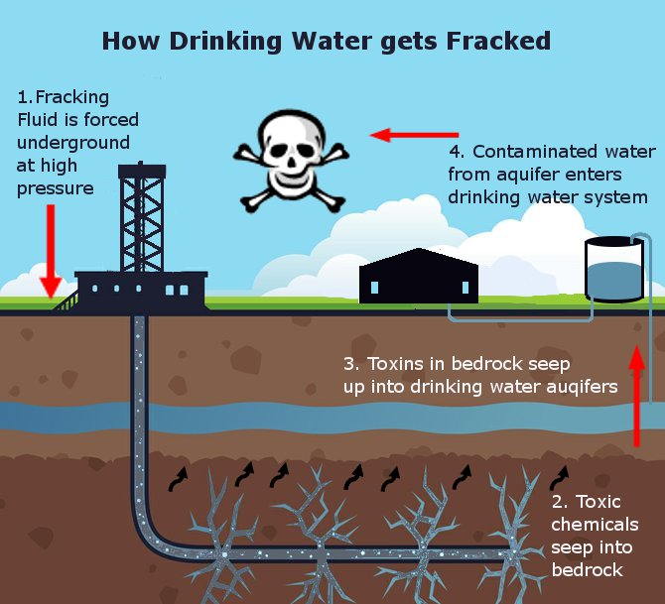

Source: <https://infograph.venngage.com/p/17864/hydro-fracking-fun_1>

According to a report done by former EPA scientist Dominic DeGiulio, the results of his work have shown valid connections between fracking wells and groundwater contamination (W1-Gayathri). One such chemical that is known to be injected along with fracking is methanol, a simple alcohol. It is injected along with water and sediments (and other chemicals) in a highly pressurized environment into ground in fracking wells. The point of the pressurized injection in fracking is to break apart the rock in order to get at the natural gas that is stored there and subsequently extracting it. But it is possible that these chemicals go farther than they were intended. Methanol, a known injection chemical, is known to cause human central nervous system damage in any large enough concentration. The incidence of this in groundwater would certainly have substantial effects on human health. According to reports from the EPA, large enough concentrations of methanol as well as diesel have been found in known locations of fracking operations in Wyoming (W1-Gayathri).

Another example from Avner Vengosh of Duke University shows the extent of fracking’s wastewater on water quality degradation. Their team analyzed a set of water samples from North Dakota in which nearly 4,000 incidences of wastewater spills were recorded out of 10,000 known locations of fracking related operations in the Bakken region (W2- Lockwood). The results of their tests showed that high levels of chemical contaminants remained in the water surrounding these locations up to 4 years after any reported spill. These results show the severity of our issue and the requirement for us to develop further methods for studying it and attempting to limit the influence that fracking might have on people, communities, and the environment.

Sources:

1. Vaidyanathan, Gayathri. “Fracking Can Contaminate Drinking Water.” *Scientific American*, Scientific American, A Division of Nature Inc., 4 Apr. 2016, www.scientificamerican.com/article/fracking-can-contaminate-drinking-water/. Accessed 28 Apr. 2017.
2. Lockwood, Deirdre. “Toxic Chemicals from Fracking Wastewater Spills Can Persist for Years.” *CEN RSS*, American Chemical Society, 20 May 2016, cen.acs.org/articles/94/web/2016/05/Toxic-chemicals-fracking-wastewater-spills.html. Accessed 28 Apr. 2017.