**Table of Contents**

1. **Executive Summary**
2. **Financial Analytics of Dataset**
3. **Conclusion**

**1. Executive Summary**

Mitsuta Global Corporation is an international company that specialises in the manufacturing and sales of products such as office supplies, technological goods and furniture. As a data analyst for the company, I was tasked with conducting an analysis on the company’s superstore dataset to extract commercial insights to maximise sales and profit for the company. The software of choice for this research was Tableau. Tableau is an interactive business intelligence software that is able to provide insights and forecasts from any dataset available. In this case, Tableau serves as a data visualization tool to present my findings from this investigation.

The company’s dataset consists of important commercial information such as sales, profit, type of product and shipping cost. The following report aims to provide a detailed financial analysis of the dataset provided. Majority of the analysis is financially driven and aims to determine products or countries that are commercially viable. The financial analysis places great emphasis on the profit ratio to determine the profitability of the company in certain countries or regions. In addition, it would be of great benefit to identify and develop customers that are very profitable for the company. Furthermore, a forecast was conducted based on Tableau exponential smoothing algorithm to determine potential sales and profit of various products in the near future. Lastly, relevant recommendations would be proposed based on the findings.

**2. Financial Analytics of Dataset**

The financial analytics of the dataset can be broken down into the following sections:

2.1 Overview of Sales and Profit Globally

2.2 Product Analysis

2.3 Customer Analysis

2.4 Financial Forecast

**2.1 Overview of Sales and Profit Globally**

This segment evaluates the top earning countries and regions in terms of sales and profit

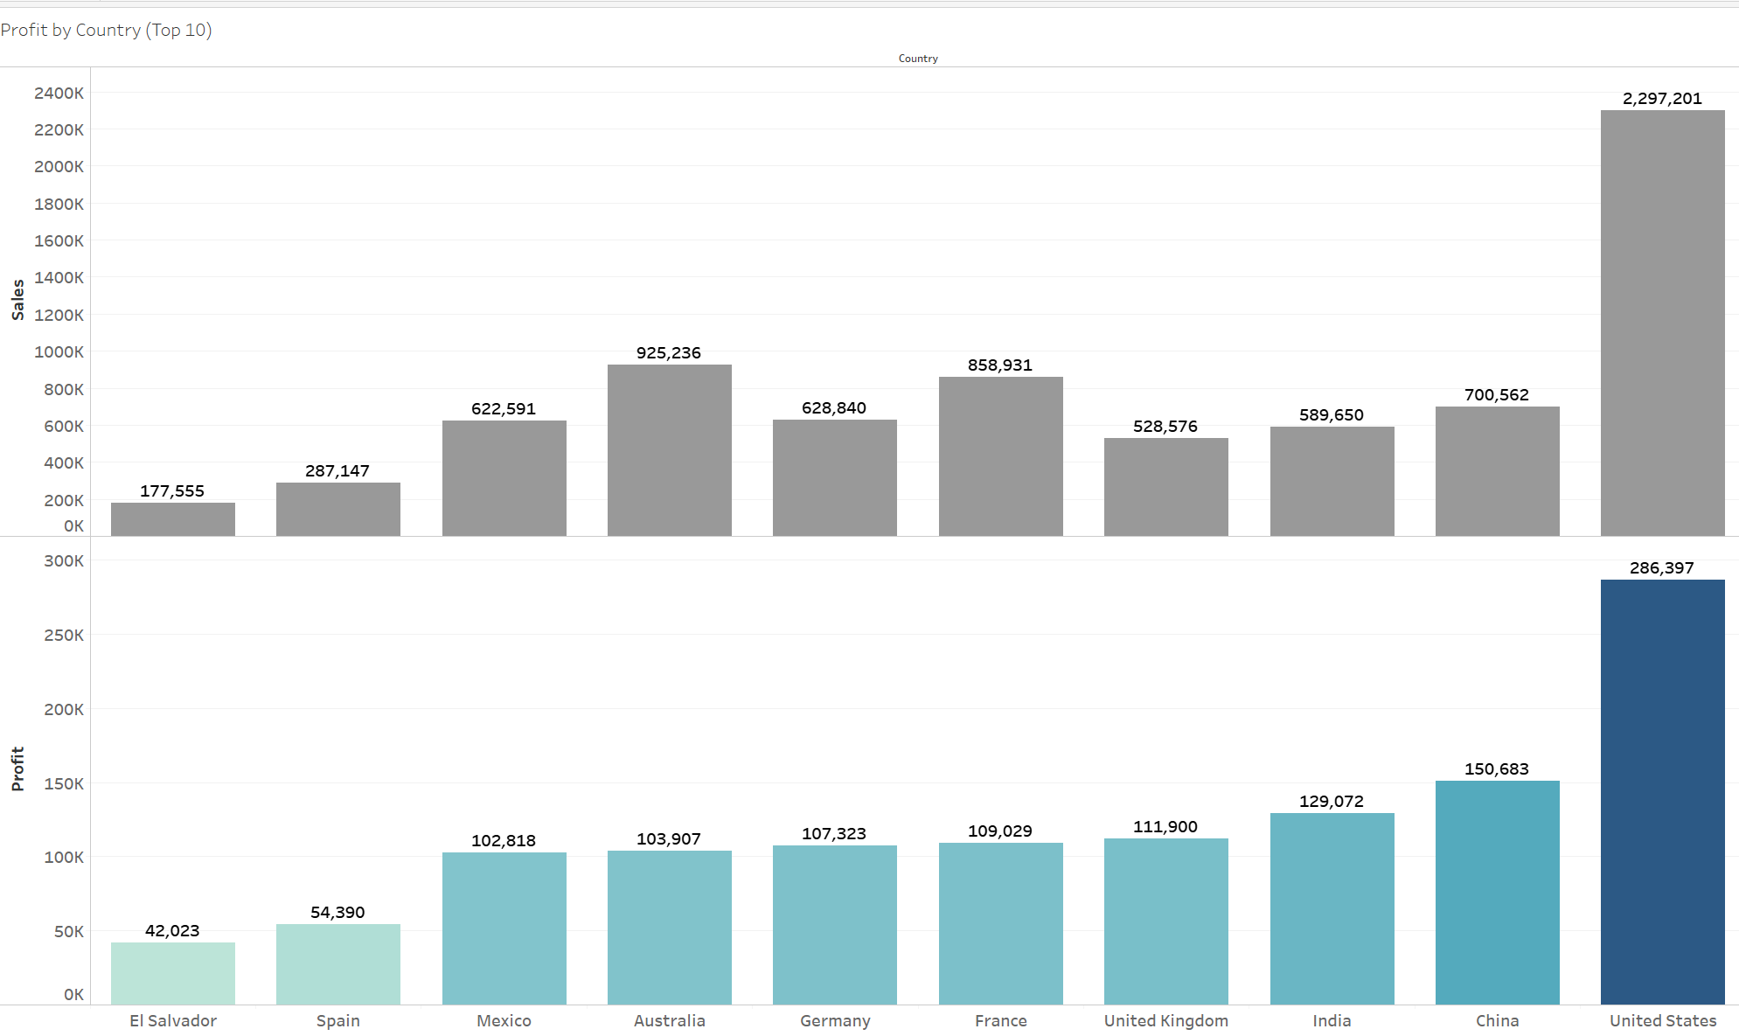Figure 1: Top 10 country in terms of profit

Figure 1 displays the highest earning countries in terms of profit for the company. This consists of countries ranked in the following order:

1. United States (US)
2. China
3. India
4. United Kingdom (UK)
5. France
6. Germany
7. Australia
8. Mexico
9. Spain
10. El Salvador

The United States is the most profitable country for our products with a profit amounting to $286,397. This could be attributed to the whopping number of sales which total up to $2,297,201. However, despite the clear dominance in terms of sales and profit for the United States, the use of profit ratio would serve as a better gauge of the degree of profitability in each country.

The profit ratio formula is as follows:

Profit Ratio (By Percentage) = Sum of Profit ÷ Sum of Sales x 100%

In this case, the profit ratio compares the total profit earned to the total amount of sales in each country.

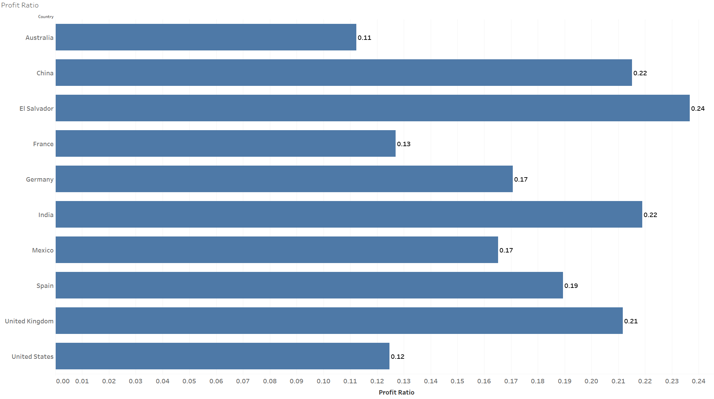

Figure 2: Profit ratio of most profitable countries

Figure 2 covers the profit ratio of the most profitable countries as indicated above. As shown in Figure 1, the United States is the most profitable country in terms of the amount of profit earned. However, the United States only records a profit ratio of 12%. This means that it has only a net profit of $0.12 for each dollar of sales generated. This pales in comparison to other countries such as China, India, United Kingdom or El Salvador which records a profit ratio that is greater than 20%.

In countries like the United States, the huge volume of sales indicates a large customer base but due to inefficient pricing strategies or poor management, profit gain is not being maximised. Further analysis in the next few sections would investigate reasons for low profit ratio.

**2.2 Product Analysis**

This segment looks to evaluate the sales of products in various categories

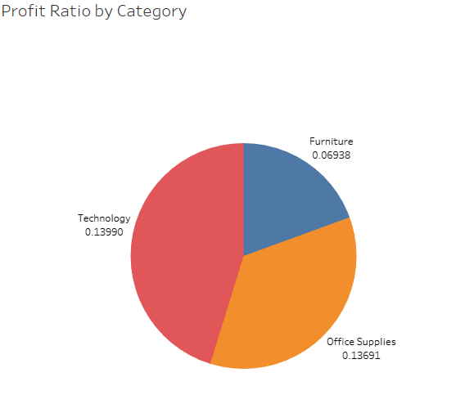

Figure 3: Profit Ratio of Products by Category (Technology, Furniture, Office Supplies)

Products sold by the company are classified under 3 different categories: Technology, Furniture and Office Supplies. As shown in Figure 3, office Supplies and Technology have relatively similar profit ratios of about 14%. However, Furniture products have a profit ratio of about 7%, which is way below average as compared to the other products. This is a clear indicator of declining revenue and there are various factors that could have led to this.

* Declining Sales

Declining Sales could be caused by a decrease in popularity of certain products as customers could favor other competitors due to better marketing or quality of product sold.

* High Production cost

The increasing prices of raw materials could have led to the increase in production cost for the products sold. The company would experience loss in profit as the prices of the product sold have to remain the same or not sales numbers would be affected.

* Poor Product Pricing

The prices of products whether high or low play an important role in determining profits and sales respectively. Products that are priced too high would deter customers and sales would decrease. Conversely, products that are priced too low may attract more customers, but the profit gained would not be as high. It is important to strike a proper balance to achieve the optimal amount of sales and profit that would maximise profit ratio.

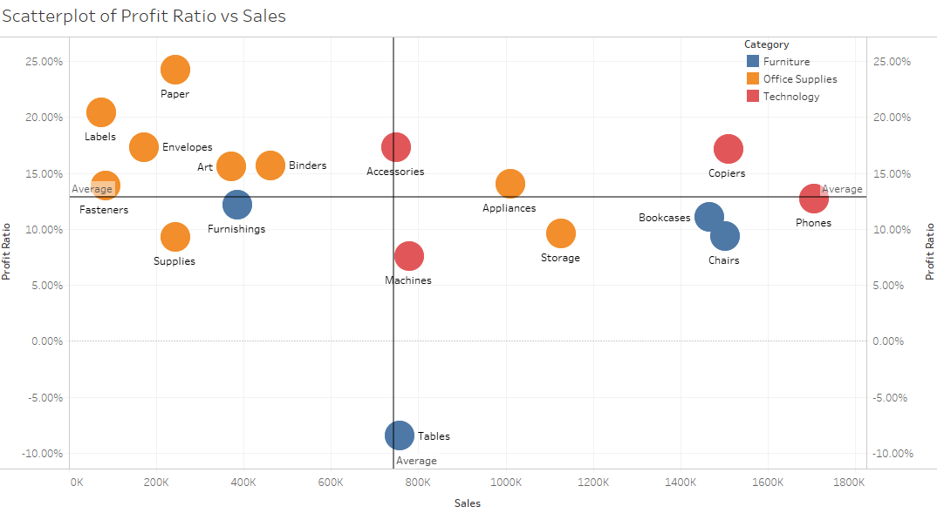

Figure 4: Scatterplot of Profit Ratio vs Sales

To investigate reasons for the low profit ratio for furniture, the products are further grouped into their various subcategories. Furniture products can be classified as furnishings, tables, bookcases and chairs. According to the scatterplot in figure 4, it can be seen that out of all the products available, only tables have a negative profit ratio. Despite boasting above average sales number, negative profit gain led to a negative profit ratio of -8.46%. This outlier is the main reason for the low profit ratio for furniture.

As for the office supplies and technology, the majority of the office supplies have lower than average sales numbers but still boast a high profit ratio. The high profit ratio of these products could be attributed to lower production costs and efficient price management. On the contrary, the production costs of technological products such as phones, copiers and machines are way higher compared to office supplies. As such, the profit gained from each product sold is lower. Hence, it is important the company maintain a high sales volume to maintain a high profit ratio.

**2.3 Customer Analysis**

This segment covers the profitability of customers around the world

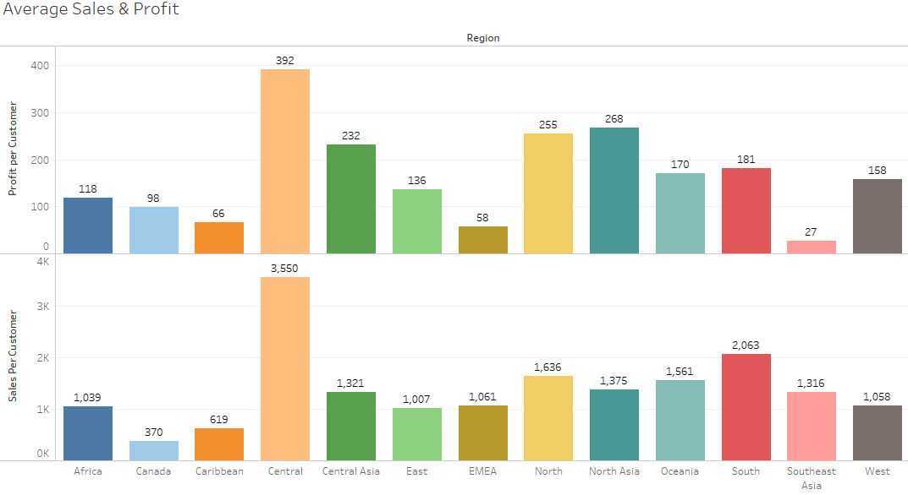 Figure 5: Average Sales & Profit per customer (Regional)

The bar chart in Figure 5 gives an overview of the sales and profit per customer in various regions around the world. Although regions such as Southeast Asia and Europe, Middle East, Africa (EMEA) average more than $1000 in sales per customer, profit values of $27 and $58 per customer respectively suggests that the profit margin in these regions are not very high. The sheer volume of sales seems to indicate that customers are purchasing products from these regions due to lower prices.

Further investigations were conducted by plotting a scatterplot comparing the profit ratio and sales for the various regions. This is reflected in Figure 6 below.

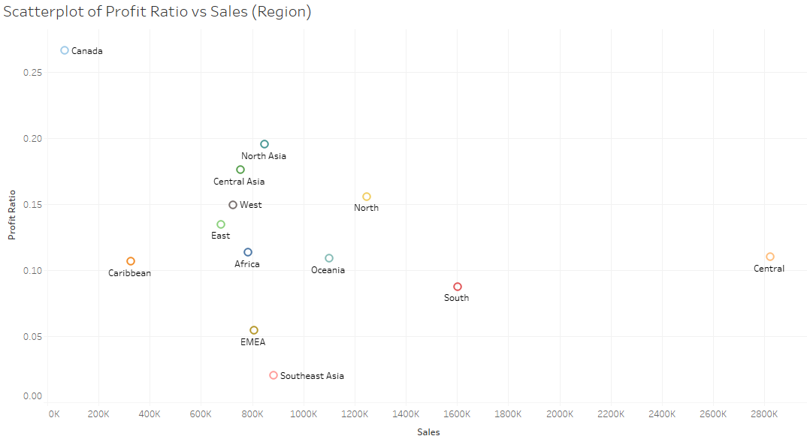

Figure 6: Scatterplot of Profit Ratio vs Sales (Regional)

The low profit values in Southeast Asia and EMEA is further reflected in the scatterplot shown in Figure 6. Both regions are the bottom 2 in terms of profit ratio. The company needs to do a review of management and pricing structure to find out the root cause for such a low profit ratio. The volume of sales in these 2 regions are above average values and concerns should be directed towards the prices and production cost of products sold.

The company could consider raising prices of essential products or other products that are higher in demand. However, the company must be wary of the decrease in sales numbers when prices are inflated. Another approach that the company could look towards would be to lower expenses in production and improve efficiency. This process is known as Economies of Scale and the company needs to look towards purchasing raw materials in greater capacity. Wholesalers are willing to give greater discounts when materials are purchased in bulk. As such, the company is able to produce goods that are in great demand at lower production cost. Hence, increasing the profit margin for each product sold.

**2.4 Financial Forecast**

This segment discusses the financial forecast over the next2 years from the last order date in Dec 2014.

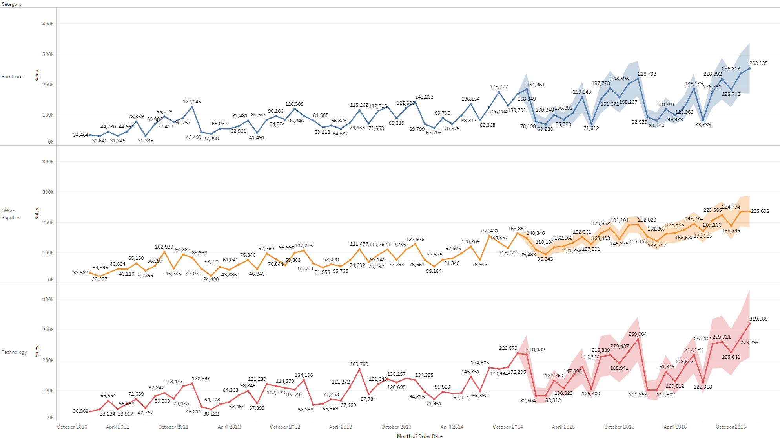Figure 7: Sales Forecast of Products

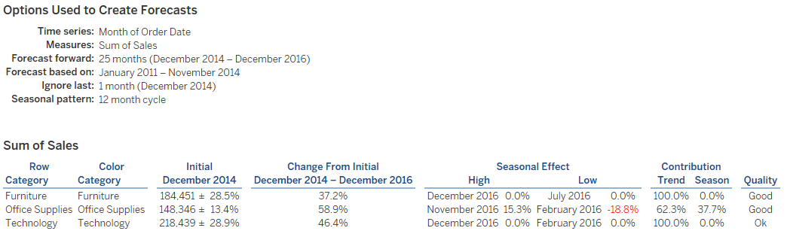

Figure 8: Forecast Summary from Dec 2014 - Dec 2016

Tableau makes use of exponential smoothing to conduct forecasting based on certain variables. In this case, forecasting is conducted for the sales of products classified under Furniture, Office Supplies and Technology.

Based on tableau forecast summary table, tableau predicts an increase in sales for all 3 products from December 2014 to December 2016. To test for a seasonal trend, tableau looks for a seasonal cycle based on the time series chosen. In this case, the time series chosen is the Month of Order Date. Hence, tableau will search for a 12-month cycle to derive the seasonal effect for each product. According to the summary table, tableau predicts a decrease in sales by 18.8% in February 2016 and a huge increase in sale by 15.3% in November 2016.

The month of November 2016 could possibly see a surge in demand for office supplies. Hence, the company should consider raising prices or increasing production level to capitalise on the increase in market demand.

**3. Conclusion**

This report concludes that the analysis of various elements from the dataset is relevant in gaining commercial insights for the company. The use of profit ratio is effective in discerning the profit margin of the company in various regions and countries around the world. The profit ratio determines the degree to which the company is earning from the sales of products. Products with high sales volume but low profit suggests that there are flaws in the pricing structure and production costs must be reviewed internally. Customer analysis helps the company determine the profitability of various customers and explains reasons for low profit ratio in certain regions. Lastly, the financial forecast helps the company plan for future sales based on the seasonality effect. The company needs to leverage on seasons of high demand to boost sales and profit.