PS2786

EU/IS/2019/PHY/36

**Network Topology**

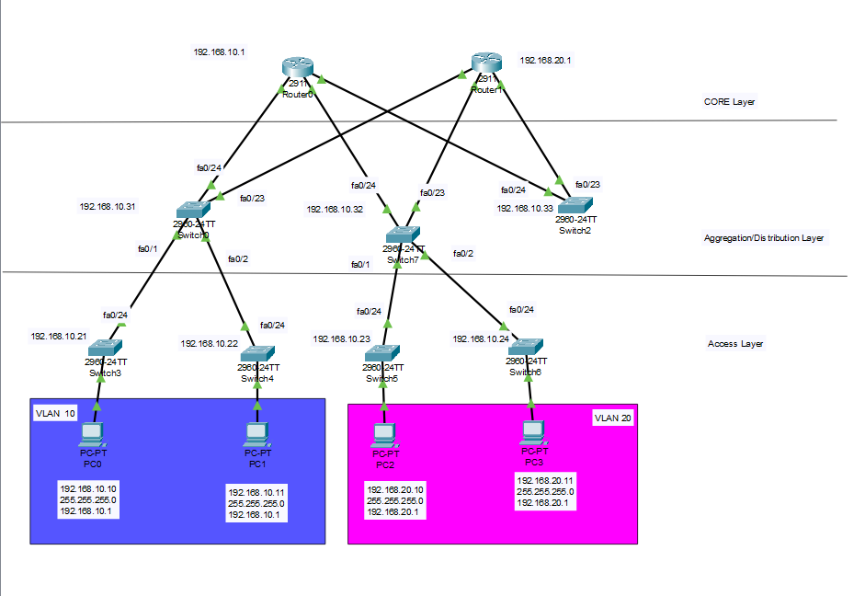

PC0, PC1 in VLAN 10.

PC2, PC3 in VLAN 20.

CORE Layer – Router0 , Router1

Aggregation/Distribution Layer- three switches

Access Layer – four switches

