1.1

user_list=list(input('engiz:').lower())  
print(user_list)

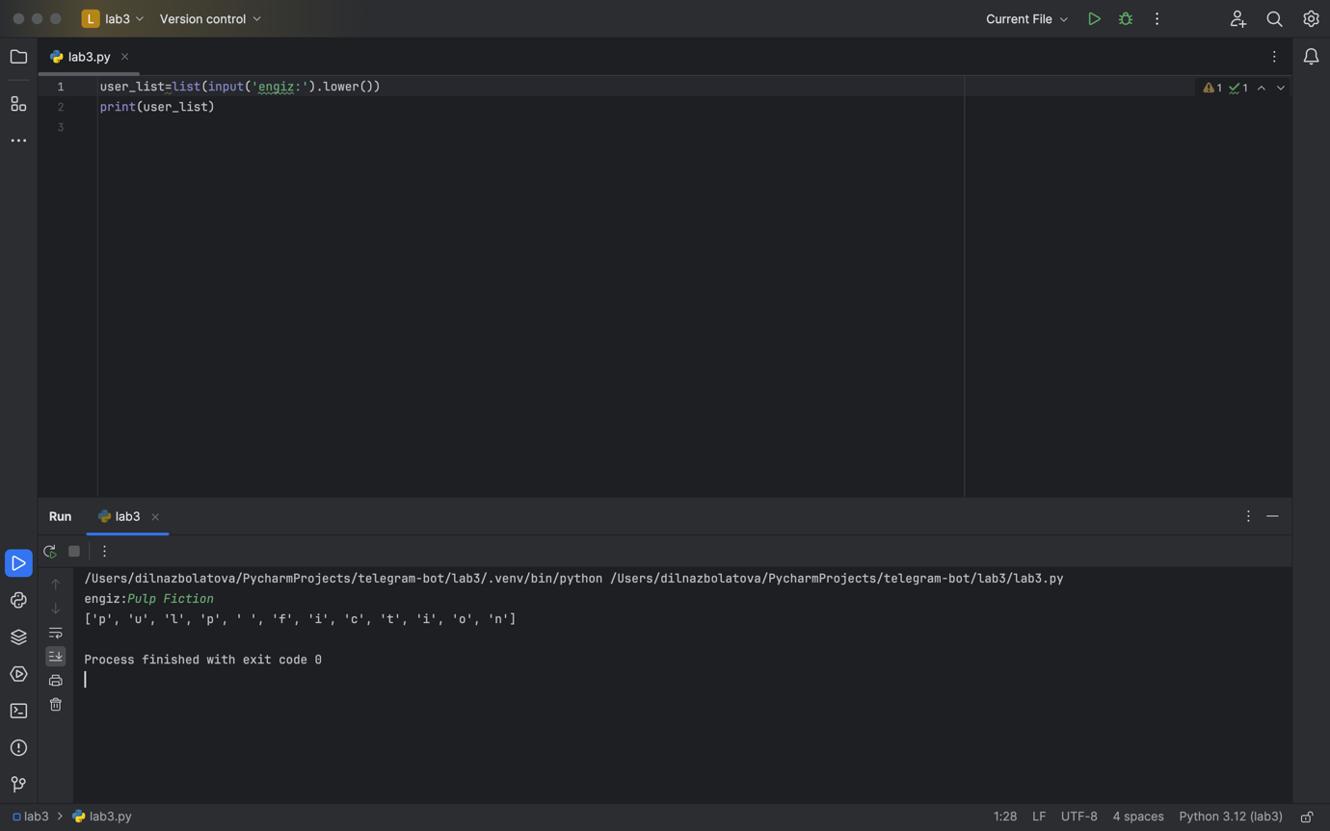

1.2

user_list=[('p', 2), ('u', 1), ('l', 1), ('' , 1), ('f', 1), ('i', 2), ('c', 1), ('t', 1), ('o', 1), ('n', 1)]  
  
vowels='aueioy'  
  
list_vow=[(char,count) for char,count in user_list if char in vowels and char.isalpha()]

list_cons=[(char,count) for char,count in user_list if char not in vowels and char.isalpha()]

list_sym=[(char,count) for char,count in user_list if not char.isalpha()]  
  
print('Dauysty:',list_vow)  
print('Dauyssyz:',list_cons)  
print('Simvoldar:',list_sym)

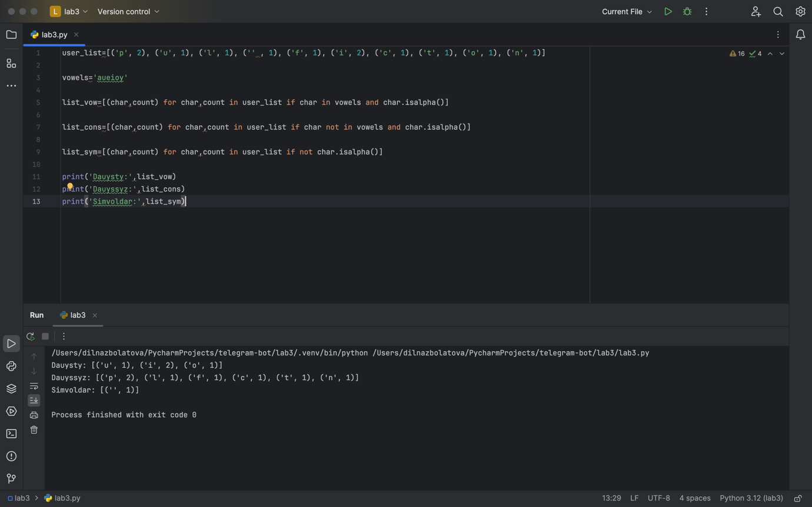

2.1

name=input('Student esimi - ')  
assignments =input('tapsyrmadan algan bagalary = ').split(',')  
labs=input('lab= ').split(',')  
tests =input('tests= ').split(',')  
  
student={  
'name':name,  
'assignment':assignments,  
'test':tests,  
'lab':labs  
}  
  
print(student)

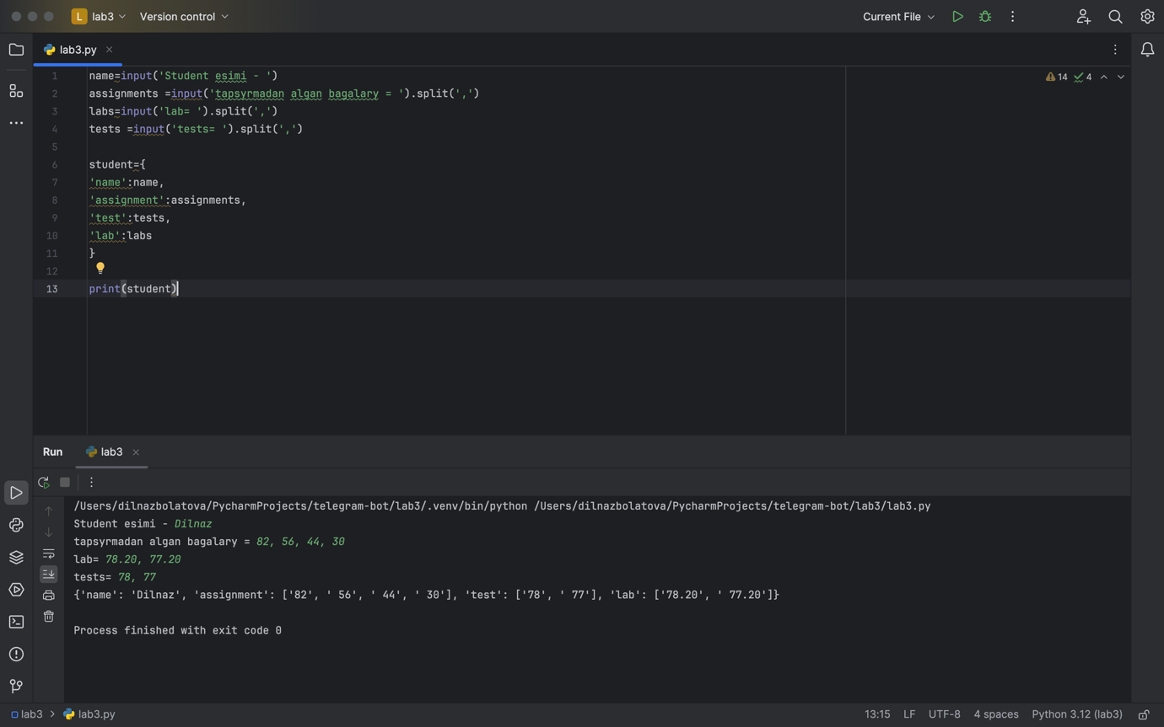

2.2

name=input('Student esimi - ')  
assignments =input('tapsyrmadan algan bagalary = ').split(',')  
labs=input('lab= ').split(',')  
tests =input('tests= ').split(',')  
  
student={  
'name':name,  
'assignment':assignments,  
'test':tests,  
'lab':labs  
}  
  
print(student)  
  
count_submission=len(student['assignment'])+len(student['test'])+len(student['lab'])  
  
submission_rate={  
 student['name']:count_submission  
}  
  
print(submission_rate)

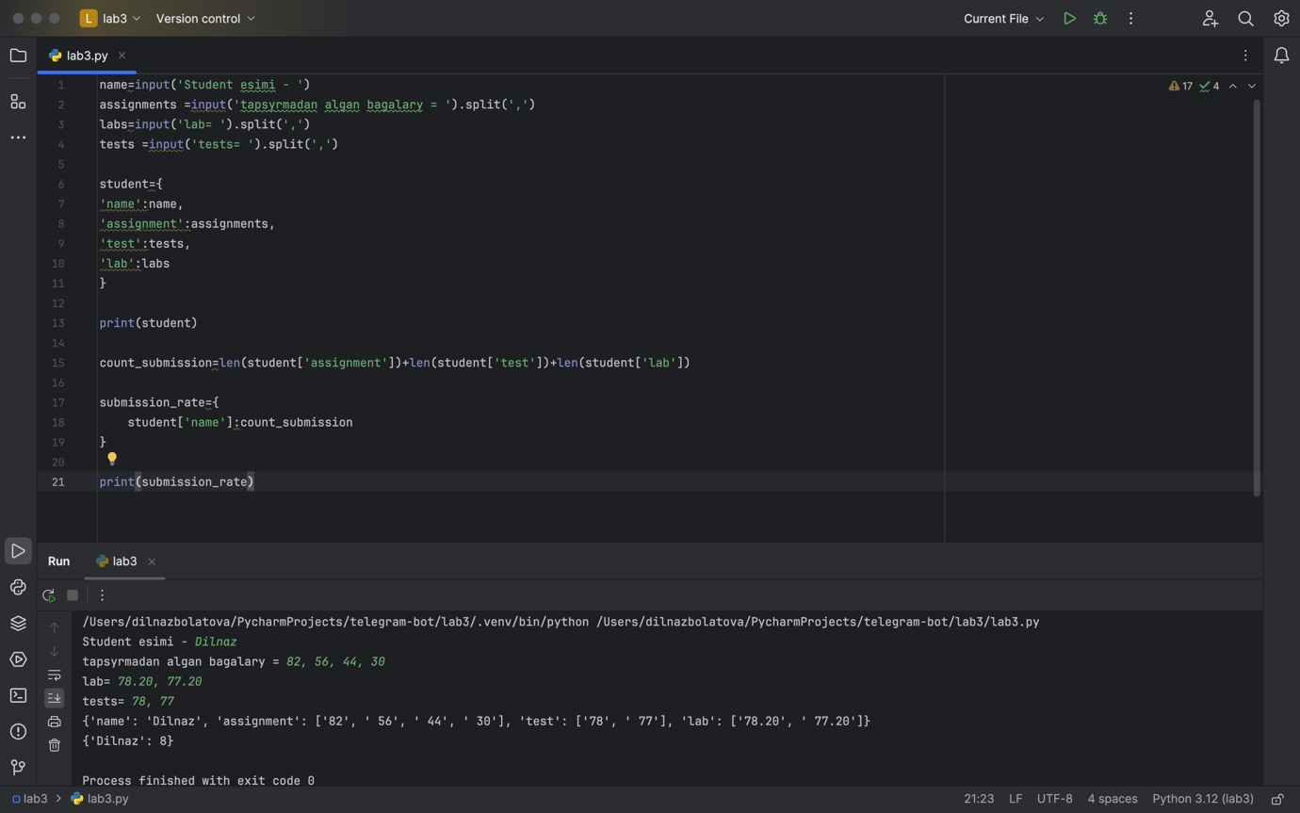

2.3

name = input('Student esimi - ')  
assignments = input('Tapsyrmadan algan bagalary = ').split(',')  
labs = input('Lab = ').split(',')  
tests = input('Tests = ').split(',')  
  
student = {  
 'name': name,  
 'assignment': assignments,  
 'test': tests,  
 'lab': labs  
}  
  
print(student)  
  
count_submission = len(student['assignment']) + len(student['test']) + len(student['lab'])  
submission_rate = {student['name']: count_submission}  
  
print(submission_rate)  
  
def average(tasks):  
 all_final = 0  
 for task in tasks:  
 if task:  
 all_final += float(task)  
 return all_final / len(tasks) if tasks else 0  
  
  
if submission_rate[student['name']] >= 4:  
 final_grade = (  
 0.3 * average(student['assignment']) +  
 0.5 * average(student['lab']) +  
 0.2 * average(student['test'])  
 )  
 student['final_grade'] = final_grade  
else:  
 student['final_grade'] = 0  
  
  
print(student)

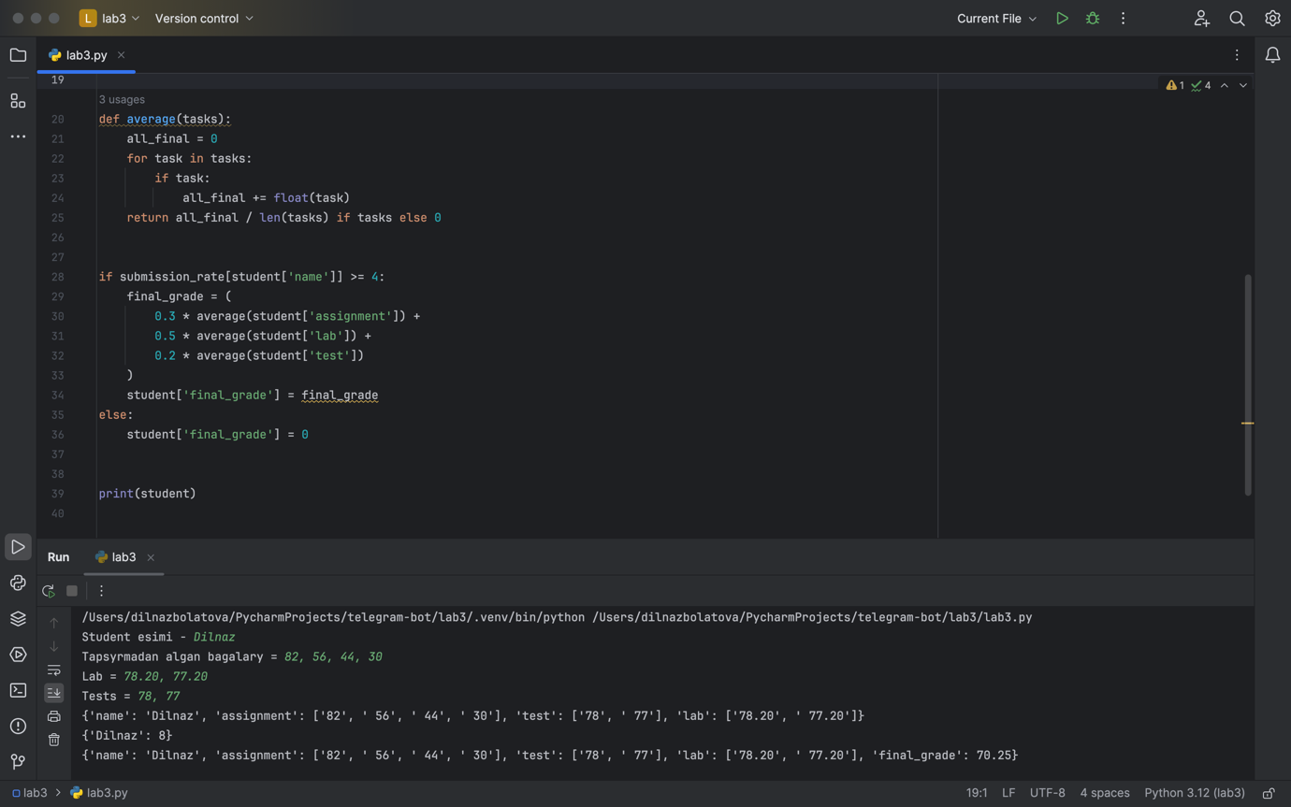

2.4

name = input('Student esimi - ')  
assignments = input('Tapsyrmadan algan bagalary = ').split(',')  
labs = input('Lab = ').split(',')  
tests = input('Tests = ').split(',')  
  
student = {  
 'name': name,  
 'assignment': assignments,  
 'test': tests,  
 'lab': labs  
}  
  
print(student)  
  
count_submission = len(student['assignment']) + len(student['test']) + len(student['lab'])  
submission_rate = {student['name']: count_submission}  
  
print(submission_rate)  
  
def average(tasks):  
 all_final = 0  
 for task in tasks:  
 if task:  
 all_final += float(task)  
 return all_final / len(tasks) if tasks else 0  
  
  
if submission_rate[student['name']] >= 4:  
 final_grade = (  
 0.3 * average(student['assignment']) +  
 0.5 * average(student['lab']) +  
 0.2 * average(student['test'])  
 )  
 student['final_grade'] = final_grade  
else:  
 student['final_grade'] = 0  
  
  
print(student)  
  
student2={  
 'name': 'Kevin',  
 'assignment': [82, 30],  
 'test': [],  
 'lab': [78.2]  
 }  
  
student_name1=student['name']  
student_name2=student2['name']  
del student['name']  
del student2['name']  
students={  
 student_name1:student,  
 student_name2:student2  
 }  
  
print(students)

