# Project Documentation

Created on: 15.02.2025

## 1. Project Overview

• Project Name: Web programming Project 1

• Objective: Develop a fully functional website in group on a topic of student’s own choices as part of **Project 1** for the **Web Programming** class using skills of front-end and back-end development, collaboration, and project management.

• Team Members: Dilnoza Eraliyeva, Nodirbek , Ruxshona Berdimurodova

- Project Manager: Ruxshona Berdimurodova

- Developers: Dilnoza Eraliyeva, Nodirbek Rejabaliyev

- Content creator: Ruxshona Berdimurodova

- Designer: Nodirbek Rejabaliyev

- QA Engineer: Dilnoza Eraliyeva

• Start Date: 15.02.2025

• End Date: 25.02.2025

## 2. Roles & Responsibilities

• Project Manager:

1. Oversees timeline and progress;
2. Assigns roles according to skills of each member;
3. Communicates with team and handle problems
4. Responsible for project documentation in two formats;
5. Task tracking and contribute to overall code quality.

• Developers:

1. Develop UI and UX of the web application;
2. Ensure accessibility;
3. Write HTML, CSS, JavaScript codes.

• Designer:

1. Creates wireframes, mockups and prototypes;
2. Ensures that the design is user-friendly and aligns the goal;
3. Converts prototypes into HTML, CSS

• Content Creator:

1. Develops the content of the web page;
2. Ensures that content is engaging;
3. Integrates content into web page using HTML and CSS.

• QA engineer:

1. Identifies and resolves any bugs and issues;
2. Ensures the web pages meets requirements;
3. Writes test script using JavaScript and assists debugging.

## 3.Project Timeline & Milestones

|  |  |  |  |
| --- | --- | --- | --- |
| **N** | **Project Milestones** | **Descriptions** | **Timeline** |
| 1 | Planning | 1. Meeting with team 2. Brainstormed on ideas and finalized topic of project 3. Assigned roles | 13.02.2025 |
| 2 | Design | 1. Defined the purpose of web page 2. Created rough wireframe 3. Chose basic designs like colors and typography | 18.02.2025 |
| 3 | Development | 1. Converted the wireframe into an actual code using HTML, CSS and JavaScript 2. Trying different types of design, colors 3. Finalized menu items and added to website | 23.02.2025 |
| 4 | Testing | 1. Ensured functionality and performance 2. Tested every part of the code manually and added some improvements where needed | 24.02.2025 |
| 5 | Deployment | 1. Release of final version | 25.02.2025 |

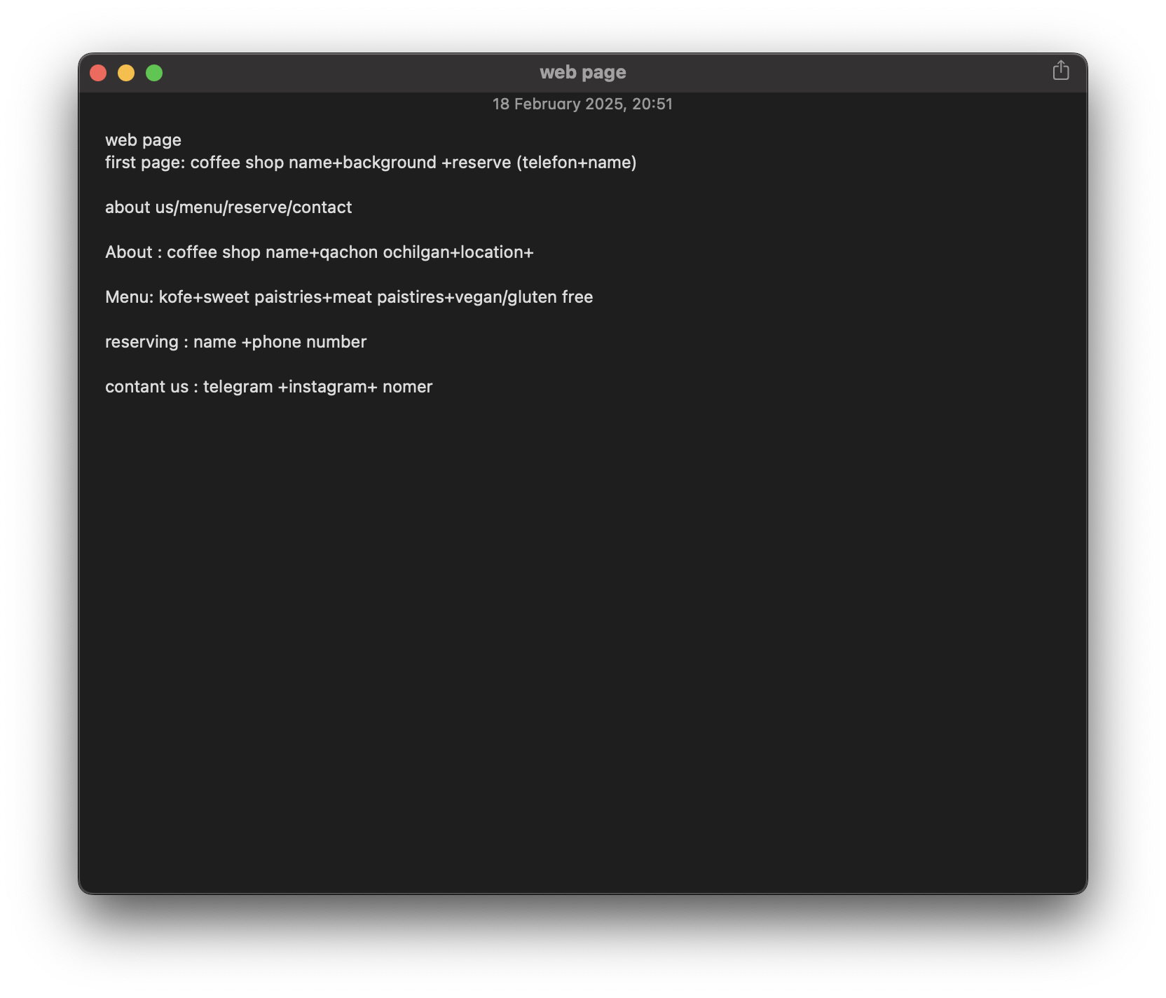

**Rough wireframe of the project**

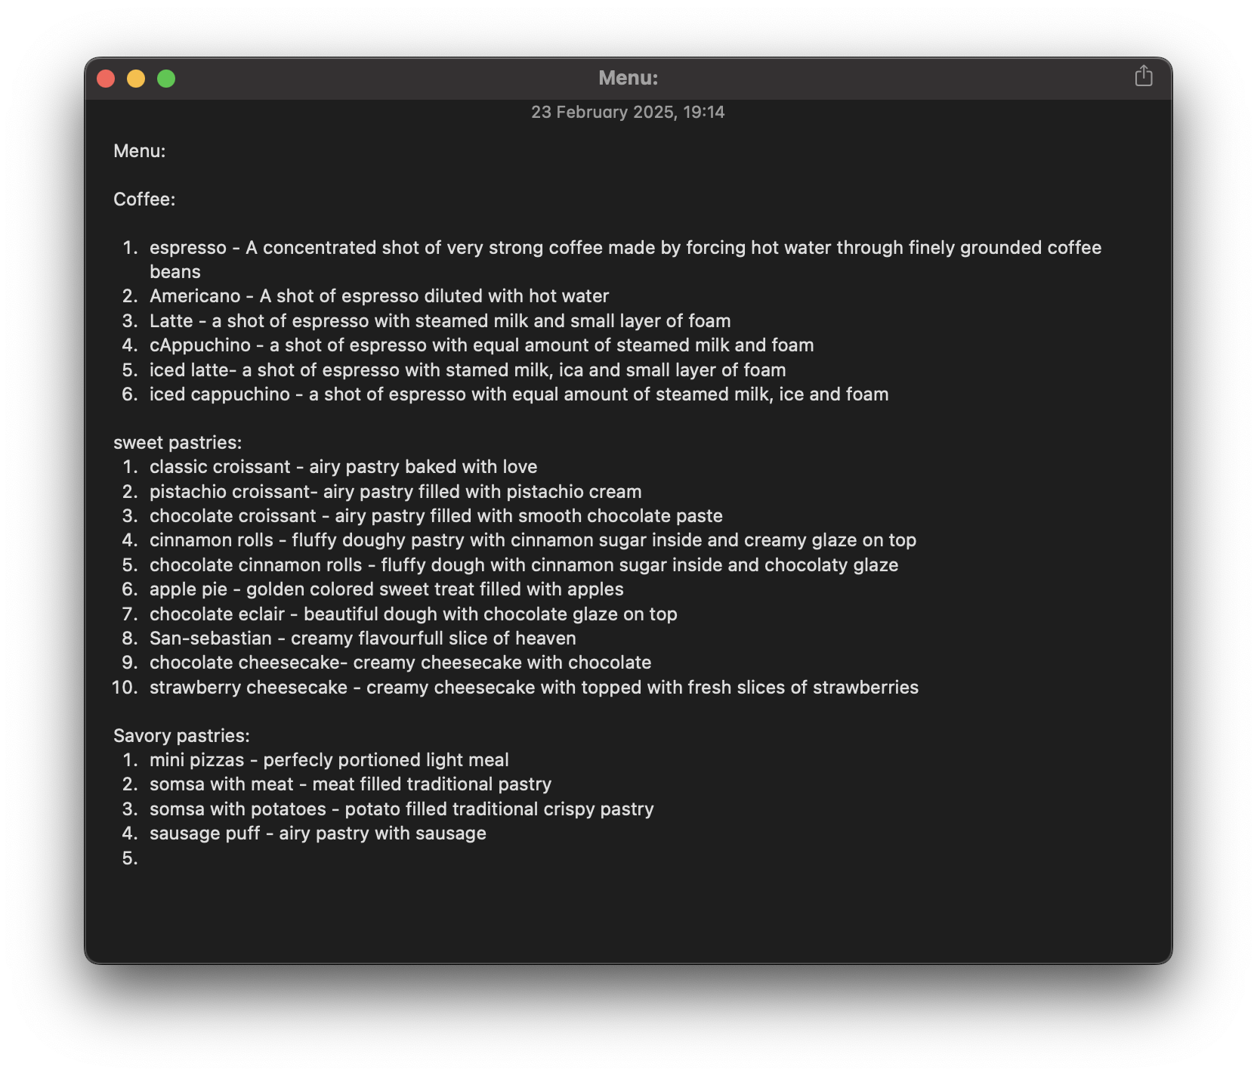

**Finalized menu of the project**