SUBMITTED BY:
DILRAG MADHURESH V
Roll No: 25MCAR0266

DECLARATION
I, DILRAG MADHURESH V, hereby declare that the project work entitled “AURA: Behavioral Biometric Stress Analyzer” is an original work carried out by me under the guidance of the Department of Computer Applications. This project has not been submitted to any other university or institution for the award of any degree.
ACKNOWLEDGEMENT
I would like to express my deep sense of gratitude to my project guide and the Head of the Department for their constant encouragement. I also thank my peers and family for their support during the development of this mini-project, which has helped me understand the intersection of Human-Computer Interaction (HCI) and Artificial Intelligence.

ABSTRACT
The AURA project is a behavioral biometric system designed to detect human stress levels through non-invasive keystroke dynamic analysis. In the modern era of high-pressure digital environments, monitoring mental well-being is crucial. AURA utilizes a heuristic algorithm to analyze typing speed, error rates, and cognitive latency to categorize a user’s mental state into four zones: Zen, Balanced, Agitated, and Burnout. The system further provides a "Recovery Protocol" using physiological grounding techniques to help users mitigate stress in real-time.
TABLE OF CONTENTS
- Introduction
- Literature Survey
- System Requirements
- System Design & Architecture
- Implementation & Code
- Results & Discussion (With Screenshots)
- Conclusion & Future Scope

1.1 Background
Affective Computing is a branch of AI that deals with the recognition and interpretation of human emotions. While traditional methods rely on heart rate or facial recognition, "Keystroke Dynamics" offers a silent, non-invasive alternative.
1.2 Problem Statement
With the rise of remote work and digital burnout, there is no simple way for users to self-assess their stress levels while working. Existing tools require wearable hardware. AURA solves this by using the keyboard—the primary input device—as a sensor.
1.3 Objectives
- To develop a web-based interface for capturing biometric typing data.
- To implement a Stress Index (SI) algorithm based on neuromotor noise.
- To provide automated, tiered health recommendations based on data.

2.1 Keystroke Dynamics
Every individual has a unique typing rhythm. Under stress, the Sympathetic Nervous System triggers "Neuromotor Noise," which causes:
- Increased error rates (Loss of fine motor control).
- Inconsistent flight time (The time between key presses).
2.2 The Heuristic Logic
The system uses the formula:
$$SI=(Errors×8)+(WPM/1.8)$$
This formula balances "Accuracy" against "Throughput." A high WPM with high errors indicates a "Frantic/Agitated" state, while a moderate WPM with zero errors indicates a "Zen/Flow" state.

3.1 Tech Stack
- Language: JavaScript (frontend logic) / Java (Backend logic).
- UI Framework: Tailwind CSS for aesthetic glassmorphism.
- Architecture: Client-Server model.
3.2 Implementation Modules
- Capture Module: Monitors keydown events to trigger the high-resolution timer.
- Comparison Module: Performs character-by-character validation against the target string.
- Analysis Module: Categorizes the Stress Index into four specific psychological states.
- Recommendation Engine: Injects customized instructions into the DOM based on the result.

4.1 Input Interface
The interface was designed with a dark-mode "Glassmorphism" aesthetic to reduce visual stress during the testing phase.
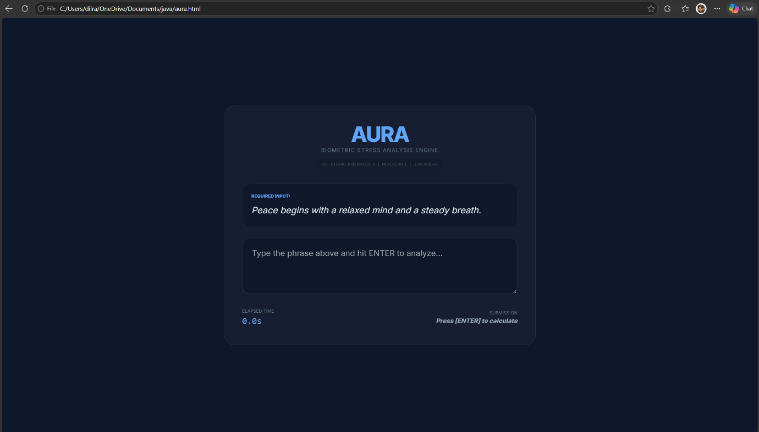

4.2 Result Analysis (Balanced State)
In the test run, a score of 31% was achieved. This indicates that the user is functional but nearing a fatigue threshold.
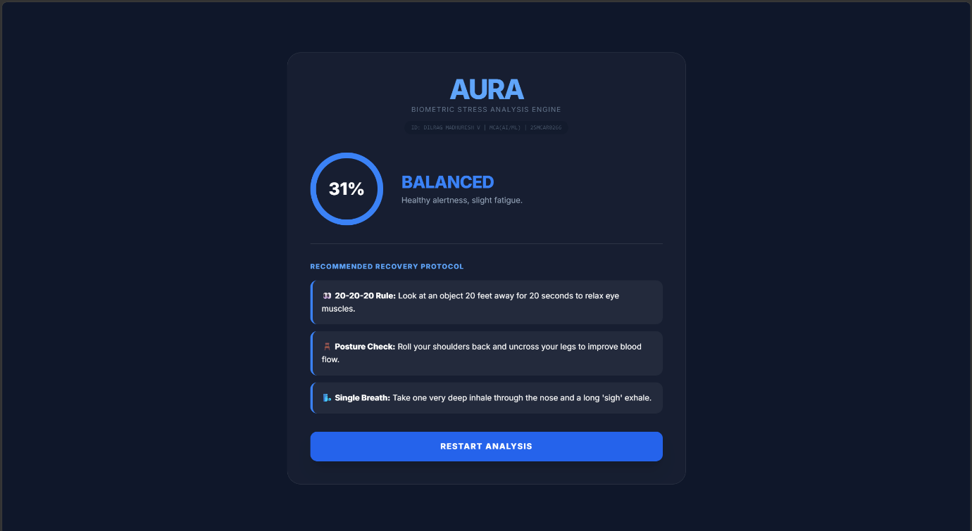
4.3 Interpretation of Recovery Protocol
For the "Balanced" state, the system suggested the 20-20-20 Rule and Posture Correction. This demonstrates the system's ability to act as a digital health coach.

5.1 Conclusion
The AURA project successfully demonstrates that software can infer human emotional states without specialized sensors. By combining MCA-level programming logic with AI-ML concepts of behavioral biometrics, we have created a tool that promotes digital well-being.
5.2 Future Scope for AI/ML Integration
- Supervised Learning: Training a Random Forest Regressor on thousands of typing samples to predict cortisol levels.
- Deep Learning: Using RNNs (Recurrent Neural Networks) to analyze typing patterns over a 24-hour period to predict burnout before it happens.
- IoT Integration: Connecting the AURA score to smart lighting (e.g., turning room lights blue when stress is high).

