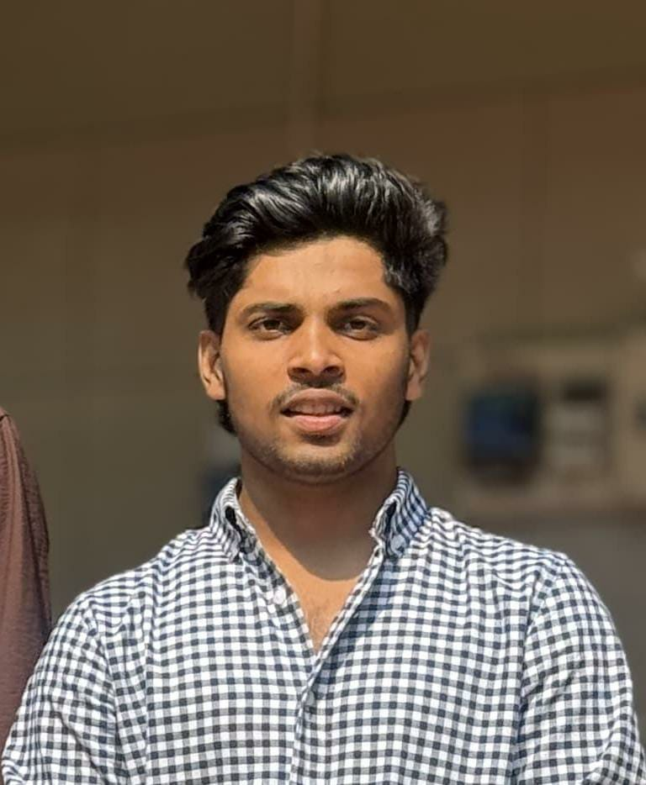 | Dilshad [Your Full Name]  Email: diludilshad1001@gmail.com  Phone: +91-9061783520  Location: Kerala, India  LinkedIn: https://www.linkedin.com/in/dilshad-mk-  Portfolio/Website: [Your Portfolio URL]

About me
Self taught MERN stack developer based in Malappuram, Kerala, curious
to learn more about developing scalable distributed systems, loves
problem solving and cares about writing readable as well as
maintainable code.

Key Skills
- Skill 1 – e.g., Frontend Development
- Skill 2 – e.g., HTML, CSS, JavaScript
- Skill 3 – e.g., Communication
- Skill 4 – e.g., Problem-solving
- Skill 5 – e.g., Teamwork / Basic German or English

Education
BSc in Computer Science
University of Calicut, Kerala, India
[September,2022] – [March, 2025]

Work Experience
Fresher

Certifications
Name of Certification – Platform or Institution, Year
E.g., "Responsive Web Design – freeCodeCamp, 2024"

Languages
- English – Proficient
- Malayalam – Native
- Hindi – Intermediate

