**Faculty Publications by Dr. ASHOKAN.C; HoD**

**WORK SHOPS CONDUCTED**

* One dayNational Workshop on **“Research Methodology”- Govt. Victoria College,** Palakkad, 27th September 2014.
* Two-day National Workshop on **“SPSS-Statistical Package for Social Science”- Govt. Victoria College, Palakkad,** 28th & 29th October 2013.

1. **ARTICLES PUBLISHED**
2. “Factors Influencing the Academic Ability of Students- An empirical study among MBA Students”- *Management Wisdom-*Volume.6, Issue 2. July-Dec 2017.pp 27-36
3. “Factors influencing the satisfaction levels of MBA Programme-An empirical study in Coimbatore”- *Organizational Management-* Vol.XXXIII.No.3 Oct-Dec.2017 pp10-15
4. “The Effects of Price on Buyers’ Product Evaluations-An Empirical Study In Health Food Drinks Among MBA Students In Coimbatore- *Organizational Management-* Vol.XXXII.No.3 Oct-Dec.2016 pp13-16
5. “Consumer Characteristics Influencing Cue Utilization Process”- *GIM Journal of Management,* Vol 6, No.1, Jan-June 2016 pp 15-18.
6. “Leadership in a VUCA World”- Proceedings of 7th International Conference on ICMUC, Kristu Jayanti College, Bangalore, 3rd & 4th April,2014.p.53
7. “Analytic Hierarchy Process: An Illustration”:-***GITAM Journal of Management***, Vol.12, Jan-March 2014, No.1pp184-193(ISSN-0972-740X)
8. “Perception of Brand, Price, Features and Product Quality, An empirical study of Trouser Brands”, ***Organizational Management***, Vol.XXIX, No.3, Oct-Dec 2013, pp19-27.(ISSN-0975-699 X)
9. “The Dimensionality of Price Perceptions: A study Among MBA Students in Coimbatore City”, SIES Journal of Management, Vol.9, Issue2, Sept’2013.
10. “Perception of Brand, Price, Features and Product Quality, An empirical study of Refrigerator Brands”, ***WIDE Spectrum Research Journal***, Vol.2, No.4, November 2013, pp15-23.(ISSN-2250-2815)
11. “Perception of Brand, Price, Features and Product Quality, An empirical study of Refrigerator Brands”, International Conference on “Contemporary Issues & Challenges Before Indian Managers and Entrepreneurs- A global Perspective”- Proceedings of the International Conference ,GRD Academy of Management, Coimbatore, p.20, (Abstract)
12. “Perception of Brand, Price, Features and Product Quality, An empirical study of Health Food Drink Brands”, Strategic Approach for Marketing Management, pp 69-75, ISBN:978-93-82338-10-9.
13. “E-Governance”- Contemporary Developments in Operations Management and Management Information Systems, Department of Management Studies, Periyar Maniammai University, Thanjavur pp.54-56.. ISBN:978-93-81583-76-0
14. “A Conceptual Model for Product Evaluation Using Cue Utilization Theory”, *GIM Journal of Management,*Vol 5,No.1,Jan-June 2010 pp 39-43
15. “Emerging Trends in Internet Marketing”, *GIM Journal of Management*,Vol.4,No.1,Jan-June 2009,pp6-13
16. “Profile and Perception of Retailer Consumers- An Empirical study in Palakkad District”, *Indian Journal of Marketing*, February, 2008, Vol.XXXXVIII,No.2,pp24-29
17. “Perceptual Mapping of Two Wheeler Brands An empirical study in Coimbatore City among MBA Students”-*The Manager Today-JOMS*, July-September 2006; Vol.1, No.3, pp 59-74
18. “Brand Equity, a Network Measurement Problem”, *Organizational Management*, Mar-June 2005 Vol XX No.2 pp 14-18
19. “Internet Business Models”- O*rganizational Management*, July-Sep’03 Vol. XIX No.2 pp 55-58
20. **PAPERS PRESENED**
21. “Big Data and Data Analytics”-National Conference on Business Solutions with Big Data Analytics, held on 19th December 2014, PSG Kishnammal College for Women, Coimbatore.
22. “Leadership in a VUCA World”- ***7th International Conference*** on ICMUC, Kristu Jayanti College, Bangalore, 3rd & 4th April, 2014.
23. “Perception of Brand, Price, Features and Product Quality, An empirical study of Refrigerator Brands”, ***International Conference*** on “Contemporary Issues & Challenges Before Indian Managers and Entrepreneurs- A global Perspective”- GRD Academy of Management, Coimbatore on Feb 6, 2013
24. “Perception of Brand, Price, Features and Product Quality, An empirical study of Health Food Drink Brands”, ***International Conference*** on “Synchronizing Management Theories and Business Practices: Challenges Ahead”, Annamalai University, 27-29th July 2012.
25. “E-Governance”- Contemporary Developments in Operations Management and Management Information Systems, Department of Management Studies, Periyar Maniammai University, Thanjavur on 12th May’2012.
26. “Intelligent Agents”- National Seminar on Innovative Strategies for Global Competitiveness”, RVSIMS, Coimbatore on 11th Feb’ 2012.
27. “Internet Privacy”-National Conference on Global Recession & Recovery, Karpagam University, 28th October’ 2011.
28. "Perception of Brand, Price, Features and Product Quality", an empirical study in Health Food Drink Brands.-National Conference on The Rise of Indian Brands- SRM University, Chennai, 8th & 9th September 2011.
29. “Segmentation, Targeting & Positioning for Online Consumers”-National Seminar, Sri Ramakrishna Engineering College, Coimbatore-March 25, 2011.
30. “A Conceptual Model for Product Evaluation Using Cue Utilization Theory”-National Conference on Marketing, 19-20 November 2010, Saintgits Institute of Management, Kottayam.
31. “Emerging Trends in Internet Marketing”-Regional Seminar on Emerging Paradigms in Management Practice-October 16 2007, GIM, Coimbatore.

**8.0 CASE STUDY PUBLISHED**

1. “TheMD’s Dilemma”, *GIM Journal of Management*, Vol.1, No.1, July-Dec 2006, pp70-72.

**9.0 BOOK REVIEWS DONE**

1. “Brand Positioning- Strategies for Competitive Advantage” *GIM Journal of Management*, Vol.1, No.1, July-Dec 2006, pp73-75.
2. “Retail Strategies: Understanding Why We Shop”, *GIM Journal of Management*, July-Dec 2011.

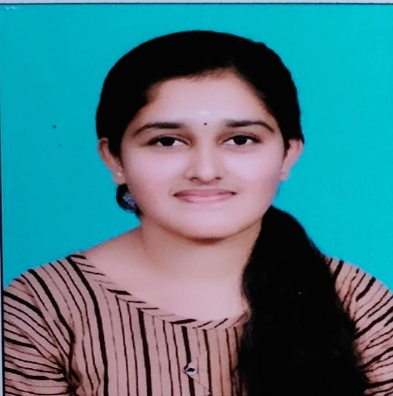

**AISWARYA V**

**MBA (First year)**

I am Aiswarya.v I am pursing MBA in JAWAHARLAL BUSINESS SCHOOL LAKKIDI. @ JAWAHARLAL COLLEGE OF ENGINEERING AND TECHNOLOGY LAKKIDI. I have my studying in my college for 9 months. I have classes through online during this pandemic situation. I went to my college in several times. During the period in our college is very helpful and worthy to help this online classes. All the online classes are very helpful and create us to studying more through online. All the study in this college is worth and time value for money. We are looking forward to attend the offline classes.



I’AJMI PT, I’m currently pursing my MBA in Jawaharlal Business School. This is an unprecedented time, with so much uncertainty, but I also think this is a great opportunity to really immerse into learning and bettering ourselves. Jawaharlal Business School has developed the overall personality of the students boosted confidence in them and provides with the wide knowledge. Personally I was very impressed with the quality of the teaching faculty support and mentors take care of mentees with the dedication. Thank you for being the place where I discovered myself and become best version of myself.

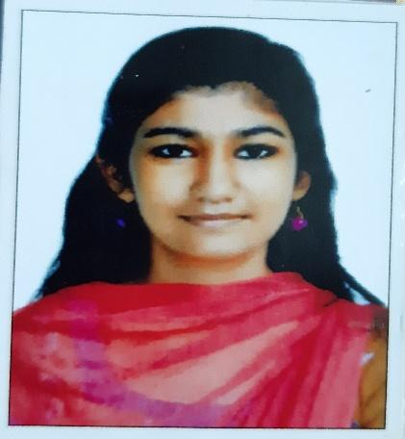

I’m AMRITHA C JOSEPH. I’m currently pursing my MBA in JAWAHARLAL BUSINESS SCHOOL . I have been studying in this college for about 9 months. In this short time this college has become a really important part of my life. I have had my classes in the online sessions due to the covid19. I went to the college a couple of times. The infrastructure is really beautiful. We have all sorts of facilities there. The faculties in the college are really helpful. Teachers are highly qualified and teach very efficiently. They continuously support and encourage us.  Even during online classes, the teachers have not only helped us with their best of providing us all sorts of knowledge but have also tried to be there for us in our personal needs also. All over to study in this college is worth the time and value-for-money. I’m looking forward in attending the offline classes soon.



My name is Arjun Dev A. I am currently pursuing my Master of Business Administration degree from Jawaharlal Business School. From the time of joining till now, the college has impressed me with the level of care and support they provide. The faculty has a lot to offer and is very willing to teach us the ropes of management. Even though I have only been to the college for a fortnight or so, I have fallen in love with all the facilities the campus has to offer and also the atmosphere is very much suitable for studying and personal growth. In short, this college is perfect for all those aspiring to be future managers.



I’m Sreehari.k. I’m currently pursing my MBA in Jawaharlal Business School. I have been studying in this college for about 9 months. In this short time this college has become a really important to me. I have had my classes in the online sessions due to the pandemic. I went to the college a couple of times. The infrastructure is really amazing. We have all sorts of facilities there. The faculties in the college are really helpful. Teachers are highly qualified and teach very efficiently. They continuously support and encourage us.  Even during online classes, the teachers have not only helped us with their best of providing us all sorts of knowledge but have also tried to be there for us in our personal needs also. All over to study in this college is worth the time and value-for-money. I’m looking forward in attending the offline classes soon.