LOGHAWK

Hawk Console
Beginner guide to the four pane terminal RAG commands tasks and collectors
A step by step guide for first time users
Windows • Linux • macOS

What Hawk Console is
Hawk Console is a standalone terminal application for operational guidance and root-cause analysis. It combines LLM chat, two command terminals, and an editor. It can run signed in through the LogHawk API or in local mode with Console-local data.
Keep execution under your control. Review /command proposals and local scripts before confirming them. Signed-in AI collectors follow approved versions and execution policies; Auto-Approved collectors can run without confirmation when input review is unchecked.

Step 1 Install Hawk Console
From the repository root, run the setup script for your operating system. It creates a separate Hawk Console Python environment, installs Console dependencies, sets up Console LanceDB, and prepares the tools environment used for local task and collector runs.

Windows
.\firsttime_setup_hawkconsole.bat
.\venv_hawkconsole\Scripts\Activate.ps1

Linux and macOS
bash firsttime_setup_hawkconsole.sh
conda activate venv_hawkconsole
If conda is unavailable in a new shell, initialize the Miniforge shell using the command printed by setup, then activate venv_hawkconsole. Windows uses a repository-local environment; Linux/macOS uses the named Conda environment. Setup also invokes setup_tools for venv_tools.

Step 2 Choose a mode and start

Signed In Mode
hawk
Signed-in mode connects to the authenticated LogHawk API. The API server must be running, and LH_API_SERVER_URL in .env must be reachable from this computer. Sign in with your LogHawk account. The initial Administrator account is user ID admin and password admin; change it in Web UI Account Settings.

Local mode
hawk --local
Local mode skips sign-in and uses Console-local SQLite and LanceDB. Its chat, RAG index, tasks, and history are separate from signed-in server data.
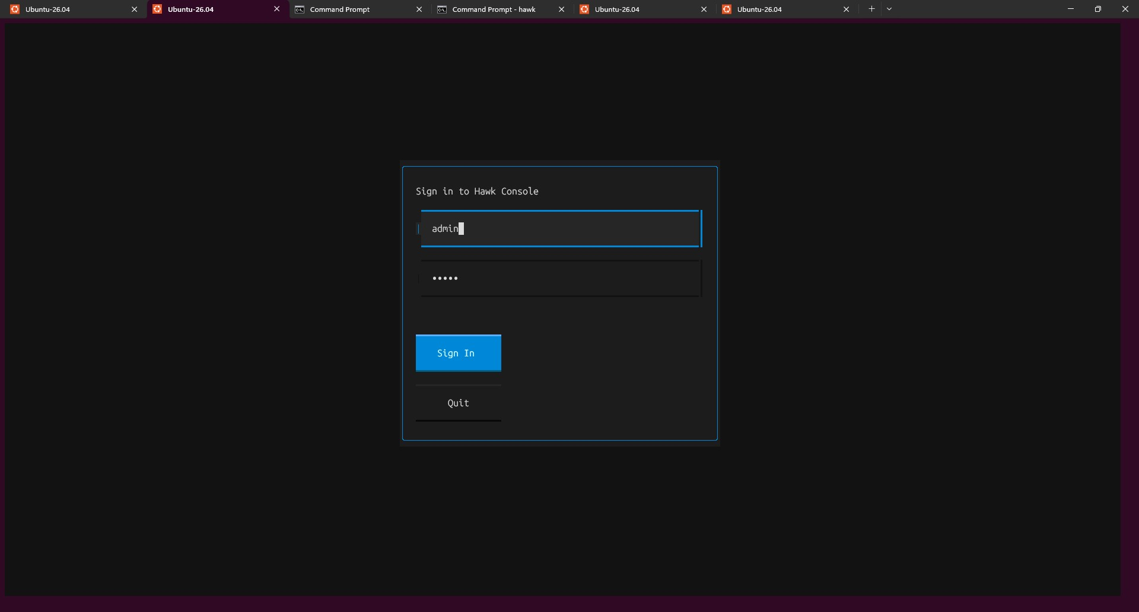
Hawk Console sign-in screen.

Step 3 Understand the four panes
The upper-left pane is the AI/LLM Terminal. The two panes below it are Command Terminal 1 and Command Terminal 2. The Editor on the right spans the height of all three terminals.
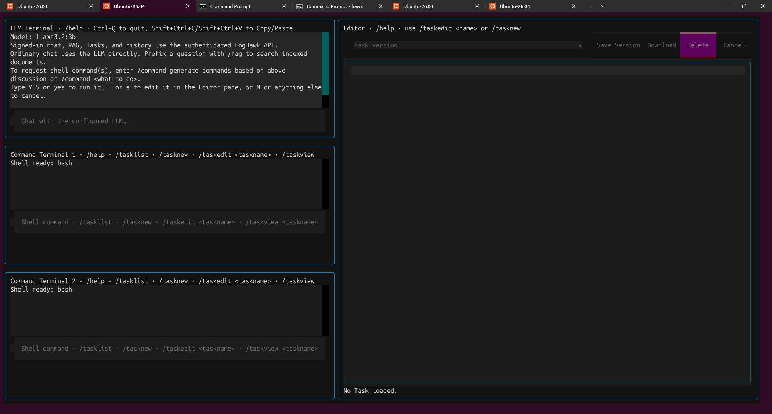
Hawk Console four-pane layout.
- AI/LLM Terminal — ordinary chat uses the configured LLM. Prefix a prompt with /rag to search indexed documents, or use /command for shell-command suggestions.
- Command Terminals — enter shell commands or Console commands. Choose the shell type configured for your operating system.
- Editor — inspect/edit task artifacts, review command proposals, manage versions, and read mirrored command output.
Keyboard: Ctrl+Q exits. Shift+Ctrl+C and Shift+Ctrl+V copy and paste.

Step 4 Chat RAG and command suggestions

Ordinary chat
Type a question in the AI/LLM Terminal to chat with the configured LLM. The response is guidance; it does not run shell commands by itself.

Ask indexed documents with /rag
/rag What do my uploaded documents say about kubectl?
/rag tell me about "CH.pdf"
/rag compare "CH.pdf" and "Science and Sports (Ch 5 to 8).pdf"
Use /rag followed by your question. Put double quotes around filenames that contain spaces. Signed-in mode searches the server index; --local searches the Console-local index.

Upload a file or crawl a website
/ragupload /mnt/c/Users/ACER/Downloads/CH.pdf
/ragupload "/mnt/c/Users/ACER/Downloads/Science and Sports (Ch 5 to 8).pdf"
/ragscrape https://example.com/
Run /ragupload or /ragscrape in Command Terminal 1 or 2. Wait for a completion or error message. Put double quotes around paths with spaces. Duplicate indexed content may be skipped.

Generate shell commands safely
/command generate commands based on above discussion
/command list Kubernetes nodes and show pod status
Review the proposal. Type YES or yes to run it in Command Terminal 1. Type E or e to edit it in the Editor; confirm the edits and review the updated proposal. Type N or anything else to cancel. Read the command before confirming.
When editing a /command proposal, Quick Save can create or version a Task. Enter its name, artifact type, and category, then select Quick Save. Python syntax is checked when saved. Quick Save does not execute the command; Confirm Changes returns it for YES/yes execution confirmation.
Use Up and Down in a Command Terminal to recall persisted command history, edit the command, and submit it. Signed-in history is saved through the API; local history uses Console storage.

Step 5 Tasks create edit and run

Create and manage tasks
/tasknew
/tasklist
/taskedit "task name"
/taskview "task name"
/taskdelete "task name"
In the Editor, set a task name, description, category, artifact type, task kind, and execution policy. Chat with the LLM to draft code, review it, then choose Save Version. Changes are not saved automatically. Each saved version is immutable; save edits as a new version.
- Artifact types include Python, Bash, PowerShell, Windows CMD, and n8n workflow JSON.
- Task kinds include General, Remediation, Rollback, and Collector.
- Execution policies are Manual, AI-Assisted, Auto-Approved, and Disabled. Signed-in AI collector execution is available when enabled on the API server. General, Remediation, and Rollback Tasks are not automatically executed by the RCA collector dispatcher.

Local development run versus API run
/taskrun "task name"
/task "task name"
/taskrun loads the latest saved version, asks for confirmation, then runs it locally in a Command Terminal. It is intended for development and debugging; it does not require approval or enabled status. Run only code you trust.
/task is the signed-in API run path. It uses the server-side runner and requires an approved and enabled version. n8n JSON is not executed by Hawk Console; import it into a customer-managed n8n instance.

Step 6 Collectors view and run
/collectlist
/collectview prometheus-query
/collect prometheus-query {"query":"up"}
/collectrun prometheus-query {"query":"up"}
/collectlist and /collectview show available collectors and their descriptions/arguments. /collect calls the authenticated API; custom collector Tasks must be approved and enabled. /collectrun runs locally in a Command Terminal for development and testing without approval or enabled status. Output is also shown in the Editor.
Arguments: If a collector expects arguments, pass a JSON object after its name and keep the braces and quotes intact.

Roles and version controls
These permissions apply to signed-in server operations. The owner is the user who created the Task. Administrator access does not bypass approval, enablement, or execution policy.
Capability | Administrator | Power User | User
Create Tasks and Collectors | Yes | Yes | Yes
Edit or delete a Task or version | Any Task | Any Task | Own Tasks
Approve Version | Yes | Yes | No
Enable or disable a version | Any Task | Any Task | Own Tasks
Set Manual AI-Assisted or Disabled policy | Any Task | Any Task | Own Tasks
Set Auto-Approved policy | Yes | Yes | No
Run approved enabled versions through API | Yes | Yes | Yes
Create and delete users | Yes | No | No
Change own password | Yes | Yes | Yes
For built-in collectors, all three roles can enable or disable a collector. Only Administrators and Power Users can change its approval or execution policy.
1. Save the artifact and select its version. A new version starts unapproved and disabled.
2. An Administrator or Power User reviews the code and argument schema, then selects Approve Version.
3. An Administrator, Power User, or Task owner selects Enable Version. Both approval and enablement are required for API execution.
4. Choose an appropriate execution policy. Saving edited code or schema creates a new version; approval and enablement do not carry over.

Execution policies
Policy | Human API request | AI collector request
Manual | Allowed if approved and enabled | Not offered to AI
AI-Assisted | Allowed if approved and enabled | Human confirmation required
Auto-Approved | Allowed if approved and enabled | Automatic unless argument review is selected
Disabled | Blocked for every role | Not offered to AI
Typing /task or /collect is an explicit human request; Manual policy does not add another Yes/No prompt. AI tool calling currently executes eligible Collectors. General, Remediation, and Rollback Tasks are not executed automatically by the RCA collector dispatcher.
Local /taskrun and /collectrun are for development and debugging. They require Y/N confirmation but do not require server approval or enablement.

Define input arguments
Arguments schema JSON is optional for every task kind and is saved with the artifact version. A schema defines allowed argument names, types, and required fields. Blank or {} is saved as the explicit no-arguments schema below; it accepts {} and rejects extra fields.
{
"type": "object",
"properties": {},
"required": [],
"additionalProperties": false
}
For a Prometheus collector that needs a query, use this schema before saving and approving the version:
{
"type": "object",
"properties": {
"query": {"type": "string", "minLength": 1, "maxLength": 2000}
},
"required": ["query"],
"additionalProperties": false
}
Python scripts receive the validated JSON through the environment:
import json
import os
arguments = json.loads(os.environ.get("LH_RUNNER_ARGUMENTS_JSON", "{}"))

Investigate with AI assisted RCA
RCA means root-cause analysis. Ask a concrete operational question, let the model discover an eligible collector, review the proposed arguments, and inspect the evidence returned by deterministic execution. An AI explanation is an interpretation of evidence, not proof that an action ran.

Prepare a collector
1. Have an Administrator configure the API server LLM settings in .env and connector access in .env_tools. The API host must be able to reach Prometheus, Kubernetes, or Jira as applicable.
2. In the Web UI, open Tasks & Collectors > Built-in Collectors. Built-ins are separate from user-created Collector Tasks. Initial built-in registration is approved and enabled with Manual policy.
3. An Administrator or Power User selects AI-Assisted or Auto-Approved policy. For a custom collector, save a description and argument schema, then approve and enable the latest version. AI discovery does not fall back to an older version when the latest is ineligible.
Built-in collector | What it reads
prometheus-query | An instant PromQL query
kubernetes-pods | Pod names and status in a namespace
jira-issue-search | Jira issues matching a JQL search

Run your first investigation
1. Start Hawk Console with hawk, sign in, and use the AI/LLM Terminal.
2. Leave Review Input Args checked in the Editor area.
3. Send the example below. When input review appears, inspect the exact collector version and JSON arguments. Use query up for a simple Prometheus connectivity check.
4. Edit arguments if needed, then choose Confirm & Execute, or choose Cancel. This reviews the inputs only; it does not approve the collector code.
5. Wait for the server-reported result. Inspect the collector name, version, status, run ID, arguments, and evidence before relying on the explanation.
Use the Prometheus collector to query Kubernetes metrics.

Example input arguments:
{"query":"up"}
Invalid arguments are rejected against the saved schema and can be corrected before confirmation. Unchanged masked values retain their original server-side values. A metric value of 1 for kube_pod_info is metadata; it does not establish that a pod is healthy or ready.
Review Input Args | Auto-Approved policy | AI-Assisted policy
Checked | Edit inputs then confirm or cancel | Edit inputs then confirm or cancel
Unchecked | Executes automatically; inputs appear with result | Still requires confirmation; inputs are read-only
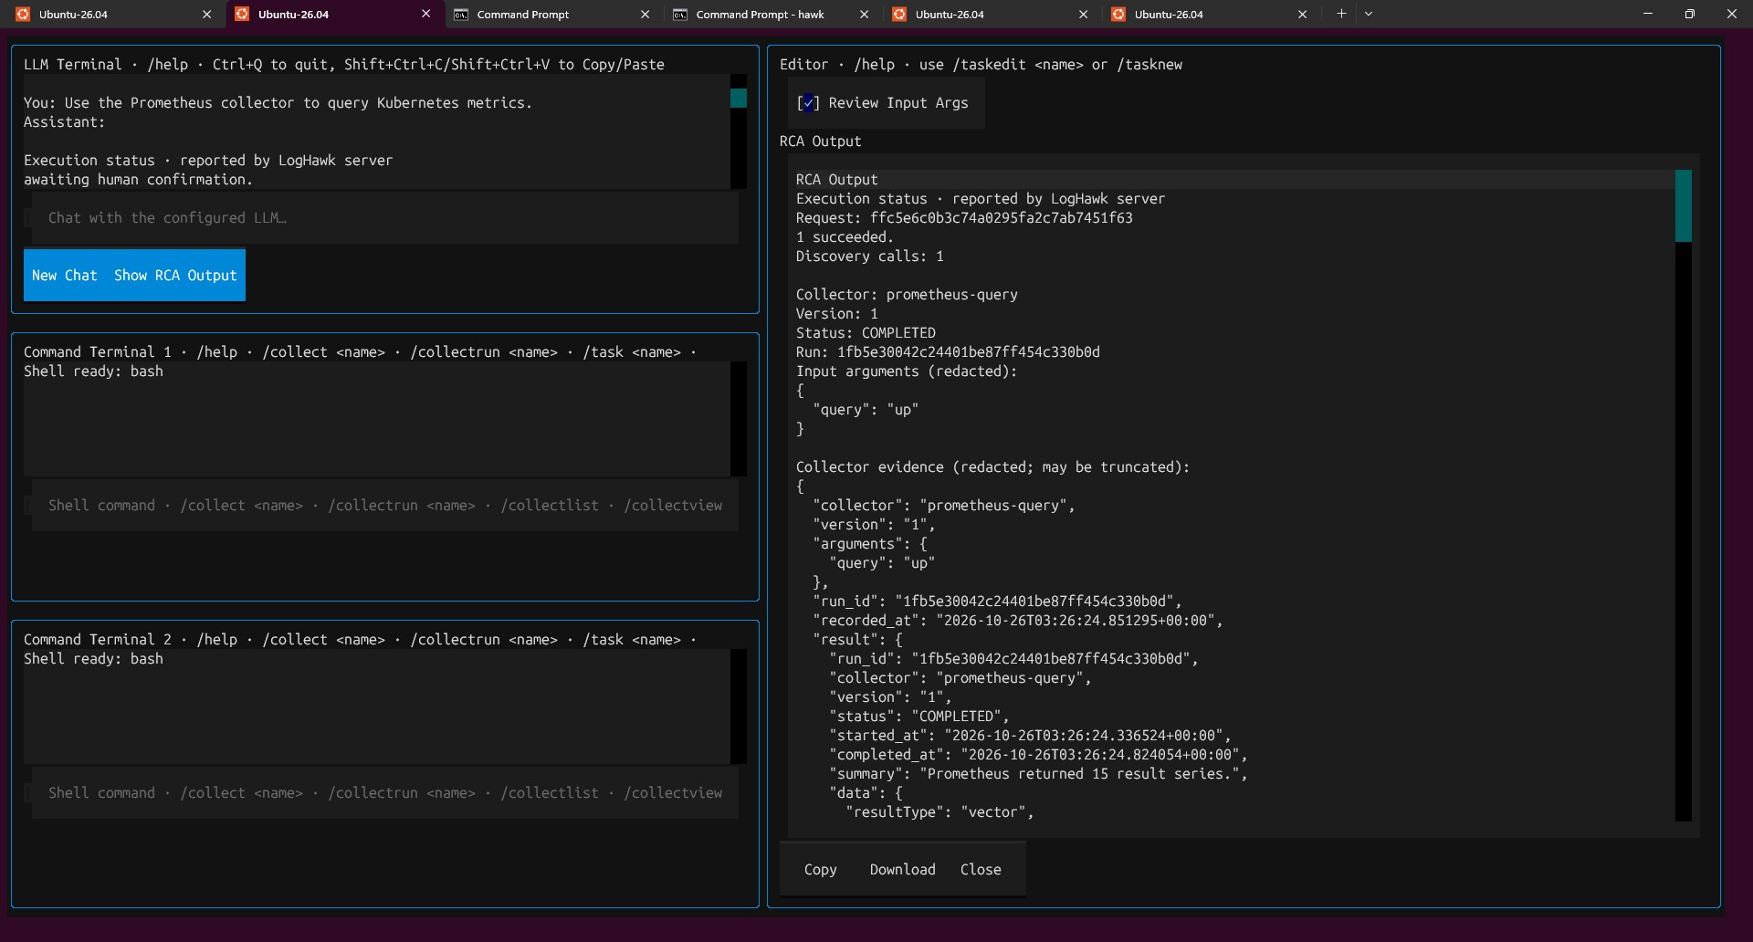
RCA with input review, example 1. Compare the displayed inputs and server status with your own request; example names and results vary.
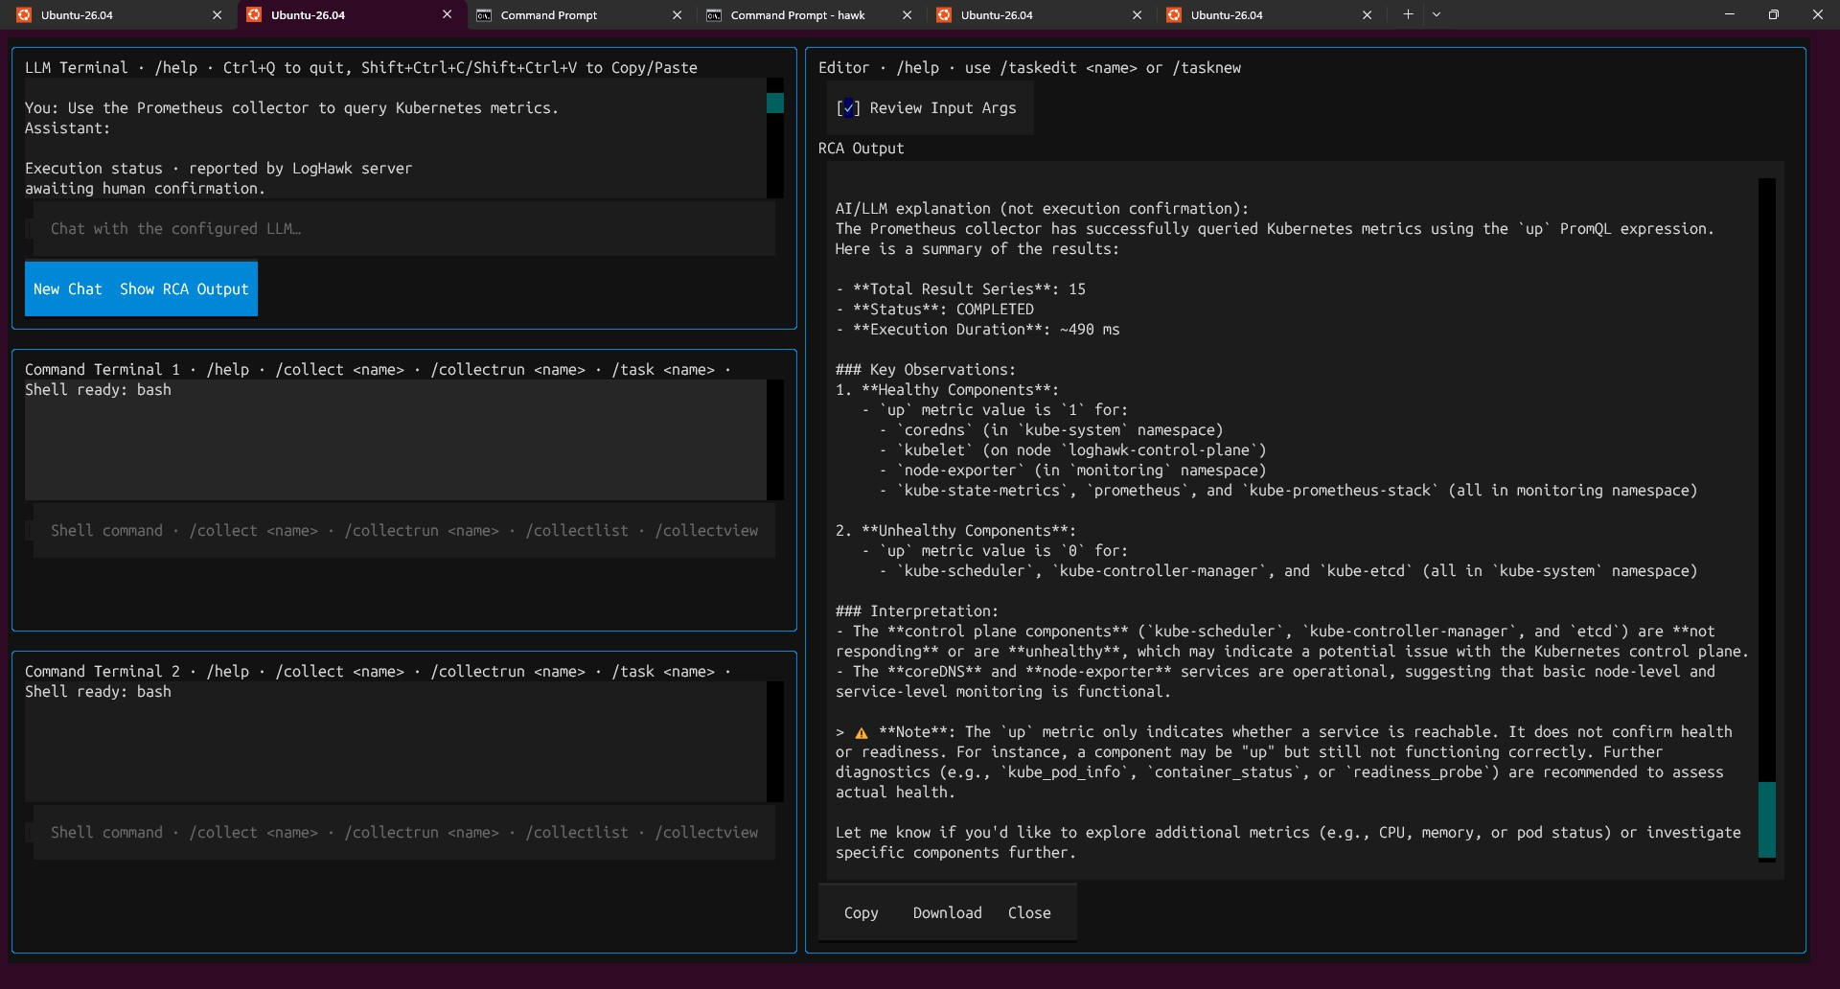
RCA with input review, example 2. Compare the displayed inputs and server status with your own request; example names and results vary.

Use automatic collector execution
Use this option only for a collector whose saved version is approved, enabled, and has Auto-Approved policy. Clear Review Input Args before sending the request. The server displays the arguments with the result. Clearing the checkbox does not override an AI-Assisted policy, which still requires confirmation.
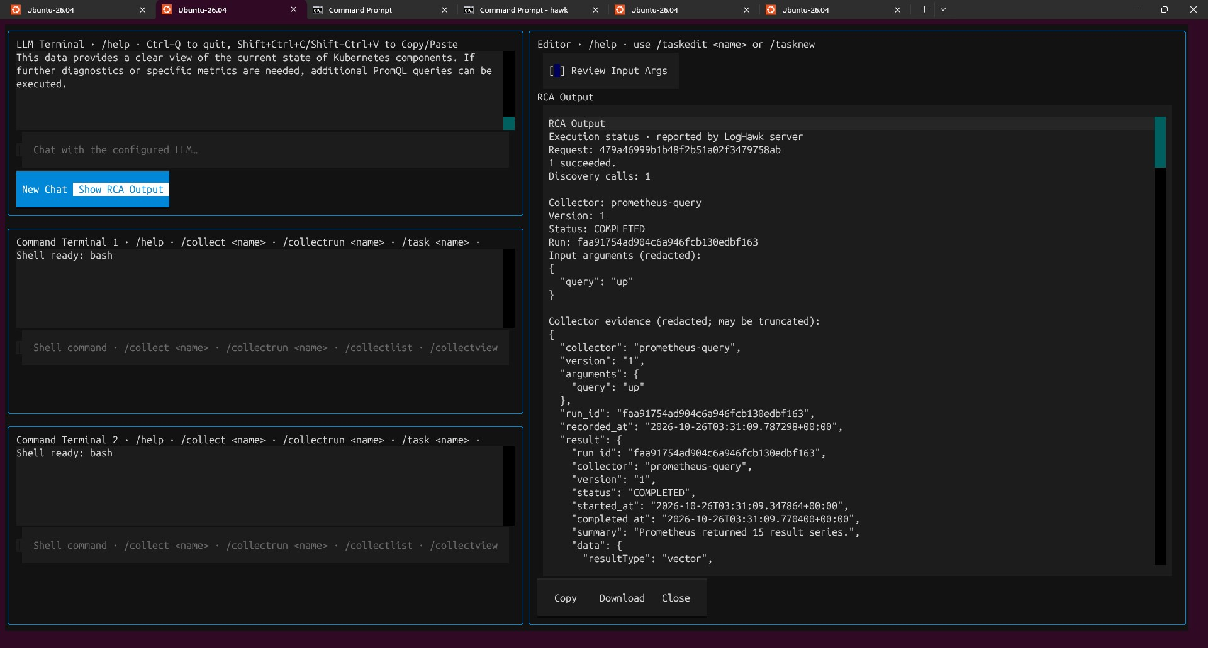
Automatic RCA example 1. Read the recorded execution outcome before interpreting the model response.
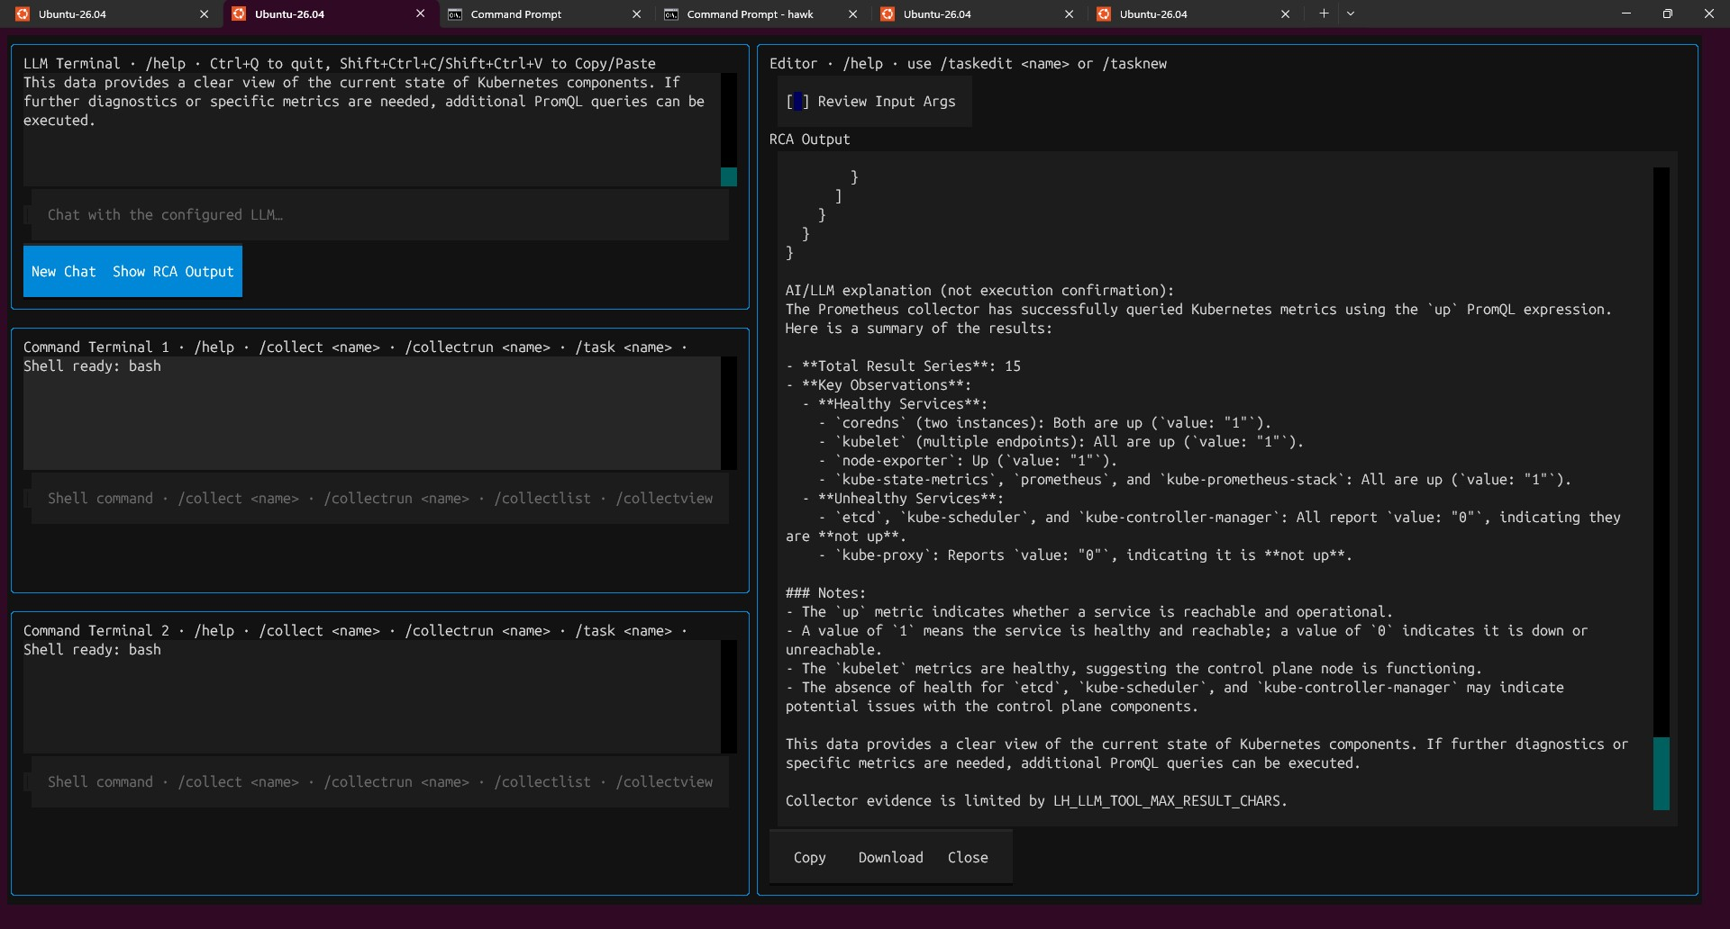
Automatic RCA example 2. Read the recorded execution outcome before interpreting the model response.

Read evidence and start a new conversation
Select Show RCA Output to display the current RCA result in the Editor. Use Copy or Download to retain it, and Close to return to your work. New Chat clears the active conversation context; it does not delete stored history. Saved conversations are not automatically replayed into a new RCA session.
The server status is authoritative. A model statement such as "proceeding with execution" does not mean a collector ran. A completed collector can still be followed by a failed AI explanation.
Redacted means sensitive values such as credentials and tokens are masked. Compacted means repeated details have been reduced. Truncated means some content was omitted. Saved returned evidence is separate from the smaller model input; collectors may themselves limit the number of records returned.
AI audit records retain origin=AI, origin_userid for the signed-in user, and origin_software=web or console. Explanation attempts are recorded separately from execution outcomes.

Retry an explanation without running the collector again
1. If execution says COMPLETED but the explanation fails or times out, inspect the saved evidence first.
2. In RCA Output, select Retry AI Explanation.
3. Wait for a new explanation based on the saved question and evidence. The retry does not rediscover or rerun collectors.
4. If it fails again, check model availability and the separate explanation timeout. Only requests with saved explanation context support this retry.
The API checks request ownership and prevents concurrent active explanation retries. Each retry has its own time budget and audit record. Do not resubmit the original collection request merely to retry an explanation.

Configure the model and time budgets
Set these values in the API server .env file. This is an example configuration, not a requirement that every machine use the same model or context size. A reasoning model can take longer to produce an answer; choose a model and context size that fit the available hardware.
LH_LLM_TOOL_CALLING_ENABLED=true
LH_LLM_TOOL_MODEL=qwen3:4b-instruct
LH_LLM_TOOL_CONTEXT_LENGTH=8192
LH_LLM_TOOL_MAX_TOKENS=1024
LH_LLM_TOOL_MAX_CALLS=3
LH_LLM_TOOL_TIMEOUT_SECONDS=300
LH_LLM_TOOL_EXPLANATION_TIMEOUT_SECONDS=180
LH_LLM_TOOL_MAX_RESULT_CHARS=6000
Setting | Meaning
Tool model | Uses the configured LiteLLM provider and base URL. Task drafting can use LH_LLM_CODEASSIST_MODEL separately.
Context length and maximum tokens | Bound model input/output and generation length. Larger budgets can increase memory use and latency.
Maximum calls | Includes collector discovery as well as execution tool calls.
Tool timeout | Shared discovery/execution processing budget; human confirmation wait is excluded. Code default: 120 seconds.
Explanation timeout | Additional, independent budget for final explanation and each retry. Code default: 180 seconds.
Maximum result characters | Bounds model-facing result and discovery text; it is not a guarantee of unlimited source evidence.
Restart the API after changing its .env settings. Restart Hawk Console after changing its local configuration so its HTTP timeout accounts for both budgets. Final explanation uses a separate model call without execution tools. Transport retries are disabled for this flow; bounded correction of narration into a tool call is not a collector execution retry.

Command reference
Command | Where | Purpose
/help | Any terminal | Show command reference in Editor
/rag question | AI/LLM | Search indexed documents
/command request | AI/LLM | Draft commands for review and optional Quick Save
/tasknew | Command 1 or 2 | Create a Task; choose any task kind
/tasklist | Command 1 or 2 | List Tasks with type category and user ID
/taskedit name | Command 1 or 2 | Load editable Task and version controls
/taskview name | Command 1 or 2 | Alias for /taskedit
/taskdelete name | Command 1 or 2 | Delete a Task after confirmation if permitted
/task name {JSON} | Command 1 or 2 | Signed-in approved enabled API run
/taskrun name {JSON} | Command 1 or 2 | Local development run after Y/N
/collectlist | Command 1 or 2 | List available collectors
/collectview name | Command 1 or 2 | Inspect builtin or open custom collector editor
/collect name {JSON} | Command 1 or 2 | Signed-in approved enabled API collector run
/collectrun name {JSON} | Command 1 or 2 | Local collector development run after Y/N
/collectenable name | Command 1 or 2 | Enable collector if permitted
/collectdisable name | Command 1 or 2 | Disable collector if permitted
/collectpolicy name policy | Command 1 or 2 | Set permitted execution policy
/ragupload path | Command 1 or 2 | Index file or folder
/ragscrape URL | Command 1 or 2 | Crawl and index website content
Use /tasknew with Task kind Collector to create a custom collector. /collectview opens its task editor; /collectrun uses the same local execution path as /taskrun. Quote names and paths containing spaces. Pass JSON arguments matching the saved schema.
/collect prometheus-query {"query":"up"}
/collectrun kubernetes-pods {"namespace":"monitoring","limit":20}
/taskrun "My Task" {}

Execution host and tools environment
/task and /collect execute on the API server host. /taskrun and /collectrun execute on the computer running Hawk Console. Python uses venv_tools; Bash, PowerShell, and Windows CMD need their corresponding interpreters. Windows CMD requires Windows. Scripts receive arguments through LH_RUNNER_ARGUMENTS_JSON. n8n JSON is not run by these commands.
Configure .env_tools on the execution host. For missing Python dependencies, update requirements_tools.txt and rerun setup_tools.bat or setup_tools.sh on that host. A localhost address refers to the execution host, so a service reachable from your laptop may not be reachable from a remote API server.

Know which data store you are using
Operation | Signed-in mode | Local mode
Startup | hawk and sign in | hawk --local
Task and history database | LH_SERVER_DATABASE_URL | LH_CONSOLE_DATABASE_URL
RAG path | LH_SERVER_LANCEDB_FILE_PATH | LH_CONSOLE_LANCEDB_FILE_PATH
RAG table | LH_SERVER_LANCEDB_TABLE_NAME | LH_CONSOLE_LANCEDB_TABLE_NAME
Chat and Task operations | Authenticated API | Local services and configured LLM
Set LH_API_SERVER_URL in .env to the API address reachable by this Console. LH_API_SERVER_BIND_URL controls where the API listens and may differ from the client URL. In signed-in mode, chat, RAG, Tasks, and history use authenticated API calls. Local task execution remains local in either mode.

Step 7 Help and safe working habits
/help
- Enter /help in any of the three terminals. The Editor displays command names, parameters, allowed terminals, and descriptions, including RAG duplicate handling. Select Close to clear the help pane.
- Check whether you are signed in or using --local; the two modes use different data stores.
- Treat AI-generated commands and scripts as untrusted until you review them.
- Use /taskrun and /collectrun for local development. Use signed-in API commands for approved operational execution.
- For tasks that change systems, document scope, preconditions, expected results, and rollback steps.
Configure and schedule Pipelines through the LogHawk Web UI and the CronJob launcher. You can use the same Config Set for Train-only and Detect-only pipelines, with separate training and detection inputs and the same RustFS/Internal S3 output bucket and batch folder. See the LogHawk Web UI Beginner Guide for the steps.

Step 8 Troubleshooting
Sign-in cannot reach the API. Start the API service, check LH_API_SERVER_URL in .env, and confirm it is reachable from Hawk Console.
The task list is empty. Check the mode. Signed-in mode reads server-backed tasks; --local reads Console-local tasks.
An API run is rejected. Confirm you are signed in and that a custom version is approved and enabled. Check that required arguments are valid JSON.
A local Python run reports a missing import. Run Hawk Console setup again so the tools environment is installed. Add script dependencies to requirements_tools.txt where appropriate.
RAG cannot find a document. Confirm indexing completed in the same mode you are querying. Ask a focused question and quote filenames with spaces.
A shell command behaves unexpectedly. Check the OS and shell used by the Command Terminal. Bash, PowerShell, and Windows CMD syntax differs.

