How to Schedule LogHawk Pipelines
A beginner guide to scheduled detection and incident email delivery
LogHawk • 29 October 2026
This guide walks you through creating a saved Pipeline, running it manually, scheduling it every 15 minutes and receiving incident results by email. The main example uses Linux or WSL Ubuntu with cron. Separate instructions cover macOS and Windows Task Scheduler.
Use the existing run_pipeline_email.sh launcher and loghawk.admin.pipeline_cron module. A schedule starts the saved Pipeline through the authenticated LogHawk API; the Temporal worker performs the processing. The scheduler does not replace the worker or start LogHawk services.
Read sections 1–7 before enabling a schedule. Commands are examples for you to adapt; no schedule or Pipeline was executed while this guide was prepared.

1 Understand the pieces
Term | Meaning
Config Set | Stores the Train and Detect source locations and processing output bucket/batch.
Saved Pipeline | Has a name, a Config Set and a mode: Train only, Detect only, or Train & Detect.
cron | An operating-system scheduler. It starts a command at specified times.
Launcher | run_pipeline_email.sh supplies settings and invokes the Python module.
API and Temporal | The API authenticates the request and starts the workflow. Temporal coordinates processing performed by the worker.
Incident output | A Parquet object read from internal S3 and converted to a CSV email attachment.

cron or Task Scheduler
-> LogHawk pipeline email runner
-> authenticated API -> Temporal workflow -> worker
-> poll completion -> read internal S3 output -> send email
The browser does not need to remain open. The API, Temporal server, worker, storage and email server must remain reachable. This is an operating-system scheduled job, not a Kubernetes CronJob resource.

2 Plan training and scheduled detection
- Create a Config Set whose Train sources contain representative QA, UAT or Pre-Prod data and whose Detect sources contain Production data.
- Create a Train-only Pipeline using that Config Set. Configure its processing output to save trained ML models in the chosen RustFS/Internal S3 bucket and batch folder.
- Run the Train-only Pipeline once and check successful completion.
- Create a Detect-only Pipeline using the same output bucket and batch so it can use the trained models. You can use the same Config Set for both Pipelines.
- Run detection manually and inspect its results before scheduling it every 15 minutes.
Example setting | Value or choice
Config Set name | production-observability
Train-only Pipeline | baseline-train
Detect-only Pipeline | pce3
Processing output | s3://loghawk-data/somefolder/
Incident object | s3://loghawk-data/somefolder/incidents/correlated_incidents.parquet

Use training data with compatible schemas, feature groups and expected Production behavior. Training on unrepresentative environments can produce poor anomaly results. Retraining frequency depends on your workload; this example schedules detection, not retraining.
Every 15 minutes describes when a run starts. It does not automatically select only the last 15 minutes of source data. Configure your input locations and upstream data organization to match the intended processing scope.

3 Prepare LogHawk and create the Pipeline
Complete the normal LogHawk first-time setup first. Use the full pipeline Python environment, typically venv312; the Console-only or tools environment is not a substitute for this scheduler’s dependencies.

Start the services
# Linux or macOS
bash start_all_servers.sh

# Windows Command Prompt
.\start_all_servers.bat
For RAPIDS deployments, use the service launcher documented for your installed RAPIDS setup. Confirm RustFS/Internal S3, Temporal, the worker and API are ready. Start only one API instance on the selected bind address.
- Open http://localhost:5173 in your browser, or your deployed Web UI URL.
- Sign in. Initial installations provide userid admin and password admin. Change the password in Account Settings and use the current password for scheduling.
- Choose ConfigSets & Pipelines, then Create Config Set. Enter Train and Detect sources and the required processing output.
- Choose Create Pipeline. Enter pce3, choose the Config Set and select Detect only for the scheduled example.
- Save, then use List Pipelines to confirm the saved name, mode and Config Set.
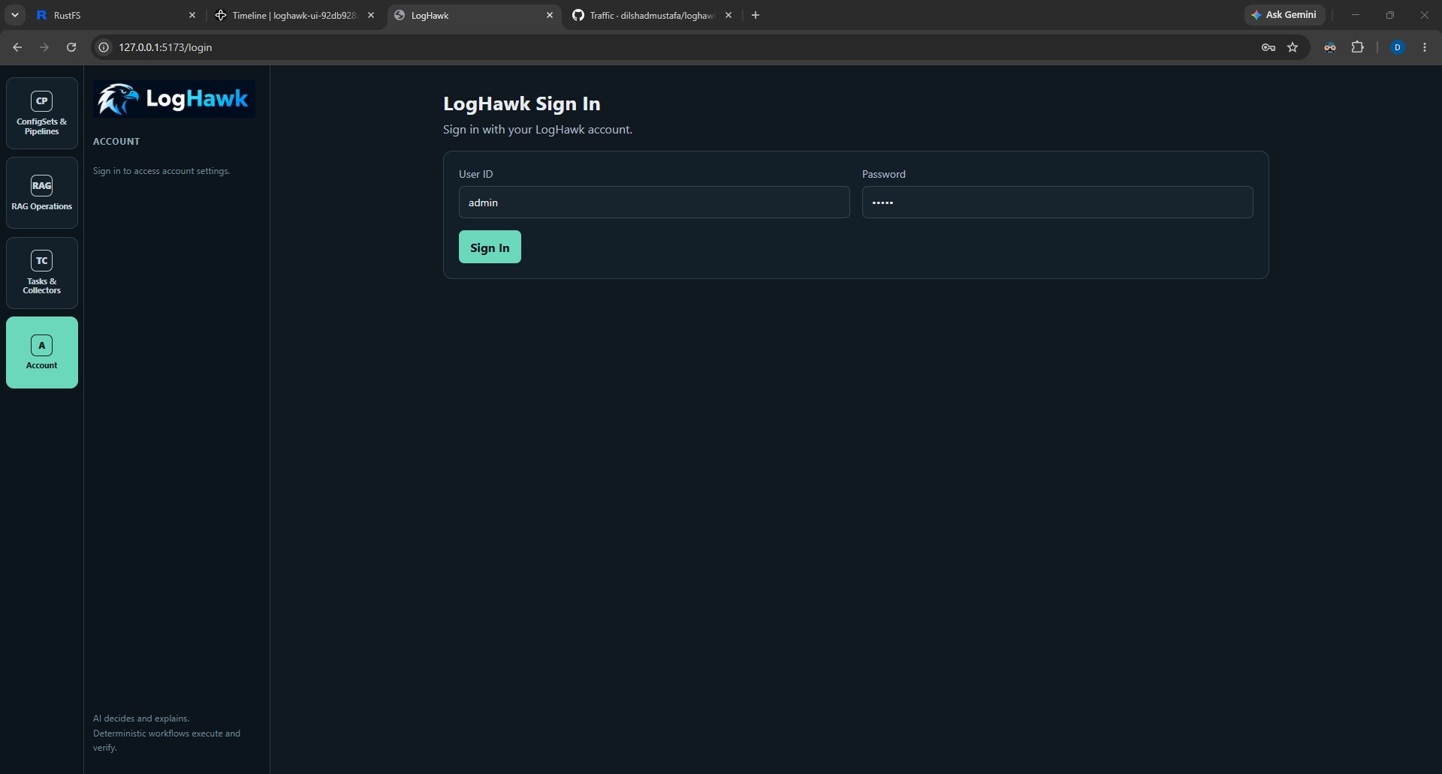
Figure 1 Web UI sign-in. Use your current account password for scheduled API authentication.
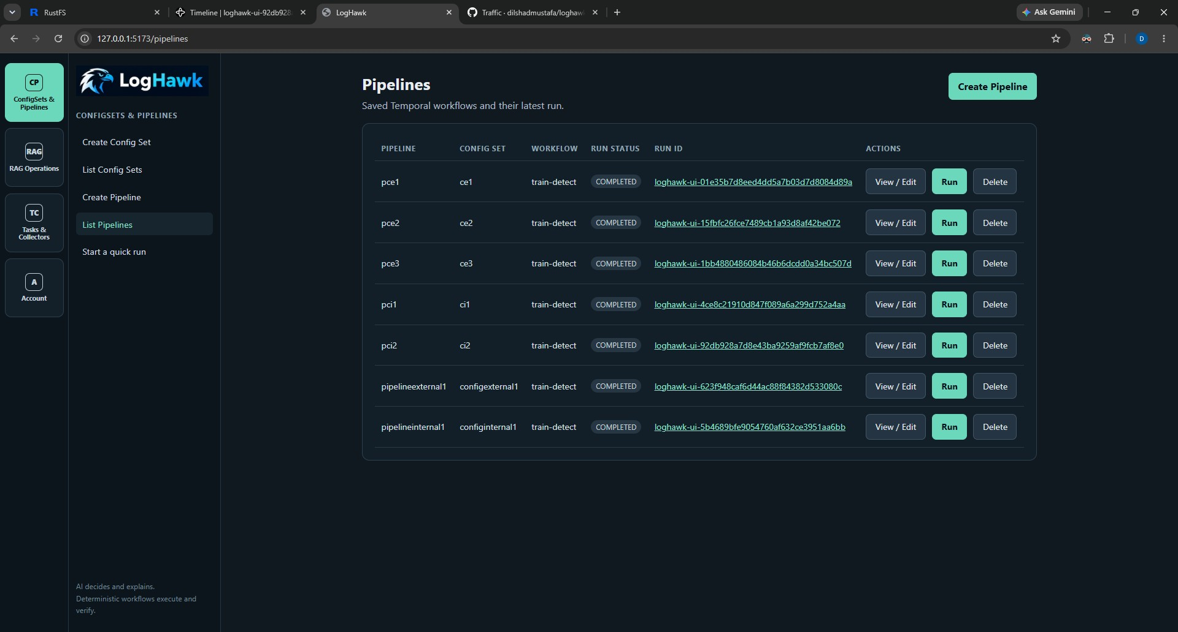
Figure 2 List Pipelines shows names, run modes, statuses and Run ID links. This existing screenshot shows pce3 as train-detect; set your example Pipeline to Detect only as described above.
The scheduler runs a saved Pipeline by name. It does not schedule Quick Run settings or create a new Config Set. The name match is case-insensitive, but spelling and spaces still matter.

4 Configure the API and storage addresses
Edit the repository-root .env file for the installation used by the scheduler:
LH_API_SERVER_URL=http://127.0.0.1:8000
LH_S3_ENDPOINT=http://localhost:9000
LH_S3_ACCESS_KEY_ID=your-internal-s3-access-key
LH_S3_SECRET_ACCESS_KEY=your-internal-s3-secret-key
LH_S3_REGION=us-east-1
LH_API_SERVER_URL is the client-facing URL the runner calls. It may use a DNS name even when LH_API_SERVER_BIND_URL uses a local IP. Do not use 0.0.0.0 as the client destination. localhost means the machine or network environment executing the scheduler; Windows and WSL endpoints must be reachable from that execution environment.
S3 settings above are for reading incident output from RustFS/Internal S3. They are independent of external Train/Detect sources. The scheduled Pipeline still reads its source configuration from the saved Config Set.
Keep the scheduler checkout/configuration aligned with the API deployment. A shared editable Python installation can import LogHawk from another clone. Check the interpreter and installed package before proceeding:
python -c "import sys, loghawk; print(sys.executable); print(loghawk.__file__)"

5 Configure the launcher and output location
The existing Bash launcher supplies these defaults when environment values are unset or blank:
LH_PIPELINE_USERID=admin
LH_PIPELINE_PASSWORD=admin
LH_PIPELINE_NAME=pce3
LH_PIPELINE_BATCH_S3_URL=s3://loghawk-data/somefolder/
Variable | What you must configure
LH_PIPELINE_NAME | Name of the saved Pipeline to start. Set it in run_pipeline_email.sh or its environment.
LH_PIPELINE_USERID | LogHawk login allowed to access the authenticated Pipeline API.
LH_PIPELINE_PASSWORD | Current password for that login. Update scheduling configuration after changing it.
LH_PIPELINE_BATCH_S3_URL | Internal S3 bucket and batch folder from which to read incident output.

Set LH_PIPELINE_BATCH_S3_URL in the launcher or scheduling environment, not in .env. This setting does not alter the Pipeline’s Config Set. It must match that Pipeline’s processing output location; otherwise the email runner can read a different object or find no output.
Batch URL: s3://loghawk-data/somefolder/
Appended: incidents/correlated_incidents.parquet
Full URL: s3://loghawk-data/somefolder/incidents/correlated_incidents.parquet
Provide the batch folder, not the incidents directory or the Parquet filename. A trailing slash is accepted. Use s3:// here; the runner uses s3fs, not Spark.
Prefer supplying current credentials through a protected scheduling environment. If you customize the tracked launcher, do not commit real credentials. Examples below use placeholders; admin/admin is only the initial default, not a recommended ongoing credential.

6 Configure SMTP email delivery
Place SMTP settings in the repository-root .env file. Use values supplied by your email administrator:
LH_PIPELINE_EMAIL_SMTP_HOST=smtp.yourcompany.com
LH_PIPELINE_EMAIL_SMTP_PORT=587
LH_PIPELINE_EMAIL_SMTP_USERNAME=your-smtp-user
LH_PIPELINE_EMAIL_SMTP_PASSWORD=your-smtp-password
LH_PIPELINE_EMAIL_FROM=loghawk@yourcompany.com
LH_PIPELINE_EMAIL_TO=devops-team@yourcompany.com
LH_PIPELINE_EMAIL_STARTTLS=true
Setting | Explanation
SMTP_HOST and EMAIL_FROM | Required before the runner starts a Pipeline.
SMTP_PORT | Defaults to 587.
SMTP_USERNAME and SMTP_PASSWORD | Set both or leave both blank for a relay that does not require login.
EMAIL_TO | Defaults to devops-team@yourcompany.com; replace the example recipient.
EMAIL_STARTTLS | Defaults to true; upgrades the SMTP connection using STARTTLS.

The implementation uses SMTP with optional STARTTLS, not implicit SMTP-over-TLS. Do not switch to port 465 and assume implicit TLS is supported. Use the endpoint and authentication method supported by your provider and this runner.
SMTP configuration is validated before Pipeline execution, but actual email connectivity is exercised after completion. An email-delivery failure does not mean the Pipeline failed. Check its Run ID before starting another run.

7 Run once manually before scheduling
Linux or WSL example. Adapt the repository path; macOS uses its actual local checkout path:
cd /mnt/c/mywork/loghawk
conda activate venv312
export LH_PIPELINE_NAME="pce3"
export LH_PIPELINE_BATCH_S3_URL="s3://loghawk-data/somefolder/"
export LH_PIPELINE_USERID="admin"
read -r -s -p "LogHawk password: " LH_PIPELINE_PASSWORD
printf "\n"
export LH_PIPELINE_PASSWORD
bash run_pipeline_email.sh
The read command is an interactive Bash example that avoids echoing the password. A scheduled task cannot use this prompt; provide its credentials noninteractively. Using bash explicitly means the launcher does not need its executable bit set.
- Look for Started Pipeline pce3 followed by its Workflow ID.
- Watch status messages. The runner polls every 30 seconds and waits up to 24 hours.
- Open List Pipelines and follow the Run ID to inspect workflow details.
- On completion, check the recipient mailbox and CSV attachment when output changed.
- If already running is reported, inspect the existing run rather than creating a second one.
The 30-second polling interval and 24-hour wait timeout are code constants, not currently LH_ environment settings. Individual API requests have a 30-second timeout. Ending the polling process does not cancel the workflow already running in Temporal.

8 Create a Linux cron schedule

Find the correct Python path
python -c "import sys; print(sys.executable)"
If the result is /home/anees/miniforge3/envs/venv312/bin/python, use its containing bin directory in cron PATH. Cron does not inherit your interactive Conda activation. Use absolute paths, and edit the crontab of the account that owns the installation, not root unless that is intentional.

Check the Ubuntu scheduler
systemctl status cron
On a systemd-based Ubuntu installation, if cron is installed but stopped, an administrator can start and enable it:
sudo systemctl enable --now cron
If the unit is missing, have your administrator install/configure the platform scheduler. On non-systemd Ubuntu, service cron status and sudo service cron start may apply. These are scheduler-administration commands, not LogHawk commands.

Edit and verify the crontab
crontab -e
Add the following example, replacing the paths and password. Keep the schedule command on one physical line. Do not paste the placeholder password unchanged:
PATH=/home/anees/miniforge3/envs/venv312/bin:/usr/local/bin:/usr/bin:/bin
LH_PIPELINE_NAME=pce3
LH_PIPELINE_BATCH_S3_URL=s3://loghawk-data/somefolder/
LH_PIPELINE_USERID=admin
LH_PIPELINE_PASSWORD="replace-with-current-password"
*/15 * * * * /bin/bash /mnt/c/mywork/loghawk/run_pipeline_email.sh >> /home/anees/loghawk-pipeline-cron.log 2>&1
Use a protected credential-loading arrangement appropriate to your organization for production. Avoid putting passwords directly into the cron command line. Shell and cron quoting rules differ; validate any special characters using your organization’s secret-management approach.
crontab -l
This lists the saved schedule. A blank crontab or missing line means the schedule has not been installed for that account. The log directory must already exist and be writable.

Understand the five time fields
minute hour day-of-month month day-of-week command
*/15 * * * * ...
*/15 in the minute field runs at minutes 0, 15, 30 and 45 of each hour. It is not fifteen minutes after the previous run finishes. Stars in the other fields mean every allowed value.
Expression | Schedule
*/15 * * * * | Every quarter hour.
0 * * * * | At minute zero of each hour.
0 2 * * * | Daily at 02:00 in the scheduler timezone.

The scheduler timezone controls these times. Check the host timezone with date; daylight-saving transitions can affect wall-clock schedules. Cron implementations differ, so consult the host’s crontab manual before adding timezone overrides. The >> operator appends standard output to the log; 2>&1 sends errors to the same log. [1]

9 Use macOS or WSL deliberately

macOS
Use the same launcher and crontab approach where cron is available. Replace the Python PATH and checkout path with your macOS paths; do not use the Linux /mnt/c path. Use crontab -e and crontab -l, and keep the Mac awake for reliable scheduled execution. Do not run the Ubuntu systemctl commands on macOS. Your administrator may prefer launchd for managed deployments.

WSL Ubuntu
Run the launcher with the Linux Python environment inside WSL. Ensure API, S3 and SMTP addresses are reachable from WSL. Enable and verify cron in the distribution; systemd availability depends on WSL configuration. Microsoft documents systemd setup for WSL. [2]
Do not assume a crontab starts the WSL distribution after Windows reboot or keeps the machine awake. Windows must be running, WSL must be available and the required LogHawk services must be running. For unattended production scheduling, use a reliably managed host or arrange startup explicitly. This guide does not install a WSL startup task.

10 Schedule on Windows with Task Scheduler
Windows can invoke the Python module directly. A Bash installation is not required. Because this bypasses run_pipeline_email.sh, supply all four launcher settings explicitly. The API and worker can run elsewhere if their addresses are reachable.

Create a private PowerShell wrapper
Save this example outside the Git repository, for example C:\LogHawkSchedules\run-pce3.ps1. Create the folder first and restrict access to the scheduling account. Replace the password placeholder through your approved credential mechanism. This guide provides the sample; it does not create the wrapper on your computer.
Set-Location -LiteralPath "C:\mywork\loghawk"
$env:LH_PIPELINE_NAME = "pce3"
$env:LH_PIPELINE_BATCH_S3_URL = "s3://loghawk-data/somefolder/"
$env:LH_PIPELINE_USERID = "admin"
$env:LH_PIPELINE_PASSWORD = "replace-with-current-password"
& "C:\mywork\loghawk\venv312\Scripts\python.exe" -m loghawk.admin.pipeline_cron >> "C:\LogHawkSchedules\pce3.log" 2>&1
exit $LASTEXITCODE
A plaintext password in a private wrapper is still a secret that needs access controls. Do not commit it. Use your organization’s supported secret-loading method when available. Follow the local PowerShell execution policy; do not globally disable it for this job.

Configure the scheduled task
- Open Task Scheduler and choose Create Task. Name it LogHawk pce3.
- Choose the Windows account that can read the checkout, configuration and credentials and reach the services. Configure unattended execution according to your organization’s policy.
- Add a Daily trigger. Under advanced trigger settings, repeat every 15 minutes for a duration of 1 day, with daily recurrence enabled. Microsoft describes trigger repetition intervals and durations. [3]
- Add a Start a program action. Program: powershell.exe. Arguments: -NoProfile -File "C:\LogHawkSchedules\run-pce3.ps1". Start in: C:\mywork\loghawk.
- Under Settings, choose Do not start a new instance if the task is already running. Review power, network and maximum runtime settings to match your operating requirements.
- Save the task, choose Run once, then inspect the task result and C:\LogHawkSchedules\pce3.log before relying on repetition.
Closing the Web UI does not stop this scheduled task. A sleeping or powered-off host cannot provide continuous execution; configure availability deliberately. Do not schedule the same Pipeline from both Windows and WSL unless that duplication is intentional.

11 Understand completion and email behavior
Situation | Current behavior
Pipeline already RUNNING | Logs a skip and returns. It does not wait for or email that existing run.
Pipeline COMPLETED and incident object changed | Reads Parquet, converts all returned rows to correlated_incidents.csv, and sends a completion email with attachment.
Pipeline COMPLETED but output missing or unchanged | Sends a completion email without attachment explaining that no new incident output was written.
Pipeline FAILED | Exits with an error. This runner does not send a failure-alert email.
Polling times out or API fails | Exits with an error; the Temporal workflow may still be running.
SMTP fails after Pipeline completion | Reports an error; the completed Pipeline is not rolled back.

Change detection compares the object’s ETag, size and modification metadata before and after the run. It is not a row-by-row incident comparison or proof that only this run wrote the object. Avoid concurrent different Pipelines writing the same incident object if you need unambiguous email attribution.
The CSV contains the selected object’s data, not only newly added incident rows. A changed object can contain zero rows. CSV opens in Excel, but the attachment is not an .xlsx workbook. Conversion loads the Parquet table into memory, and large outputs may exceed available memory or email attachment limits.
A second invocation that races with the first may receive an API conflict instead of a clean skip. Pipeline concurrency protection prevents duplicate active runs, but the launcher is not a general scheduler lock. There is no persistent email-delivery ledger or automatic send retry. Check the Run ID and logs before rerunning after an email error.

12 Monitor and troubleshoot
# Linux or macOS
tail -n 100 "$HOME/loghawk-pipeline-cron.log"
tail -f "$HOME/loghawk-pipeline-cron.log"
Press Ctrl+C to stop tail -f; this stops log viewing, not the Pipeline. On Windows:
Get-Content "C:\LogHawkSchedules\pce3.log" -Tail 100
Symptom | What to check
python not found or wrong module | Cron PATH or scheduled interpreter path; the correct full pipeline environment and editable install.
HTTP authentication failure | Current userid/password, account status and the API URL. Update credentials after password changes.
Pipeline not found | Saved Pipeline name in Web UI versus LH_PIPELINE_NAME; correct API deployment.
Connection refused | API host/port and whether the API is running. localhost resolves from the scheduler’s host.
Run stays RUNNING | Worker and Temporal connectivity; inspect Run ID and activity errors.
No attachment | Output object missing or unchanged; wrong batch URL; mode/stages did not write incident output.
S3 access error | Internal endpoint, credentials, region and permissions; ensure the object path matches the Config Set.
Email not received | SMTP settings, provider restrictions, spam filtering and log errors. Pipeline may still have completed.
Works manually but not in cron | Absolute paths, environment values, permissions, scheduler service and Python PATH.
WSL schedule stops after reboot | Distribution availability, cron startup and LogHawk service startup.
API conflict during launch | Another request may have started the Pipeline. Inspect the existing run before retrying.

The runner authenticates at the start and tries to log out in a finally block. It does not automatically refresh an expired session during a long wait. Treat authentication errors during polling as a reason to inspect the ongoing workflow, not as evidence that processing stopped.

13 Change or stop the schedule
- Use crontab -e to change the time expression, Pipeline name or output setting. Keep Pipeline name and batch location aligned.
- To pause cron scheduling, comment out only the relevant command line with #, save and verify with crontab -l. Avoid crontab -r, which removes all entries for that user.
- On Windows, disable the specific Task Scheduler task. Enable it again when ready.
- Removing a schedule prevents future launches. It does not cancel an already-started Temporal workflow.
- Use the normal operational procedure to cancel a workflow when necessary. Stopping the email/polling process alone can leave processing running without an eventual email.

14 Final checklist
- Training completed and detection uses compatible models from the intended bucket/batch.
- Saved Pipeline name and run mode are correct.
- LH_PIPELINE_BATCH_S3_URL matches the Config Set output and is supplied by the launcher or scheduling environment.
- API, Temporal, worker, internal S3 and SMTP are reachable.
- Current credentials are private and available to the scheduling account.
- Manual execution completed and email behavior was checked.
- The installed schedule uses the correct absolute interpreter and launcher paths.
- Logs are accessible, rotated as needed and monitored for failures.
- Host availability, timezone and duplicate-schedule risks have been reviewed.

References
LogHawk implementation reviewed: run_pipeline_email.sh; src/loghawk/admin/pipeline_cron.py; src/loghawk/api/routers/pipelines2.py; README section How to schedule LogHawk pipeline run using CronJob. Behavior described here reflects those files as reviewed on 29 October 2026.
[1] crontab format and environment reference: https://www.man7.org/linux/man-pages/man5/crontab.5.html
[2] Microsoft WSL systemd guidance: https://learn.microsoft.com/en-us/windows/wsl/systemd
[3] Microsoft Task Scheduler repetition: https://learn.microsoft.com/en-us/windows/win32/taskschd/repeating-a-task
For broader setup and navigation, see LogHawk_Web_UI_Beginners_Guide.docx. Database retention scheduling is a separate procedure described in How_to_Clean_Up_Old_Database_Entries_and_Manage_Retention.docx.

