How to Create Custom Collectors
LogHawk Web UI and Hawk Console
Input schemas, complete Python programs, local testing, approved execution, and AI-assisted RCA
Updated 28 October 2026

What you will build
Create a named Python Collector Task that accepts JSON arguments, queries an operational service, and prints structured evidence. Test it locally, save an immutable version, obtain approval, and run it through the API or AI-assisted RCA. The examples cover a required Prometheus query and optional Kubernetes namespace and limit arguments.
Start with Prometheus if you have a reachable service. Use the Kubernetes example when you have a working kubeconfig and permission to list pods. Both examples read data without changing target systems.

1 Understand collectors
Concept | Examples | Meaning
Task kind | Collector, General, Remediation, Rollback | Purpose of the Task
Artifact type | Python, Bash, PowerShell, Windows CMD | Program format
Built-in collector | prometheus-query, kubernetes-pods | Installed connector
Custom collector | prometheus1, podstatus1 | User-created Task with kind Collector

n8n JSON is supported for drafting and import into Customer/User managed n8n. It is not executed by the Task runner or RCA dispatcher. Built-in and custom collectors now use the same supported JSON Schema format. Built-ins may additionally normalize values, such as trimming strings; implement any such normalization explicitly in custom code.

2 Prepare the execution environment
Path | Execution host | Requirement
/collectrun or /taskrun | Computer running Console | Local Y/N confirmation; approval and enablement not required
/collect or /task | API server host | Approved enabled version and permitted policy
AI-assisted RCA | API server host | Eligible Collector and enforced review/policy

localhost refers to the execution host. If the API runs in WSL or on another machine, configure and reach the service from that host. A local success does not establish that remote execution will succeed.
Windows from repository root:
.\setup_tools.bat

Linux or macOS:
bash setup_tools.sh

Setup creates venv_tools and installs requirements_tools.txt. The runner selects its Python without requiring you to activate it before each command. Set LH_TOOLS_PYTHON in .env_tools if an explicit interpreter path is needed. Run setup for the checkout you intend to use; a shared editable install can otherwise resolve imports to another clone.

Connector configuration
Use .env_tools on each execution host. Process environment values take precedence. Do not put credentials in artifact code, schema descriptions, or output.
LH_TOOLS_PROMETHEUS_URL=http://127.0.0.1:9090
LH_TOOLS_PROMETHEUS_BEARER_TOKEN=
LH_TOOLS_KUBERNETES_KUBECONFIG=/home/yourname/.kube/config

Use a kubeconfig path valid on that host, including a Windows path on Windows. Leave the bearer token blank only when authentication is not required. A service inside kind needs host connectivity, such as an active port-forward; the collector does not start one. Add missing packages to requirements_tools.txt and rerun setup_tools on the host that executes the script.

3 Create the Collector Task

Web UI steps
1. Start LogHawk and sign in. Initial installations provide admin / admin; change the password in Account Settings.
2. Open Tasks & Collectors > Create Collector. Confirm Task kind Collector.
3. Name the example prometheus1. Select Python and category OBSERVABILITY.
4. Describe it clearly: Read-only Prometheus instant PromQL query. Accepts query and returns bounded metric series for Kubernetes metrics or target status. No range query or system changes.
5. Create the Task, add or generate code, and paste the matching Arguments schema JSON below.
6. Review both code and schema, then Save Version. Generation alone does not save a version or execute it.
Categories are stored in uppercase. Descriptions help AI discover the appropriate collector, so describe its inputs, evidence, scope and limitations. Python syntax is checked when saving; generated code remains editable before saving.

Hawk Console steps
hawk

# In Command Terminal 1 or 2:
/tasknew

1. Sign in to work with server Tasks shared with Web UI. hawk --local uses separate local Tasks and RAG data.
2. In the Editor enter the name, description and category. Select Python and Task kind Collector.
3. Paste code and Arguments schema JSON. Select Save Version.
4. Use /collectview prometheus1 or /taskedit prometheus1 to reopen it and select the required version.
Saving edits to an older version creates a new version; it does not overwrite that version code or schema. Version history lets permitted users inspect, download and delete saved versions.

Use built-in code as a reference
Open Built-in Collectors and choose View Source. Source Code shows installed Python code; Input Schema shows JSON Schema. Each tab has Copy to Clipboard. Close or Escape returns to the list. Installed connector source may only define a function and import LogHawk helpers: copied code needs an entry point to run as a custom program.
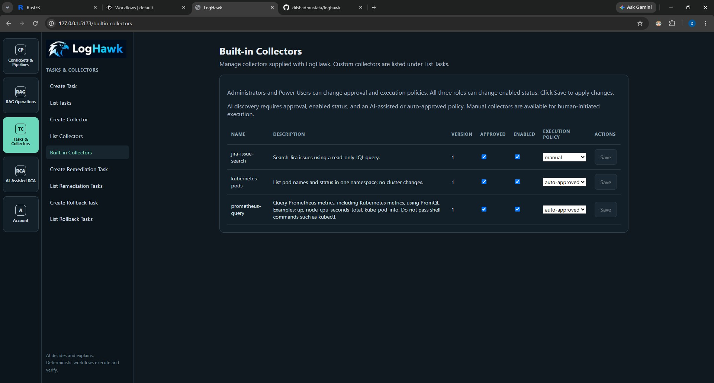
Built-in collector management and Create Collector navigation. This earlier screenshot predates View Source; the current screen places that button beside Save.

4 Understand JSON input schemas
The schema describes allowed fields and constraints. Runtime arguments contain actual values. Paste the schema into Arguments schema JSON; pass the values to /collectrun, /collect, or the AI argument review.
Runtime input example:
{"query":"up"}

Keyword | Meaning
type | object, array, string, integer, number, boolean or null
properties | Allowed field definitions inside an object
required | Names that the validated object must contain
default | Value LogHawk inserts when the property is omitted
additionalProperties: false | Reject undeclared field names
minLength / maxLength | String character limits
minimum / maximum | Inclusive numeric bounds
enum | Explicit allowed values
items / minItems / maxItems | Array element schema and length bounds
description | Explanation for users and AI

LogHawk supports a bounded JSON Schema subset. Each object must set additionalProperties to false. References such as $ref, regular-expression patterns, and composition keywords such as oneOf are not supported.

Required query schema
{
"type": "object",
"properties": {
"query": {
"type": "string",
"minLength": 1,
"maxLength": 2000,
"description": "A PromQL expression, not a shell command. Example: up."
}
},
"required": ["query"],
"additionalProperties": false
}

Input | Result
{"query":"up"} | Valid
{} | Invalid: missing query
{"query":""} | Invalid: too short
{"query":123} | Invalid: expected string
{"query":"up","debug":true} | Invalid: undeclared debug

minLength counts characters. A whitespace-only string may pass that generic check. The sample program also rejects whitespace-only queries. JSON Schema does not trim strings automatically.

Optional fields and defaults
{
"type": "object",
"properties": {
"namespace": {
"type": "string",
"default": "default",
"minLength": 1,
"maxLength": 253
},
"limit": {
"type": "integer",
"default": 100,
"minimum": 1,
"maximum": 200
}
},
"required": [],
"additionalProperties": false
}

required: [] means neither field must be supplied. LogHawk inserts defaults, so {} becomes {"namespace":"default","limit":100}. Supplying only {"namespace":"monitoring"} keeps that namespace and fills limit with 100.
Defaults apply to omitted properties. null is a supplied value and is invalid for these custom string/integer fields. To require caller input, use required without a default. LogHawk fills defaults before checking required fields, so a required field with a default can be supplied automatically.
Input | Result
{} | Valid: both defaults
{"namespace":"monitoring","limit":20} | Valid: explicit values
{"limit":201} | Invalid: above maximum
{"limit":"20"} | Invalid: string instead of integer
{"namespace":null} | Invalid: null instead of string
{"extra":1} | Invalid: undeclared field

No arguments
Blank schema or {} is normalized to the explicit schema below. It accepts an empty object and rejects extra fields; it does not accept arbitrary arguments.
{
"type": "object",
"properties": {},
"required": [],
"additionalProperties": false
}

Enums arrays and nested objects
This illustrates a different collector contract, not the Prometheus program contract. Each nested object must also reject undeclared fields.
{
"type": "object",
"properties": {
"environment": {
"type": "string", "enum": ["qa", "uat", "prod"], "default": "qa"
},
"namespaces": {
"type": "array", "items": {"type": "string", "minLength": 1},
"minItems": 1, "maxItems": 5
},
"options": {
"type": "object",
"properties": {
"include_labels": {"type": "boolean", "default": false}
},
"required": [], "additionalProperties": false
}
},
"required": ["namespaces"],
"additionalProperties": false
}

Valid input: {"namespaces":["monitoring"],"options":{}}. Defaults supply environment=qa and options.include_labels=false. If options is omitted entirely, this schema does not create the containing object automatically.

5 Complete Prometheus collector
Create prometheus1 as a Python Collector with the required query schema in section 4. This program reads runner arguments, sends an instant PromQL query, and prints JSON evidence. requests is included in requirements_tools.txt. It limits results to 100 series and uses a 20-second HTTP timeout.
This is an instant-query example. It does not implement a three-hour range query; that requires /api/v1/query_range and a schema including time range and step.
import json
import os
import sys
from urllib.parse import urlparse

import requests

def main():
args = json.loads(os.environ.get("LH_RUNNER_ARGUMENTS_JSON", "{}"))
if not isinstance(args, dict) or set(args) != {"query"}:
raise ValueError("Supply exactly one argument named query.")
query = args["query"]
if not isinstance(query, str) or not query.strip():
raise ValueError("query must be a non-empty PromQL string.")
if len(query) > 2000:
raise ValueError("query exceeds 2000 characters.")

base = os.environ.get("LH_TOOLS_PROMETHEUS_URL", "").strip().rstrip("/")
parsed = urlparse(base)
if parsed.scheme not in {"http", "https"} or not parsed.netloc:
raise ValueError("Configure LH_TOOLS_PROMETHEUS_URL in .env_tools.")
headers = {}
token = os.environ.get("LH_TOOLS_PROMETHEUS_BEARER_TOKEN", "").strip()
if token:
headers["Authorization"] = "Bearer " + token
try:
response = requests.post(
base + "/api/v1/query",
data={"query": query.strip(), "limit": 100},
headers=headers,
timeout=20,
)
except requests.RequestException:
raise RuntimeError("Prometheus request failed; check connectivity.") from None
if not response.ok:
raise RuntimeError("Prometheus returned HTTP " + str(response.status_code))
try:
payload = response.json()
except ValueError:
raise RuntimeError("Prometheus returned invalid JSON.") from None
if not isinstance(payload, dict) or payload.get("status") != "success":
raise RuntimeError("Prometheus reported an unsuccessful query.")
data = payload.get("data", {})
if not isinstance(data, dict):
raise RuntimeError("Unexpected Prometheus data format.")
if data.get("resultType") not in {"vector", "matrix"}:
raise RuntimeError("This example supports vector or matrix results only.")
series = data.get("result", [])
if not isinstance(series, list):
raise RuntimeError("Unexpected Prometheus result format.")
print(json.dumps({
"summary": "Returned " + str(len(series[:100])) + " result series.",
"data": {"resultType": data.get("resultType"), "result": series[:100]},
"returned_series": len(series[:100]),
"truncated_by_script": len(series) > 100,
"source_limit": 100,
"notice": "The source or script may limit result series.",
}, ensure_ascii=False))

if __name__ == "__main__":
try:
main()
except (ValueError, RuntimeError) as exc:
print(str(exc), file=sys.stderr)
sys.exit(1)

Why the entry point matters
def main() only defines a function. The if __name__ == "__main__" block invokes it. Without an invocation, a script can exit successfully without collecting or printing evidence.
The runner loads .env_tools into the subprocess environment and supplies LH_RUNNER_ARGUMENTS_JSON. Existing environment values take precedence. A custom program can read os.environ without loading .env_tools again.
Exit code 0 means successful execution; nonzero means failure. JSON on stdout is a useful evidence convention, but custom output is captured as text. Printing {"status":"FAILED"} and exiting 0 does not mark the runner result as failed. Do not print secrets: task execution stdout/stderr is stored before AI redaction.

6 Kubernetes collector with optional arguments
Create podstatus1 as a Python Collector and use the optional namespace/limit schema from section 4. Description: List Kubernetes pod phase, readiness and restart count in a namespace. Optional namespace defaults to default and limit to 100. Read-only bounded listing.
This complete wrapper calls the installed LogHawk Kubernetes helper. That helper uses the configured kubeconfig or tries in-cluster configuration followed by normal kubeconfig when no path is configured. It requires the kubernetes dependency in venv_tools.
import json
import os
import sys
from loghawk.collectors.kubernetes import list_pods

def main():
args = json.loads(os.environ.get("LH_RUNNER_ARGUMENTS_JSON", "{}"))
if not isinstance(args, dict):
raise ValueError("Arguments must be an object.")
if set(args) - {"namespace", "limit"}:
raise ValueError("Only namespace and limit are supported.")
namespace = args.get("namespace", "default")
limit = args.get("limit", 100)
if not isinstance(namespace, str) or not namespace.strip():
raise ValueError("namespace must be a non-empty string.")
if len(namespace) > 253:
raise ValueError("namespace is too long.")
if isinstance(limit, bool) or not isinstance(limit, int):
raise ValueError("limit must be an integer.")
if not 1 <= limit <= 200:
raise ValueError("limit must be between 1 and 200.")
result = list_pods(namespace.strip(), limit)
result["requested_limit"] = limit
result["notice"] = "Bounded listing; more pods may exist."
print(json.dumps(result, ensure_ascii=False))

if __name__ == "__main__":
try:
main()
except Exception as exc:
# Avoid printing Kubernetes response bodies or credentials.
print("Pod collection failed: " + type(exc).__name__, file=sys.stderr)
sys.exit(1)

Defaults in args.get are also useful outside LogHawk. Inside LogHawk, shared validation supplies omitted defaults first. The helper does not paginate through all cluster pods; the response is a bounded listing.

7 Save and test locally
1. Save Version after entering both code and schema. New versions start unapproved and disabled.
2. Open Console in the same mode as the Task. Sign in to load a Web UI Task; --local has separate storage.
3. Enter a command below in Command Terminal 1 or 2.
4. Inspect the displayed code and answer Y or y at the local prompt to run it. N cancels. Review stdout, stderr and exit code in the terminal and Editor output.
5. Correct any problems and save a new version. The new version needs its own approval and enablement before API use.
/collectrun prometheus1 {"query":"up"}
/collectrun podstatus1 {}
/collectrun podstatus1 {"namespace":"monitoring","limit":20}

Local /collectrun and /taskrun are development commands and bypass server approval/enablement. JSON property names and strings use double quotes. Quote collector names containing spaces: /collectrun "Prometheus Check" {"query":"up"}. Pass argument values, not the schema.

8 Approve enable and set policy
Action | Administrator | Power User | User
Create Collector | Yes | Yes | Yes
Edit/delete custom Task/version | Any Task | Any Task | Own Tasks
Approve Version | Yes | Yes | No
Enable/disable custom version | Any Task | Any Task | Own Tasks
Set Auto-Approved policy | Yes | Yes | No
Set Manual AI-Assisted Disabled | Any Task | Any Task | Own Tasks
Run approved enabled API version | Yes | Yes | Yes
Create/delete users | Yes | No | No

Even Administrators need approved and enabled versions for API execution. Select the intended version, have an Administrator or Power User review its exact code/schema and choose Approve Version, then enable it if permitted. New versions do not inherit those flags. Code/schema immutability does not prevent changes to approval and enablement.
Policy | Human API request | AI collector request
Manual | Allowed | Not offered to AI
AI-Assisted | Allowed | Human confirmation required
Auto-Approved | Allowed | Automatic unless argument review is selected
Disabled | Blocked for every role | Not offered to AI

Every permitted API request still requires approval and enablement. For custom Tasks, policy belongs to the Task; approval/enablement belongs to a saved version. RCA executes eligible Collectors, not General, Remediation or Rollback Tasks. Built-in policy/approval changes require Administrator or Power User; all three roles can enable/disable a built-in.

9 Execute through the API
/collect prometheus1 {"query":"up"}
/collect podstatus1 {"namespace":"monitoring","limit":20}

Use these in a signed-in Console Command Terminal. They call the authenticated API and execute on the API host using its tools environment and settings. Typing the command is human initiation; Manual policy does not add a second Yes/No prompt. Approval, enablement and non-Disabled policy are still required.
Check API-host dependencies, endpoint, credentials and kubeconfig separately from local setup. Bash and PowerShell artifacts require their corresponding interpreters on the execution host. Windows CMD requires Windows. Python artifacts use venv_tools.

10 Invoke collectors through AI assisted RCA
1. Enable collector tool calling in API .env and configure a tool-capable model and provider.
2. Save a clear description and argument schema. Approve and enable the latest custom Collector version and select AI-Assisted or Auto-Approved policy. AI discovery does not fall back to an older eligible version.
3. Open Web UI > AI-Assisted RCA > RCA Chat, or use the AI/LLM Terminal in signed-in Console.
4. Keep Review Input Args checked for your first run and send the example below.
5. Inspect the chosen collector/version and inputs. Edit if needed, then Confirm & Execute or Cancel.
6. Read server-reported status and evidence before relying on the model explanation.
Use the custom collector prometheus1 with query up.

Use podstatus1 to list up to 20 pods in namespace monitoring.

Review Input Args | Auto-Approved | AI-Assisted
Checked | Review/edit then confirm or cancel | Review/edit then confirm or cancel
Unchecked | Automatic; inputs appear with result | Confirmation remains required; inputs read-only

Argument review does not approve collector code, enable a version, or change policy. Invalid inputs remain correctable before confirmation. The checkbox is at the top of Web RCA Chat and in the Console Editor area.
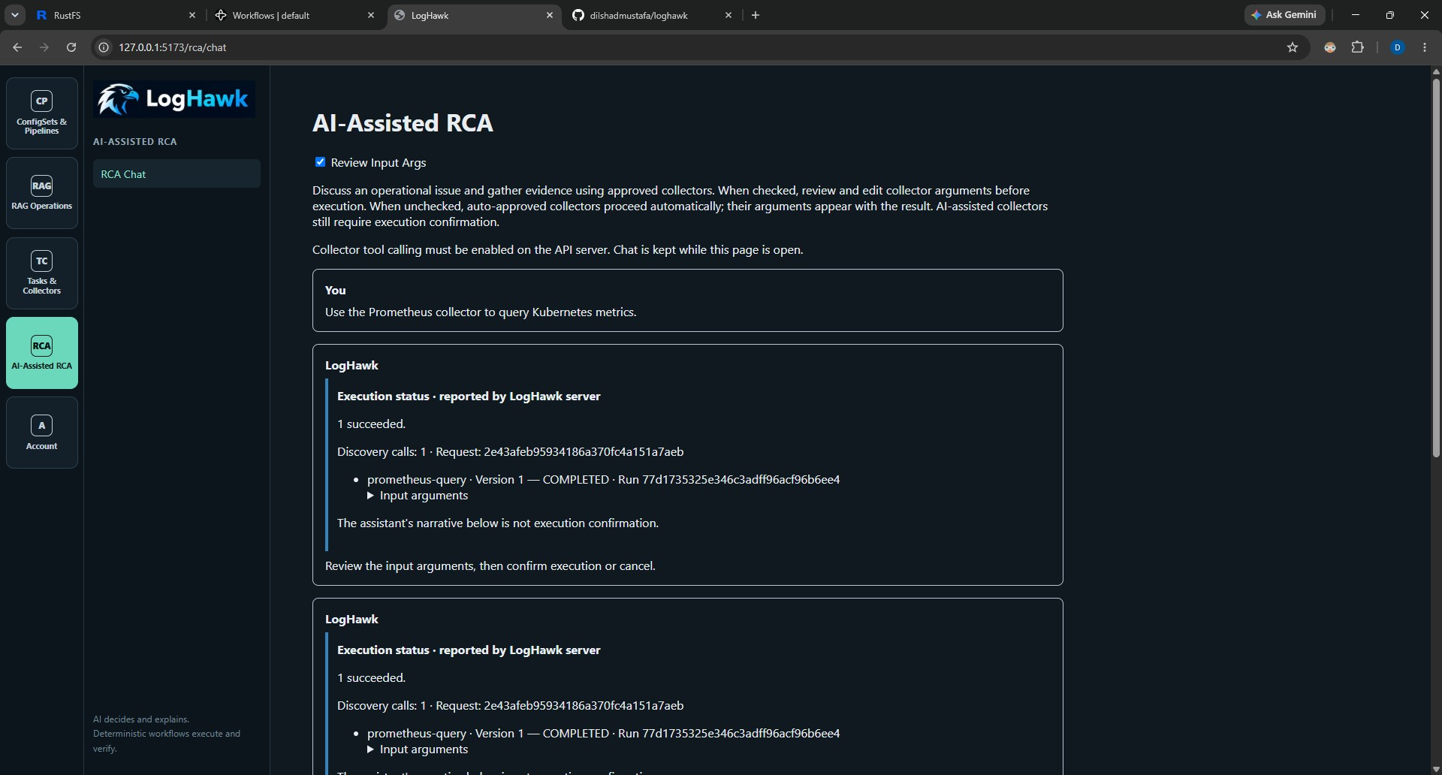
Web UI RCA with argument review and server-reported execution details. This built-in example illustrates the same flow used for custom collectors.
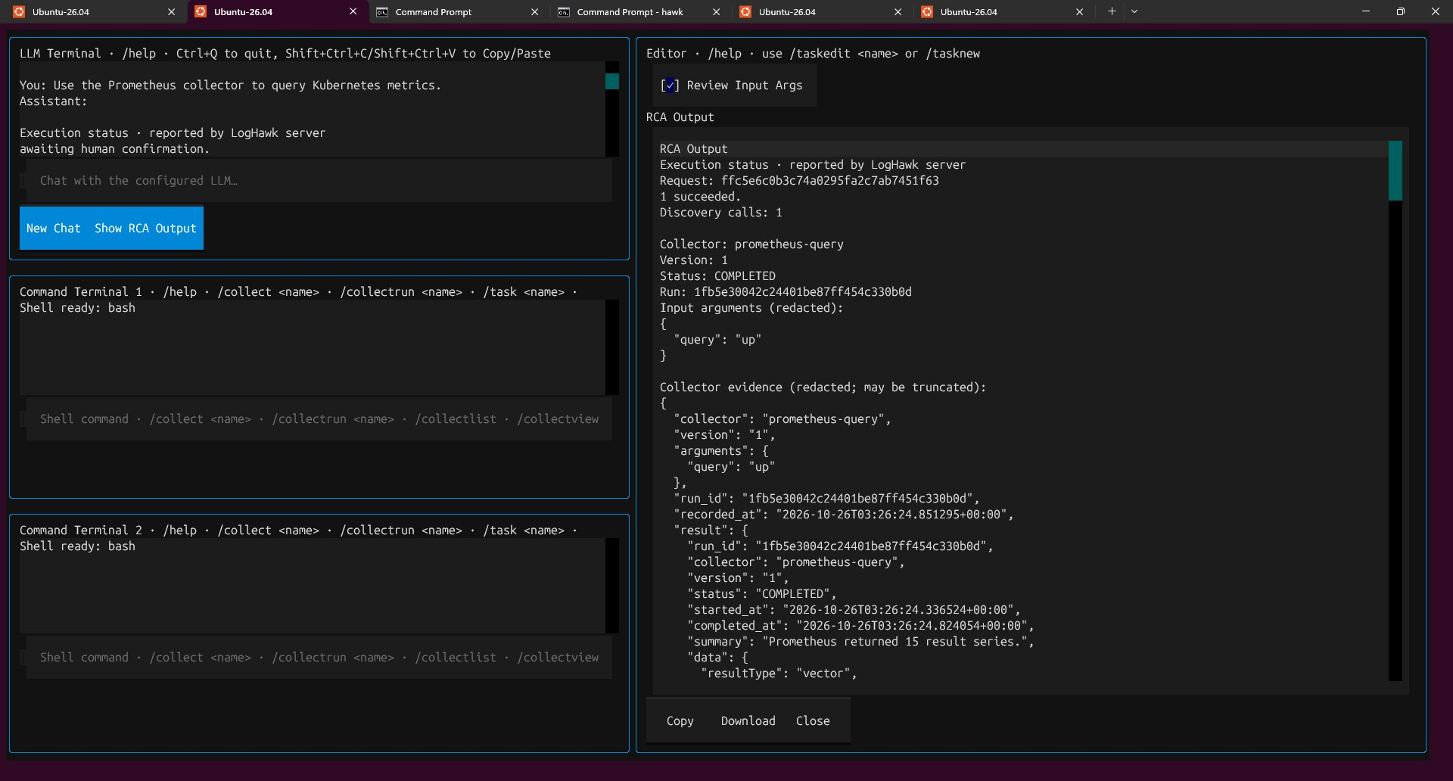
Console argument review and Show RCA Output. Inspect evidence in the Editor; use Copy or Download to retain it.
An AI statement such as proceeding with execution is not confirmation that it ran. Use recorded status and run ID. kube_pod_info is metadata: a value of 1 does not establish readiness or health. Seek readiness, phase, restart and other relevant evidence.

11 Timeouts and explanation retries
LH_LLM_TOOL_CALLING_ENABLED=true
LH_LLM_TOOL_MODEL=qwen3:4b-instruct
LH_LLM_TOOL_CONTEXT_LENGTH=8192
LH_LLM_TOOL_MAX_TOKENS=1024
LH_LLM_TOOL_MAX_CALLS=3
LH_LLM_TOOL_TIMEOUT_SECONDS=300
LH_LLM_TOOL_EXPLANATION_TIMEOUT_SECONDS=180
LH_LLM_TOOL_MAX_RESULT_CHARS=6000

These are example API .env settings. Tool calling uses the configured LiteLLM provider/base URL; Task drafting may separately use LH_LLM_CODEASSIST_MODEL. Restart API after changing server settings and Console after changing its local configuration.
Tool timeout covers discovery/execution processing and excludes human confirmation wait. Explanation has a separate additional budget. Collector HTTP timeouts are independent: increasing the LLM timeout does not override the example program 20-second service timeout. Maximum calls includes discovery. Maximum result characters bounds model-facing evidence, not the entire source dataset.
Reasoning models may be slower with large evidence or limited GPU memory. Choose a tool-capable model and context size suitable for the machine. Larger budgets do not guarantee valid tool calls or correct conclusions.
1. If execution completed but explanation failed, inspect saved evidence.
2. Choose Retry AI Explanation in the Web response or Console RCA Output.
3. The API uses saved question/evidence and records a new explanation attempt. It does not rediscover or rerun collectors.
Retry requires saved explanation context. The API checks ownership and prevents concurrent active attempts. Model transport retries are disabled in this flow. Bounded correction of narration into a tool call is not a collector execution retry.

12 Find execution records and saved evidence
Server records use LH_SERVER_DATABASE_URL. Audit records explain who requested an action and how the AI flow handled it; execution records describe what the runner actually did. API console messages and diagnostic log files are separate from these database records.
Table | Purpose
llm_tool_requests | AI request owner, interface, status and confirmation or explanation state.
llm_tool_calls | Tool events, collector/version, redacted inputs and results, status, run identifiers and explanation attempts.
collector_runs | Built-in executions: user ID, argument names, short summary, status, error and timestamps.
task_runs | Custom script executions: task/artifact version, user ID, status, exit code, captured stdout/stderr, error and timestamps.

For AI-assisted RCA in both the Web UI and signed-in Hawk Console, llm_tool_calls.result_text stores the full returned collector evidence after sensitive values are redacted and before model compaction. The LLM receives a smaller copy. Compaction does not replace saved evidence. Redaction removes or masks sensitive values; it is different from abbreviation or truncation.
Full returned evidence is not unlimited source data. Collector query limits, pagination choices and runner limits still apply. Custom script stdout and stderr are each limited to 100,000 characters by the runner, with a truncation marker when needed. The examples also impose service timeouts and result limits.
Custom task_runs stdout/stderr are not the AI-redacted evidence copy. Never print credentials or tokens. A custom collector invoked through AI produces AI audit records and a task execution record; direct API custom execution produces task_runs records. Built-in execution uses collector_runs, which is not the full evidence store. Local /collectrun and /taskrun do not create server execution records; command history is separate.
AI tool audit records identify origin=AI, origin_userid as the signed-in user, and origin_software as web or console. Use the request ID to locate AI tool events, then the run ID to find execution details. A rejected request may have no execution run ID because execution never began.

13 Troubleshoot common problems
Symptom | What to check
Required argument missing | Send a values object such as {"query":"up"}; do not pass the schema as input.
Unexpected argument rejected | Use only keys declared under properties when additionalProperties is false.
Default not applied | Omit the optional property. Explicit null is not the same as omission.
Exit code 0 but no useful output | Ensure the script calls main and prints its result. Defining a function alone does not run it.
ModuleNotFoundError | Install the needed dependency in venv_tools on the execution host through requirements_tools.txt and setup_tools.
Local run works but API run fails | Check API-host networking, .env_tools, kubeconfig, tools environment and interpreter availability.
Prometheus HTTP 400 | Inspect the PromQL expression and endpoint request. An HTTP response means a server responded; this alone is not evidence that it is unreachable.
No result series | Check metric names, label filters, scrape targets and time range. Empty results do not prove every target is healthy or unhealthy.
AI cannot discover the collector | Check kind, description, enabled/approved latest version, argument schema and AI-eligible execution policy.
API execution rejected | Check version approval, enablement, permissions and policy. Administrators also need an approved and enabled version.
Unchecked argument review still asks | AI-Assisted policy still requires human execution confirmation.
Execution completed but explanation failed | Inspect saved evidence and use Retry AI Explanation. Do not rerun collection merely to retry the explanation.
Task missing in Console | Check signed-in versus --local mode and the selected database. Local and server stores are separate.

14 Checklist before sharing a collector
1. Use a meaningful name and description that explain scope and expected evidence.
2. Keep credentials in environment configuration, never in saved code or printed output.
3. Define properties, types, defaults, bounds and required fields; reject unexpected keys.
4. Develop with /collectrun and inspect output and exit codes before approval.
5. Bound service requests and output; use clear errors and a nonzero exit code on failure.
6. Save a version, have an authorized reviewer approve that exact version, and enable it.
7. Choose an execution policy appropriate to its behavior and confirm API-host configuration.
8. Verify the recorded execution result and evidence when using AI-assisted RCA.
Use /help in Hawk Console for current command syntax and terminal availability. For broader navigation and setup, see LogHawk_Web_UI_Beginners_Guide.docx and Hawk_Console_Beginners_Guide.docx in Howto_Guides.

