How to do RCA And Investigation With LogHawk
A practical beginner guide for the Web UI and signed-in Hawk Console
Use this guide to collect evidence, connect it to incidents, ask focused questions, and review how LogHawk reached an explanation. You will learn to distinguish saved observations from an AI hypothesis and to correct attachment mistakes without losing earlier RCA records.
Prepared for the current LogHawk implementation on 4 November 2026. Existing screenshots illustrate the workflow; labels and layout can differ from the latest screens. Investigation procedures below follow the current implementation.

Start here
For a quick collector question, follow sections 2 and 3. For an incident with files, follow sections 4 through 9. Use sections 10 through 12 when interpreting history or diagnosing slow responses. Section 13 covers Hawk Console. Section 14 brings the workflow together.

Contents
1 Concepts and relationships
2 Prepare LogHawk
3 Ask your first RCA question
4 Create an Investigation
5 Import local and Internal S3 evidence
6 Select records and attach evidence
7 Create and link incidents
8 Correct mistakes
9 Investigate and record findings
10 Read RCA History
11 Understand timelines and saved evidence
12 Troubleshoot and retry explanations
13 Use Hawk Console
14 Complete worked example
15 Checklist and glossary

1 Concepts and relationships
Root cause analysis, or RCA, asks why an operational problem happened. A useful answer identifies the evidence, the likely cause, alternative explanations, and what still needs checking. A model response alone is not proof of the cause.
Term | Meaning
Investigation | A saved workspace for one problem, reported context, linked incidents, evidence, findings and RCA requests.
Incident | An event being investigated. It can originate from a Stage C record and can be linked to more than one investigation.
Evidence source | An imported file or saved collector result. Its parsed records can be selected and attached.
Finding | A saved observation or assessment, optionally linked to evidence that supports or contradicts it.
RCA request | One assistant request with its execution records, explanation attempts and saved investigation context.

How the pieces fit
Investigation
-> one or more linked incidents
-> one or more evidence sources or selected records
-> directly attached evidence
-> findings and their evidence references
-> RCA requests with saved context snapshots
An incident can include Stage C correlation records, Stage B anomalies, Stage A features, raw logs and Other evidence. You can also attach evidence directly to the investigation when it describes the wider problem rather than one incident.

Three important distinctions
Imported means the file has been parsed and is available for selection. Attached means selected records are connected to an investigation or incident. READY is an import status; it does not mean the evidence is already attached or that the system described by it is healthy.
Reported context is what you tell LogHawk, such as the affected service and time. Evidence is what a file or collector returned. An AI explanation interprets these inputs and may still be incomplete or wrong.
Earlier RCA requests retain the context snapshot used at that time. Changing an attachment or finding affects later requests; it does not rewrite the context of yesterday’s request.

2 Prepare LogHawk
1. Complete the installation instructions for the Web UI. Start the required services from the repository root using start_all_servers.bat on Windows or bash start_all_servers.sh on Linux/macOS.
2. Open http://localhost:5173 unless your deployment uses another address. Sign in with your assigned account. A fresh installation provides admin / admin; change that password in Account Settings.
3. Open AI Investigation in the left navigation. Locate RCA Chat, RCA History and Investigations.
4. Ask an Administrator or Power User to check that the required collector version is approved, enabled, has a valid input schema and permits AI use.
5. Check that the API server can reach the collector’s target, such as Prometheus. Connector configuration belongs in the server-side .env_tools for signed-in execution.

If using Ollama
Run Ollama on the machine providing inference. Pull each Ollama model named in your configured .env settings on that machine. Pulling a model downloads it; it does not automatically change LogHawk’s selected model.
ollama pull qwen3:4b-instruct
ollama list
ollama ps
The model above is an example. Use your actual configured model names, including separate explanation or embedding models if configured. Check the Ollama address from the API server’s environment: localhost inside WSL or a container may refer to a different machine. Restart the API after changing its environment configuration.

Roles and execution policy
Policy | What AI execution requires
Manual | Human initiation; not an AI execution option.
AI-Assisted | Human execution confirmation, even when Review Input Args is unchecked.
Auto-Approved | May execute automatically when Review Input Args is unchecked.
Disabled | Execution is not permitted.
Server execution requires an enabled and approved version, including for Administrators. Administrators and Power Users can approve versions. Users can create, modify and enable versions, but cannot approve them. Saving changed code or schema creates a version that needs approval and enablement.
Investigations are edited by their owner while OPEN. Administrators and Power Users can view other users’ records where permitted; that does not make another user’s investigation editable. Use an account that owns the investigation for this walkthrough.

3 Ask your first RCA question
1. Open RCA Chat. Keep Review Input Args checked for your first attempt.
2. Enter: Use the Prometheus collector to query up. Explain what this tells us and what it does not tell us.
3. When an argument review appears, inspect the selected collector, version and JSON arguments. For this example, the query should be up. Edit the argument if needed, then confirm or cancel.
4. Wait for the server-reported execution status. COMPLETED confirms collector execution succeeded. Read the returned evidence before relying on the assistant’s explanation.
5. Ask a focused follow-up based on the evidence. Use New Chat when starting a different problem; confirm Yes only when you want to clear the current conversation.
{"query":"up"}
The review is for input arguments. It is not a source-code review or approval of a new collector version. Approval and enablement remain separate controls.
Unchecked Review Input Args allows auto-approved collectors to proceed, with their arguments displayed in results. AI-assisted collectors still need confirmation. Cancelling a proposed execution prevents that pending call from being run.
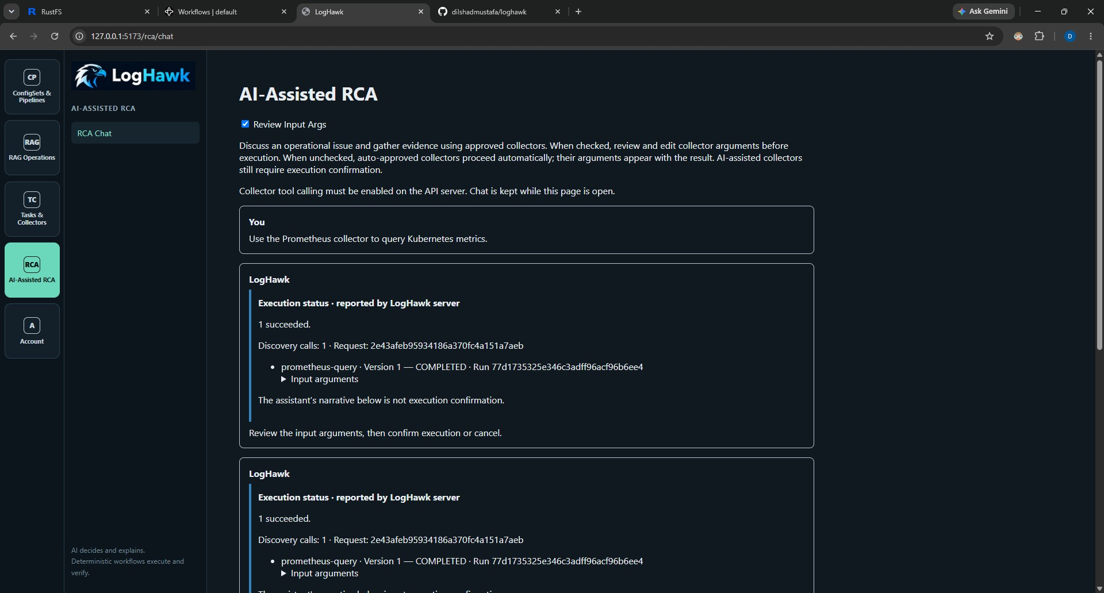
Example Web UI RCA screen. Use the current server status and argument review controls described above.

Interpret metric values carefully
The up metric indicates whether Prometheus successfully scraped a target. It does not prove the application is working correctly. kube_pod_info is pod metadata; a value of 1 does not establish pod readiness, application health or the absence of errors. Ask for the specific readiness, restart, error or resource metric needed.

4 Create an Investigation
1. Open Investigations and select New Investigation.
2. Write a specific problem, for example: Checkout requests failed between 11:05 and 11:10 UTC; investigate payment-service and order-service.
3. Expand the optional reported context. Add the entity or service, environment and incident start/end times when known.
4. Use an explicit timezone in timestamps, for example 2026-11-03T11:05:00Z or 2026-11-03T16:35:00+05:30. Ensure the end is not earlier than the start.
5. Create the investigation. Confirm its problem, owner and OPEN status on the detail page. Copy the investigation ID from technical details when you need to reopen it in Console or report a problem.
Tab | Use it to
Overview | Review the problem, reported context, counts and next steps.
Evidence | Import sources, preview records, classify them and manage attachments.
Incidents | Review linked incidents and their evidence.
Findings | Save observations or assessments with supporting or contradictory evidence.
RCA History | Open assistant requests made in this investigation.

A useful problem statement
Include what failed, where, when and its impact. For example: Customers received HTTP 503 responses from checkout in production from 09:07 to 09:10 UTC. Compare payment and order logs and identify whether the failures share a cause.
Avoid stating an unverified cause as a fact. Write “suspected payment dependency failure” rather than “the payment database caused the outage” unless evidence already supports it.

Opening and closing
Use Open RCA Chat from the investigation header to ask questions with this investigation selected. Refresh retrieves current saved state. Actions allows the owner to close the investigation with confirmation. Closed investigations remain available for review but cannot receive normal edits or new investigation requests. Finish active work before closing.

5 Import local and Internal S3 evidence

Import a file or folder from your computer
1. Open Evidence and choose Add Evidence, then Local files / Folder.
2. Choose the evidence type. Use Stage C for correlated incident records, Stage B for anomaly results, Stage A for features, Raw logs for original logs, or Other for relevant supporting material.
3. Browse to a file or folder. Supported formats are CSV, Parquet, JSON, JSONL, LOG and TXT. Review the file list and any excluded unsupported files.
4. Import the files. Check each result: READY means parsing succeeded; FAILED means you need to inspect the error.
5. Choose Preview / Select for a READY source. Import alone does not attach its records to AI context.
Other is a classification, not permission to import every file format. A PDF or Word document is not supported by this investigation import flow merely because Other is selected. The separate RAG document-upload workflow serves a different purpose.

Browse Internal S3
1. Choose Add Evidence, then Internal S3. Select the Input bucket from the dropdown.
2. Navigate through folders, using breadcrumbs or Up one folder. Select individual files or folders, or Select This Folder.
3. Choose Review Selected Files. Folder selections expand into supported files, including subfolders. Overlapping selections are deduplicated.
4. Review the resolved filenames and sizes. Remove unwanted files and import the reviewed selection with the intended evidence type.
5. Wait for the results, then preview and attach the records you want to investigate.
s3://loghawk-data/somefolder/incidents/
s3://loghawk-data/somefolder/anomalies/
s3://loghawk-data/somefolder/features/
These are example locations. Browse your actual pipeline output; Stage A and Stage B can contain nested per-file or per-service datasets. Import smaller batches if the configured file-count, byte or listing limit is exceeded. The default import file count is 20, but your installation may differ.

Other import options
Saved collector evidence uses a saved tool-call event ID, not the request ID or execution run ID. Existing source uses an accessible source ID. Verify the resulting attachment and record selection; these identifiers are not interchangeable.
For JSON with records inside a nested property, Advanced options can specify a JSON Pointer such as /incidents. Use it only when that path matches the actual document structure.

6 Select records and attach evidence
1. In Evidence, choose Preview / Select beside the imported source.
2. Read the preview. Expand a row to inspect all fields; the table initially shows only a subset of columns.
3. Choose Attach to: the investigation itself or a linked incident.
4. Select individual records, Select This Page, or the all-records option. Page selection is different from all records in the source. Use Previous and Next to inspect further pages.
5. Choose Save Evidence Selection. Confirm the attachment appears in the source’s Attached to list.
Saving a selection replaces the previous selection for that source and target. For example, replacing records 1 and 2 with record 3 means later context uses record 3 for that attachment. Use Remove Attachment to detach completely; saving an empty selection is not the removal workflow.

Which target should I choose
Attach a payment error log to the payment incident when it explains that event. Attach a deployment summary directly to the investigation when it helps explain several incidents. A source can have more than one attachment, so check the target name before removing or replacing a selection.

Choose useful evidence
Prefer records covering the incident window and affected entities. Large unrelated datasets consume context without necessarily helping diagnosis. Include preceding normal behaviour where it is useful for comparison. Preserve timestamp timezone information and identify whether data represents a sample or a complete period.

Column mapping
If the standard incident fields have different names, use Advanced column mapping before creating incidents. Map standard fields to actual columns, for example incident_id to case_id. Do not invent columns or change timestamps simply to make an import succeed. Mapping becomes restricted once incident records are linked, to protect existing references.
{"incident_id":"case_id"}

What happens to the original file
The import preserves a source snapshot for parsing and investigation. Changing the source classification or removing an attachment does not edit the original S3 object or local file. Saved RCA requests keep their own context snapshots; new attachments do not retroactively change earlier explanations.

7 Create and link incidents
1. Import correlated_incidents.parquet as Stage C and open its preview.
2. Inspect incident_id, start_time, end_time, affected services and severity. Select the record or records representing the incident you want.
3. If all-records mode is selected, switch to individual row selection. The Create / Link button uses selected incident rows.
4. Click the blue Create / Link N Selected Incident(s) button and confirm.
5. Open Incidents. Check that the expected external incident ID, services and time window appear.
6. Return to Evidence, preview Stage B anomalies or logs, choose this incident under Attach to, select the relevant records and save.

One incident can have many sources
Evidence type | Example contribution
Stage C | Correlation window, severity and affected services.
Stage B | Which observations were anomalous and their anomaly metadata.
Stage A | Feature values used by the anomaly detector.
Raw logs | Original error messages, request failures and event details.
Other | Additional supported structured or text evidence relevant to the incident.
A Stage B file normally supplies anomaly evidence. Do not create an incident from every anomaly row unless that is deliberately what you want. Evidence type labels describe the source; they do not automatically create incidents.

External and internal IDs
An ID such as INC-20260928110500-0000 comes from the incident file. LogHawk also assigns an internal incident ID for linking. Use the internal ID when a command requests an incident-id. Reusing the same imported record can reuse its incident; identical external IDs in separate imports should not be assumed to merge automatically.
An investigation can link more than one incident. An incident can also be reused in another investigation owned by the same user. Evidence attached to that shared incident is shared with those investigations, so review the removal confirmation carefully.

8 Correct mistakes

Wrong evidence type
1. Find the source in Evidence and click Change Type.
2. Choose the correct classification and Save. For correlated_incidents.parquet, choose Stage C when it contains correlation records.
3. Confirm the new label. This changes source metadata; it does not re-upload or reparse the file, create incidents, or rewrite earlier request snapshots.
The source classification is shared wherever that source is referenced. You can change it again if you selected the wrong value. A READY source that is Not attached currently has no Remove button. Remove Attachment applies only to an existing attachment; Remove on a failed import applies only to eligible failed sources.

Failed import
Use Inspect error to read the reason. Correct a format or nested-record-path issue and use Retry Parsing Preserved Source where available. If the source is no longer useful, use Remove on its failed row or Clear Failed Imports for eligible failures. Confirm the action. Failed records are dismissed from the working list, not physically deleted; referenced sources may be skipped. This action does not have the attachment Undo button.

Remove an attachment or unlink an incident
1. For a source attachment, use Remove Attachment beside the specific destination in Evidence. In Incidents, use Remove Evidence beside that incident’s source.
2. Read the confirmation, especially when the incident is shared. Confirm only the relationship you intend to remove.
3. To remove an incident from this investigation, use Unlink Incident. Its underlying record and evidence remain saved.
4. Use Undo in Recent removals immediately if you made a mistake. Keep the page open until you are satisfied.
Undo is available during the current page session. Refreshing or navigating away loses that convenience; retained sources or incidents can still be linked again using their IDs. Undo restores the prior record selection and refuses to overwrite an attachment that has since been recreated. If you removed both an incident link and its evidence, restore the incident link first.

Finding references
A source referenced by a finding is handled through Revise Finding. Create a replacement finding that omits or corrects the reference. The old revision is retained for traceability. Removing another attachment does not erase the source reference from an existing finding.

9 Investigate and record findings
1. After attaching evidence, use Open RCA Chat from the investigation header. Verify that the chat identifies the selected investigation.
2. Ask a focused question using the incident time window and service names. Review proposed collector arguments before execution.
3. Read server execution status and evidence. Compare the AI’s claim with the actual fields and timestamps.
4. Open Findings in the investigation. Save a concise observation or assessment, identifying what supports it and what remains uncertain.
5. Link the relevant evidence source and record numbers, marking Supports or Contradicts. Save a revision when your conclusion changes.

Example prompts
Using the attached Stage C incident and Stage B anomalies, explain the sequence of events. Separate observed facts, hypotheses and missing evidence. Do not infer a cause from severity alone.
Compare payment-service and order-service during the attached incident window. Identify evidence for a shared dependency failure and evidence against it.
Use the custom collector named prometheus1 for this question. Check the required arguments first. Current metrics must be described as current observations, not as proof of what happened yesterday.

Historical incidents need historical evidence
A live Kubernetes collector may report healthy pods now even though an incident occurred earlier. That does not contradict a past transient failure. Ask for metrics covering the actual incident period where the collector supports them, or import historical logs and anomaly output. An instant Prometheus query and a historical range query are not interchangeable.

Write a useful finding
Example: Payment and order errors overlap from 09:07 to 09:09 UTC. This supports a shared failure window. The attached data does not yet establish whether payment caused order failures. Refer to the specific supporting rows rather than claiming that the model proved the cause.
You may save an AI response as a finding source, but read it first. A saved response can contain a timeout or an incomplete hypothesis. Only current finding revisions are included in later investigation context; earlier revisions remain available.

10 Read RCA History
1. Open RCA History from AI Investigation, or the RCA History tab of a particular investigation.
2. Find the request by time, user or request ID. Open its detail page.
3. Start with Overview to establish whether collectors ran and whether an explanation succeeded.
4. Inspect Evidence & Inputs before interpreting the explanation. Check arguments, returned data and truncation details.
5. Use AI Explanations, Timeline and LLM Usage to understand later retries, models and elapsed time.
Tab | Questions it answers
Overview | Which request is this, who initiated it, and what was its overall result?
Evidence & Inputs | What arguments and saved evidence were used? What was shortened before model input?
AI Explanations | What did the initial response and each later explanation attempt say?
Timeline | In what order did model invocations occur, and how long did each take?
LLM Usage | Which provider, model, settings and token counts were recorded for each stage?

Access and identifiers
Administrators and Power Users can view all users’ RCA history. Users view their own history. Retention cleanup may remove old requests, in which case an investigation’s historical link may no longer open the full record.
The request ID identifies the whole assistant request. A run ID identifies a collector/task execution. An invocation ID identifies a model call. An explanation attempt ID identifies an initial or later explanation attempt. A tool-call reference links a tool message to its originating model tool request. Use the appropriate ID when searching logs.

Saved context
The request detail can link to the investigation and show the saved context snapshot. This is the investigation context used by that request, not necessarily the investigation’s current attachment list. Use it to explain why an older response did not include a file attached later.

11 Understand timelines and saved evidence

Why discovery may appear more than once
The model may first request list_collectors. The backend returns eligible collector names, versions, descriptions and schemas. Another model invocation uses that discovery result to select a collector and arguments. If the model narrates an intended action without issuing a tool call, a bounded narration-correction turn can ask it to make a real call.
Two invocations can contain the same dispatcher_tool_input and tool-call reference because the same discovery result remains in their input. This does not prove two collector executions occurred. Count actual execution records and run IDs. A narration-correction label explains the corrective model turn; COMPLETED on a model invocation means the model call completed, not that a collector ran.

Read duration and token usage together
A slow discovery or selection entry points toward tool-model latency, context size or model behaviour. A fast collector followed by a slow initial_explanation points toward explanation generation. Prompt tokens measure model input; completion tokens measure generated output. Duration including preparation is not a pure GPU benchmark.

Full saved evidence and compact model input
For AI-assisted RCA, the full returned collector output is saved in llm_tool_calls.result_text after sensitive values are redacted and before model compaction. Any limit already applied by the collector or runner still applies. It is not a guarantee that every source record was collected.
Redacted means sensitive content was masked. Compacted means data was reduced for the model. Truncated means some content was cut off or omitted. These are different operations. The smaller copy sent to the LLM does not replace saved returned evidence.
LH_LLM_TOOL_MAX_RESULT_CHARS limits model-facing result characters per call. The context-token budget can require additional reduction. A small result can still lose repeated label sets during compaction. Check recorded truncation/compaction details rather than assuming the 6000-character limit was the only cause.

Do not infer omitted facts
If the explanation says all series were omitted, inspect saved collector evidence to see what was actually returned. Ask a narrower collector question when you need particular labels or records. A statement that evidence is missing from model input does not necessarily mean it was absent from the saved execution result.

12 Troubleshoot and retry explanations
Setting | Purpose and default
LH_LLM_TOOL_CALLING_ENABLED | Enable tool calling on the API server; default false.
LH_LLM_TOOL_CONTEXT_LENGTH | Ollama context length; 8192 tokens.
LH_LLM_TOOL_MAX_TOKENS | Maximum generated tokens per response; 2048.
LH_LLM_TOOL_MAX_DISCOVERY_CALLS | Discovery-call limit; 5.
LH_LLM_TOOL_MAX_EXECUTION_REQUESTS | Execution-request limit; 5.
LH_LLM_TOOL_TIMEOUT_SECONDS | Tool-processing budget excluding human wait; 300 seconds.
LH_LLM_TOOL_EXPLANATION_TIMEOUT_SECONDS | Separate explanation budget; 300 seconds.
LH_LLM_TOOL_MAX_RESULT_CHARS | Model-facing result limit per call; 6000 characters.
These are documented defaults, not a promise of your active settings. Read the saved invocation settings in RCA History. A local .env may override them; for example, a slow model may use a 900-second explanation timeout. Longer timeouts allow more waiting but do not make generation faster.

Collector completed but explanation failed
1. Confirm the collector is COMPLETED and has a run ID. Open its saved evidence.
2. Inspect the failed explanation attempt. Distinguish a timeout from an output-token limit or model error.
3. If changing model settings, update the API server configuration and restart it. Avoid restarting while important requests are still running.
4. Choose Retry AI Explanation for the failed response. Use Regenerate AI Explanation when available to produce another explanation from an existing result, for example with a new model.
5. Compare the saved attempts in RCA History. These explanation actions use saved evidence and do not execute the collectors again.
A long-running model on limited RAM or VRAM can time out while generating normally. Reduce unnecessary context, request a shorter answer, or adjust the relevant budget. A token-limit failure needs enough output capacity; blindly increasing every limit can make latency worse. For model residency and duplicate Ollama servers, consult How_to_Troubleshoot_Ollama.docx.

12 Troubleshooting with API logs

Locate and inspect the API log
When launched through start_all_servers.sh, check the API log in the user home directory. Run these commands in the same WSL/Linux account that started the services. Replace REQUEST_ID with the ID shown in RCA History.
tail -n 100 "$HOME/.loghawk/logs/webui-api.log"
grep -n -F "REQUEST_ID" "$HOME/.loghawk/logs/webui-api.log"
grep -n -Ei "timeout|error|exception|narration" \
"$HOME/.loghawk/logs/webui-api.log" | tail -n 50
Use the timestamp and request ID together. If an ID is not present in a log message, inspect nearby messages at the corresponding time and the saved timeline. A missing grep match is not proof that execution did not occur.
On Windows, inspect the API window started by start_all_servers.bat. Do not assume the WSL log path applies to Windows. For Ollama on Windows, its server log is normally under %LOCALAPPDATA%\Ollama\server.log.

Common situations
Symptom | Next action
No collector execution recorded | Inspect discovery and narration-correction entries. Check collector eligibility and model tool-calling behaviour.
Collector failed with HTTP 400 | Read the returned structured error and query arguments. A server returning 400 was reached; it may reject the query.
Connection refused or timeout in collector | Check the connector endpoint from the API host and the target service’s availability.
Imported source says Not attached | Preview it, select records and save an attachment, or create/link its incident.
Evidence import failed | Read Inspect error; verify format and nested JSON path, then retry parsing or dismiss the failed import.
Buttons are read-only | Check ownership and OPEN status; finish pending work before another action.

13 Use Hawk Console
These persistent investigation commands require signed-in Hawk Console. Activate the Console environment, launch hawk and sign in. hawk --local provides local functionality and does not provide this authenticated server investigation workflow.
1. Enter /help in any of the three terminals to see commands and parameters.
2. Create an investigation with /investigate followed by the problem, or open an existing one using its ID.
3. Upload evidence, preview its returned source ID and select records explicitly.
4. Create an incident if needed and attach related evidence to its internal incident ID.
5. Ask the investigation question in the LLM Terminal. Use Review Input Args, then inspect Show RCA Output.
/investigate Checkout failed during the payment incident
/investigation
/investigation list
/investigation open <investigation-id>

Upload and select
/investigation upload "C:\data\correlated_incidents.parquet" stage-c
/investigation upload "/mnt/c/data/anomaly_results.parquet" stage-b
/investigation preview <source-id>
/investigation select {"source_id":"<source-id>","records":[1]}
/investigation incident {"source_id":"<stage-c-source-id>","record_number":1}
Replace angle-bracket placeholders with actual returned IDs. JSON property names and string values need double quotes. The file path belongs to the machine running Console; use Windows or Linux paths accordingly. File names containing spaces must be quoted.
/investigation select {"source_id":"<source-id>",
"records":[1],"incident_id":"<internal-incident-id>"}
Enter each JSON command on one line; the example wraps here for readability. records:null selects all records. Record numbers come from the preview, not from counting visible rows manually.
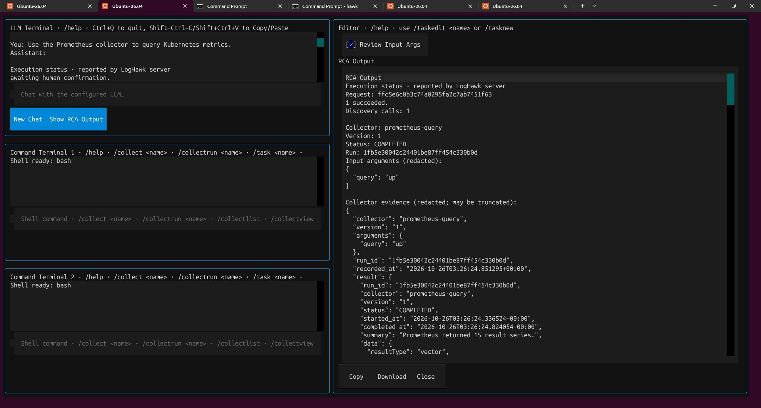
Example Hawk Console RCA interface. Review server execution status separately from the assistant narrative.

13 More Console investigation actions

Find sources and reuse incidents
/investigation s3 s3://loghawk-data/somefolder/incidents/
/investigation link <internal-incident-id>
/investigation collector <tool-call-event-id>
The s3 command lists source objects; it does not itself attach them. Use the Web UI Internal S3 picker for the easiest beginner import workflow. The Console also provides import-s3 with a JSON payload; consult /help and the returned object metadata rather than inventing an ETag or object selection.

Record a finding
/investigation finding {"content":"Errors overlap in time",
"evidence":[]}
Enter this as one line. An empty evidence list saves a finding without source references; it does not prove the statement. Prefer adding source_id, records and supports/contradicts references through the Web UI when learning the structure. A supersedes_id creates a revision of an earlier finding.

End or change the conversation
New Chat asks for confirmation and starts a fresh conversation. It clears the active investigation selection in Console; use /investigation open <id> again when you want to continue that saved investigation. Saved investigations, history and audit records are retained.
/investigation close
Close marks the active investigation closed and clears it from the Console’s active selection. It is different from simply starting a new chat. Use Web UI for the current Change Type, Remove Attachment, Remove Evidence, Unlink Incident and Recent removals Undo controls; corresponding Console commands are not provided by this workflow.

RCA is different from RAG
/rag searches indexed documents. Investigation imports parse structured or text evidence and attach selected records to a saved investigation. Uploading a document through /ragupload does not automatically make it an investigation evidence attachment.

14 Complete worked example
Scenario: checkout returned 503 errors. Stage C identified a payment/order incident; Stage B and raw logs are available. The locations below are examples. Use files and timestamps from your own pipeline run.
1. Create an investigation named Checkout errors during payment incident. Enter the production environment and the actual start/end timestamps.
2. Import somefolder/incidents/correlated_incidents.parquet from Internal S3 with type Stage C. Confirm READY, preview the incident row, select it and Create / Link the incident.
3. Import the relevant anomaly_results.parquet dataset with type Stage B. Choose the new incident under Attach to and select anomalies from the same time window.
4. Import matching Stage A features and raw payment/order logs. Attach relevant rows to the incident; attach shared background information directly to the investigation.
5. If you accidentally chose Stage B for the correlation file, use Change Type. If you attached unrelated logs, remove only that attachment; use Undo if the wrong one was removed.
6. Open RCA Chat from the investigation and ask for a timeline, supported hypotheses and missing evidence.
7. Review any proposed collector arguments. If the collector is live-only, ask the model to clearly separate current state from the historical incident.
8. Save a finding describing the observed overlap and references. Record a suspected cause as a hypothesis until more evidence supports it.
9. Open RCA History. Check the saved context, returned evidence, explanation attempts and model settings. Retry only the explanation if collector execution succeeded but explanation generation failed.
10. Record what remains unknown and the next verification step. Close the investigation when your work is complete.

Expected outcome
You have a saved problem statement, a linked incident, selected supporting evidence, traceable assistant requests and findings that distinguish facts from interpretation. You can explain why a hypothesis is plausible and what evidence would confirm or reject it.
Do not conclude that an anomaly score, correlated time window or successful collector run alone proves causation. A useful conclusion can be “insufficient evidence”; document the specific missing logs, metrics or dependency information needed next.

15 Checklist and glossary

Before asking the model
• The investigation describes the problem and the correct time zone.
• The relevant sources are READY and the intended records are attached.
• Incidents have the expected services and timestamps.
• The collector is eligible and its arguments match the question.
• Historical evidence and current observations are clearly distinguished.

Before accepting a conclusion
• Server status confirms what actually executed.
• Claims can be traced to returned evidence or saved findings.
• Any missing or compacted data is acknowledged.
• Alternative explanations and uncertainty are recorded.
• An explanation retry was not mistaken for another collector execution.
Term | Plain meaning
Schema | The expected structure of input arguments or records.
JSON | Structured text using named fields; valid syntax matters.
JSON Pointer | A path to a nested value, such as /incidents.
PromQL | The query language used by Prometheus.
Redaction | Masking sensitive values.
Compaction | Reducing data before it is sent to the model.
Context snapshot | The saved inputs associated with one RCA request.
Hypothesis | A possible explanation that needs evidence.
Run | One actual task or collector execution.

Related guides
See LogHawk_Web_UI_Beginners_Guide.docx and Hawk_Console_Beginners_Guide.docx for general navigation; How_to_Create_Custom_Collectors.docx for collector authoring; How_to_Troubleshoot_Ollama.docx for inference troubleshooting; and How_to_Clean_Up_Old_Database_Entries_and_Manage_Retention.docx for retention operations.
This guide documents the current application workflow. It does not execute collectors, import files or change your database. Follow your environment’s operational permissions before running actions against production systems.

