LOGHAWK

LogHawk Web UI
Beginner guide to setup sign in pipelines RAG and task management
A step by step guide for first time users
Windows • Linux • macOS

What you will do
This guide takes you from a fresh LogHawk checkout to your first pipeline run. The Web UI is the browser interface for configuring data sources, starting workflows, searching indexed documents, and managing tasks.
How LogHawk works The Web UI starts and monitors work. The Temporal worker processes pipeline activities. AI can explain and suggest; deterministic workflows perform processing.

Before you begin
- Use the repository root as your working directory. Keep the project’s .env file private; it may contain credentials.
- Install Python 3.12, Java 17, Docker (Docker Desktop on Windows), and AWS CLI. Keep Ollama reachable if your configured LLM or identity-mapping setup uses it.
- Start Docker Desktop or the Docker Engine before starting RustFS and Temporal.
- The first-time setup installs Python packages and prepares the project. Allow time and internet access for initial downloads.

Step 1 Set up LogHawk once
Open PowerShell on Windows, or a terminal on Linux/macOS, change to the repository directory, then run the matching setup script.

Windows
cd C:\mywork\loghawk
.\firsttime_setup.bat

Linux and macOS
cd /path/to/loghawk
bash firsttime_setup.sh
The scripts create or update the main Python environment and install application dependencies. Linux/macOS uses the Python 3.12 Conda environment named venv312 under Miniforge; Windows uses venv312 in the repository.
Rerunning setup SKIP_* flags skip the matching service/setup steps only. They do not skip Python environment or package installation.

Step 2 Start services and the Web UI
Windows PowerShell: .\start_all_servers.bat
Linux / macOS: bash start_all_servers.sh
The launcher checks RustFS and Temporal, checks Node.js/npm, installs the Web UI packages, and starts the worker, API, and Vite development server as separate processes.
Web UI: http://localhost:5173
RustFS: http://localhost:9001
Temporal UI: http://localhost:8233
API health: http://127.0.0.1:8000/api/v1/health
If Docker is unavailable RustFS and Temporal will not start. The Web UI may open, but pipeline operations that depend on those services will not work.

Step 3 Sign in and change the initial password
Open http://localhost:5173. On first API startup, the initial Administrator account is:
User ID: admin
Password: admin
After signing in, open Account and change the initial password. Keep credentials private and do not commit them to the repository.
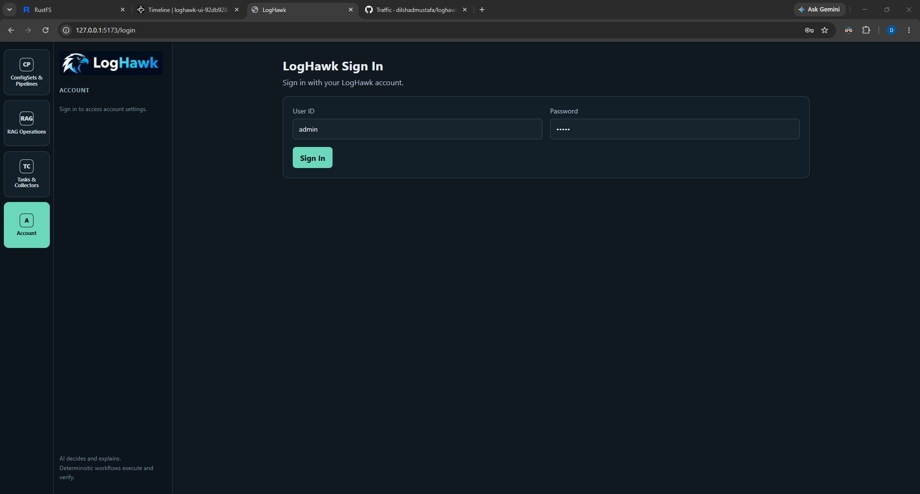
LogHawk sign-in screen.

Step 4 Find your way around
The left rail groups pages. Select a square button to reveal its links:
- ConfigSets & Pipelines — create Config Sets, create or list Pipelines, or start a Quick Run.
- RAG Operations — upload documents, crawl a website, and ask questions about indexed material.
- Tasks & Collectors — create and manage AI-assisted artifacts and operational collectors.
- Account — manage your password and, for Administrators, users.
AI-Assisted RCA opens RCA Chat for evidence collection through approved collectors. Tasks & Collectors includes separate create/list links for Collectors, Remediation Tasks, and Rollback Tasks, plus Built-in Collectors after List Collectors.

Step 5 Create a Config Set
1. Open ConfigSets & Pipelines, then choose Create Config Set.
2. Enter a clear name that teammates can recognize.
3. Choose Internal S3 for data in LogHawk’s RustFS bucket, or External S3 for AWS or another configured external source.
4. For Internal S3, choose the Train and Detect input locations, including the bucket and batch folder.
5. For External S3, add each Train and Detect source separately and specify that source’s AWS region. Choose the RustFS/Internal S3 output bucket and batch folder.
6. Review the displayed paths and save the Config Set.
External S3 regions Each source URL is paired with the region in the same list position. The configured external S3 credentials must be allowed to list and read each selected source.

Step 6 Create and run a Pipeline
1. Choose Create Pipeline, enter a name, and select the Config Set.
2. Choose Train, Detect, or Train & Detect, then save.
3. On List Pipelines, select Run. A Pipeline that is already RUNNING cannot be started again until its current run finishes.
4. Open the Run ID to view workflow details. The Web UI shows status and timestamps from Temporal; timestamps are displayed in the computer’s local timezone.
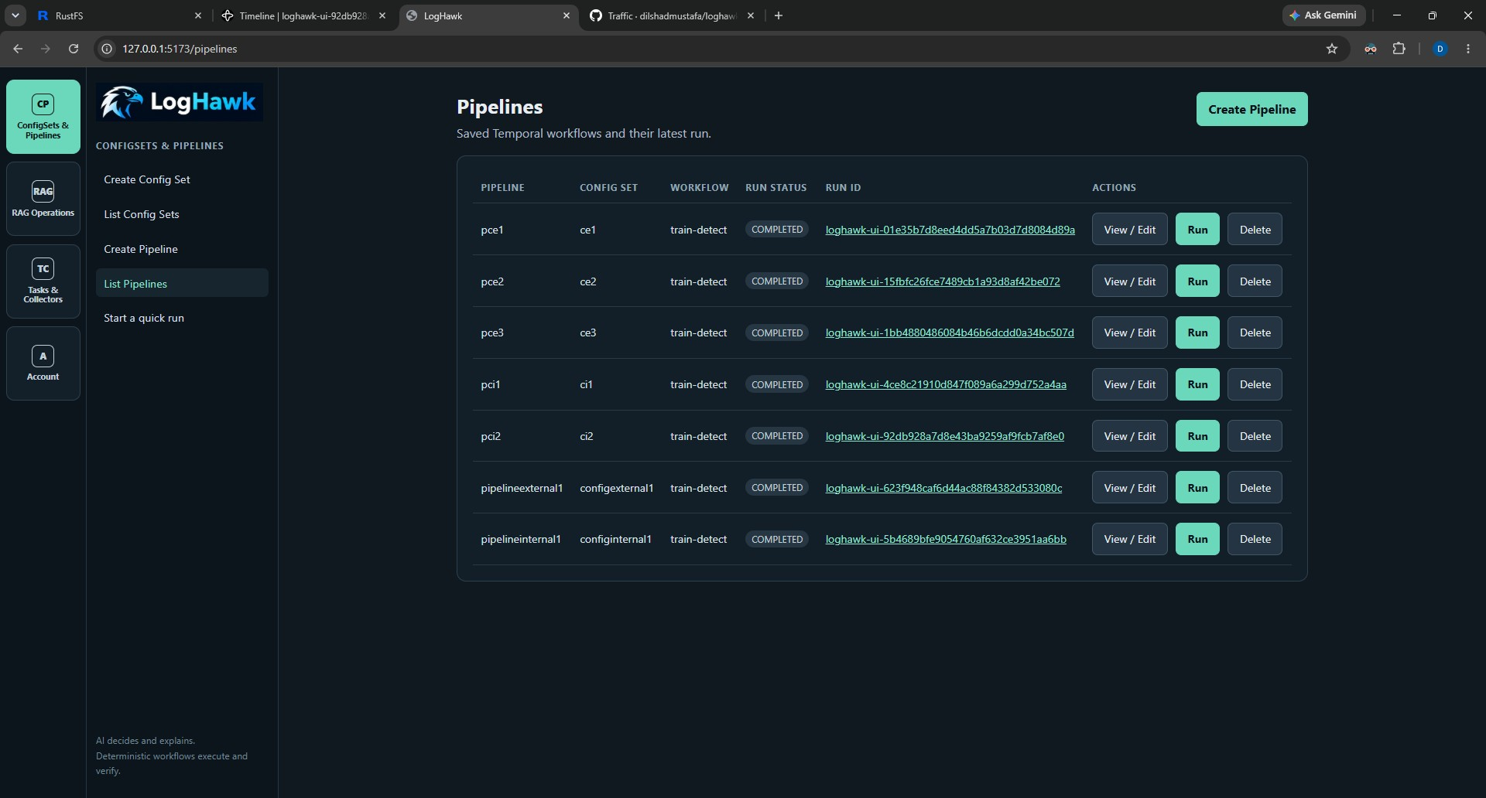
List Pipelines example; names and run IDs shown are example local data.

Quick Run
Choose Start a quick run when you want to run a workflow without first saving a named Pipeline. Review the input and phase settings before starting.

Step 7 Use RAG upload web scrape and questions

Upload documents
1. Open RAG Operations and choose document upload.
2. Select one or more supported local files or a folder, then submit.
3. Wait for the ingestion job to report completion. LogHawk indexes extracted text and metadata in the configured LanceDB table.

Crawl a website
1. Enter the starting URL in the Web Scrape page and submit.
2. Wait for the crawl and indexing job to complete; a crawl can index multiple pages and linked documents.

Ask a question
Use the RAG chat to ask a concrete question about indexed documents. A filename can help identify the source; also ask about the content you need.
What do the indexed documents say about kubectl?
Summarize "CH.pdf".
Compare "CH.pdf" with "Science and Sports (Ch 5 to 8).pdf".
If an answer is incomplete Check that ingestion completed and that the source contains extractable text. Then ask a narrower question.

Step 8 Tasks and Collectors

AI Assisted Tasks
1. In Tasks & Collectors, choose Create Task. Enter a name, description, category, task type, and task kind.
2. Chat with the configured LLM to draft the artifact. Review and edit the code or JSON.
3. Choose Save Version to save explicitly. Drafts are not saved automatically; each save creates a separate version.
4. Review the saved version. A version must be approved and enabled before API-based execution.
Task types include Python, Bash, PowerShell, Windows CMD, and n8n workflow JSON. LogHawk does not execute generated n8n workflows; import them into a customer-managed n8n instance and review them there.
Use a clear description so AI discovery can identify a suitable collector. Categories are stored in uppercase. In Version history, select a version to inspect, download, or delete it if permitted. Saving edited code or schema creates a new version; validation occurs when you save, not while the model is drafting.
For n8n, configure LH_N8N_BASE_URL and LH_N8N_API_KEY for your Customer/User managed instance. Save the current editor content as a version, select Import Into n8n, then Open in n8n. Imported workflows are inactive and should be reviewed there before activation.

Collectors
Collectors gather data through built-in or user-created connectors such as Prometheus and Kubernetes. Review a collector’s description and arguments before running it. Custom collector versions need approval and enabled status for API execution.

Roles and version controls
These permissions apply to signed-in server operations. The owner is the user who created the Task. Administrator access does not bypass approval, enablement, or execution policy.
Capability | Administrator | Power User | User
Create Tasks and Collectors | Yes | Yes | Yes
Edit or delete a Task or version | Any Task | Any Task | Own Tasks
Approve Version | Yes | Yes | No
Enable or disable a version | Any Task | Any Task | Own Tasks
Set Manual AI-Assisted or Disabled policy | Any Task | Any Task | Own Tasks
Set Auto-Approved policy | Yes | Yes | No
Run approved enabled versions through API | Yes | Yes | Yes
Create and delete users | Yes | No | No
Change own password | Yes | Yes | Yes
For built-in collectors, all three roles can enable or disable a collector. Only Administrators and Power Users can change its approval or execution policy.
1. Save the artifact and select its version. A new version starts unapproved and disabled.
2. An Administrator or Power User reviews the code and argument schema, then selects Approve Version.
3. An Administrator, Power User, or Task owner selects Enable Version. Both approval and enablement are required for API execution.
4. Choose an appropriate execution policy. Saving edited code or schema creates a new version; approval and enablement do not carry over.

Execution policies
Policy | Human API request | AI collector request
Manual | Allowed if approved and enabled | Not offered to AI
AI-Assisted | Allowed if approved and enabled | Human confirmation required
Auto-Approved | Allowed if approved and enabled | Automatic unless argument review is selected
Disabled | Blocked for every role | Not offered to AI
Typing /task or /collect is an explicit human request; Manual policy does not add another Yes/No prompt. AI tool calling currently executes eligible Collectors. General, Remediation, and Rollback Tasks are not executed automatically by the RCA collector dispatcher.
Local /taskrun and /collectrun are for development and debugging. They require Y/N confirmation but do not require server approval or enablement.

Define input arguments
Arguments schema JSON is optional for every task kind and is saved with the artifact version. A schema defines allowed argument names, types, and required fields. Blank or {} is saved as the explicit no-arguments schema below; it accepts {} and rejects extra fields.
{
"type": "object",
"properties": {},
"required": [],
"additionalProperties": false
}
For a Prometheus collector that needs a query, use this schema before saving and approving the version:
{
"type": "object",
"properties": {
"query": {"type": "string", "minLength": 1, "maxLength": 2000}
},
"required": ["query"],
"additionalProperties": false
}
Python scripts receive the validated JSON through the environment:
import json
import os
arguments = json.loads(os.environ.get("LH_RUNNER_ARGUMENTS_JSON", "{}"))

Investigate with AI assisted RCA
RCA means root-cause analysis. Ask a concrete operational question, let the model discover an eligible collector, review the proposed arguments, and inspect the evidence returned by deterministic execution. An AI explanation is an interpretation of evidence, not proof that an action ran.

Prepare a collector
1. Have an Administrator configure the API server LLM settings in .env and connector access in .env_tools. The API host must be able to reach Prometheus, Kubernetes, or Jira as applicable.
2. In the Web UI, open Tasks & Collectors > Built-in Collectors. Built-ins are separate from user-created Collector Tasks. Initial built-in registration is approved and enabled with Manual policy.
3. An Administrator or Power User selects AI-Assisted or Auto-Approved policy. For a custom collector, save a description and argument schema, then approve and enable the latest version. AI discovery does not fall back to an older version when the latest is ineligible.
Built-in collector | What it reads
prometheus-query | An instant PromQL query
kubernetes-pods | Pod names and status in a namespace
jira-issue-search | Jira issues matching a JQL search
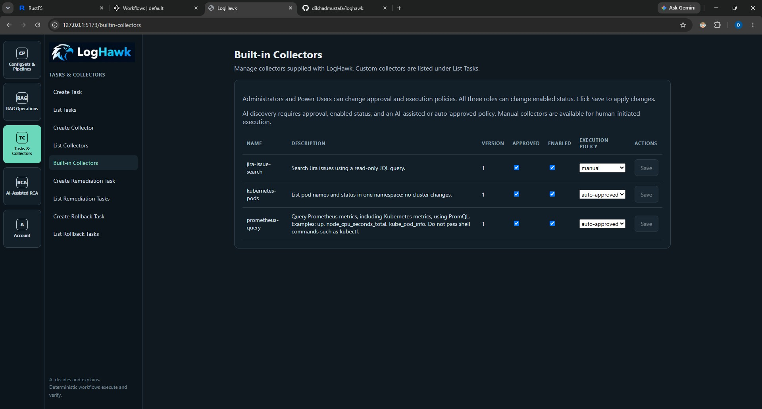
Built-in Collectors: inspect approval, enabled status, and execution policy before requesting an AI run.

Run your first investigation
1. Open AI-Assisted RCA > RCA Chat.
2. Leave Review Input Args checked at the top of RCA Chat.
3. Send the example below. When input review appears, inspect the exact collector version and JSON arguments. Use query up for a simple Prometheus connectivity check.
4. Edit arguments if needed, then choose Confirm & Execute, or choose Cancel. This reviews the inputs only; it does not approve the collector code.
5. Wait for the server-reported result. Inspect the collector name, version, status, run ID, arguments, and evidence before relying on the explanation.
Use the Prometheus collector to query Kubernetes metrics.

Example input arguments:
{"query":"up"}
Invalid arguments are rejected against the saved schema and can be corrected before confirmation. Unchanged masked values retain their original server-side values. A metric value of 1 for kube_pod_info is metadata; it does not establish that a pod is healthy or ready.
Review Input Args | Auto-Approved policy | AI-Assisted policy
Checked | Edit inputs then confirm or cancel | Edit inputs then confirm or cancel
Unchecked | Executes automatically; inputs appear with result | Still requires confirmation; inputs are read-only
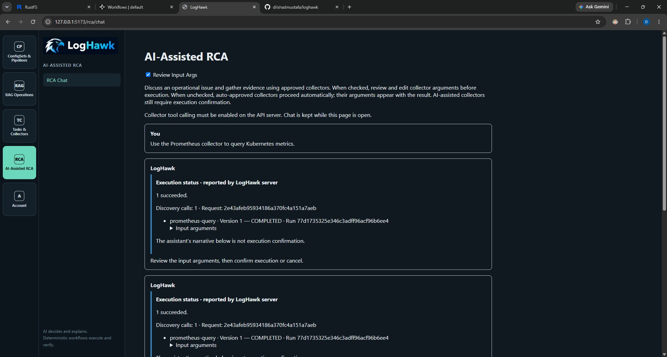
RCA with input review, example 1. Compare the displayed inputs and server status with your own request; example names and results vary.
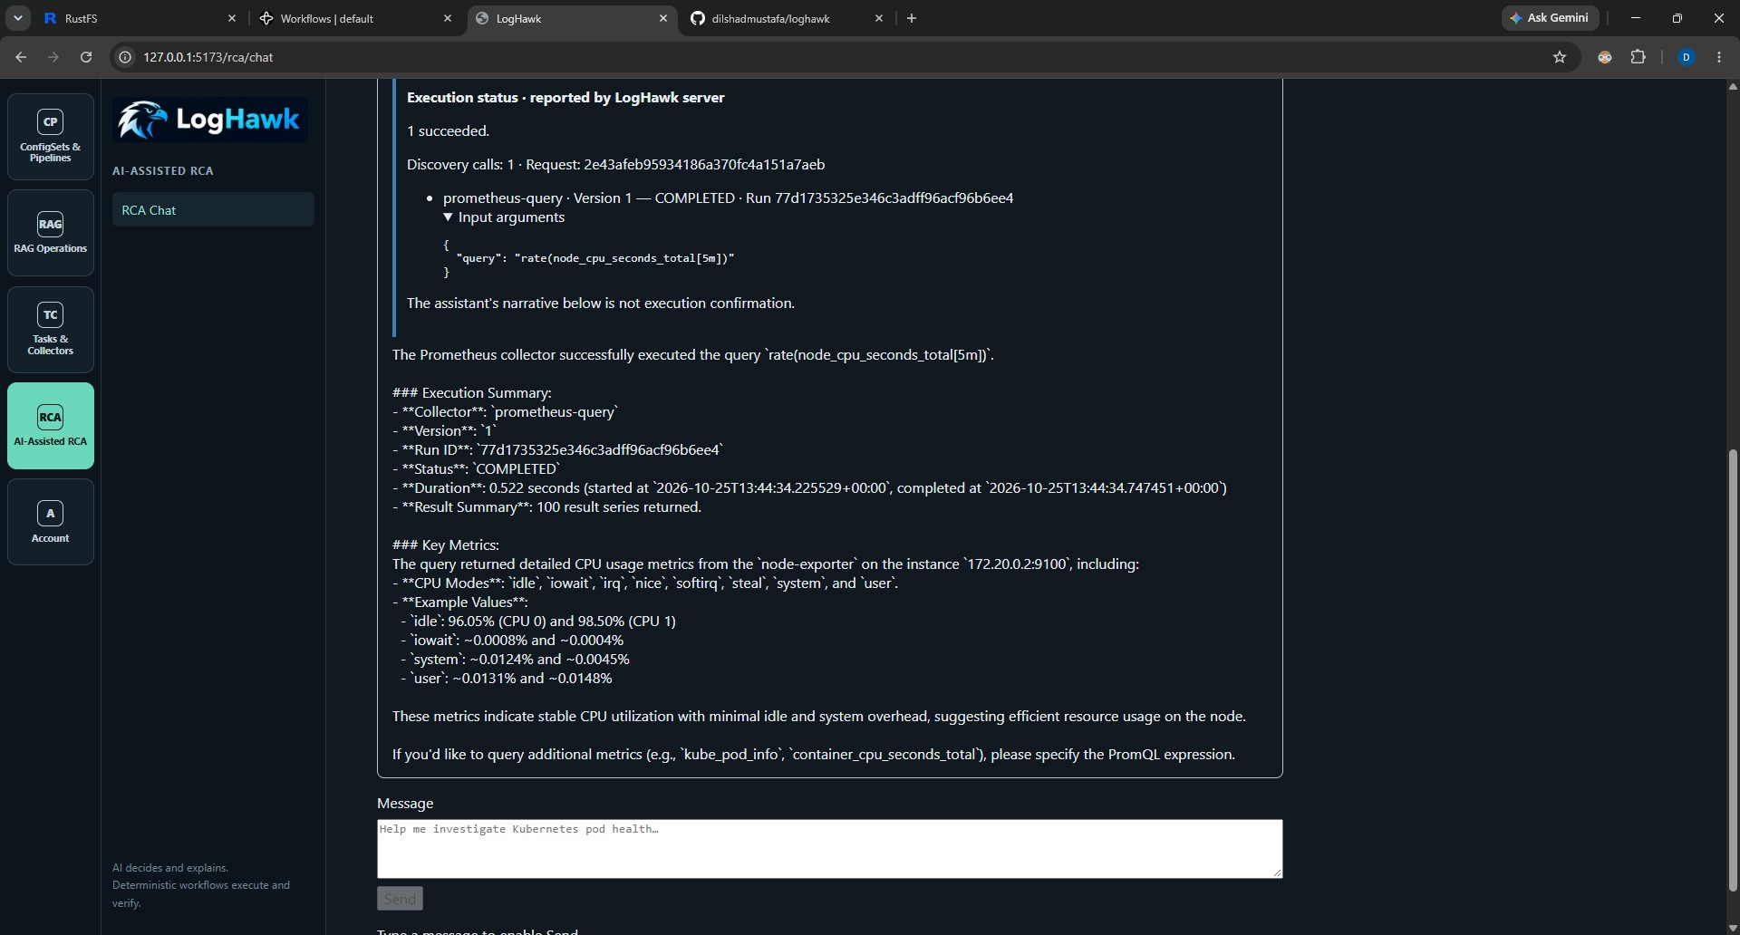
RCA with input review, example 2. Compare the displayed inputs and server status with your own request; example names and results vary.

Use automatic collector execution
Use this option only for a collector whose saved version is approved, enabled, and has Auto-Approved policy. Clear Review Input Args before sending the request. The server displays the arguments with the result. Clearing the checkbox does not override an AI-Assisted policy, which still requires confirmation.
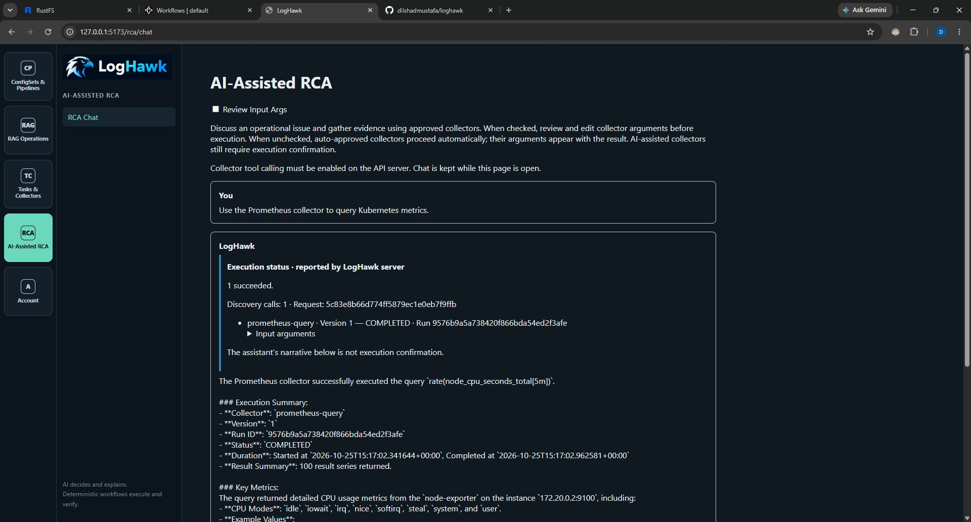
Automatic RCA example 1. Read the recorded execution outcome before interpreting the model response.
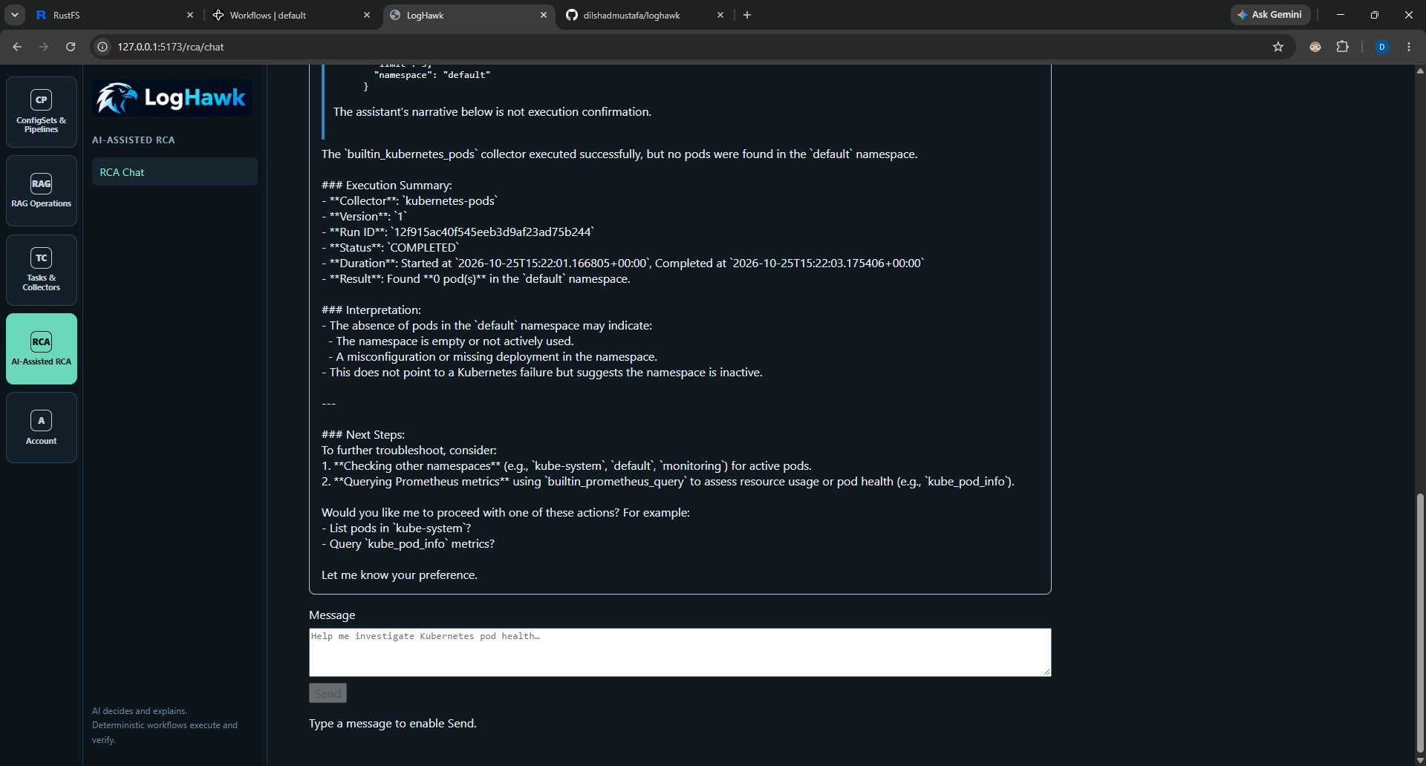
Automatic RCA example 4. Read the recorded execution outcome before interpreting the model response.

Read evidence and start a new conversation
Expand Input arguments and Collector evidence in the response. Earlier chat messages keep their original execution status. The RCA conversation is retained while the page is open; begin a fresh page session when you need a fresh conversation.
The server status is authoritative. A model statement such as "proceeding with execution" does not mean a collector ran. A completed collector can still be followed by a failed AI explanation.
Redacted means sensitive values such as credentials and tokens are masked. Compacted means repeated details have been reduced. Truncated means some content was omitted. Saved returned evidence is separate from the smaller model input; collectors may themselves limit the number of records returned.
AI audit records retain origin=AI, origin_userid for the signed-in user, and origin_software=web or console. Explanation attempts are recorded separately from execution outcomes.

Retry an explanation without running the collector again
1. If execution says COMPLETED but the explanation fails or times out, inspect the saved evidence first.
2. Select Retry AI Explanation on the failed explanation response.
3. Wait for a new explanation based on the saved question and evidence. The retry does not rediscover or rerun collectors.
4. If it fails again, check model availability and the separate explanation timeout. Only requests with saved explanation context support this retry.
The API checks request ownership and prevents concurrent active explanation retries. Each retry has its own time budget and audit record. Do not resubmit the original collection request merely to retry an explanation.

Configure the model and time budgets
Set these values in the API server .env file. This is an example configuration, not a requirement that every machine use the same model or context size. A reasoning model can take longer to produce an answer; choose a model and context size that fit the available hardware.
LH_LLM_TOOL_CALLING_ENABLED=true
LH_LLM_TOOL_MODEL=qwen3:4b-instruct
LH_LLM_TOOL_CONTEXT_LENGTH=8192
LH_LLM_TOOL_MAX_TOKENS=1024
LH_LLM_TOOL_MAX_CALLS=3
LH_LLM_TOOL_TIMEOUT_SECONDS=300
LH_LLM_TOOL_EXPLANATION_TIMEOUT_SECONDS=180
LH_LLM_TOOL_MAX_RESULT_CHARS=6000
Setting | Meaning
Tool model | Uses the configured LiteLLM provider and base URL. Task drafting can use LH_LLM_CODEASSIST_MODEL separately.
Context length and maximum tokens | Bound model input/output and generation length. Larger budgets can increase memory use and latency.
Maximum calls | Includes collector discovery as well as execution tool calls.
Tool timeout | Shared discovery/execution processing budget; human confirmation wait is excluded. Code default: 120 seconds.
Explanation timeout | Additional, independent budget for final explanation and each retry. Code default: 180 seconds.
Maximum result characters | Bounds model-facing result and discovery text; it is not a guarantee of unlimited source evidence.
Restart the API after changing its .env settings. Restart Hawk Console after changing its local configuration so its HTTP timeout accounts for both budgets. Final explanation uses a separate model call without execution tools. Transport retries are disabled for this flow; bounded correction of narration into a tool call is not a collector execution retry.

Schedule a Pipeline with CronJob
On Linux or macOS, cron can start a saved Pipeline every 15 minutes. Keep the API, Temporal server, and worker running. Cron does not activate your interactive Python environment automatically.

Typical usage
1. Create and run a Train-only Pipeline once against External/Internal S3 locations containing QA, UAT, or Pre-Prod logs, metrics, and traces. Configure the Train only pipeline to write the trained models into a RustFS/Internal S3 bucket and batch folder.
2. Create a Detect-only Pipeline using Production input locations. Select the same RustFS/Internal S3 output bucket and batch folder where the training run saved its ML models.
3. Use training data representative of expected Production behavior, with compatible schemas and feature groups. Schedule the Detect-only Pipeline every 15 minutes.

Configure the launcher
Edit run_pipeline_email.sh. Set the saved Pipeline name, credentials, and batch S3 URL there, or provide them in its environment. The batch URL is a launcher setting; it identifies where the runner reads incidents.
LH_PIPELINE_NAME=pce3
LH_PIPELINE_USERID=admin
LH_PIPELINE_PASSWORD=replace-with-your-current-password
LH_PIPELINE_BATCH_S3_URL=s3://loghawk-data/somefolder/
Change the initial admin password and keep credentials out of version control. Configure SMTP host, port, sender, recipient, authentication, and STARTTLS using the LH_PIPELINE_EMAIL_* settings in .env. Configure internal S3 access so the runner can read the incident output.
Run crontab -e and add the following, replacing every /absolute/path value with the real path on your machine:
PATH=/absolute/path/to/venv312/bin:/usr/local/bin:/usr/bin:/bin
*/15 * * * * /absolute/path/to/loghawk/run_pipeline_email.sh >> "$HOME/loghawk-pipeline-cron.log" 2>&1
Cron uses the machine local timezone. The runner skips a Pipeline that is already running; otherwise it starts the run and waits for completion or failure. It derives incidents/correlated_incidents.parquet from LH_PIPELINE_BATCH_S3_URL and emails changed incident output as CSV. Confirm the output URL matches the Pipeline output location.

Account and user management
Every signed-in user can change their own password from Account Settings. Administrators can create users and assign roles from User Management. Use unique passwords and do not share administrator credentials.

Troubleshooting
The startup script says Docker is unavailable. Start Docker Desktop/Engine and confirm docker works in that terminal, then rerun the launcher.
The browser cannot reach the API. Confirm the API is running and LH_API_SERVER_URL in .env points to an address reachable by the Web UI proxy.
A Pipeline stays pending or fails. Confirm Temporal and the worker are running; inspect the run details in Temporal UI and the worker console.
External buckets cannot be listed. Check credentials, endpoint, region, bucket policy, and network reachability.
RAG returns no useful information. Check ingestion status, confirm the source contains extractable text, and ask a focused question.
Collector completed but AI explanation failed: expand Collector evidence and use Retry AI Explanation. No collector was recorded: inspect discovery and policy rather than trusting narrative text. HTTP 400 from Prometheus: inspect the input PromQL and server error; a response was received, so this is not proof that the server is unreachable.

A simple first session
Set up the environment → start services → sign in and change the password → create a Config Set → create a Pipeline → run it → inspect the result → upload a runbook → ask a RAG question.

