Table of Contents

System

Table of Figures

System

Entity Relationship Diagram

# System

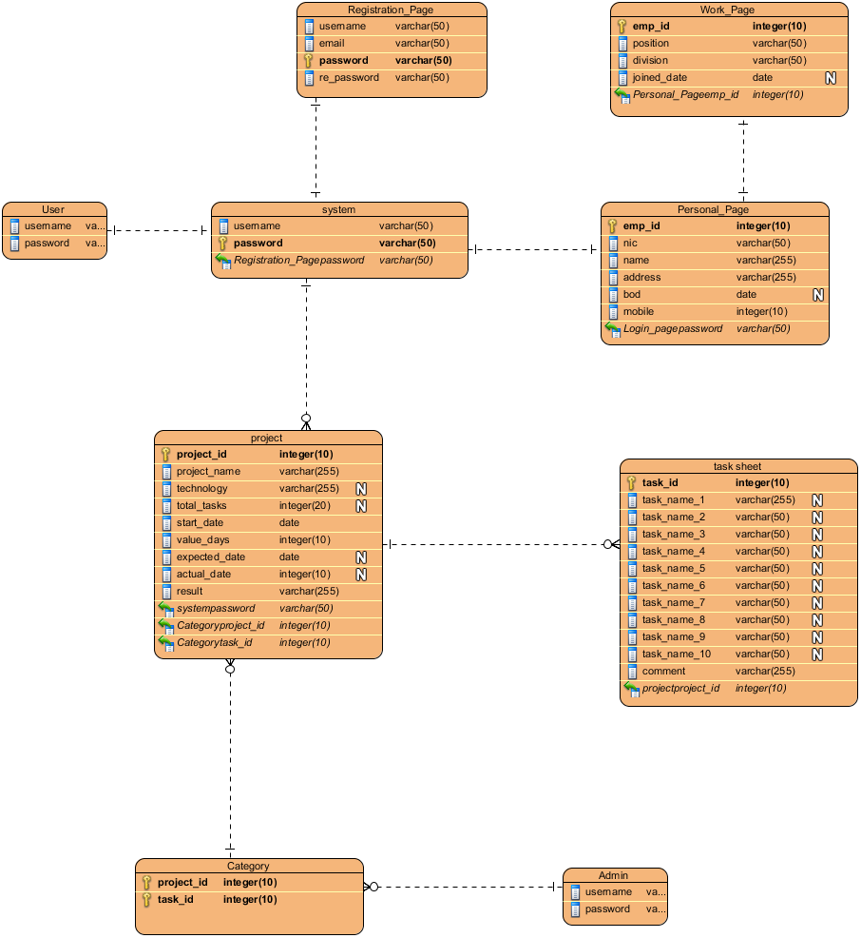

|  |  |
| --- | --- |
| **Name** | **Value** |
| Name | System |
| Author | User |
| Create Date Time | May 11, 2020 1:20:59 PM |
| Last Modified | May 12, 2020 11:06:56 PM |
| Data Model | Physical |

## Summary

|  |  |
| --- | --- |
| **Name** | **Documentation** |
| Image1.png Registration_Page |  |
| Image1.png Work_Page |  |
| Image1.png User |  |
| Image1.png system |  |
| Image1.png Personal_Page |  |
| Image1.png project |  |
| Image1.png task sheet |  |
| Image1.png Category |  |
| Image1.png Admin |  |

## Details

### Image1.png Registration_Page

|  |  |
| --- | --- |
| **Name** | **Value** |
| Author | User |
| Create Date Time | May 11, 2020 1:28:19 PM |
| Last Modified | May 11, 2020 2:13:27 PM |
| Data Model | Physical |
| Quality Score | Ignore |
| Records | N/A |

#### Columns Summary

|  |  |  |  |  |
| --- | --- | --- | --- | --- |
| **Name** | **DataType** | **Constraints** | **Nullable** | **Documentation** |
| username | varchar(50) |  | No |  |
| email | varchar(50) |  | No |  |
| password | varchar(50) | PK | No |  |
| re_password | varchar(50) |  | No |  |

#### Relationships

|  |  |
| --- | --- |
| **Unnamed Relationship** | |
| To | Image1.png system |
| Author | User |
| Create Date Time | May 11, 2020 1:57:04 PM |
| Last Modified | May 11, 2020 2:23:58 PM |
| Quality Score | Good |
| Identifying | false |
| Subtype | false |
| To Multiplicity | 1 |
| From Multiplicity | 1 |
| Sync To Association | Yes |
| Data Model | Physical |

### Image1.png Work_Page

|  |  |
| --- | --- |
| **Name** | **Value** |
| Author | User |
| Create Date Time | May 11, 2020 1:35:09 PM |
| Last Modified | May 11, 2020 2:13:27 PM |
| Data Model | Physical |
| Quality Score | Ignore |
| Records | N/A |

#### Columns Summary

|  |  |  |  |  |
| --- | --- | --- | --- | --- |
| **Name** | **DataType** | **Constraints** | **Nullable** | **Documentation** |
| emp_id | integer(10) | PK | No |  |
| position | varchar(50) |  | No |  |
| division | varchar(50) |  | No |  |
| joined_date | date |  | Yes |  |
| Personal_Pageemp_id | integer(10) | FK (Personal_Page.emp_id) | No |  |

#### Relationships

|  |  |
| --- | --- |
| **Unnamed Relationship** | |
| From | Image1.png Personal_Page |
| Author | User |
| Create Date Time | May 11, 2020 1:59:40 PM |
| Last Modified | May 11, 2020 2:23:58 PM |
| Quality Score | Good |
| Identifying | false |
| Subtype | false |
| To Multiplicity | 1 |
| From Multiplicity | 1 |
| Sync To Association | Yes |
| Data Model | Physical |

### Image1.png User

|  |  |
| --- | --- |
| **Name** | **Value** |
| Author | User |
| Create Date Time | May 12, 2020 10:48:56 PM |
| Last Modified | May 12, 2020 10:59:11 PM |
| Data Model | Physical |
| Quality Score | Ignore |

#### Columns Summary

|  |  |  |  |  |
| --- | --- | --- | --- | --- |
| **Name** | **DataType** | **Constraints** | **Nullable** | **Documentation** |
| username | varchar(50) |  | No |  |
| password | varchar(50) |  | No |  |

#### Relationships

|  |  |
| --- | --- |
| **Unnamed Relationship** | |
| To | Image1.png system |
| Author | User |
| Create Date Time | May 12, 2020 11:00:07 PM |
| Last Modified | May 12, 2020 11:00:07 PM |
| Identifying | false |
| Subtype | false |
| To Multiplicity | 1 |
| From Multiplicity | 1 |
| Sync To Association | Yes |
| Data Model | Physical |

### Image1.png system

|  |  |
| --- | --- |
| **Name** | **Value** |
| Author | User |
| Create Date Time | May 11, 2020 1:24:42 PM |
| Last Modified | May 12, 2020 10:59:11 PM |
| Data Model | Physical |
| Quality Score | Ignore |
| Records | N/A |

#### Columns Summary

|  |  |  |  |  |
| --- | --- | --- | --- | --- |
| **Name** | **DataType** | **Constraints** | **Nullable** | **Documentation** |
| username | varchar(50) |  | No |  |
| password | varchar(50) | PK | No |  |
| Registration_Pagepassword | varchar(50) | FK (Registration_Page.password) | No |  |

#### Relationships

|  |  |
| --- | --- |
| **Unnamed Relationship** | |
| To | Image1.png Personal_Page |
| Author | User |
| Create Date Time | May 11, 2020 1:57:43 PM |
| Last Modified | May 11, 2020 2:23:58 PM |
| Quality Score | Good |
| Identifying | false |
| Subtype | false |
| To Multiplicity | 1 |
| From Multiplicity | 1 |
| Sync To Association | Yes |
| Data Model | Physical |

|  |  |
| --- | --- |
| **Unnamed Relationship** | |
| To | Image1.png project |
| Author | User |
| Create Date Time | May 12, 2020 10:56:35 PM |
| Last Modified | May 12, 2020 10:59:11 PM |
| Identifying | false |
| Subtype | false |
| To Multiplicity | 0..* |
| From Multiplicity | 1 |
| Sync To Association | Yes |
| Data Model | Physical |

|  |  |
| --- | --- |
| **Unnamed Relationship** | |
| From | Image1.png Registration_Page |
| Author | User |
| Create Date Time | May 11, 2020 1:57:04 PM |
| Last Modified | May 11, 2020 2:23:58 PM |
| Quality Score | Good |
| Identifying | false |
| Subtype | false |
| To Multiplicity | 1 |
| From Multiplicity | 1 |
| Sync To Association | Yes |
| Data Model | Physical |

|  |  |
| --- | --- |
| **Unnamed Relationship** | |
| From | Image1.png User |
| Author | User |
| Create Date Time | May 12, 2020 11:00:07 PM |
| Last Modified | May 12, 2020 11:00:07 PM |
| Identifying | false |
| Subtype | false |
| To Multiplicity | 1 |
| From Multiplicity | 1 |
| Sync To Association | Yes |
| Data Model | Physical |

### Image1.png Personal_Page

|  |  |
| --- | --- |
| **Name** | **Value** |
| Author | User |
| Create Date Time | May 11, 2020 1:31:22 PM |
| Last Modified | May 11, 2020 2:13:27 PM |
| Data Model | Physical |
| Quality Score | Ignore |
| Records | N/A |

#### Columns Summary

|  |  |  |  |  |
| --- | --- | --- | --- | --- |
| **Name** | **DataType** | **Constraints** | **Nullable** | **Documentation** |
| emp_id | integer(10) | PK | No |  |
| nic | varchar(50) |  | No |  |
| name | varchar(255) |  | No |  |
| address | varchar(255) |  | No |  |
| bod | date |  | Yes |  |
| mobile | integer(10) |  | No |  |
| Login_pagepassword | varchar(50) | FK (system.password) | No |  |

#### Relationships

|  |  |
| --- | --- |
| **Unnamed Relationship** | |
| To | Image1.png Work_Page |
| Author | User |
| Create Date Time | May 11, 2020 1:59:40 PM |
| Last Modified | May 11, 2020 2:23:58 PM |
| Quality Score | Good |
| Identifying | false |
| Subtype | false |
| To Multiplicity | 1 |
| From Multiplicity | 1 |
| Sync To Association | Yes |
| Data Model | Physical |

|  |  |
| --- | --- |
| **Unnamed Relationship** | |
| From | Image1.png system |
| Author | User |
| Create Date Time | May 11, 2020 1:57:43 PM |
| Last Modified | May 11, 2020 2:23:58 PM |
| Quality Score | Good |
| Identifying | false |
| Subtype | false |
| To Multiplicity | 1 |
| From Multiplicity | 1 |
| Sync To Association | Yes |
| Data Model | Physical |

### Image1.png project

|  |  |
| --- | --- |
| **Name** | **Value** |
| Author | User |
| Create Date Time | May 11, 2020 1:38:17 PM |
| Last Modified | May 12, 2020 10:59:11 PM |
| Data Model | Physical |
| Quality Score | Ignore |
| Records | N/A |

#### Columns Summary

|  |  |  |  |  |
| --- | --- | --- | --- | --- |
| **Name** | **DataType** | **Constraints** | **Nullable** | **Documentation** |
| project_id | integer(10) | PK | No |  |
| project_name | varchar(255) |  | No |  |
| technology | varchar(255) |  | Yes |  |
| total_tasks | integer(20) |  | Yes |  |
| start_date | date |  | No |  |
| value_days | integer(10) |  | No |  |
| expected_date | date |  | Yes |  |
| actual_date | integer(10) |  | Yes |  |
| result | varchar(255) |  | No |  |
| systempassword | varchar(50) | FK (system.password) | No |  |
| Categoryproject_id | integer(10) | FK (Category.project_id) | No |  |
| Categorytask_id | integer(10) | FK (Category.task_id) | No |  |

#### Relationships

|  |  |
| --- | --- |
| **Unnamed Relationship** | |
| To | Image1.png task sheet |
| Author | User |
| Create Date Time | May 12, 2020 10:54:13 PM |
| Last Modified | May 12, 2020 10:59:11 PM |
| Quality Score | Good |
| Identifying | false |
| Subtype | false |
| To Multiplicity | 0..* |
| From Multiplicity | 1 |
| Sync To Association | Yes |
| Data Model | Physical |

|  |  |
| --- | --- |
| **Unnamed Relationship** | |
| From | Image1.png system |
| Author | User |
| Create Date Time | May 12, 2020 10:56:35 PM |
| Last Modified | May 12, 2020 10:59:11 PM |
| Identifying | false |
| Subtype | false |
| To Multiplicity | 0..* |
| From Multiplicity | 1 |
| Sync To Association | Yes |
| Data Model | Physical |

|  |  |
| --- | --- |
| **Unnamed Relationship** | |
| From | Image1.png Category |
| Author | User |
| Create Date Time | May 12, 2020 11:02:16 PM |
| Last Modified | May 12, 2020 11:02:16 PM |
| Identifying | false |
| Subtype | false |
| To Multiplicity | 0..* |
| From Multiplicity | 1 |
| Sync To Association | Yes |
| Data Model | Physical |

### Image1.png task sheet

|  |  |
| --- | --- |
| **Name** | **Value** |
| Author | User |
| Create Date Time | May 11, 2020 1:44:44 PM |
| Last Modified | May 12, 2020 10:59:11 PM |
| Data Model | Physical |
| Quality Score | Ignore |
| Records | N/A |

#### Columns Summary

|  |  |  |  |  |
| --- | --- | --- | --- | --- |
| **Name** | **DataType** | **Constraints** | **Nullable** | **Documentation** |
| task_id | integer(10) | PK | No |  |
| task_name_1 | varchar(255) |  | Yes |  |
| task_name_2 | varchar(50) |  | Yes |  |
| task_name_3 | varchar(50) |  | Yes |  |
| task_name_4 | varchar(50) |  | Yes |  |
| task_name_5 | varchar(50) |  | Yes |  |
| task_name_6 | varchar(50) |  | Yes |  |
| task_name_7 | varchar(50) |  | Yes |  |
| task_name_8 | varchar(50) |  | Yes |  |
| task_name_9 | varchar(50) |  | Yes |  |
| task_name_10 | varchar(50) |  | Yes |  |
| comment | varchar(255) |  | No |  |
| projectproject_id | integer(10) | FK (project.project_id) | No |  |

#### Relationships

|  |  |
| --- | --- |
| **Unnamed Relationship** | |
| From | Image1.png project |
| Author | User |
| Create Date Time | May 12, 2020 10:54:13 PM |
| Last Modified | May 12, 2020 10:59:11 PM |
| Quality Score | Good |
| Identifying | false |
| Subtype | false |
| To Multiplicity | 0..* |
| From Multiplicity | 1 |
| Sync To Association | Yes |
| Data Model | Physical |

### Image1.png Category

|  |  |
| --- | --- |
| **Name** | **Value** |
| Author | User |
| Create Date Time | May 11, 2020 1:52:27 PM |
| Last Modified | May 12, 2020 10:59:11 PM |
| Data Model | Physical |
| Quality Score | Ignore |
| Records | N/A |

#### Columns Summary

|  |  |  |  |  |
| --- | --- | --- | --- | --- |
| **Name** | **DataType** | **Constraints** | **Nullable** | **Documentation** |
| project_id | integer(10) | PK | No |  |
| task_id | integer(10) | PK | No |  |

#### Relationships

|  |  |
| --- | --- |
| **Unnamed Relationship** | |
| To | Image1.png project |
| Author | User |
| Create Date Time | May 12, 2020 11:02:16 PM |
| Last Modified | May 12, 2020 11:02:16 PM |
| Identifying | false |
| Subtype | false |
| To Multiplicity | 0..* |
| From Multiplicity | 1 |
| Sync To Association | Yes |
| Data Model | Physical |

|  |  |
| --- | --- |
| **Unnamed Relationship** | |
| From | Image1.png Admin |
| Author | User |
| Create Date Time | May 12, 2020 10:53:50 PM |
| Last Modified | May 12, 2020 10:59:11 PM |
| Quality Score | Good |
| Identifying | false |
| Subtype | false |
| To Multiplicity | 0..* |
| From Multiplicity | 1 |
| Sync To Association | Yes |
| Data Model | Physical |

### Image1.png Admin

|  |  |
| --- | --- |
| **Name** | **Value** |
| Author | User |
| Create Date Time | May 12, 2020 10:49:47 PM |
| Last Modified | May 12, 2020 10:59:11 PM |
| Data Model | Physical |
| Quality Score | Fair |
| Quality Reason | |  |  | | --- | --- | | **Problem** | **Suggestion** | | Model element at root | Add model element to a container | | Name does not contain glossary terms | Define name as term in glossary | |

#### Columns Summary

|  |  |  |  |  |
| --- | --- | --- | --- | --- |
| **Name** | **DataType** | **Constraints** | **Nullable** | **Documentation** |
| username | varchar(50) |  | No |  |
| password | varchar(50) |  | No |  |

#### Relationships

|  |  |
| --- | --- |
| **Unnamed Relationship** | |
| To | Image1.png Category |
| Author | User |
| Create Date Time | May 12, 2020 10:53:50 PM |
| Last Modified | May 12, 2020 10:59:11 PM |
| Quality Score | Good |
| Identifying | false |
| Subtype | false |
| To Multiplicity | 0..* |
| From Multiplicity | 1 |
| Sync To Association | Yes |
| Data Model | Physical |