

|  |
| --- |
|  |
| OpenCart Web Application |

| Related Artifacts |
| --- |
| Name |
| |  | | --- | | OpenCart Test Plan |  |  | | --- | |  | |
| |  | | --- | | OpenCart Test Cases Document |  |  | | --- | |  | |
| OpenCart Bug Reports Document |
|  |

Contents

1 Introduction 4

1.1 Purpose 4

1.2 Scope 4

1.3 Definitions, Acronyms, and Abbreviations 4

1.4 Overview 4

2 Test Results Summary 5

3 Test Cases executed 5

4 Suggested Actions 6

5 Diagrams 7

5.1 Test Execution Summary 7

5.2 Defect Severity Distribution 7

5.3 Defect Priority Breakdown 8

5.4 Defect Status Overview 9

# Introduction

## Purpose

The purpose of this Test Result Report is to present the outcomes of manual testing activities conducted on the demo instance of the OpenCart e-commerce platform (<https://demo.opencart.com>). This document provides a summary of the executed test cases, their results, and identified defects. It serves to validate that the system functions as expected within the defined scope and to ensure it meets the specified functional requirements.

The report also aims to highlight critical issues, analyze test coverage, and assess the overall quality and readiness of the application for use.

## Scope

This Test Result Report covers the manual black-box testing of the demo OpenCart application, specifically focusing on key user-facing functionalities such as user registration, login/logout, product search, cart operations, checkout process, and order history. Testing was conducted based on predefined test cases aligned with the functional requirements of a standard e-commerce platform.

The scope of this report is limited to the demo environment provided by OpenCart and does not include performance testing, security testing, or testing of any third-party extensions. The results are intended to evaluate the default behavior and stability of the core features available in the demo version.

## Definitions, Acronyms, and Abbreviations

| **Term/Acronym** | **Definition** |
| --- | --- |
| **TRR** | Test Result Report – A document summarizing the outcomes of software testing activities. |
| **SUT** | System Under Test – The OpenCart demo application being tested. |
| **UI** | User Interface – The visual part of the application with which users interact. |
| **TC** | Test Case – A set of conditions or actions used to verify a particular feature or functionality. |
| **Defect/Bug** | An error or flaw in the software that causes it to produce incorrect or unexpected results. |
| **PASS** | A test case status indicating that the actual result matches the expected result. |
| **FAIL** | A test case status indicating that the actual result does not match the expected result. |
| **Black-box Testing** | A testing method where the tester does not need to know the internal workings of the application. |
| **OpenCart** | A free, open-source e-commerce platform used for online stores. |

## Overview

This Test Result Report documents the results of manual black-box testing conducted on the OpenCart demo application. It includes summaries of testing activities, coverage analysis, and final observations to evaluate the application’s readiness.

The document is organized as follows:

**Section 1** provides the introduction, including the purpose, scope, and definitions relevant to this report.

**Section 2** presents a summary of overall test results.

**Section 3** covers test cases executed during the testing process..

**Section 5** outlines suggested actions based on the test outcomes.

**Section 6** includes diagrams that support and visualize the testing process and results.

# Test Results Summary

Manual testing was performed on the OpenCart demo application, covering 185 test cases across 17 functional areas. Out of the total test cases:

* **Executed Test Cases:** 185
* **Passed:** 163
* **Failed:** 22
* **Blocked/Not Executed:** 0

A total of **22 defects** were reported during testing. The breakdown of defect severity and priority is as follows:

* **Severity Levels:**
  + **Critical:** 5
  + **Major:** 12
  + **Minor:** 5
  + **Blocker:** 0
* **Priority Levels:**
  + **P0 (Critical):** 2
  + **P1 (High):** 11
  + **P2 (Medium):** 5
  + **P3 (Low):** 4
* **Defect Status:**
  + **Open:** 13
  + **Closed:** 9

Notably, several **Critical and Major defects** remain **open**, which directly impact key workflows and stability. As a result, the current state of the system **cannot be considered stable** for production use. Further iterations and defect resolution are recommended before release or UAT.

# Test Cases executed

During this testing cycle, a total of **185 test cases** were executed across **17 functional areas** of the OpenCart demo application. The focus was on validating key user flows, and business logic.

| **Test Case Metric** | **Current Cycle** | **Trend/Remarks** |
| --- | --- | --- |
| Total Test Cases | 185 | - |
| Passed | 163 | Majority stable |
| Failed | 22 | Higher than expected failure rate |
| Blocked/Not Run | 0 | No blocked cases this cycle |

#### Key Observations:

* A total of **22 test cases failed**, mainly due to open defects of **Critical** and **Major** severity.
* Although no test cases were blocked or deferred, the **22 failed cases (≈12%)** is a **significant regression** from previous expectations of stability.
* **No improvement trend** observed yet, as critical workflows still break under common test conditions.

#### Functional Areas with Most Failures:

* **Registration**: 2 failures
* **Login**: 3 failures
* **Search**: 4 failures
* **Shopping Cart**: 2 failures

These modules account for **11 out of the 22 total failures** and are closely linked to **critical user journey scenarios**.

Further testing is recommended following resolution of the current open defects to verify fixes and ensure stability before considering release readiness.

# Suggested Actions

Based on the test results and current defect distribution, the following actions are recommended:

1. **Prioritize Resolution of Open Critical and Major Defects**
   * **2 critical** and **7 major** issues are still open, directly impacting key user flows like **registration, login, search, and shopping cart**.
   * Immediate triage and resolution of these should be top priority. Assign ownership and expedite fix timelines to reduce risk.
2. **Plan for Rapid Retesting of High-Priority Fixes**
   * As critical and major defects are addressed, ensure timely **re-execution of associated test cases**.
   * Focus regression on dependent modules to verify stability and prevent recurrence.
3. **Monitor and Mitigate Minor Defects**
   * **4 minor issues** should be tracked but may be deferred based on release timelines and impact.
   * Where quick wins are possible, consider addressing them to polish the user experience.
4. **Stability Gate Before Advancing to Next Test Phases**
   * Hold off on progressing to UAT or other testing phases until critical and major issues are resolved and the system demonstrates baseline stability.
5. **Enhance Coverage in Problematic Areas**
   * Review and expand tests around **registration, login, search, and cart** functionalities to cover edge cases and avoid regression.
6. **Retrospective & Root Cause Analysis**
   * Post-resolution, conduct a quick analysis to understand why defects weren’t caught earlier and how test design, environment, or process could be improved.

These steps aim to drive quality improvements and ensure the system is stable enough for end-user validation or release preparation.

# Diagrams

## Test Execution Summary

**Pie Chart** – **Test Case Execution Status**

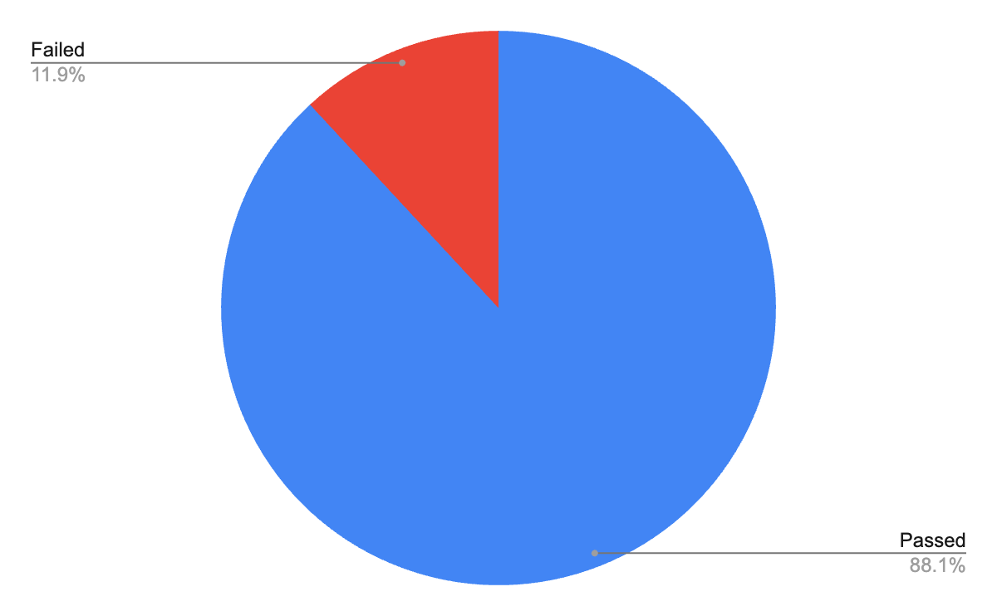

## 5.2 Defect Severity Distribution

**Bar Chart** – **Defects by Severity**

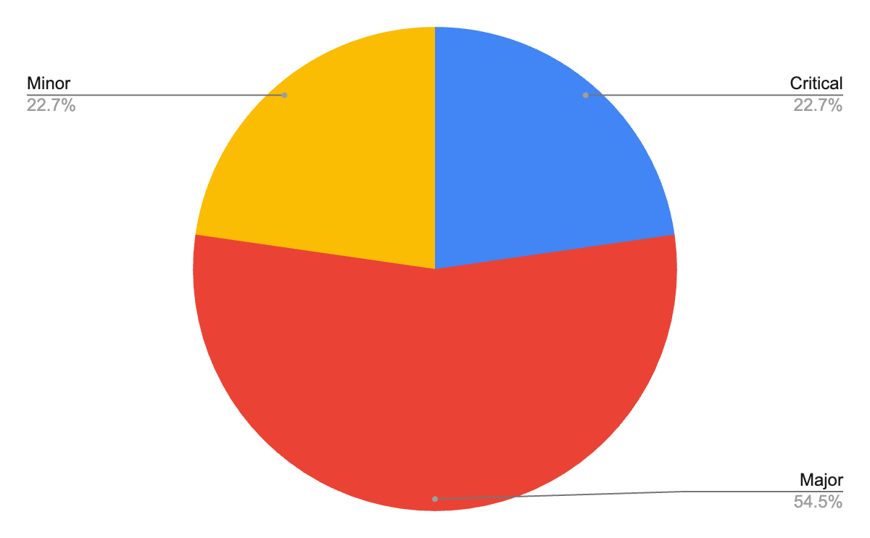

## 5.3 Defect Priority Breakdown

**Pie Chart** – **Defects by Priority**

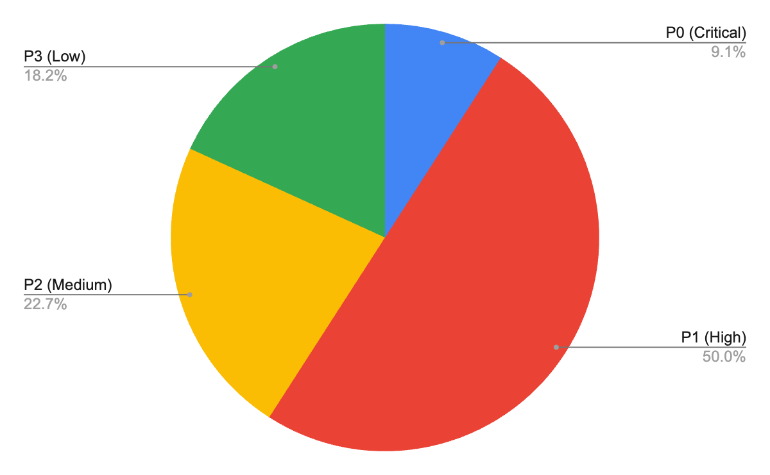

## 5.4 Defect Status Overview

**Pie Chart** – **Defect Status**

