Applexus - Trainee Consultant (ABAP)

* Area: Academic projects, technologies, company
* ABAP is a programming language which can use to develop business applications in SAP environment
* Enterprise Resource Planning (ERP) = Systems Applications and Products (SAP)
* Enterprise Business Process

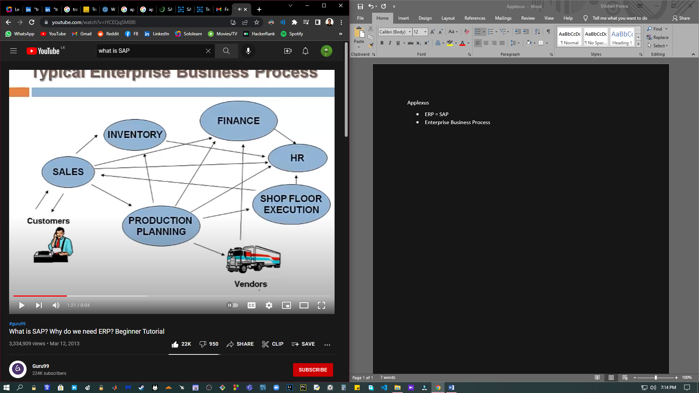

* Enterprise Software Systems
  + Decentralized Systems: Data managed at individual departments (BU). Depts don’t have access to other deptments

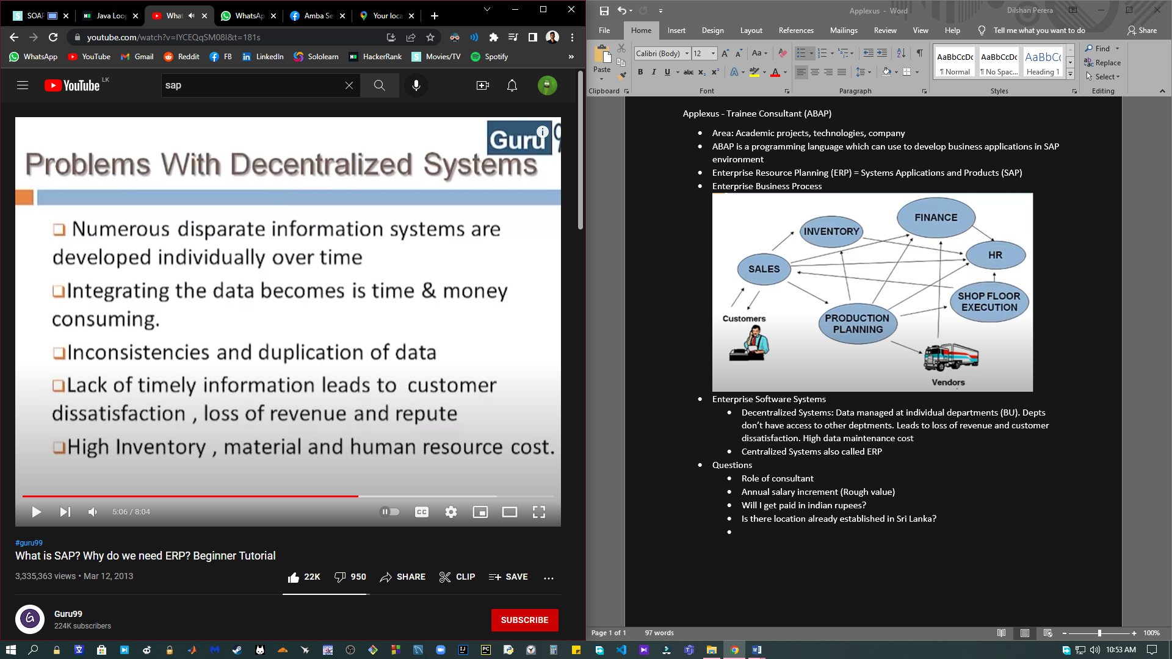

* + Centralized Systems also called SAP (Systems Applications and Products) or ERP (Enterprise Resource Planning)

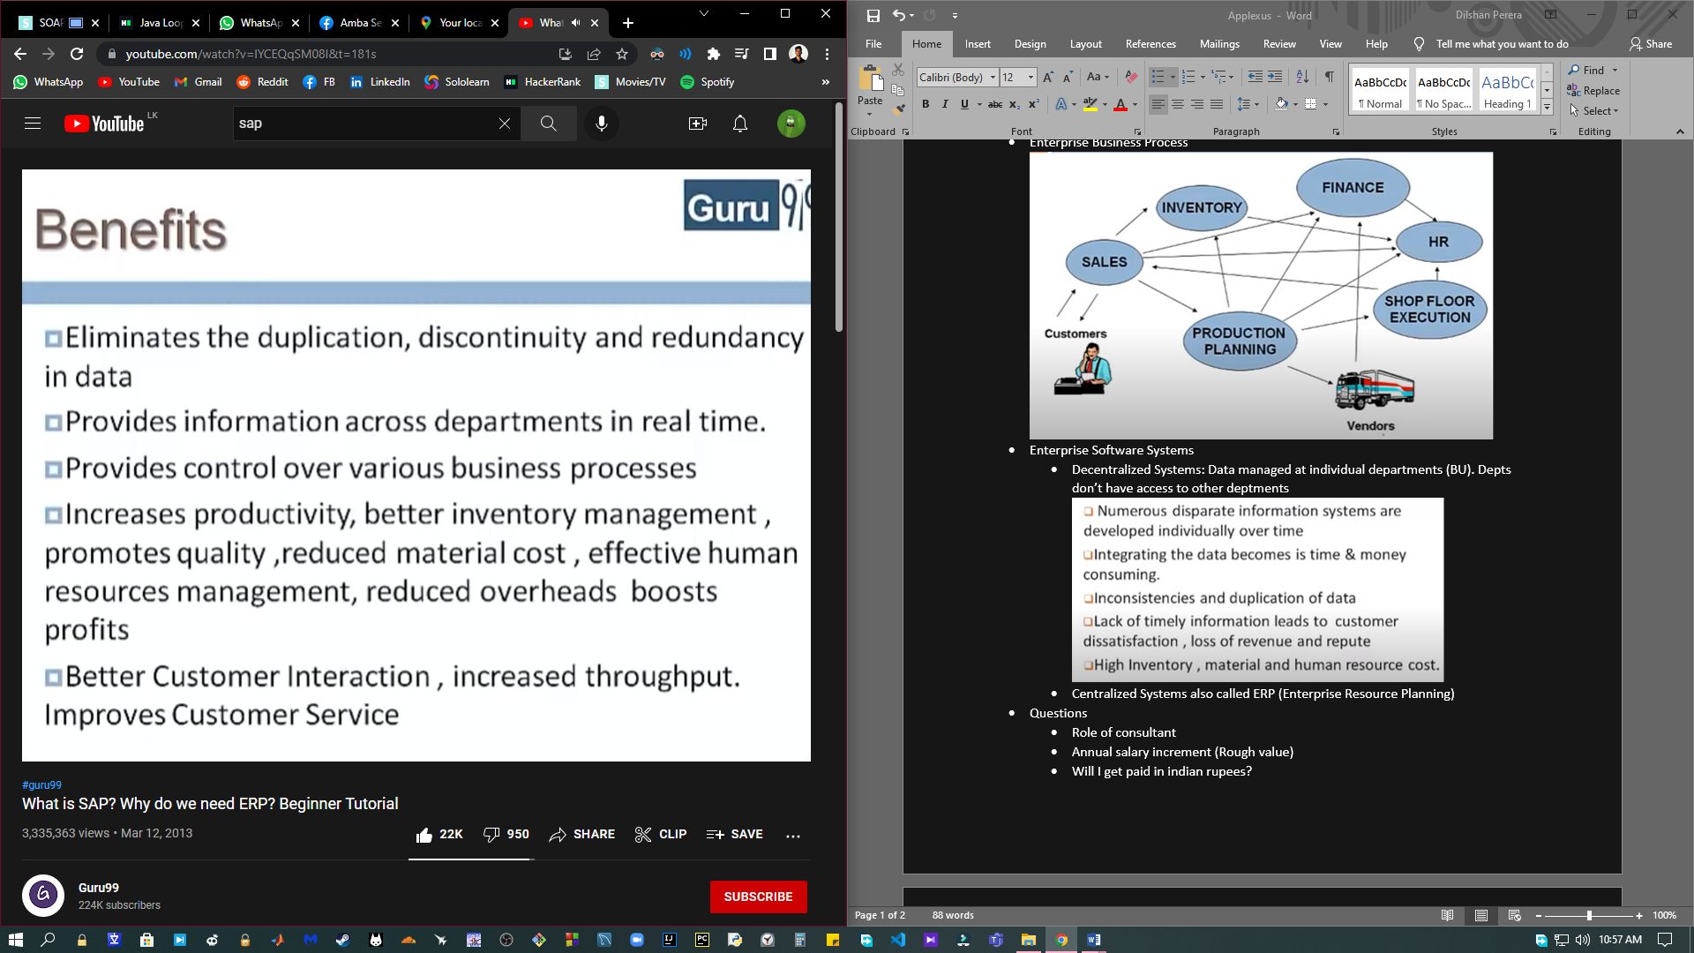

* API: Application Programming Interface
* ABAP: Advanced Business Application Programming
* OOP: Object Oriented Programming
  + Programming model that organizes software design aroud data or objects rather 4767365.05than functions and logic
  + Inheritance - Inheriting attributes and methods of another class
  + Encapsulation - Hides data from outside access
  + Polymorphism - Function having same name but carrying different functionalities
  + Data abstraction - Hiding internal details of a function and showing its functionality only
* Data class: A list of data set allocation attributes and their values
* HANA: High Performance Analytic Appliance
* R3 ABAP
* Questions
  + Role of consultant
  + Annual salary increment (Rough value)
  + Will I get paid in indian rupees?
  + Is there location already established in Sri Lanka?
  + VISA sponsored by company for 3 months? tickets and accomation?