Section 1: Demographics (Part A)

Major Findings
- Age range: The majority of participants are young adults, with 73.6% falling between the ages of 18 and 34.
- Gender: The sample is majority female, comprising 57.2% of the respondents.
- Educational Level: The two major educational variants are those who studied up to A/L (41.3%) and Undergraduates (21.4%).
- Marital Status: 65.2% of the participants are single, while 34.8% are married.
- Employment: Approximately 60.7% are employed (Private, Government, or Self-Employed), while 37.8% are unemployed.
- Religion: The vast majority are Buddhist (87.6%), compared to other religions (12.4%).
- Children: Among the married participants (34.8% total), the majority have children (25.4% of total sample), while a smaller portion do not (9.4% of total sample).
- Diagnosis Location: Most participants were screened at educational institutions (48.8%) compared to community screenings (22.9%).
- Screening Year Inconsistency: Data regarding the year of screening was largely inconsistent or missing (39.8% missing). This limits the ability to effectively evaluate how screening effectiveness impacts Knowledge, Attitudes, and Practices (K,A,P) over time.
- Enrollment Challenges: The vast majority of participants were Sinhalese (97.0%). The study faced challenges in enrolling a significant number of participants from Tamil or other ethnic backgrounds, limiting cross-cultural comparisons.

Summary
Overall, the demographic profile reveals a predominantly young, female, Sinhalese, and Buddhist cohort with a strong educational background. While the high rate of screening at educational institutions highlights the success of school-based programs, the inconsistency in screening year data restricts longitudinal analysis of screening effectiveness. Furthermore, the lack of ethnic diversity presents a challenge for generalizing these findings across all communities in Sri Lanka.

1. Age Distribution
Question: What was your age at last birthday?
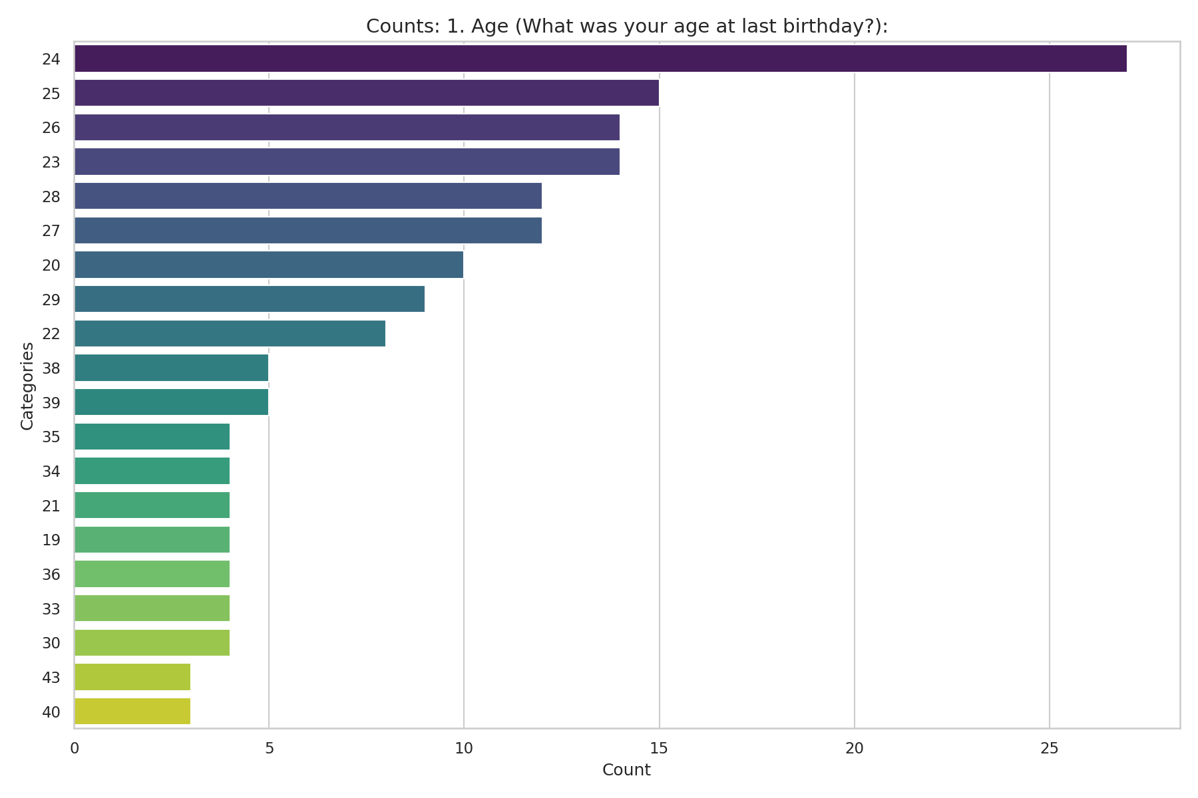
Observed Results:
The mean age of the participants is approximately 29.9 years (median = 26). The majority of the respondents fall into the younger adult categories, with 38.3% between the ages of 25-34, and 35.3% between 18-24 years old.

2. Gender Distribution
Question: Gender:
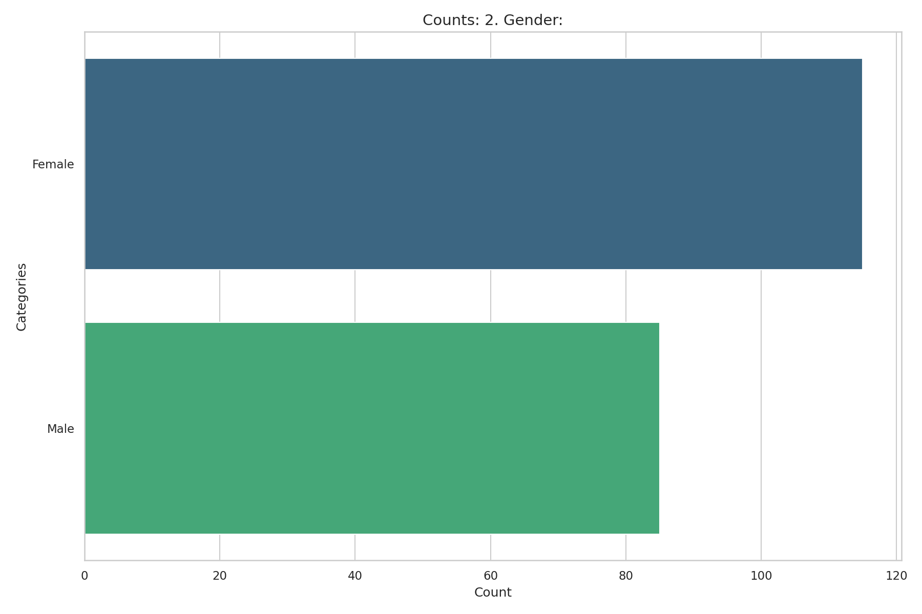
Observed Results:
The sample is slightly female-dominated, with 57.2% of the participants identifying as female and 42.3% as male.

3. Ethnicity
Question: Ethnicity:
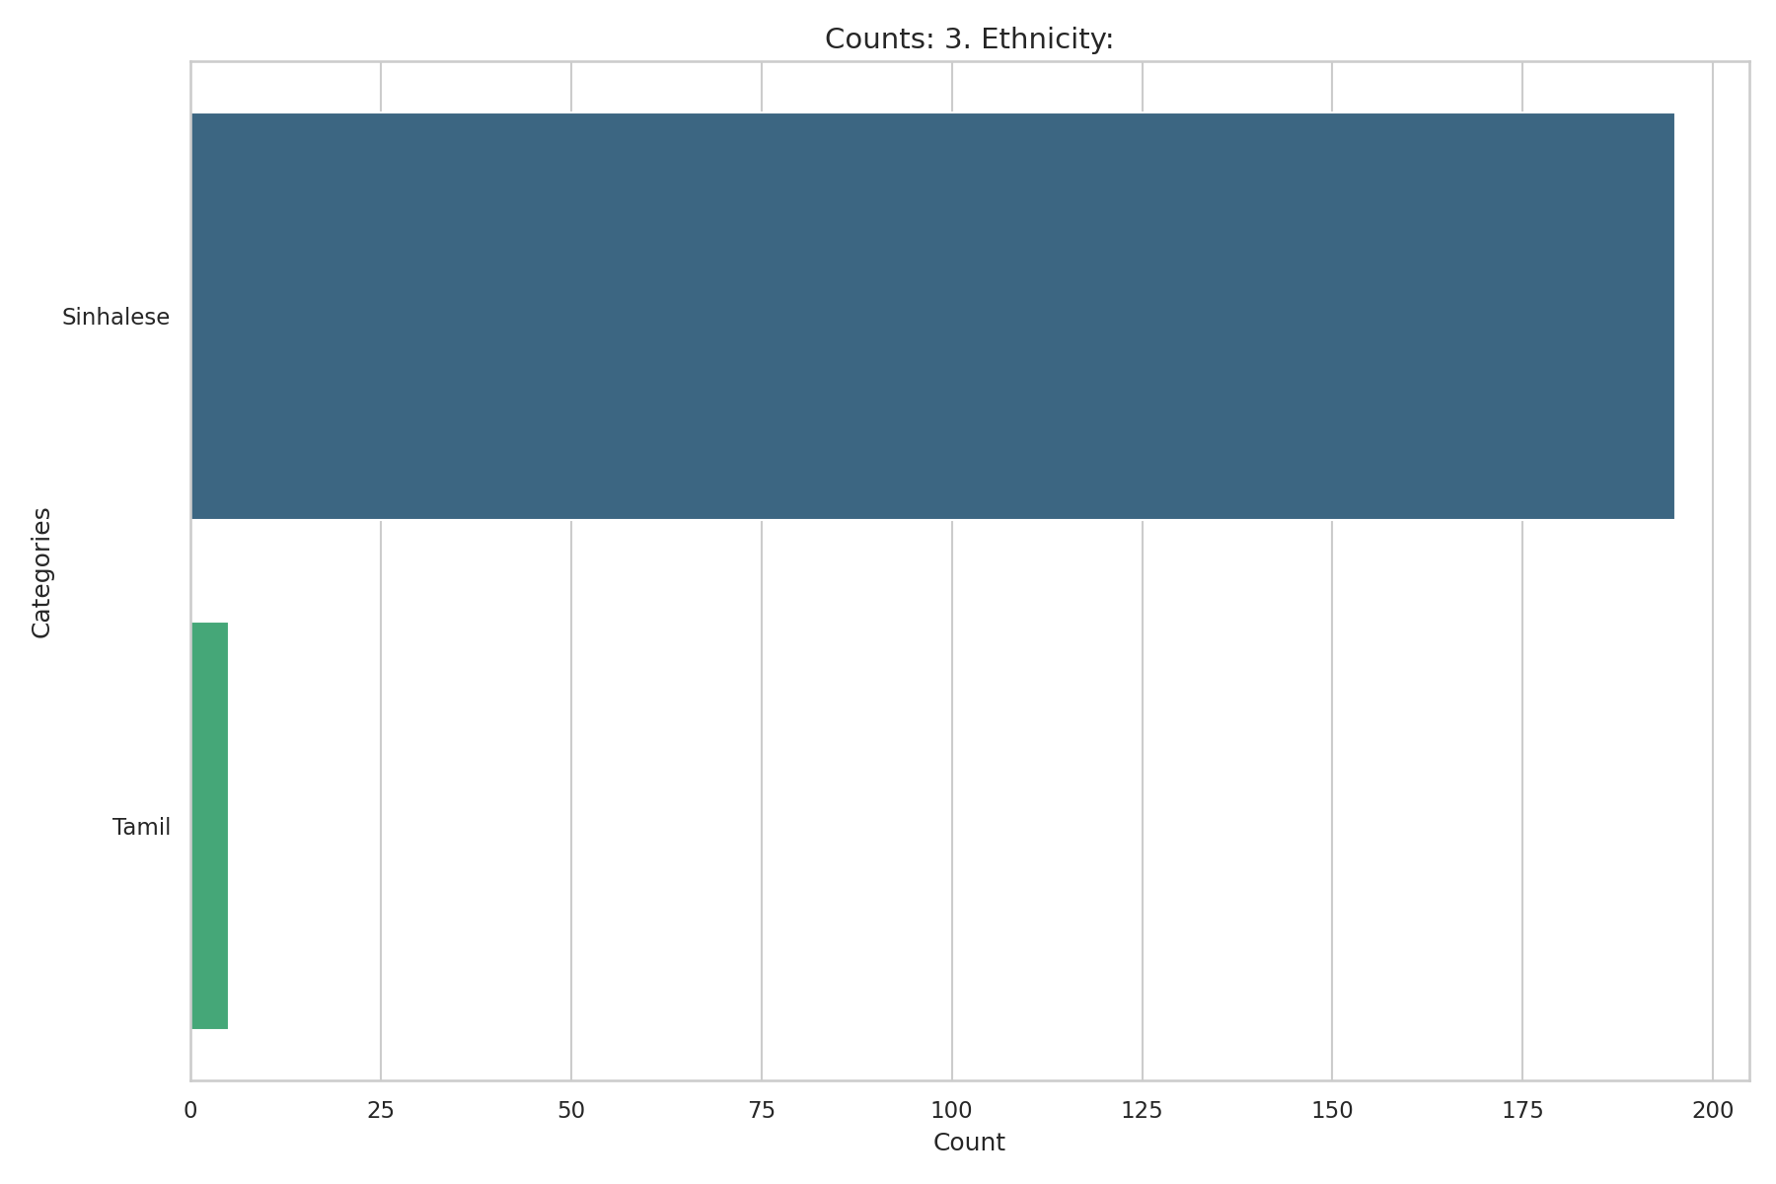
Observed Results:
The sample is highly homogenous in terms of ethnicity. 97.0% of respondents identified as Sinhalese.

4. Religion
Question: Religion:
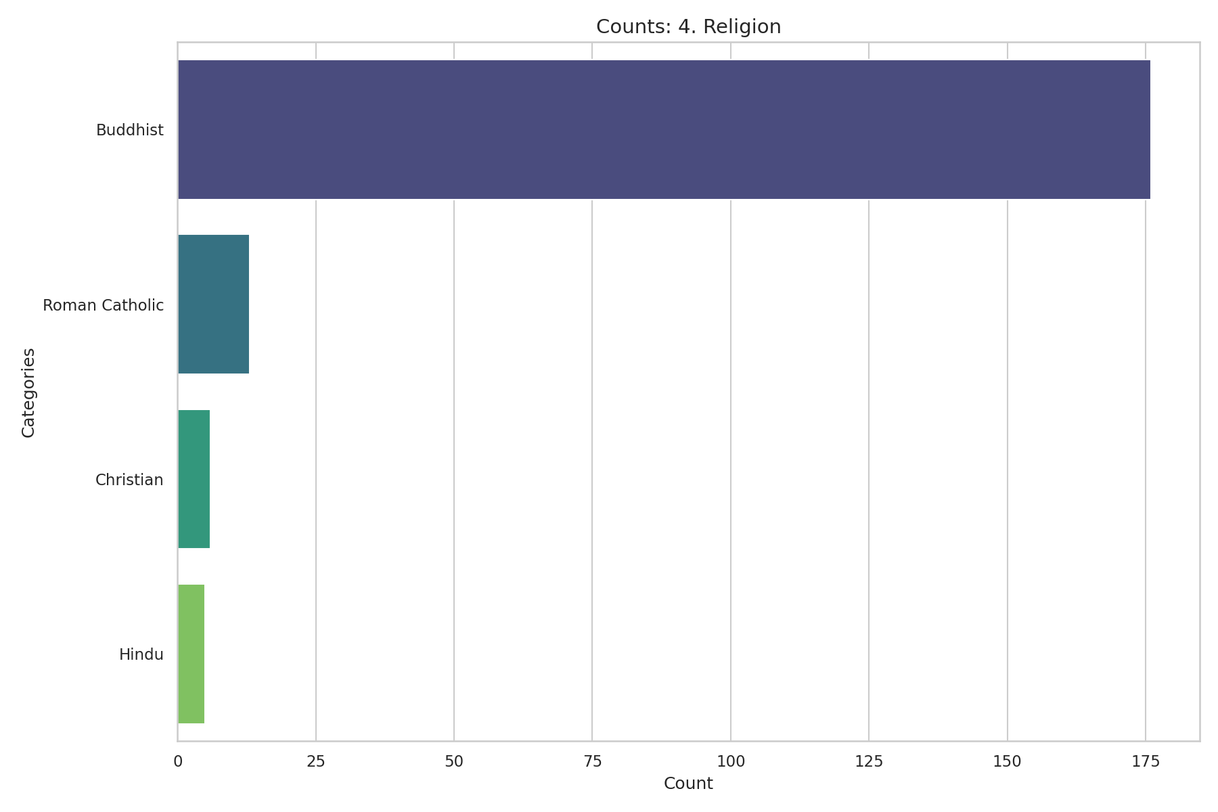
Observed Results:
The majority of the respondents (87.6%) identified as Buddhist, followed by Roman Catholic (6.5%) and Christian (3.0%).

5. Occupation
Question: Occupation:
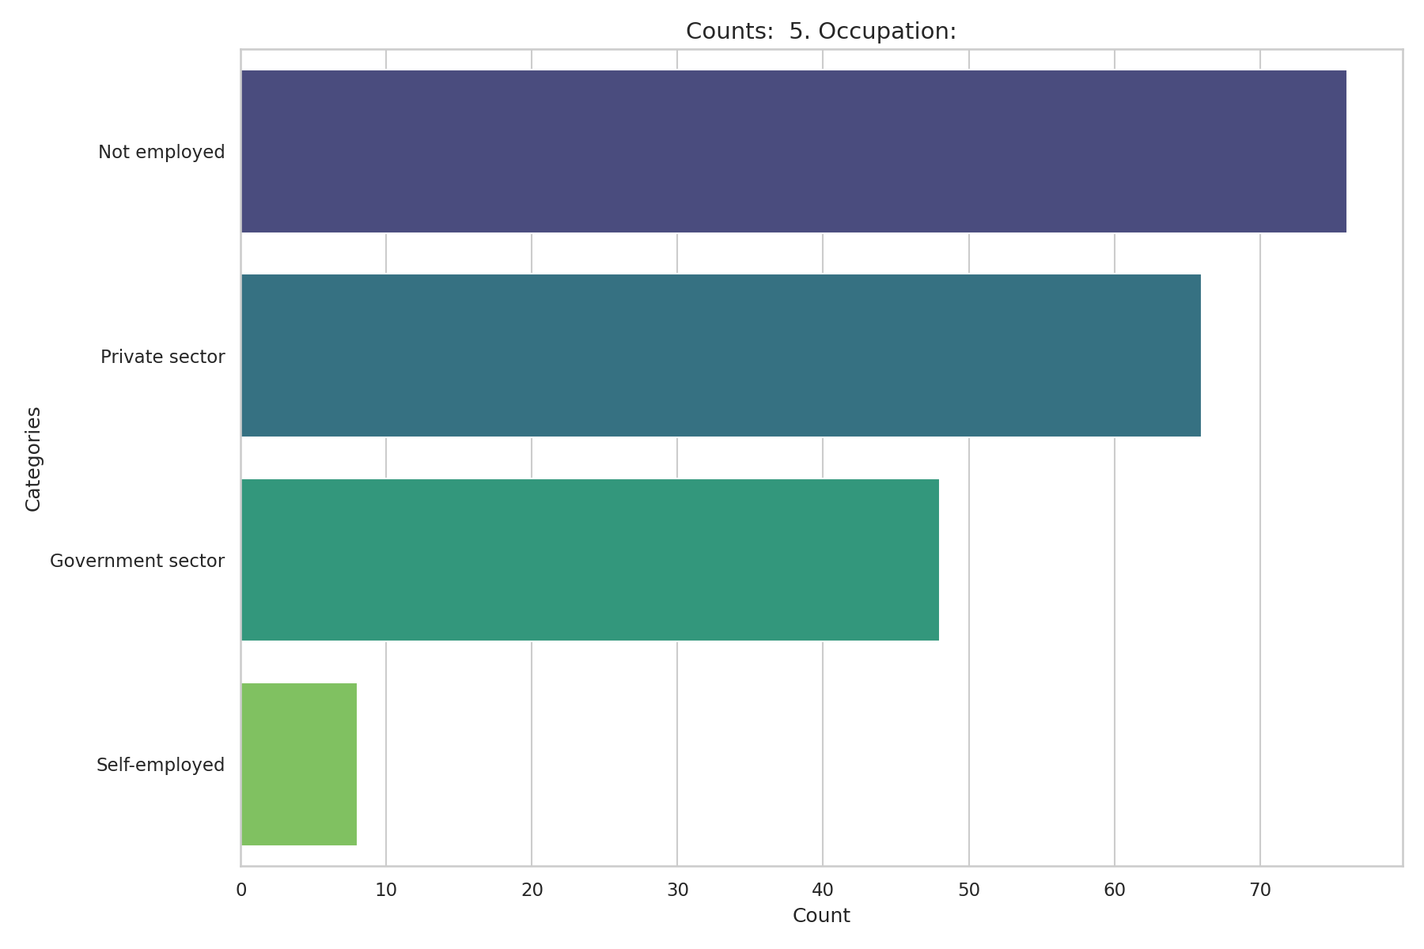
Observed Results:
The largest group is not employed (37.8%), followed closely by private sector employees (32.8%) and government sector employees (23.9%). Only 4.0% are self-employed.

6. Monthly Income
Question: Monthly Income (LKR):
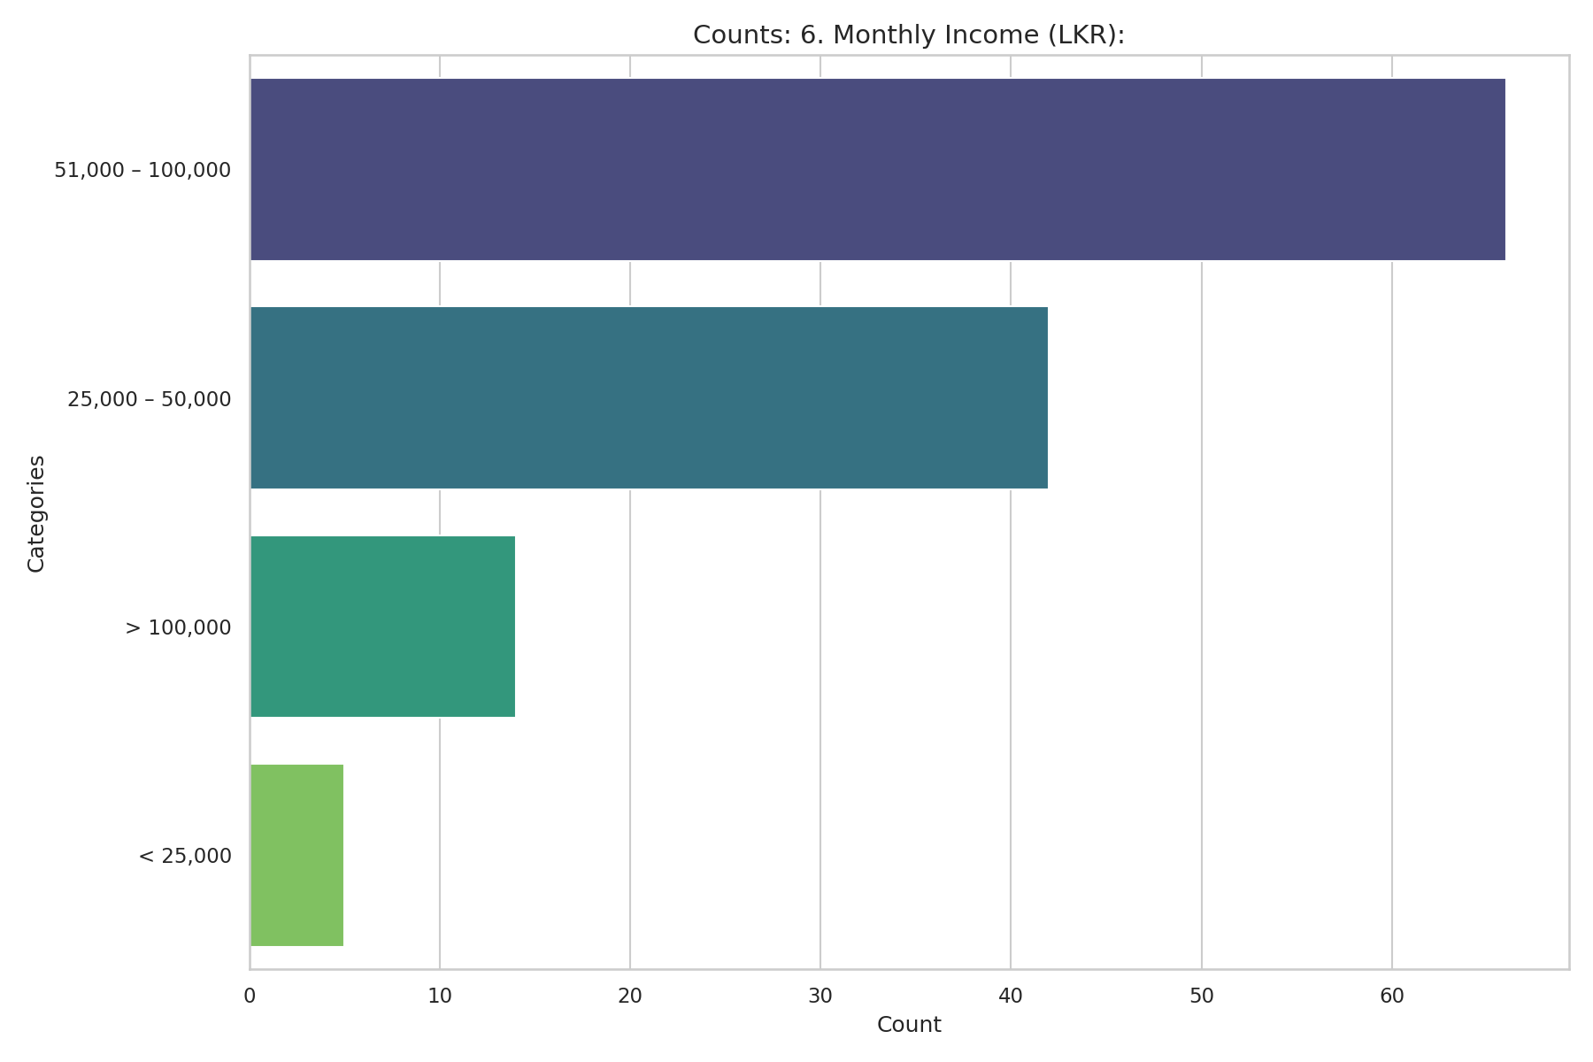
Observed Results:
A large segment (36.8%) did not respond to the income question. Among those who did, the most common bracket is 51,000 – 100,000 LKR (32.8%), followed by 25,000 – 50,000 LKR (20.9%).

7. Education Level
Question: Education Level:
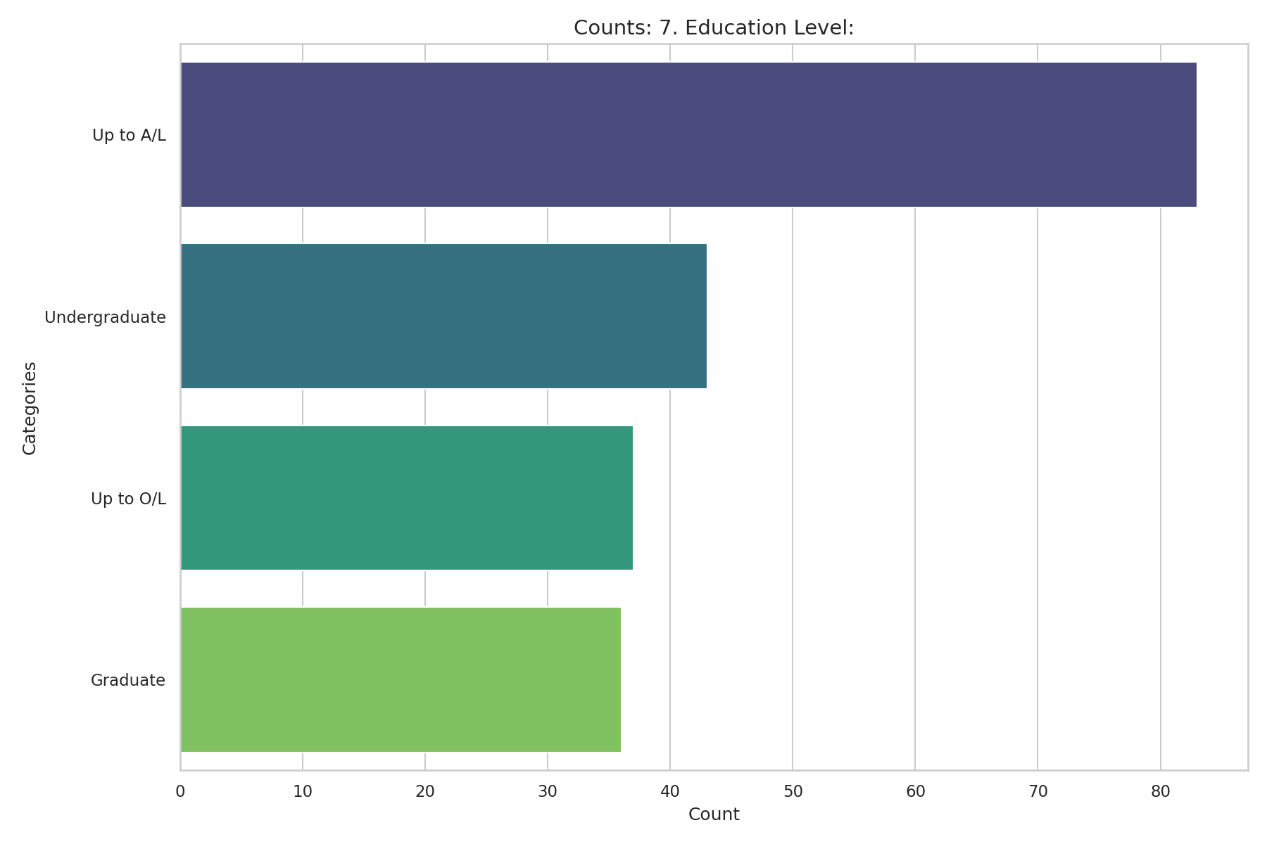
Observed Results:
Participants have a strong educational background. 41.3% have studied up to A/L, 21.4% are undergraduates, and 17.9% are graduates.

8. Residing Province
Question: Residing Province:
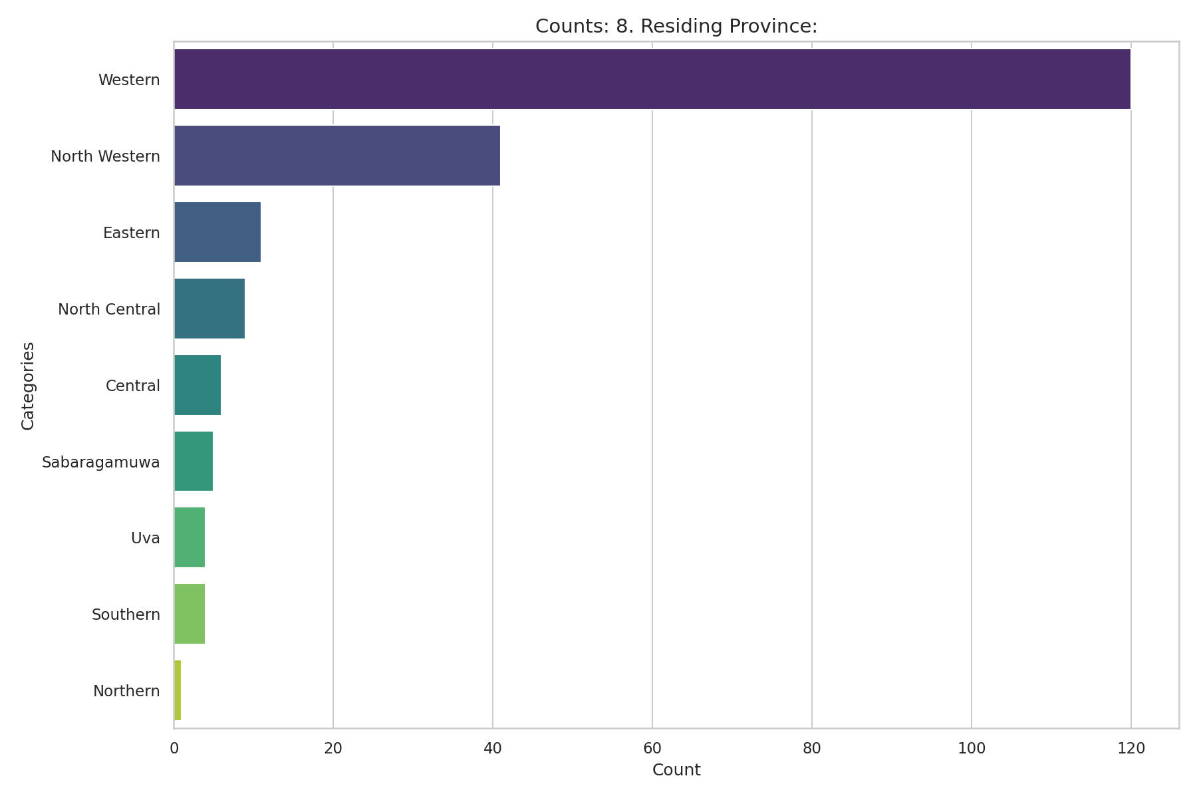
Observed Results:
The majority of participants (59.7%) reside in the Western Province, with the North Western Province being the second most common (20.4%).

9. Marital Status
Question: Marital Status:
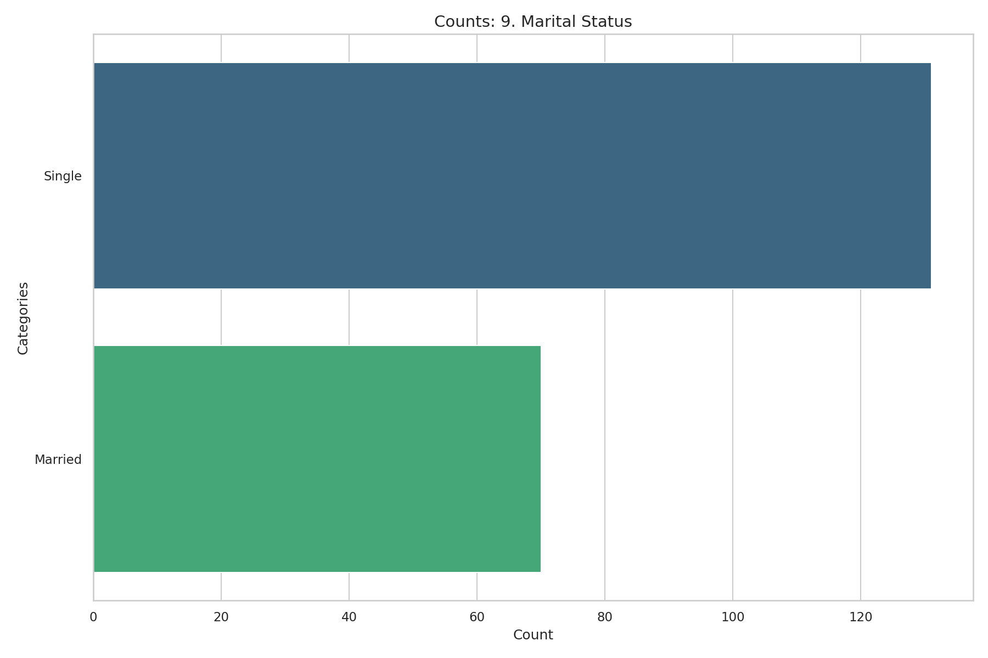
Observed Results:
65.2% of the participants are single, while 34.8% are married.

10. Children
Question: Do you have children?
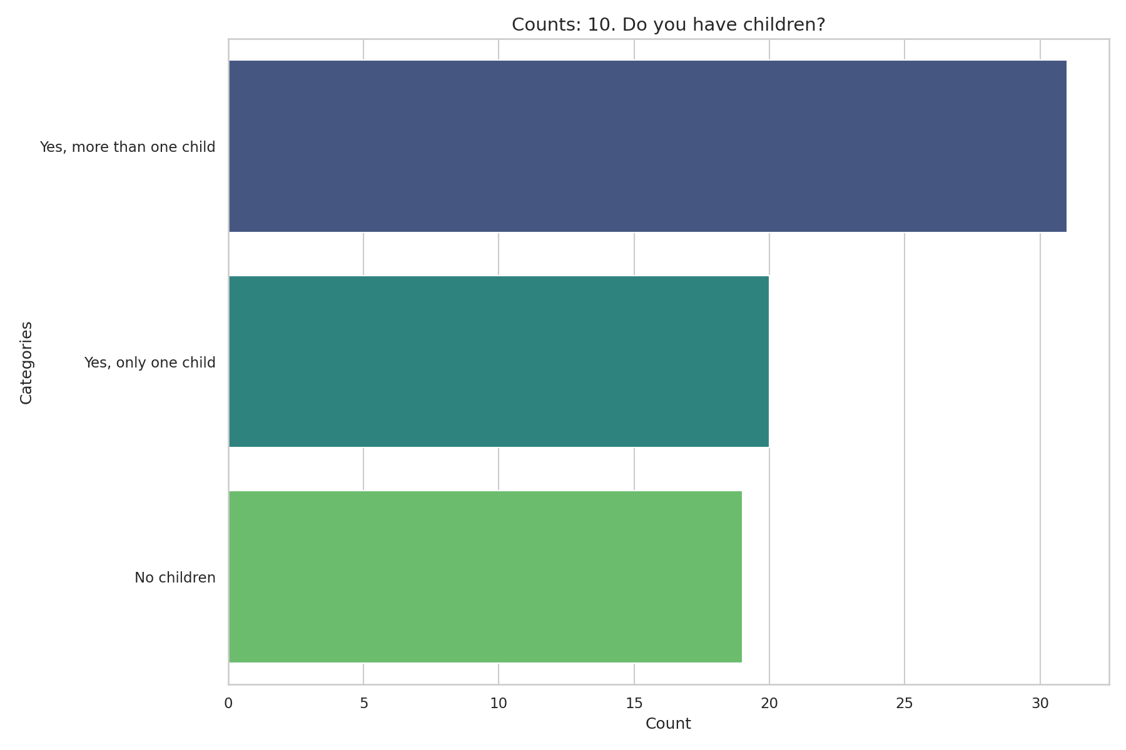
Observed Results:
Corresponding with the marital status, 65.2% reported not having children (or gave no response). 15.4% have more than one child and 10.0% have only one child.

11. Family History
Question: Do you have a family history of an inherited blood disorder?
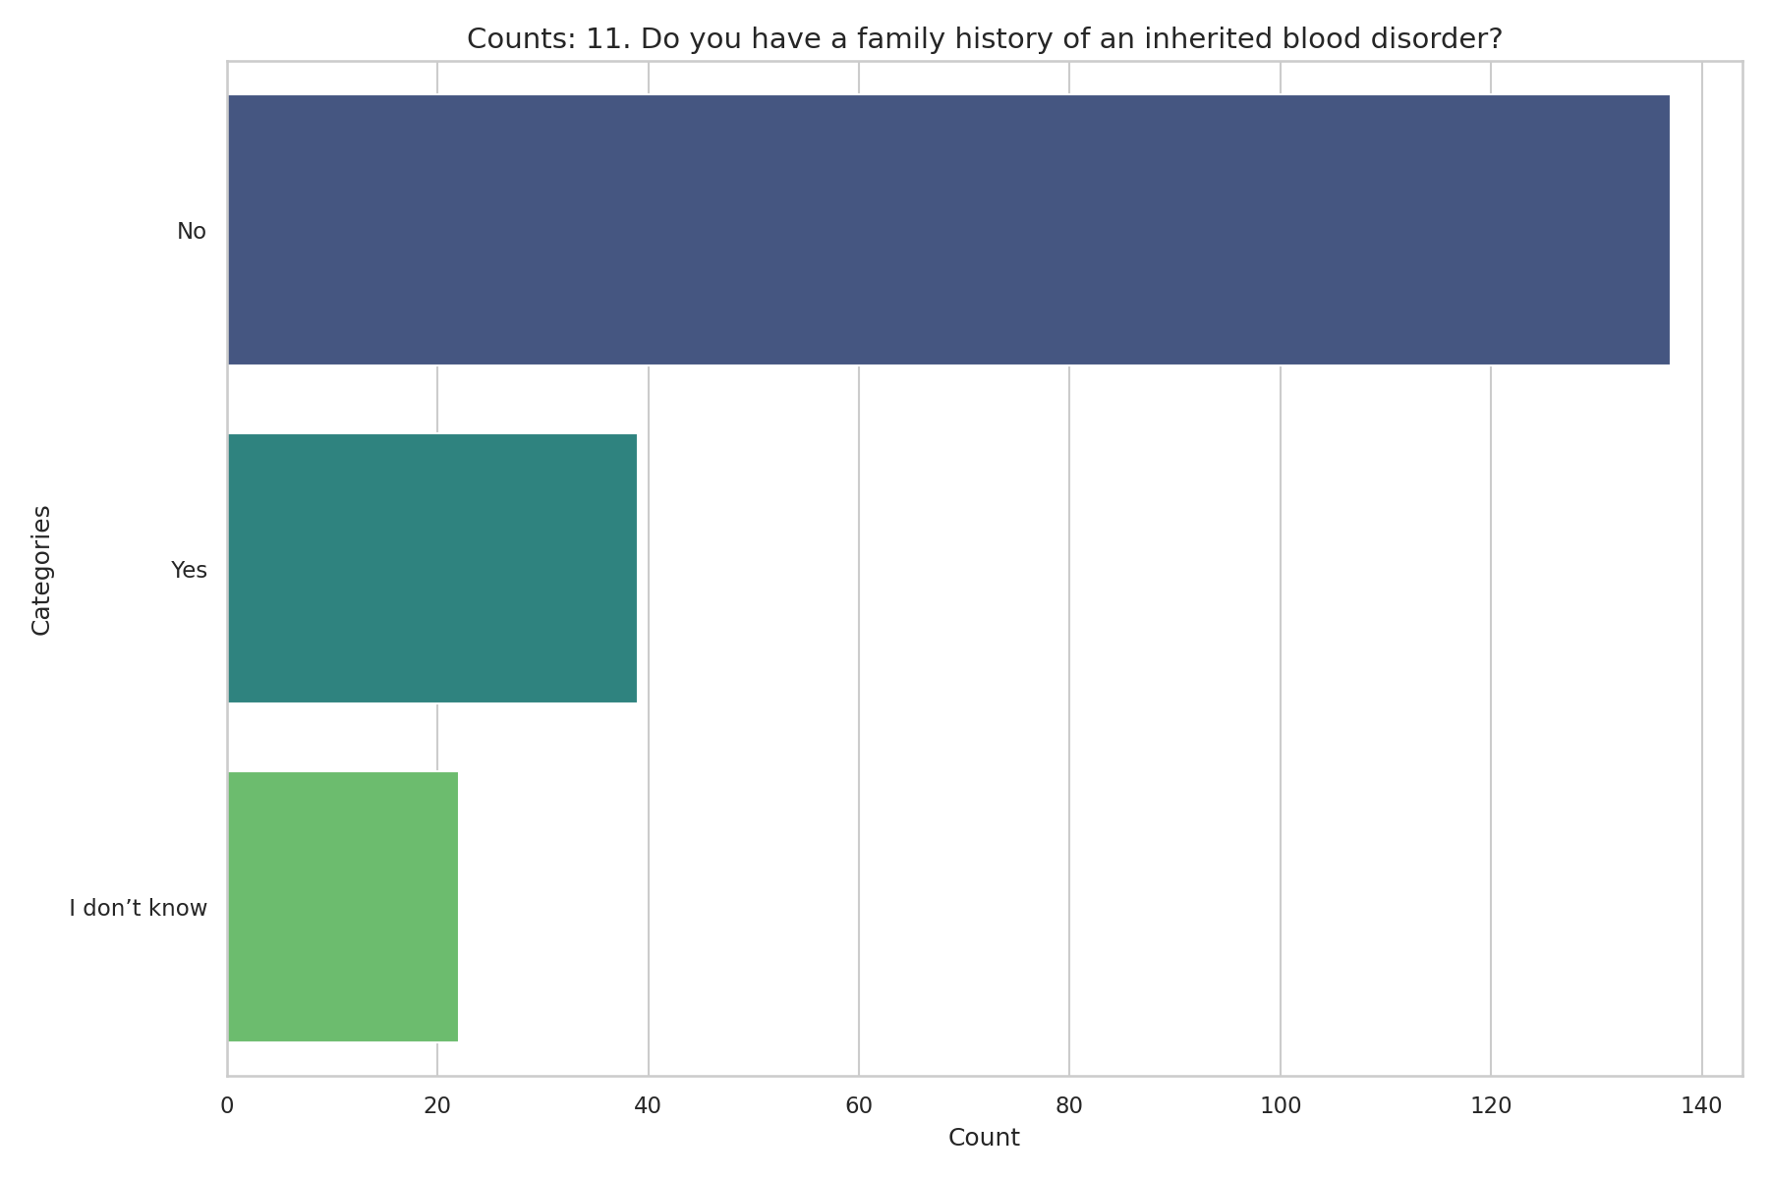
Observed Results:
19.4% of participants reported having a family history of an inherited blood disorder. 10.9% did not know their family history, and 68.2% did not have a family history.

12. Specified Blood Disorder
Question: If yes, please specify:
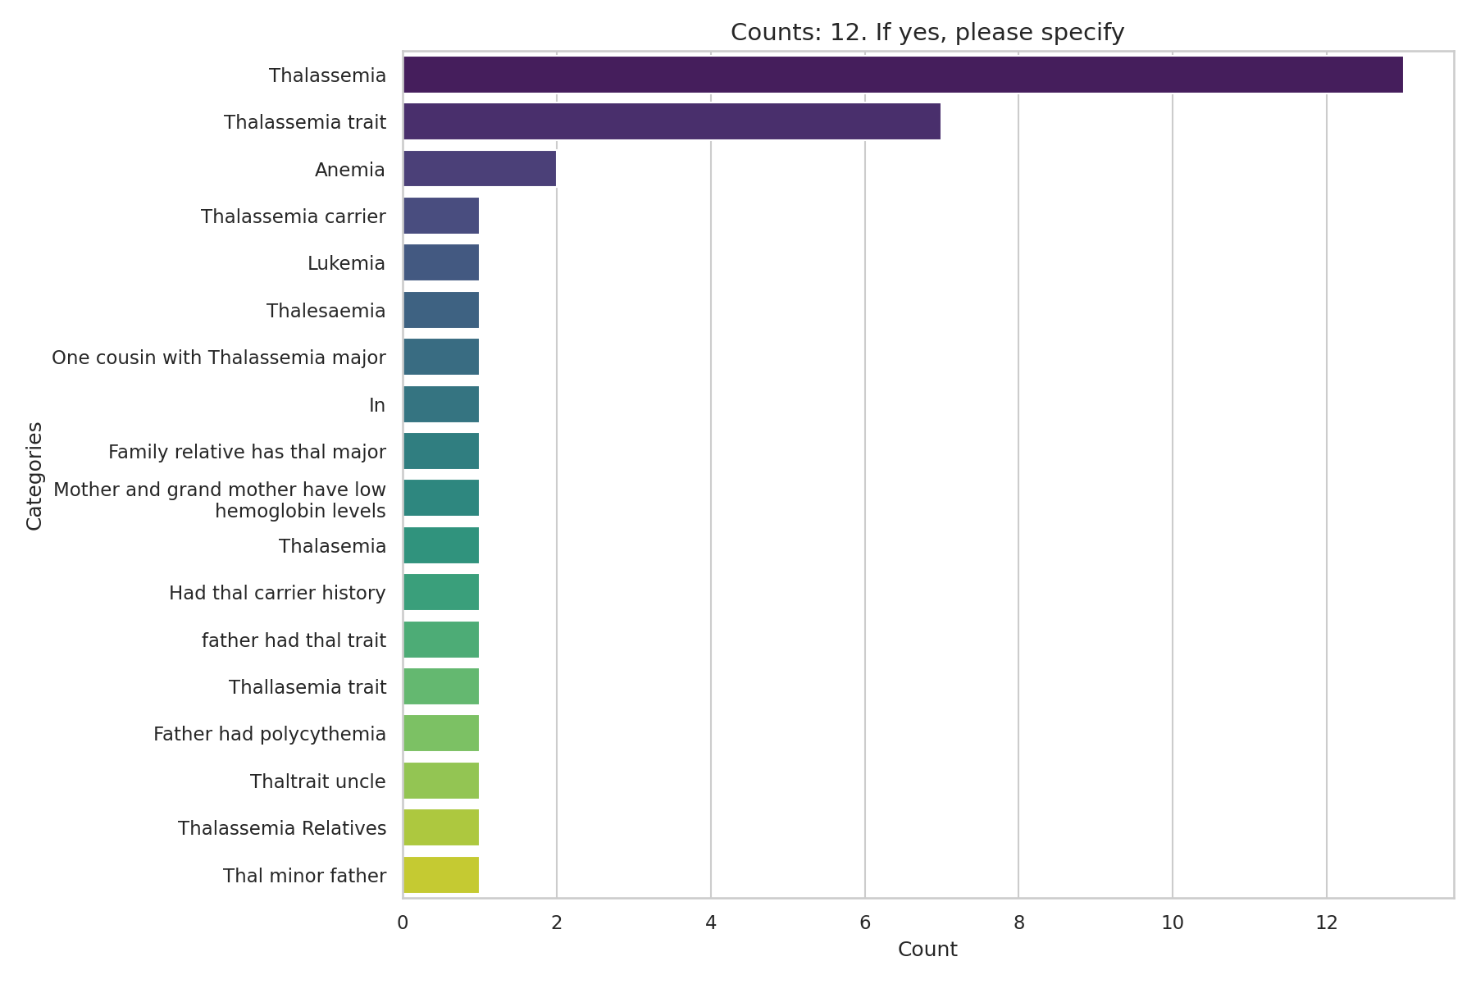
Observed Results:
Among those who had a family history (excluding the 81.6% missing response), Thalassemia was the most frequently specified condition (6.5%), followed by Thalassemia trait (3.5%).

13. Diagnosis Year
Question: When were you diagnosed as a carrier? (Year):
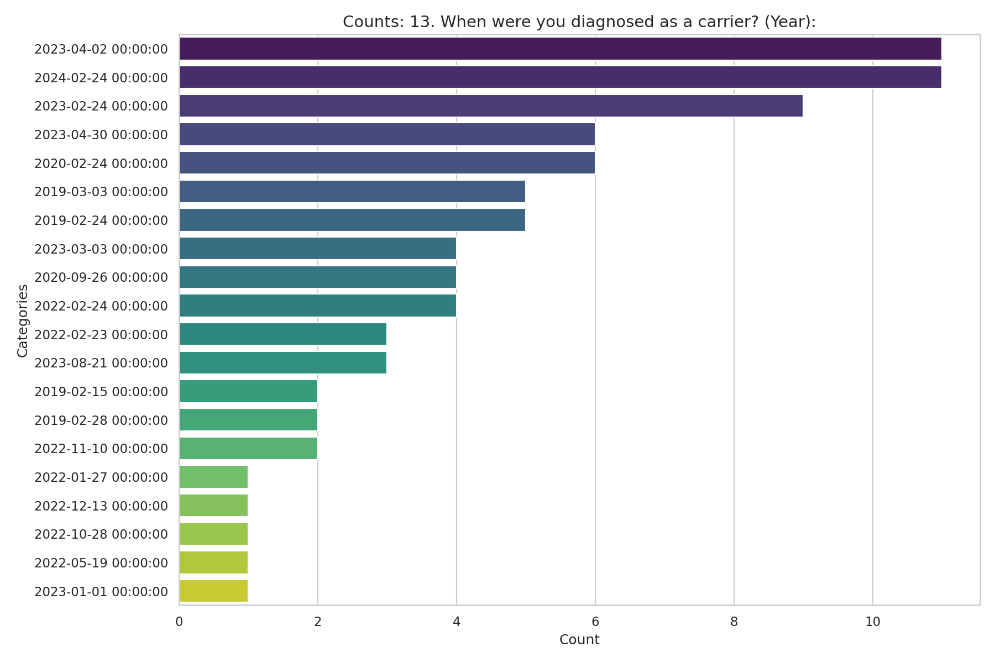
Observed Results:
The most common year of diagnosis among respondents was 2023 (19.9%), followed by 2019 (13.4%). A large portion (39.8%) did not provide a diagnosis year.

14. Where Diagnosed
Question: Where were you diagnosed as a thalassemia carrier?
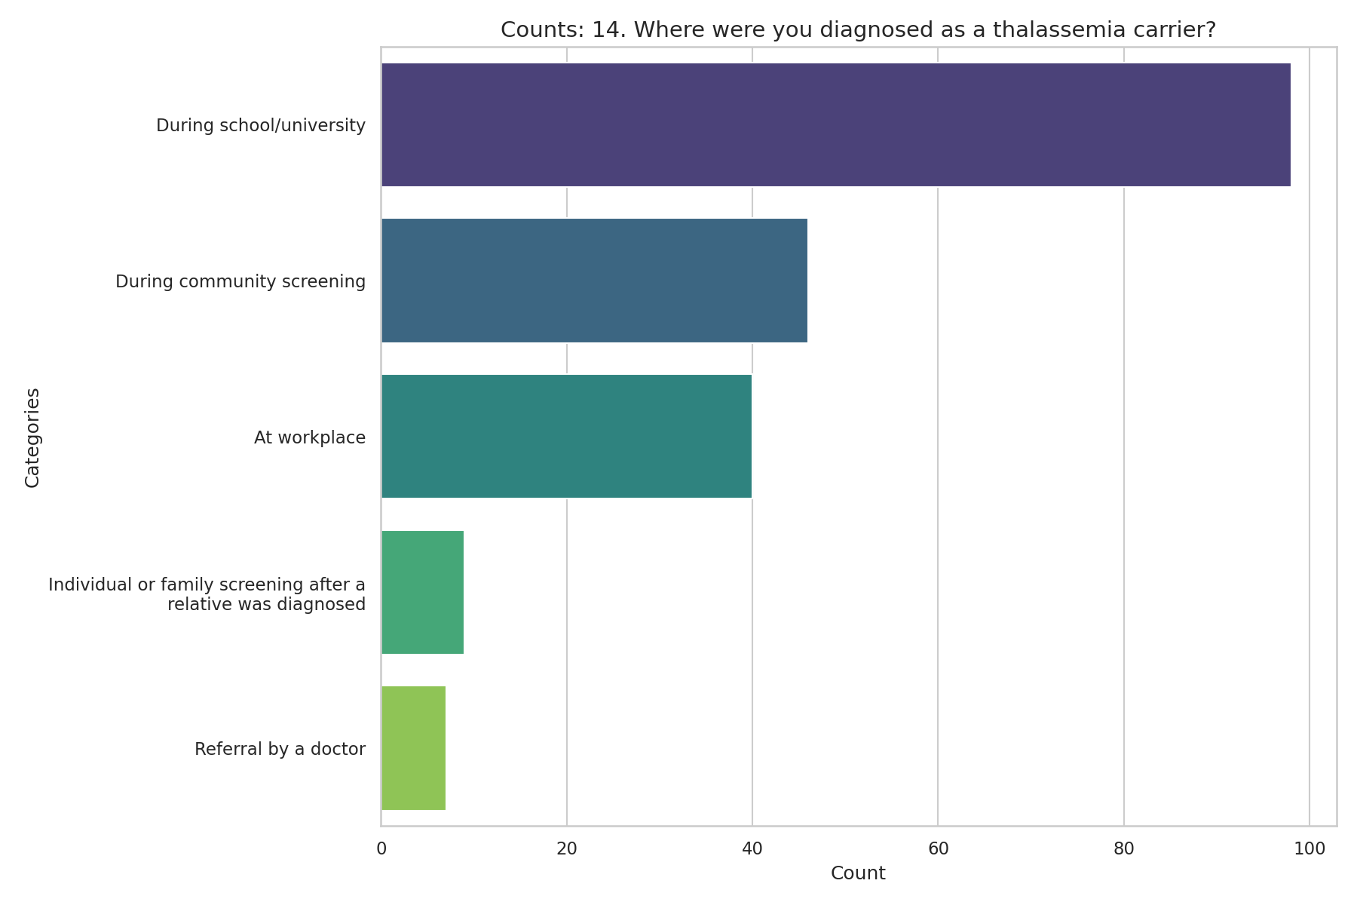
Observed Results:
The primary location for diagnosis was during school/university screening (48.8%), followed by community screening (22.9%) and at the workplace (19.9%).

