Section 4: Attitudes & Practices Regarding Family Screening (Part D)

Major Findings
- High Support for Cascade Screening: 95.0% agree that family members should undergo screening, and 93.5% rate cascade screening as important or very important.
- Transparency: 90.5% of participants have already informed their family members about their thalassemia carrier status.
- Proximity Effect: Screening rates are highest among immediate (first-degree) relatives (39.8% screened all), but plummet for extended family, with over 50% reporting no second or third-degree relatives have been screened.
- Primary Barrier: The overwhelming barrier preventing family screening is a 'Lack of knowledge' (48.8%), significantly outweighing structural issues like cost (7.0%) or social issues like stigma (10.4%).
- Persuasive Difficulty: While 60.7% find it easy to convince relatives to screen, nearly 1 in 5 (18.9%) find it actively difficult.

Summary
Cascade screening is widely accepted in theory and successfully initiated among immediate family members. However, its reach is severely stunted when it comes to extended relatives. The data clearly indicates that this is not primarily due to stigma or financial cost, but rather a profound lack of knowledge and a perception that extended screening is unnecessary. Educational interventions targeted at extending risk-awareness beyond the nuclear family could drastically improve cascade screening efficacy.

35. Importance of Family Screening
Question: Do you think is it important for your family members to undergo screening?
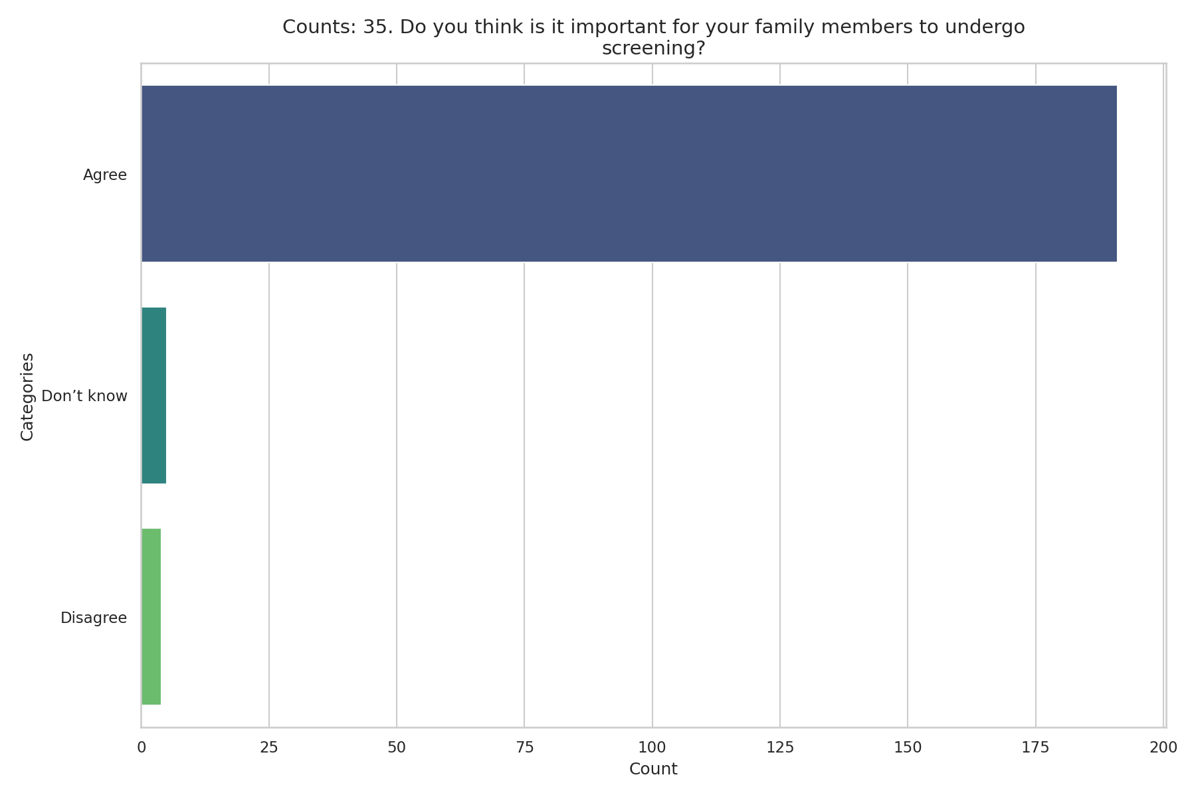
Observed Results:
95.0% of respondents agreed that it is important for family members to undergo screening, showing near-universal recognition of its value.

36. Family Awareness
Question: Do your family members know your thalassemia status?
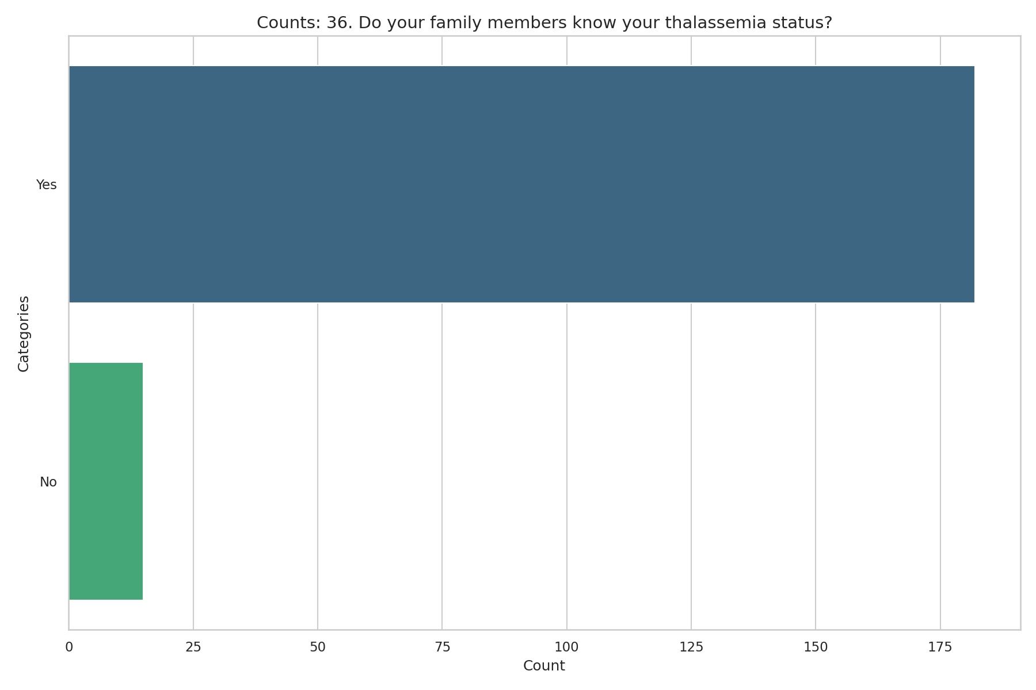
Observed Results:
90.5% reported that their family members are already aware of their thalassemia status, while 7.5% reported they are not.

37a. First-Degree Relatives Screened
Question: To what extent have your First-degree relatives (parents, siblings, children) undergone screening?
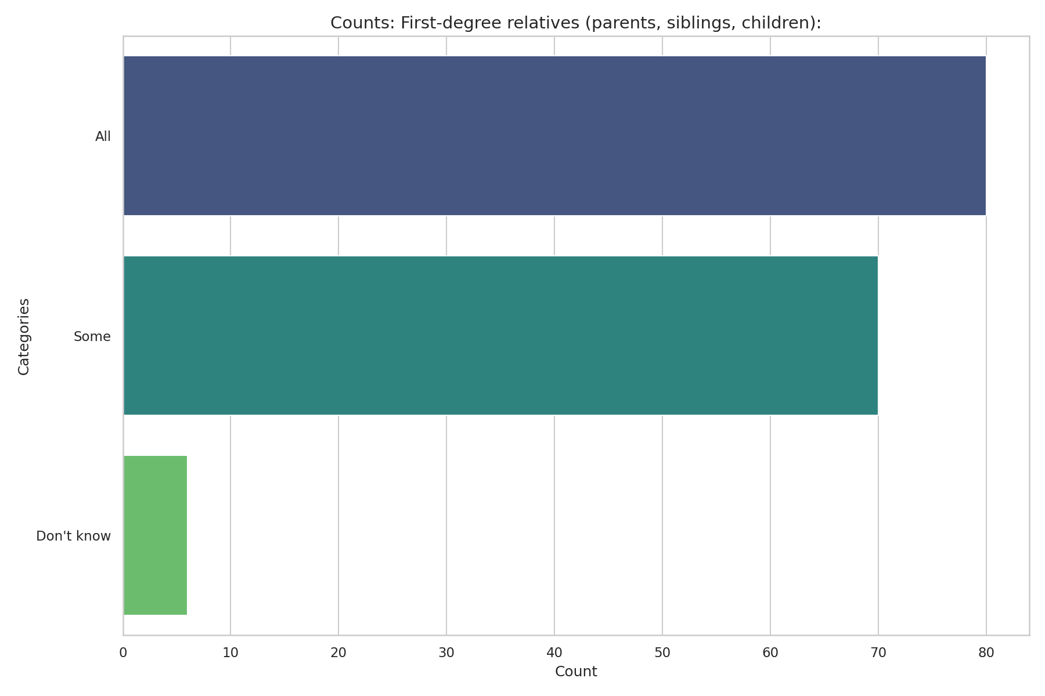
Observed Results:
39.8% reported that all first-degree relatives have been screened, and 34.8% reported some have been screened. 22.4% reported none had been screened.

37b. Second-Degree Relatives Screened
Question: To what extent have your Second-degree relatives (grandparents, uncles, aunts) undergone screening?
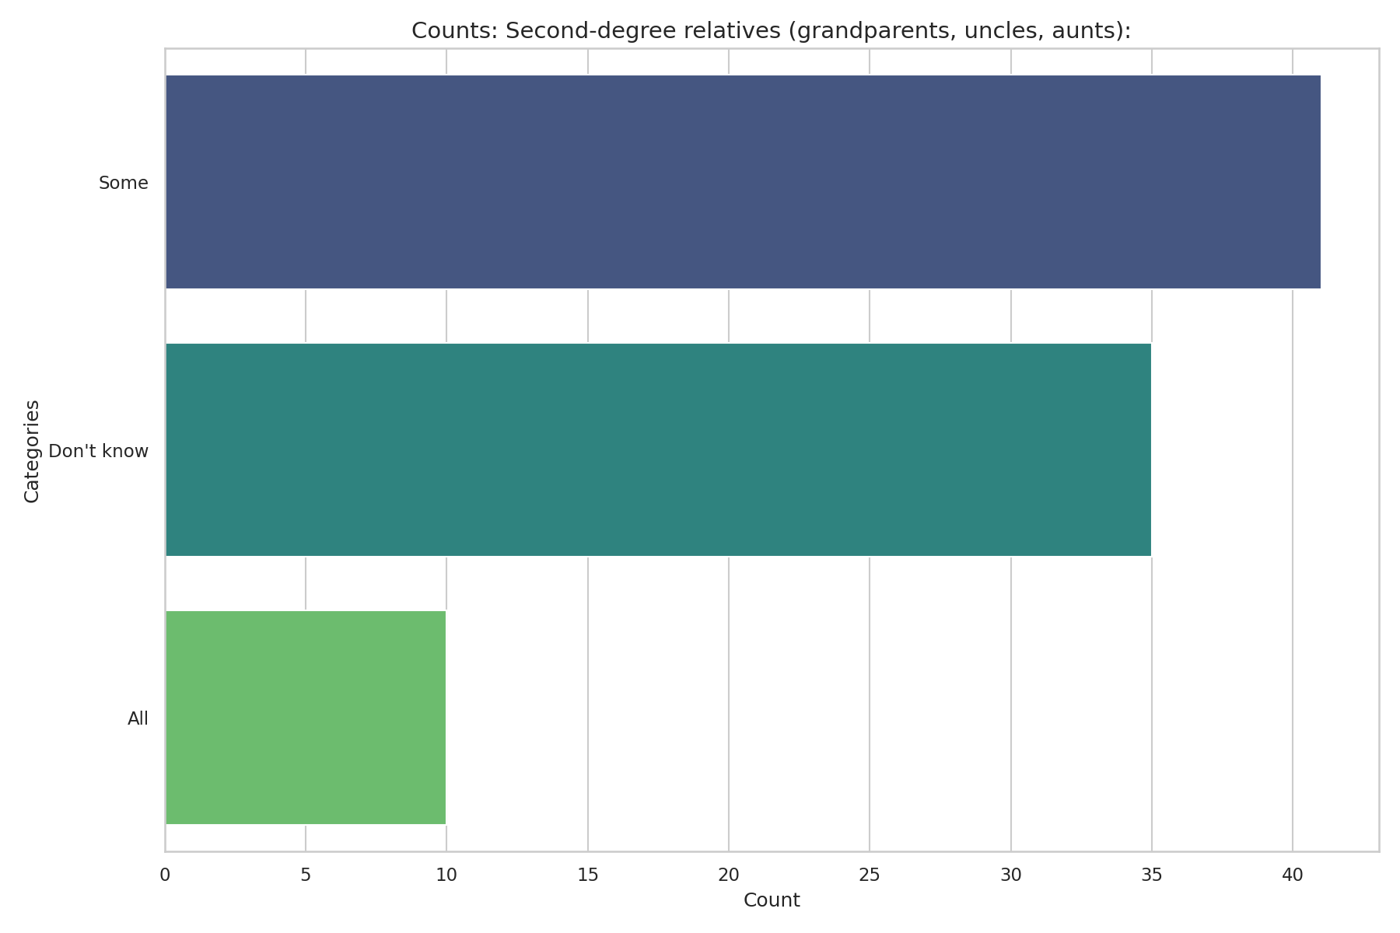
Observed Results:
Screening drops significantly for extended family. 54.2% reported that no second-degree relatives had been screened, and only 5.0% reported that all had been screened.

37c. Third-Degree Relatives Screened
Question: To what extent have your Third-degree relatives (cousins, etc.) undergone screening?
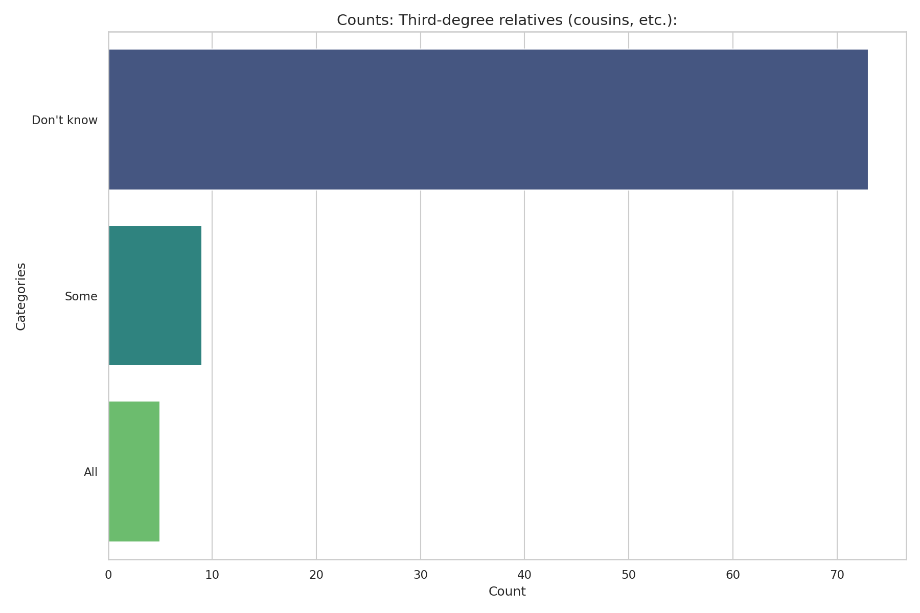
Observed Results:
52.2% reported that no third-degree relatives had been screened, while 36.3% did not know if their cousins had been screened.

38. Barriers to Screening
Question: If not screened, what were the reasons? (Tick all that apply)
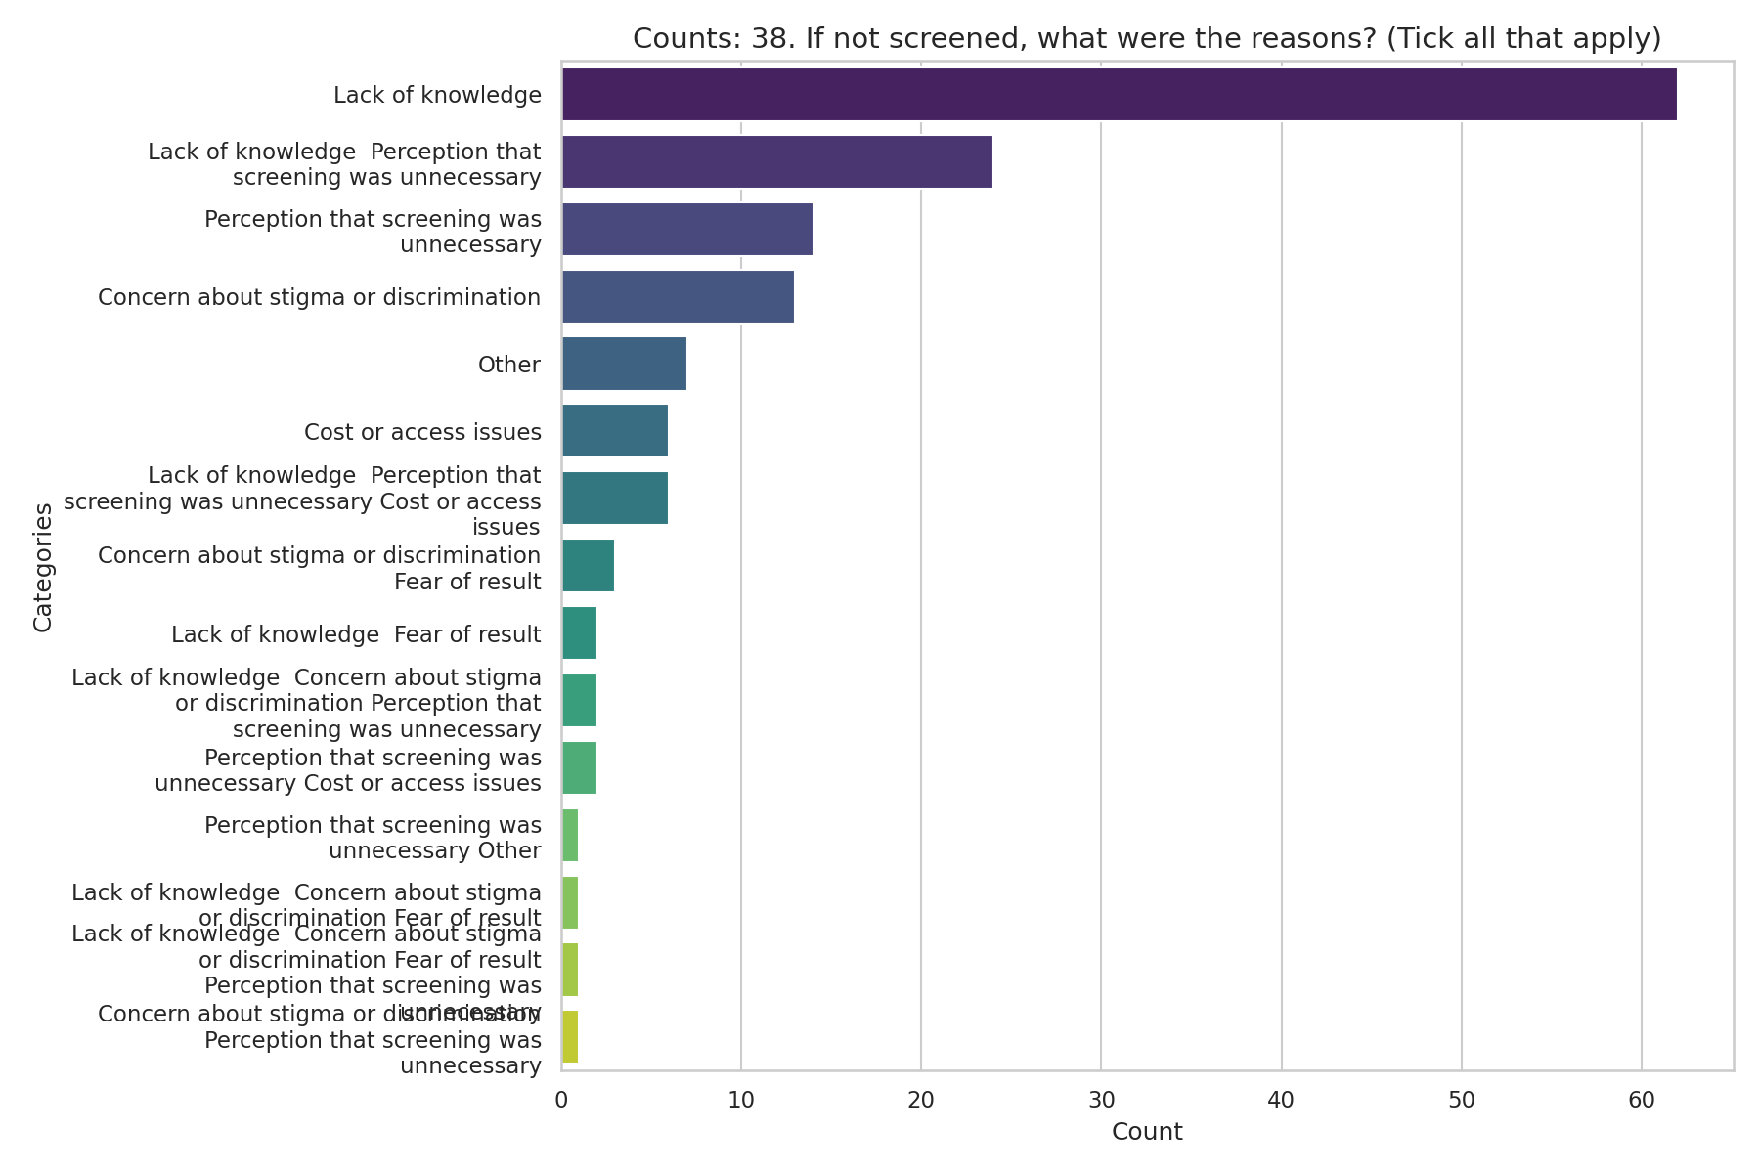
Observed Results:
The primary barrier preventing family members from getting screened is 'Lack of knowledge' (48.8%), followed by the 'Perception that screening was unnecessary' (25.4%). Cost (7.0%) and Stigma (10.4%) were lesser concerns.

39. Ease of Convincing Relatives
Question: How easy is it to convince relatives to undergo screening?
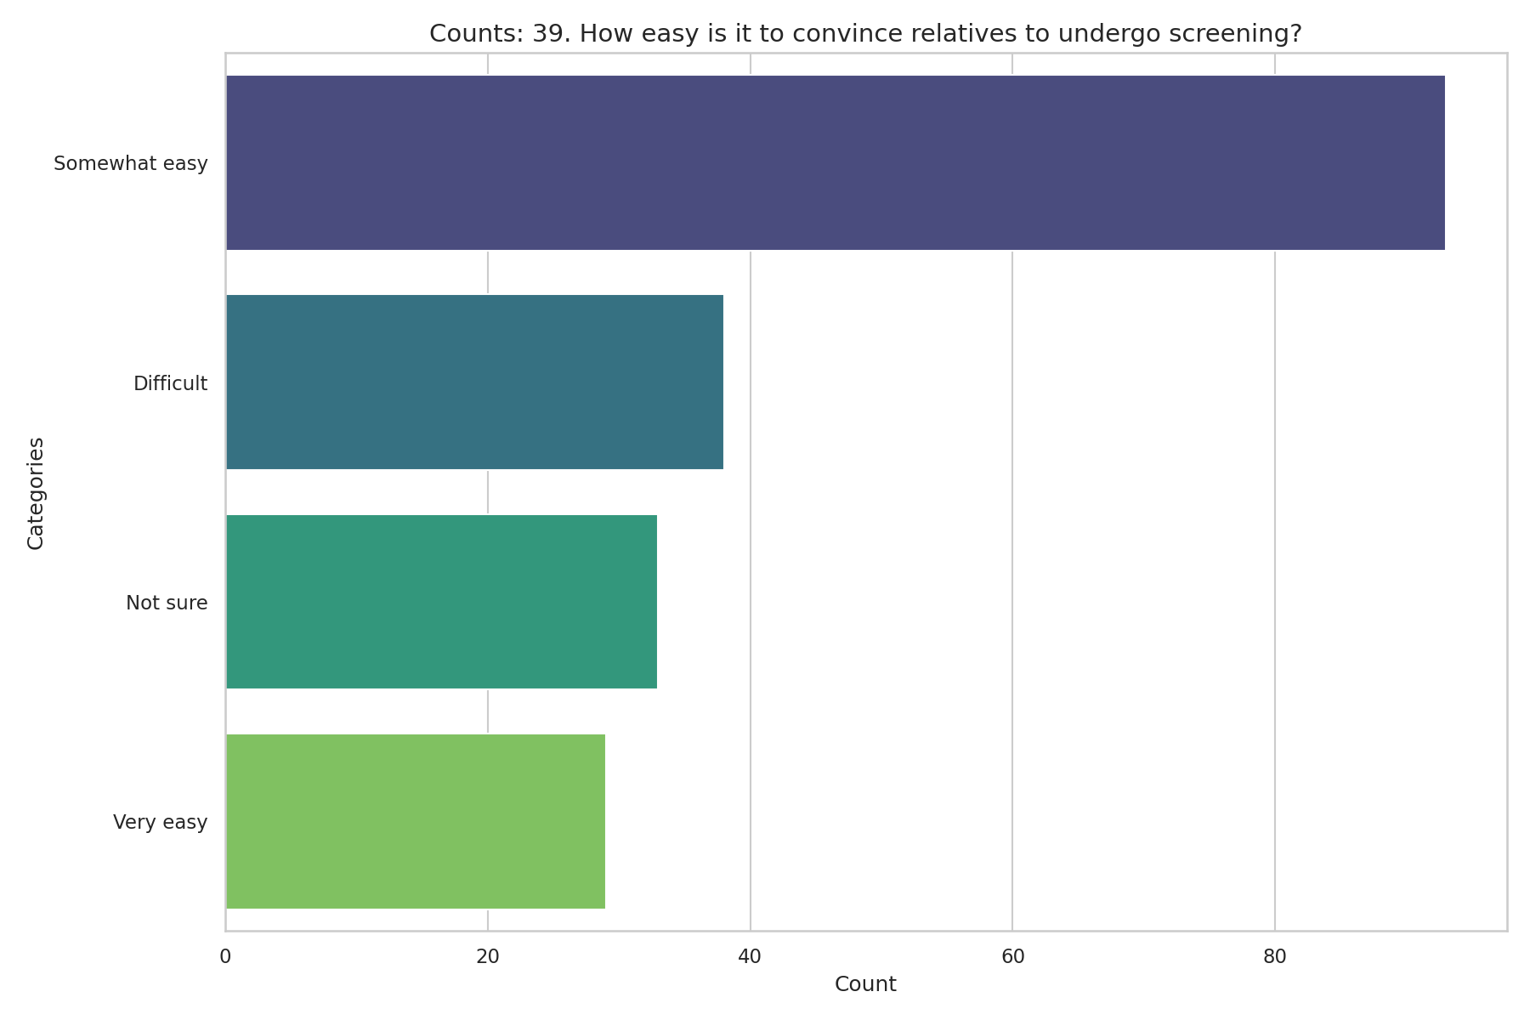
Observed Results:
46.3% find it 'Somewhat easy' to convince relatives, and 14.4% find it 'Very easy'. Conversely, 18.9% find it 'Difficult'.

40. Importance of Cascade Screening
Question: How important is cascade screening in thalassemia prevention?
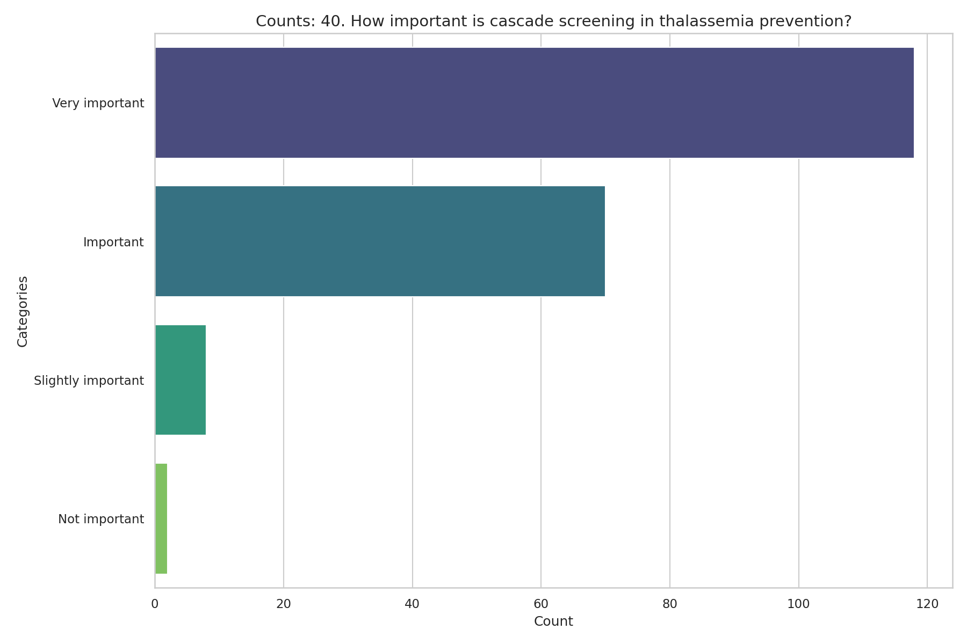
Observed Results:
Overall, cascade screening is viewed very positively; 58.7% consider it 'Very important', and 34.8% consider it 'Important'.

