Section 2: Knowledge on Thalassemia (Part B)

Major Findings
- High Baseline Awareness: A significant 90.0% correctly identify thalassemia as a blood-related disease, and 89.1% understand its hereditary transmission.
- Confusion on Curability: There is considerable misunderstanding regarding the cure; 47.8% believe it cannot be cured, and 33.3% do not know, while only 14.9% recognize it as very difficult to cure (e.g., via bone marrow transplant).
- Misunderstanding of Inheritance: While 60.2% understand there is a 25% chance of a child being affected if both parents are carriers, a concerning 29.4% mistakenly believe the child will always be affected.
- Late Awareness: A large segment (41.8%) only learned about thalassemia after being screened themselves, indicating a lack of proactive public health education.
- Sufficient Counseling: Post-diagnosis, 67.7% of participants felt the counseling and information they received was sufficient.

Summary
The participants demonstrate strong foundational knowledge regarding the nature and transmission of thalassemia. However, significant clinical misconceptions remain—particularly regarding the curability of the disease and the exact probabilities of inheritance. The fact that a large portion only learned about the disease at the time of their own screening underscores the critical need for broader, preemptive educational campaigns in schools and mass media.

15. Blood-Related Disease
Question: Is thalassemia a blood-related disease?
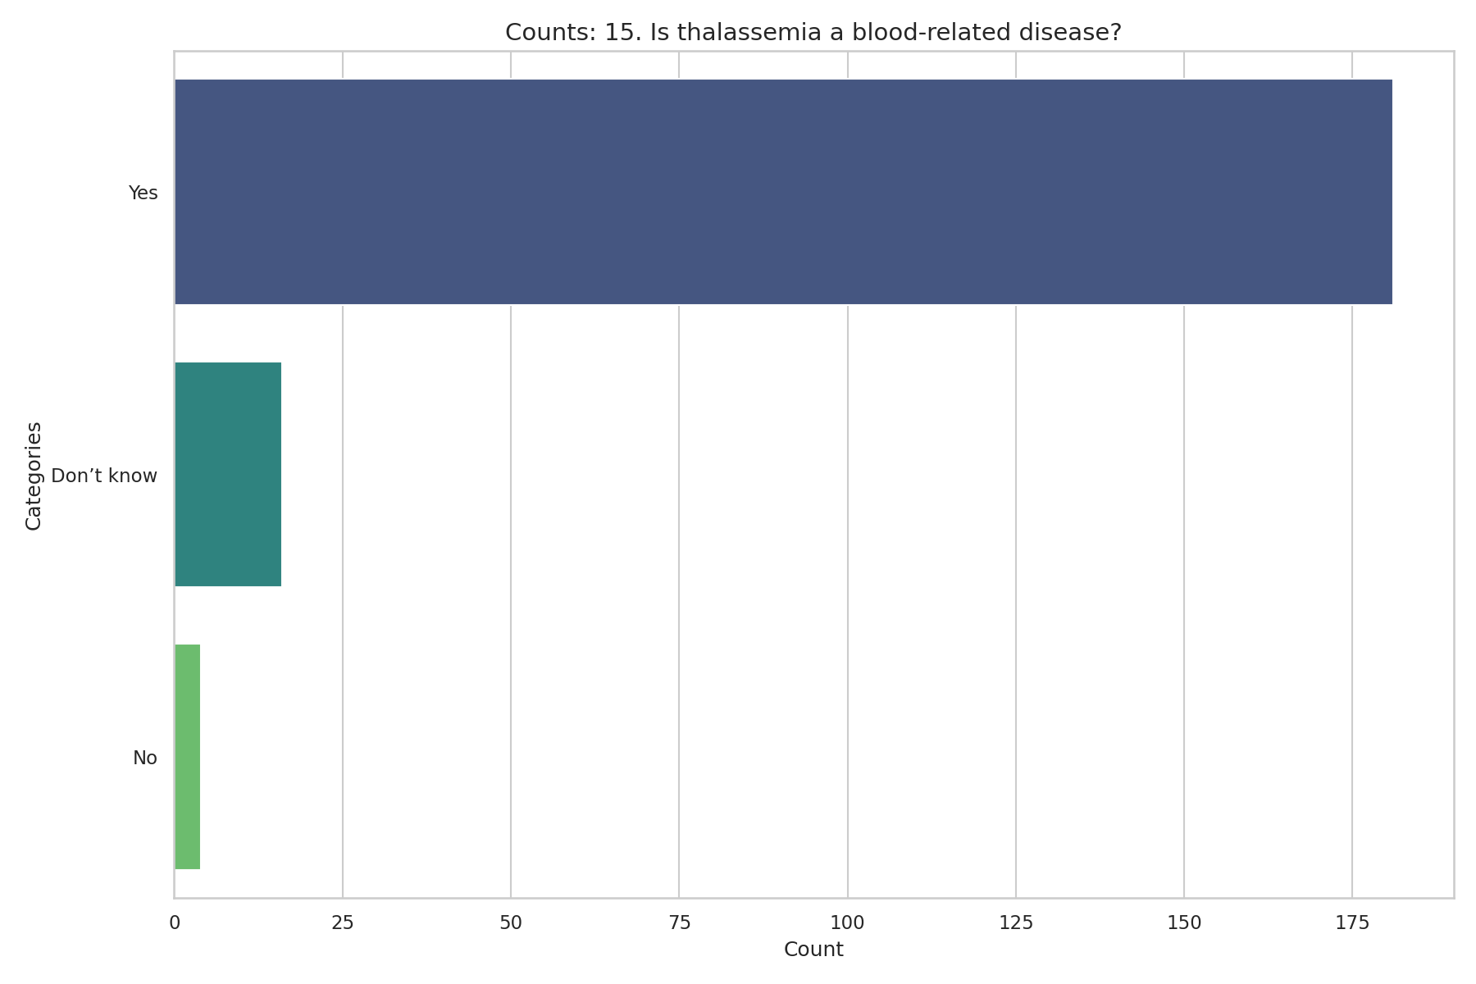
Observed Results:
90.0% of participants correctly identified that Thalassemia is a blood-related disease, while 8.0% did not know.

16. Clinical Forms
Question: What are the clinical forms of thalassemia? (Tick all that apply)
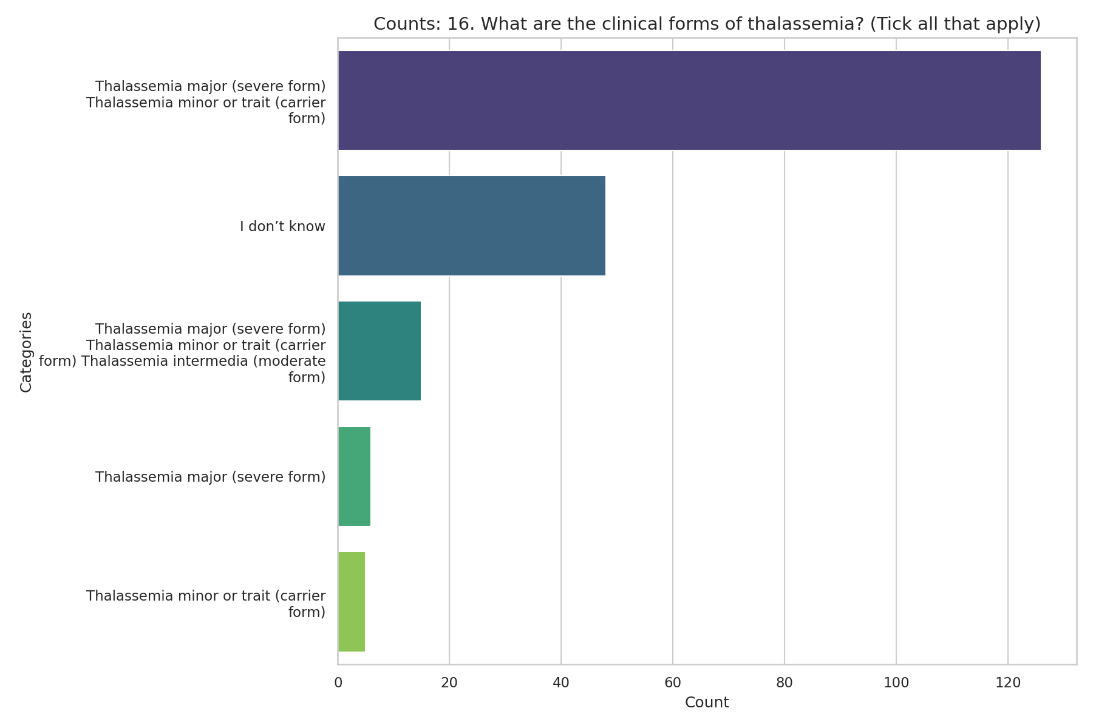
Observed Results:
73.1% identified Thalassemia major (severe form), and 72.6% identified Thalassemia minor or trait (carrier form). 23.9% did not know the clinical forms.

17. Most Severe Form
Question: What is the most severe form of thalassemia?
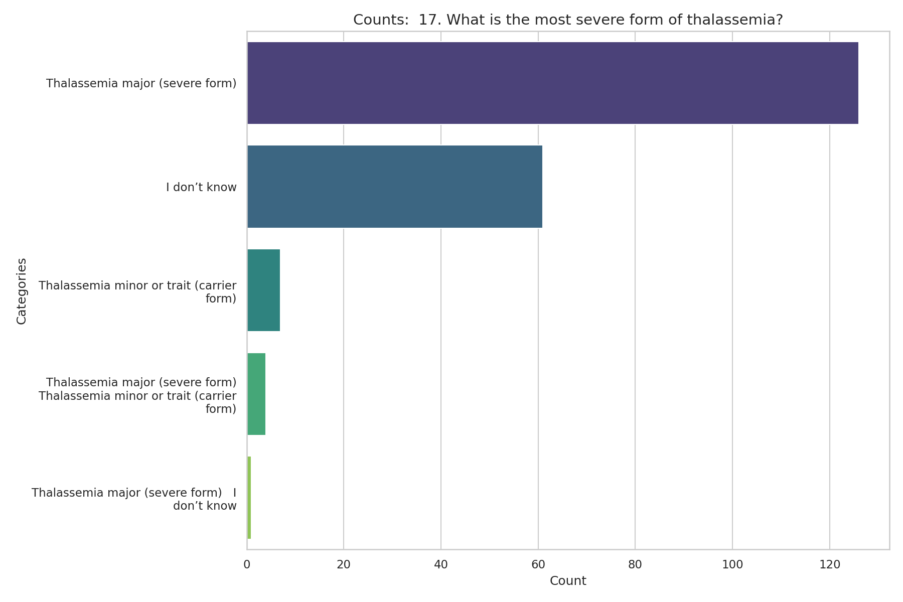
Observed Results:
62.7% correctly identified Thalassemia major as the most severe form, while a significant portion (30.3%) did not know.

18. Form of Thalassemia Diagnosed
Question: What form of thalassemia do you have?
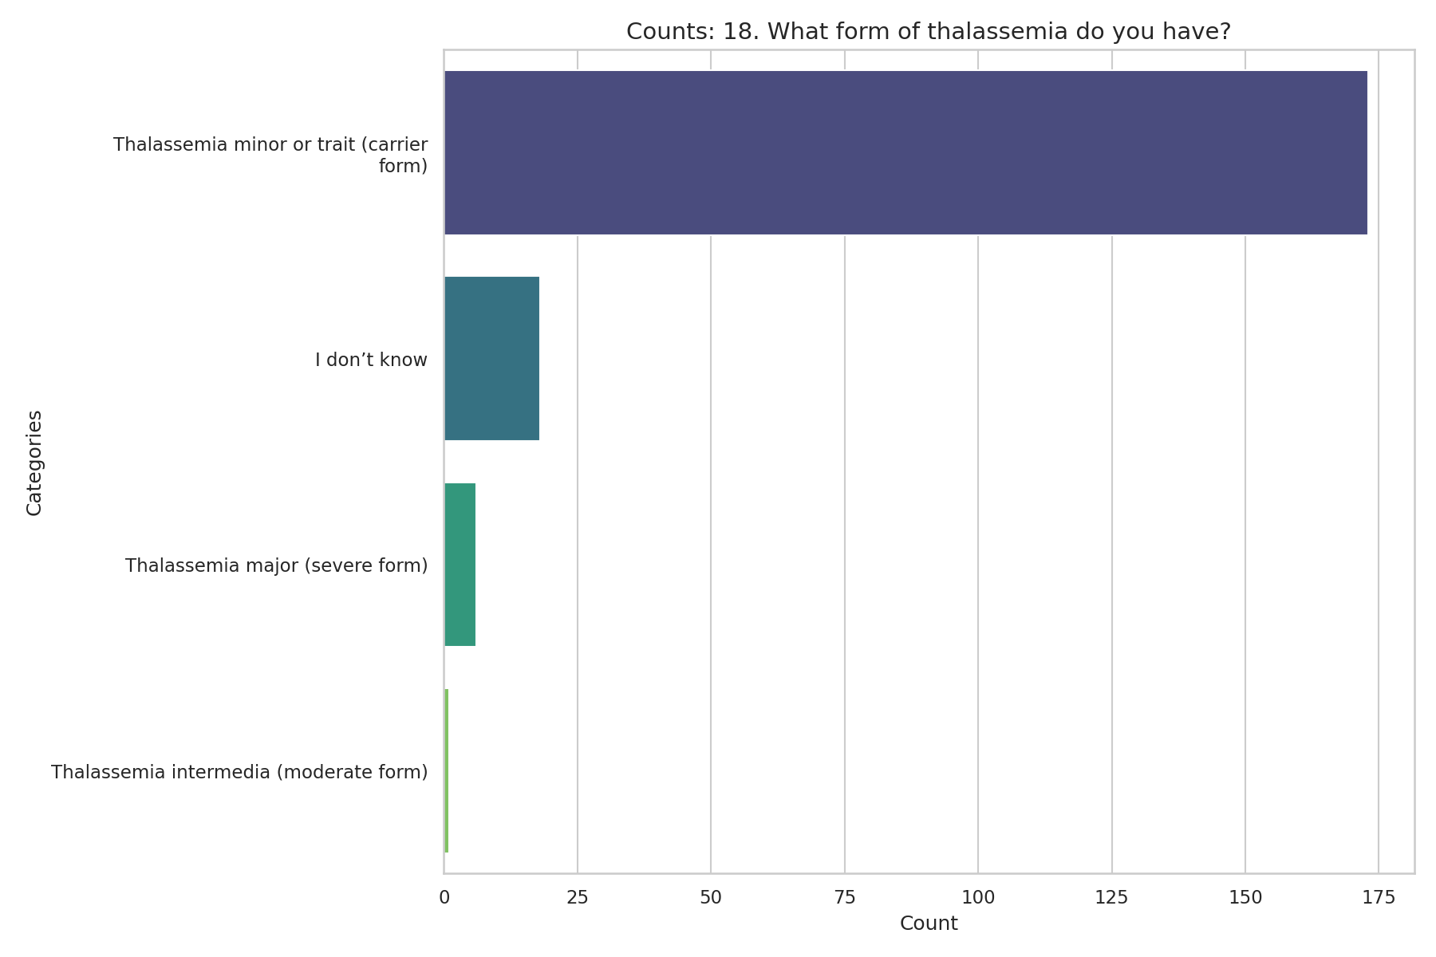
Observed Results:
The vast majority of diagnosed participants (86.1%) have Thalassemia minor or trait (carrier form). 9.0% did not know their specific form.

19. Lifelong Treatment
Question: Does thalassemia major require lifelong treatment?
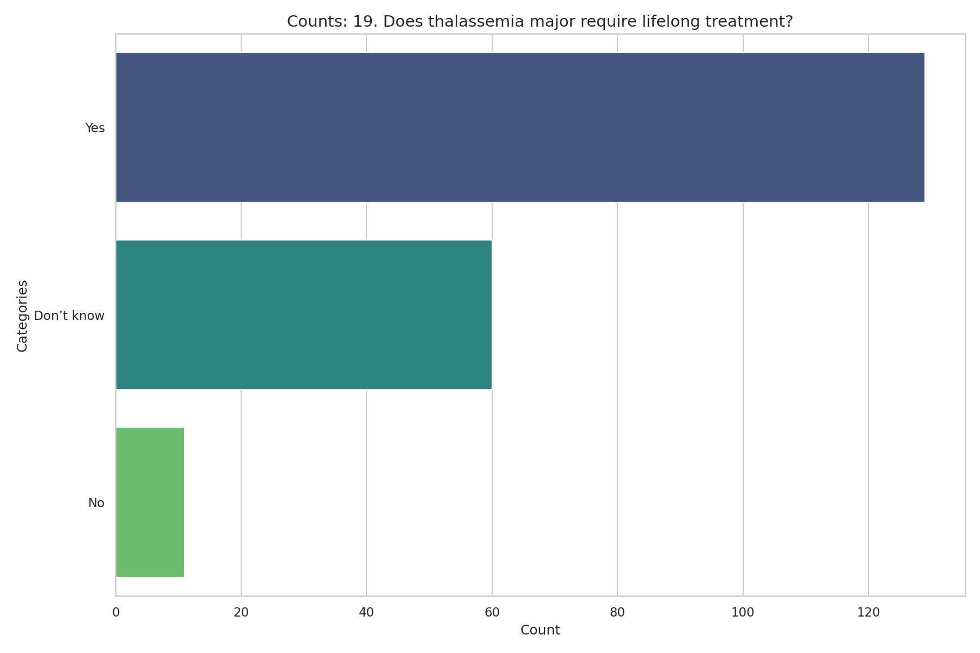
Observed Results:
64.2% correctly stated that it requires lifelong treatment. However, 29.9% did not know.

20. Cure
Question: Can thalassemia major be cured?
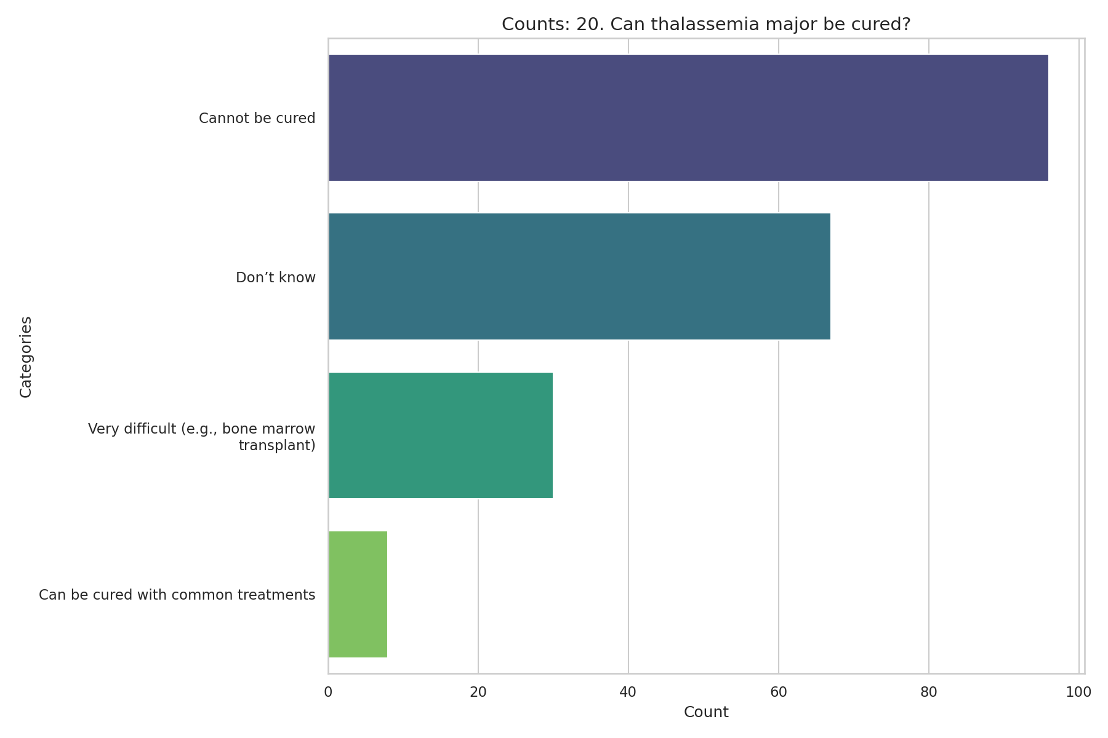
Observed Results:
47.8% believed it cannot be cured, and 33.3% did not know. Only 14.9% correctly identified that it is very difficult to cure (e.g., via bone marrow transplant).

21. Prevention
Question: Can the spread of thalassemia be prevented?
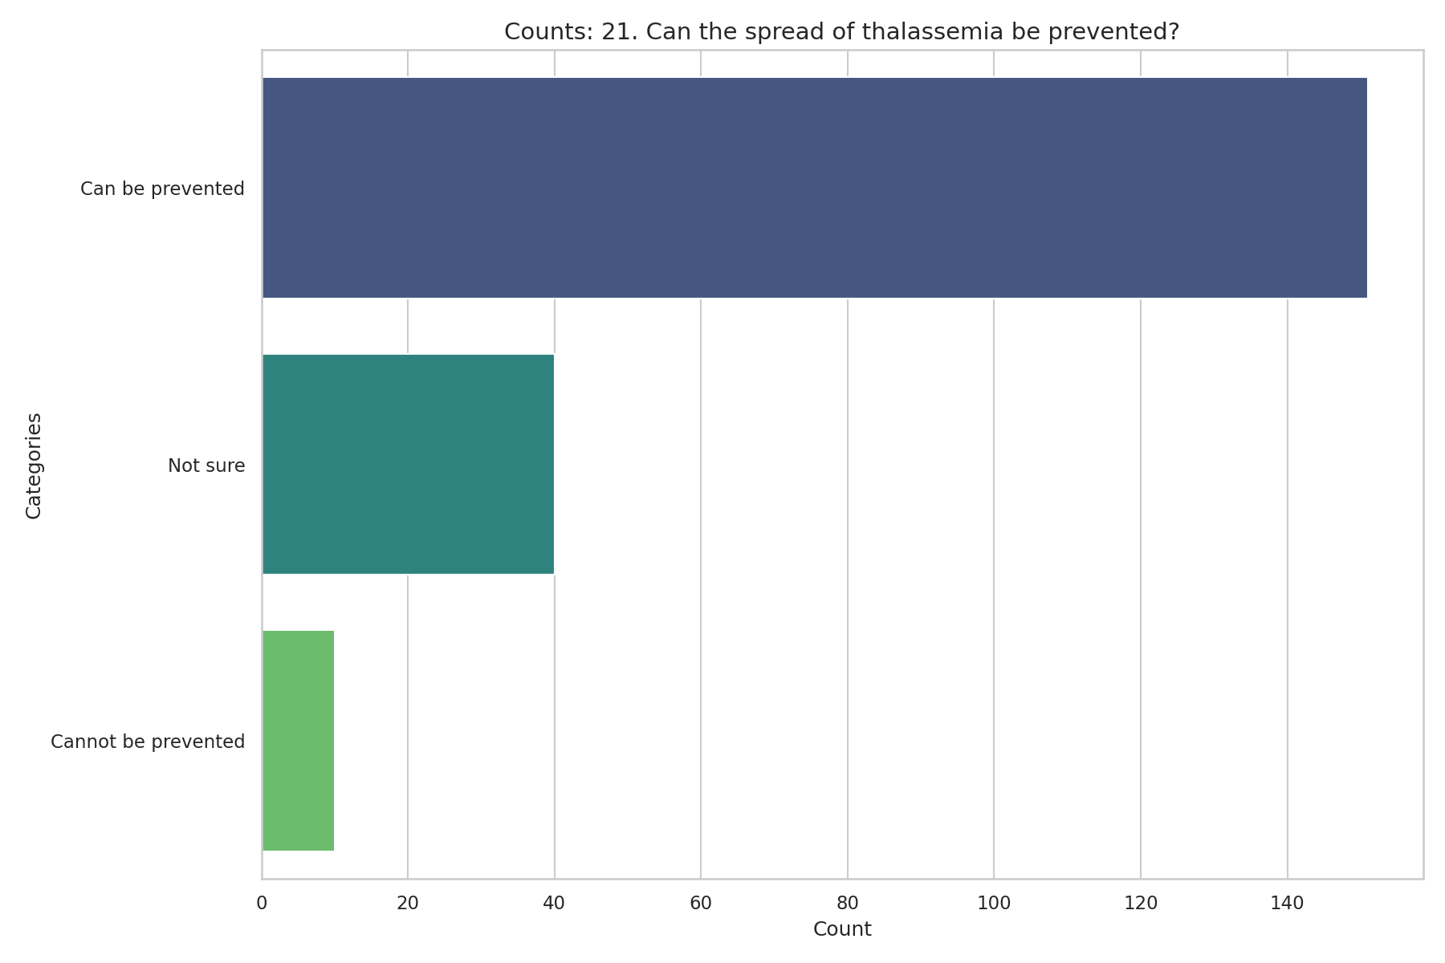
Observed Results:
A strong majority (75.1%) believe the spread of Thalassemia can be prevented, though 19.9% are not sure.

22. Transmission
Question: How is thalassemia transmitted?
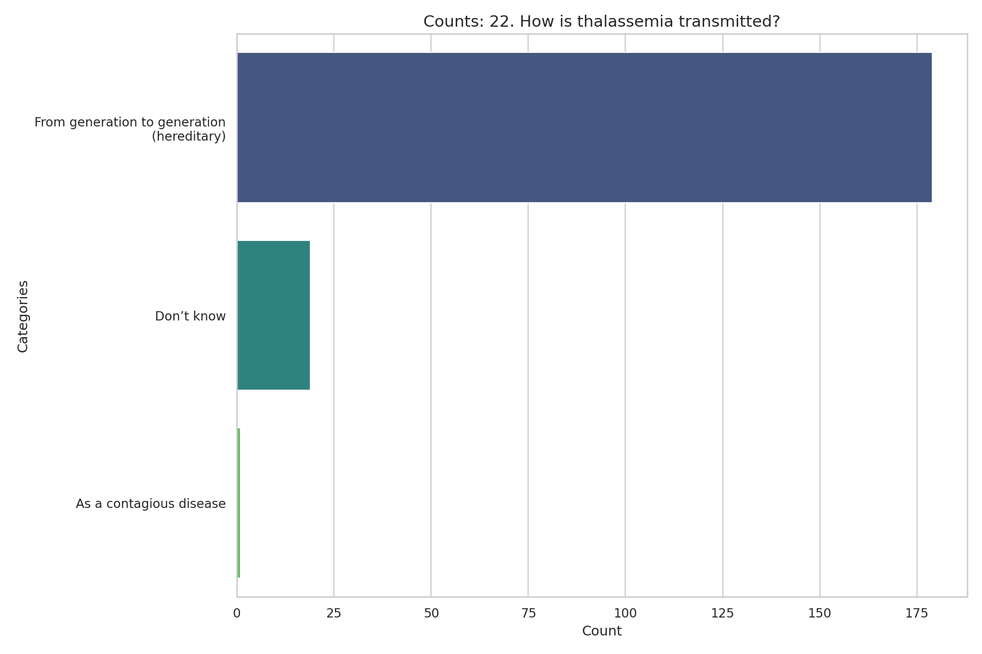
Observed Results:
89.1% correctly identified that Thalassemia is transmitted from generation to generation (hereditary).

23. Carrier Health
Question: Is a thalassemia carrier usually sick or healthy?
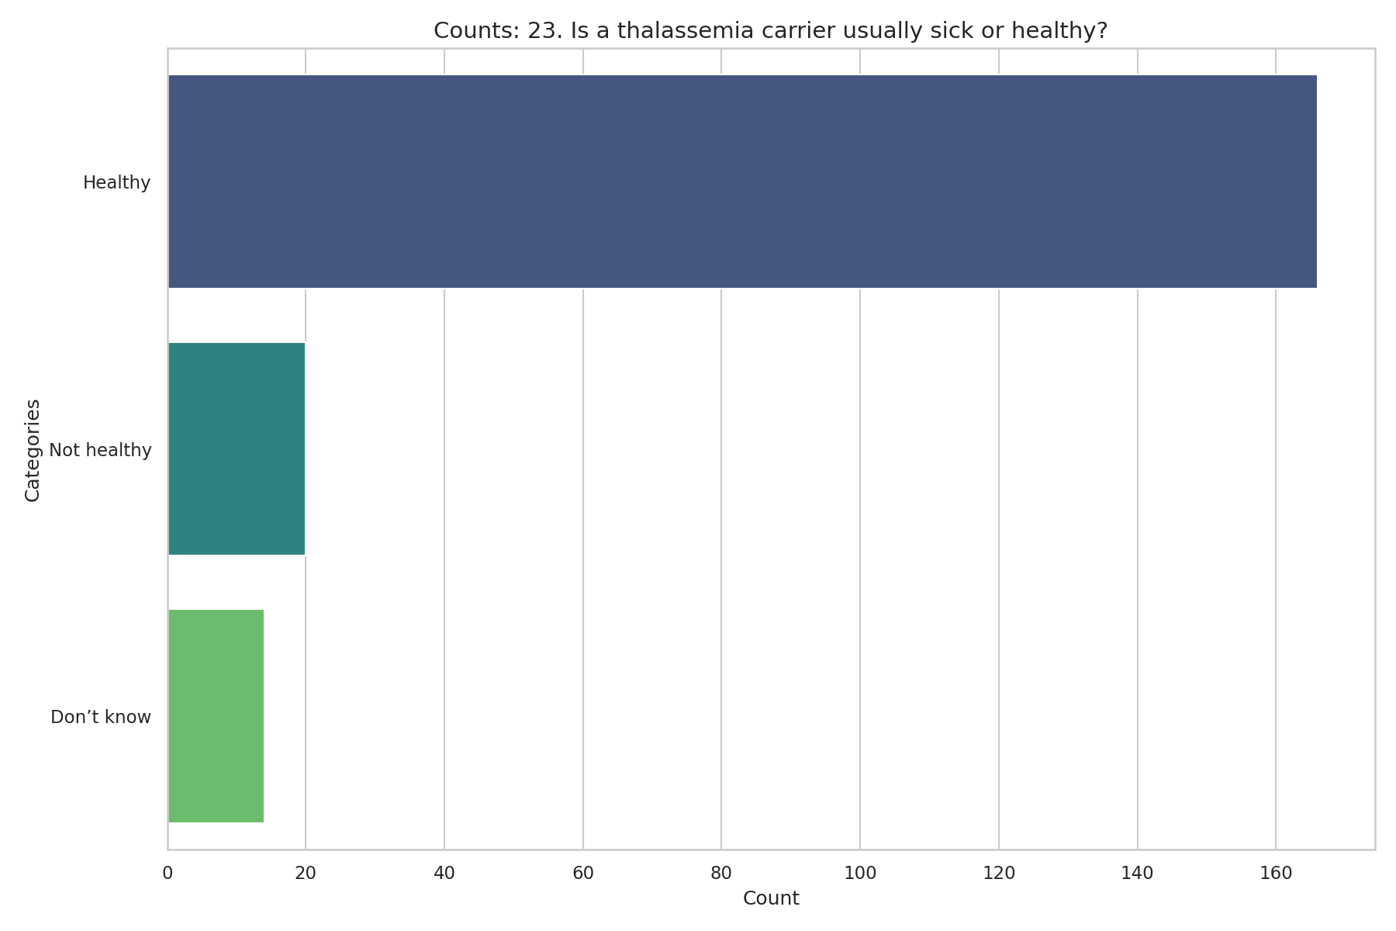
Observed Results:
82.6% correctly answered that a thalassemia carrier is usually healthy. 10.0% incorrectly believed they are not healthy.

24. Inheritance Probability
Question: A child born from two thalassemia carriers will be:
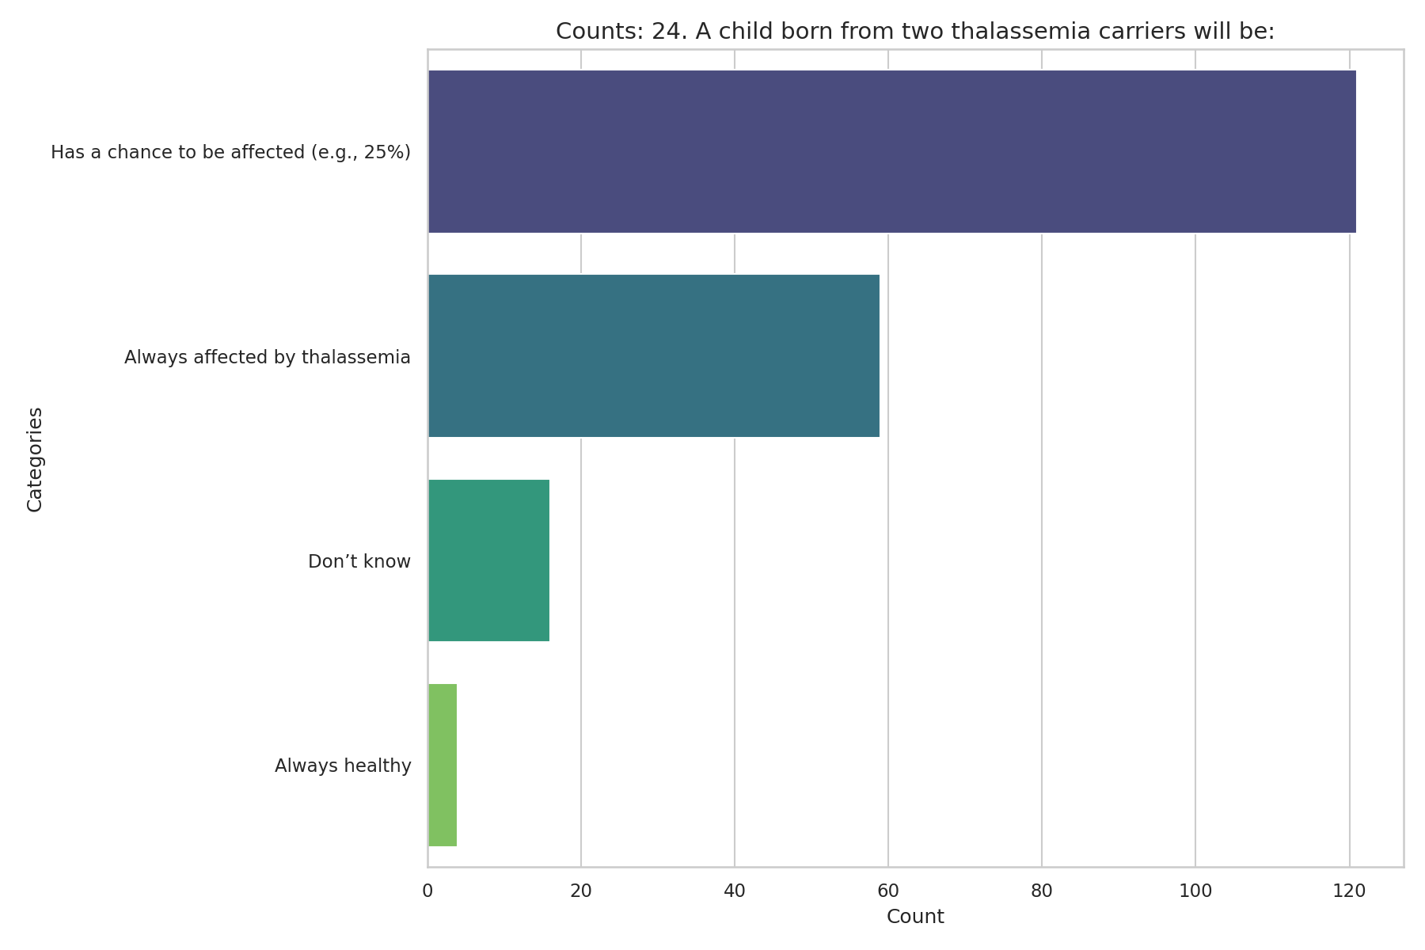
Observed Results:
60.2% correctly identified that a child has a chance to be affected (e.g., 25%). However, 29.4% incorrectly believed the child will always be affected.

25. Counseling Sufficiency
Question: After diagnosis, was counseling/information sufficient?
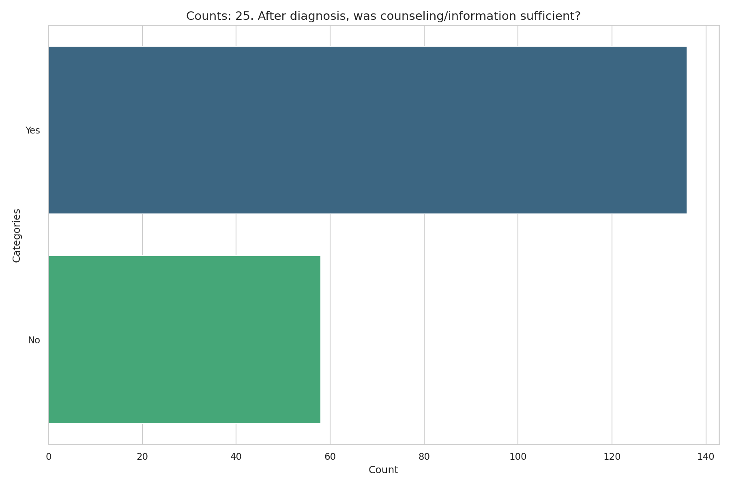
Observed Results:
67.7% felt the counseling/information they received was sufficient, whereas 28.9% felt it was not.

26. Birth Statistics
Question: How many thalassemia births occur in Sri Lanka per year?
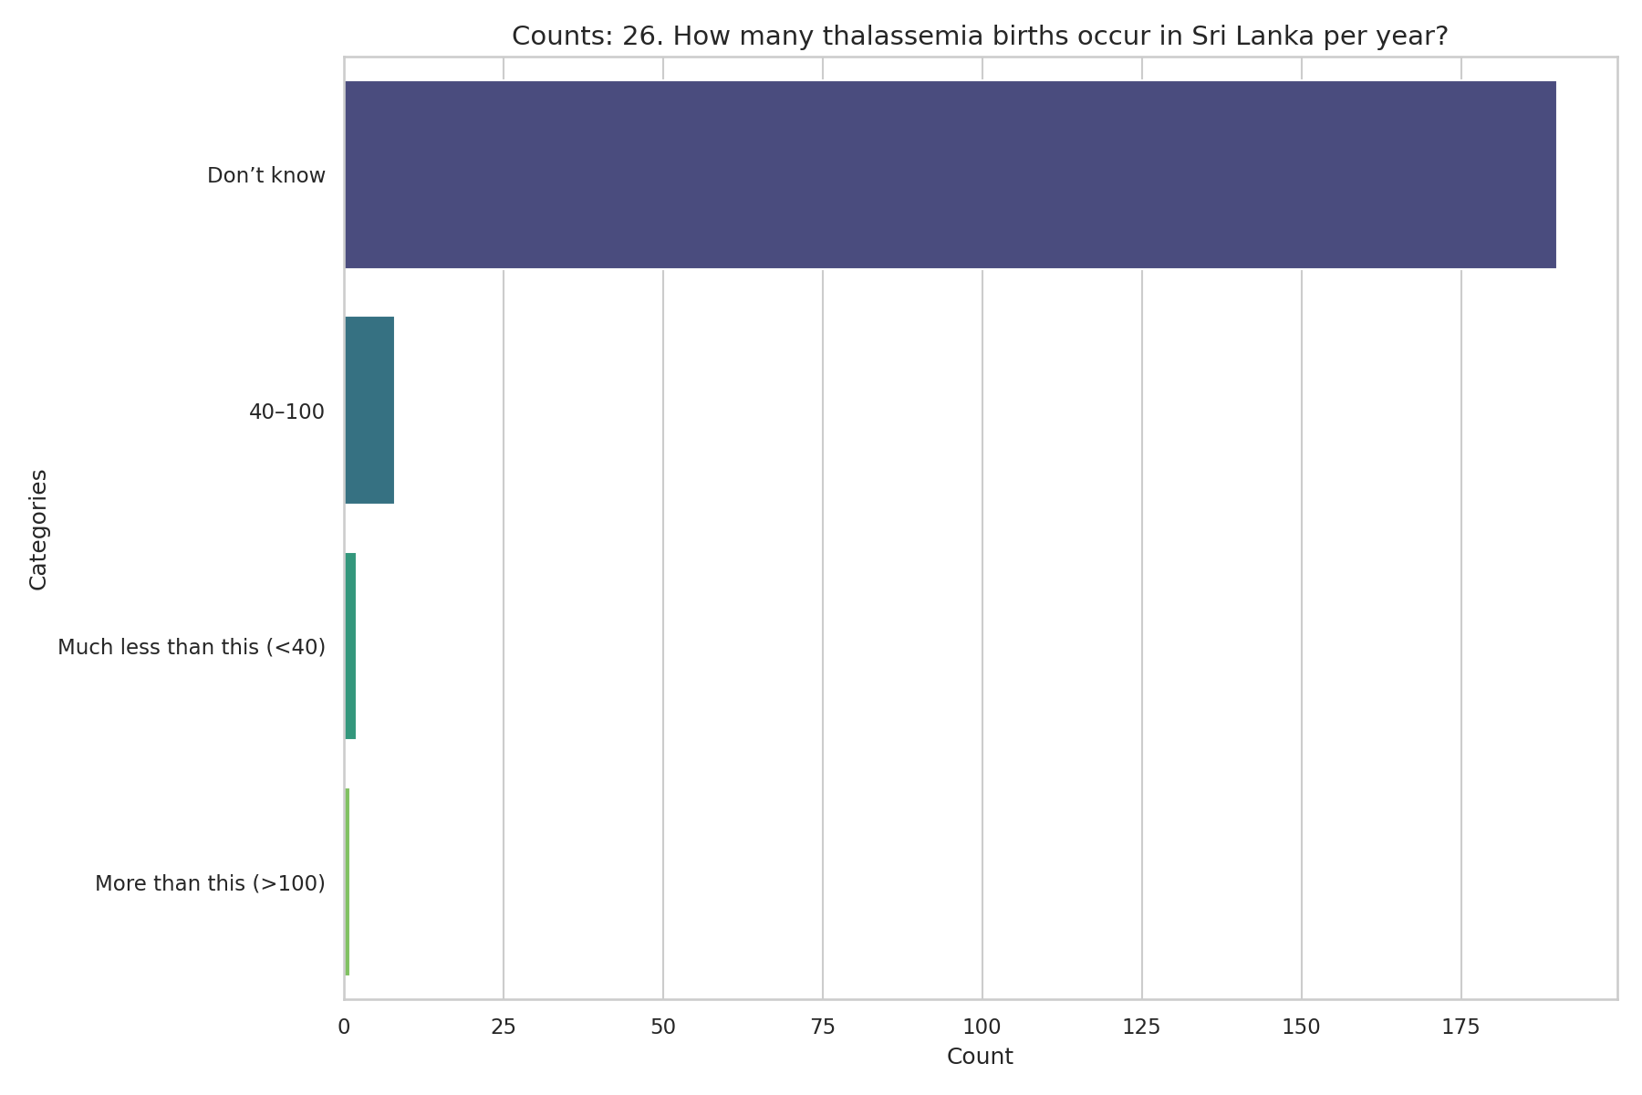
Observed Results:
The vast majority of participants (94.5%) did not know the annual birth rate of thalassemia in Sri Lanka.

27. Patient Problems
Question: Problems faced by thalassemia major patients (Tick all that apply):
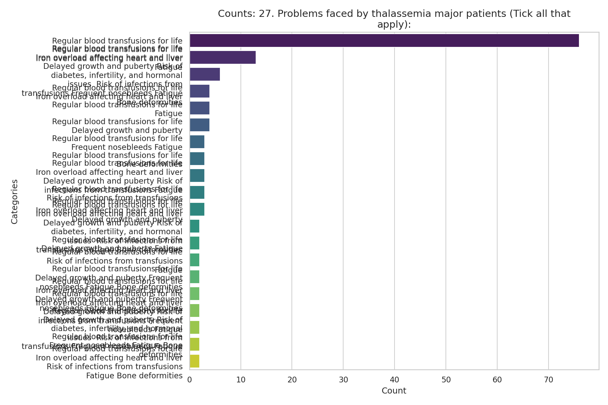
Observed Results:
The most recognized problem was 'Regular blood transfusions for life' (84.1%), followed by Fatigue (31.8%) and Iron overload (26.4%).

28. Actions After Diagnosis
Question: What should a thalassemia carrier do after diagnosis? (Tick all that apply)
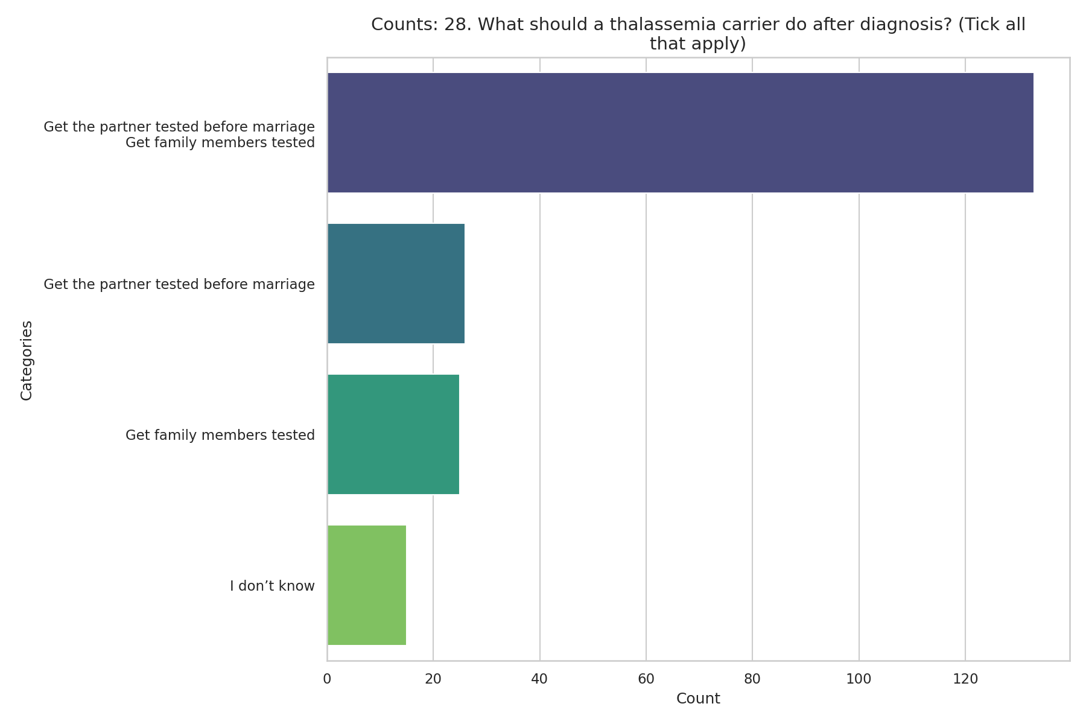
Observed Results:
A high proportion correctly indicated they should get their partner tested before marriage (79.1%) and get family members tested (78.6%).

29. Source of Information
Question: How did you learn about thalassemia?
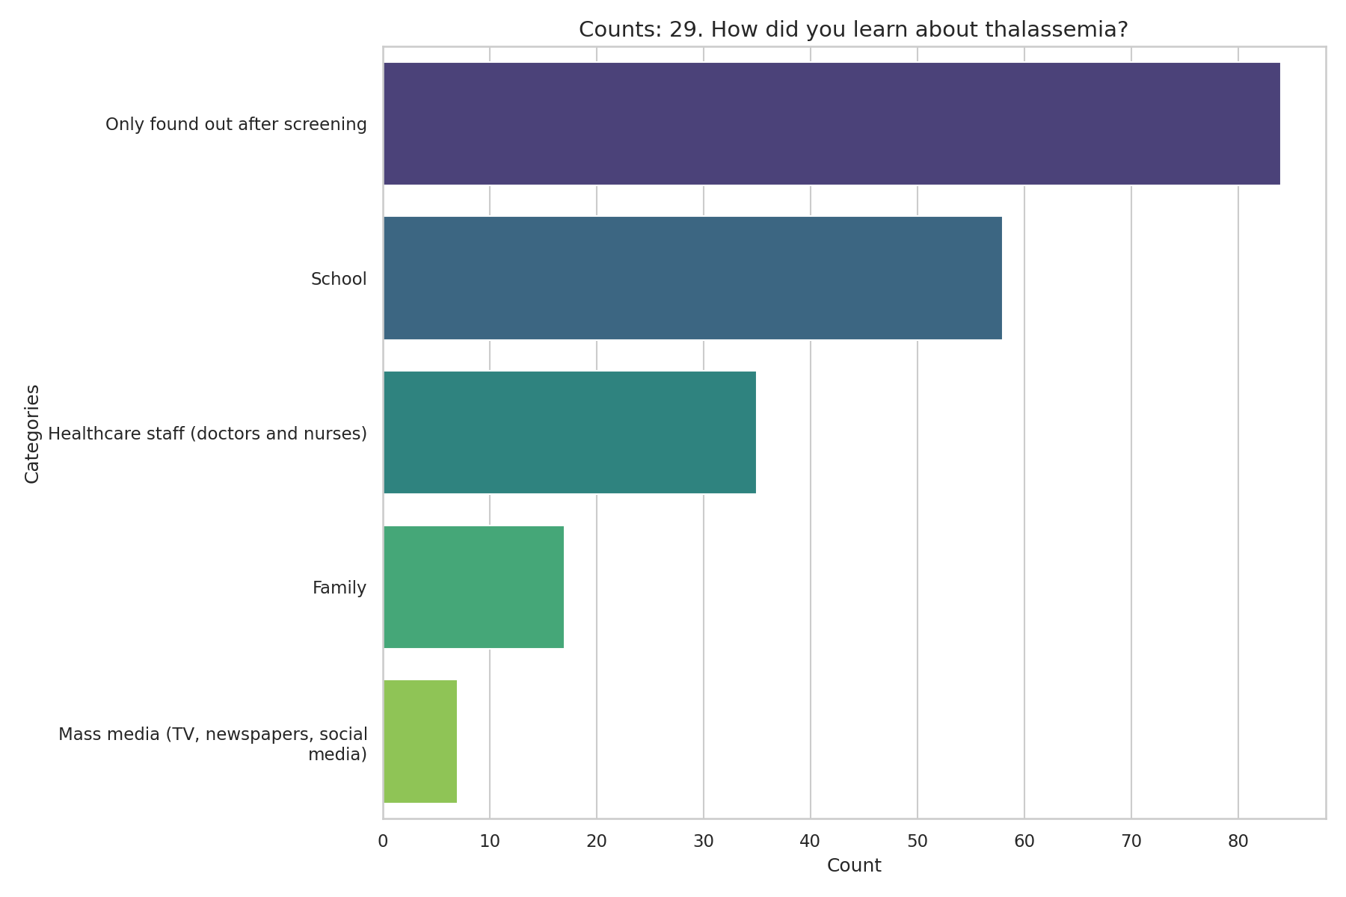
Observed Results:
41.8% only found out after screening. 28.9% learned from school, and 17.4% from healthcare staff.

Overall Knowledge Score Distribution
Question: Cumulative score of all 15 knowledge questions
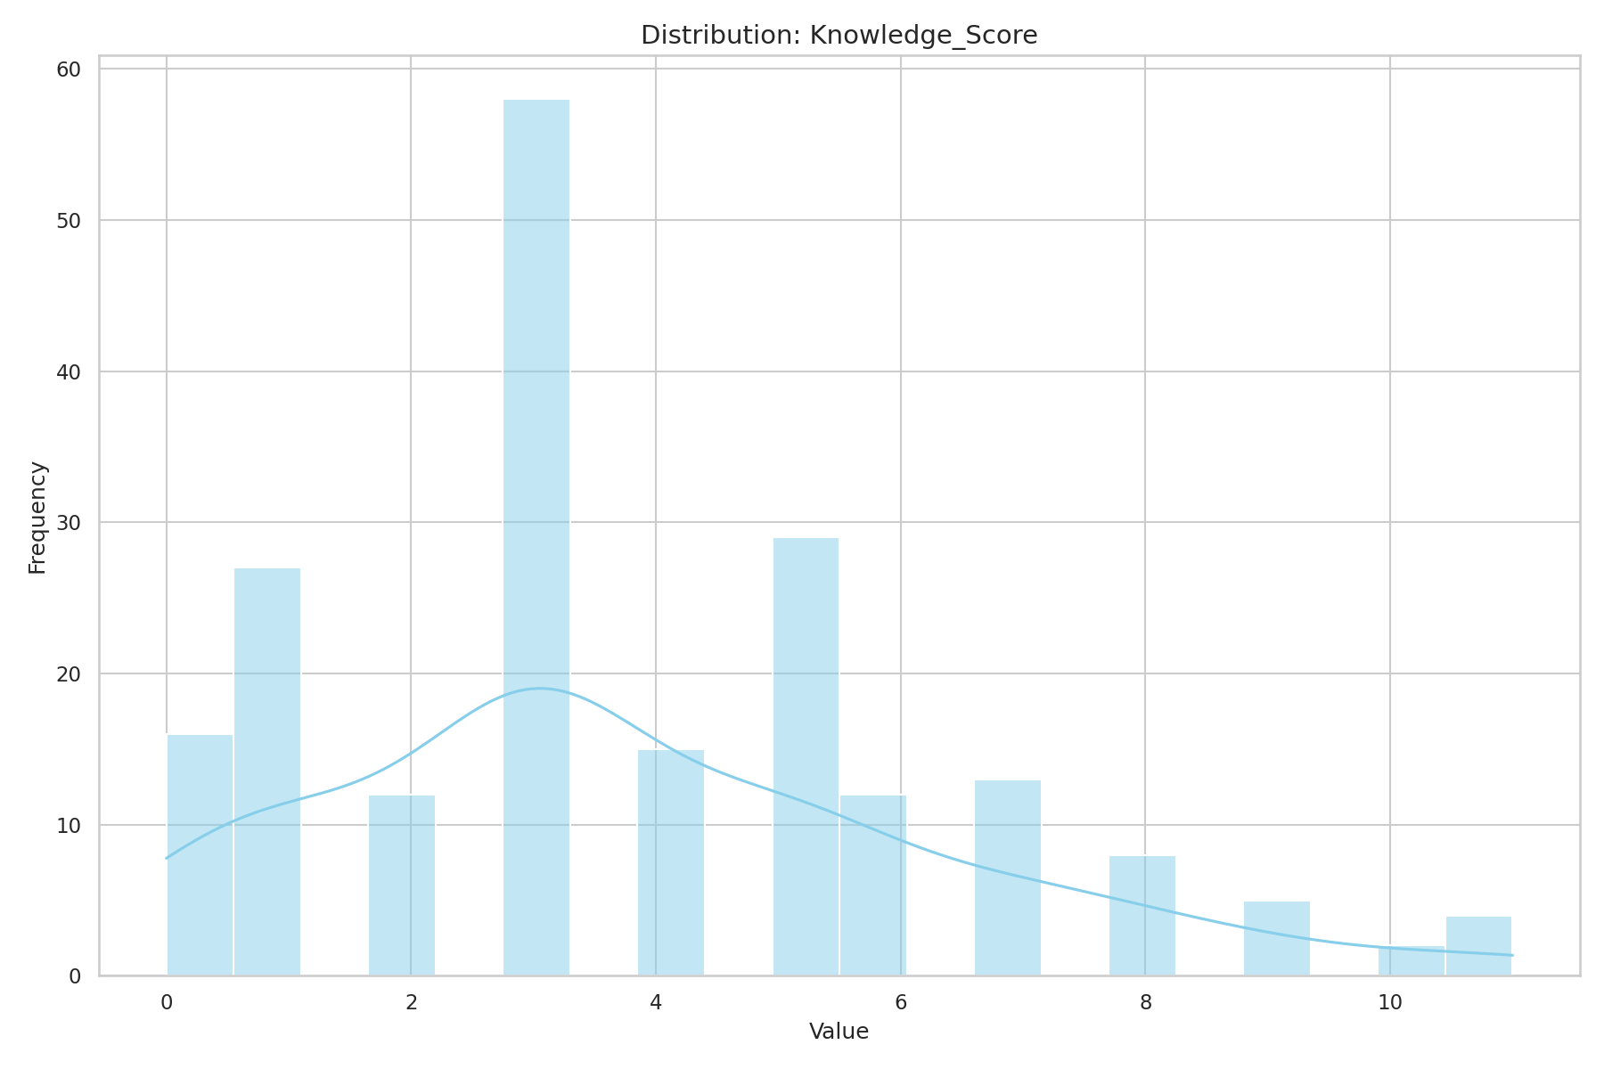
Observed Results:
The overall knowledge score distribution highlights the general competency in basic thalassemia awareness, while identifying gaps in detailed clinical knowledge.

