Section 3: Attitudes & Practices Regarding Partner Screening

Major Findings
- High Theoretical Importance: Over 90% of participants agree that pre-marital thalassemia screening is either 'Very important' or 'Important'.
- Strong Opposition to Carrier/Consanguineous Marriage: 79.6% are strictly against consanguineous marriages, and 77.1% do not accept marriages between two thalassemia carriers.
- Attitude-Practice Gap: Despite high perceived importance, actual pre-marital screening rates are remarkably low. Only 10.4% reported screening their partner before marriage, while 16.4% screened after marriage, and 12.9% did not screen at all.
- Reasons for Non-Disclosure: Among those who did not disclose their carrier status, the primary reasons cited were a lack of understanding regarding its importance or simply not thinking it was necessary.

Summary
There is a pronounced disconnect between attitudes and actual practices regarding partner screening. While the vast majority intellectually grasp the importance of pre-marital screening and strongly oppose high-risk marriages, these positive attitudes do not translate into preventative action. The reliance on post-marital screening or omitting screening altogether points to deep-seated cultural, logistical, or communicative barriers that need to be addressed in future interventions.

30. Consanguineous Marriage
Question: Are you willing to / Do you have a consanguineous marriage?
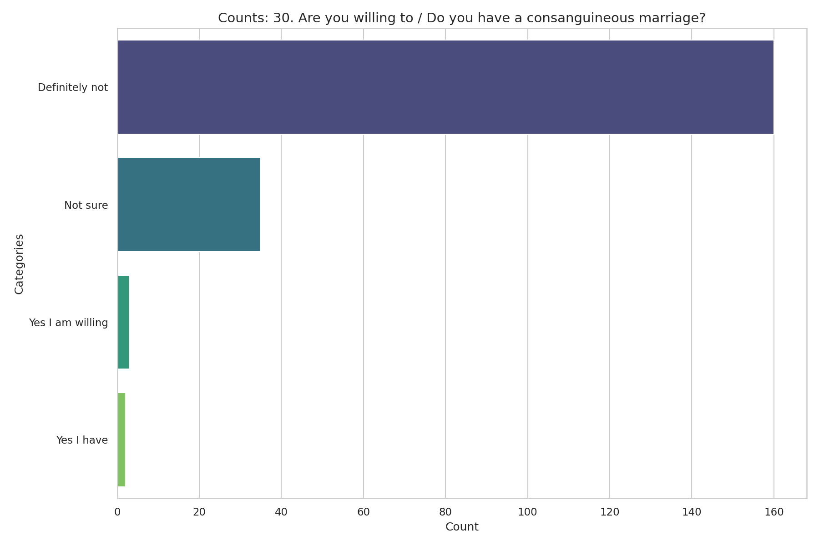
Observed Results:
Participants strongly oppose consanguineous (blood-relative) marriages, with 79.6% stating 'Definitely not,' and only 1.5% stating they are willing.

31. Carrier Marriage
Question: Do you accept marriage between two thalassemia carriers?
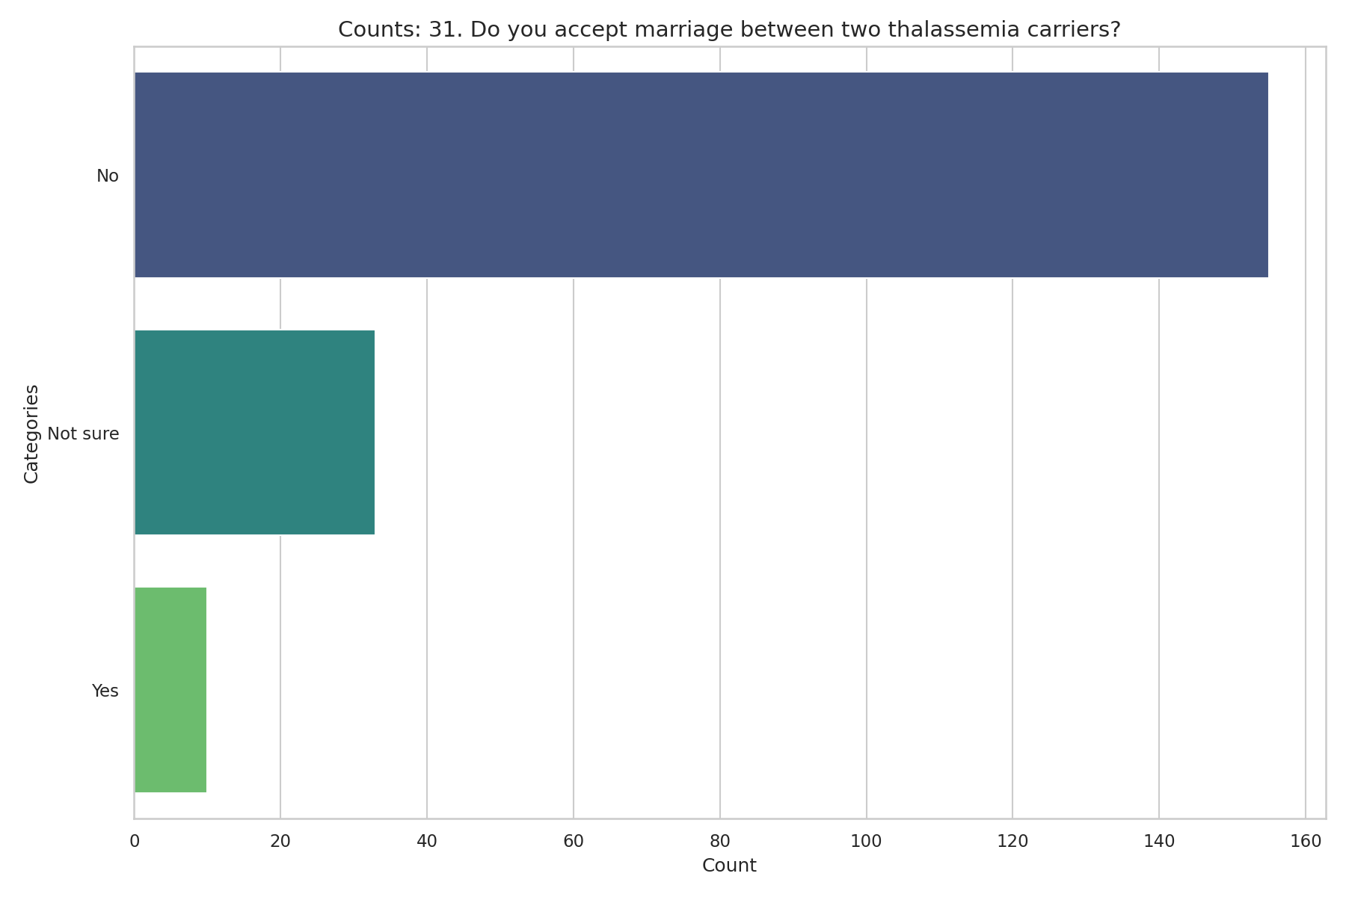
Observed Results:
The vast majority (77.1%) do not accept marriage between two thalassemia carriers. 16.4% are not sure, and only 5.0% accept it.

32. Importance of Pre-Marital Screening
Question: How important is thalassemia screening before marriage?
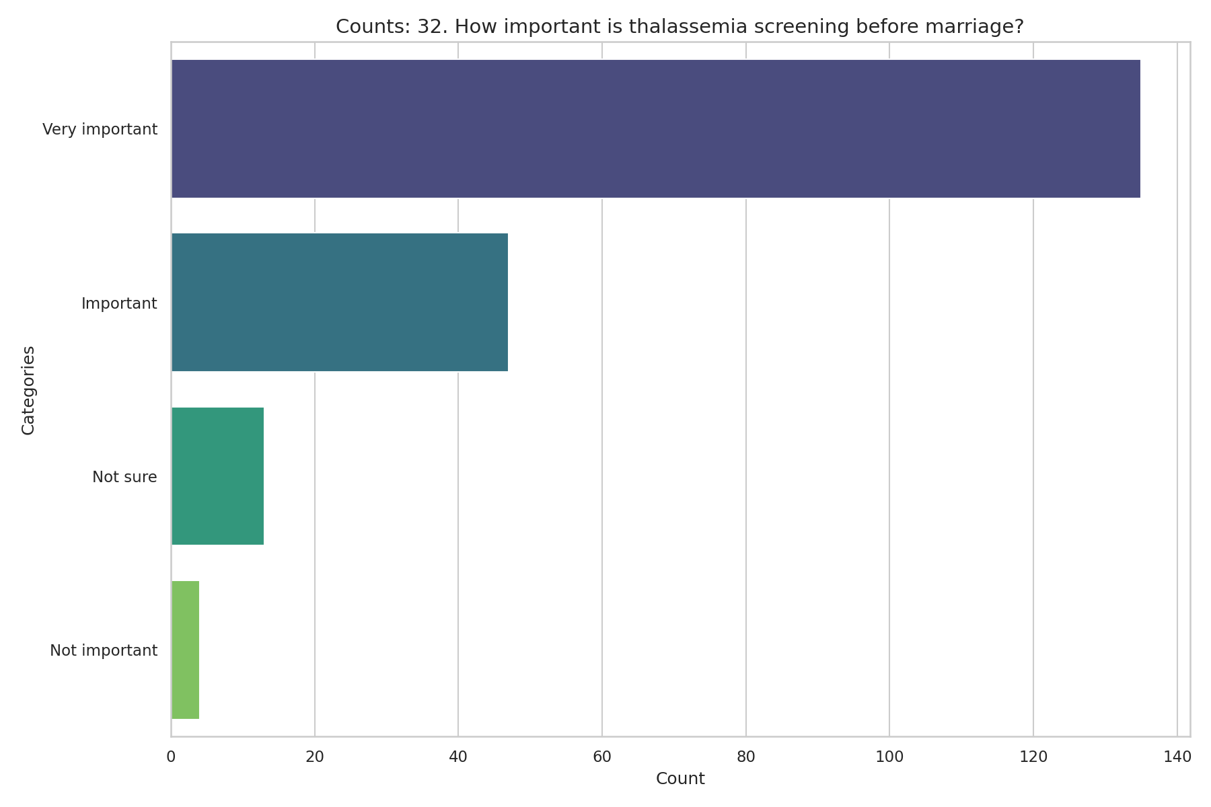
Observed Results:
A combined 90.5% of participants consider it either 'Very important' (67.2%) or 'Important' (23.4%). Only 2.0% deemed it not important.

33. Practice of Partner Screening
Question: What was your practice of partner screening?
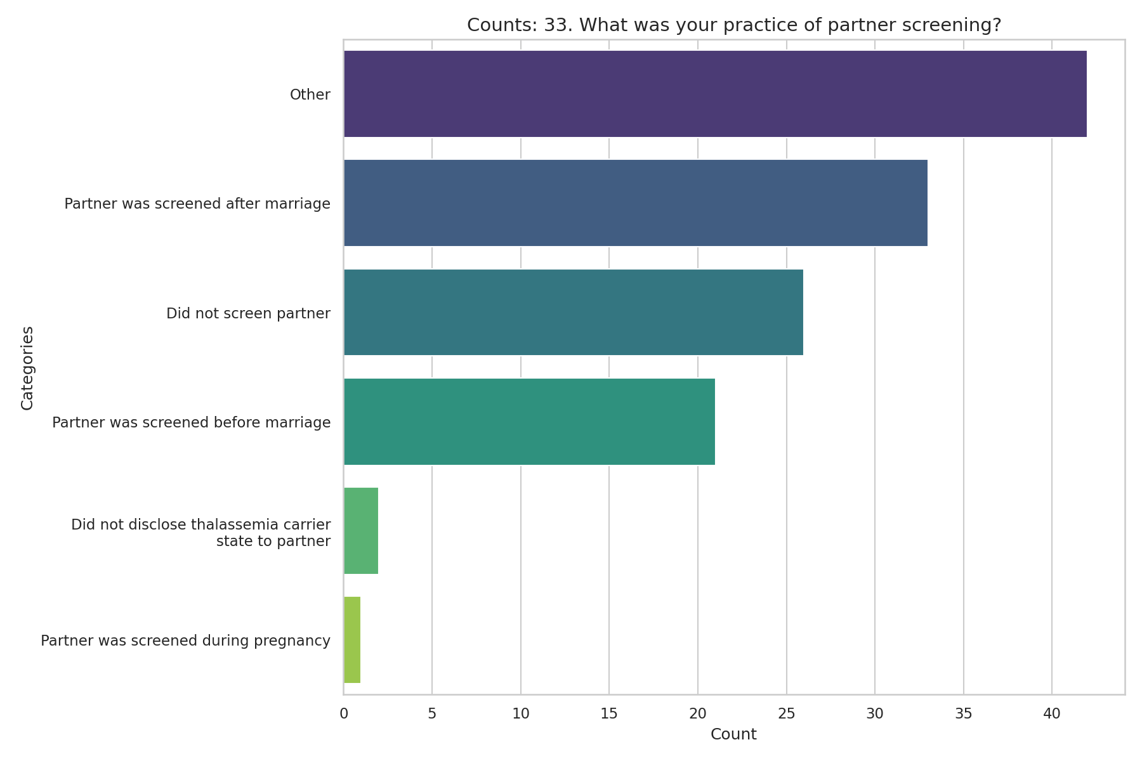
Observed Results:
Among those who provided a definitive answer (excluding the 37.8% missing response/unmarried), 16.4% reported that their partner was screened after marriage, and 12.9% did not screen their partner at all. Only 10.4% reported that their partner was screened before marriage.

34. Non-disclosure Reasons
Question: If you did not disclose your carrier status to your partner before marriage, what was the reason?
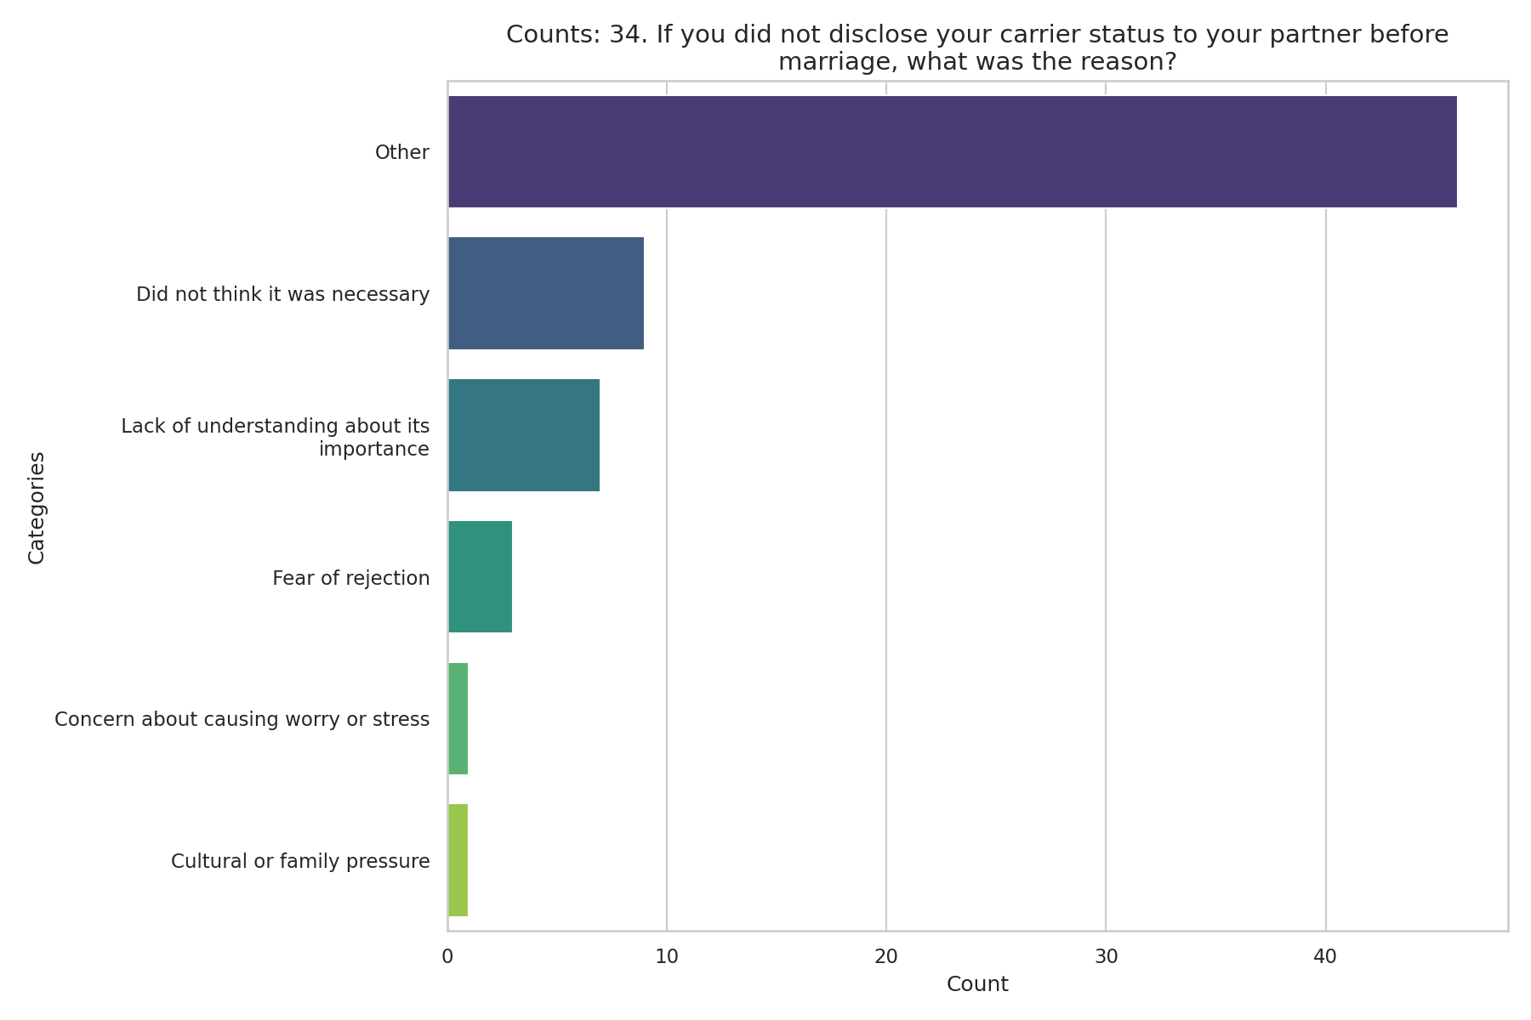
Observed Results:
The majority (66.7%) skipped this question (likely because they disclosed it or are not married). Of those who did answer, 'Did not think it was necessary' (4.5%) and 'Lack of understanding about its importance' (3.5%) were the primary reasons.

