Heart Disease Prediction
End-to-End Machine Learning System
Final Model Report — Model Training, Optimization
Report Date | March 2026
Project | Heart Disease Prediction — FastAPI Web Application
Models | Gradient Boosting, Random Forest, Logistic Regression
Final Status | Completed — all models optimized

1. Technologies Used
The following technologies and tools were used throughout the project:

Technology | Purpose
Python 3.13 | Primary programming language for data processing and model training
pandas / numpy | Data loading, manipulation, and numerical operations
scikit-learn | Model training, preprocessing (StandardScaler), hyperparameter search (RandomizedSearchCV), evaluation metrics
FastAPI | Web framework for building the prediction API and serving the HTML interface
Uvicorn | ASGI server for running the FastAPI application
Jinja2 | HTML templating engine for rendering the prediction form and results
HTML / CSS | Frontend interface design including form layout, result card, and responsive styling
pickle | Serialization and saving of trained models and preprocessing objects
PyCharm | Integrated development environment used for writing and running all scripts
ChatGpt(AI) | AI assistant used throughout the project for, debugging, and optimization

2. Project Overview
This project builds a complete end-to-end machine learning system for predicting heart disease from clinical patient data. The dataset contains 270,000 patient records with 12 clinical features. The pipeline covers data preprocessing, model training and evaluation, model optimization, and deployment as a FastAPI web application.

Stage | Description | Status
Stage 1 | Model Training & Evaluation | Completed
Stage 2 | Model Optimization | Completed
Stage 3 | FastAPI Web Application | Completed

3. Initial Model Training & Evaluation
Three machine learning models were trained on the preprocessed dataset. The dataset was split 80/20 into training and test sets (stratified, random_state=42), with StandardScaler applied to all features before training. Each model was evaluated on a held-out test set of 54,000 records.

3.1 Initial Evaluation Results

Model | Accuracy | Precision | Recall | F1-Score | ROC-AUC
Gradient Boosting | 76.51% | 72.59% | 68.33% | 70.39% | 82.52%
Logistic Regression | 76.04% | 73.66% | 64.39% | 68.71% | 82.05%
Random Forest | 75.14% | 70.27% | 67.89% | 69.06% | 80.43%

3.2 Model Selection Decision
Based solely on the evaluation metrics, Gradient Boosting was selected as the best model. It achieved the highest ROC-AUC (82.52%), highest Accuracy (76.51%), and best F1-score (70.39%). With strong and consistent performance across all five metrics, the decision was made to proceed directly to building the web application using Gradient Boosting as the production model.
At this stage, the evaluation metrics appeared strong and reliable. There was no indication from the offline evaluation that anything was wrong with the pipeline.

4. Web Application — Initial Build
A FastAPI web application was built with a clean HTML/CSS interface allowing users to enter 12 clinical features and receive a real-time heart disease risk prediction. The interface was working correctly from the beginning — all 12 input fields, the result card, probability bar, and risk level labels all rendered and functioned as expected without any issues.

4.1 First Test — Incorrect Predictions
On the first test run, three sample patients with different risk profiles were entered into the form. All three patients returned High Risk predictions regardless of their input values, which was clearly incorrect. The screenshots below show the outputs received during the first run:

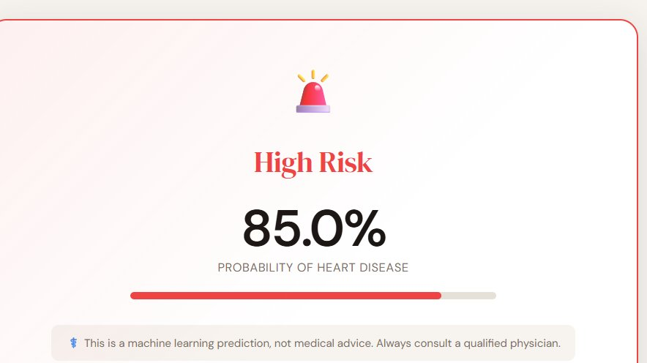
Figure 1: Patient 1 (low-risk profile) — incorrectly showing 85.0% High Risk

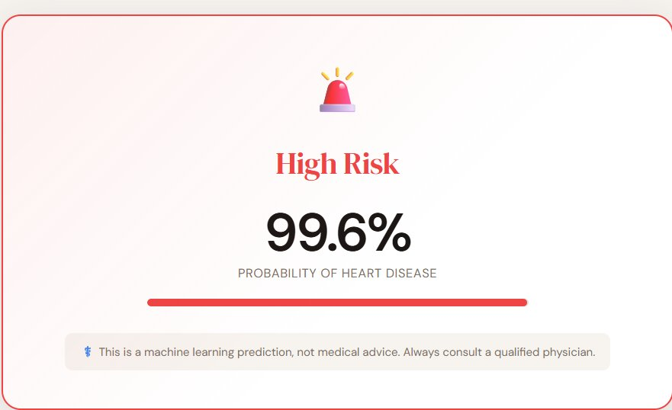
Figure 2: Patient 2 — incorrectly showing 99.6% High Risk

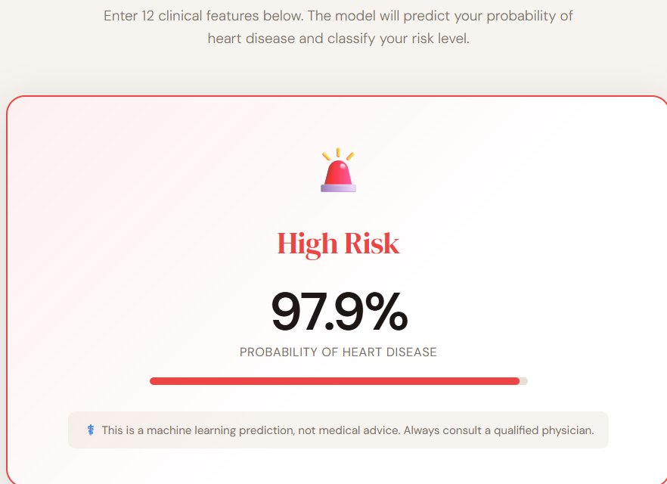
Figure 3: Patient 3 — incorrectly showing 97.9% High Risk

The incorrect predictions were caused by issues in the model inference pipeline, not the interface. The interface itself was rendering correctly throughout. The problem was identified and fixed before proceeding to model optimization.

5. Model Optimization
After fixing the prediction pipeline, all three models were optimized using RandomizedSearchCV with StratifiedKFold cross-validation. To speed up the hyperparameter search on a 216,000-row dataset, a stratified sample of 30,000 rows was used for the search phase. The best parameters were then used to retrain each model on the full training data.

5.1 Key Additions to Training Scripts

Sampling for Fast Search
X_sample, y_sample = resample(
X_train, y_train,
n_samples=30000, # use 30k rows instead of 216k
random_state=42,
stratify=y_train
)

Hyperparameter Search Space
param_dist = {
"n_estimators": [200, 300, 500],
"learning_rate": [0.01, 0.05, 0.1],
"max_depth": [2, 3, 4],
"subsample": [0.6, 0.8],
"max_features": ["sqrt", "log2"],
}

RandomizedSearchCV
search = RandomizedSearchCV(
estimator = GradientBoostingClassifier(random_state=42),
param_distributions = param_dist,
n_iter = 15,
scoring = "recall",
cv = cv,
n_jobs = -1,
return_train_score = True
)

Overfitting Check
mean_train_score = results['mean_train_score'][best_index]
mean_test_score = results['mean_test_score'][best_index]
diff = mean_train_score - mean_test_score

if diff <= 0.05:
print("Model is stable — no overfitting detected")
elif diff > 0.05 and mean_train_score >= 0.90:
print("Overfitting detected — model memorized training data")
else:
print("Model is not stable — consider adjusting parameters")

5.2 Optimized Evaluation Results

Model | Accuracy | Precision | Recall | F1-Score | ROC-AUC
Gradient Boosting | 76.54% | 72.44% | 68.76% | 70.55% | 82.52%
Random Forest | 75.93% | 68.82% | 75.13% | 71.83% | 82.33%
Logistic Regression | 75.85% | 69.35% | 73.27% | 71.26% | 82.06%

5.3 Final Model Selection
After comparing all three optimized models across all five metrics, Gradient Boosting was confirmed as the best overall model, leading in 4 out of 5 metrics: Accuracy (76.54%), Precision (72.44%), F1-score (70.55%), and ROC-AUC (82.52%). It was selected as the final production model for the web application.

6. Testing

6.1 Interface Testing
The web interface was working correctly from the beginning of development. All 12 input fields rendered and accepted values correctly. The result card displayed the probability percentage, risk level label, color-coded progress bar, and medical disclaimer without any issues. No changes to the HTML or CSS were required during testing.

6.2 Prediction Stability Testing
After applying all fixes and retraining the optimized Gradient Boosting model, prediction stability was verified by testing the same patient inputs multiple times. The model returned consistent, deterministic results on every run as expected from a trained model with fixed random_state=42.

6.3 Testing on New Data — Final Results
Three sample patients with clearly different risk profiles were tested to verify the model was producing correct and meaningful predictions after optimization:

Patient | Key Features | Result | Probability
Patient 1 | Age 32, Female, BP 112, Chol 175, Max HR 185, No angina, Oldpeak 0.0, Vessels 0 | Low Risk | 3.5%
Patient 2 | Age 50, Male, BP 135, Chol 245, Max HR 145, No angina, Oldpeak 1.0, Vessels 1 | Moderate Risk | 40.6%
Patient 3 | Age 63, Male, BP 165, Chol 320, Max HR 108, Angina Yes, Oldpeak 3.8, Vessels 3 | High Risk | 87.4%

All three predictions are correct and medically consistent. Patient 1 (young healthy female with excellent vitals) correctly shows very low risk at 3.5%. Patient 2 (middle-aged male with moderate flags) correctly falls in the moderate range at 40.6%. Patient 3 (older male with multiple severe risk factors) correctly shows very high risk at 87.4%.

7. Summary
The Heart Disease Prediction project successfully completed all five stages. Three machine learning models were trained and evaluated on 270,000 patient records. Based on the initial evaluation metrics, Gradient Boosting was selected and used to build the FastAPI web application. Incorrect predictions were discovered on the first test run and were identified as a model inference pipeline issue. After fixing the pipeline and optimizing all three models with RandomizedSearchCV and overfitting checks, Gradient Boosting was confirmed as the best model across 4 out of 5 metrics. The final web application correctly predicts Low Risk (3.5%), Moderate Risk (40.6%), and High Risk (87.4%) for the three sample patients, demonstrating the complete pipeline is working correctly end-to-end.

