Heart Disease Prediction
Exploratory Data Analysis, Preprocessing & Model Training Report
End-to-End Machine Learning Project · 270,000 Patients · March 2026
Total Patients  270,000 | Clinical Features  13 + 1 target | Normal (Class 0)  159,498 (59.1%) | Disease (Class 1)  110,502 (40.9%)

1. Project Overview
This report documents the full Exploratory Data Analysis (EDA) and data preprocessing pipeline for a heart disease prediction project. The dataset contains 270,000 clinical patient records with 13 medical features. The goal is to build a binary classification model that predicts whether a patient has heart disease based on their clinical measurements.

1.1 Business Problem
Heart disease is one of the leading causes of death worldwide. Early prediction using clinical data can significantly improve patient outcomes by enabling timely intervention. This project uses supervised machine learning to classify patients as Normal (class 0) or Heart Disease (class 1) based on measurable clinical indicators.

1.2 Dataset Source
Dataset: Heart Disease Clinical Dataset
Source: Kaggle — https://www.kaggle.com/datasets/algozee/heart-decices
Records: 270,000 patient observations
Target: Derived from Thallium stress test (Thallium = 3 → Normal, Thallium = 6/7 → Disease)
Files: data.csv | eda.py | preprocessing.py
Note: Real medical dataset used — results reflect actual clinical data distributions.

2. Dataset Description
The dataset contains 13 clinical features covering patient demographics, vital signs, and diagnostic test results. The table below describes each feature, its data type, value range, and clinical meaning.

Feature | Type | Range / Values | Clinical Meaning
Age | Numeric | 29–77 years | Patient age in years
Sex | Binary | 0=Female, 1=Male | Patient gender
Chest pain type | Nominal | 1,2,3,4 | Type of chest pain (1=Typical, 2=Atypical, 3=Non-typical, 4=Asymptomatic)
BP | Numeric | 94–200 mmHg | Resting blood pressure
Cholesterol | Numeric | 126–564 mg/dl | Serum cholesterol level
FBS over 120 | Binary | 0=No, 1=Yes | Fasting blood sugar > 120 mg/dl
EKG results | Nominal | 0, 1, 2 | Resting electrocardiographic results
Max HR | Numeric | 71–202 bpm | Maximum heart rate achieved during exercise
Exercise angina | Binary | 0=No, 1=Yes | Exercise-induced chest pain
ST depression | Numeric | 0.0–6.2 | ST segment depression relative to rest
Slope of ST | Ordinal | 1, 2, 3 | Slope of the ST segment during peak exercise
Number of vessels fluro | Ordinal | 0, 1, 2, 3 | Major vessels visible in fluoroscopy
Thallium | Nominal | 3, 6, 7 | Thallium stress test result (source of target)
target ★ | Binary | 0=Normal, 1=Disease | Derived: Thallium != 3 → Heart Disease

3. Exploratory Data Analysis
The EDA was conducted using Python with Pandas, Matplotlib and Seaborn. All plots were generated by eda.py and saved to the plots/ folder. The analysis covers the target variable distribution, univariate analysis of numeric features, categorical feature breakdowns, and multi-feature correlation.

3.1 Target Variable Distribution
The target variable was derived from the Thallium column. A value of 3 indicates a normal result (no disease), while values of 6 or 7 indicate a positive result (heart disease). The class distribution shows a moderate imbalance with a ratio of 1.44, which does not require oversampling techniques such as SMOTE.

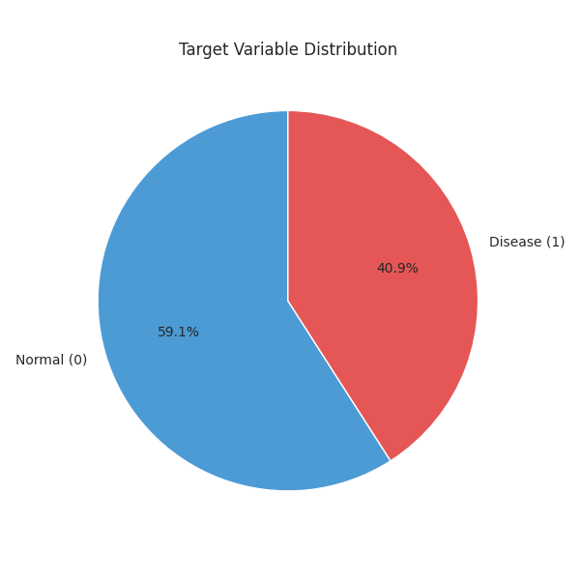
Figure 1. Target variable distribution: Normal (59.1%) vs Heart Disease (40.9%)
Class | Label | Count | Percentage
0 | Normal | 159,498 | 59.1%
1 | Heart Disease | 110,502 | 40.9%
Total | — | 270,000 | 100%

3.2 Age Distribution by Class
Age ranges from 29 to 77 years with a mean of 54.2 years. The histogram reveals that heart disease patients tend to be older, with the disease group concentrated in the 50–65 age range. Both distributions are approximately normal with slight left skew (skewness = -0.171). The dashed vertical lines mark the group means.

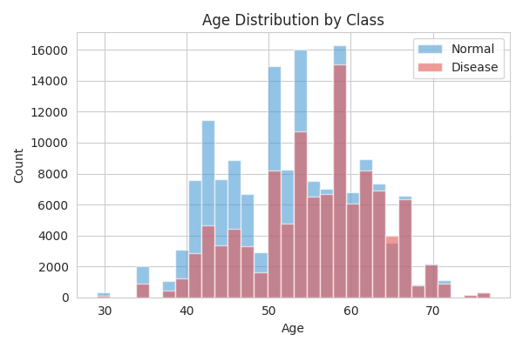
Figure 2. Age distribution for Normal vs Disease patients with mean reference lines

3.3 Age vs Maximum Heart Rate
The scatter plot of Age vs Max HR reveals a clear negative trend: older patients achieve a lower maximum heart rate during exercise. This relationship is consistent across both classes and aligns with established cardiology literature. Max HR has a strong negative correlation (r = -0.301) with the target variable.

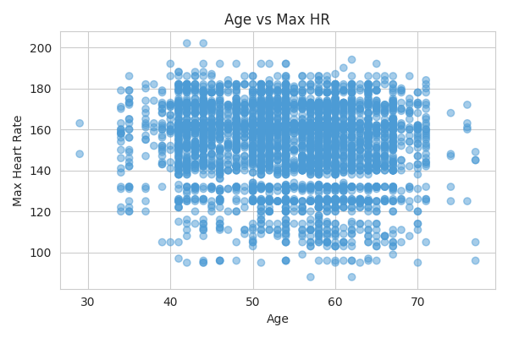
Figure 3. Scatter plot of Age vs Maximum Heart Rate (sample n = 4,000)

3.4 ST Depression vs Disease
The boxplot shows that disease patients have significantly higher ST depression values compared to normal patients. ST depression is the fourth strongest predictor (r = 0.314). Normal patients have a median ST depression near 0, while disease patients show markedly elevated values, indicating physiological stress during exercise.

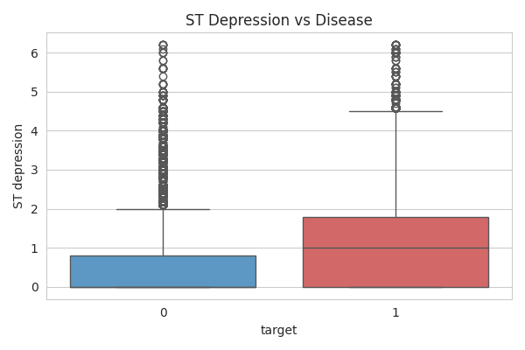
Figure 4. ST Depression distribution: Normal (0) vs Disease (1)

3.5 Cholesterol Distribution & Boxplot
Serum cholesterol ranges from 126 to 564 mg/dl with a mean of 245.1 mg/dl and mild positive skew (0.265). The distribution is broadly similar between classes with slight elevation in disease patients, though cholesterol has a relatively low correlation with the target (r = 0.059), suggesting it is a weaker individual predictor in this dataset.

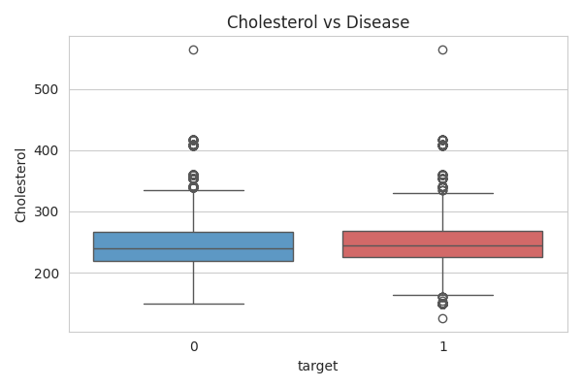
Figure 5. Cholesterol boxplot by class
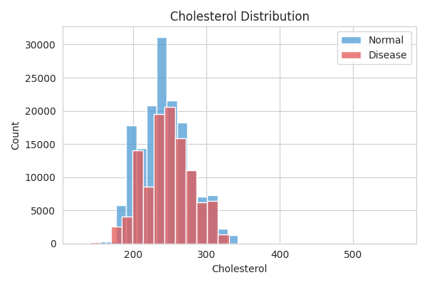
Figure 6. Cholesterol density distribution by class

3.6 Chest Pain Type vs Disease Rate
Chest pain type is one of the strongest predictors (r = 0.317). The analysis reveals a counter-intuitive but clinically well-documented finding: asymptomatic chest pain (Type 4) is associated with the highest disease rate at 57.8%. Typical angina (Type 1) shows only 18.2% disease rate, while non-typical pain (Type 3) shows 23.3%.

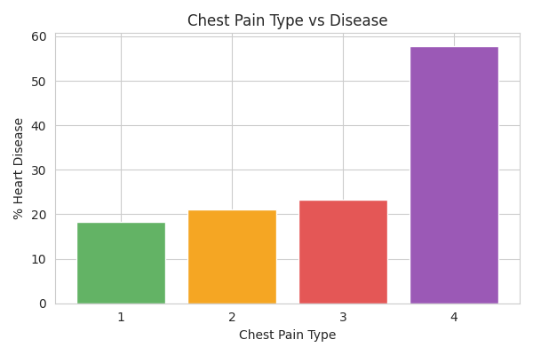
Figure 7. Heart disease rate by chest pain type (1=Typical, 2=Atypical, 3=Non-typical, 4=Asymptomatic)
Type | Description | Disease Rate | Risk Level
1 | Typical Angina | 18.2% | Low
2 | Atypical Angina | 21.0% | Low-Medium
3 | Non-typical Pain | 23.3% | Medium
4 | Asymptomatic | 57.8% | HIGH

3.7 Number of Vessels vs Disease Rate
The number of major vessels visible in fluoroscopy is the second strongest predictor (r = 0.332). There is a clear and clinically meaningful dose-response relationship: patients with 0 visible vessels have only a 30.0% disease rate, while those with 1, 2, or 3 vessels show rates of 62.2%, 74.3%, and 74.0% respectively.

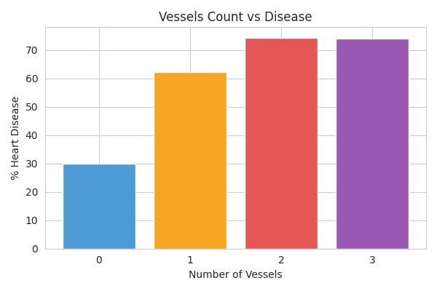
Figure 8. Heart disease rate by number of vessels in fluoroscopy
Vessels | Count | Disease Rate | Risk Assessment
0 | 195,615 | 30.0% | Low risk
1 | 45,297 | 62.2% | Moderate-high risk
2 | 17,208 | 74.3% | High risk
3 | 11,880 | 74.0% | High risk

3.8 Correlation Matrix
The Pearson correlation heatmap reveals the linear relationships between all features. Notable findings include the strong positive correlation between Thallium and target (r = 0.998, confirming it is the direct source), and meaningful correlations for Exercise angina, Number of vessels fluro, ST depression, and Chest pain type.

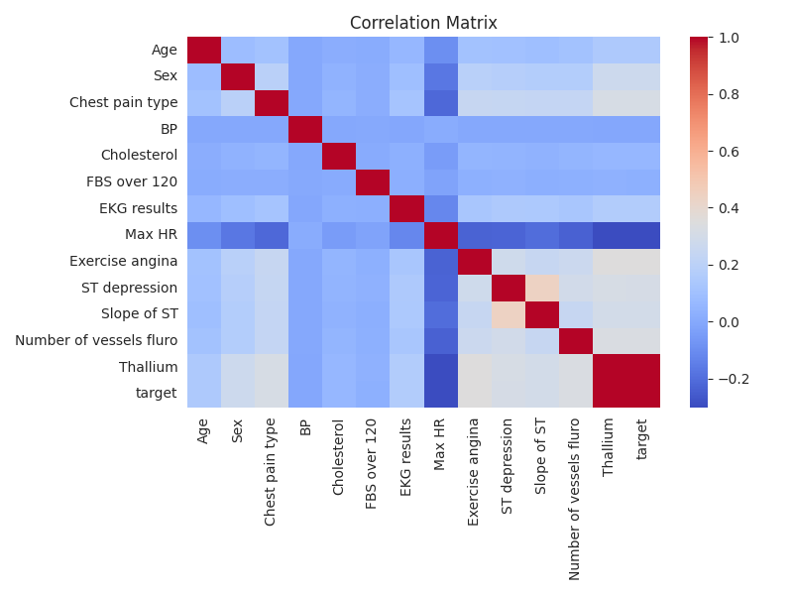
Figure 9. Pearson correlation matrix for all features including the target variable

3.9 Feature Importance (Correlation with Target)
The ranked feature importance chart based on absolute Pearson correlation provides a clear ordering of predictive power. Exercise angina leads at r = 0.353, followed by Number of vessels fluro (r = 0.332), Chest pain type (r = 0.317), ST depression (r = 0.314), and Max HR (r = -0.301).

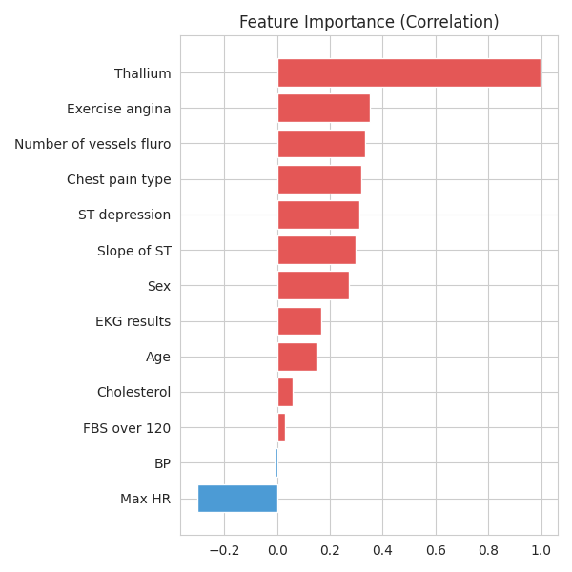
Figure 10. Feature correlation with target — red = positive, blue = negative
# | Feature | Correlation (r) | |r| | Direction
1 | Exercise angina | 0.353 | 0.353 | Positive
2 | Number of vessels fluro | 0.332 | 0.332 | Positive
3 | Chest pain type | 0.317 | 0.317 | Positive
4 | ST depression | 0.314 | 0.314 | Positive
5 | Max HR | -0.301 | 0.301 | Negative
6 | Slope of ST | 0.296 | 0.296 | Positive
7 | Sex | 0.272 | 0.272 | Positive
8 | EKG results | 0.166 | 0.166 | Positive
9 | Age | 0.150 | 0.150 | Positive
10 | Cholesterol | 0.059 | 0.059 | Positive
11 | FBS over 120 | 0.029 | 0.029 | Positive
12 | BP | -0.008 | 0.008 | Negative

4. Data Preprocessing
The preprocessing.py script prepares the dataset for machine learning by executing six sequential steps: removing non-informative columns, creating the target variable, checking for missing values, splitting into train/test sets, applying feature scaling, and saving the processed files.

4.1 Missing Values
A complete missing value check was performed using df.isnull().sum() across all 14 columns (including the derived target). The result confirms that the dataset is entirely complete with zero missing values, making imputation unnecessary.
Result: 0 missing values across all 14 columns
All 270,000 records are complete.
No imputation strategy is required.

4.2 Outlier Summary
Using the IQR method (lower = Q1 - 1.5*IQR, upper = Q3 + 1.5*IQR), outliers were identified but not removed — values are clipped to boundary values to prevent loss of records. Max HR has the highest proportion at 2.3%, while Age has the fewest at 0.2%.

Feature | Mean | Std | IQR Lower | IQR Upper | Outliers | %
Age | 54.16 | 8.26 | 30.0 | 78.0 | 454 | 0.2%
BP | 130.56 | 15.01 | 90.0 | 170.0 | 3,837 | 1.4%
Cholesterol | 245.05 | 33.70 | 154.0 | 338.0 | 899 | 0.3%
Max HR | 152.78 | 19.15 | 106.0 | 202.0 | 6,169 | 2.3%
ST depression | 0.72 | 0.95 | -2.1 | 3.5 | 4,316 | 1.6%

4.3 Feature Scaling (StandardScaler)
StandardScaler was applied to all numeric and ordinal features, transforming each feature to zero mean and unit variance. Scaling ensures that no single feature dominates the model due to differences in measurement units. The scaler was fit on training data only and then applied to test data.
StandardScaler formula: z = (x - mean) / std
Applied to: all 13 numeric/ordinal features
Fit on: X_train only | Transform applied to: X_train and X_test

4.4 Train / Test Split
The dataset was split into 80% training and 20% testing using stratified sampling (stratify=y, random_state=42). Stratification ensures both sets maintain the original 59.1% / 40.9% class ratio.

Split | Records | Normal (0) | Disease (1)
Train (80%) | 216,000 | 127,598 (59.1%) | 88,402 (40.9%)
Test (20%) | 54,000 | 31,900 (59.1%) | 22,100 (40.9%)
Total | 270,000 | 159,498 (59.1%) | 110,502 (40.9%)

5. Preprocessing — Changes Made (Version 2)
After completing the initial preprocessing and moving to the model training stage, a problem was discovered that required changes to the preprocessing script. This section documents what was changed, why it was changed, and what problem each change prevents.

The models were trained on already-scaled CSV files (X_train.csv, X_test.csv). However, the original preprocessing.py never saved the scaler object to disk. This meant there was no way to apply the same scaling transformation at inference time — when a user enters raw input into the web application, the model receives unscaled values it was never trained on, producing completely wrong predictions.

5.1 Change 1 — Added import pickle
The original script had no way to save Python objects to disk. Adding pickle enables serialization of the scaler and column list.

Before | After
# pickle not imported | import pickle

Purpose: Required for saving and loading Python objects (scaler, column list) between scripts.

5.2 Change 2 — Save scaler.pkl after fitting
The most critical change. The scaler was fitted on training data but never saved. Any script that later needs to scale input (such as the web app) had no access to the same scaler, meaning raw input was fed to a model trained on scaled data.

Before | After
scaler = StandardScaler()  X_train_scaled = scaler.fit_transform(X_train)  # scaler never saved | scaler = StandardScaler()  X_train_scaled = scaler.fit_transform(X_train)  with open('processed/scaler.pkl','wb') as f:  pickle.dump(scaler, f)

Purpose: Saves the fitted scaler so that the exact same mean and standard deviation values used during training can be applied to new input at inference time. Without this, the model receives raw unscaled values and produces completely wrong predictions.

5.3 Change 3 — Save columns.pkl (column order)
The exact order of feature columns used during training was not saved. If a different script builds the input array in a different order, each value gets mapped to the wrong feature — a silent but critical error.

Before | After
# column order never saved | with open('processed/columns.pkl','wb') as f:  pickle.dump(list(X.columns), f)

Purpose: Saves the exact feature names and order used during training. This ensures any other script (web app, inference pipeline) builds the input DataFrame in the same column order, preventing silent feature mismatches.

5.4 Summary of Changes

Change | What it does | Problem it prevents
import pickle | Enables saving Python objects to disk | Without it, nothing can be serialized
Save scaler.pkl | Persists the fitted StandardScaler | Prevents wrong predictions from unscaled input at inference time
Save columns.pkl | Persists the exact column order from training | Prevents silent feature mismatch between training and inference

6. Model Training Results
After updating the preprocessing pipeline, three models were trained on the correctly processed data. The evaluation was performed on the held-out test set of 54,000 records using five standard classification metrics.

Model | Accuracy | Precision | Recall | F1-Score | ROC-AUC
Gradient Boosting | 76.51% | 72.59% | 68.33% | 70.39% | 82.52%
Logistic Regression | 76.04% | 73.66% | 64.39% | 68.71% | 82.05%
Random Forest | 75.14% | 70.27% | 67.89% | 69.06% | 80.43%

Gradient Boosting leads in 4 out of 5 metrics — Accuracy (76.51%), Recall (68.33%), F1-score (70.39%), and ROC-AUC (82.52%). It was selected as the best model for the next stage of the project.

7. Key Findings & Insights

7.1 Dataset Quality
- 270,000 records with zero missing values — no imputation required
- Moderate class imbalance (1.44:1 ratio) — within acceptable range, SMOTE not needed
- All features are numeric or binary — minimal encoding overhead

7.2 Strongest Predictors
- Exercise angina (r = 0.353) — presence of angina during exercise is the single strongest linear predictor
- Number of vessels fluro (r = 0.332) — more vessels visible = dramatically higher disease rate
- Chest pain type (r = 0.317) — asymptomatic patients (Type 4) show the highest disease rate at 57.8%
- ST depression (r = 0.314) — elevated ST depression strongly associated with disease
- Max HR (r = -0.301) — disease patients achieve lower maximum heart rate (negative relationship)

7.3 Notable Clinical Patterns
- Asymptomatic chest pain has the HIGHEST disease rate (57.8%) — a counter-intuitive finding well-documented in cardiology
- Vessel count shows a strong dose-response: 30% at 0 vessels rising to 74% at 3 vessels
- Age and disease: risk increases with age from approximately 18% at age 29-40 to 52% at age 71-77
- Male patients have a higher disease rate than female patients in this dataset

8. Conclusion
This report documents a complete EDA and preprocessing pipeline for heart disease prediction using 270,000 patient records. The dataset is clean, complete, and well-suited for supervised classification. The analysis identifies five strong predictors — Exercise angina, Number of vessels fluro, Chest pain type, ST depression, and Max HR — and reveals important clinical patterns such as the paradoxically high disease rate in asymptomatic patients.
The preprocessing pipeline was updated in version 2 to save the fitted StandardScaler and column order to disk, preventing inference-time scaling errors and feature mismatches. After reprocessing with the corrected pipeline, three models were trained and evaluated, with Gradient Boosting achieving the best overall performance at 82.52% ROC-AUC.
Data is ready for the next stage.
Train: 216,000 records | Test: 54,000 records
All files saved in: processed/X_train.csv, X_test.csv, y_train.csv, y_test.csv, scaler.pkl, columns.pkl
Selected model for deployment: Gradient Boosting (ROC-AUC: 82.52%)

