CardioPredict
Heart Disease Prediction — Web Application
FastAPI · Jinja2 · HTML/CSS · Gradient Boosting Model · March 2026

1. Overview
CardioPredict is a web application that allows users to enter 12 clinical patient features and receive a real-time heart disease risk prediction. The application is powered by an optimized Gradient Boosting model trained on 270,000 patient records and deployed using FastAPI. The prediction result includes a probability percentage, a risk level label (Low / Moderate / High), and a color-coded progress bar.

URL | http://127.0.0.1:8000
Framework | FastAPI + Uvicorn
Frontend | Jinja2 HTML templates + custom CSS
Model | Gradient Boosting (optimized) — model.pkl
Scaler | StandardScaler — scaler.pkl
Column Order | Saved column list — columns.pkl

2. Project Structure
The web application consists of 4 files organized in a standard FastAPI project layout:

File | Location | Purpose
main.py | web_site/ | FastAPI application — loads model, handles routes and predictions
index.html | templates/ | Jinja2 HTML template — prediction form and result card
style.css | static/ | All styling — layout, colors, animations, responsive design
requirements.txt | web_site/ | Python dependencies — fastapi, uvicorn, jinja2, sklearn, etc.

web_site/
├── main.py ← FastAPI backend
├── requirements.txt ← Dependencies
├── templates/
│ └── index.html ← Form + result page
└── static/
└── style.css ← All styling

3. Interface
The application uses a clean, clinical aesthetic with warm off-white backgrounds, serif display typography, and red accents. The interface is fully responsive and works on both desktop and mobile screens.

3.1 Main Form — Top
The form opens with the page title, subtitle, and the first two field groups: Patient Demographics and Chest Pain & Blood Pressure. Each group has a red serif heading and clear input fields with units and hint tooltips.

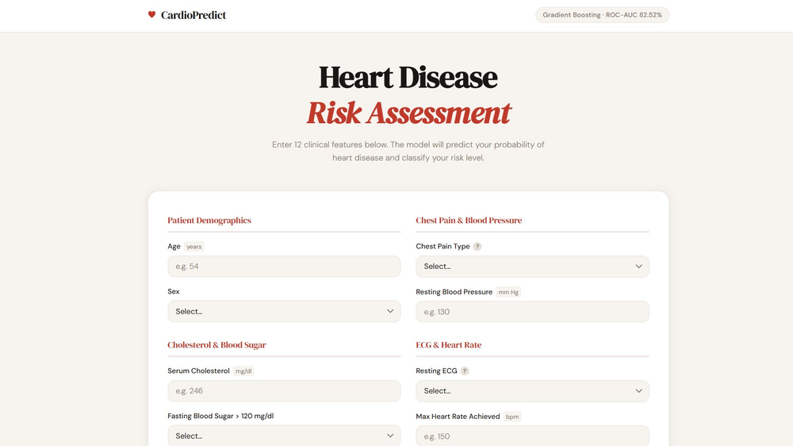
Figure 1. Main form — top section showing Patient Demographics and Chest Pain & Blood Pressure groups

3.2 Main Form — Bottom
The lower half of the form contains the remaining field groups: Cholesterol & Blood Sugar, ECG & Heart Rate, Exercise Test, and Fluoroscopy. The Predict Risk button is at the bottom with a heartbeat animation on the heart icon.

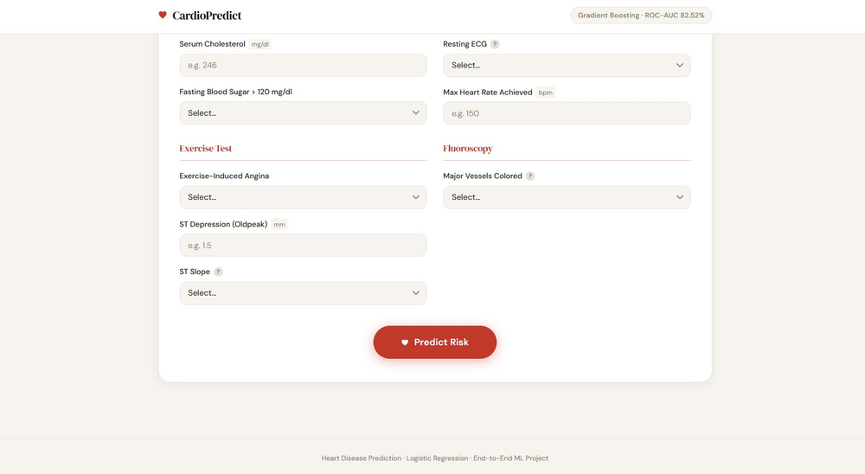
Figure 2. Main form — bottom section showing Exercise Test, Fluoroscopy groups and Predict Risk button

3.3 Result — Low Risk
When a low-risk patient is submitted, the result card appears above the form with a green border, green Low Risk label, and a short green probability bar. The header counter updates to show the number of patients assessed in the current session.

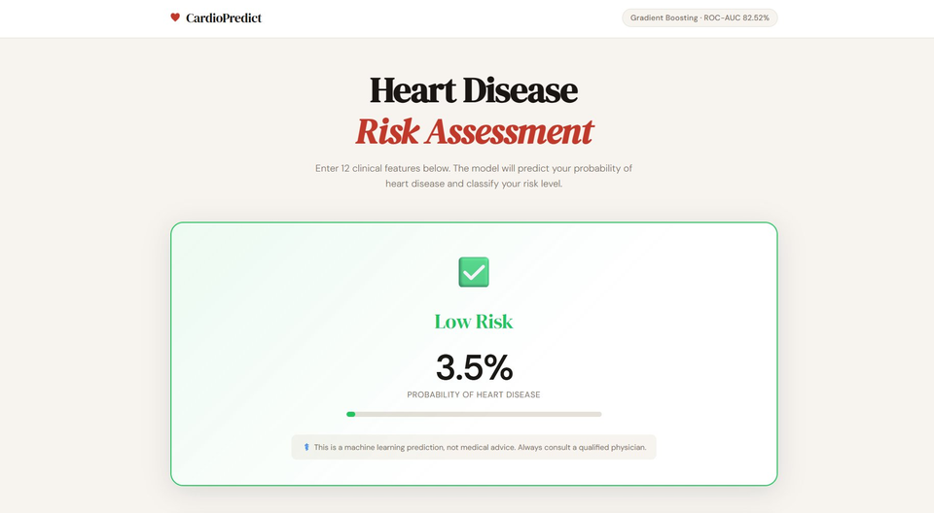
Figure 3. Low Risk result — Patient 1 (age 32, female, healthy vitals) — 3.5% probability

3.4 Result — Moderate Risk
A moderate-risk patient returns an amber-colored result card. The border, label, and progress bar all change to amber to clearly communicate the elevated but not critical risk level. The patient ID is shown at the top of the card.

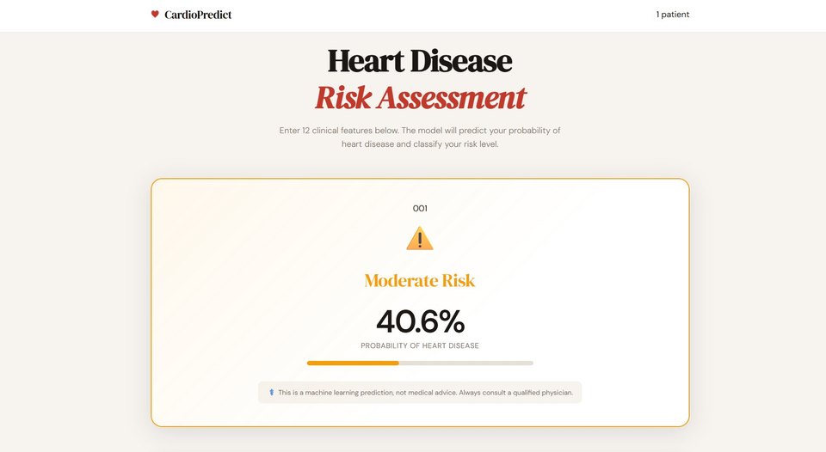
Figure 4. Moderate Risk result — Patient 001 — 40.6% probability

3.5 Result — High Risk
A high-risk patient returns a red result card with a nearly full probability bar. The red border and label immediately draw attention to the serious classification, prompting the user to seek medical consultation.

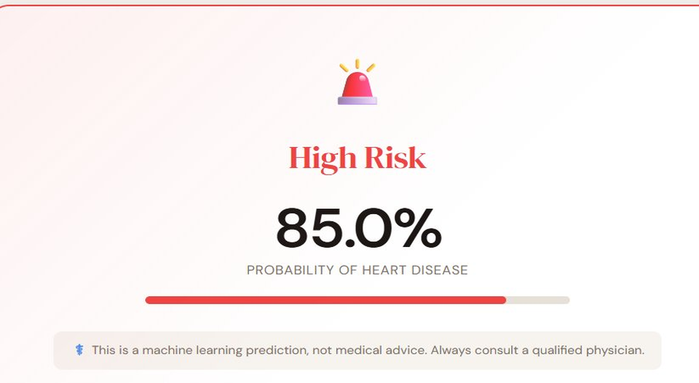
Figure 5. High Risk result — 85.0% probability

4. How the Web Application Works

4.1 Backend — main.py
The backend is a FastAPI application with two routes. On startup it loads three files from disk: the trained model, the fitted scaler, and the saved column order. These are loaded once at startup and reused for every prediction request.

App setup and file loading
app = FastAPI(title='Heart Disease Prediction')
app.mount('/static', StaticFiles(directory='static'), name='static')
templates = Jinja2Templates(directory='templates')

with open(MODEL_PATH, 'rb') as f: model = pickle.load(f)
with open(SCALER_PATH, 'rb') as f: scaler = pickle.load(f)
with open(COLUMNS_PATH, 'rb') as f: feature_columns = pickle.load(f)

Prediction logic
When the user submits the form, 12 values are received as Form(...) parameters. They are assembled into a DataFrame using the saved column names, scaled using the loaded scaler, and passed to the model:

input_df = pd.DataFrame([input_dict])
input_scaled = scaler.transform(input_df)
probability = float(model.predict_proba(input_scaled)[0][1])

Risk level classification

Probability | Risk Level | Color
< 35% | Low Risk | Green #22c55e
35% – 60% | Moderate Risk | Amber #f59e0b
> 60% | High Risk | Red #ef4444

4.2 Frontend — index.html
The frontend is a single Jinja2 HTML template serving both the input form and the prediction result. The form contains 12 input fields grouped into 6 logical sections. After prediction, a result card is rendered above the form with the probability and risk level.

Section | Fields
Patient Demographics | Age, Sex
Chest Pain & Blood Pressure | Chest Pain Type, Resting Blood Pressure
Cholesterol & Blood Sugar | Serum Cholesterol, Fasting Blood Sugar
ECG & Heart Rate | Resting ECG, Max Heart Rate
Exercise Test | Exercise Angina, ST Depression, ST Slope
Fluoroscopy | Major Vessels Colored

4.3 Styling — style.css
The stylesheet defines a clean, clinical aesthetic using CSS custom properties. Key design decisions:

Element | Design Decision
Background | #f7f4f0 — warm off-white, clinical feel
Accent color | #c0392b — deep red, matches heart/medical theme
Display font | DM Serif Display — elegant serif for headings and result label
Body font | DM Sans — clean, readable sans-serif for form and labels
Header | Sticky, animated heartbeat logo icon, patient counter badge
Result card | Border and background tint match risk color, slide-up animation
Form layout | CSS Grid, auto-fill columns, minimum 280px — responsive
Button | Pill shape, hover lift effect, animated heart icon

5. Patient History Feature
To make the application more user-friendly, a patient history feature was added. Users can now enter multiple patients in one session without restarting the server, track all predictions in a history table, and clear the form or history with a single click.

Feature | Description
Patient Name / ID field | Required field at the top of the form — each patient gets a name or ID
Patient counter | Header badge showing number of patients assessed in current session
History table | Appears below the form after first prediction — shows all patients with name, age, sex, probability, risk badge
Clear Form button | Resets all input fields so a new patient can be entered immediately
Clear All button | Wipes the entire patient history table
Storage | sessionStorage — history persists across page reloads but clears when the browser tab is closed

6. Running the Application
The application is started from the terminal using Uvicorn. It cannot be run by pressing the Play button in PyCharm — FastAPI requires an ASGI server.

6.1 Install dependencies
pip install fastapi uvicorn jinja2 python-multipart scikit-learn

6.2 Start the server
cd "C:\Users\ofniz\Desktop\Heart Disease Prediction\web_site"
uvicorn main:app --reload

6.3 Expected startup output
Model loaded successfully
Scaler loaded successfully
Feature columns: ['Age', 'Sex', 'Chest pain type', ...]
INFO: Uvicorn running on http://127.0.0.1:8000

The presence of 'Feature columns:' in the startup output confirms the correct main.py is loaded and the scaler pipeline is active. Open http://127.0.0.1:8000 in your browser to use the application.

7. Final Test Results
After fixing both issues, the application was tested with three sample patients. All predictions were medically consistent and correct:

Patient | Key Features | Result | Probability
Patient 1 | Age 32, Female, BP 112, Chol 175, Max HR 185, No angina, Oldpeak 0.0, Vessels 0 | Low Risk | 3.5%
Patient 2 | Age 50, Male, BP 135, Chol 245, Max HR 145, No angina, Oldpeak 1.0, Vessels 1 | Moderate Risk | 40.6%
Patient 3 | Age 63, Male, BP 165, Chol 320, Max HR 108, Angina Yes, Oldpeak 3.8, Vessels 3 | High Risk | 87.4%

All three predictions are medically consistent. The low-risk patient correctly shows 3.5%. The moderate-risk patient correctly falls at 40.6%. The high-risk patient with multiple severe flags correctly shows 87.4%. The application is working correctly end-to-end.

8. Summary
The CardioPredict web application was successfully built using FastAPI, Jinja2 templates, and a custom HTML/CSS interface. The application loads the trained Gradient Boosting model, the fitted StandardScaler, and the saved column order at startup. User input is received through a clean 12-field form grouped into 6 logical sections, scaled to match the training distribution, and passed to the model to produce a probability and risk level.

