 **DATA & MEDIA TRAINING**

**FACILITATOR’S GUIDE**

**Goal:**

**Duration: 1 – 1.5 hours**

**AGENDA**

I. Ice-breaker Activity (10 min)

II. Collecting and Spinning Your Data (30 – 40 min)

A. Good vs. Bad Spreadsheet

B. Media analysis

C. Survey Outreach

III. Data Visualization (20 - 30 min)

A. Create Charts

VI. Wrap-Up/Questions (5 min)

**ICE-BREAKER**

Description: Each person selects color stickers and place stickers on two charts. Select your favorite ice cream flavor from your childhood by placing color sticker dots on chart. Place sticker dots from a different color on favorite ice cream flavorsyou currently like.

*Example Chart Layout*

|  |  |
| --- | --- |
| Chocolate  xxxxxxx | Vanilla  xxxxxxxxx |
| Strawberry  xxxxxxxxxxxx | Other  xxxx |

**COLLECTING AND SPINNING DATA**

Good vs. Bad Spreadsheet

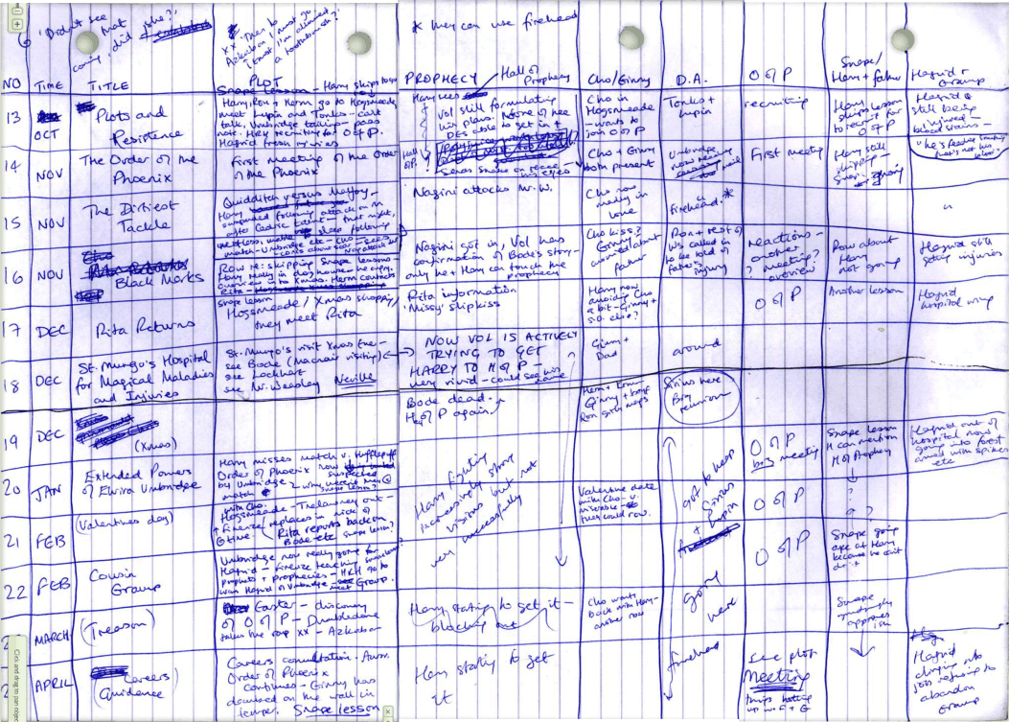

Discussion: This is a joke! However, the main point is that “good” data is information that could be easily manipulated. Columns should be clearly labeled and defined for you to SORT, PARSE, and ANALYZE.

**Create Charts**

- Bar/Pie/Line/Point – what are benefits to each type?

- Flow chart

- Map

- Timeline

- Most frequently used words, Wordle

**Survey Outreach**

**A survey question helps you crowd source more information about a topic.**

- **Electronic Polls or Surveys** (via email, Twitter)

- **Market research and focus groups** (counting number of red houses on your block or playgrounds in your neighborhood, typically provides an incentive, open ended questions, multiple languages so it is inclusive)

- **Creative techniques** (via Events, doodle poll, collecting marbles in a jar, popular hashtags, “likes” on social media, downloads or views)

**Example Case Study: #WhoMadeMyClothes?**

This campaign turned their survey collection into an awareness campaign. Organizers asked participants to document clothing labels.

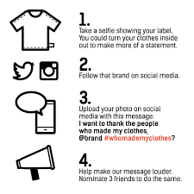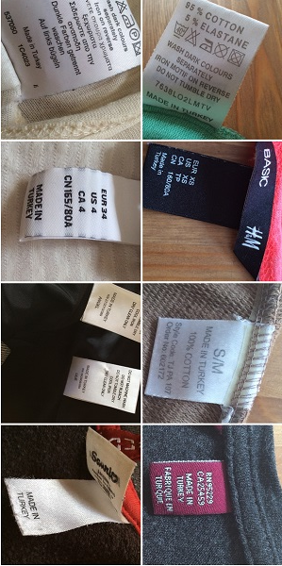

**Example 2: Using a map to capture testimony, a public map that allows people to submit coordinates.**

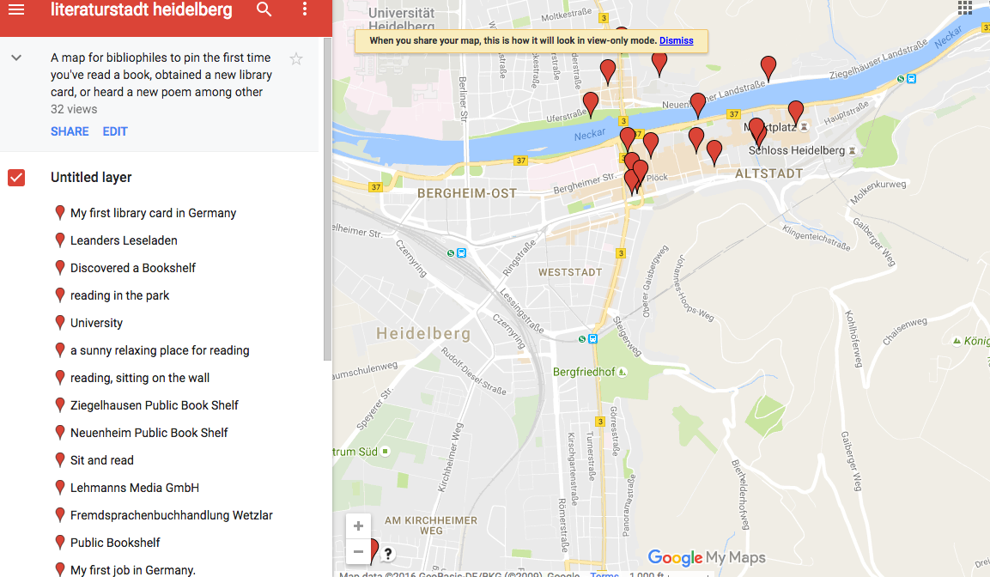

**Group Activity** (below are several sample activities):

Example1: Our Ice-breaker is an example of how to collect and analyze information

Example2: Everyone lines up according to distance they’ve traveled from home to workshop location without speaking or sounds.

Example3: “Red Light, Green Light” with a twist. Participants line up in a row in back of room. Each time you agree with a statement, you take one step up. Please remain in place if you do not agree with statement.

Sample statements:

* Take one step forward if you have volunteered or worked on a political campaign

* Take one step forward if you have written a newspaper article or blog

* Take one step forward if you are politically engaged

* Take one step forward if you care about public education in your community

* Take one step forward if you have a Twitter account

**Media Analysis Group Activity**

Introduction: Media analysis is a synthesis of newspaper articles or YouTube clips to spot trends, similar themes, or create a timeline. Some tools are Lexis- Nexus or Google Scholar/News. Paid services are also available.

**DATA VISUALIZATION**

**Group Activity:** Participants will use data they’ve provided during ice-breaker to create an infographic. Participants work in small groups or pairs to create their infographic. Teams share their ideas and other participants

|  |  |  |
| --- | --- | --- |
| **Name** | **Ice Cream Flavor – Child** | **Ice Cream Flavor - Now** |
| Amber | Strawberry | Strawberry |
| Bryan | Vanilla | Other |
| Carl | Chocolate | Chocolate |
| Di | Other | Vanilla |
| Frank | Chocolate | Other |
| Edna | Other | Other |

Discussion Questions:

1. Who is audience you’re addressing with infographic?

2. What is your end goal or idea you want to express with infographic?

3. What tools do you have at your disposal to create this graphic?

4. Do you need additional research?

5.Which medium will you use to broadcast your results?

**INFOGRAPHIC CHECKLIST**

* Source/Reference/Citation
* Labels/Titles
* Author/Creator
* Dates
* Easy to read
* Other?

**RESOURCES**

**Canva** is free for creating infographics, slide presentations, and other visualization. [https://www.canva.com/]

**YouTube Transcript** is text to help you review important points

**Open Data Philly** [https://www.opendataphilly.org/dataset?_groups_limit=0]

[Di will add additional sources]

**Facebook** if your page receives more than 100 likes, you would be provided with additional information about users demographics.

TrashyRatClub [https://devpost.com/software/trashy-rat-club#updates] is a creative use of government data. In this example, these creators used free datasets from **NYC OpenData**, specifically health-related information based on 311 complaints. Instead of trying to make sense of everything, they decided to approach the data in different perspectives -- a rat’s mind.

TrashyRatClub helps single rats in NYC find a mate. Rats can find the filthiest social events according to food waste, promise of dirty water and potential rat rendezvous. They start by choosing which borough they would like to mingle in. Then, they are presented with a map showing events along with a score, which they can then drill down to get details on the specific matrix TrashyRatClub uses. Additionally, they can also see how many other filthiest friends are going.

**APPENDIX A**

