  **DATA TRAINING 101**

**FACILITATOR’S GUIDE**

**Goal:** This workshop is intended for artists, advocates, and community organizers to learn how data could strengthen their message and communicate ideas.

**Duration:** 1hour

AGENDA

I. Introduction: What is data? (5 min)

II. How to read data (10 – 15 min)

A) Bad vs. Good information

III. How to use data (20 min)

A) Group Activity: Apples2Apples

IV. How to access data (10 – 15 min)

A) Government

B) Media analysis

C) Other sources?

V. Create your own data (10 – 15 minutes)

A) Tools are interviews, surveys

B) Activity: Space Travel

VI. Wrap-Up/Questions (5 min)

**How to Read Data**

BAD Chart1

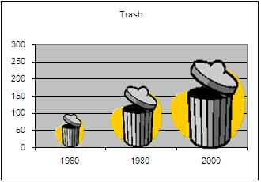

BAD Chart2

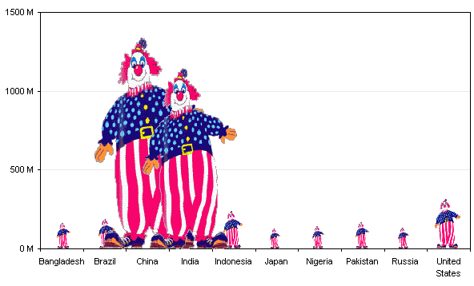

**Discussion Question: Could you spot what is wrong with graph?**

Answers: Unclear labels, disproportional images (250 looks much bigger than 200), is data from US or from a neighborhood, type of measurement, timeframe is very large…

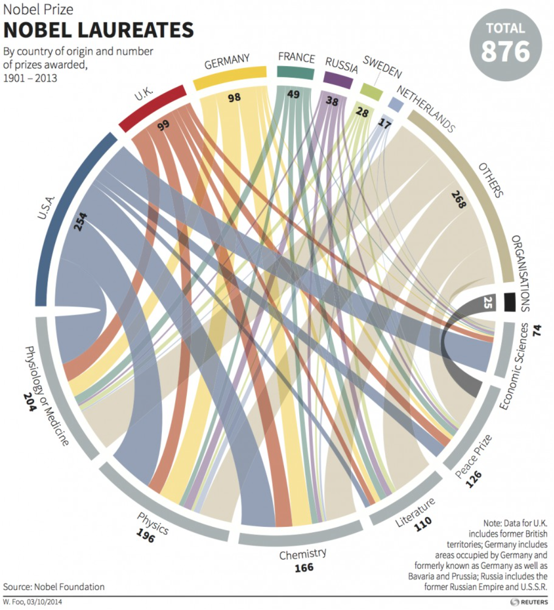

Answer: Good source of info, clever layout, informative, however UNCLEAR

**Basic chart with clear labels/impartial data**

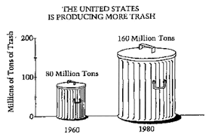

Answer: Graphics are proportional, clear labels and main title, message comes across

**Median Income in Los Angeles**

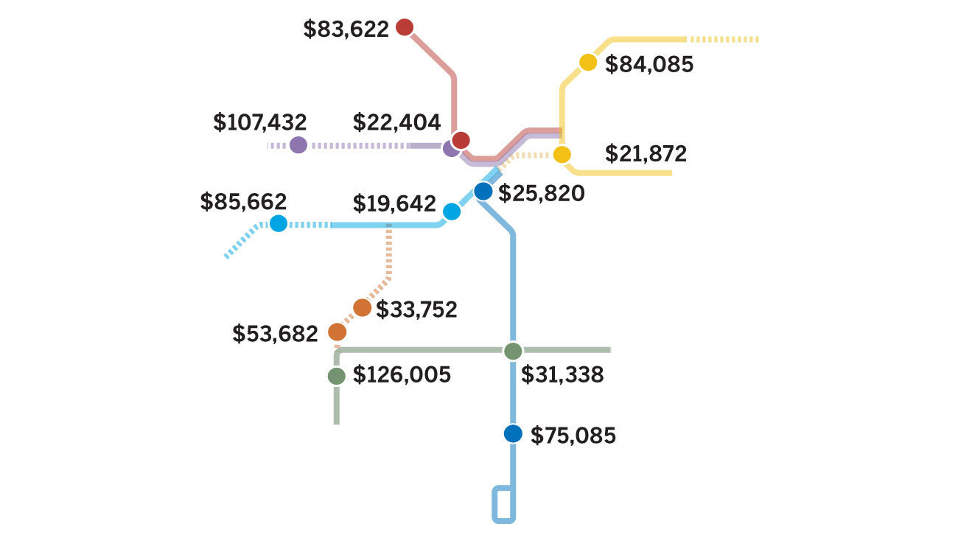

**Answer:** Effective chart because it is clear, concise, and accurate. This chart engages audience and helps them to see an old problem in a new way.

**How to Use Data**

**“Apples2Apples” Group Activity**

Instructions: Participants look at picture of apples and brainstorm as a group what they observe. This activity will help participants think critically about basic observations. Discussion Question: How do you like them apples? What could we say about this photo of apples?

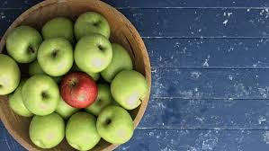

Answer:

1. Compare apples to apples, e.g., color, shape, type

2. Count the apples

3. Compare ripe apples to fresh apples, e.g., year to year, a particular timeframe like 5 or 10 years, drastic change or event

4. Compare apples to oranges, e.g., a bowl of green oranges with one orange colored orange is *different* than our current image. Example: You can’t compare people to skittles.

***TIP****: Observations we make about apples in a basket are similar to how we manipulate information. Data should give you clarity and inspiration*

**How to Access Data**

Data sources: Government, e.g., Census, local data, newspapers, academic, market research. What other sources do you recommend?

**“Newsies” Group Activity (5 – 10 min)**

Instructions: Participants are given “non-traditional” sources of data, e.g., take-out menus, nutrition labels, children’s books, etc. to peruse. Participants work together in pairs or in small groups to discuss what inferences they could make from information provided.

Example Discussion Questions:

1. What assumptions could we make from data?

2. Does information from your source point to a particular problem?

3. What sort of data are we missing?

4. What other information could we gather to help strengthen or expand our research?

***TIP****: Like a game of CLUE, we have basic clues: a weapon, a location, or a suspect. We need to investigate further to collect pieces for our puzzle.*

**Create Your Own Data**

**Discussion Question: How are you currently collecting information?**

Answer: interviews, surveys, other?

Activity: Commercial flights to the moon are now affordable and accessible to the public. You and your team are helping NASA create a marketing strategy. Please work with your team to develop questions for the public. OR each team creates a marketing campaign from a theme of their choice.

1. What is your goal? What is your research question? How would you like to eventually use data?

2. Who is target audience?

3. **Numbers vs. Stories Discussion:**

a) What questions would you inquire about apples?

b). Type of questions you could ask for quantitative or numerical answer:

*Example1: What is your age?*

*Example2: On a scale of 1 to 5, how do you rate this workshop?*

c) Type of questions you could ask for qualitative, testimony, quote, story, or narrative:

*Example1: How would you describe…*

*Example2: Please elaborate on your experience…*

***TIP****: survey monkey, questionnaires, sign-in sheet. No need to get fancy, just incorporate new elements to routine activities.*

**APPENDIX A: OTHER CHARTS**

