|  |
| --- |
|  |
|  |
|  |
| **2D Barcode platform**  **Software Requirements Specification**  **Version 2.2** |
|  |
| Logo.jpg |

|  |
| --- |
|  |

**February 2013**

|  |  |  |  |
| --- | --- | --- | --- |
| Date | Version | Author | Description |
| 24-04-2012 | 1.0 | Michael Medagama | Initial Draft based on the 2D barcode platform requirement 0.1 |
| 10-05-2012 | 2.0 | MichaelMedagama | Second Draft based on the 2D barcode SRS version 1.0. Purpose of this document is to detail out the content in the 1stsegments of the SRS 1.0. |
| 25-06-2012 | 2.1 | Dewmini Premeratne  Sumudu Hasala | Modifications done according to the discussion with Dialog on 25th June 2012. Based on SRS V2.0 |
| 22-01-2013 | 2.2 | Dewmini Premeratne  Dilusha Weeraddana | Modifications done according to the discussion with Dialog. Based on SRS V2.1  User management section has been modified, Campaign management is also covered in the user management section  Changes are made to barcode creation(Added dynamic URL, barcodes should be created under a campaign) |

# **TABLE OF CONTENTS**

TABLE OF CONTENTS 2

Table of Figures 3

1 Introduction 4

Purpose 4

Scope 4

Intended Audience 4

Glossary 4

References 4

Document Overview 4

2 Overall Description 5

System Environment 5

Functional Requirements Definitions 5

User Management 6

Barcode Creation 9

Reporting 11

Use Cases 12

Use Cases for User Management 12

Use Cases for Barcode Creation 14

Use Cases for Reporting 16

Non-functional Requirements 17

3 Requirement Specification 18

User Interface Specifications 18

User Management Interfaces 18

Barcode Creation Interfaces 32

Reporting Interfaces 35

Functional Requirements 36

User Management Requirements 36

Barcode Creation Requirements 40

Reporting Requirements 42

Detailed Non-functional Requirements 43

# **Table of Figures**

Figure 2.1.Low level architecture of the system 5

Figure 2.2 Hierarchical view of user management 6

Figure 2.3 Use Case Diagram of Create Corporate 12

Figure 2.4Use Case Diagram of Create Corporate Admin 12

Figure 2.5Use Case Diagram of Corporate User 13

Figure 2.6Use Case Diagram of Create LOB 13

Figure 2.7Use Case Diagram of Create Campaign 14

Figure 2.8Use Case Diagram of Guest User Create Barcodes 14

Figure 2.9Use Case Diagram of CSA/CA Create Barcodes 15

Figure 2.10Use Case Diagram for CU Create Barcodes 15

Figure 2.11Use Case Diagram for DSA-Reporting 16

Figure 2.12 Use Case Diagram for CSA Reporting 16

Figure 3.1User Interface for Create Corporate 18

Figure 3.2 User Interface for Edit/Delete Corporate 19

Figure 3.3User Interface for View Corporate 20

Figure 3.4User Interface for Create Corporate Admin 21

Figure 3.5 User Interface for Edit/Delete Corporate Admin 22

Figure 3.6 User Interface for View Corporate Admin 23

Figure 3.7 User Interface for Create Corporate User 24

Figure 3.8 User Interface for Edit Corporate User 25

Figure 3.9 User Interface for View Corporate User 26

Figure 3.10 User Interface for DSA Dashboard 27

Figure 3.11 User Interface for CSA/CA Dashboard 27

Figure 3.12 User Interface for CU Dashboard 28

Figure 3.13 User Interface for Edit/View User Profile 28

Figure 3.14 User Interface for Change own password 29

Figure 3.15 User Interface for Create LOB 29

Figure 3.16 User Interface for Create Campaign 30

Figure 3.17 User Interface for Edit Campaign 30

Figure 3.18 User Interface for View Campaign 31

Figure 3.19 User login 31

Figure 3.20 User Interface for Guest User Create Barcodes 32

Figure 3.21 User Interface for logged in user create barcodes 33

Figure 3.22 User Interface for Create Bulk Barcodes 34

Figure 3.23 User Interface for Edit Dynamic URL 34

Figure 3.24 User Interface for Reporting 35

# **Introduction**

## Purpose

Purpose of this document is to describe the main functions and the specifications of the 2D Barcode Creation Platform.

## Scope

This system will target users who wish to create a barcode for personal use and corporates who want to create barcodes for campaigns. The system will be web based and the presented features will depend on the user type.

Corporates can create their own barcodes under the Campaigns. Those barcodes can be used for advertising, promotions, in other applications etc. and can segregate the usage of a particular barcode.

## Intended Audience

Developers, Stake Holders, QA

## Glossary

|  |  |
| --- | --- |
| **Term** | **Definition** |
| 2D | Two Dimensional |
| 2DBC | Two Dimensional Barcode Creation |
| CA | Corporate Admin |
| CSA | Corporate Super Admin |
| CU | Corporate User |
| DM | Data Matrix 2D Barcodes |
| DSA | Dialog Super Admin |
| IEEE | Institute of Electrical and Electronic Engineers |
| QA | Quality Assurance |
| QR | Quick Response 2D Barcodes |
| SRS | Software Requirement Specification |

## References

* [IEEE] The applicable IEEE standards are published in “IEEE Standards Collection,” 2001 edition.
* 2D_Barcodes_SRS_1.0
* 2D_Barcodes_SRS_2.0

## Document Overview

The remainder of this document is organized as two chapters, the first providing a full description of the project for the stakeholders. It lists all the functions performed by the system. The second chapter provides details of each of the system functions and actions in full for the software developers’ assistance. These two chapters are cross-referenced by topic, to increase understanding by both groups involved.

# **Overall Description**

The web based 2D Barcode Creation (2DBC) system will enable external users to create barcode for their personal use without logging in to the system, as well as provide extended features for logged in users who have valid user accounts. User accounts will be created under a particular Corporate subscribing to the system. Features presented to users will be depended on their user type.

A Corporate can define Campaigns under different Line of Businesses (LOBs) and create and evaluate barcodes created under those Campaigns.

The system will consist of several major parts which address user management, campaign management, barcode creation and reporting.

## System Environment

The low level architecture of the 2DBC system is shown in the Figure 2.1.The System mainly consisted of two layering components. The Application layer is the programmatic boundary of the web application. The web service functions on the Service layer for barcode creation.



Figure ..Low level architecture of the system

## Functional Requirements Definitions

Functional Requirements are those that refer to the functionality of the system, i.e., what services it will provide to the user.

### User Management

The hierarchy of the users of the system is as shown in Figure 2.2.

Figure . Hierarchical view of user management

This section describes how the user management module on the 2DBC application should be operated. The Application is managed by the Dialog Super Admin (DSA) account belonging to Dialog Telekom. The DSA will be responsible for registering/creating Corporates. Once the Corporate account is created, the Corporate Super Admin (CSA) will also be created with all the privileges assigned to it by default. Either the DSA or the CSA can create the Corporate Admin (CA) account by selecting relevant privileges. The CSA or CA (according to privileges) will be responsible for creating CU user accounts under its corporate account.

#### Dialog Super Admin

The DSA is the top level user having all the privileges over the subscribed Corporates.DSA can log in to the system with user credentials (user name password, account name). The DSA will create the Corporate upon the Corporate subscribing to the system along with the Corporate Super Admin (CSA) account.

DSA will have the following privileges:

* Creating a Corporate account
  + CSA will also be created at the same time.
  + CSA will be assigned all the privileges by default
* Edit Corporate
  + Information of the Corporate with the basic attributes of the CSA can be updated.
* Delete Corporate
* View Corporate
* Create Corporate Admin(CA)
* Under a Corporate many Corporate Admins(CAs) can be created, by assigning required privileges
* Edit Corporate Admin(CA)
* Basic attributes of the CA can be updated(Including assigned privileges )
* Delete Corporate Admin(CA)
* View all the Corporate Admins(CAs) under each Corporate
* Access to all the reports.
  + Overall reports
  + Corporate based reports (By refining by criteria such as Corporate, LOB, Campaign etc.)
* Profile of the DSA can be updated.

#### Corporate Super Admin

The CSA will get created once the Corporate is created by the DSA. The CSA will have all the privileges given to a Corporate by default.

Following are the privileges given to the CSA:

* Create Corporate Admin(CA)
* Under a Corporate many Corporate Admins(CAs) can be created, by assigning required privileges
* Edit Corporate Admin(CA)
* Basic attributes of the CSA can be update(Including assigned privileges )
* Delete Corporate Admin(CA)
* View all the Corporate Admins(CAs) under the Corporate
* Create Corporate User(CU)
* Under the Corporate many Corporate Users(CU) can be created, by assigning required privileges
* Edit Corporate User(CU)
* Basic attributes of the CU can be updated(Including assigned privileges )
* Delete Corporate User(CU)
* View all the Corporate Users(CU)s under the Corporate
* Create LOB (Line of Business) Groups
* Edit LOB
* Delete LOB
* View LOB
* Create Campaigns
* Edit Campaigns
* Delete Campaigns
* View Campaigns
* Create Barcodes
* View Barcodes
* Access reports under the particular Corporate.
  + Corporate based reports
* Profile of the CSA can be updated

#### Corporate Admin

The CA can be created either by the DSA or the CSA.

The CA can be assigned privileges from the following:

* Create Corporate User(CU)
* Under the Corporate many Corporate Users(CUs) can be created, by assigning required privileges
* Edit Corporate User(CU)
* Basic attributes of the CU can be updated(Including assigned privileges )
* Delete Corporate User(CU)
* View all the Corporate Users(CU)s under the Corporate
* Create LOB (Line of Business) Groups
* Edit LOB
* Delete LOB
* View LOB
* Create Campaigns
* Edit Campaigns
* Delete Campaigns
* View Campaigns
* Create Barcodes
* View Barcodes
* Access reports under the particular Corporate.
* Corporate based reports
* Profile of the CA can be updated

#### Corporate User

The Corporate user can be created/modified/deleted by either the CSA or the CA in that Corporate.

Privileges can be assigned at the moment of creation of the CU, by selecting privileges from following privileges set:

* Create Campaigns
* Edit Campaigns
* Delete Campaigns
* View Campaigns
* Create Barcodes
* View Barcodes
* Access reports under the particular Corporate.
  + Corporate based reports
* Profile of the CU can be updated including

### Barcode Creation

Barcode creation is one of the main functionalities to be fulfilled via the 2DBC System. Barcode creation functions under two main levels within the system as:

1. Create barcodes by guest users who access the system without logging in.
2. Create barcodes by users who logged in to the system.

#### Special Characteristics

Codes can be either QR or Data Matrix which triggers *Go To Static/Dynamic Website, Message, Contact Details, Send SMS, Initiate Call* functions*.*

* Support static URLs and Dynamic URLs.

Static URL – Barcode always redirects to the same web page

Dynamic URL –User can change the redirect URL contained in the Barcode at

any time by editing that particular barcode.

* Support multiple error correction options for QR codes
* Support multiple image formats
* Support multiple sizes
* Support only Dialog numbers for *Contact Details, Send SMS, Initiate Call*
* Support long and short numbers for *Send SMS* and *Initiate Call*.
* Ability to create codes (in bulk) for Campaigns using CSV file uploaded – only for logged in users of the Corporates.
* Each code created should have a code name(unless for external users) to particularly identify created barcodes at a later time
* Given title (optional) for the barcode will be displayed under the created barcode.

When creating barcodes the inputs are as shown in Table 2.1.

|  |  |  |  |
| --- | --- | --- | --- |
| **Inputs** | **Guest User** | **CSA/ CA** | **CU** |
| **LOB** | NA | Required | NA |
| **Campaign** | NA | Required | Required |
| **Barcode Action** | Go To Website, Message, Contact Details, Send SMS, Initiate Call | Go To Website, Go To Dynamic Website, Message, Contact Details, Send SMS, Initiate Call | Go To Website, Go To Dynamic Website, Message, Contact Details, Send SMS, Initiate Call |
| **Barcode Type** | Either QR / DM | Either QR / DM | Either QR / DM |
| **Barcode size** | Small/ Medium/ Large  Pre-defined sizes stored in database | 4x4, 8x8, 12x12, 16x16 | 4x4, 8x8, 12x12, 16x16 |
| **Error correction** | Low/ Medium/ Quality/ High  Applicable only for QR type | Low/ Medium/ Quality/ High  Applicable only for QR type | Low/ Medium/ Quality/ High  Applicable only for QR type |
| **Image Type** | NA | JPG/ GIF/ PNG/ EPS | JPG/ GIF/ PNG/ EPS |
| **Code Name** | NA | Required | Required |
| **Title** | Optional | Optional | Optional |

**Table 2.1 Inputs for Creating Barcodes**

According to selected Barcode Action relevant input fields should be dynamically changed as shown in Table 2.2.

|  |  |
| --- | --- |
| **Barcode Action** | **Inputs** |
| Go To Website | Web Site Address |
| Dynamic Website | Dynamic Web Site Address |
| Message | Text message |
| Contact Details | Name, Telephone No, Email, Organization |
| Send SMS | Telephone No, Message |
| Initiate Call | Telephone No |

**Table 2.2. Relevant Inputs for Barcode Action**

For Bulk barcode creation CSV file should be in the format shown in Table 2.3.

|  |  |
| --- | --- |
| **Column 1 :** | File name of the created barcode. Make this a unique name to avoid getting over-written |
| **Column 2 :** | Barcode Action, Should be one of;  WEB,MSG,CONTACT,SMS,CALL |
| **Column 3 :** | Content related to the selected action; If action is CONTACT, this should contain the following Information in this format <NAME: Jane Doe><PHONE:XXXXXXXXX><MAIL:jane@doe.com> |
| **Column 4 :** | Size should be one of the 4,8,12 or 16 (i.e. in centimeters). Providing one value is sufficient as the barcode will be a rectangle |

**Table 2.3. CSV File format for bulk barcode creation**

### Reporting

The DSA and the CSA are able to create reports by customizing the Report columns. The DSA is able to view reports on behalf of all subscribed Corporates. The CSA is able to view reports for his Corporate. The purpose of the report is to get the information of barcode creation and URL hit count for each Campaign.

#### Special Characteristics

Table 2.4 shows the selection criteria for creating reports.

|  |  |
| --- | --- |
| Inputs | Description |
| Corporate | List all the Corporate (not applicable to CSA) |
| LOB Group | All the LOBs under Corporate |
| Campaign | All the Campaigns under a LOB |
| Code Name | All the Code Names under a Campaign |
| Date Created | The creation date of the barcode |
| Created User | Created user of the barcode |
| Designation | User’s designation |
| URL Hit Count | URL hit count of the barcode when the barcode type is Static/Dynamic Web |

**Table 2.4. Reporting Criteria**

* The column headers of reports which the user can customize are:

Corporate Name, Lob Name, Campaign, Code Name, Code size, Date Created, User, Designation, URL Hit Time

## Use Cases

### Use Cases for User Management

#### Use Case : Create Corporate



Figure . Use Case Diagram of Create Corporate

* The DSA logged in to the system.
* Navigate to ‘Create Corporate’
* Give all the relevant inputs.
* Validate *Corporate Account*  for uniqueness of the Corporate
* Save the Corporate.

#### Use Case : Create Corporate Admin



Figure .Use Case Diagram of Create Corporate Admin

* The DSA/CSA logged in to the system.
* Navigate to ‘Create Corporate Admin’
* Give all the relevant inputs.
* Validate the *User Name* for uniqueness within the Corporate.
* Save the Corporate Admin.

#### Use Case : Create Corporate User



Figure .Use Case Diagram of Corporate User

* The CSA/CA logged in to the system.
* Navigate to ‘Create User’
* Give all the relevant inputs.
* Validate the *User Name* for uniqueness within the Corporate.
* Save the User.

#### Use Case : Create LOB Group



Figure .Use Case Diagram of Create LOB

* The CSA/CA logged in to the system.
* Navigate to ‘Create LOB’
* Give the *Lob Name*.
* Validate the *Lob Name* for the uniqueness and the length.
* Save the LOB.

#### Use Case : Create Campaign



Figure .Use Case Diagram of Create Campaign

* The CSA/CA/CU logged in to the system.
* Navigate to ‘Create Campaign’
* Give the *Campaign Name*.
* Define Campaign active period – *Start Date, End Date*.
* Select the *Status*.
* Validate uniqueness of the *Campaign name*.
* Save the Campaign.

### Use Cases for Barcode Creation

#### Use Case : External User Create Barcode



Figure .Use Case Diagram of Guest User Create Barcodes

* User enters the URL and system home page displays.
* Give the inputs and create barcode.
* Validate the inputs and generate the barcode accordingly.

#### Use Case : Logged in User Create Barcodes

Create barcodes by logged in users are mainly differentiated by two user types

1. Barcodes/Bulk Barcodes created by the CSA/CA



Figure .Use Case Diagram of CSA/CA Create Barcodes

* The CSA/CA logged in to the system.
* Navigate to ‘Create Barcode’
* Select the LOB. According to the LOB, select the Campaign and give other inputs for the barcode creation.
* Users can create barcodes in bulk.
* Validate the inputs and generate barcodes.

1. Barcodes/Bulk Barcodes created by CU



Figure .Use Case Diagram for CU Create Barcodes

* The CU logged in to the system.
* Navigate to ‘Create Barcode’
* Select Campaign and give other inputs for the barcode creation.
* Users can create barcodes in bulk.
* Validate the inputs and generate barcodes.

### Use Cases for Reporting

#### Use Case : View Corporate Reports

1. DSA View Reports



Figure .Use Case Diagram for DSA-Reporting

* The DSA logged in to the system.
* Navigate to ‘Reports’
* Table of barcode creation summary for all the Corporates are displayed.
* The DSA can do filtering by any filtering criteria(s).
* Download report as a PDF.

1. CSA View Reports



Figure . Use Case Diagram for CSA Reporting

* The CSA logged in to the system.
* Navigate to ‘Reports’
* Table of barcode creation summary for all the Corporate is displayed.
* The CSA can do filtering by any filtering criteria(s).
* Download report as a PDF.

## Non-functional Requirements

The sytem should support following browsers.

* Internet Explorer
* Mozilla Firefox

# **Requirement Specification**

## User Interface Specifications

The user interface of the system is described under three major sections, i.e. User Management, Barcode Creation and Reporting.

### User Management Interfaces

#### Create Corporate

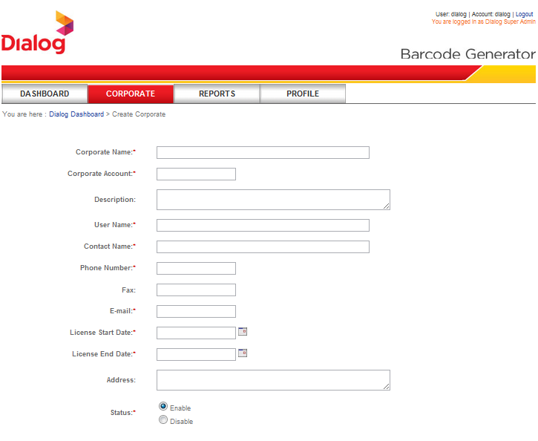

Figure .User Interface for Create Corporate

The DSA is able to create new corporate accounts. With that the CSA will be automatically created.

Here among 12 parameters 8 parameters are mandatory.

Mandatory Parameters

Corporate Name: Represents the name of the corporate

Corporate Account: This uniquely identifies the corporate

User Name: Username of the CSA, This is unique to the corporate

Contact Name: This may be a long name of the contact person in the corporate, can be CSA

Phone Number, Email: Contact details of the corporate

License Start Date: Start date of the License

License End Date: End date of the corporate License, this should be later than the License Start Date, and later than the current date. Once the License End Date is passed, the license will get expired and the corporate will be inactive. All the users under the corporate will also be inactive.

Optional Parameters

Description: A small description about the company

Status: Whether it is an inactive corporate or active corporate (If license start date is later than the current date this may be inactive)

Fax number

Address

#### Edit/Delete Corporate

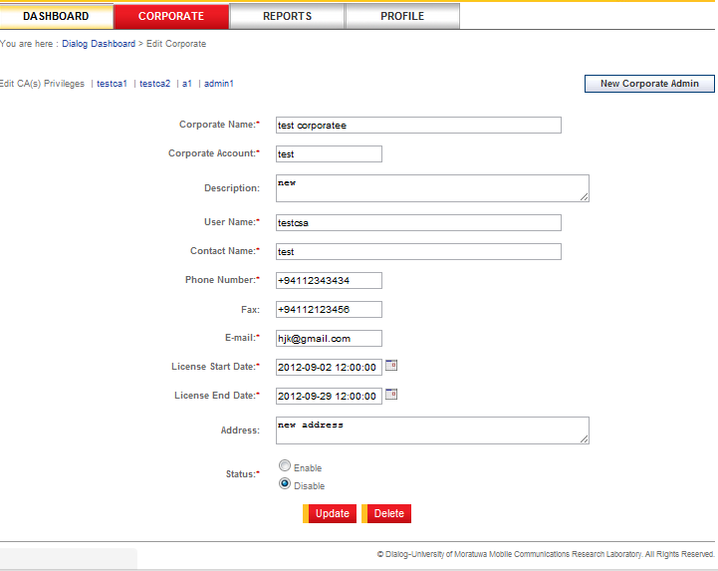

Figure . User Interface for Edit/Delete Corporate

Edit:

Corporate information can be modified by the DSA,

Here except corporate account and user name all the other details in the form can be modified.

Delete:

Corporate can be deleted by the DSA,

Once the corporate is deleted, all the users of the corporate will also get deleted.

Deleted flag is set in the database, and records for the deleted corporate remain in the database (But no user in that corporate can access the 2DBC site).

#### View Corporate

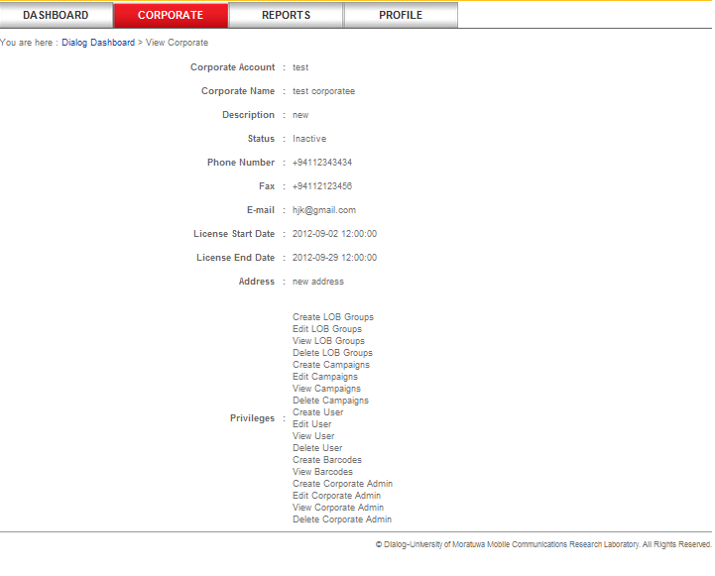

Figure .User Interface for View Corporate

Corporate information can be viewed by the DSA

#### Create Corporate Admin

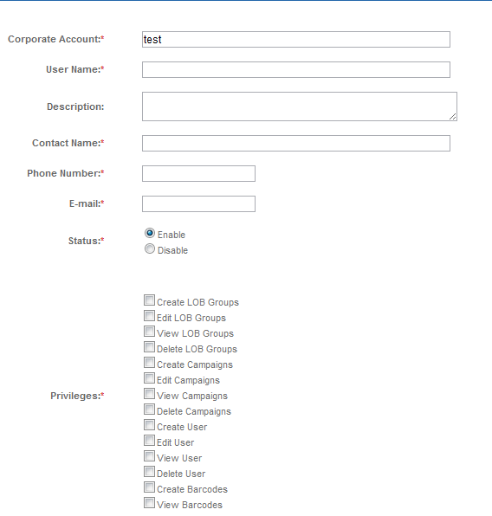

Figure .User Interface for Create Corporate Admin

The DSA/CSA is able to create new Corporate Admins under each corporate. Here among 8 parameters 5 parameters are mandatory.

Mandatory Parameters

Corporate Account: This will be prompted by the system

User Name: User name of the CA. This is unique to the corporate

Contact Name: Contact name of the CA

Phone Number, Email: Contact details of the CA

Optional Parameter

Status: Whether it is an inactive user account or an active user account

Privileges: According to the requirements privileges to the CA can be assigned among given set of privileges.

Description: description about the CA

#### Edit/Delete Corporate Admin

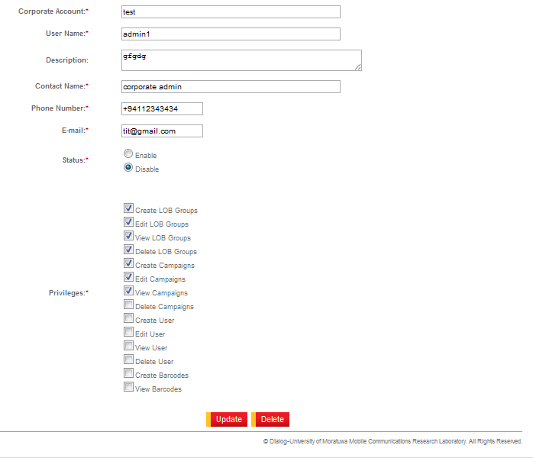

Figure . User Interface for Edit/Delete Corporate Admin

Edit:

The CA user account information can be edited by the DSA/CSA,

Here except corporate account and user name all the other details in the form can be edited.

Delete:

The CA account can be deleted by the DSA/CSA,

Deleted flag is set in the database, and record for the deleted CA account remains in the database (But the CA cannot access the 2DBC site).

#### View Corporate Admin

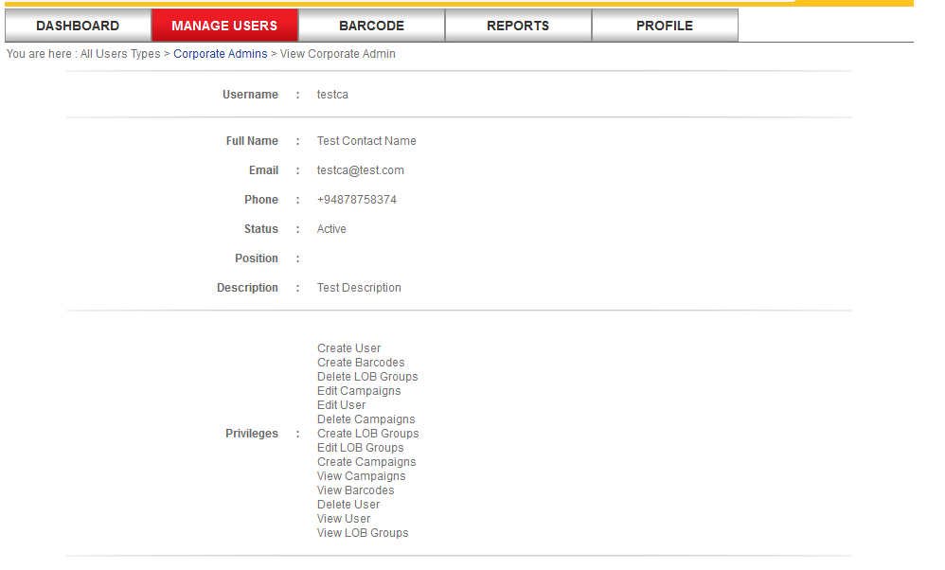

Figure . User Interface for View Corporate Admin

#### Create Corporate User

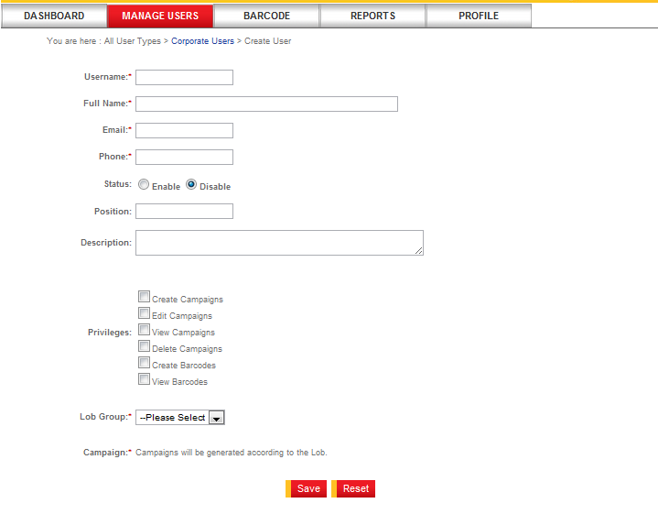

Figure . User Interface for Create Corporate User

The CSA/CA is able to create many CU s under the corporate by giving indicated parameters.

Mandatory parameters

User name: this parameter should be entered when logging to the system by the CU, this is unique to each corporate.

Full name: full contact name of the CU

Email/Phone: Contact details of the CU

LOB: The CU should be created under a selected LOB

Campaign: The CU should be assigned to a Campaign if he is not granted the ‘Create Campaign’ Privilege. Otherwise assigning the CU to a Campaign is optional.

#### Edit Corporate User

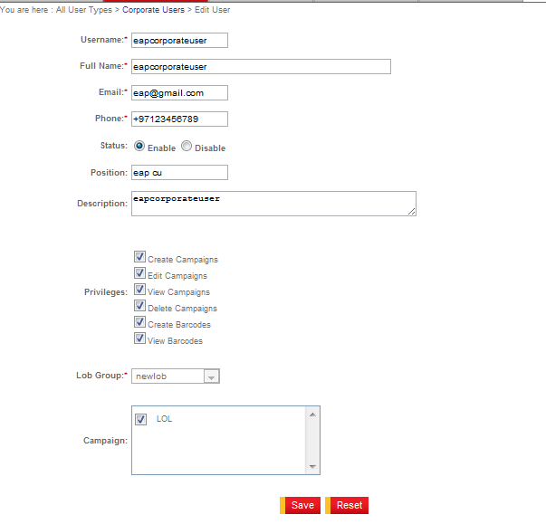

Figure . User Interface for Edit Corporate User

All the parameters in the above form can be modified except the username.

#### View Corporate User

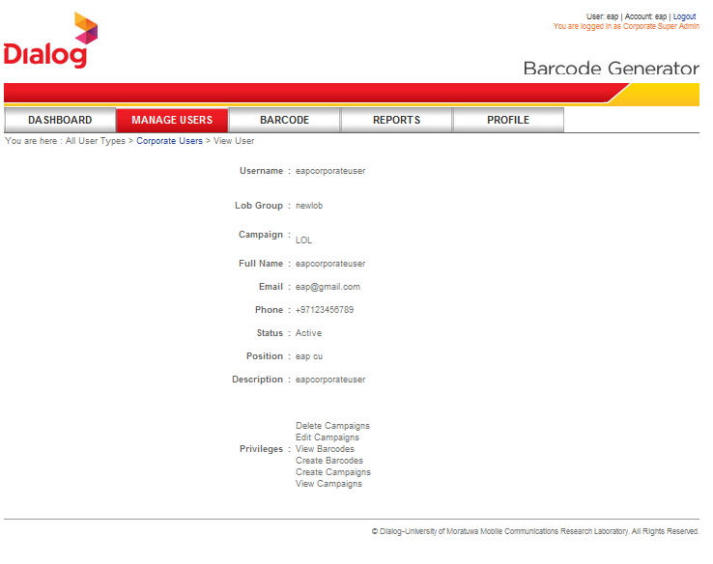

Figure . User Interface for View Corporate User

All the details of the CU can be viewed by the CSA/CA.

#### DSA Dashboard

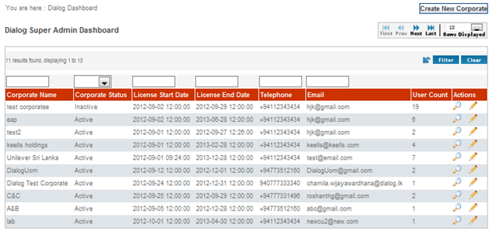

Figure . User Interface for DSA Dashboard

The DSA will be able to view all Corporates summary, and edit/view a particular Corporate.

#### CSA/CA Dashboard

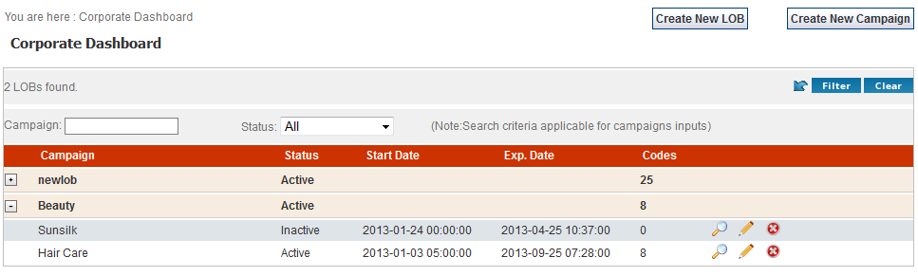

Figure . User Interface for CSA/CA Dashboard

A Summary of the LOBs and Campaigns will be appeared. Quick buttons are available for ‘Create LOB’ and ‘Create Campaign’

#### CU Dashboard

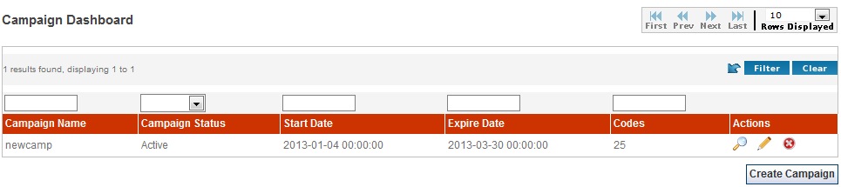

Figure . User Interface for CU Dashboard

A Summary of the Campaigns which are assigned CU will be appeared. ‘Create Campaign’ button will appear only if the CU has the *Create Campaign* Privilege.

#### Edit User’s (Currently logged in) own Profile

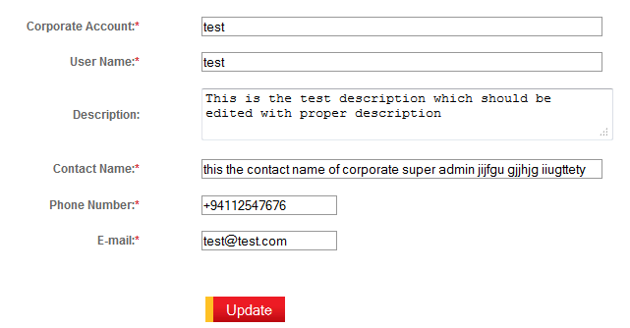

Figure . User Interface for Edit/View User Profile

#### Change User’s own password

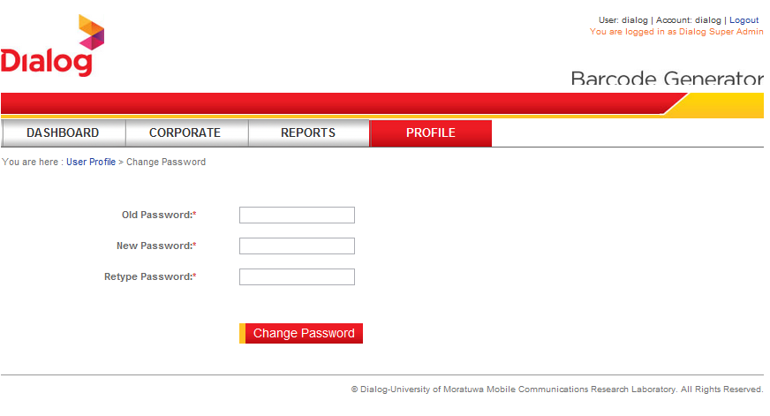

Figure . User Interface for Change own password

#### Create LOB

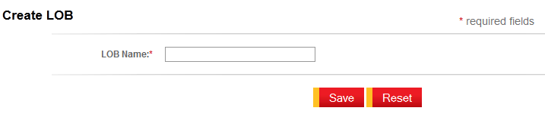

Figure . User Interface for Create LOB

Only one parameter; *LOB Name* should be given. This should be a unique name to the Corporate. Once created, it will be appeared on the CSA/CA Dashboard.

#### Create Campaign

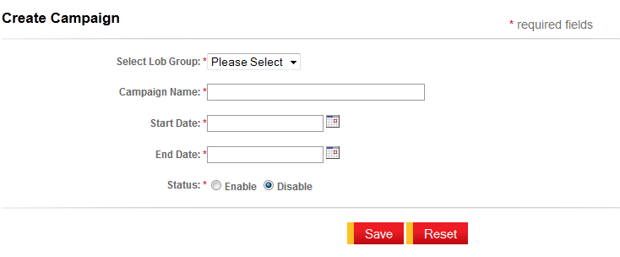

Figure . User Interface for Create Campaign

The CSA/CA/CU will be able to create Campaigns under a LOB (if the privilege is available).

#### Edit Campaign

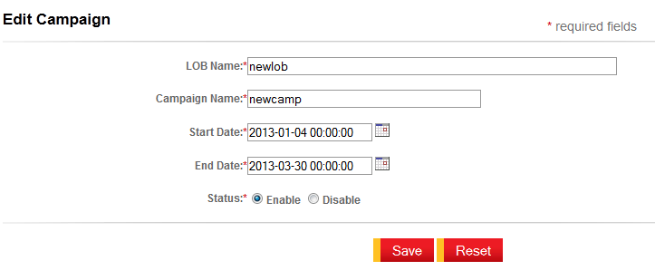

Figure . User Interface for Edit Campaign

#### View Campaign

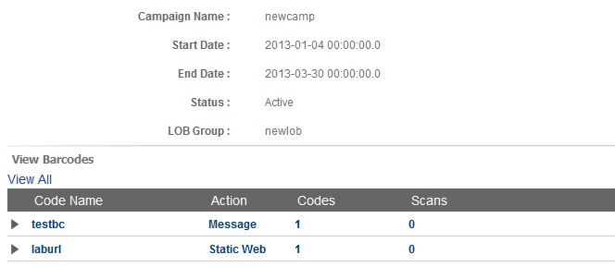

Figure . User Interface for View Campaign

The CSA/CA/CU is able to view the details of Campaigns, with the basic information of the Campaign (LOB, campaign name, start date, end date, status) and barcodes which were created under the Campaign.

#### User login

Figure . User login

The DSA/CSA/CA/CU can access to the system by giving correct user credentials in the login interface. If the password is forgotten it can be reset by navigating to ‘*Unable to login’* hyperlink.

### Barcode Creation Interfaces

#### Guest User Create Barcodes

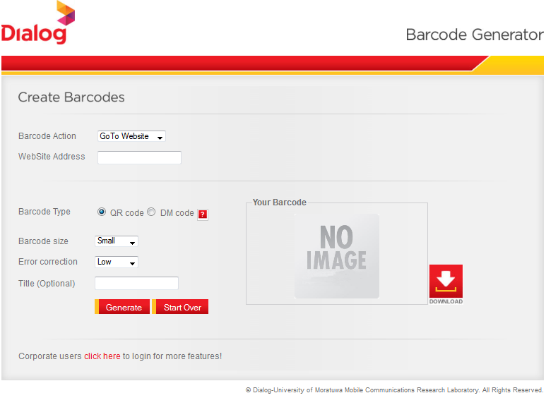

Figure . User Interface for Guest User Create Barcodes

#### Creates Barcodes by Logged in users

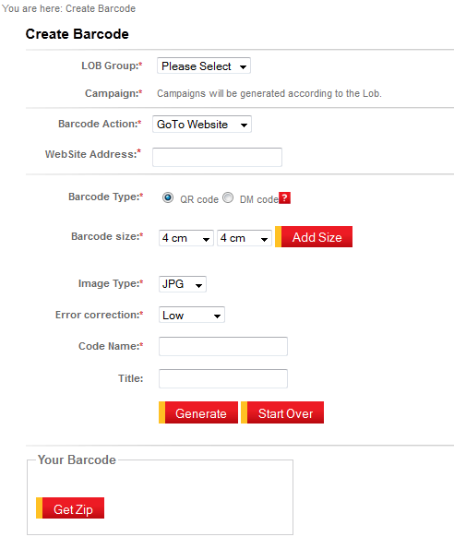

Figure . User Interface for logged in user create barcodes

Logged in users can create barcodes under a given LOB and a Campaign.

#### Create Bulk Barcodes

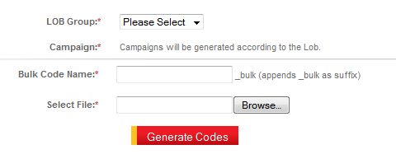

Figure . User Interface for Create Bulk Barcodes

Logged in users are able to create Bulk Barcodes by navigating to the interface shown in Figure 3.21.Required CSV file should be browsed and uploaded.

#### Edit Dynamic URL

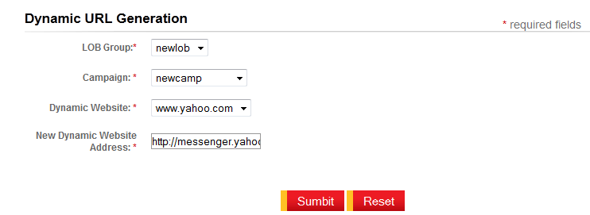

Figure . User Interface for Edit Dynamic URL

Logged in users have the capability of modifying the Dynamic Website as needed by navigating to the interface shown in Figure 3.22.All the Campaigns under a selected LOB are loaded. Then for the selected Campaign relevant Dynamic URLs will be loaded in the ‘Dynamic Website’ Drop down box. The existing ‘Dynamic Website’ can be then modified by giving a required website address to the ‘New Dynamic Website Address’ field.

### Reporting Interfaces

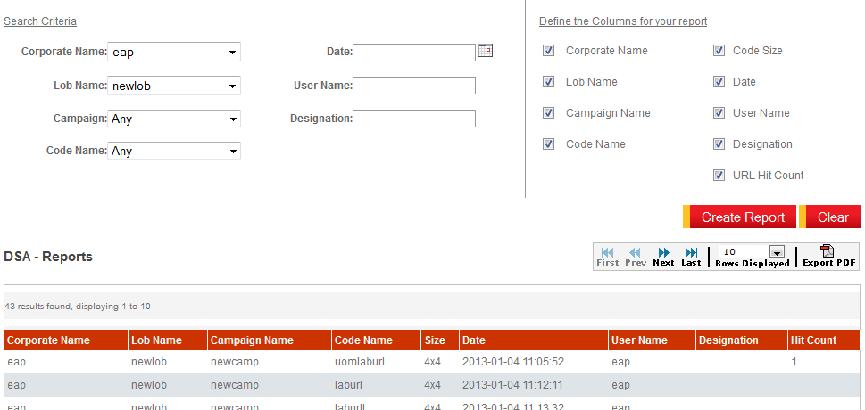

Figure . User Interface for Reporting

Reporting feature is only available for the DSA/CSA type users.

## Functional Requirements

### User Management Requirements

#### Create Corporate

|  |  |  |  |
| --- | --- | --- | --- |
| **Use Case Number** | 01 | **Use Case Name** | Create Corporate |
| **Main Actor** | Dialog Super Admin( DSA) | **Actors** | 2DBC System, Corporate, Corporate Super Admin(CSA) |
| **Pre Conditions** | 1. User is logged in to the system 2. User has accessed the page ‘Create Corporate’. | | |
| **Post Conditions** | 1. New Corporate is created on the 2DBC System. 2. Information entered by the user are appropriately stored in the system 3. After creating a Corporate proper message should be displayed. | | |
| **Business Rules**   1. When creating a Corporate, at the same time CSA account should be created. 2. CSA will be automatically assigned all the pre-defined privileges for his role. 3. Each Corporate should have an account name, which cannot be modified after created. 4. Contact details of the Corporate and the CSA should be same 5. There should be an input field to give a *username* for the CSA. 6. All the mandatory fields should be marked with asterisks. 7. Corporate should have *License Start Date* and *License End Date* | | | |
| **Main Scenario**   1. System allows user to enter information about the Corporate and the CSA. 2. User enters the relevant information on the GUI. 3. System does validation on input fields. 4. User clicks on the *Save* button to create a Corporate. 5. Relevant information is passed to the 2DBC Database. 6. System prompts message stating the successful creation of Corporate (Refer Notes) 7. Use case terminates with post condition 1 | | | |
| **Alternative Path**   1. If user clicks on *Reset* button all the inputs should be reset to their default values and returns user to step 1. 2. If validation fails proper validation messages will be appeared while the form remains as it is and returns user to step 2. | | | |
| **Notes**   1. Success message: Corporate and Corporate Super Admin account was successfully created. Login password is "dialog". User will be prompted to change the login password at the time of first login. 2. Information is same between the Corporate and the CSA – *Contact number, Email, Contact Name, description, Status* | | | |
| **Assumptions**   1. For a particular Corporate there should be only one CSA. 2. Corporate account name is unique within the system. | | | |

#### Create Corporate Admin

|  |  |  |  |
| --- | --- | --- | --- |
| **Use Case Number** | 02 | **Use Case Name** | Create Corporate Admin |
| **Main Actor** | Dialog Super Admin (DSA)  Corporate Super Admin(CSA) | **Actors** | 2DBC System, Corporate Admin(CA) |
| **Pre Conditions** | 1. User is logged in to the system 2. User has accessed the page ‘Create Corporate Admin’. 3. The Corporate should be already created in order to create a CA for the Corporate | | |
| **Post Conditions** | 1. The CA basic information and his privileges entered by the user are appropriately stored in the system 2. After creating the CA proper message should be displayed. | | |
| **Business Rules**   1. The CA can be created by both the DSA and the CSA type users. 2. Pre-defined list of privileges for the CA’s role should be appeared on the page. 3. The CA should be assigned to all or subset of available privileges. 4. Corporate account name should be appeared on the page, but it should not be allowed to modify. 5. System should validate the username given for the CA within the Corporate. If it is already being registered within that Corporate prompt a text validation “The username already exists” | | | |
| **Main Scenario**   1. System allows user to enter CA basic information and assign privileges which are predefined for user’s role. 2. User enters the information on the GUI. 3. User assigns privileges to the CA. 4. System does validation on the input fields. 5. User clicks on the *Save* button to create a CA. 6. Relevant information is passed to the 2DBC Database. 7. System prompts message stating the successful creation of the CA (Refer Notes) 8. Use case terminates with post condition 1 | | | |
| **Alternative Path**   1. If user clicks on *Reset* button all the inputs should be reset to their default values and returns user to step 1. 2. If validation fails proper validation messages appear while the form remains and returns user to step 2. | | | |
| **Notes**   1. Success message: Corporate Admin account was successfully created. Login password is "dialog". User will be prompted to change the login password at the time of first login. | | | |
| **Assumptions**   1. Username is unique within the Corporate. | | | |

#### Create Corporate User

|  |  |  |  |
| --- | --- | --- | --- |
| **Use Case Number** | 03 | **Use Case Name** | Create Corporate User |
| **Main Actor** | Corporate Super Admin(CSA)  Corporate Admin(CA) | **Actors** | 2DBC System, Corporate User(CU) |
| **Pre Conditions** | 1. User is logged in to the system 2. User has accessed the page ‘Create Corporate User’. 3. The Corporate should be already created in order to create a CU for the Corporate 4. LOB Group(s) should be already created. | | |
| **Post Conditions** | 1. The CU basic information and his privileges entered by the user are appropriately stored in the system 2. After creating the CU proper message should be displayed. | | |
| **Business Rules**   1. The CU can be created by both the CSA and the CA type users. 2. The message “At Least 1 LOB group must be created in the system before creating corporate users.” Should be appeared on the page. 3. Pre-defined list of privileges for the CU’s role should be appearing on the page. 4. The CU should be assigned to all or subset of available privileges. 5. The Corporate account name should be appeared on the page, but it should not be allowed to modify. 6. The System should validate the username given to the CU within the Corporate. If it is already being registered within that Corporate prompt a text validation “The username already exists” | | | |
| **Main Scenario**   1. System allows user to enter the CU basic information and assign privileges which are predefined for user’s role. 2. User enters the information on the GUI. 3. User assigns privileges to the CU. 4. System does validation on the input fields. 5. User clicks on the *Save* button to create a CU. 6. Relevant information is passed to the 2DBC Database. 7. System prompts message stating the successful creation of CU (Refer Notes) 8. Use case terminates with post condition 1 | | | |
| **Alternative Path**   1. If user clicks on *Reset* button all the inputs should be reset to their default values and returns user to step 1. 2. If validation fails proper validation messages appear while the form remains as it is and returns user to step 2. | | | |
| **Notes**   1. Success message: Corporate User account was successfully created. Login password is "dialog". User will be prompted to change the login password at the time of first login. | | | |
| **Assumptions**   1. Username is unique within the Corporate. | | | |

#### Create LOB Group

|  |  |  |  |
| --- | --- | --- | --- |
| **Use Case Number** | 04 | **Use Case Name** | Create LOB Group |
| **Main Actor** | Corporate Super Admin(CSA)  Corporate Admin(CA) | **Actors** | 2DBC System, |
| **Pre Conditions** | 1. User is logged in to the system 2. User has accessed the page ‘Create LOB’. | | |
| **Post Conditions** | 1. The LOB information entered by the user is appropriately stored in the system database. 2. After creating the LOB Group proper message should be displayed. | | |
| **Business Rules**   1. The LOB Groups can be created only by the CSA and the CA type users. 2. System should validate the LOB Name given within the Corporate and if that name already taken prompt a text validation “The LOB Name already taken” | | | |
| **Main Scenario**   1. System allows user to enter the *LOB Name*. 2. User enters a *LOB Name*. 3. System does validation on the *LOB Name*. 4. User clicks on the *Save* button to create the new LOB Group. 5. Relevant information is passed to the 2DBC Database. 6. System prompts message stating the successful creation of LOB (Refer Notes) 7. Use case terminates with post condition 1 | | | |
| **Alternative Path**   1. If user clicks on *Reset* button the input field should be set to blank and returns user to step 1. 2. If validation fails proper validation messages is appeared and returns user to step 2. | | | |
| **Notes**   1. Success message: New Line of Business Group was successfully created. | | | |
| **Assumptions**   1. LOB Name is unique within the Corporate. | | | |

#### Create Campaign

|  |  |  |  |
| --- | --- | --- | --- |
| **Use Case Number** | 05 | **Use Case Name** | Create Campaign |
| **Main Actor** | Corporate Super Admin(CSA)  Corporate Admin(CA)  Corporate User(CU) | **Actors** | 2DBC System |
| **Pre Conditions** | 1. User is logged in to the system 2. System should have LOB(s) already created for the particular Corporate. 3. User has accessed the page ‘Create Campaign’. | | |
| **Post Conditions** | 1. The Campaign information entered by the user is appropriately stored in the system database. 2. After creating the Campaign proper message should be displayed. | | |
| **Business Rules**   1. Create the Campaign feature will be available for the CSA, CA and CU type users. 2. ‘Create Campaign’ is one of the privilege available for above users and only granted users are able to Create Campaigns. 3. Each Campaign should belong to a particular LOB Group. 4. Campaigns are active for a particular period of time so user must be able to define a Start Date and End Date for the Campaign. 5. System should validate the *Campaign Name* given within the LOB Group and if that name already taken prompt a text validation “The Campaign Name already taken” | | | |
| **Main Scenario**   1. System allows user to enter the Campaign details. 2. User enters relevant Campaign information. (Refer Notes 2) 3. System does validation on the *Campaign Name*. 4. User clicks on the *Save* button to create a new Campaign. 5. Relevant information is passed to the 2DBC Database. 6. System prompts message stating the successful creation of Campaign (Refer Notes 1) 7. Use case terminates with post condition 1 | | | |
| **Alternative Path**   1. If user clicks on *Reset* button all the input should set to their defaults and user returns to step 1. 2. If validation fails proper validation message appears and returns the user to step 2. | | | |
| **Notes**   1. Success message: New Campaign was successfully created. 2. Campaign information : *Campaign Name, Start Date, End Date, Status(Enable/Disable)* | | | |
| **Assumptions**  1. Campaign Name is unique within the LOB Group. | | | |

### Barcode Creation Requirements

#### External User Create Barcode

|  |  |  |  |
| --- | --- | --- | --- |
| **Use Case Number** | 06 | **Use Case Name** | External User Create Barcode |
| **Main Actor** | External User | **Actors** | 2DBC System |
| **Pre Conditions** | 1. User is on the system main page to enter barcode information | | |
| **Post Conditions** | 1. Information entered by the user are appropriately stored in the 2DBC System Database 2. Barcode creation is done by calling a web service. 3. Created barcode image should be displayed on the same page while the entered values are still being displayed at the relevant inputs. | | |
| **Business Rules**   1. The user should be able to select the barcode action of the barcode to be created (Refer Notes) 2. Depending on the selection of above “1” subsequent content of the page should be changed. 3. Barcode type should be either QR or DM 4. User should be able to create barcode under three different sizes; Small, Medium, Large 5. Error Correction Level is only applicable for QR type barcodes(Refer Notes) 6. Giving *Title* for the code is optional. 7. The created barcode image can be downloaded as a Zip file. | | | |
| **Main Scenario**   1. System allows user to enter information about the barcode. 2. User enters the barcode information on the GUI. 3. System does validation on the input fields. 4. User clicks on the *Generate* button to create a barcode. 5. Relevant information is passed to the web service and image byte stream is returned to the system. 6. System creates the image from image byte stream. 7. Created image is displayed to user on same page. 8. Use case terminates with post condition 3 | | | |
| **Alternative Path**   1. If user clicks on *Reset* button all the inputs should be reset to their default values and returns user to step 1. 2. If validation fails proper validation messages appear while the form remains as it is and returns user to step 2. | | | |
| **Notes**   1. Barcode Actions: *Go to Website, Message, Contact Details, Send SMS, Initiate Call* 2. Subsequent data relevant to the above action   *Go to Website :* Website Address  *Message :* Message  *Contact Details :* Name, Phone, Email, Organization  *Send SMS* : Long/Short number(3-6 digits), Message  *Initiate Call* : Long/Short number(3-6 digits)   1. *Error Correction*: Low, Medium, Quality, High | | | |
| **Assumptions**   1. The system allows only dialog numbers. | | | |

#### Logged in User Create Barcodes

|  |  |  |  |
| --- | --- | --- | --- |
| **Use Case Number** | 07 | **Use Case Name** | Logged in User Create Barcode |
| **Main Actors** | CSA/CA/CU | **Actors** | 2DBC System |
| **Pre Conditions** | 1. User is logged in to the system 2. User has accessed the page ‘Create Barcode’. | | |
| **Post Conditions** | 1. Information entered by the user are appropriately stored in the 2DBC System Database 2. Barcode creation is done by calling a web service. 3. Created barcode image(s) should be display on the same page while the entered values are still displaying at relevant inputs. | | |
| **Business Rules**   1. User should be able to select the barcode action of the barcode to be created (Refer Notes) 2. Depending on the selection of above “1” subsequent content of the page should be changed. 3. Barcode type should be either QR or DM(Data Matrix) 4. User should be able to create barcode under the sizes; 4x4, 8x8, 12x12, 16x16 5. Error Correction Level is only applicable for QR type barcodes(refer Notes) 6. Giving *Title* for the code is optional and Title will be displayed under the barcode. 7. Giving *Code Name* is essential to identify the created barcode later on. 8. The created barcode image(s) can be downloaded as a Zip file. | | | |
| **Main Scenario**   1. System allows user to enter the information about barcode. 2. User enters the barcode information on the GUI. 3. System does validation on the input fields. 4. User clicks on the *Generate* button to create a barcode. 5. Relevant information is passed to the web service and image byte stream is returned to the system. 6. System creates the image(s) from image(s) byte stream. 7. Created image(s) is displayed to user on same page. 8. Use case terminates with post condition 3 | | | |
| **Alternative Path**   1. If user clicks on *Reset* button all the inputs should be reset to their default values and returns user to step 1. 2. If validation fails proper validation messages appear while the form remains as it is and returns user to step 2. | | | |
| **Notes**   1. Barcode Actions: *Go to Static/Dynamic Website, Message, Contact Details, Send SMS, Initiate Call* 2. Subsequent data relevant to the above action   *Go to Static Website* : Website Address  *Go to Dynamic Website* : Website Address  *Message* : Message  *Contact Details* : Name, Phone, Email, Organization  *Send SMS* : Long/Short number(3-6 digits), Message  *Initiate Call* : Long/Short number(3-6 digits)   1. *Error Correction* : Low, Medium, Quality, High | | | |
| **Assumptions**   1. The system allows only dialog numbers. 2. Code name is unique within the Campaign. | | | |

### Reporting Requirements

#### View Corporate Reports

|  |  |  |  |
| --- | --- | --- | --- |
| **Use Case Number** | 08 | **Use Case Name** | View Reports |
| **Main Actors** | DSA/CSA | **Actors** | 2DBC System |
| **Pre Conditions** | 1. User is logged in to the system 2. User has accessed the page ‘View Reports’. | | |
| **Post Conditions** | 1. After the result is displayed the details given for the search criteria should be shown on relevant inputs. | | |
| **Business Rules**   1. Reports should represent the information mentioned under SRS 2.2.3.1. 2. Reporting criteria should be presented on the drop down boxes where applicable. 3. User should be able to define the columns to be appeared on his reports. 4. There should be an input field to give the date as search criteria. This will allow user to check barcode(s) created on a particular date. 5. Generated *Report* can be downloaded as a PDF. | | | |
| **Main Scenario**   1. System allows user to enter search criteria for the report. 2. System allows user to define columns to be appeared in the report. 3. User specifies reporting parameters according to the desired content output of the report. 4. User clicks on the *Create Report* button to create a Report. | | | |
| **Alternative Path**   1. If user clicks on *Reset* button all the inputs should be reset to their default values and returns user to step 1. | | | |
| **Notes** | | | |
| **Assumptions** | | | |

## Detailed Non-functional Requirements

|  |  |  |
| --- | --- | --- |
| **Attribute Name** | **Attribute Type** | **Size/Format** |
| Username | String | 20 |
| Corporate Account | String | 20 |
| Corporate Name | String | 100 |
| Email | String | 100 |
| Telephone/Fax | String | 12 / +94xxxxxxxxx |
| Descriptions | String | 200 |
| Date | Date | yyyy-MM-ddHH:mm:ss |

Code Standard MVC Architecture

Database MySQL