1. **Reporting**

Dialog Super Admin (DSA) and Corporate Super Admin (CSA) are able to view and customize reports. DSA is able to view reports behalf of all corporate. CSA is able to view reports for his corporate.

* 1. **Use Cases**

When DSA navigate to view reports barcode creation summary for the all corporate will be listed in a table. When considering from corporate’ perspective they will be able to view the summary of its barcode creation after navigate to view report and that privilege is only applicable for CSA. CA and CU users are not able to view reports instead they when the neediness occurs they might ask it from CSA manually.

* + 1. Use Case : DSA View Reports

Once DSA navigates through reports, table of corporate summary for the created barcode page is appeared. Table can be filtered by each appropriate column of the table.(eg. By corporate, lob, campaign, etc.)



**Figure 4.1 Reports – DSA**

1. DSA logged in to the system.
2. Navigate for the ‘Reports’
3. Table of barcode creation summary for all corporate is displayed.
4. DSA can do filtering by any filtering criteria(s).
5. Download report as a pdf.
   * 1. Use Case : CSA View Reports

Once CSA navigates through reports, table of his corporate summary for the created barcode page is appeared. Table can be filtered by each appropriate column of the table.(eg. By lob, campaign, etc.)



**Figure 4.2 Reports – CSA**

1. CSA logged in to the system.
2. Navigate for the ‘Reports’
3. Table of barcode creation summary for all corporate is displayed.
4. CSA can do filtering by any filtering criteria(s).
5. Download report as a pdf.

* 1. **Nun Functional Requirements**

Report is covering the following information.

* Corporate Name
* Contact Details: Address, Telephone, Fax, Email
* LOB Group
* Campaign
* Code Name
* Date Created
* Url Hit Count
* Created Username
* User Designation
  1. **User Interfaces**
     1. DSA View Reports

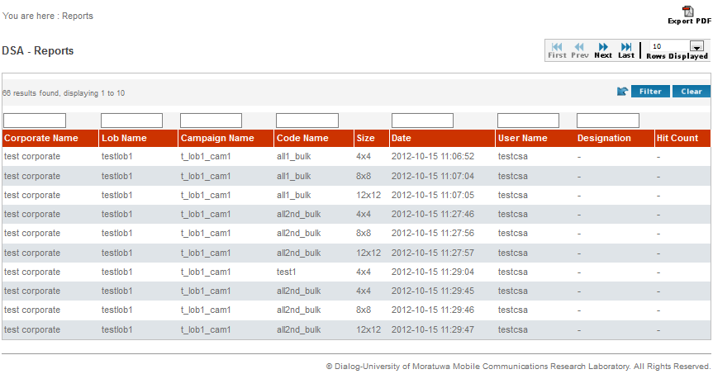

**Figure 4.3 User Interface of DSA Reports**

* + 1. CSA View Reports

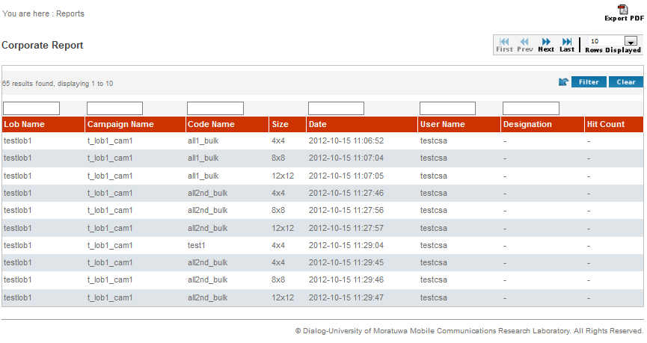

**Figure 4.4 User Interface of CSA Reports**