**Click to Call- Specifications**

1. **User levels**

User levels with granted permissions is shown in Table 1.1

**Table 1.1**

|  |  |
| --- | --- |
| Dialog Admin | * Create Company Account * Create Agents * View reports |
| Dialog User | * View Reports |
| Customer Care Admin | * View reports * Create Agents * Modify Company Accounts |

1. **Interfaces**
2. Login Page
3. Company Dashboard
   1. Company(Create/Edit/View/Delete)
   2. Agents(Create/Edit/View/Delete)
   3. Generate iframe
   4. Modify Black List
4. User Dashboard
   1. User(Create/Edit/View/Delete)
5. Reports
6. **Database**

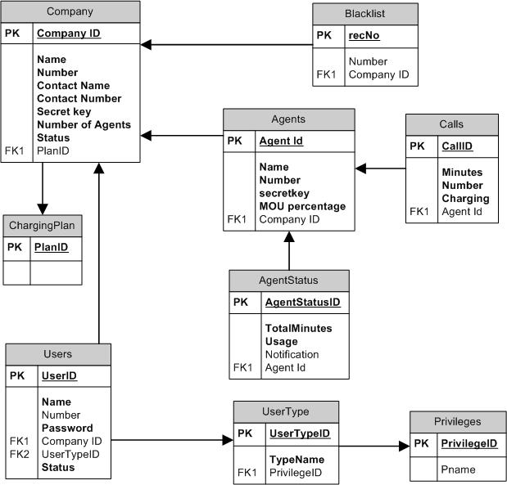Figure 3.1 shows the Data Model.

**Figure 3.1**