**OverTheWire – Bandit**

**Level 0-1**

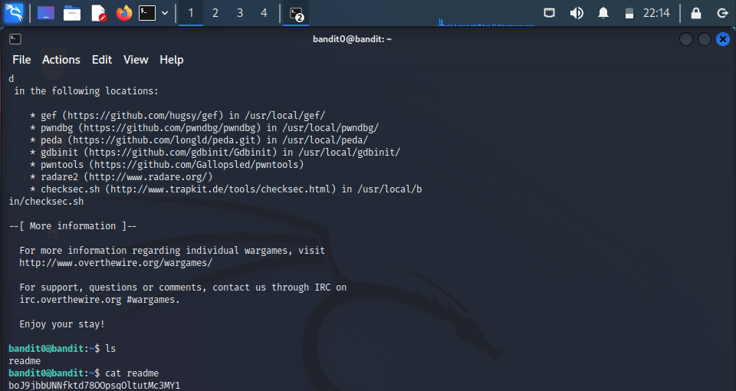

* **Password** : boJ9jbbUNNfktd78OOpsqOltutMc3MY1

**Level 1-2**

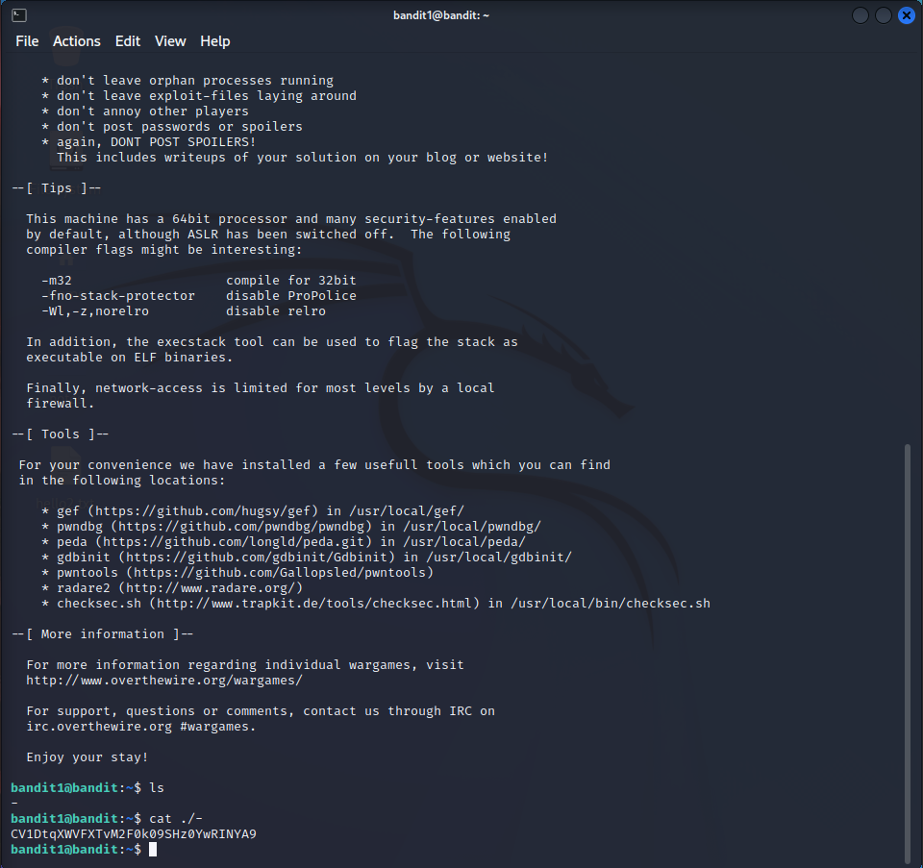

* **Password** : CV1DtqXWVFXTvM2F0k09SHz0YwRINYA9

**Level 2-3**

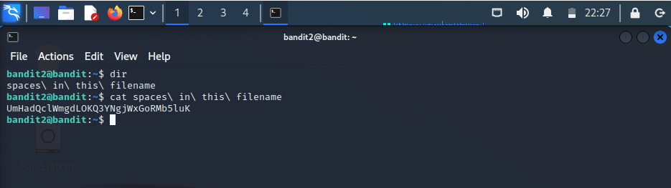

* **Password** : UmHadQclWmgdLOKQ3YNgjWxGoRMb5luK

**Level 3-4**

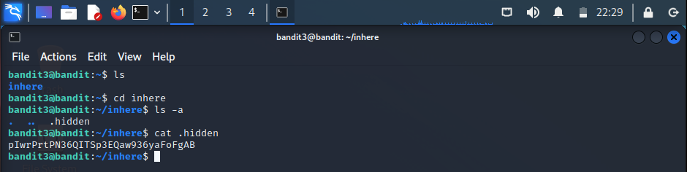

* **Password** : pIwrPrtPN36QITSp3EQaw936yaFoFgAB

**Level 4-5**

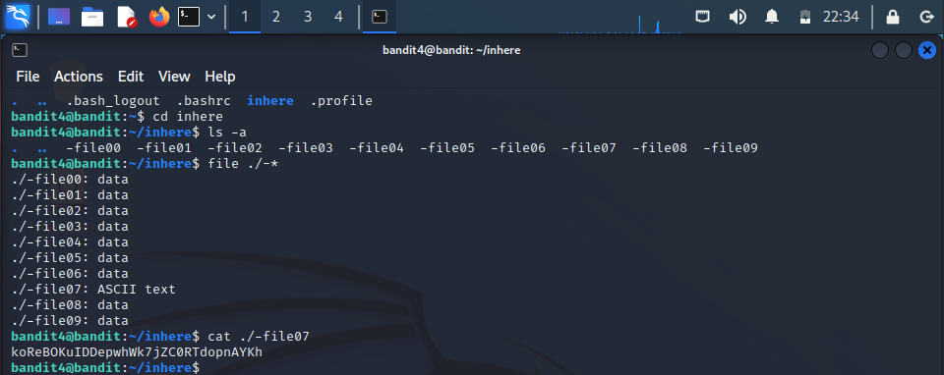

* **Password** : koReBOKuIDDepwhWk7jZC0RTdopnAYKh

**Level 5-6**

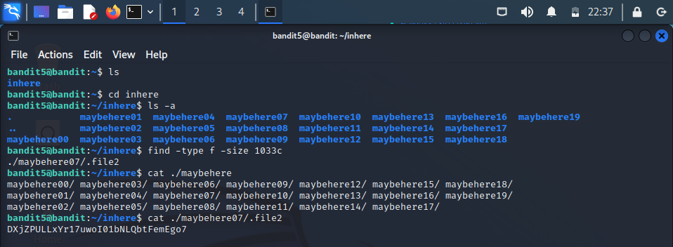

* **Password** : DXjZPULLxYr17uwoI01bNLQbtFemEgo7

**Level 6-7**

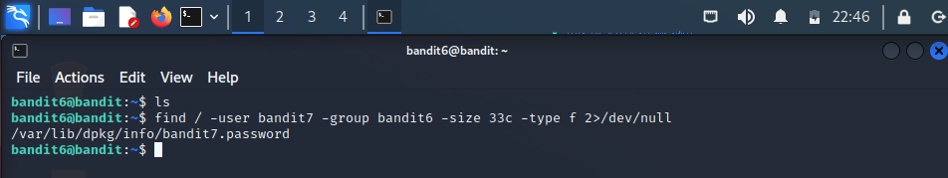

* **Password** : HKBPTKQnIay4Fw76bEy8PVxKEDQRKTzs

**Level 7-8**

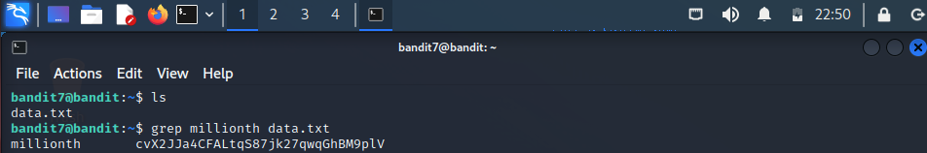

* **Password** : cvX2JJa4CFALtqS87jk27qwqGhBM9plV

**Level 8-9**

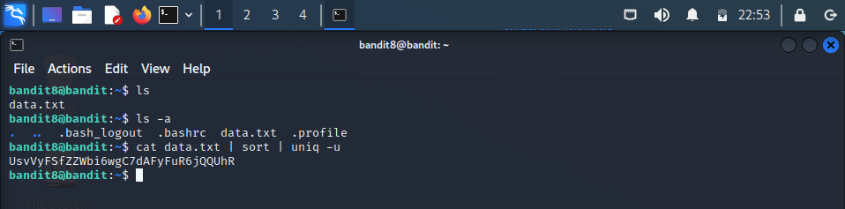

* **Password** : UsvVyFSfZZWbi6wgC7dAFyFuR6jQQUhR

**Level 9-10**

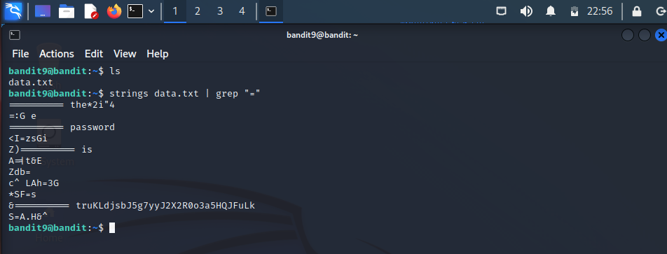

* **Password** : truKLdjsbJ5g7yyJ2X2R0o3a5HQJFuLk

**Level 10-11**

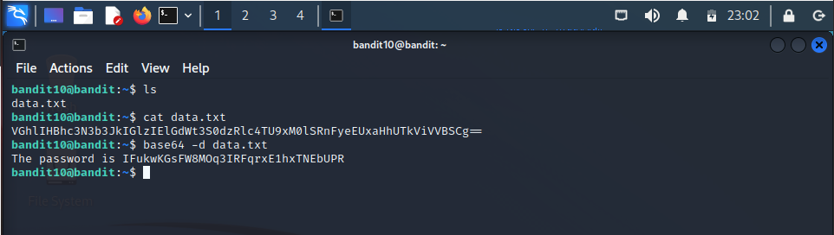

* **Password** : IFukwKGsFW8MOq3IRFqrxE1hxTNEbUPR

**Level 11-12**

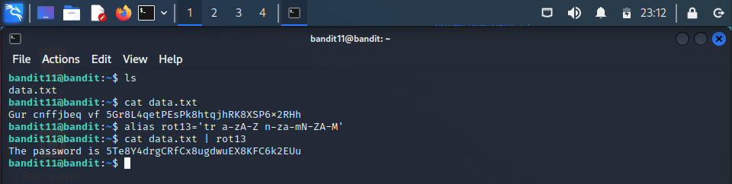

* **Password** : 5Te8Y4drgCRfCx8ugdwuEX8KFC6k2EUu

**Level 12-13**

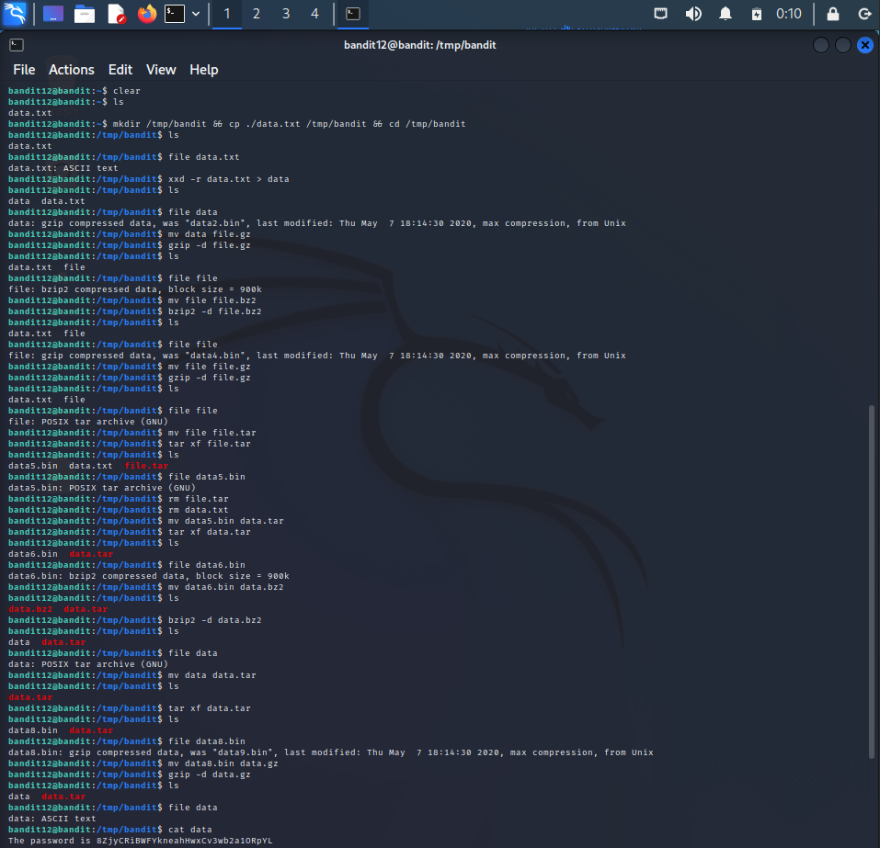

* **Password** : 8ZjyCRiBWFYkneahHwxCv3wb2a1ORpYL

**Level 13-14**

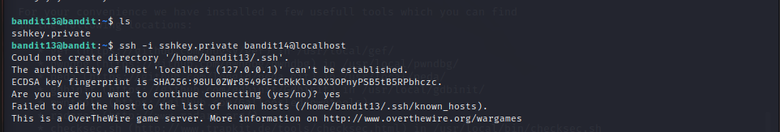



* **Password** : 4wcYUJFw0k0XLShlDzztnTBHiqxU3b3e

**Level 14-15**

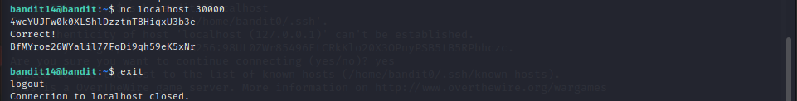

* **Password** : BfMYroe26WYalil77FoDi9qh59eK5xNr