AI-Powered Bug Detection & Resolution Platform

Complete Client Report

Final Year Project (FYP) — Second Evaluation

College of Computing & Software Engineering
Ziauddin University (FESTM)

Prepared for: Client Presentation
Date: May 2026

1. Introduction — What is this Project?

The Bug Detector is a smart, AI-powered web platform that automatically finds errors (called "bugs") in software code. It was built as a Final Year Project to help software teams save time and catch bugs faster than traditional manual code reviews.

In simple terms: You upload your code file → The AI scans it → You get a full bug report in seconds.

Why is this important?
Software bugs cost companies billions of dollars every year.
Manual code reviews are slow, expensive, and miss many bugs.
Our AI-powered platform can scan thousands of lines of code instantly.
It finds bugs with 87% accuracy and classifies their type with 99% accuracy.

1.1 What Does the Platform Do?
- Accepts any source code file (Python, Java, JavaScript, etc.) or log file
- Automatically scans the code and finds bugs using Machine Learning
- Tells you exactly what type of bug it is and how serious it is
- Shows which line of code has the problem
- Suggests how to fix it and who should fix it
- Keeps a full history of all past analyses
- Optionally uses Claude AI for deeper, enhanced bug explanations

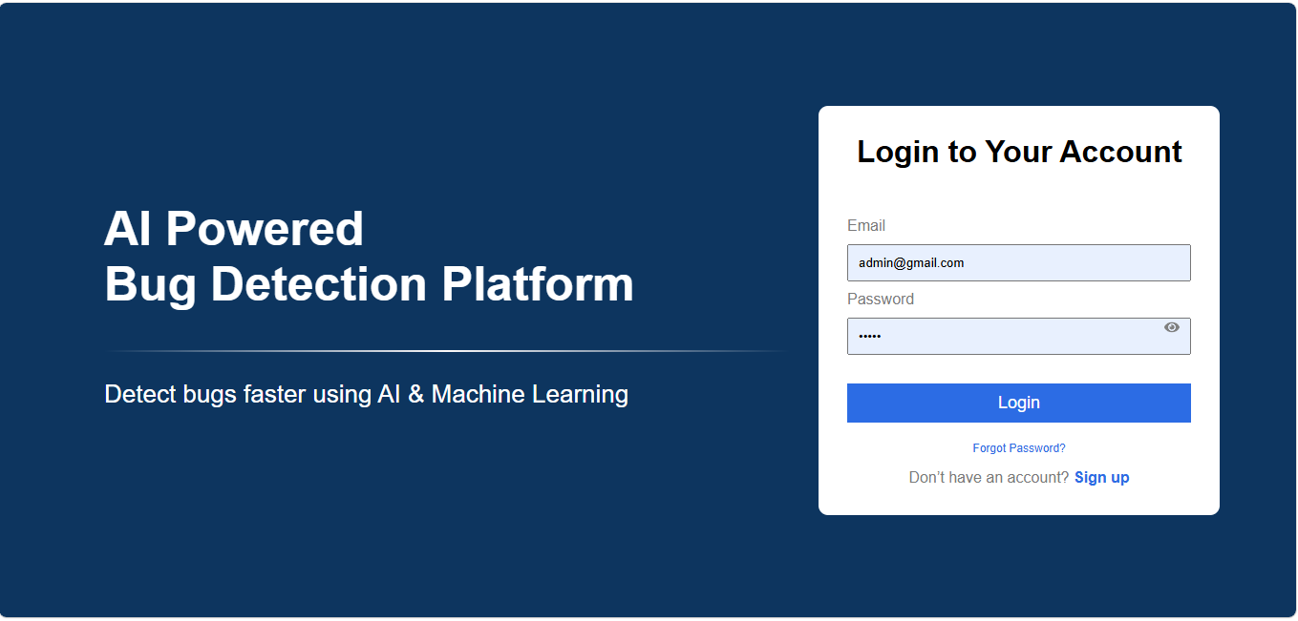
Figure 1: Login Screen — AI-Powered Bug Detection Platform

2. The Problem We Solve

Finding bugs in software is one of the biggest challenges in software development. Here is why traditional methods fail and how our platform solves these problems:

The Old Way (Manual Review)  • Developers manually read thousands of lines of code  • Takes days or weeks — very slow and expensive  • Human reviewers miss many bugs, especially in large projects  • No automated record of which bugs were found  • Different developers may have different standards  • Hard to track which bugs were fixed and when | Our AI Solution  • Upload any code file — AI scans it in seconds  • 87% accuracy in detecting buggy files  • 99% accuracy in classifying the type of bug  • Full history with timestamps kept automatically  • Consistent, unbiased analysis every time  • Track bug status: Open, In Progress, Fixed

3. How It Works — Step by Step

The platform follows a simple 7-step process from file upload to bug resolution:

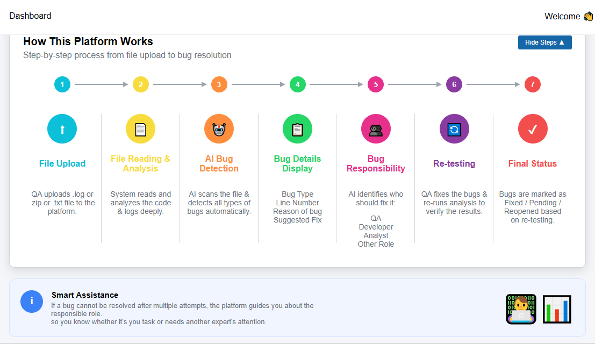
Figure 2: 7-Step Platform Workflow

Step-by-Step Explanation
Step 1: File Upload
The QA Engineer or Developer logs into the platform and uploads a code file or log file. Supported formats include .py, .java, .js, .ts, .cpp, .c, .cs, .log, .txt, and .zip (for entire project folders).

Step 2: File Reading & Analysis
The system reads the uploaded file and extracts 20 different measurements of code quality. These are called CK Metrics (named after researchers Chidamber & Kemerer). Examples include how complex the code is, how many lines there are, and how many other files it depends on.

Step 3: AI Bug Detection
The AI model scans the extracted measurements and decides: Does this file have a bug? If yes, the system continues to classify the type of bug.

Step 4: Bug Details Display
For each bug found, the platform shows: Bug Type, Line Number, Reason the AI flagged it, Suggested Fix, and Severity level.

Step 5: Bug Responsibility
The AI automatically assigns the bug to the right person: Developer (for Crash and Logical bugs), QA Engineer (for UI bugs), or Analyst (for Performance bugs).

Step 6: Re-testing
After the developer fixes the bug, the QA Engineer can re-upload the same file to verify that the bug has been resolved.

Step 7: Final Status
Bugs are marked as Fixed, Pending, or Reopened based on re-testing results. All changes are saved in the platform's history.

4. Datasets Used to Train the AI

To teach the AI how to detect bugs, we used two large, real-world datasets that researchers and companies have used for decades:

4.1 Dataset 1: NASA Software Defect Dataset
File name: nasa_combined.csv

About this Dataset
Source: NASA publicly released real project data
Contains data from real NASA space software projects
Each record represents one software module (file)
Tells us: Does this module have a bug? (Yes = Defective, No = Clean)
Total records used: ~17,000 software modules
This dataset teaches the AI: Is this code buggy or clean?

4.2 Dataset 2: CK Metrics Dataset
File name: ck_combined.csv

About this Dataset
CK stands for Chidamber & Kemerer — famous software quality researchers
Measures 20 different qualities of code for each file
WMC — Weighted Methods per Class: how complex is the code?
LOC — Lines of Code: how big is the file?
CBO — Coupling Between Objects: how many other files does it depend on?
RFC — Response for a Class: how many different functions are called?
DIT — Depth of Inheritance Tree: how many layers of inheritance?
LCOM — Lack of Cohesion: how loosely connected are the methods?
This dataset teaches the AI: What TYPE of bug is this?

Together, these datasets gave us enough data to train highly accurate AI models that can analyze any code file and make reliable predictions.

5. AI Models — Explained in Simple Language

Our platform uses three layers of AI intelligence working together. Here is each one explained simply:

87%  Bug Detection Accuracy (AUC) | 99%  Bug Type Classification Accuracy | 35  Code Features Analyzed | 12,454  Training Records Used

5.1 Model 1: Bug Detection Model (Is there a Bug?)

Simple Explanation
Think of this like a doctor doing a health check.
The doctor looks at your test results (code measurements).
Then decides: Are you healthy (no bug) or sick (has a bug)?
Our AI model does the same — but for code files.

Technical Details (simplified):
- Type: Ensemble Model (combines 3 AI algorithms together)
- XGBoost — A very powerful prediction algorithm (given 3× weight)
- Random Forest — Like a group of experts voting on the answer (2× weight)
- Gradient Boosting — Learns from past mistakes step by step (2× weight)
- Why combine 3 models? Because each model has different strengths. Together, they are more accurate than any single model alone.
- Accuracy: 87% AUC Score. AUC measures how well the model separates buggy files from clean files. 87% is considered excellent for this type of problem.
- Training Data: 12,454 real software records
- Features Used: 35 different code measurements

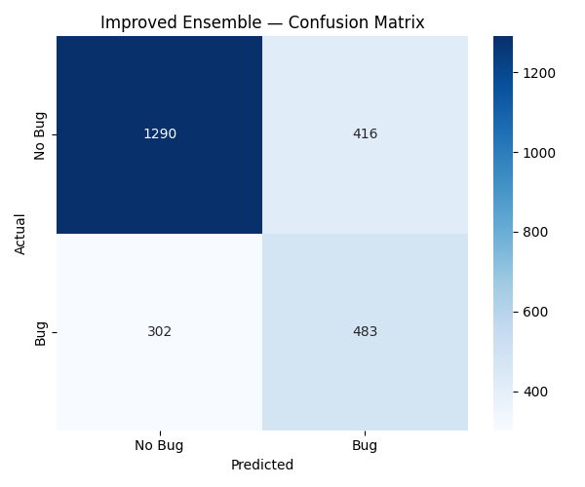
Figure 3: Bug Detection Model — Confusion Matrix (Correct vs Incorrect Predictions)

Reading this chart: The dark blue squares on the diagonal show correct predictions. Out of 1,290 "No Bug" cases, 1,290 were correctly identified. Out of 785 "Bug" cases, 483 were correctly found.

5.2 Model 2: Bug Type Classifier (What kind of bug is it?)

Simple Explanation
Once we know a bug exists, this model identifies WHAT TYPE it is.
Like a specialist doctor who identifies the specific illness.
4 Types: Crash Bug, Logical Bug, Performance Bug, UI Bug.

The 4 Bug Types:
- Crash Bug — The app will stop working or crash completely. Most serious.
- Logical Bug — The code gives a wrong answer or incorrect result.
- Performance Bug — The app runs very slowly or uses too much memory.
- UI Bug — Something looks wrong on the screen (display issue).

- Algorithm: Random Forest Classifier
- Accuracy: 99.09% — nearly perfect bug type classification!
- Training Data: 3,200 labeled examples (800 per bug type)

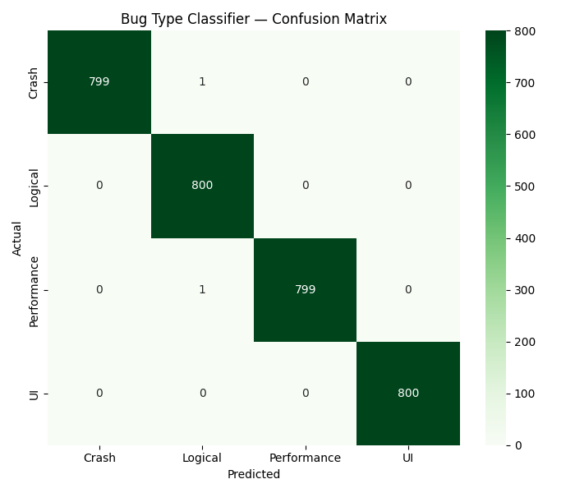
Figure 4: Bug Type Classifier — Confusion Matrix (Almost Perfect Classification)

Reading this chart: The dark green squares on the diagonal show correct predictions. Out of 800 Crash bugs, 799 were correctly identified. Out of 800 Logical bugs, 800 were identified. This is exceptional accuracy.

5.3 What the AI Looks At — Feature Importance

The AI does not look at all 35 measurements equally. Some measurements are much more important than others for detecting bugs:

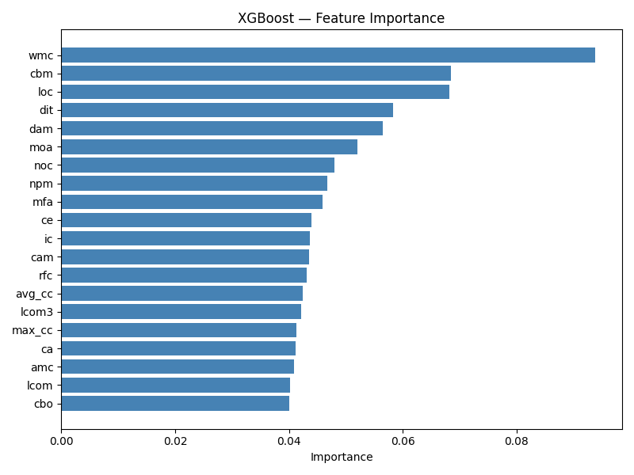
Figure 5: Feature Importance Chart — Which Code Measurements Matter Most

- WMC (Code Complexity) — The single most important signal. More complex code = higher bug risk.
- CBM & LOC (Size) — Larger code files tend to have more bugs.
- DIT (Inheritance Depth) — Deeply nested classes are harder to maintain and test.
- CBO (Dependencies) — Files that depend on many other files are riskier.

5.4 Model 3: Claude AI Enhancement (Optional)

What is Claude AI?
Claude is a powerful AI assistant made by Anthropic (a leading AI company).
We use the Claude Haiku version — fast, smart, and accurate.
It acts like a senior software engineer reviewing each bug in detail.

When "Claude AI Mode" is enabled in Settings, after our ML models find a bug, Claude AI adds:
- Enhanced Description — A clear, 2-sentence explanation of what the bug is and why it matters
- Technical Reason — Why the AI flagged this specific code section
- Corrected Code — The actual fixed version of the buggy line (real working code)
- Fix Explanation — What was changed and why (in 2-3 sentences)

How to use it: Go to Settings → Enable "Claude AI Mode" → Upload your file. Note: Analysis takes slightly longer when Claude AI Mode is enabled.

6. Platform Walkthrough — Screenshots

Here is a complete tour of every screen in the platform with explanations:

6.1 Login Screen

Figure 6: Login Screen
Users log in with their registered email and password. The platform uses bcrypt encryption to store passwords safely. There is also a "Forgot Password" feature that lets users reset their password using an OTP (One-Time Password) sent by email.

6.2 Signup Screen
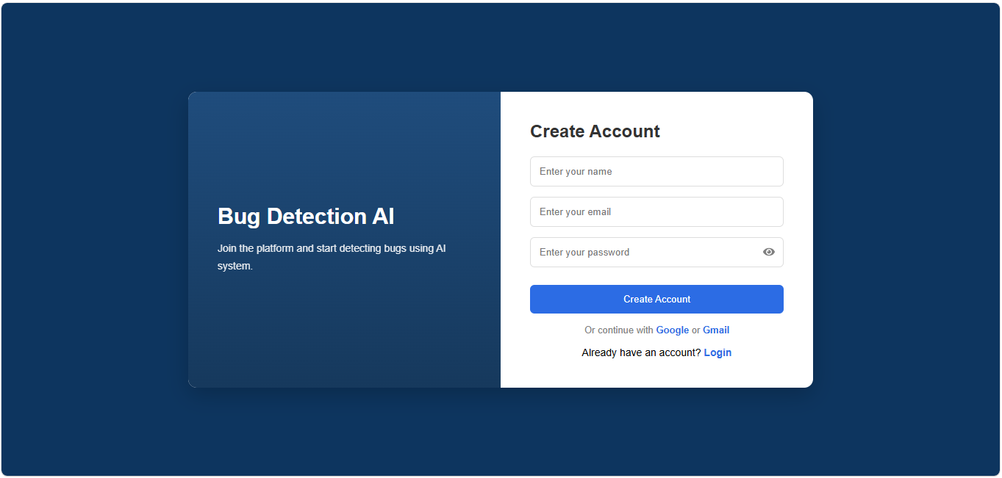
Figure 7: Signup / Create Account Screen
New users can create a free account by entering their name, email, and password. The system automatically assigns the role of "QA Engineer" to all new users.

6.3 Dashboard
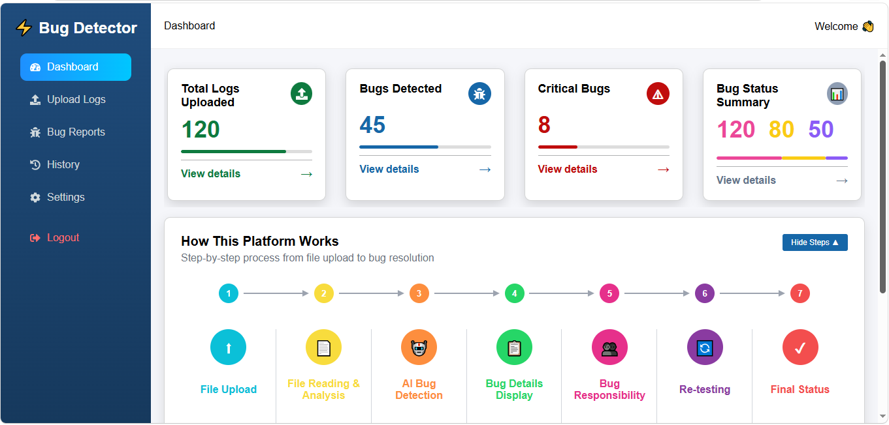
Figure 8: Main Dashboard — Statistics and Workflow Overview
The Dashboard is the main home screen. It shows 4 key statistics cards at the top: Total Logs Uploaded, Bugs Detected, Critical Bugs, and Bug Status Summary (Fixed / In-Progress / Pending). Below the cards, there is a step-by-step visual guide showing how the platform works.

6.4 Upload Files
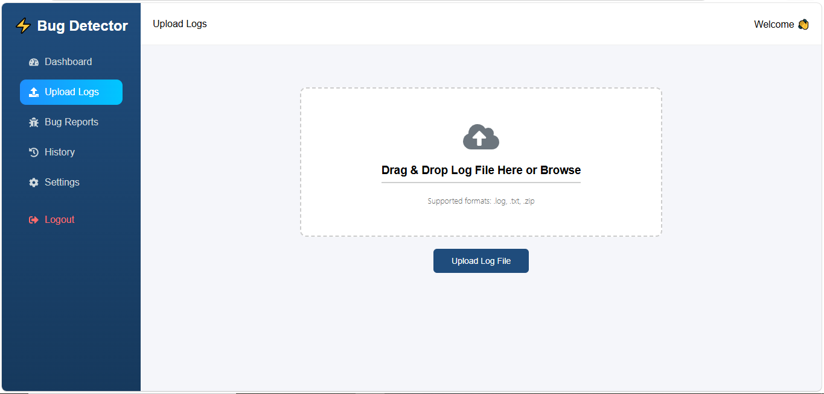
Figure 9: Upload Files Screen
Users upload their code files or log files here. They can drag and drop the file onto the upload area, or click to browse and select a file. Supported formats include Python (.py), Java (.java), JavaScript (.js), TypeScript (.ts), C/C++ (.cpp, .c), C# (.cs), Log files (.log, .txt), and ZIP archives (.zip) for entire project folders. Maximum file size is 50 MB.

6.5 Bug Reports
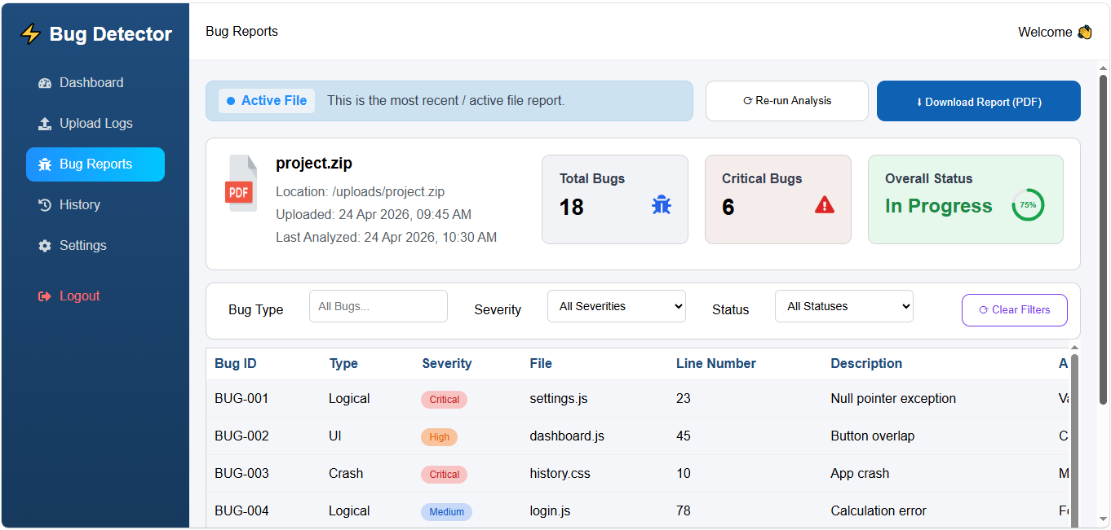
Figure 10: Bug Reports Screen — Overview

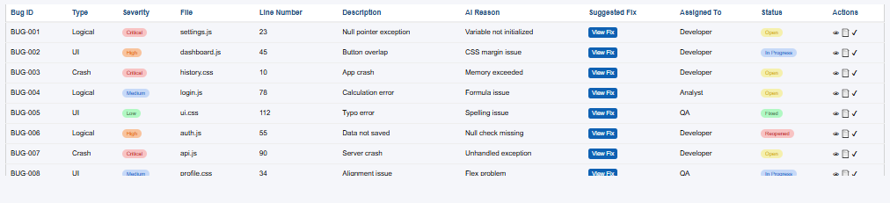
Figure 11: Bug Reports — Detailed Bug Table
The Bug Reports screen shows every bug found in the uploaded file. Each bug has a unique ID (BUG-001, BUG-002, etc.), its type (Logical / Crash / Performance / UI), severity level (Critical / High / Medium / Low), the file name and line number, a description of the bug, the AI's reason for flagging it, the suggested fix, who should fix it, and the current status.

Users can filter bugs by severity, type, or status. They can also update the bug status (Open → In Progress → Fixed) and download the full report as a PDF.

6.6 Analysis History
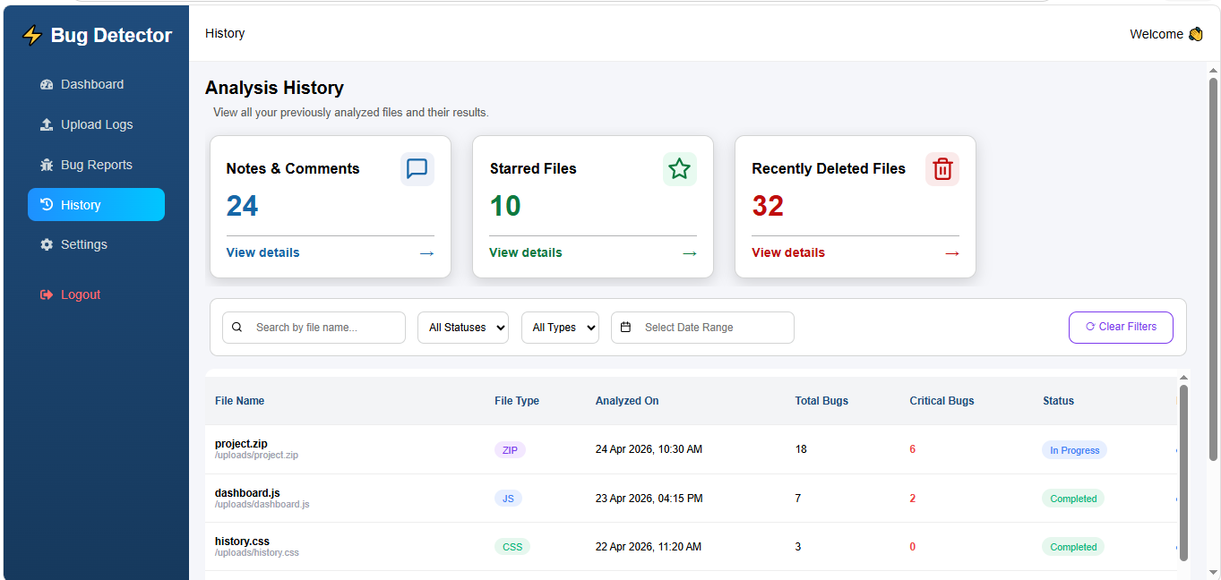
Figure 12: Analysis History Screen

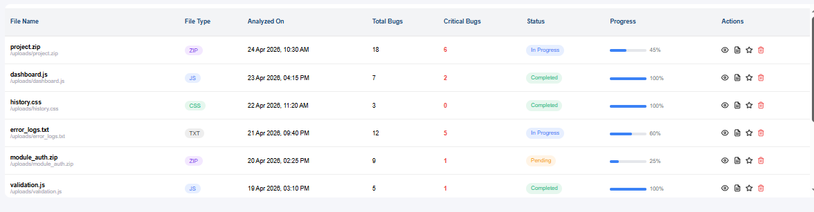
Figure 13: History — Detailed File List
The History screen keeps a complete record of every file that has been analyzed. For each file, it shows the file name, type, date analyzed, total bugs found, critical bugs, current status, and progress percentage. Users can star important analyses, delete old records, and search or filter by any criteria.

7. System Design Diagrams

The following diagrams show the technical design of our system. Each diagram is explained in simple language for non-technical readers:

7.1 Use Case Diagram — Who Uses the System?
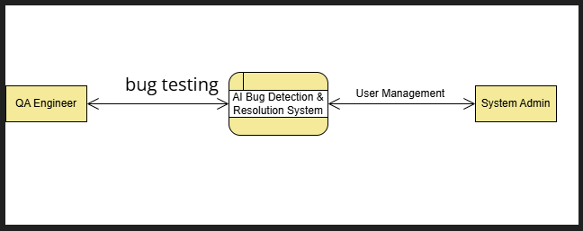
Figure 14: Use Case Diagram — System Users and Their Actions
This diagram shows the two types of users in our system and what each person can do:
- QA Engineer — The main user. They upload code files, view bug reports, update bug statuses, and manage their analysis history.
- System Admin — Manages user accounts and has access to system-wide activity reports.

7.2 Data Flow Diagram — How Data Moves
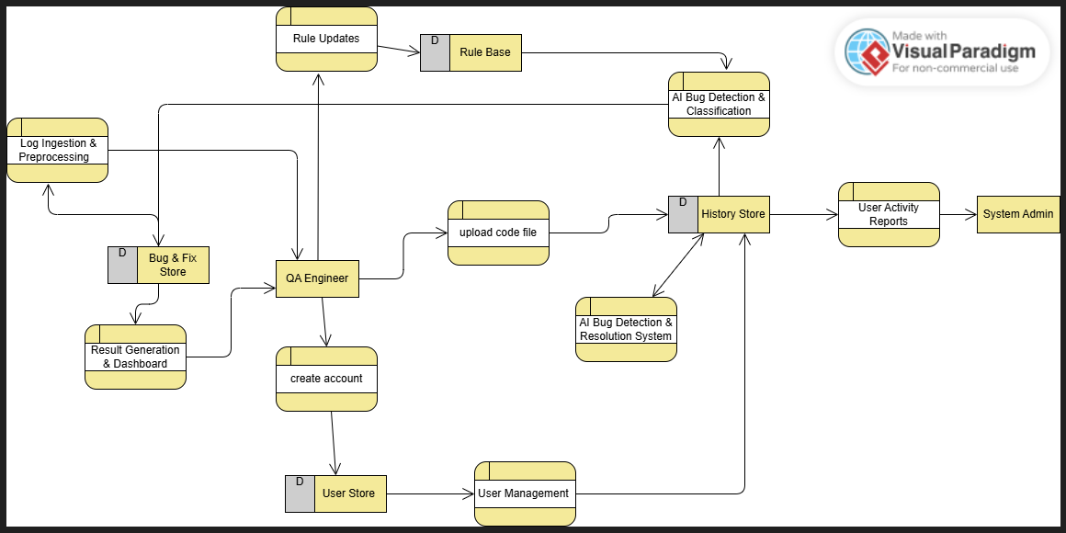
Figure 15: Data Flow Diagram (DFD) — Data Movement in the System
This diagram shows the path that data takes from when a user uploads a file to when they see their results:
- The QA Engineer uploads a code file and creates an account.
- The file goes through log ingestion and preprocessing.
- The AI Bug Detection system analyzes the file.
- Results are stored in the History Store database.
- The dashboard generates a report for the user.
- The System Admin can access activity reports.

7.3 Database Design (Entity-Relationship Diagram)
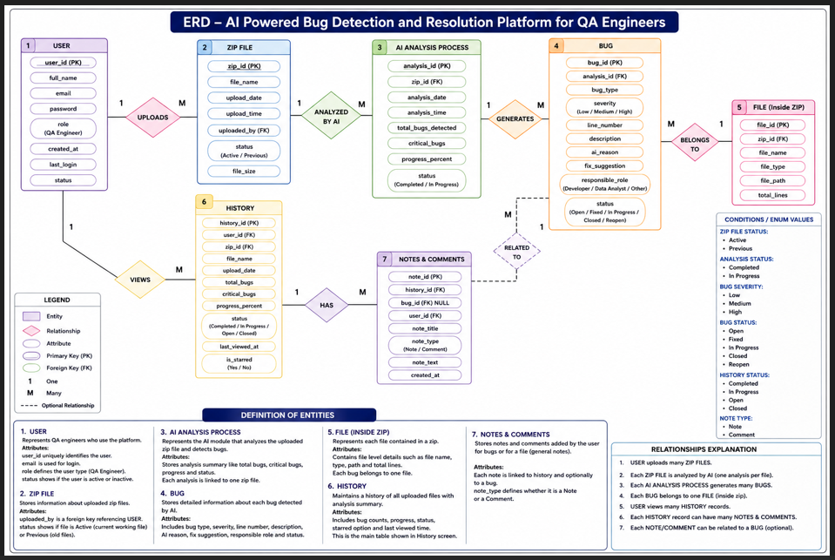
Figure 16: ERD — Database Structure
Our platform uses MongoDB (a flexible database) with 5 main data collections:
- Users — Stores: name, email, encrypted password, role, and account creation date.
- Uploads — Stores: every file uploaded (filename, size, type, upload date).
- Analysis — Stores: each analysis run with its status (queued / processing / completed / failed).
- Bugs — Stores: every bug found with full details (type, severity, file, line, description, fix, status).
- History — Stores: a summary record for each completed analysis, used for the History screen.

8. How to Run the Project Locally

Follow these steps exactly to run the Bug Detector platform on your computer:

Step 1: Install Required Software
Before anything else, install these free programs:
- Python 3.9 or newer — Download from: https://www.python.org/downloads/
- Node.js (v16 or newer) — Download from: https://nodejs.org/
- MongoDB Community Edition (free) — Download from: https://www.mongodb.com/try/download/community

Quick Check
After installing, open a terminal (Command Prompt on Windows) and type:
python --version (should show Python 3.9+)
node --version (should show v16+)
mongod --version (should show MongoDB version)

Step 2: Install Python Libraries (Backend)
- Open a terminal / Command Prompt
- Navigate to the "backend" folder: cd path/to/Bug Detector/backend
- Run: pip install -r requirements.txt
- Wait for all packages to install (takes 1-3 minutes)

Step 3: Install Frontend Libraries
- Open a new terminal
- Navigate to the React app folder: cd path/to/bug-detector1_extracted/bug-detector
- Run: npm install
- Wait for all packages to install (takes 1-5 minutes)

Step 4: Start MongoDB Database
- Open a terminal and start MongoDB by running: mongod
- Leave this terminal window open. MongoDB runs in the background.
- The database will be created automatically when you first use the platform.

Step 5: Start the Backend Server
- Open a terminal in the "backend" folder
- Run: python app.py
- You should see: "Backend running on http://localhost:5000"
- Leave this terminal window open.

Step 6: Start the Frontend Website
- Open a terminal in the "bug-detector" folder
- Run: npm start
- The website will automatically open in your browser at: http://localhost:3000

Step 7: Use the Platform
- The browser will open to the Login screen
- Click "Sign Up" to create a new account
- Login with your new account
- Go to "Upload Logs" to upload a code file
- Wait for the analysis to complete
- Go to "Bug Reports" to see the results

Important Notes
Always start MongoDB FIRST, then the backend, then the frontend.
Keep all three terminal windows open while using the platform.
If you change settings, restart the backend server.
Claude AI Mode requires an API key in the backend/.env file.

9. Future Plans — What We Plan to Build Next

The current platform is fully functional. However, we have planned several enhancements to make it even more powerful:

- Cloud Deployment
- Make the platform available online so anyone can use it without local installation.
- Deploy on platforms like AWS, Azure, or Google Cloud.

- Email Notifications
- Automatically email developers when new critical bugs are found in their code.
- Send weekly bug status summary reports.

- GitHub Integration
- Connect directly to GitHub repositories for automatic scanning on every code push.
- Integrate with CI/CD pipelines for continuous bug detection.

- Mobile App
- A mobile app for iOS and Android to view bug reports from your phone.
- Push notifications for critical bugs.

- Support for More Programming Languages
- Currently supports: Python, Java, JavaScript, TypeScript, C, C++, C#.
- Planned: PHP, Ruby, Swift, Kotlin, Go, Rust.

- Advanced Analytics Dashboard
- Charts and graphs showing bug trends over time.
- Team-level reports: which developer has the most bugs?

- More Powerful AI Models
- Retrain models with larger datasets for even higher accuracy.
- Integrate GPT-4 or Claude Opus for even smarter bug explanations.

