TOPIC: AI POWERED BUG DETECTION AND RESOLUTION PLATFORM FOR QA ENGINEERS
INTRODUCTION:
The AI Powered Bug Detection and Resolution Platform for QA Engineers is an intelligent web-based system designed to automate the process of software bug detection, analysis, classification, and resolution. In modern software development, Quality Assurance (QA) engineers spend a significant amount of time manually identifying bugs, analyzing errors, preparing reports, and communicating issues to development teams. This manual process can be time-consuming, complex, and less efficient when handling large software projects. To solve these challenges, this platform introduces Artificial Intelligence (AI) based automation for detecting and managing software bugs more accurately and efficiently.
The platform allows QA engineers to create an account, log in securely, and upload project ZIP files containing source code and related project files. After uploading the file, the system automatically analyzes the code using AI techniques and detects potential bugs within the project. The AI engine identifies different types of bugs, their severity levels, and the exact line numbers where issues occur. In addition, the system provides detailed descriptions explaining why a bug occurred and also generates fix suggestions to help developers resolve issues quickly.
One of the major features of the platform is the generation of a complete bug report. The report contains important information such as bug ID, bug type, severity level, affected file name, line number, AI-generated reason, fix suggestions, responsible role, and current bug status. The system can also identify which team member or department may be responsible for the issue, such as developers, data analysts, or other related roles. This improves communication and accountability within software development teams.
Overall, the AI Powered Bug Detection and Resolution Platform enhances software testing by reducing manual effort, improving bug detection accuracy, and providing intelligent fix recommendations. The system helps QA engineers manage software quality more effectively while saving time and increasing productivity in the software development lifecycle.

FRONTEND DESIGN:
Login screen:
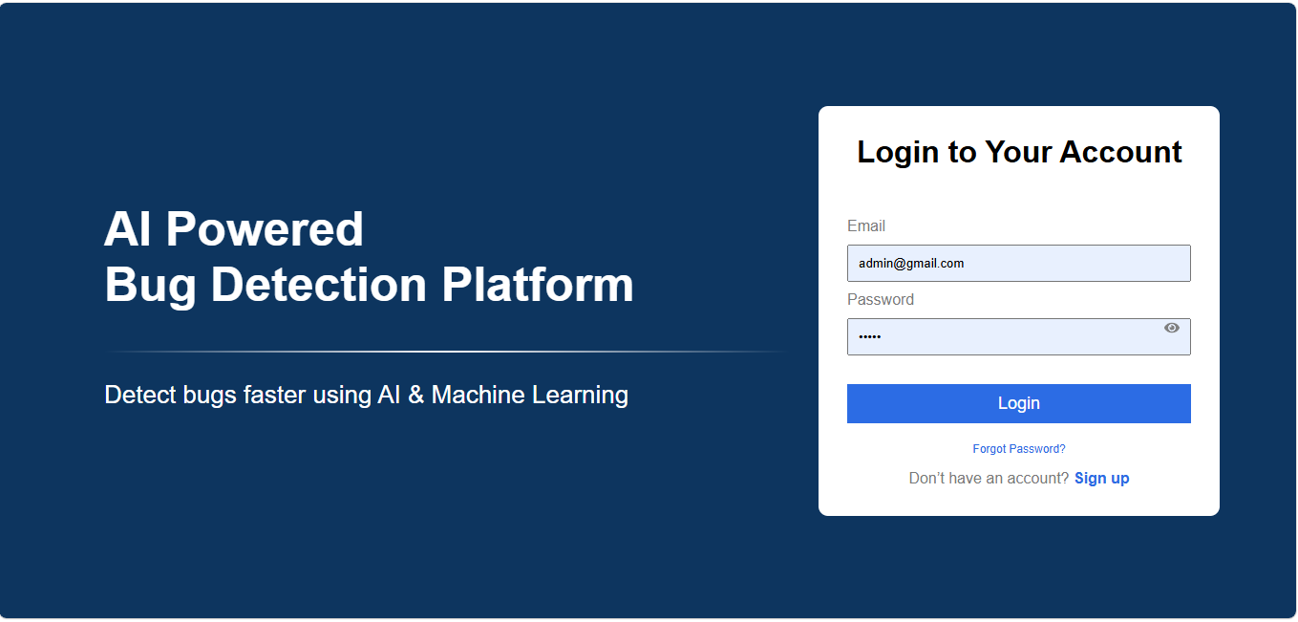
Signup screen:
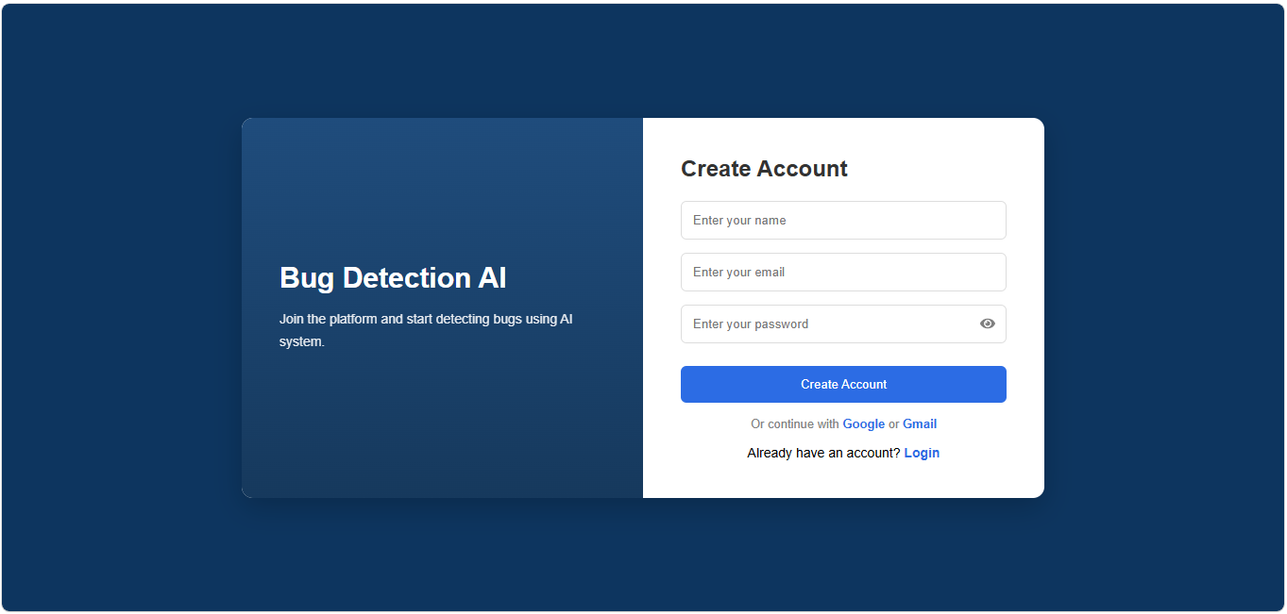

Dashboard screen:
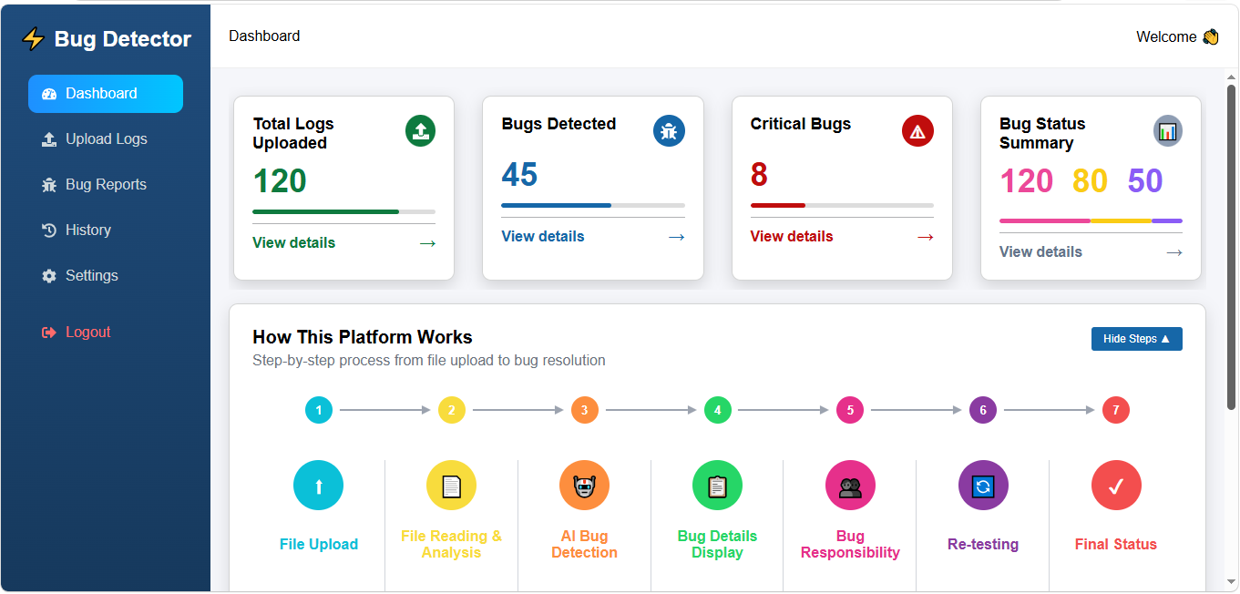
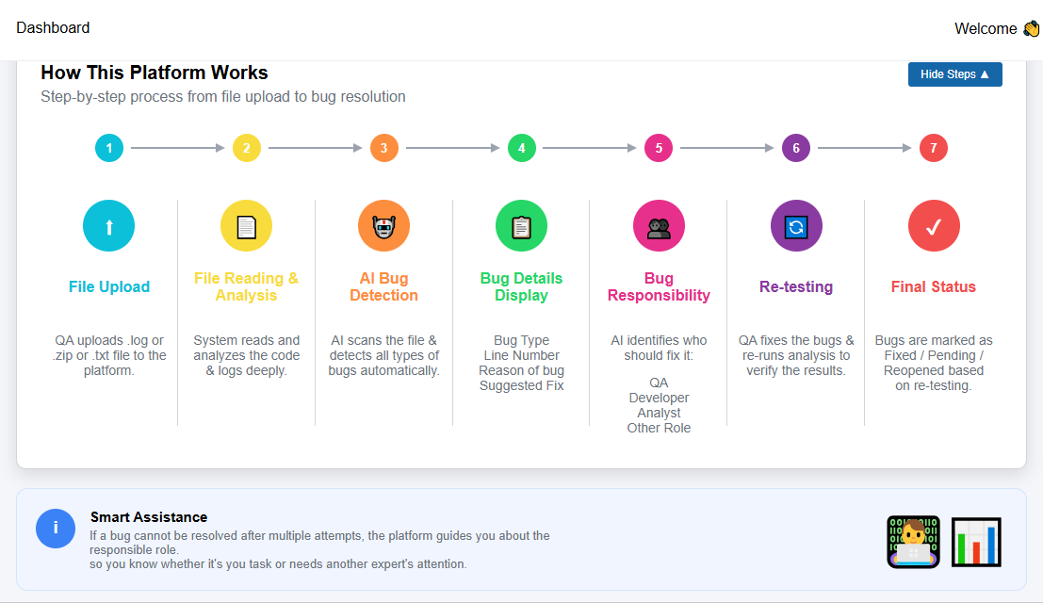

Upload screen:
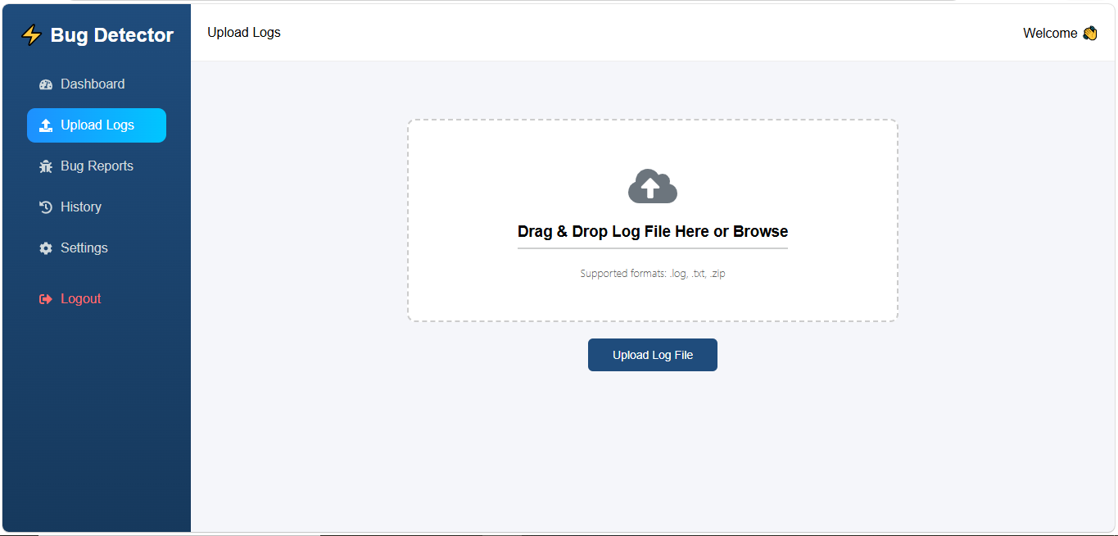
Bug Report screen:
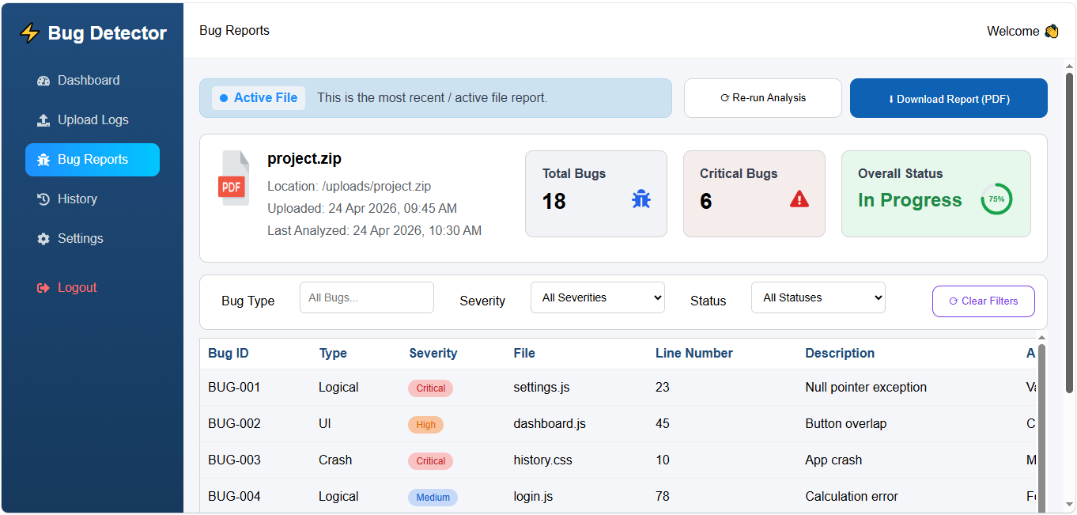
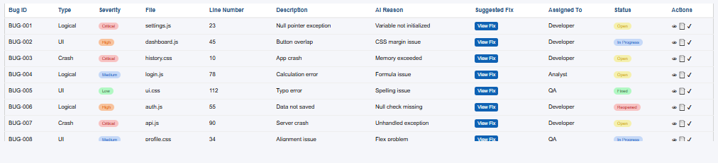
History screen:
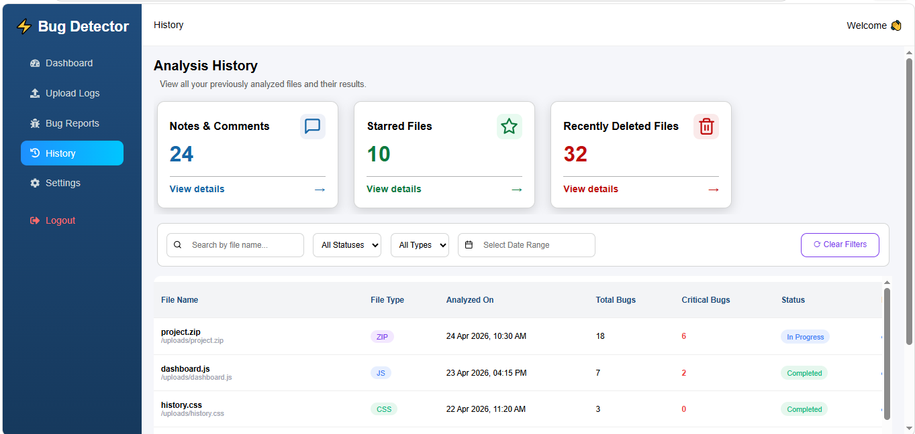
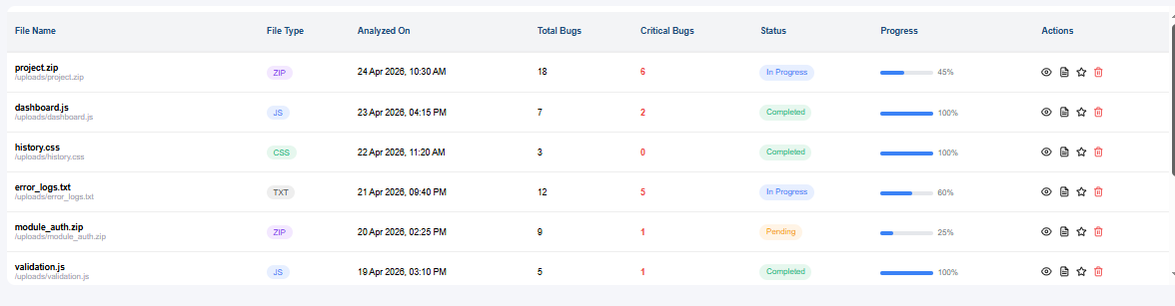

ERD DIAGRAM:
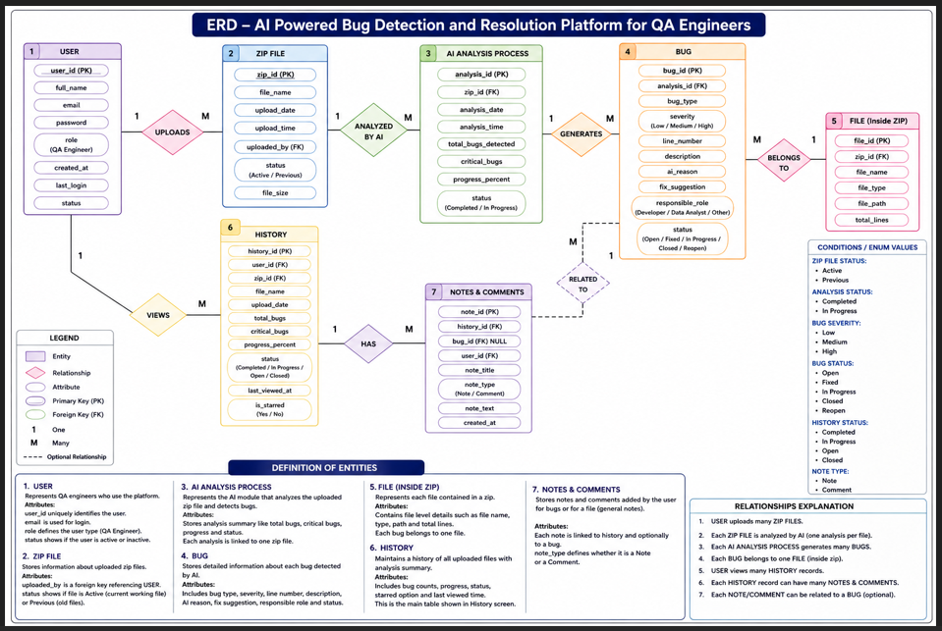
DFD LEVEL 0:
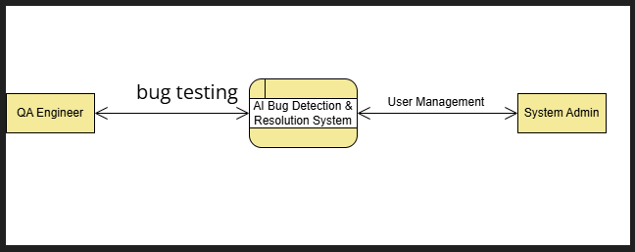
This diagram represents the Level 0 Data Flow Diagram (DFD), also known as the Context Diagram, for the AI Powered Bug Detection & Resolution Platform for QA Engineers.
The diagram provides a high-level overview of the entire system and shows how external entities interact with the main system.

✅ DFD Method Used
This DFD uses the:
Gane & Sarson DFD Method
because:
- the main process is represented using a rounded rectangle
- external entities are shown using rectangles
- arrows represent data flow between entities and the system
This notation is commonly used in structured system analysis and software engineering documentation.

🔷 Definition of the DFD
1. QA Engineer (External Entity)
Represents the main user of the platform.
The QA Engineer interacts with the system to:
- upload project or zip files
- perform bug testing
- view bug reports
- receive AI-generated fix suggestions
The data flow labeled “bug testing” represents the interaction between the QA Engineer and the AI system for bug analysis and testing.

🔷 2. AI Bug Detection & Resolution System (Main Process)
This is the core process of the platform.
The system performs:
- AI-based bug detection
- code analysis
- bug classification
- severity identification
- fix suggestion generation
- bug report creation
It acts as the central processing unit of the entire platform.

🔷 3. System Admin (External Entity)
Represents the administrator of the platform.
The admin interacts with the system for:
- user management
- monitoring activities
- supervising system operations
- managing platform functionality
The data flow labeled “User Management” shows the communication between the AI system and the System Administrator.

✅ Overall Working of the System
- The QA Engineer sends files and testing requests to the AI Bug Detection & Resolution System.
- The system analyzes the uploaded code using AI techniques.
- Bugs and fixes are generated automatically.
- The System Admin manages users and oversees system operations.

✅ Conclusion
This Level 0 DFD provides a simplified overview of the AI-powered platform by showing:
- the main system,
- the external users,
- and the primary data interactions.
It helps in understanding the overall functionality of the system before moving to detailed Level 1 DFD processes.
DFD LEVEL 1:
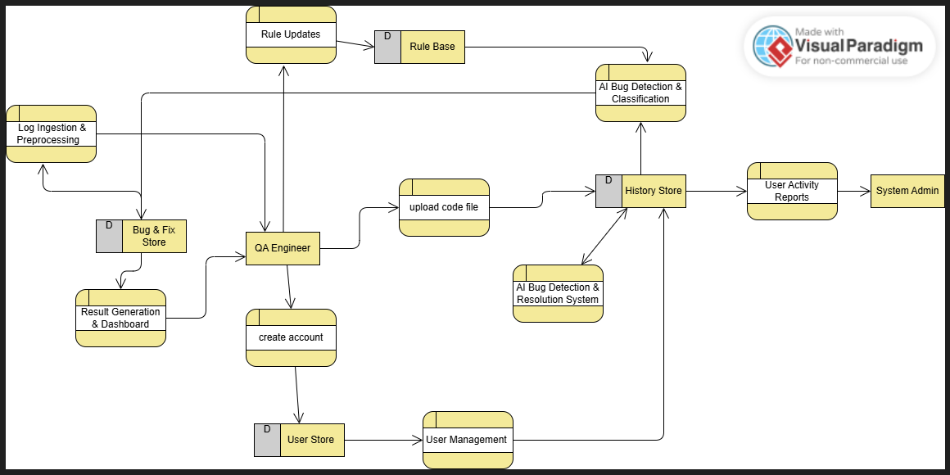
This diagram represents the Data Flow Diagram (DFD) of the AI Powered Bug Detection & Resolution Platform for QA Engineers.
The DFD shows how data moves between users, processes, and data stores inside the system.
The diagram uses the:
✅ Gane & Sarson DFD Method (Structured Analysis Method)
because:
- Processes are shown with rounded rectangles
- Data stores are shown using open-ended rectangles with “D”
- Arrows represent data flow
- External entities interact with the system processes
This is a very commonly used professional DFD notation in software engineering.

🔷 Definition of the Complete DFD
1. QA Engineer (External Entity)
Represents the user of the system.
The QA Engineer:
- creates an account
- uploads zip/code files
- views bug reports
- checks AI generated fixes
- monitors dashboard results
The QA Engineer is the main actor interacting with the platform.

🔷 2. Create Account (Process)
This process handles:
- user registration
- login/signup information
- account creation
The entered user information is stored in the User Store.

🔷 3. User Store (Data Store)
Stores all user-related information such as:
- user ID
- name
- email
- password
- role
This database is used for authentication and user management.

🔷 4. User Management (Process)
Handles:
- user authentication
- account management
- user activity handling
It communicates with the History Store to maintain user activities.

🔷 5. Upload Code File (Process)
This process allows the QA Engineer to upload:
- zip files
- project files
- source code files
The uploaded file is then sent for AI analysis and stored in history.

🔷 6. AI Bug Detection & Resolution System (Process)
This is the core AI module of the platform.
The system:
- analyzes uploaded files
- detects bugs automatically
- identifies bug severity
- finds line numbers
- generates bug descriptions
- suggests fixes
- identifies responsible roles
The generated results are stored in the History Store.

🔷 7. History Store (Data Store)
Stores:
- uploaded files history
- bug reports
- analysis summaries
- fixes
- user activities
This helps users revisit previous reports and project analyses.

🔷 8. AI Bug Detection & Classification (Process)
This process classifies detected bugs into categories such as:
- Low
- Medium
- High severity
It also organizes bugs according to their type and status.
The process uses rules from the Rule Base.

🔷 9. Rule Base (Data Store)
Contains predefined AI rules and logic for:
- bug detection
- classification
- analysis behavior
The AI system uses these rules during file analysis.

🔷 10. Rule Updates (Process)
Updates and maintains the Rule Base.
This ensures:
- AI logic remains updated
- detection accuracy improves
- new bug patterns can be added

🔷 11. Bug & Fix Store (Data Store)
Stores:
- detected bugs
- AI generated fixes
- bug solutions
This data is later used in dashboards and reports.

🔷 12. Log Ingestion & Preprocessing (Process)
Handles:
- preprocessing uploaded logs/files
- cleaning and preparing data
- extracting useful information before AI analysis
This improves bug detection accuracy.

🔷 13. Result Generation & Dashboard (Process)
Generates:
- dashboard cards
- bug statistics
- progress reports
- critical bug counts
- summaries
The QA Engineer views these results on the dashboard.

🔷 14. User Activity Reports (Process)
Generates reports related to:
- user activities
- uploads
- bug handling
- system usage
These reports are useful for monitoring and management.

🔷 15. System Admin (External Entity)
Represents the administrator.
The admin:
- monitors reports
- manages system activities
- supervises user actions

✅ Overall Working of the System
- QA Engineer creates an account
- User uploads a zip/code file
- File is preprocessed
- AI analyzes the file
- Bugs are detected and classified
- Fix suggestions are generated
- Reports are stored in history
- Dashboard displays results
- Admin monitors activity reports

✅ Conclusion
This DFD clearly explains how the AI-powered platform:
- receives uploaded files,
- processes them using AI,
- detects and classifies bugs,
- stores analysis history,
- and generates dashboards and reports for QA Engineers and administrators.

