**proga.cpp**

**Фунция main**

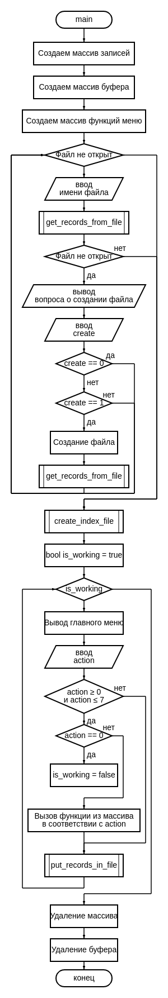

**train_func.cpp**

**Ф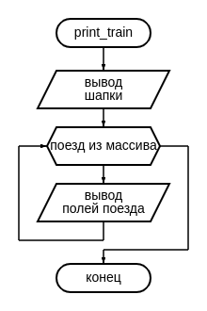ункция print_train**

**Функция delete_train**

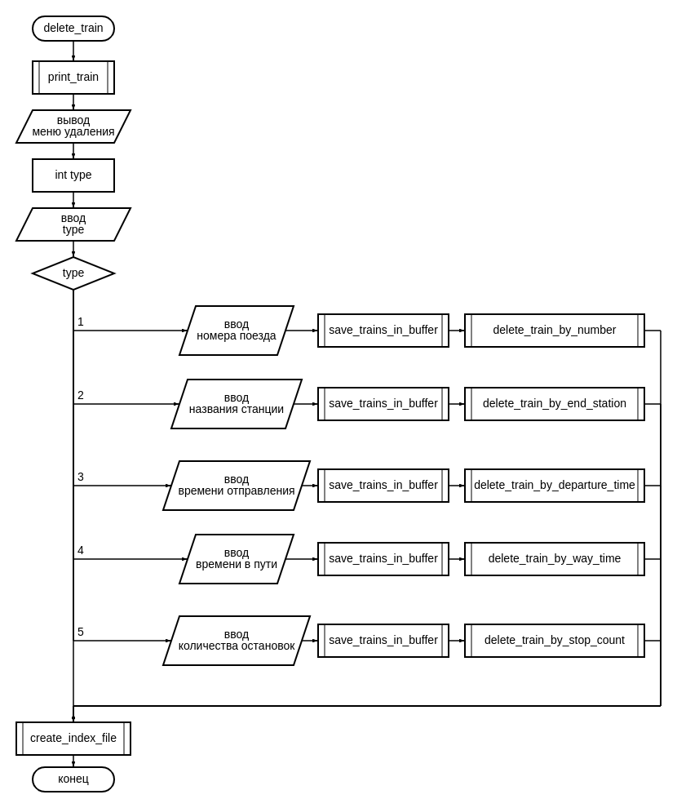

**Функция add_train**

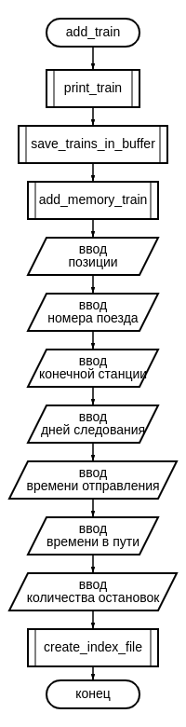

**Функция sort_train**

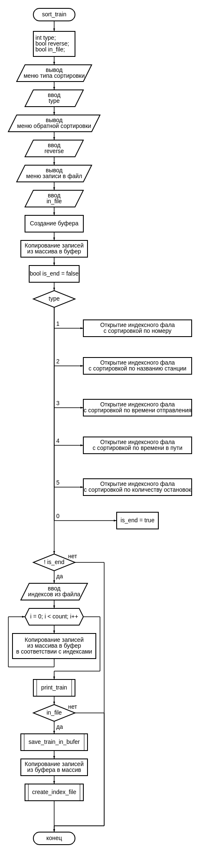

**Функция change_train**

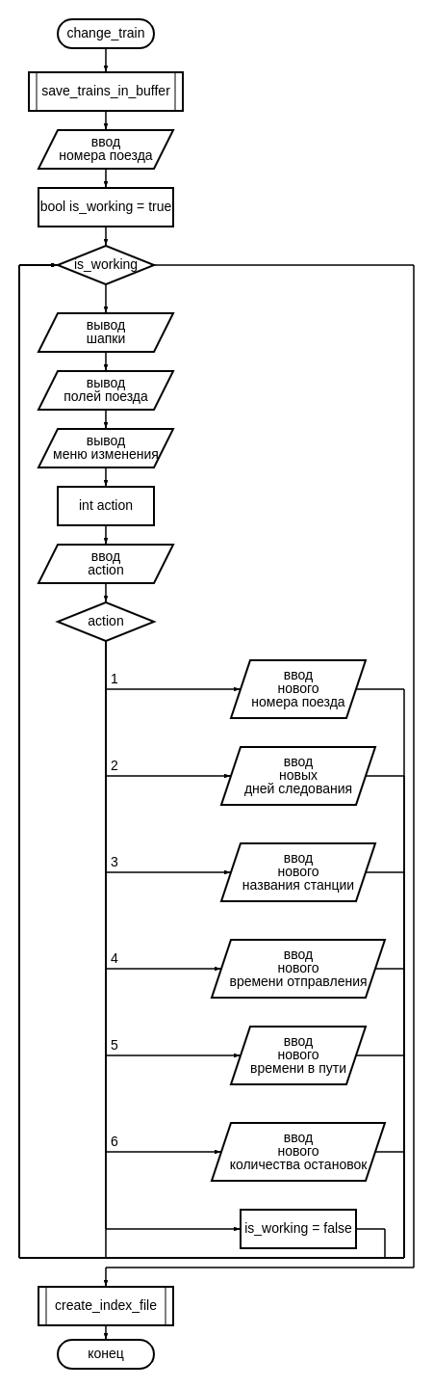

**Функция select_train**

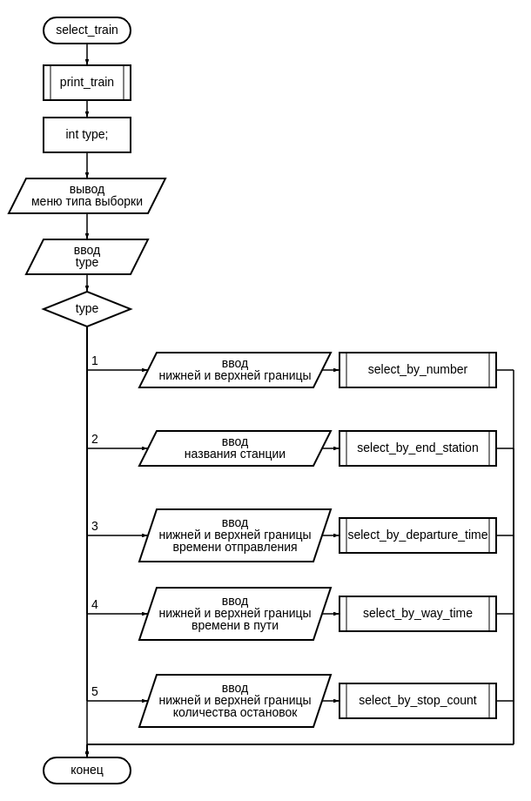**Функция undo_train**

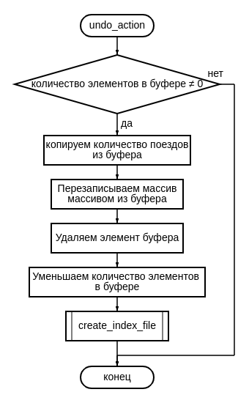

**config_func.cpp**

**Функция add_memory_train**

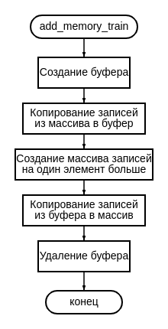

**Функция sub_memory_train**

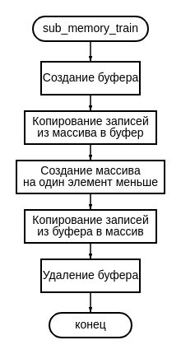

**Функция save_trains_in_buffer**

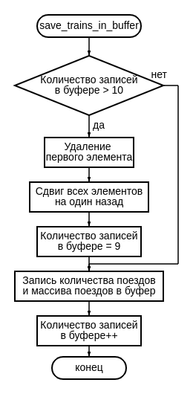

**delete_func.cpp**

**Функция delete_train_by_number**

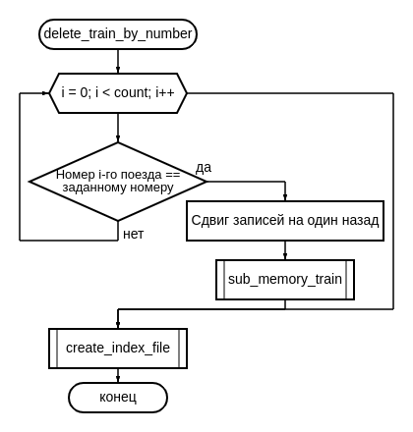**Функция delete_train_by_end_station**

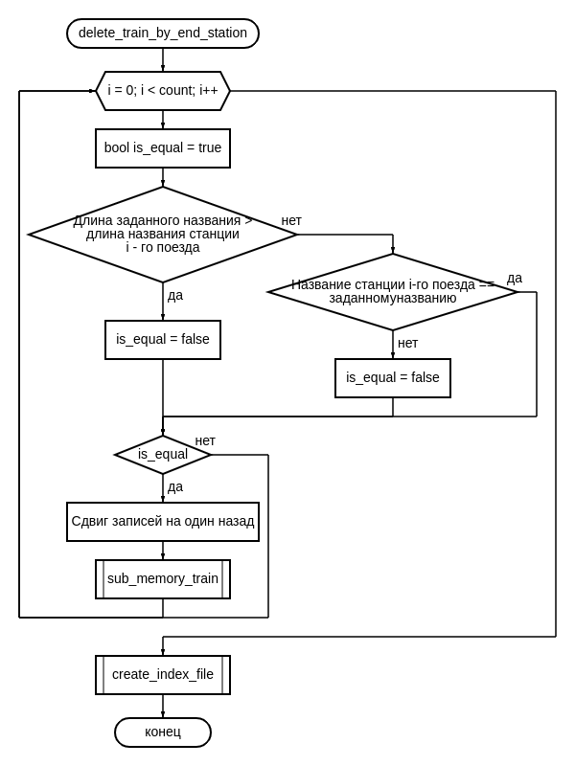

**Функция delete_train_by_departure_time**

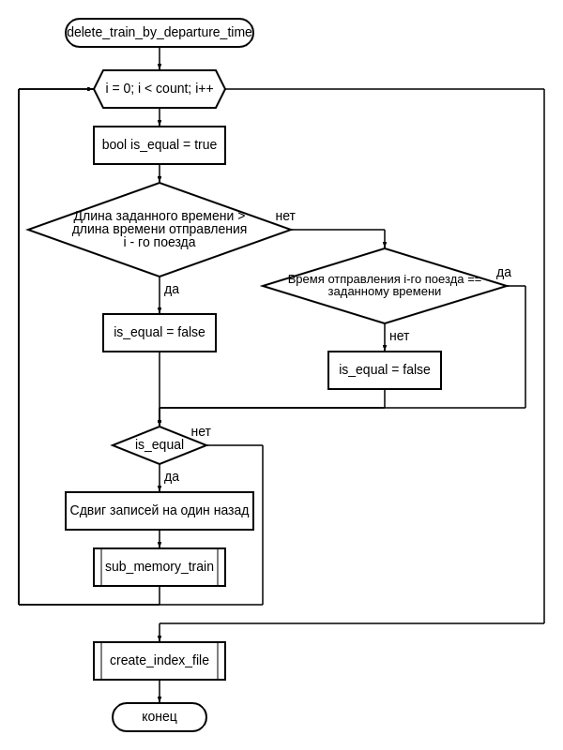**Функция delete_train_by_way_time**

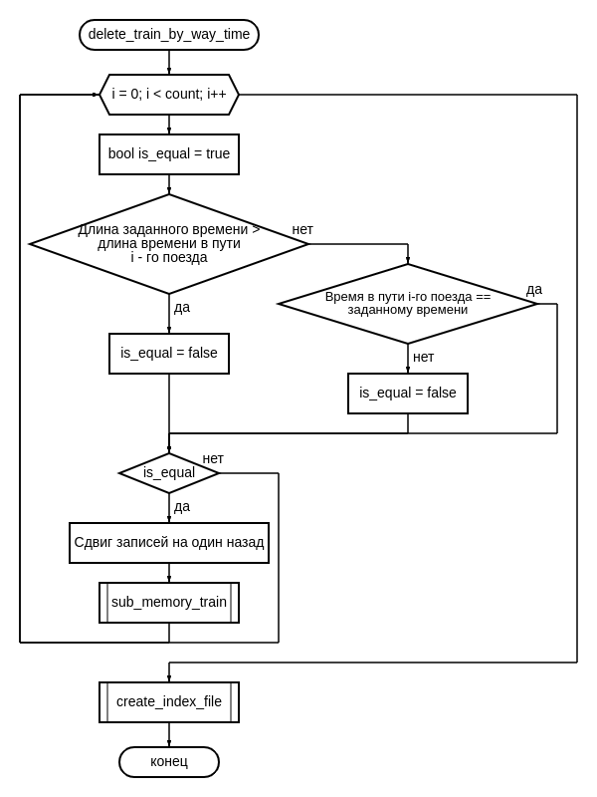

**Функция delete_train_by_stop_count**

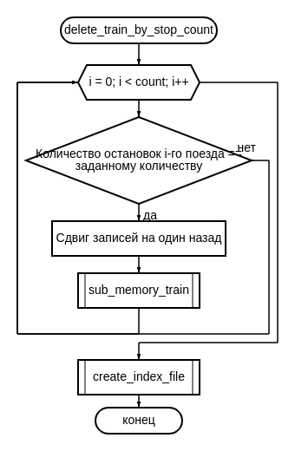

**select_func.cpp**

**Функция select_by_number**

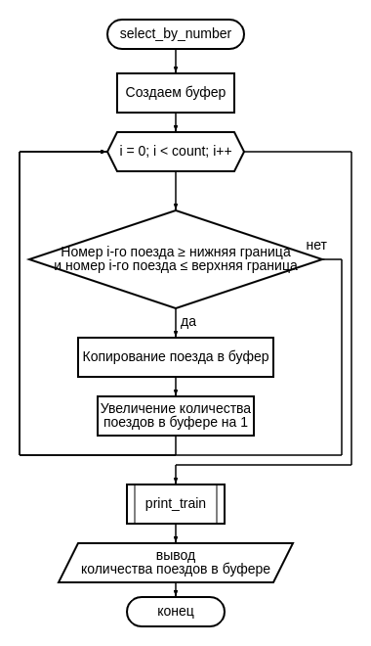**Ф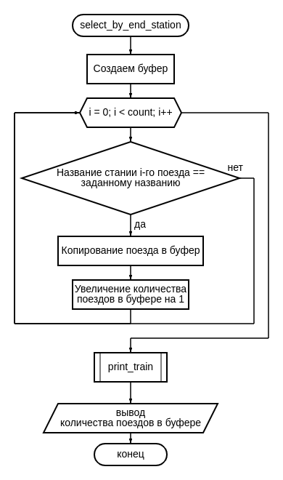ункция select_by_end_station**

**Функция select_by_departure_time**

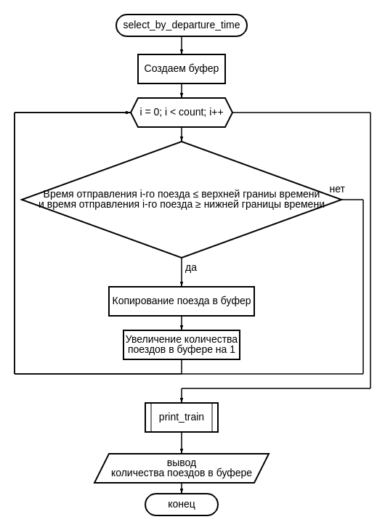**Функция select_by_way_time**

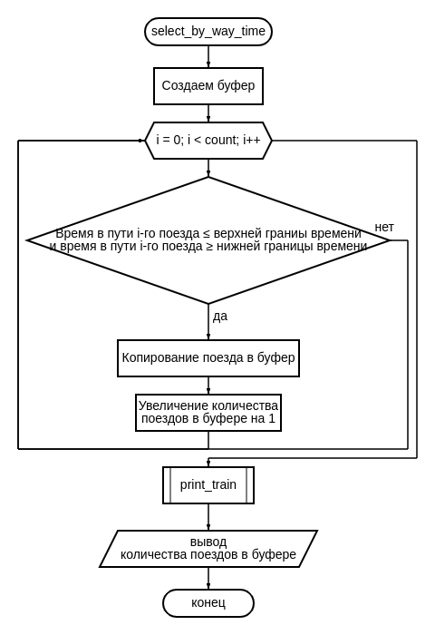

**Функция select_by_stop_count**

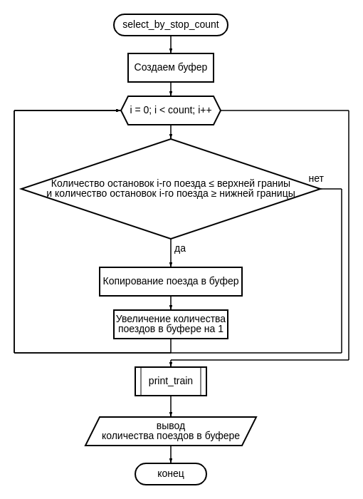

**sort_func.cpp**

**Функция number_sort**

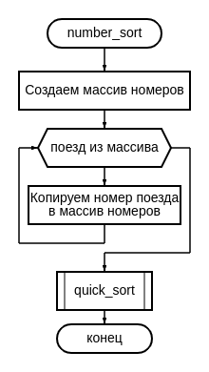

**Функция end_station_sort**

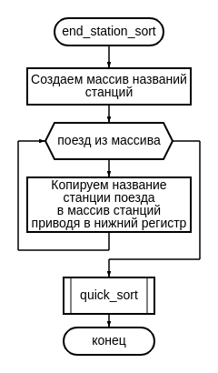

**Функция departure_time_sort**

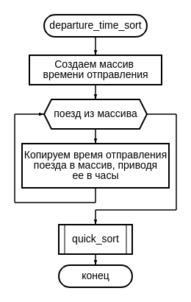

**Функция way_time_sort**

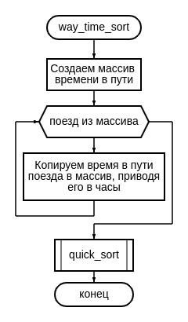

**Функция stop_count_sort**

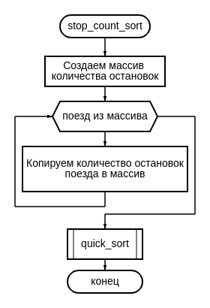**Функция quick_sort**

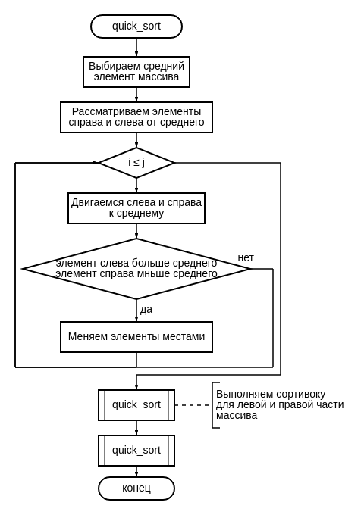

**file.cpp**

**Функция get_records_from_file**

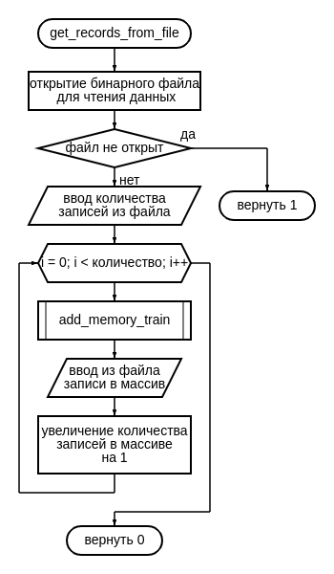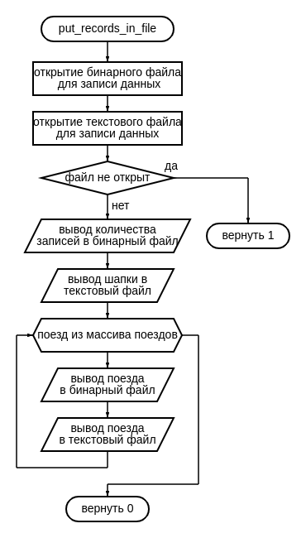**Функция put_records_in_file**

**Функция create_index_file**

