
An-Najah National University
Computer Engineering Department
Distributed Operating Systems
Bazar Bookstore Project
Lab 1 Report: Multi-tier Online Book Store
Prepared by:
Hoor Yaish
Deema Hazeem
2026

1. Introduction
This report describes the implementation of Part 1 of the Bazar Bookstore project for the Distributed Operating Systems course. The goal of Part 1 was to build a small online bookstore using a multi-tier microservices architecture. The system consists of a frontend service, a catalog service, and an order service. All services communicate using REST API calls, and persistent data is stored using SQLite databases.
The bookstore supports three main user operations: searching books by topic, requesting information about a book by item number, and purchasing a book. The implementation was containerized using Docker and managed using Docker Compose.
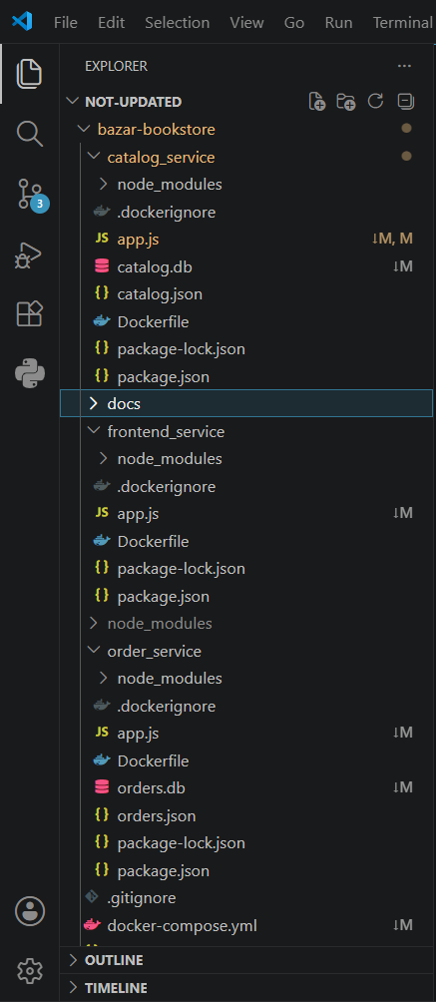
Figure 1: Project hierarchy showing the frontend, catalog, and order services.

2. System Architecture
The Part 1 system contains three main services:
Service | Responsibility | Port
Frontend service | Receives client requests and forwards them to the correct backend service. | 5000
Catalog service | Stores book information and supports search, info, and update operations. | 5001
Order service | Handles purchase requests and stores order records. | 5002

The request flow is simple and follows the multi-tier model:
Client -> Frontend Service -> Catalog Service / Order Service
GET /search/:topic -> Frontend -> Catalog
GET /info/:id -> Frontend -> Catalog
POST /purchase/:id -> Frontend -> Order -> Catalog

3. Technologies Used
Technology | Use in the Project
Node.js | Runtime environment for the services.
Express.js | Creating REST API endpoints.
Axios | Sending HTTP requests between services.
SQLite | Persistent storage for catalog and order data.
Docker | Containerizing each service.
Docker Compose | Building and running the three containers together.
Postman / Browser | Testing the REST API endpoints.

4. Service Implementation

4.1 Frontend Service
The frontend service is the entry point of the system. It exposes endpoints to the client and forwards requests to either the catalog service or the order service. It does not access the database directly. This separation keeps the frontend lightweight and follows the microservices design.
Endpoint | Method | Purpose
/search/:topic | GET | Forward a search request to the catalog service.
/info/:id | GET | Forward a book information request to the catalog service.
/purchase/:id | POST | Forward a purchase request to the order service.

4.2 Catalog Service
The catalog service maintains the bookstore catalog. It stores each book with its item number, title, topic, price, and available quantity. The service creates the books table if it does not already exist and inserts the initial four books required for Part 1.
Endpoint | Method | Purpose
/search/:topic | GET | Return all books that match a topic.
/info/:id | GET | Return title, quantity, and price for a book.
/update/:id | PUT | Update the quantity or price of a book.

4.3 Order Service
The order service handles purchase requests. When a purchase request is received, it first asks the catalog service for the book information. If the item is in stock, the order service calls the catalog update endpoint to decrease the quantity by one and then stores the order in the orders database.
Purchase flow:
1. Receive POST /purchase/:id
2. Query catalog service using GET /info/:id
3. Check if quantity > 0
4. Decrement quantity using PUT /update/:id
5. Insert the order into SQLite
6. Return a success message

5. Data Persistence
Persistent storage was implemented using SQLite. The catalog service stores book information in catalog.db, and the order service stores purchase records in orders.db. This ensures that catalog and order data are maintained on disk instead of being stored only in memory.
Database | Used By | Stored Data
catalog.db | Catalog service | Book id, title, topic, price, and quantity.
orders.db | Order service | Order id, item id, title, and purchase time.

6. Docker Deployment
Each service was containerized using a Dockerfile. Docker Compose was used to build and run the three containers together. All containers were connected to the same Docker bridge network so that the services could communicate using their service names.
docker compose down --remove-orphans
docker compose up --build
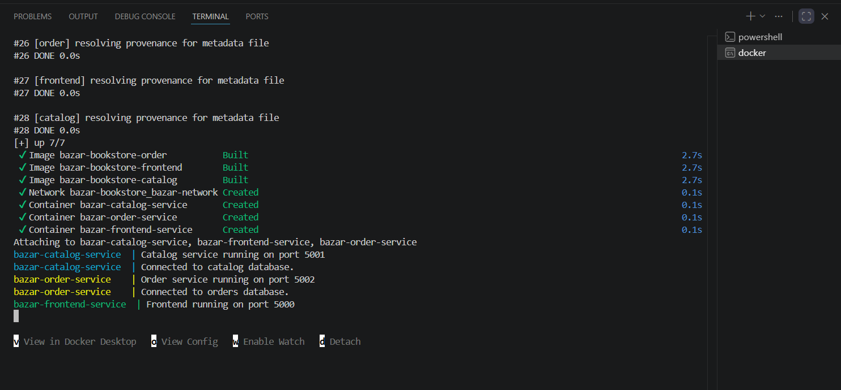
Figure 2: Terminal output showing that the three Lab 1 services started successfully.
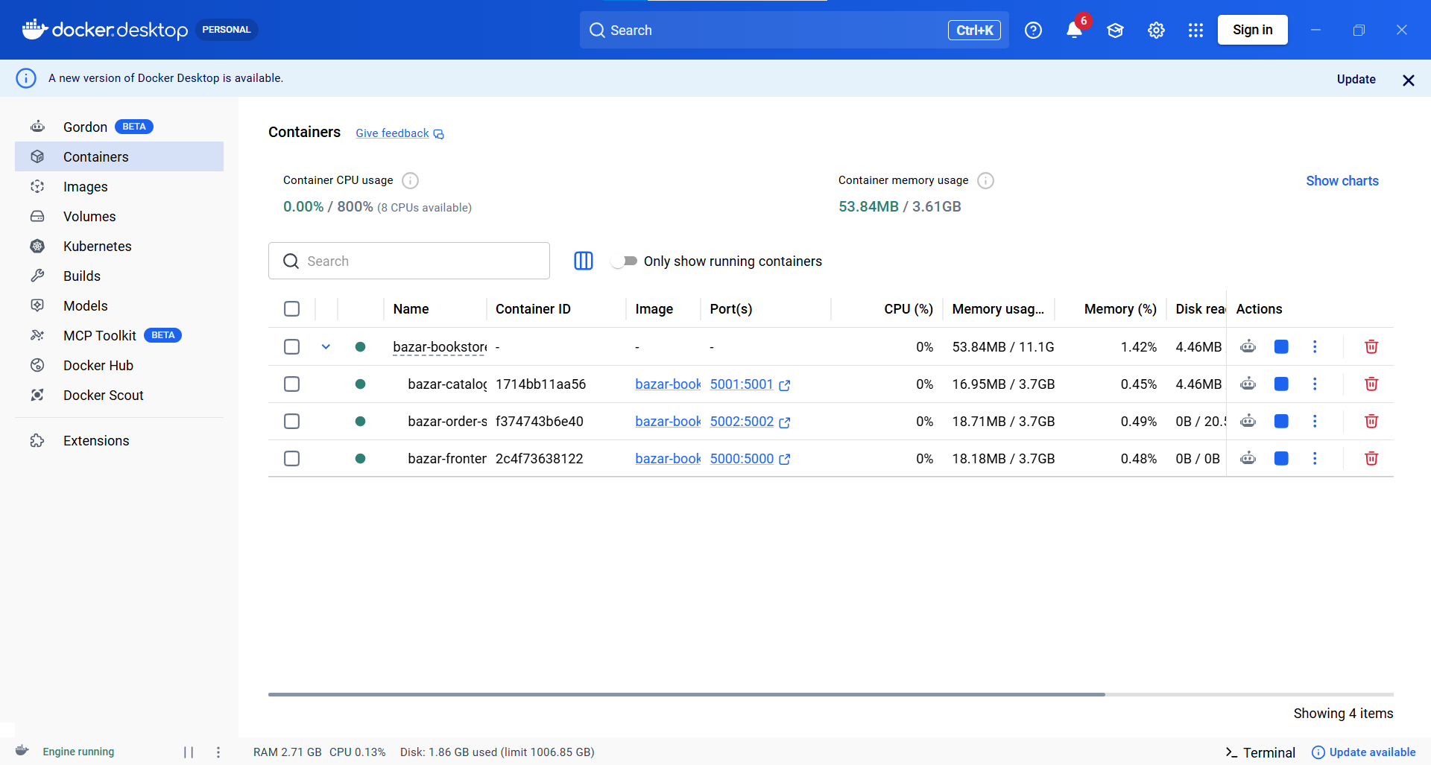
Figure 3: Docker Desktop showing the three Part 1 containers running.

7. Testing and Output
The system was tested using Postman and Docker logs. The tests demonstrate that search, info, and purchase operations work correctly, and that a successful purchase decreases the book quantity.

7.1 Search Request
The search request returns all books that belong to the distributed systems topic.
GET http://localhost:5000/search/distributed%20systems
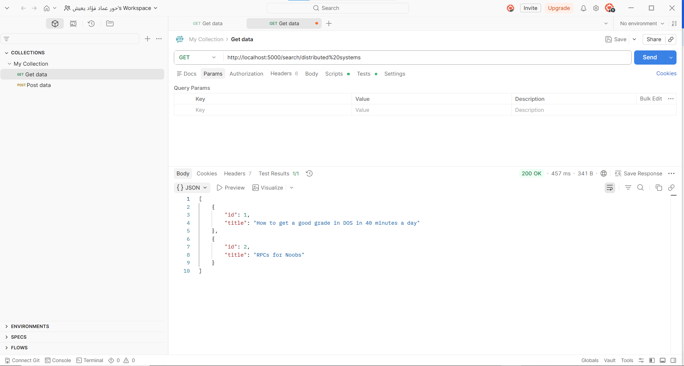
Figure 4: Search request returning books from the distributed systems topic.

7.2 Info Request Before Purchase
The info request returns the details of a book using its item number. In this test, item 2 had quantity 5 before the purchase.
GET http://localhost:5000/info/2
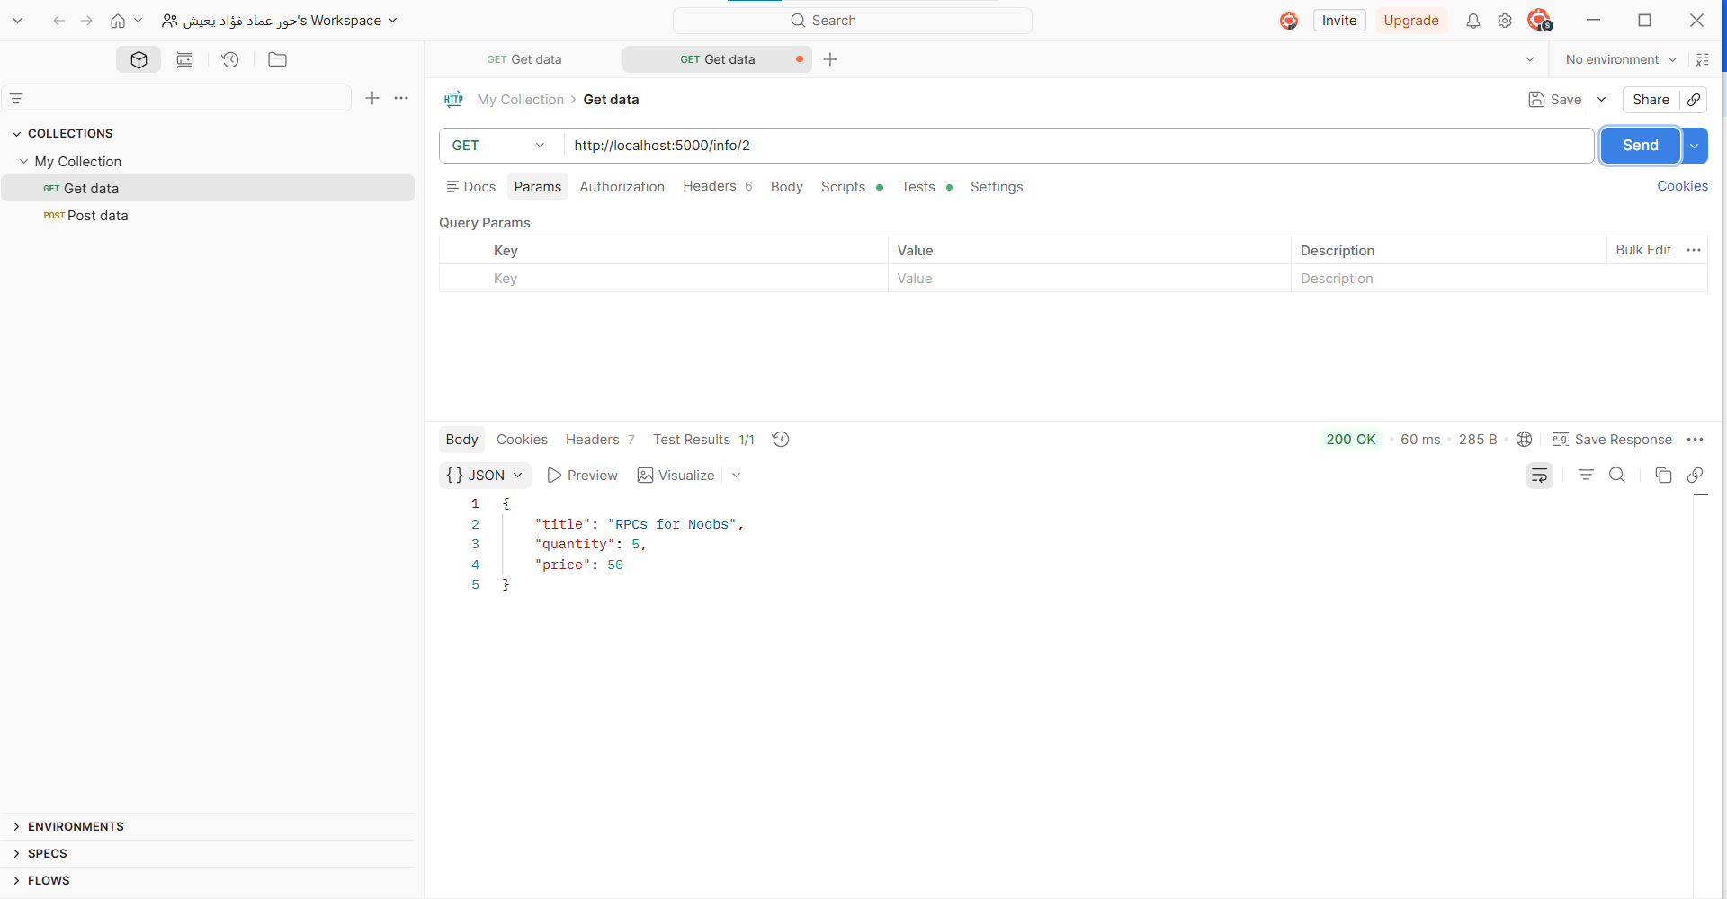
Figure 5: Info request for item 2 before purchase.

7.3 Purchase Request
The purchase request buys item 2. The order service checks the catalog, verifies that the book is in stock, decreases the quantity, stores the order, and returns a success message.
POST http://localhost:5000/purchase/2
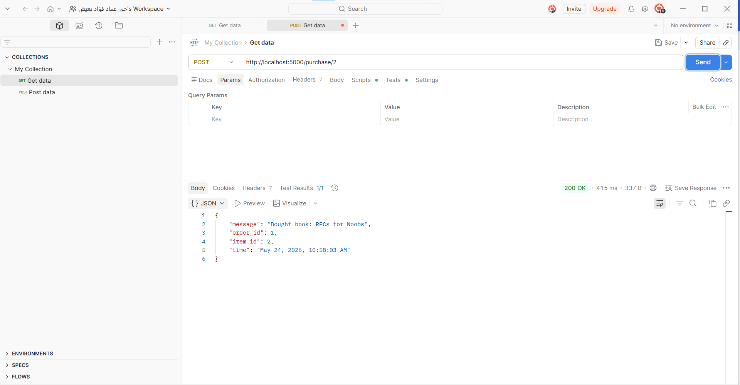
Figure 6: Successful purchase request for item 2.

7.4 Quantity Decrease After Purchase
After the purchase, another info request shows that the quantity of item 2 decreased from 5 to 4.
GET http://localhost:5000/info/2
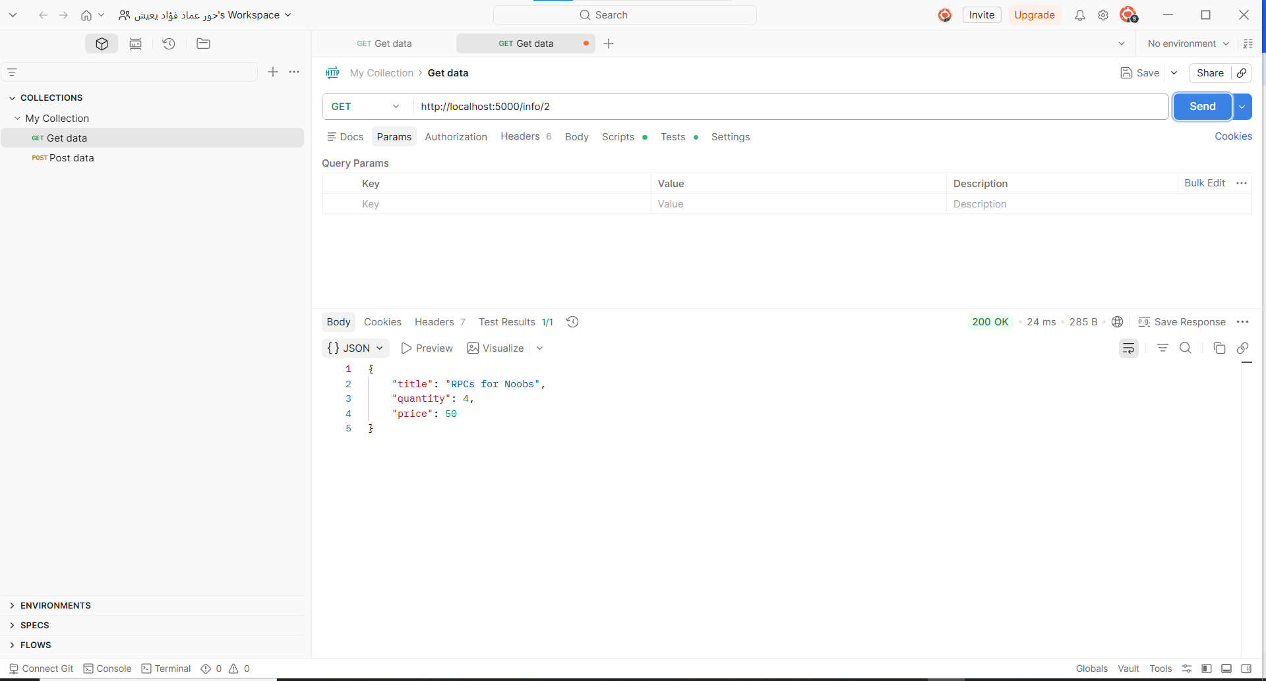
Figure 7: Info request after purchase showing that the quantity decreased.

7.5 Runtime Logs
The frontend logs show the complete flow: search request, info request, purchase request, and the updated quantity after purchase.
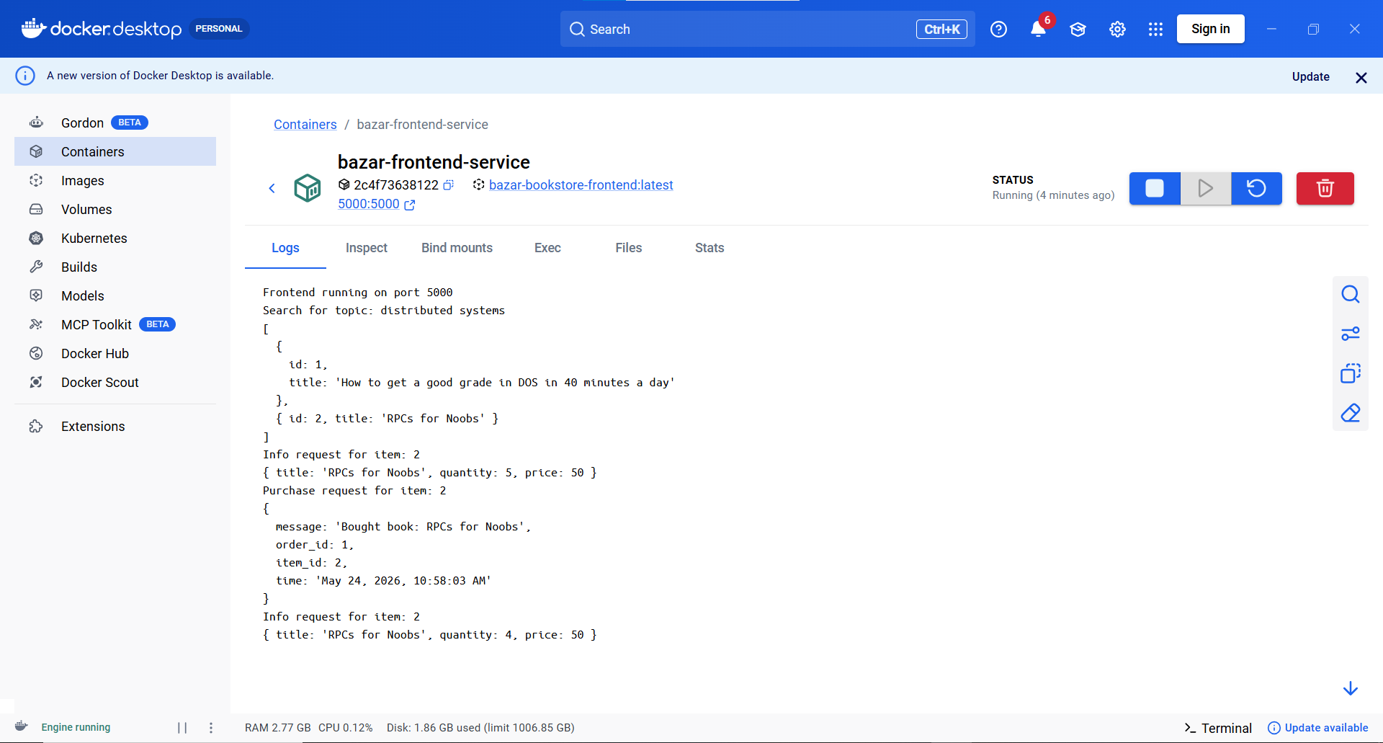
Figure 8: Frontend logs showing the search, info, purchase, and updated quantity outputs.

8. Design Tradeoffs
The design uses three separate microservices instead of one monolithic application. This makes the system more modular and easier to extend, but it requires service-to-service communication using HTTP calls.
SQLite was selected because it is lightweight and suitable for this lab. A heavier database would add unnecessary complexity for a small project.
Docker Compose was used to simplify deployment. Instead of starting each service manually, the whole system can be started with one command.

9. Known Limitations
The Lab 1 system has the following known limitations:
- There is only one catalog service and one order service, so there is no replication in Part 1.
- There is no caching, so every info request must contact the catalog service.
- The frontend is a single entry point and is not replicated.
- The system uses simple REST communication and does not include advanced fault tolerance.
- Concurrent purchases of the same item may require stronger transaction handling in a real production system.

10. Possible Improvements
Possible improvements and extensions include:
- Add caching in the frontend to reduce read latency.
- Replicate the catalog and order services to improve scalability and availability.
- Add load balancing between replicas.
- Add synchronization between replicated databases.
- Add better error handling, health checks, and automated tests.

11. How to Run the Project
Open a terminal in the project folder and run:
docker compose down --remove-orphans
docker compose up --build
Then test the system using these endpoints:
Operation | Method and URL
Search | GET http://localhost:5000/search/distributed%20systems
Info | GET http://localhost:5000/info/2
Purchase | POST http://localhost:5000/purchase/2

12. Conclusion
Part 1 successfully implements the required multi-tier online bookstore system. The project contains a frontend service, a catalog service, and an order service. The system supports search, info, and purchase operations through REST APIs. SQLite is used for persistent data storage, and Docker Compose is used to run the services as separate containers. The testing outputs prove that the services run correctly, book information can be retrieved, purchases are processed successfully, and stock quantity decreases after a purchase.

