
An-Najah National University
Computer Engineering Department
Distributed Operating Systems
Bazar Bookstore Project
Part 2 Report
Replication, Caching, and Consistency
Student Names: | - Hoor Yaish  - Deema Hazeem
Course | Distributed Operating Systems
Project | Bazar Bookstore - Part 2
Implementation | Node.js, Express.js, SQLite, Docker Compose

Bazar Bookstore - Part 2 Report

1. Introduction
This report explains the second part of the Bazar Bookstore project. Part 2 extends the original Lab 1 bookstore system by adding distributed-system features such as replication, caching, cache consistency, load balancing, and performance measurements. The system was implemented using Node.js with Express.js, SQLite for persistent storage, Axios for REST communication between services, and Docker Compose for deployment.
In this part, the backend services were replicated. The final system contains one frontend service, two catalog replicas, and two order replicas. The frontend receives client requests, performs caching for read operations, and distributes requests among the replicas using round-robin load balancing.

2. Project Structure
The project is divided into independent microservice folders. Each service has its own app.js file, package files, Dockerfile, and database files. The experiments folder contains the performance measurement script, while the docs folder contains the documentation and output files.
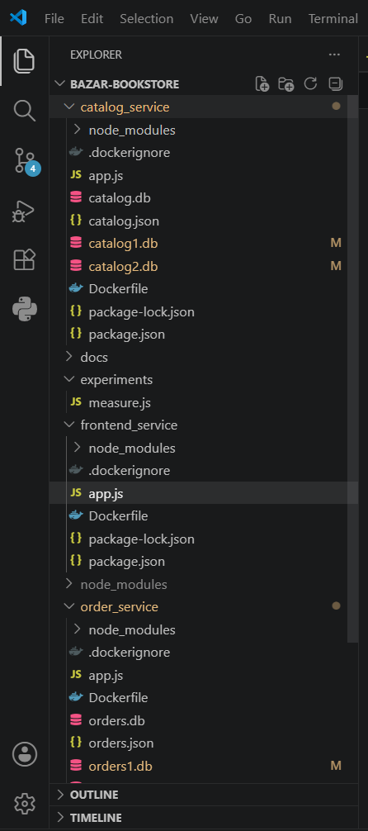
Figure 1: Project hierarchy showing service folders, documentation folder, and experiment script.
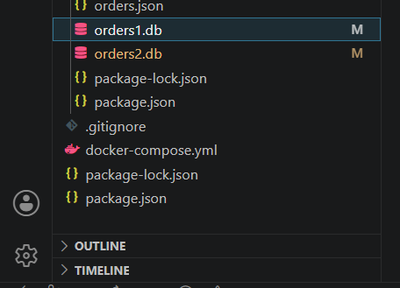
Figure 2: Project hierarchy continuation showing Docker Compose and order replica databases.

3. Lab 2 System Architecture
The final Lab 2 architecture contains five running services: one frontend service, two catalog replicas, and two order replicas. The frontend is the single client-facing service. It forwards read requests to catalog replicas and purchase requests to order replicas.
- Frontend service: receives user requests, checks cache, and load-balances backend requests.
- Catalog replica 1 and catalog replica 2: store book data and synchronize catalog updates.
- Order replica 1 and order replica 2: process purchases and synchronize order records.
- Docker network: allows containers to communicate using service names such as catalog1, catalog2, order1, and order2.
Service | Host Port | Container Port | Main Responsibility
frontend | 5000 | 5000 | Client entry point, cache, and load balancer
catalog1 | 5001 | 5001 | First catalog replica
catalog2 | 5003 | 5001 | Second catalog replica
order1 | 5002 | 5002 | First order replica
order2 | 5004 | 5002 | Second order replica

4. Docker Deployment
Docker Compose was used to run the complete distributed system. Each service runs in its own container. The catalog and order services are each replicated into two containers. The containers are connected to the same Docker bridge network, which allows them to communicate through internal service names.
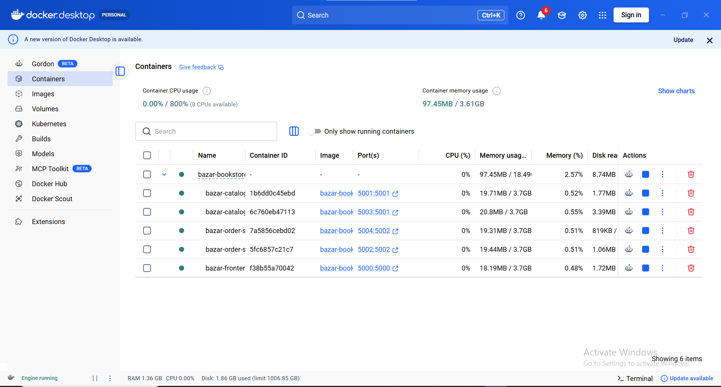
Figure 3: Docker Desktop showing the five Lab 2 containers running successfully.
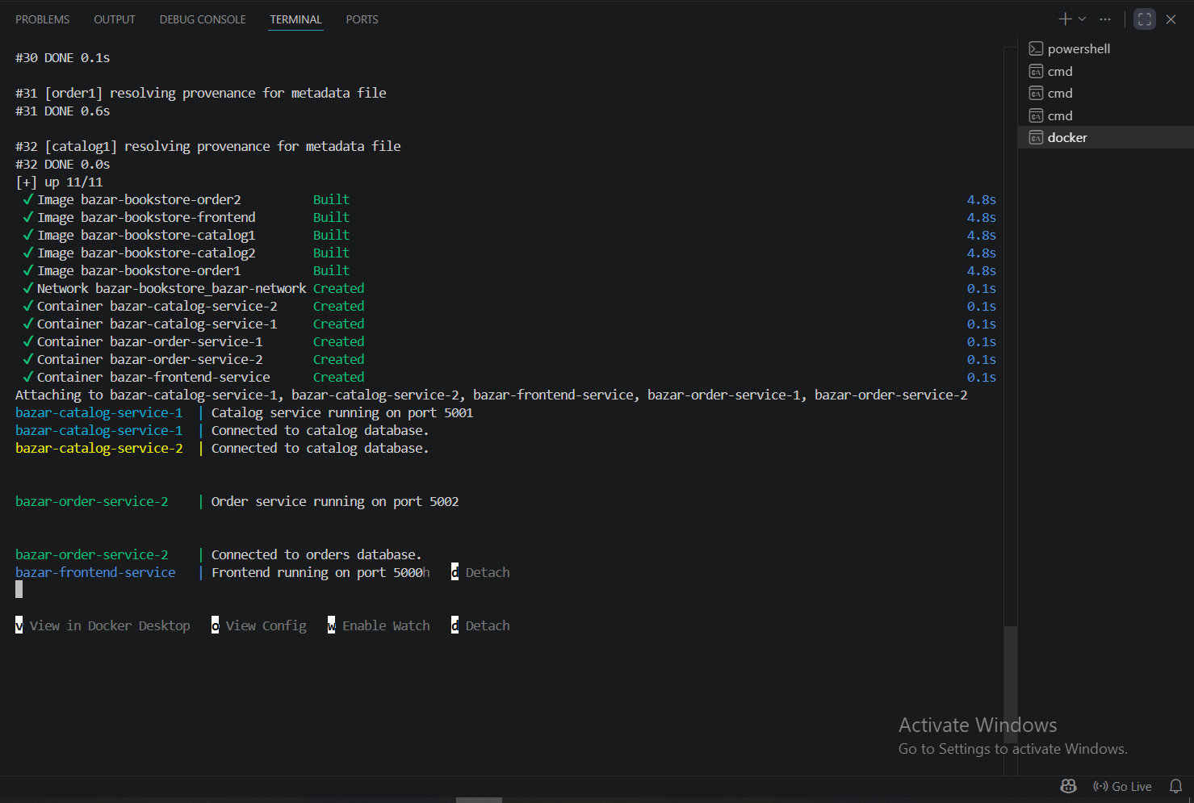
Figure 4: Terminal output showing the frontend, catalog replicas, and order replicas starting successfully.

5. New Books Added in Lab 2
Lab 2 required adding three new books to the catalog. These books were added to the catalog database initialization code and can be accessed through the frontend info endpoint.
ID | Title | Topic | Price
5 | How to finish Project 3 on time | undergraduate school | 45
6 | Why theory classes are so hard | undergraduate school | 35
7 | Spring in the Pioneer Valley | undergraduate school | 25

The following request tests one of the new books:
GET http://localhost:5000/info/5
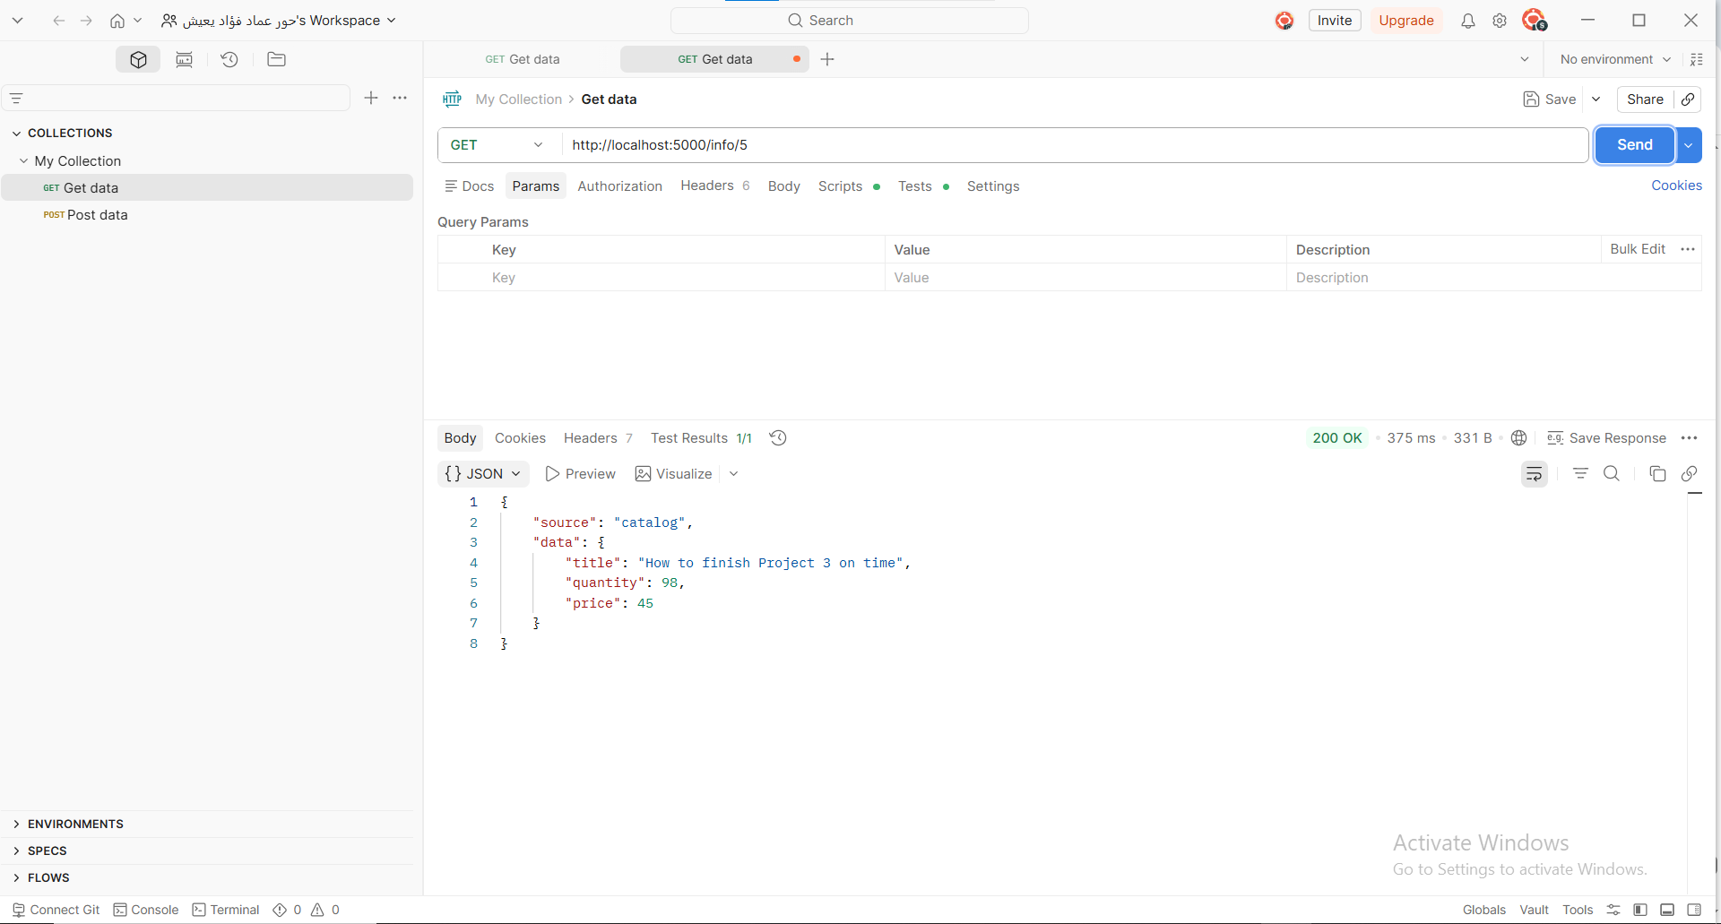
Figure 5: API response showing one of the three new Lab 2 books.

6. Frontend In-Memory Cache
An in-memory cache was implemented inside the frontend service. It stores recent info request results using keys such as info:5. The cache is used only for read operations, especially /info/:id. Purchase requests are not served from cache because they modify the stock quantity.
Before testing the cache, the cache was cleared manually through the DELETE /cache endpoint:
DELETE http://localhost:5000/cache
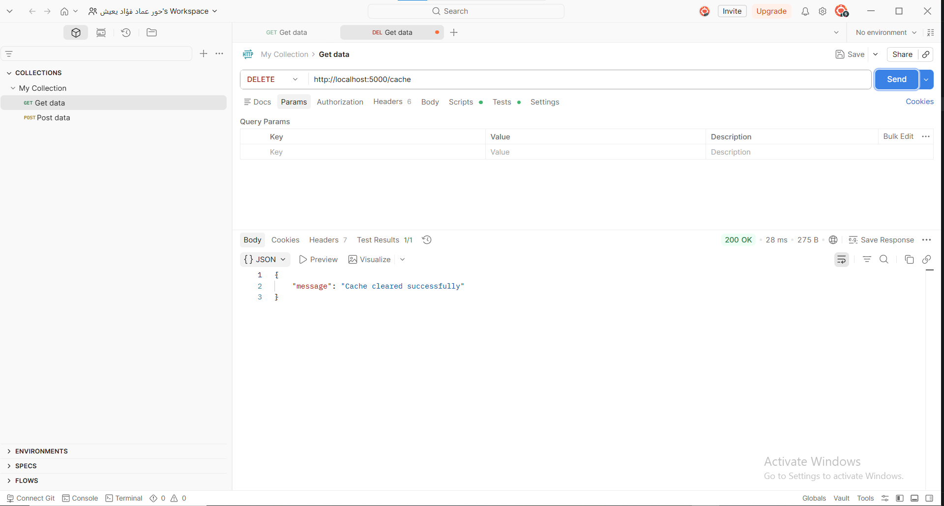
Figure 6: Cache cleared successfully before testing cache behavior.

7. Cache Miss and Cache Hit
When the frontend receives an info request, it first checks the cache. If the item is not found, the request becomes a cache miss, and the frontend forwards the request to a catalog replica. The result is then stored in the cache. If the same item is requested again, the frontend returns it directly from memory as a cache hit.
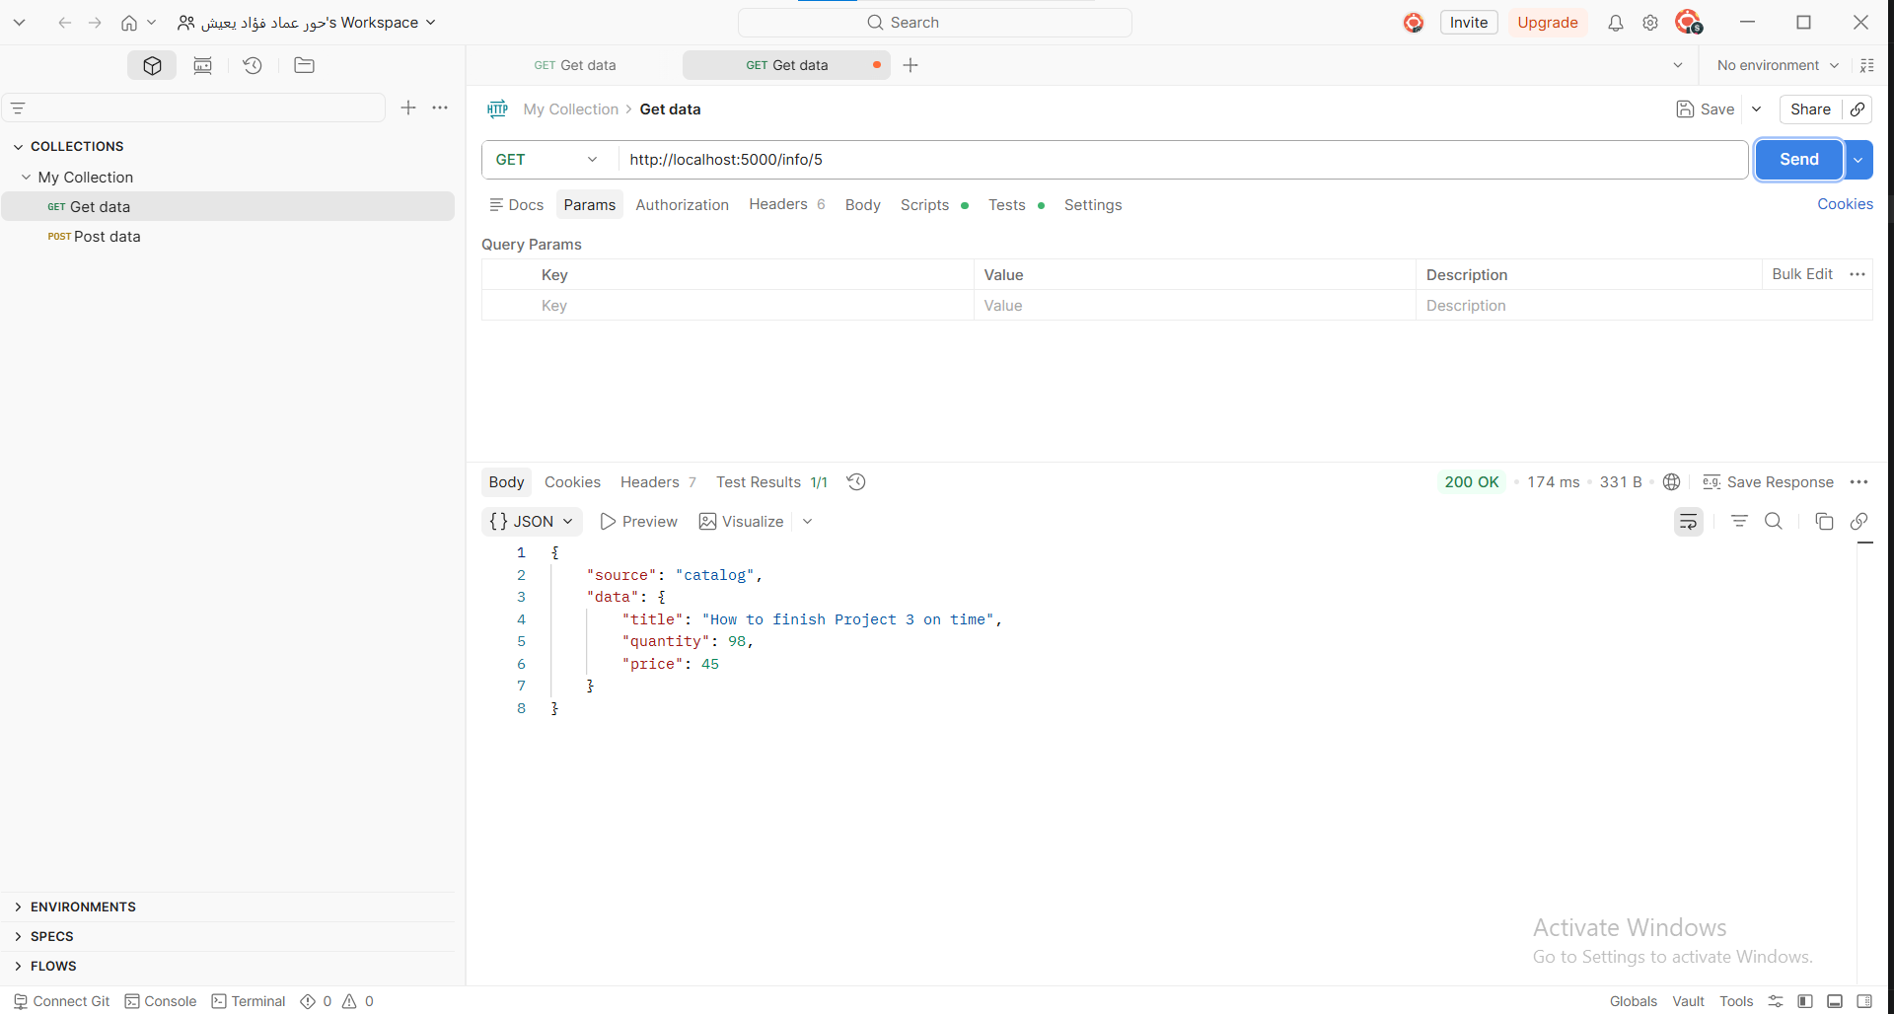
Figure 7: First info request showing source = catalog, meaning a cache miss.
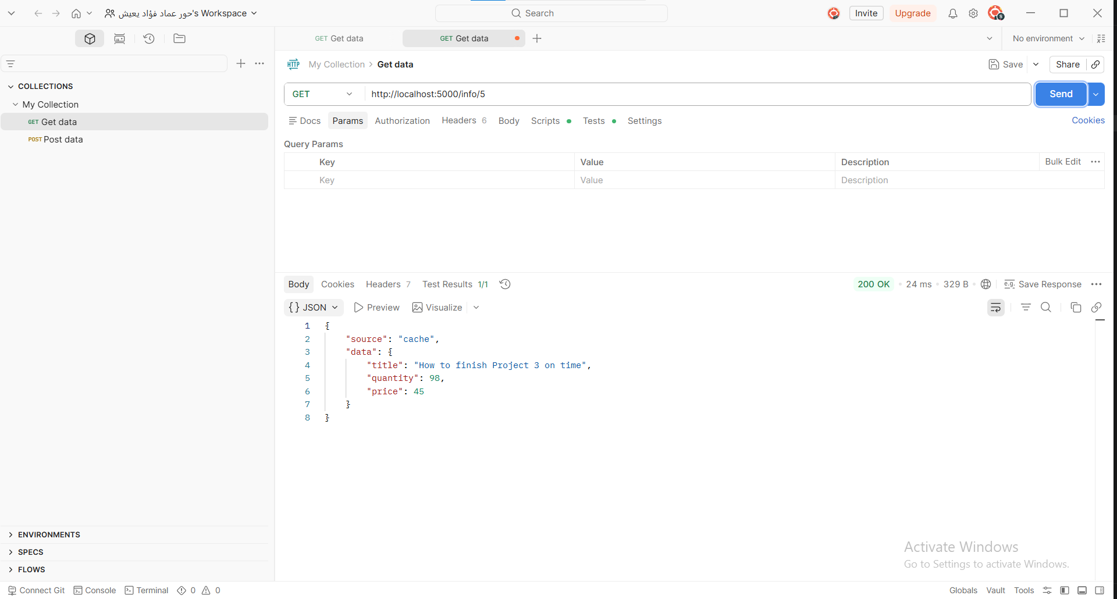
Figure 8: Repeated info request showing source = cache, meaning a cache hit.
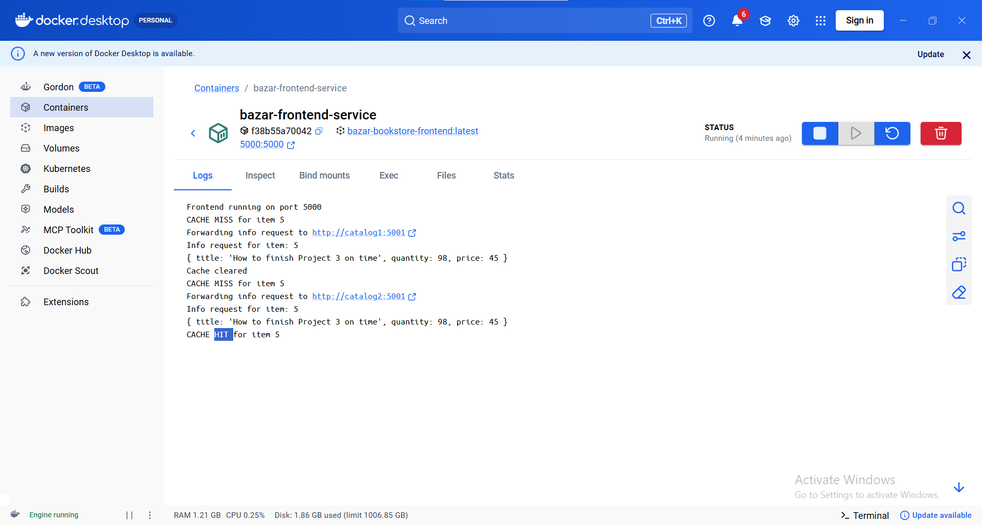
Figure 9: Frontend logs showing cache miss, forwarding to catalog, and cache hit.
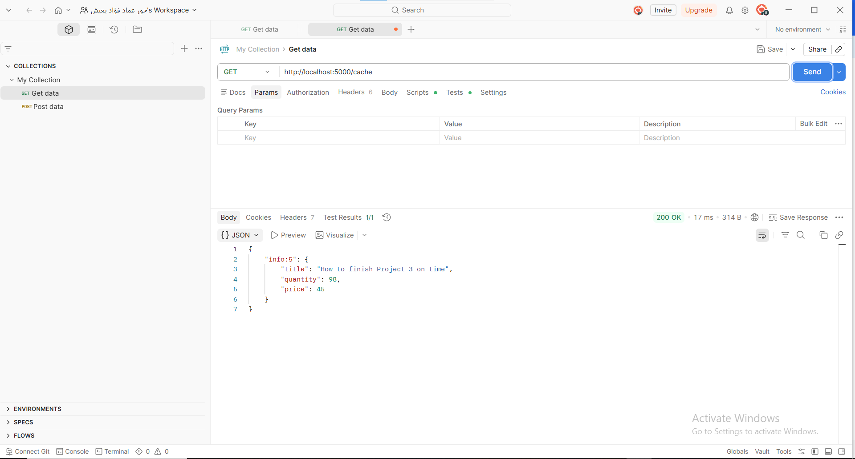
Figure 10: Frontend cache contents after an info request.

8. Round-Robin Load Balancing
The frontend uses round-robin load balancing to distribute requests across backend replicas. For catalog requests, the frontend alternates between catalog1 and catalog2. For purchase requests, it alternates between order1 and order2. This avoids sending all requests to one backend service.
Catalog requests: catalog1 -> catalog2 -> catalog1
Order requests: order1 -> order2 -> order1
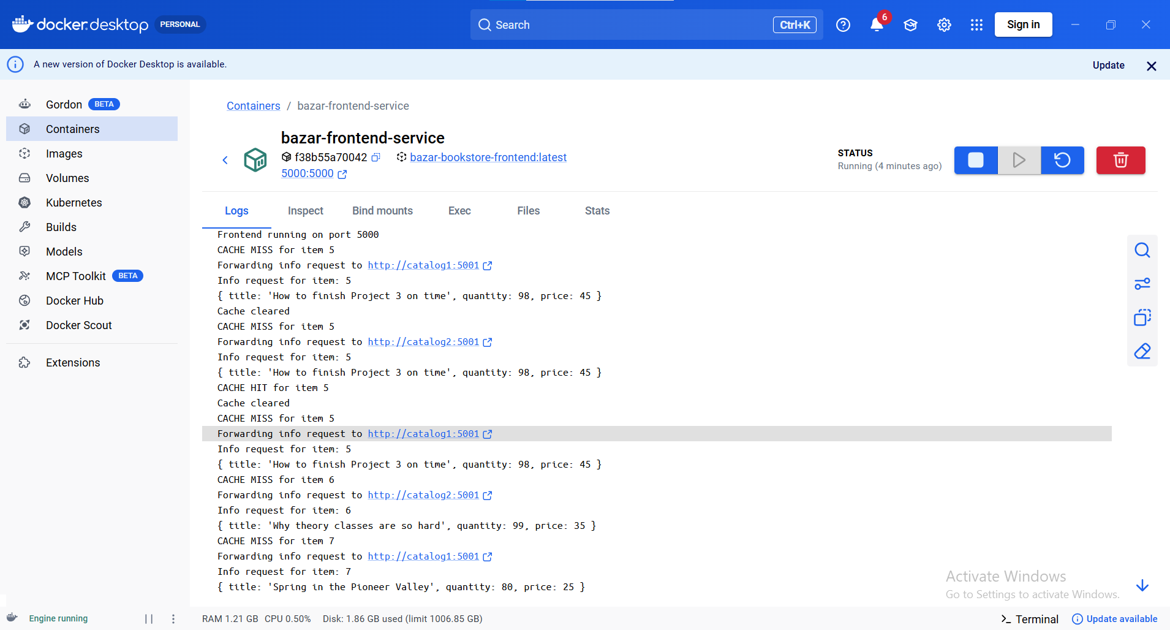
Figure 11: Frontend logs showing round-robin load balancing between catalog replicas.

9. Cache Invalidation and Consistency
Cache invalidation is needed to prevent stale data. For example, if an item is cached with quantity 98 and a purchase reduces the quantity, the cached value should not be returned again. To solve this, the catalog service sends an invalidate request to the frontend before updating the database. The frontend deletes the cached item, so the next info request is forced to retrieve fresh data from the catalog.
POST /invalidate/:id
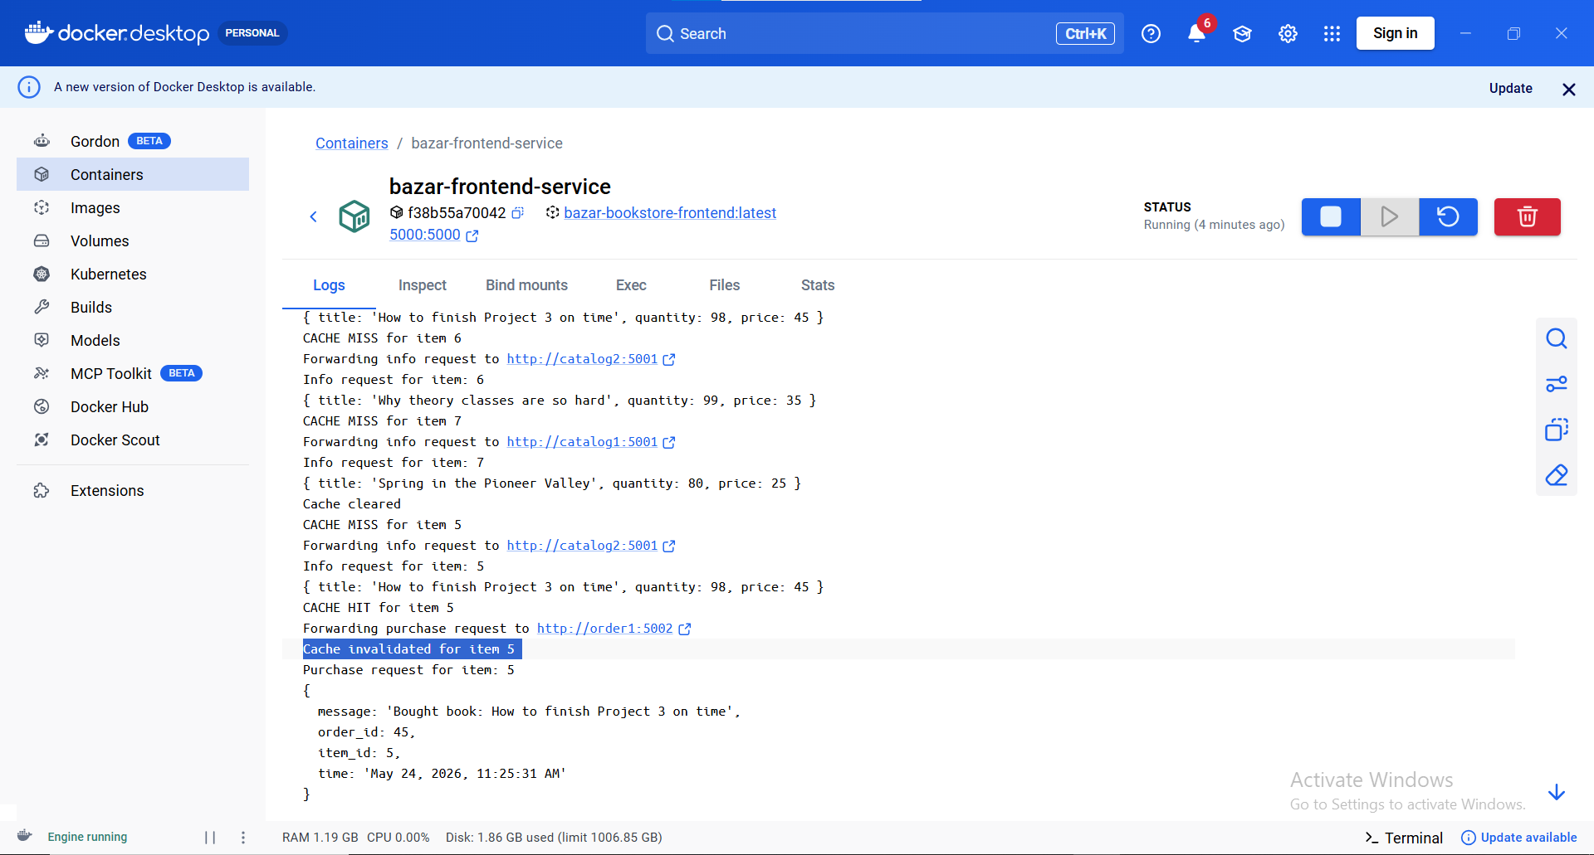
Figure 12: Logs showing cache invalidation after a purchase request.

10. Catalog Replica Synchronization
Each catalog replica has its own SQLite database file. When one catalog replica receives an update, it updates its local database and then sends the same update to the other catalog replica using the internal sync endpoint /sync/update/:id. The receiving replica updates its database without forwarding the update again, which avoids an infinite synchronization loop.
PUT /sync/update/:id
After purchasing item 5, both catalog replicas were checked directly. The two replicas returned the same quantity, proving synchronization.
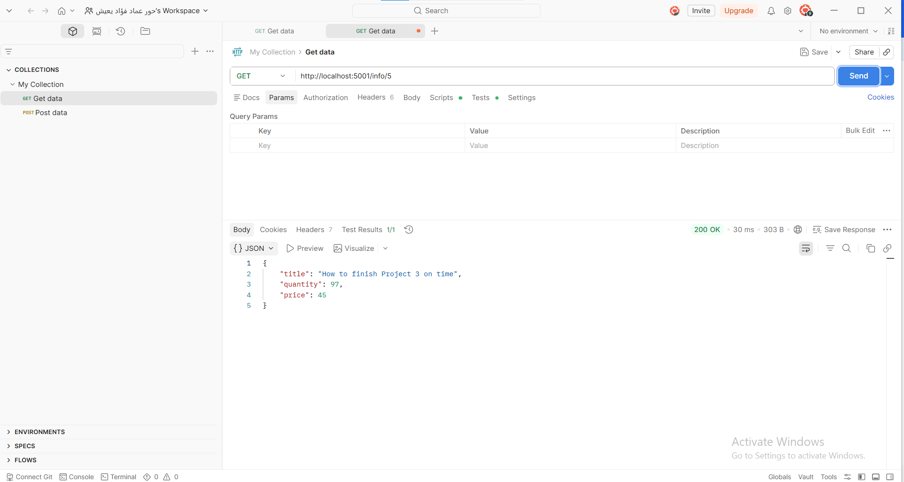
Figure 13: Direct check of catalog replica 1 after synchronization.
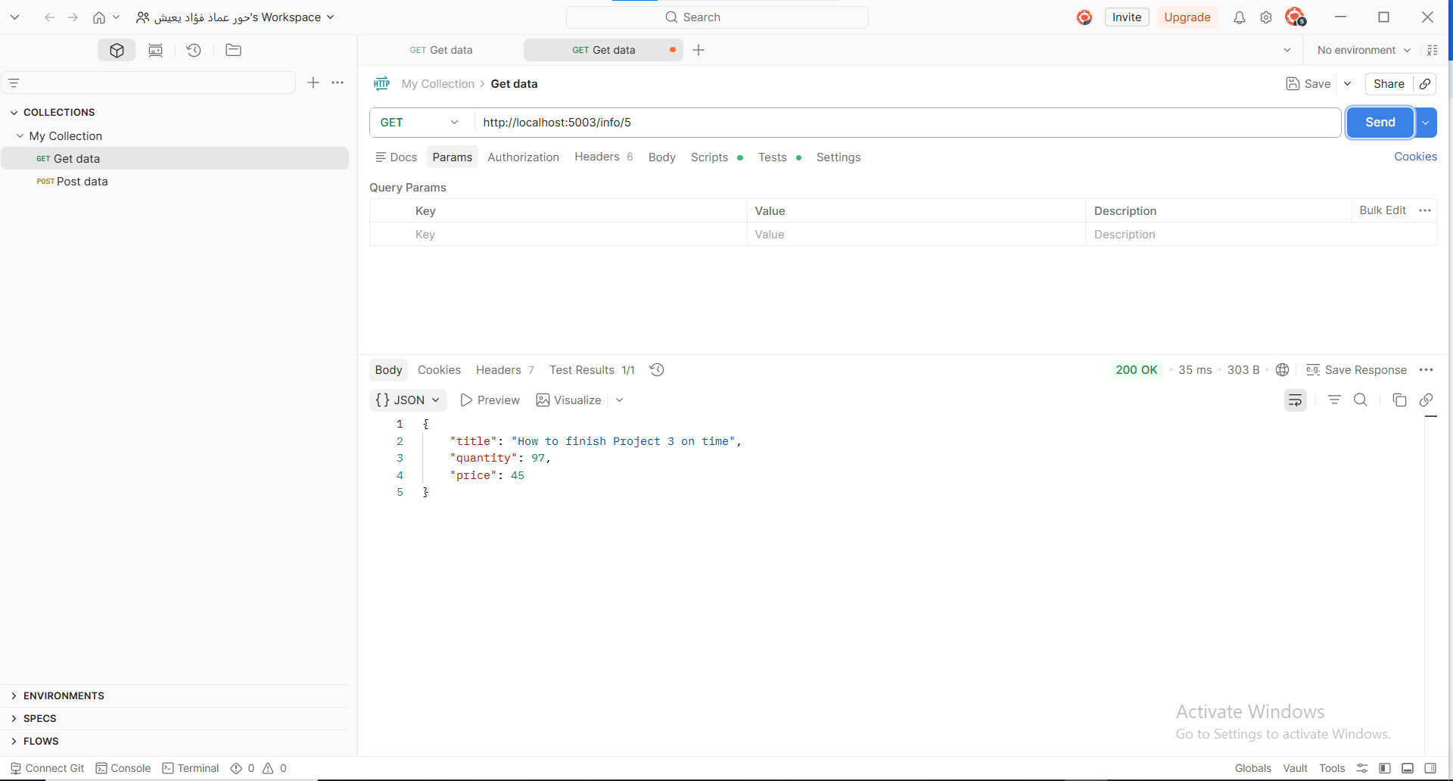
Figure 14: Direct check of catalog replica 2 showing the same quantity after synchronization.

11. Order Replica Synchronization
The order replicas also synchronize order records. When an order replica receives a purchase request, it stores the order locally and sends the same order record to the other order replica through /sync/order. The receiving replica stores the synchronized order but does not send it back again, preventing an infinite loop.
POST /sync/order
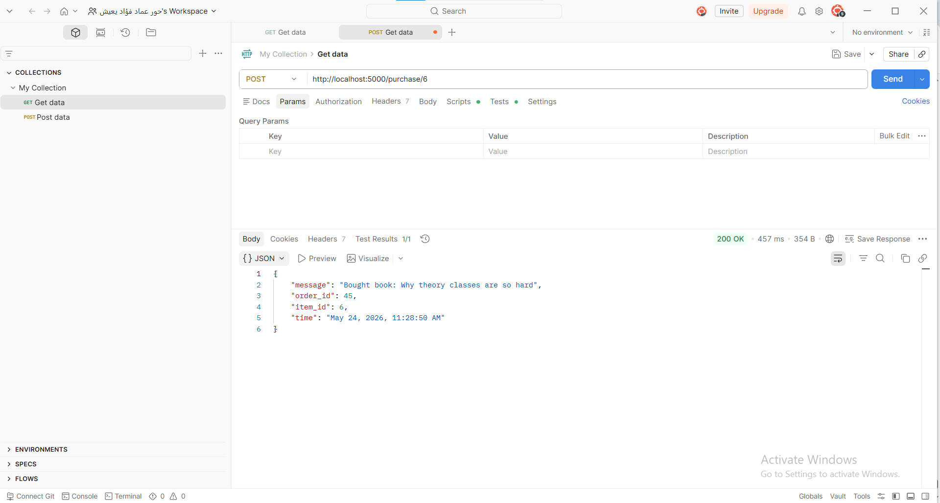
Figure 15: Successful purchase request through the frontend.
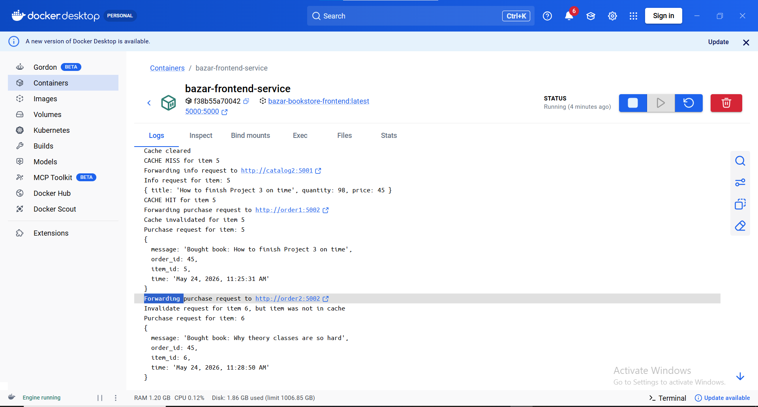
Figure 16: Docker logs showing order synchronization and catalog update synchronization.
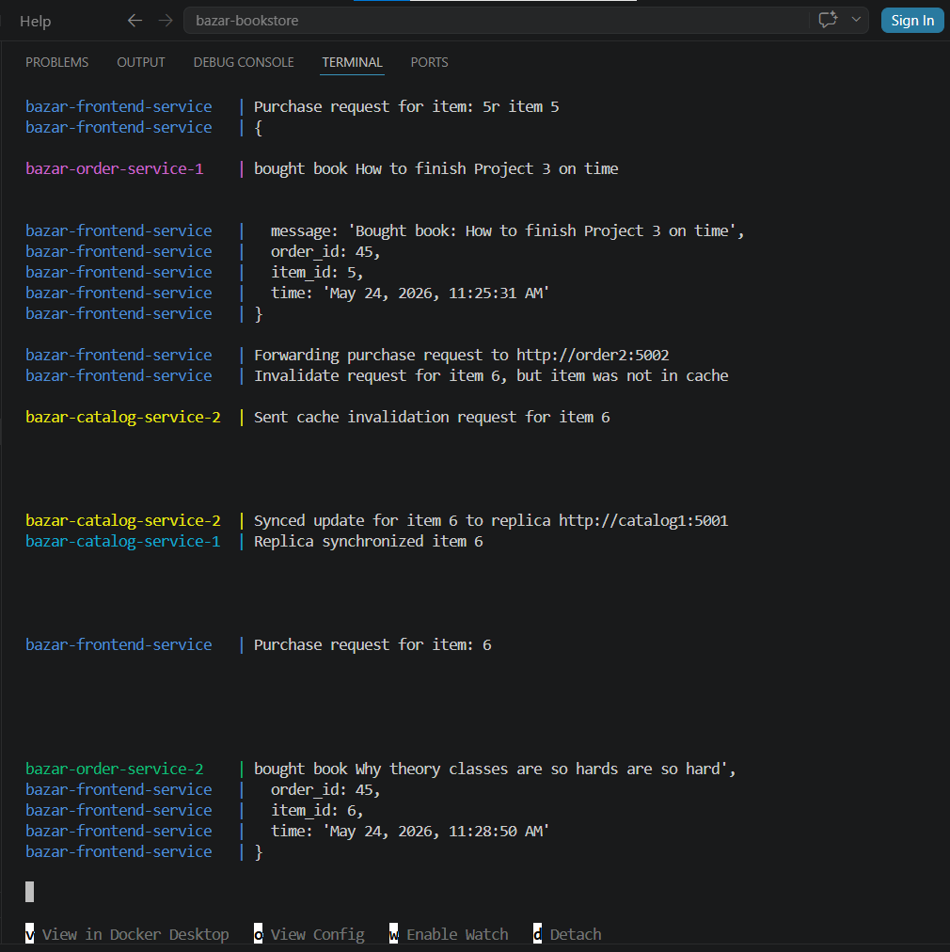
3
2
1
Figure 17: Terminal logs showing purchase processing, cache invalidation, catalog synchronization, and order synchronization.

12. Performance Measurements
A performance experiment script was created in experiments/measure.js. The script measures average response time for info requests without cache, info requests with cache, purchase requests, cache invalidation writes, and cache miss after invalidation. During the experiment, quantities were temporarily increased to avoid out-of-stock errors during repeated purchases.
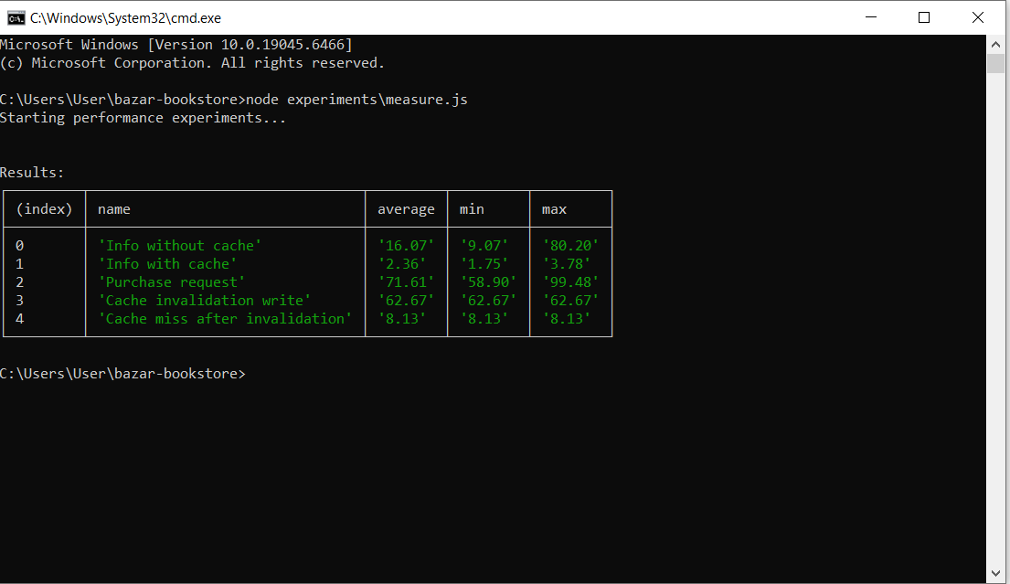
Figure 18: Performance measurement results comparing response times with and without caching.
Experiment | Average (ms) | Minimum (ms) | Maximum (ms)
Info without cache | 16.07 | 9.07 | 80.20
Info with cache | 2.36 | 1.75 | 3.78
Purchase request | 71.61 | 58.90 | 99.48
Cache invalidation write | 62.67 | 62.67 | 62.67
Cache miss after invalidation | 8.13 | 8.13 | 8.13

The results show that caching significantly improves read performance. The average info request without cache was 16.07 ms, while the average info request with cache was 2.36 ms. Purchase requests are slower because they involve the order service, catalog update, database write, cache invalidation, and replica synchronization.

13. Design Tradeoffs
The cache was implemented inside the frontend instead of as a separate cache service. This made the implementation simpler and reduced the number of REST calls. The tradeoff is that the cache is lost when the frontend restarts.
Round-robin load balancing was selected because it is simple and easy to verify using logs. A more advanced least-loaded strategy could distribute requests based on actual server load, but it would require additional monitoring.
SQLite was used for persistence because it is lightweight and suitable for this lab. For a larger real-world system, a more scalable database system or a message queue could be used.

14. Known Limitations and Possible Improvements
Although the system satisfies the Lab 2 requirements, it still has limitations. The frontend is not replicated, so it remains a single point of failure. Synchronization is implemented using simple REST calls, so if a replica is down during synchronization, the update may fail and there is no automatic retry mechanism. Also, the system does not implement a consensus protocol for strong consistency.
Possible improvements include adding retry logic, health checks, frontend replication, least-loaded load balancing, cache size limits, LRU cache replacement, structured logging, and automated tests.

15. How to Run the Project
To run the Lab 2 system, open a terminal inside the project folder and execute:
docker compose down --remove-orphans
docker compose up --build
The main frontend URL is:
http://localhost:5000
Example API requests:
GET http://localhost:5000/info/5
GET http://localhost:5000/cache
DELETE http://localhost:5000/cache
POST http://localhost:5000/purchase/5
GET http://localhost:5001/info/5
GET http://localhost:5003/info/5
To run the performance experiment:
node experiments\measure.js

16. Conclusion
Part 2 successfully extended the Bazar Bookstore project from a basic multi-tier microservice application into a more distributed system. The final implementation includes backend replication, frontend caching, cache invalidation, replica synchronization, round-robin load balancing, Docker deployment, and performance measurements. The experiment results show that caching reduces read request latency significantly, while synchronization and invalidation maintain consistency after writes.

