**Initial Assessment**

|  |  |  |
| --- | --- | --- |
| **Presenting Symptom/Chief Complaint** | | |
| Acute episodes of pain at the right hip area with radiation along the side of the leg to the thigh area. Difficulty with walking. Worst with every new episode. | | |
| **Main Signs and Symptoms** | | |
| Pain at the right hip area with radiation along the right thigh periodically to the groin. | | |
| **Other Signs and Symptoms** | | |
| Patient is complaining that he experiences the difficulties with movement due to right hip pain and his gait is changing | | |
| **TCM Diagnosis and Treatment (identified TCM disease, TCM differentiation of syndromes)** | | |
| Painful obstruction syndrome to the right hip due to cold and dampness invasion. Qi stagnation at the great Yang Channels. | | |
| **Treatment Principles and Strategies** | | |
| Expel cold, remove dampness. Nourish and stimulate Qi, and remove obstruction of Qi movement at the main channels involved. | | |
| **Treatment Plan (Modalities; acupuncture, herbal, dietary, manual therapies), frequency and duration** | | |
| Acupuncture with Moxibition in main local channel, GB, UB, St channel with involvement of Girdle Channel and Yang Heel Vessels. Acupuncture 1 hour 2-3 times a week till the symptoms resolved. | | |
| **Any other Advice Given to Patients** | | |
| Pain episodes. Acupuncture started with distal points GB41 as the main point that affect the hip and expel dampness. It is opening points to the Girdle Vessel. GB40; UB62 (opening points to the Yang Heel Vessel) and very useful for the stiff hip. ST 3 used when pain radiates to the groin. Local points: GB30 – expel dampness and remove obstruction from the Yang channels. GB29; Ex1 around the GB30 points, all 4 points with needles pointed to GB 80 point. | | |
| **Practitioner:** | **Date:** | **Signature:** |

**Dally Charting____________________________________Patient Name:_________________________**

**Date:________________**

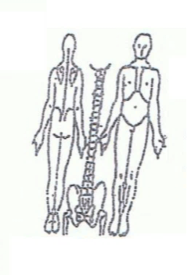 **Working Diagnosis:** Painful Obstruction syndrome to the right hip due

to dampness invasion and further predisposition to cold invasion. Qi stagnation and

obstruction at the GB channel.

.

S: Patient is complaining of acute episode of pain at the right hip. Stiffness of the muscle. Difficulties with walking.

O:

Treatment (P) Acupuncture 1 hour due to the protocol.

(A)

**Date:________________**

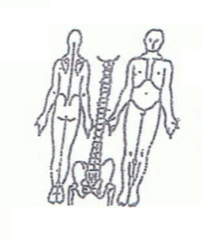**Working Diagnosis:**

S: Patient is still experiences the pain that still bother him during the day. Also pain interfere with sleep as patient cant internally rotate the right hip and need to find the comfortable position to sleep.

O:

Treatment (P) Acupuncture 1 hour with Moxibistion.

(A)

**Date:________________**

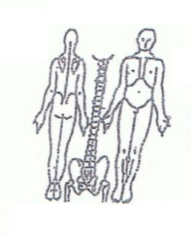**Working Diagnosis:**

S: Patient is sleeping and moving better. Pain. ROM. Still have difficulties with the right hip internal rotation.

O:

Treatment (P) Acupuncture 1 hour with tonification of local points.

(A)

**Date:________________**

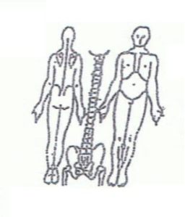**Working Diagnosis:**

S: Patient is feeling much better. Pain episode resolved. ROM is still limited to the internal rotation of the right hip that is showing the constant deformity of the destructive process (osteoarthritis).

O:

Treatment (P) Acupuncture 1 with Moxibustion.

(A)

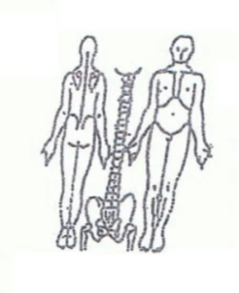**Date:________________**

**Working Diagnosis:**

S:

O:

Treatment (P) Acupuncture 1 hour with Moxibustion.

(A)