**Neck, back and back of the knees Robert Adducul**

**Initial Assessment**

|  |  |  |
| --- | --- | --- |
| **Presenting Symptom/Chief Complaint** | | |
| Painful neck obstruction syndrome, aggravated by the work - keep the head in fixed position of intense concentration for the long period of time. | | |
| **Main Signs and Symptoms** | | |
| Pain radiates to the back, weak legs muscle, pain at the back of both knees. | | |
| **Other Signs and Symptoms** | | |
| Very often feels tired, bad sleep, low level of energy, often cold. Feeling worse in rainy weather. | | |
| **TCM Diagnosis and Treatment (identified TCM disease, TCM differentiation of syndromes)** | | |
| Neck painful obstruction syndrome, chronic condition due to cold damp with liver blood deficiency. Spleen channel syndrome. | | |
| **Treatment Principles and Strategies** | | |
| Eliminate cold, reduce dampness. Stimulate blood production, stimulate spleen (SP) channel. QI level. | | |
| **Treatment Plan (Modalities; acupuncture, herbal, dietary, manual therapies), frequency and duration** | | |
| Acupuncture only with main use of the local points. Treatment of underlined condition with involvement of SP and TW channels. | | |
| **Any other Advice Given to Patients** | | |
| Acupuncture: Distal points: UB60 (bilateral). TW5, TW8 (bilateral), stimulates all three Yang area channels. P6 – bilateral – decrease nervousness and muscle spasm. ST40 – bilateral, SP8, SP9 – release dampness. Due to chronic condition K4 (bilateral).  Stimulates kidney and spleen channels. SI9, SI10, SI11, SI15 (bilateral) due to point’s tenderness on diagnose. | | |
| **Practitioner:** | **Date:** | **Signature:** |

**Neck, back and back of the knees**

**Daily Charting____________________________________Patient Name:_**

**Date:**

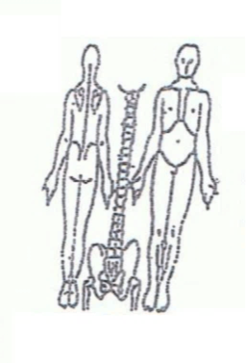 **Working Diagnosis:** Painful neck obstruction syndrome due to cold and damp with underlined liver blood deficiency. SP channel syndrome (neck, back. back of knees pain).

S: Feeling tired. Pain in neck, upper back and back of the knee. Sleep disturbance. Leg

muscle weakness.

O:

**Treatment (P)** Acupuncture: Distal points: UB60 (bilateral). TW5, TW8 (bilateral), stimulates all three Yang area channels. P6 – bilateral – decrease nervousness and muscle spasm. ST40 – bilateral, SP8, SP9 – release dampness. Due to chronic condition K4 (bilateral).Stimulates kidney and spleen channel - SI9, SI10, SI11, SI15 (bilateral) due to point’s tenderness on diagnose.

**(A)** According to assessment plan.

**Date:**

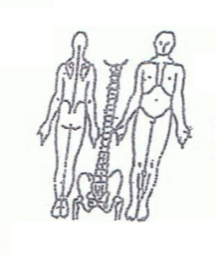**Working Diagnosis:**

S: Condition the same.

O: ROM , Energy level . Pain 4-5 of 10 level pain scale.

Treatment (P) According to the plan.

(A)

**Date:_ _______________**

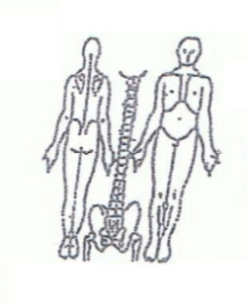**Working Diagnosis:**

S: Better sleep. Pain the same, ROM – same. Energy level still

O:

Treatment (P) Acupuncture + Moxa for 1 hour.

(A)

**Date:_ _______________**

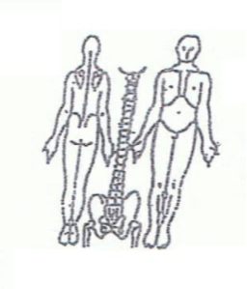**Working Diagnosis:**

S: Sleep better, ROM , pain 3-4 on the scale. Energy level the same.

O:

Treatment (P) Acupuncture with remove off the needles with patient movement.

(A)

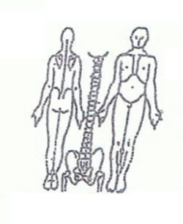**Date: ________________**

**Working Diagnosis:**

S: Sleep normal. ROM . Energy level . Pain the same.

O:

Treatment (P) According to the plan 1 hour.

(A)

**Daily Charting____________________________________Patient Name:_ Robert Adducul ________________________**

**Date:_**

 **Working Diagnosis:**.

S: Sleep N. ROM . Energy level . Pain 2-3.

O:

Treatment (P) Acupuncture with stretching light exercises.

(A)

**Date: __ ______________**

**Working Diagnosis:**

S: Sleep N. Energy level N. ROM N. No pain.

O:

Treatment (P) Acupuncture 1 hour, exercises, diet, no dairy products.

(A)