**Right and left leg pain (thigh)**

**Initial Assessment**

|  |  |  |
| --- | --- | --- |
| **Presenting Symptom/Chief Complaint** | | |
| Chronic pain in both legs, weakness of leg muscles, cold feeling in legs. | | |
| **Main Signs and Symptoms** | | |
| Pain dull by character, pain in thighs, knee and joint to the ankles area, worst with cold and rainy condition. | | |
| **Other Signs and Symptoms** | | |
| Patient is overweight. Otherwise healthy. | | |
| **TCM Diagnosis and Treatment (identified TCM disease, TCM differentiation of syndromes)** | | |
| Leg obstruction painful syndrome due to cold and wind invasion QI stagnation in the GB channels. | | |
| **Treatment Principles and Strategies** | | |
| Expel cold, remove wind. Stimulation of Qi, remove blockage from the GB channels. | | |
| **Treatment Plan (Modalities; acupuncture, herbal, dietary, manual therapies), frequency and duration** | | |
| Acupuncture every 3rd day 1 hour with local joints of GB; ST and UB channels involved. Diet with warm food + exercise to strengthen the leg muscle. | | |
| **Any other Advice Given to Patients** | | |
| Acupuncture:  Local joints UB 58 - thigh pain  UB 35, UB 37, GB 30, GB 33, GB 34, relax tendons. Distal joints ST 36;SP 7;K3;K4;UB 60;UB 62;GB 40 in acute hip and thigh pain, removing obstruction from GB channels  Liv 7, Liv 8-reduce dampness with combination of SP6; K3 nourish K and Liver QI and liver blood. | | |
| **Practitioner:** | **Date:** | **Signature:** |

**Right and left leg pain (thigh)**

**Daily Charting____________________________________Patient Name:**

**Date:_**

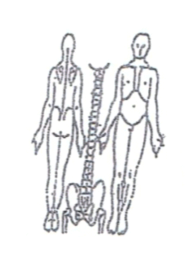 **Working Diagnosis:**

Leg obstruction painful syndrome due to cold and wind invasion, QI stagnation in the GB channels; channel blockage.

S: Patient c/c pain of dull character in both thighs on the lateral side, leg weakness,

feeling cold inside, low energy level, feels empty at the evening.

O:

**Treatment (P)** Acupuncture: Local joints UB 58 - thigh pain UB 35, UB 37, GB 30, GB 33, GB 34, relax tendons. Distal joints ST 36;SP 7;K3;K4;UB 60;UB 62;GB 40 in acute hip and thigh pain, removing obstruction from GB channels, Liv 7, Liv 8-reduce dampness with combination of SP6; K3 nourish K and Liver QI and liver blood.

(A) Acupuncture + Moxibition 1 hour as per plan.

**Date:_**

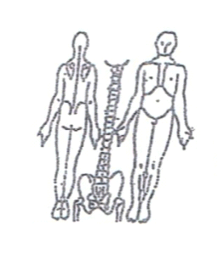**Working Diagnosis:**

S: Symptoms persist. Sleep much better after the first session. Pain still the same,

worse in cold and windy (air conditioner) weather. Less tired at the end of the day.

O:

Treatment (P) Acupuncture 1 hour with warm needles tonification method.

(A)

**Date:**

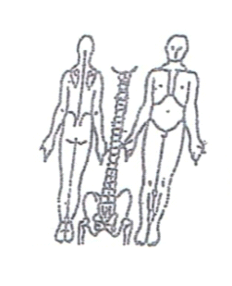**Working Diagnosis:**

S: Patient sleeps N, level of energy, less tired during the day. ROM; N Appetite; No

pain with walking

O:

Treatment (P) Acupuncture + Moxibition 1hour. Start leg strengthening exercises 5

(A)

**Date:_**

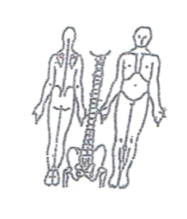**Working Diagnosis:**

S: Patient feeling much better. No cold feeling inside. N level of energy during the

day. N sleep and feels recharged during the day.

O:

Treatment (P) Acupuncture + moxa 1 hour according to the protocol + exercises

10-15 min.

(A)

**Date:**

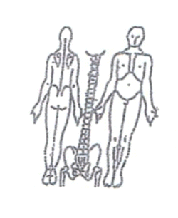**Working Diagnosis:**

S: Patient don’t have any symptoms in the morning. N sleep. N level of energy.

Remains leg muscle weakness at the end of the day. N ROM

O:

Treatment (P) Acupuncture with tonification of the joints + Moxibition.

Continue leg exercises for 10-15 min

(A)

**Date:**

 **Working Diagnosis:**

S: Symptom ;N sleep ;No pain in the legs. Still feeling weakness of the leg muscle,

low energy at the end of the day.

O:

Treatment (P) Acupuncture + Moxibition1 hour. Start leg strengthening exercises

increase for 30 min.

(A)

**Date:_**

**Working Diagnosis:**

S: Patient feels well. No pain. N level of energy throughout the day.

Leg strengthening exercise continue.

O:

Treatment (P) Acupuncture + Moxibition 1 hour according to the protocol.

(A)