

Data Technician

Name:
Course Date:
Table of contents
Day 1: Task 1 2
Day 1: Task 2 2
Day 2: Task 1 3
Day 2: Task 2 3
Day 3: Task 1 4
Day 3: Task 2 5
Day 4: Task 1 6
Day 4: Task 2 7
Course Notes 7
Additional Information 8

Day 1: Task 1

Please research the different versions of Tableau, compare and contrast them below and explain the limited functionality on ‘Tableau Public’.

Different Tableau versions | 1. Tableau Public  Free to use  You must save your work online (can’t save privately)  Anyone can see your dashboards – not good for sensitive or private data  Basic features only – limited data sources (like Excel or Google Sheets)  Good for learning or sharing public projects  2. Tableau Desktop  Paid version  Full features – connect to many data sources (like databases, cloud services)  Can save work locally and privately  More tools for building dashboards and doing deep analysis  Used by professionals in businesses  3. Tableau Server / Tableau Online  Used to share dashboards across a company  Tableau Server is hosted by your company  Tableau Online is hosted by Tableau (cloud)  Great for teams – people can view and interact with dashboards online  Needs Tableau Desktop to create dashboards first  Main Limitation of Tableau Public:  You can’t keep your data private – everything is public. It also doesn’t connect to as many data sources and has fewer features than the full version.

Day 1: Task 2

Using the EMSI_JobChange_UK dataset, create your own dashboard, I want to see a bar chart showing percentage change and a UK based map showing the key city locations impacted.

Paste your print screen here | 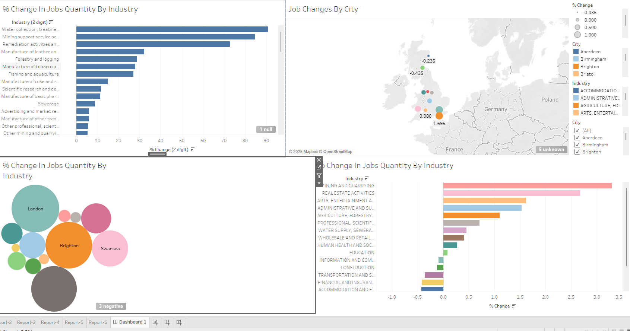

Day 2: Task 1

Using the Spotify data set, conduct an analysis to find trends and key information that could be used by an organisation for future projects.

There is no set scope for the analysis, simply to find trends and document them below:

Paste your print screens here | 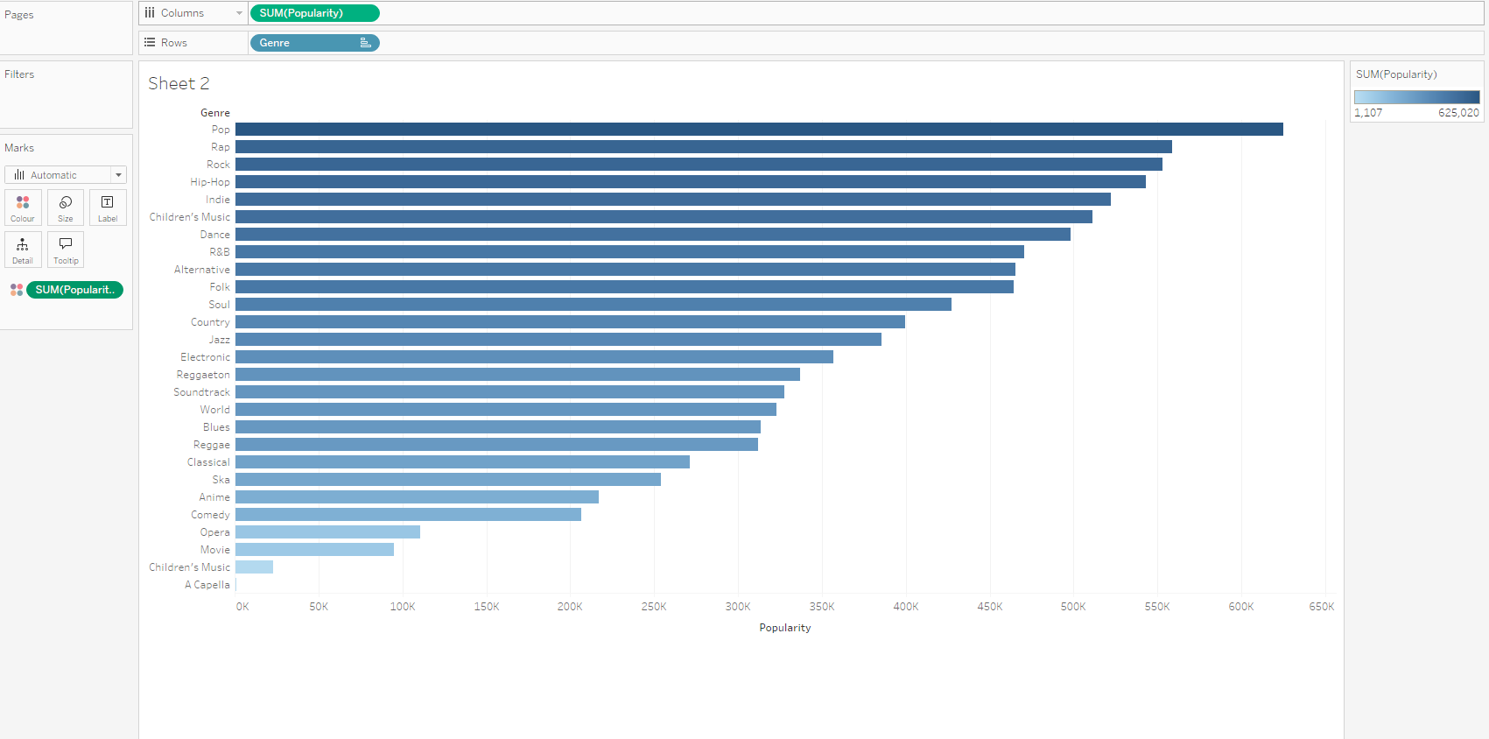  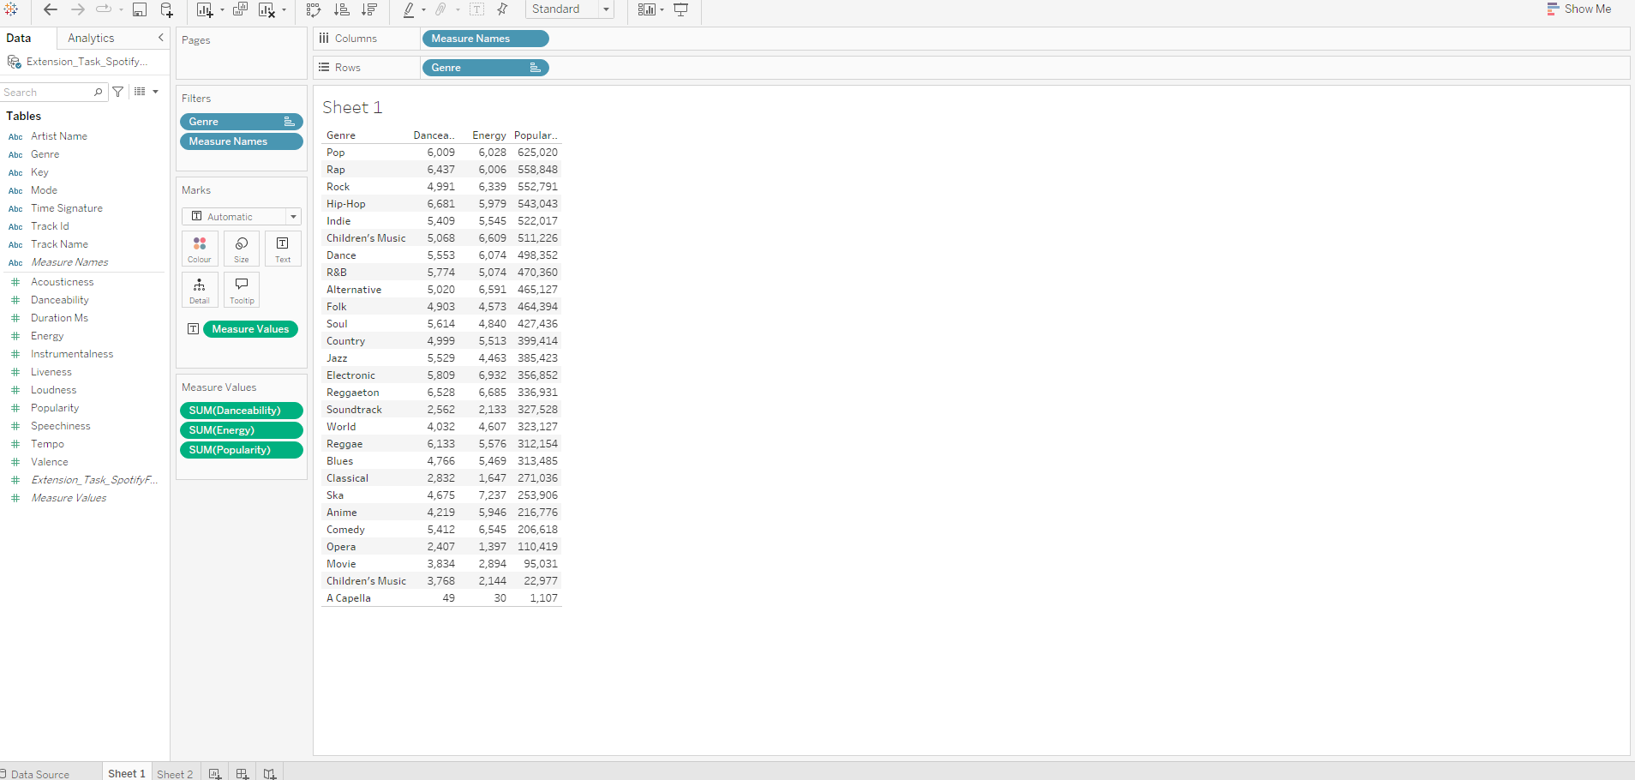  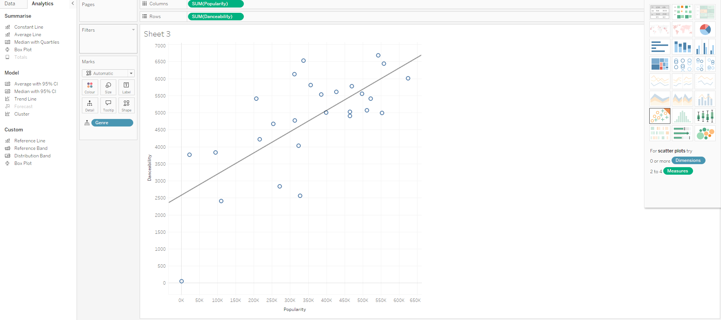

What did you find? | I found that the more energetic and danceable the genre is, the more popular it is. For example : rap and rock have on of highest scores for energy and danceability and they have one of the highest ranks in popularity.  Also, rap artists are the most popular in this data set.

Day 2: Task 2

Using the Health, conduct an analysis to find trends and key information that could be used by an organisation for future support.

There is no set scope for the analysis, simply to find trends and document them below.

- Data can be lifesaving and is being used more within the NHS, reflect on how this data could support decision making for the NHS.

Paste your print screens here | 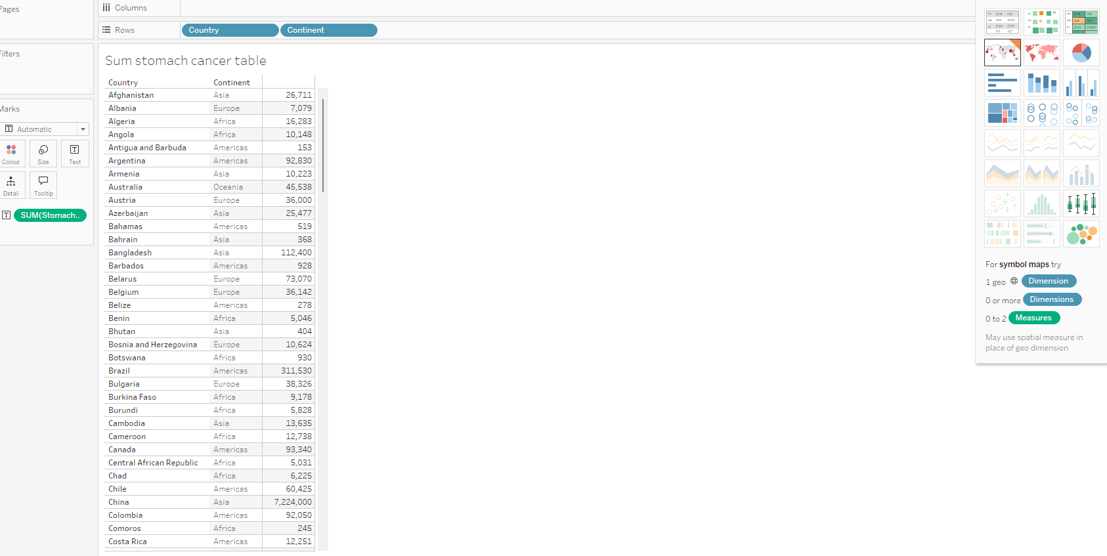  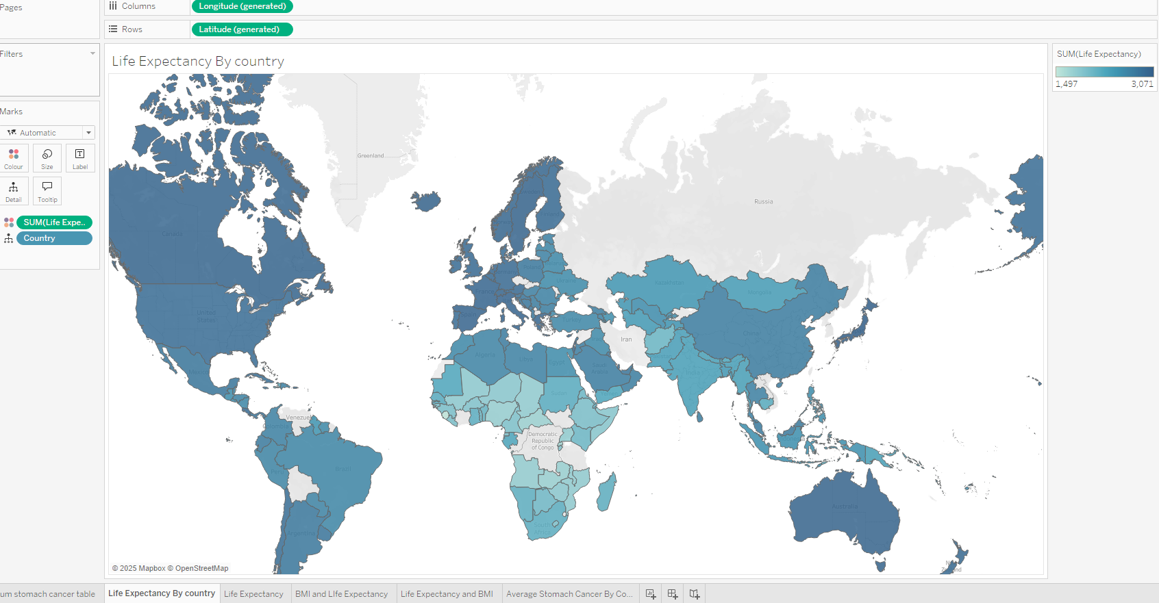  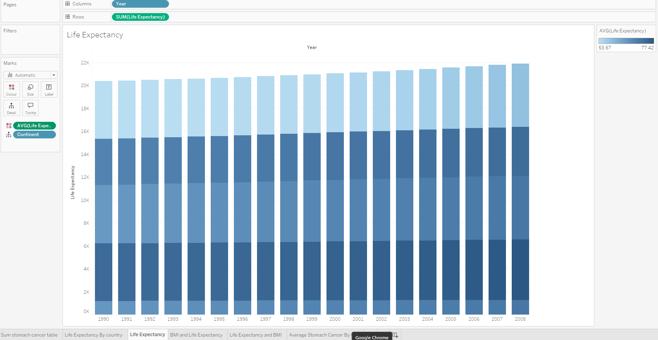  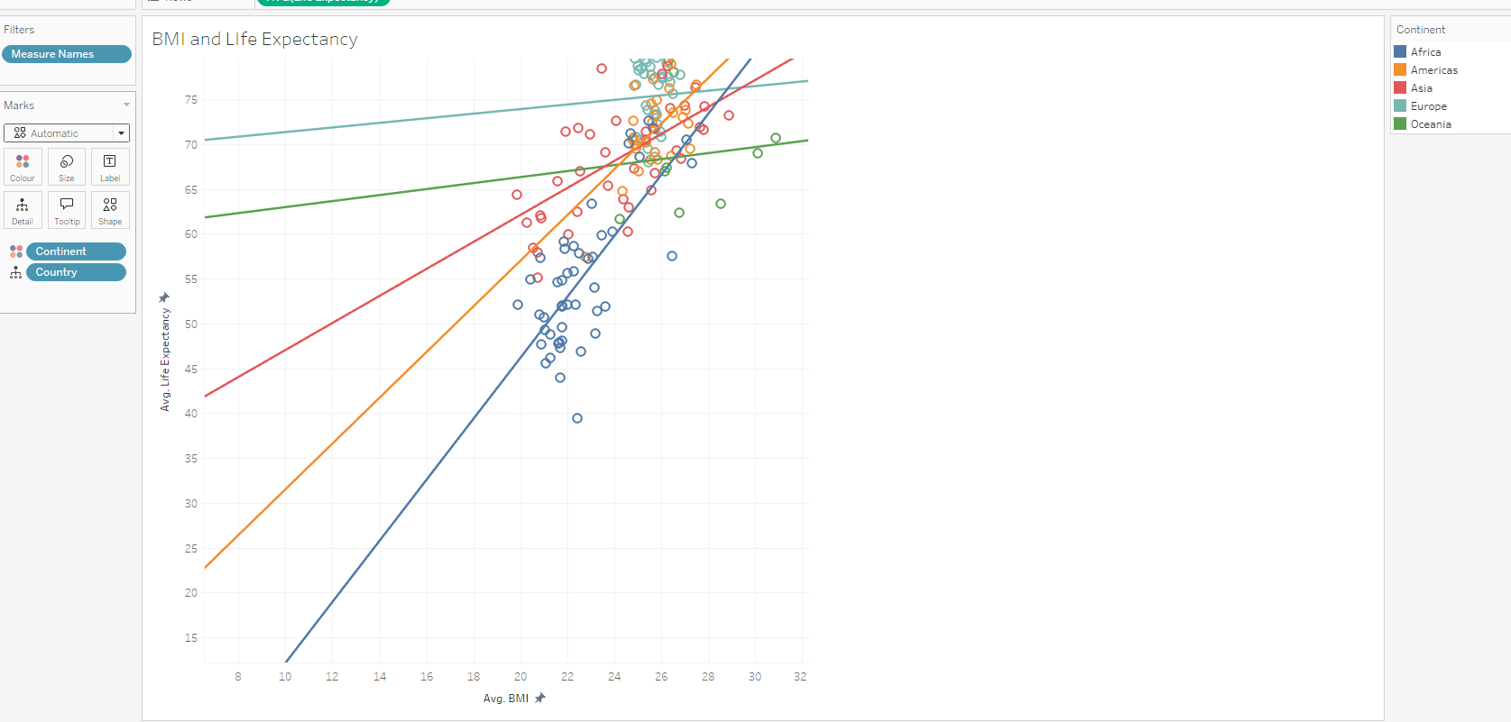  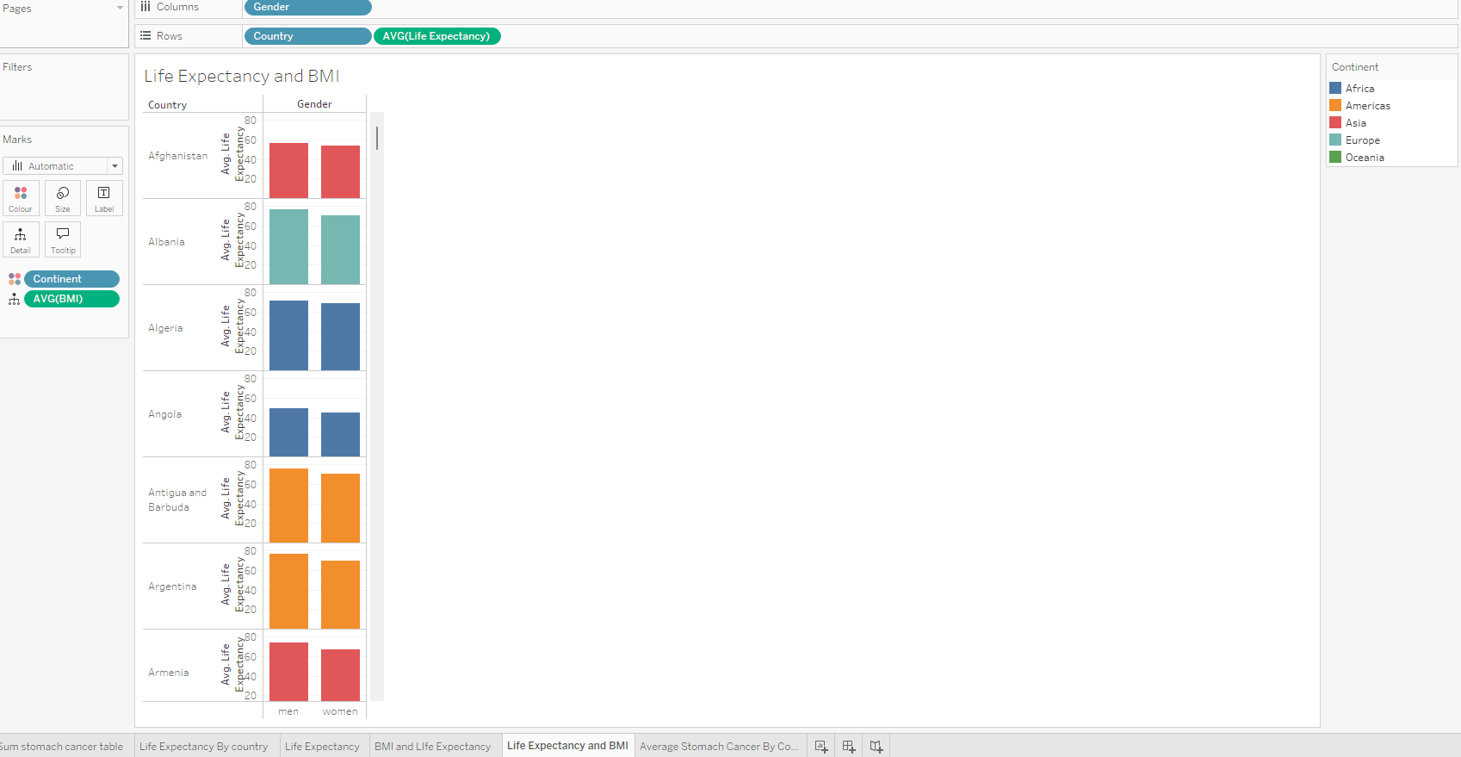  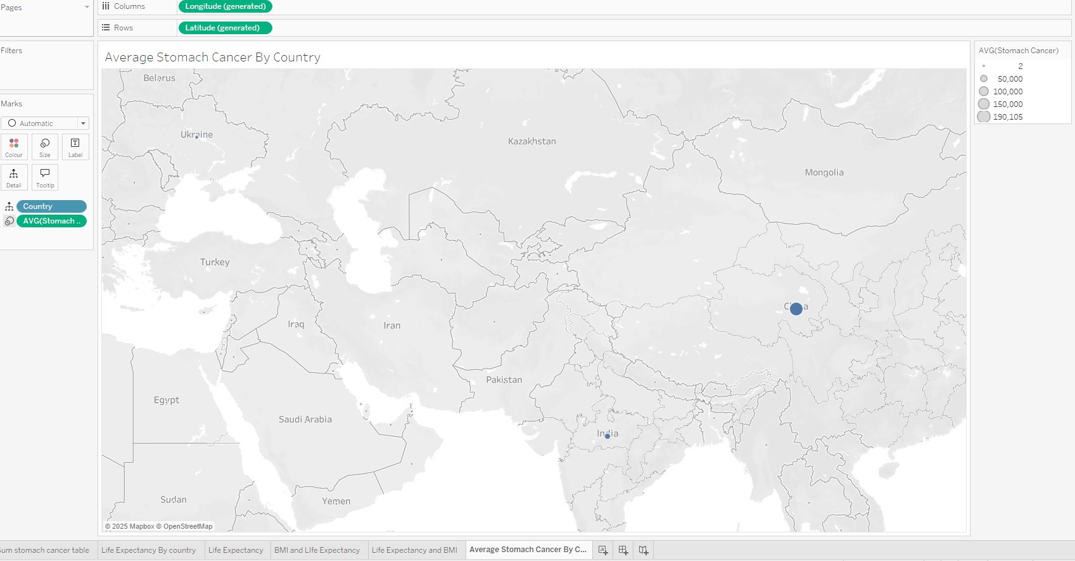  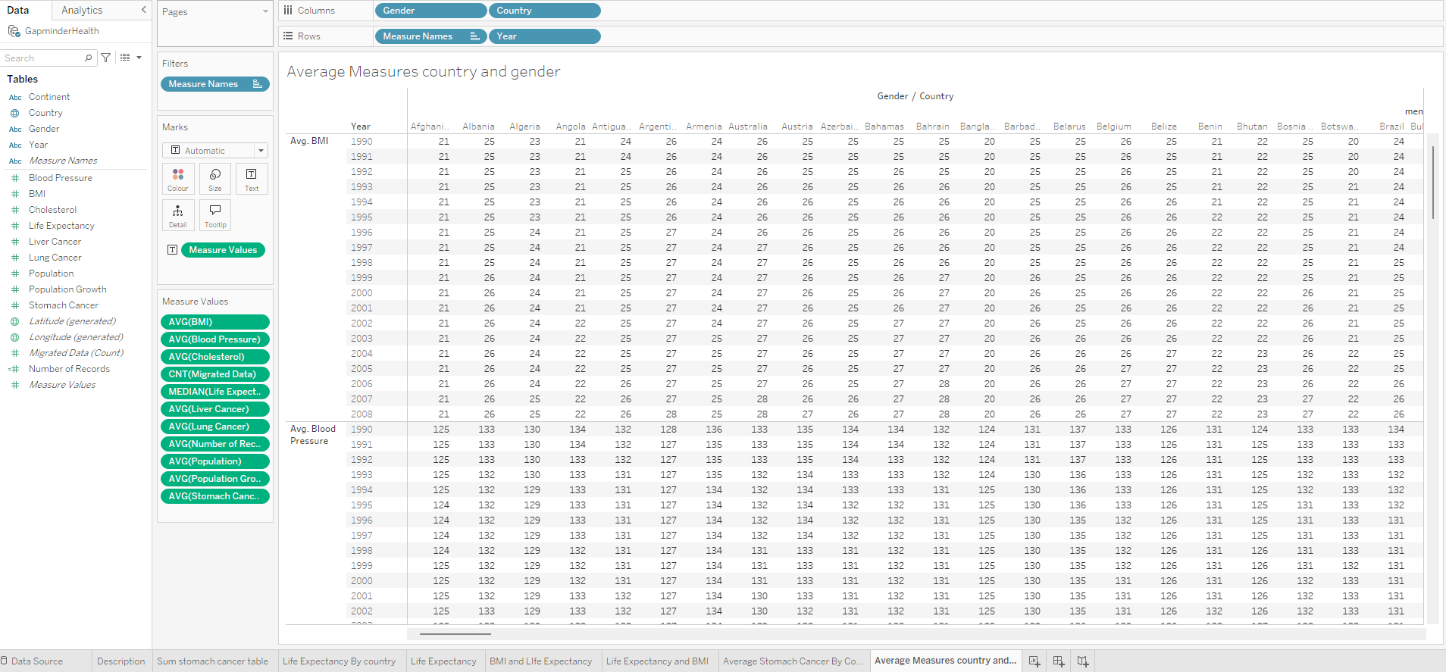  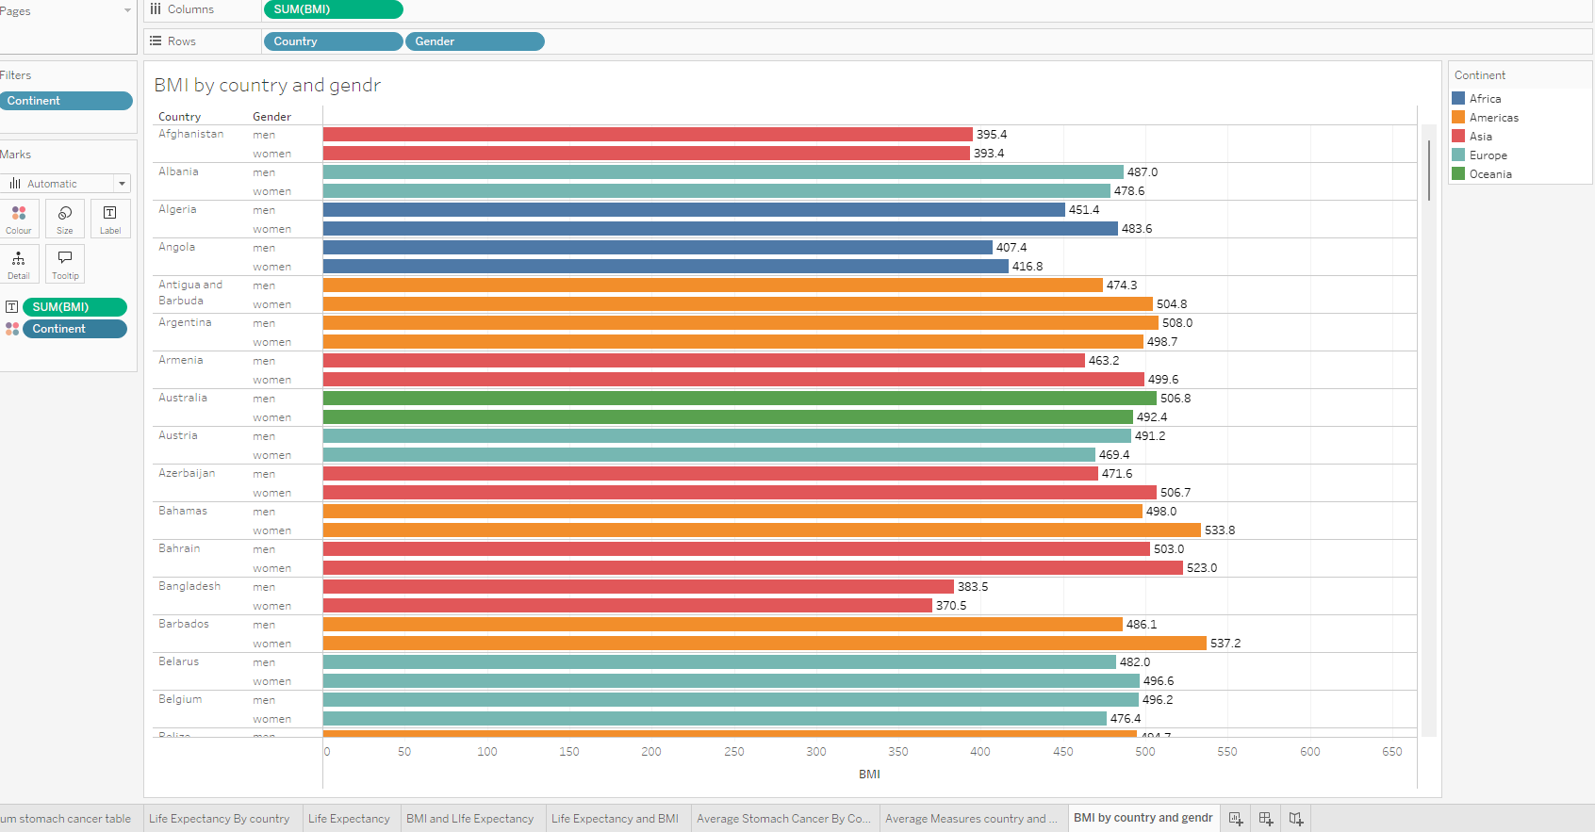
What did you find and any reflections on how the NHS could use this? | Big Differences: Stomach cancer figures vary greatly by country.  Hotspots: Some countries (like China, visibly) show much higher numbers, needing priority support.  Continent Matters: The amount of stomach cancer seems different across continents, suggesting regional factors.  Action: Focus support on high-burden countries and tailor strategies by continent. Sorting the table and looking at continents separately in Tableau will give more details.  Life expectancy is highest in North America, Europe, East Asia, and Australia (darker blue on the map). It's lowest in much of Africa and parts of South Asia (lighter blue). This highlights where support for health and well-being is most needed globally.  Higher BMI generally correlates with higher life expectancy, but this relationship differs across continents. Africa shows a stronger increase in life expectancy with BMI at lower levels, while Europe shows a weaker increase at higher levels. The Americas and Asia fall somewhere in between.  Visualization clearly demonstrates the common trend of women living longer than men across various countries, while also emphasizing that the size of this gender gap in life expectancy is not uniform globally.  Also, I did a detailed table providing a year-by-year comparison of average health measures (like BMI, blood pressure, life expectancy) between men and women across various countries, enabling the analysis of trends and gender-based differences over time and geography.

Day 3: Task 1

Please complete Lab 1 ‘Get Data in Power Bi Desktop’. Once complete, paste a print screen below and in the collaboration board.

“Teaching is the best way to learn, so please listen out for support requests from the class and we’ll work through the challenges together”

Paste your completed lab here | 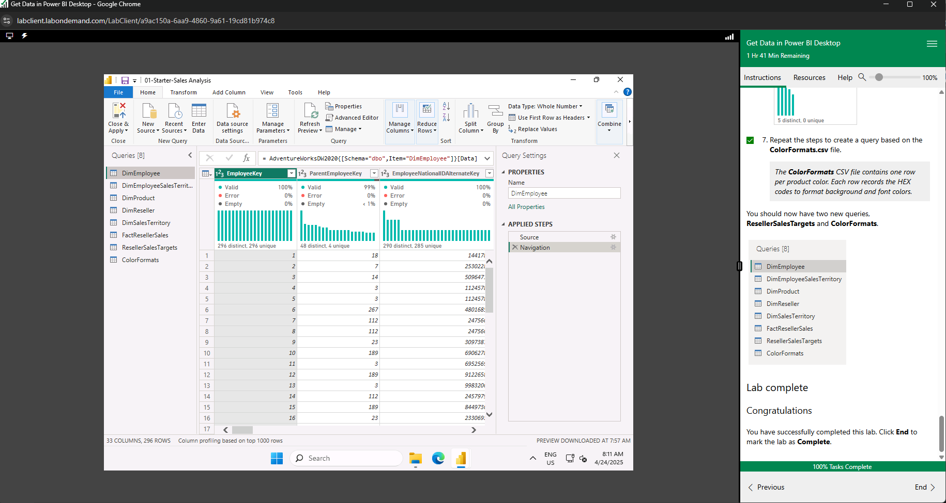

Day 3: Task 2

Please complete Lab 2 ‘Load Transformed Data in Power BI Desktop’. Once complete, paste a print screen below and in the collaboration board.

“Teaching is the best way to learn, so please listen out for support requests from the class and we’ll work through the challenges together”

Paste your completed lab here | 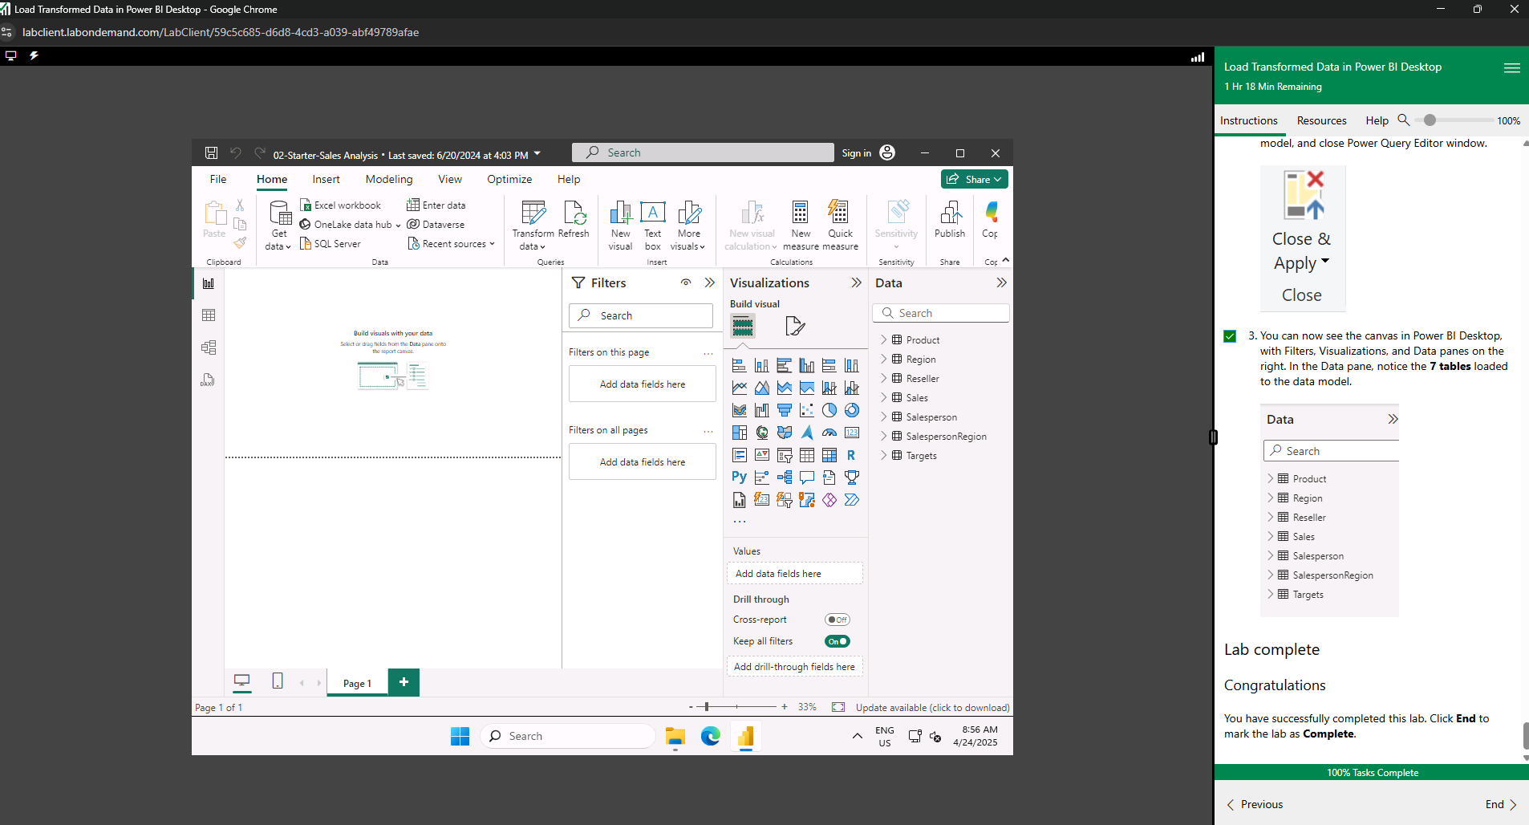

Day 4: Task 1

Please complete Lab 6 ‘Design a Report in Power BI Desktop’. Once complete, paste a print screen below and in the collaboration board.

“Teaching is the best way to learn, so please listen out for support requests from the class and we’ll work through the challenges together”

Paste your completed lab here | 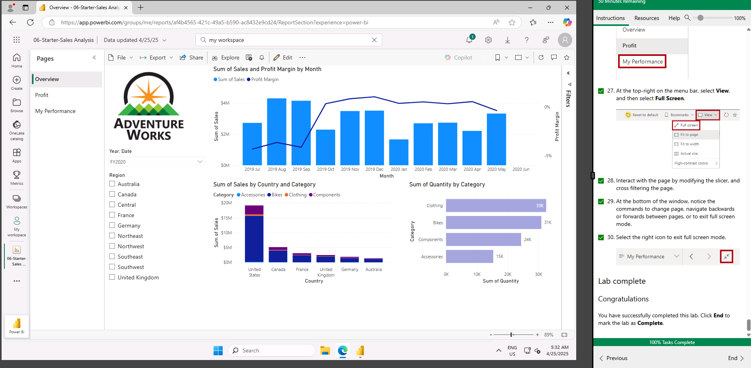

Day 4: Task 2

Please complete Lab 10 ‘Create a Power BI Dashboard’. Once complete, paste a print screen below and in the collaboration board.

“Teaching is the best way to learn, so please listen out for support requests from the class and we’ll work through the challenges together”

Paste your completed lab here | 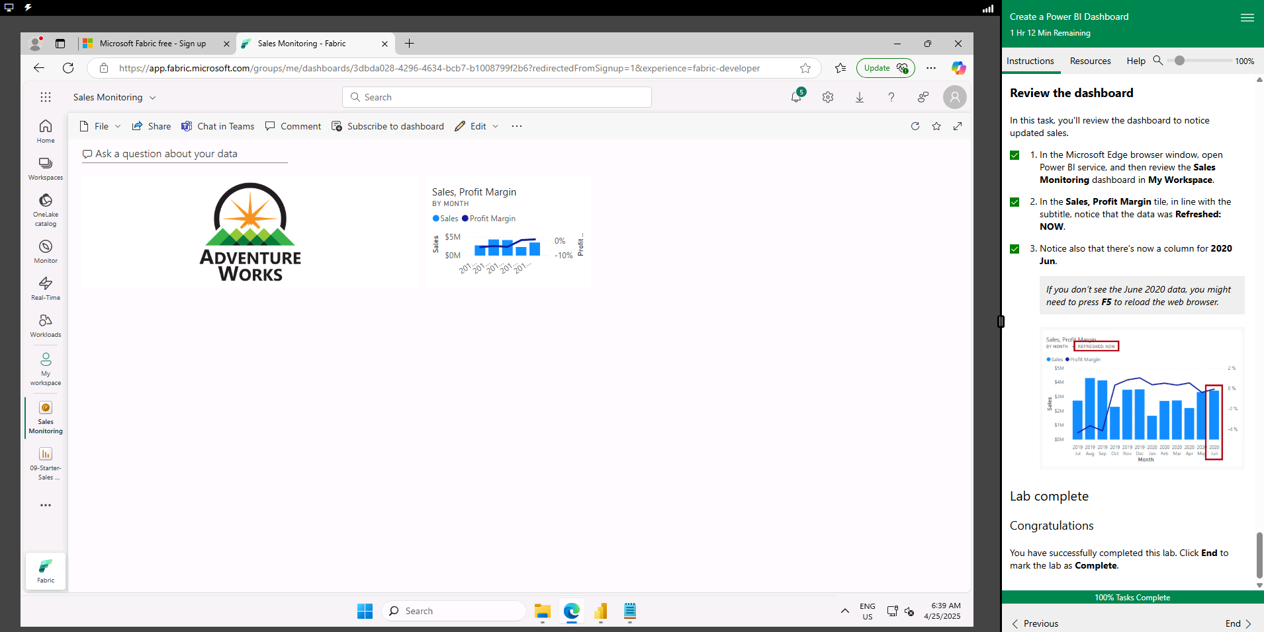

Course Notes

It is recommended to take notes from the course, use the space below to do so, or use the revision guide shared with the class.

We have included a range of additional links to further resources and information that you may find useful, these can be found within your revision guide.

END OF WORKBOOK

Please check through your work thoroughly before submitting and update the table of contents if required.

Please send your completed work booklet to your trainer.

Information

